SmartDine Testing and Evidence
Prepared for ICT203 Assessment 3

SmartDine Test Cases
The test cases have been the taken in the last version from SmartDine. To showcase the primary workflows, their working and how they interact with each other: (Frontend, Backend, Database, Authentication, User roles, Ordering, Actions (Admin), Chatbot support).
ID | Area | Test Steps | Expected Result | Evidence
TC-01 | Frontend loads | Start the React frontend and open http://127.0.0.1:5173. | No Vite error is detected – and no smartDine error. | UI working.png
TC-02 | Menu from database | Starts back end and mysql, and displays Menu page, | MySQL's menu items are displayed in the frontend. | Menu loading DB items.png
TC-03 | Customer login | Log in using Open Logon, Customer login and the demo customer account. | Customer is equipped to use the customer options. | Customer login.png
TC-04 | Customer order | All the functions to add menu items, open Orders and place orders as Customer are included. | The order list displays order which is made and visible. | Customer placing order.png
TC-05 | Admin dashboard | As ADMIN sign in and click the Admin button. | Administrative Dashboard and controls are visible. | Admin dashboard.png
TC-06 | Admin updates order | Admin View: Update the status of an order. | Successfully receives updates about orders. | Admin updating order status.png
TC-07 | Role restriction | Make an effort to use customer ordering as admin. | The customer order can't be processed by Admin. | Can be shown during demo.
TC-08 | Chatbot recommendation | Open chatbot and ask for a food recommendation. | suggest the matching items on the menu. | Chatbot recommendation.png
TC-09 | Git workflow | Display branches and commits, pull requests and merges. | History provides information on changes occurring in the collaborative project. | GitHub branches commits PR merge.png, 02-chatbot-pr-merged.png
TC-10 | UI improvement | Look at the improved layout, sidebar, log-in and the Chatbot pop up. | Both the user and administrator interfaces have a good look and are intuitive. | improving UI.png

Manual Checks Completed
- Production build of frontend is successful.
- JavaScript syntax check was done in the backend process for the ChatBot Controller.
- Analyze the file planservice/frontend/src/main.jsx and remove conflict markers: Main.jsx in project planservice/frontend has been analyzed and the conflict markers have been removed.
- The following sets of questions were used for testing the chatbot: Account questions, Spicy questions, Greeting questions, Not spicy questions, Recommendation questions.
- Administración Orders could not be created in the back end.

Evidence Screenshot Index
This folder contains the screenshots which were enabled throughout the development and testing. Photos are stored on local computer and uploaded for selection of quality photos to be used for the final report and presentation.
Screenshot | What it proves
UI working.png | The React front end has been opened up and the primary SmartDine screen will load.
Menu loading DB items.png | The foods are not only loaded from demo data, they're also being loaded from the database/API.
Customer login.png | There is a login path for customers and no relationship with it with the admin login.
Customer placing order.png | Customers are able to make their additions and order.
Admin dashboard.png | You will be able to view your Dashboard with Admin only privileges when logged in as Admin.
Admin updating order status.png | Your order will be updated by Admin.
Chatbot recommendation.png | SmartDine Assistant can give suggestions on foods using the taste options.
improving UI.png | Enhancements in UI while working on development.
GitHub branches commits PR merge.png | Strengths related to branches, commits and pull request workflow evidence.
02-chatbot-pr-merged.png | I merged Chatbot Work - through pull requests.

Recommended Final Selection
Use these screenshots in the final report or presentation:
- Menu loading DB items.png
- Customer login.png
- Customer placing order.png
- Admin dashboard.png
- Admin updating order status.png
- Chatbot recommendation.png
- GitHub branches commits PR merge.png
- 02-chatbot-pr-merged.png

Screenshot Evidence

Menu loading DB items
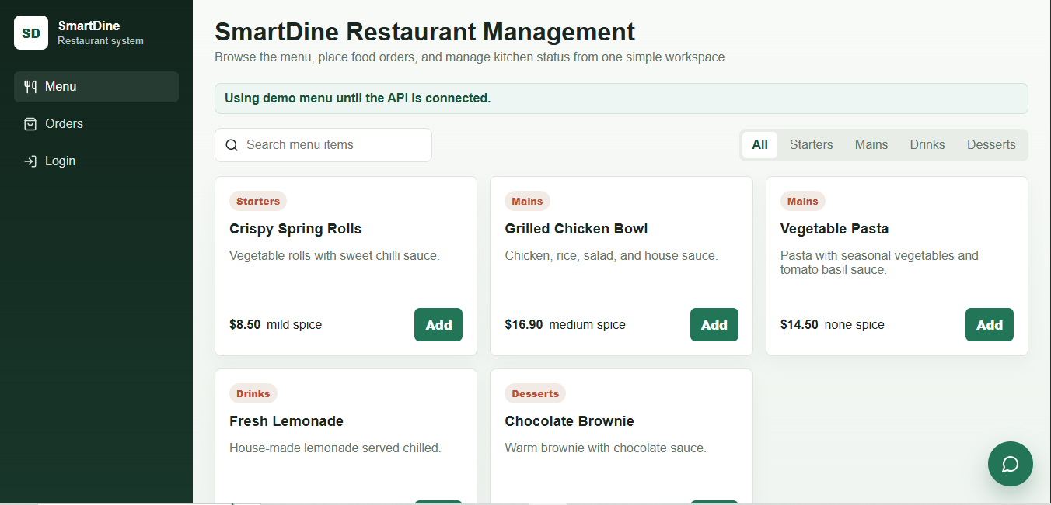

Customer login
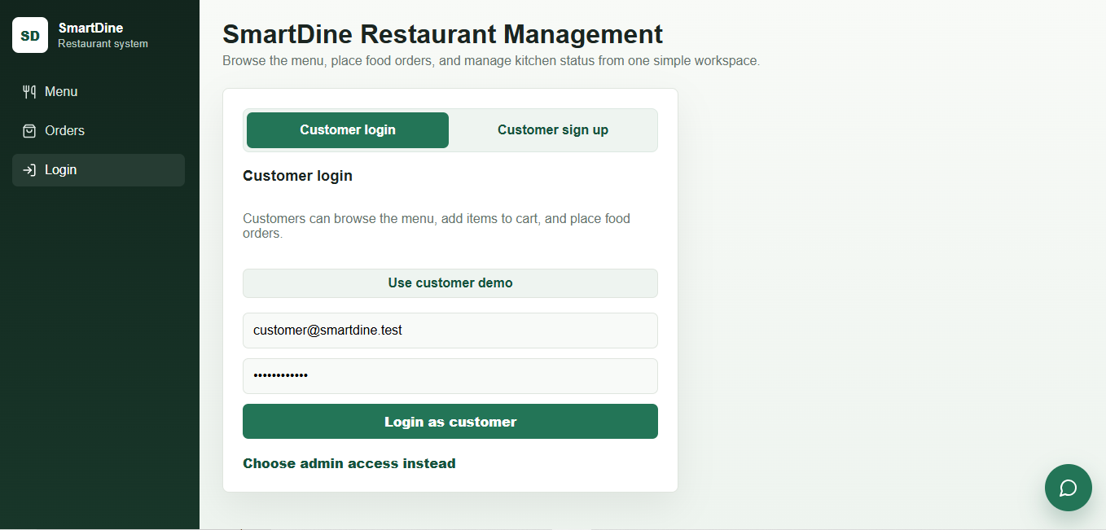

Customer placing order
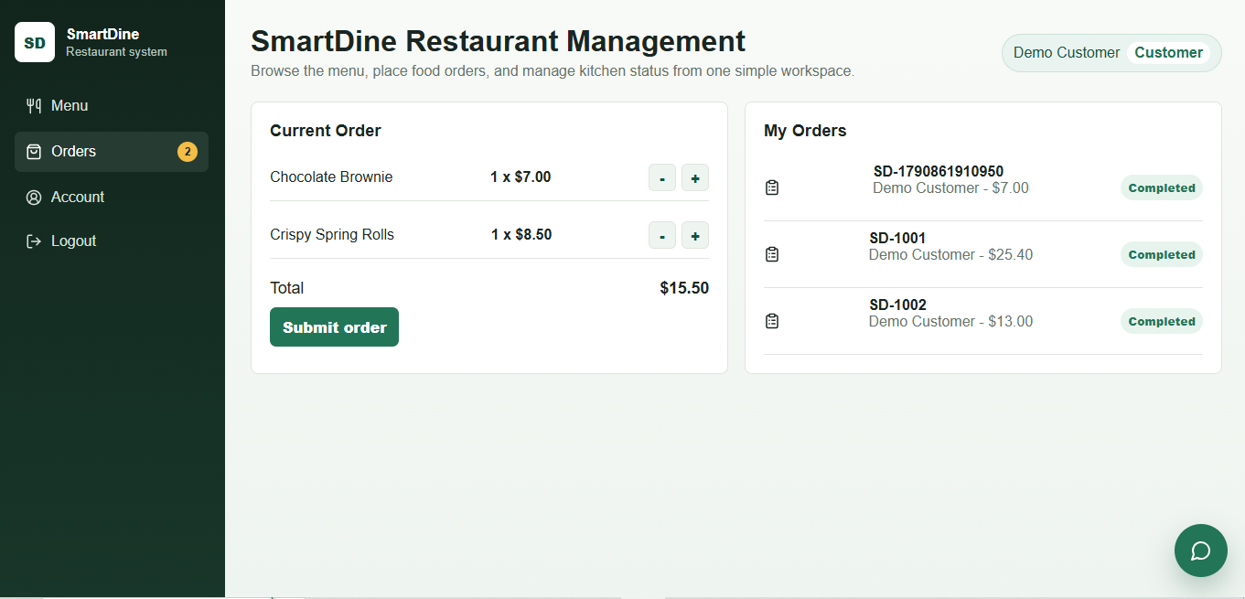

Admin dashboard
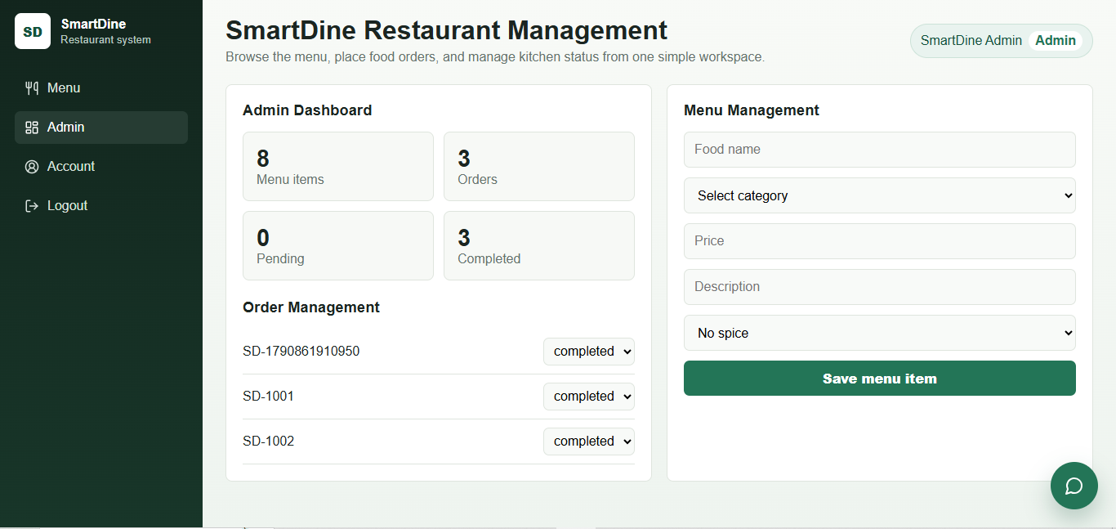

Admin updating order status
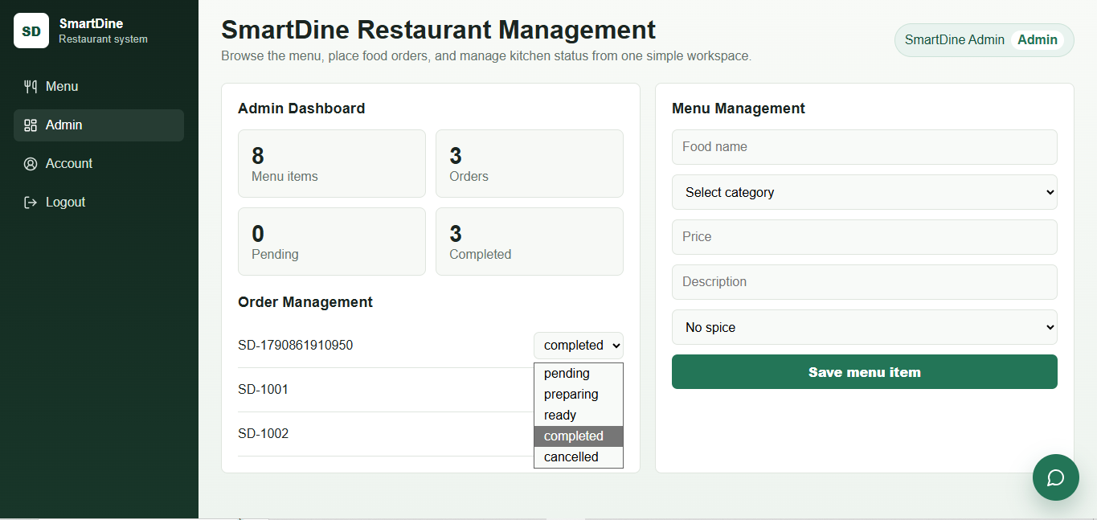

Chatbot recommendation
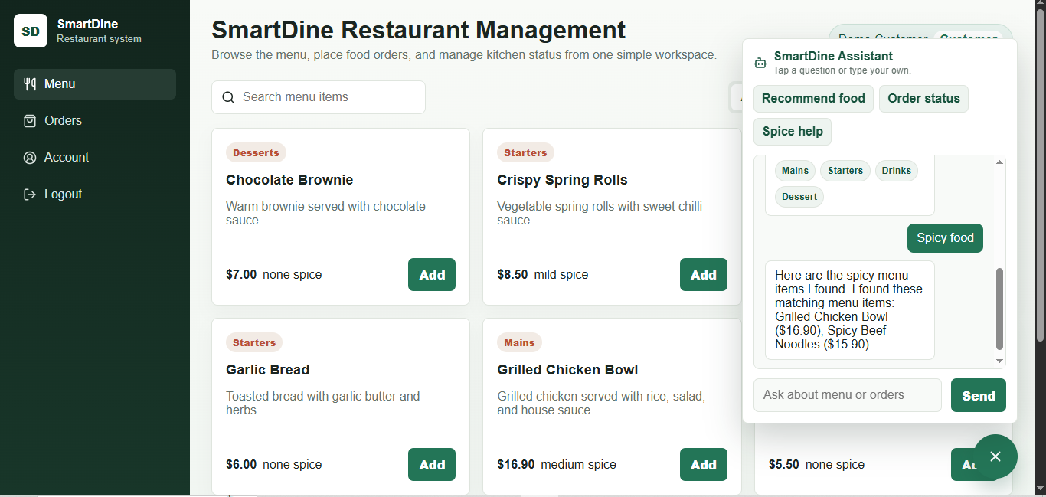

GitHub branches commits PR merge
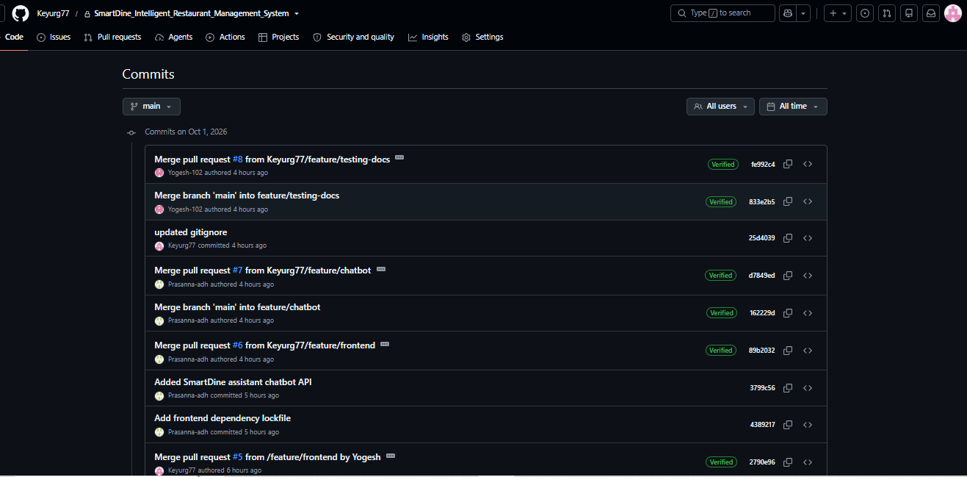

02-chatbot-pr-merged
