SmartDine Intelligent Restaurant Management System
ICT203 Assessment 3 Final Report

Team Member Contributions

Team Member | Contribution (%) | Responsibilities for the Project
Keyurg Gairapipli | 25% | Team Lead / Scrum Master. Developed and maintained the primary repository on github, orchestrated branches and pull requests, made merges, prepared deployment configuration, updated readme, final integration and documentation support.
Yogesh | 25% | Front-End Lead. Built React-based front end pages, collaborated on UI fixes, functioning of Chatbot & front end integration, helped with fixing bugs and helped with merge updates.
Prasanna | 25% | Back-End / Chatbot Lead. Developed and tested backend APIs, SmartDine Assistant chatbot API, frontend dependency layout and assistance in integration.
Anip | 25% | UI / QA Support. Implemented dark theme styling, SmartDine logo/favicon, Frontend minor changes, Backend minor changes in validation message, and End of testing support.

TABLE OF CONTENTS
Team Member Contributions 1
1. Introduction 3
2. Problem Background 3
3. Objectives 3
4. Technology Stack 3
5. System Users 4
Customer 4
Admin 4
6. Main Features 4
Authentication and Roles 4
Menu Browsing 4
Customer Ordering 4
Admin Dashboard 5
SmartDine Assistant 5
7. Database Design 5
8. Security Considerations 5
9. Testing Summary 5
10. Collaboration and GitHub Workflow 6
11. Challenges Faced 6
12. Deployment 6
13. Conclusion 6
Screenshot Evidence 8
Menu loading DB items 8
Customer login 8
Customer placing order 9
Admin dashboard 9
Admin updating order status 10
Chatbot recommendation 10
GitHub branches commits PR merge 11
02-chatbot-pr-merged 11

1. Introduction
SmartDine is a complete restaurant management solution to support ICT203 Assessment 3. This is an application that will be useful to a small restaurant that wants a way to handle their menus, customer orders, order status and minimal customer help desk functionality.
This project is built with a React front end, an Express.js back end and a MySQL database. It also has SmartDine Assistant, the rule-based chatbot which helps users to find answers to questions regarding menu, ordering method, the flavor and the suggestion of food.
The project aimed to create not just a visual prototype but to begin designing a product prototype. The expectation was to be able to develop a system that was operative between a front-end application and API routes on the back-end of which the back-end was to access and modify live records in MySQL.

2. Problem Background
A restaurant that has shifted to a paper-based approach encounters problems with keeping track of food and drink availability, as well as order status, quickly.If a restaurant processes menu information and orders by hand, it is easy to lose track of what is available, and what status these are in. Customers may also have to get simple answers to staff questions, which may be directly answerable in the system.
SmartDine attempts to correct this by offering one shining example: they encourage their users to utilize a clear menu and ordering system. It also provides admins with their separate area to organize menu things and order progress. There's a simple support feature, and users can ask common questions without having to navigate away from the page they're on.

3. Objectives
The main objectives were:
- Develop a comprehensive Restaurant Management application.
- Separate user access for customer & admin.
- Load Menu information from a MySQL Database.
- Allow customers to create food orders.
- Add the ability for the administrators to modify order status and menu items.
- Introduce an intelligent assistant with rules.
- Utilize GitHub branches, GitHub pull requests as evidence of collaboration.
- Create evidence (test, screenshots) to be submitted at the end.

4. Technology Stack
Layer | Technology | Reason Used
Frontend | React with Vite | Fast building server and component based interface..
Backend | Node.js and Express.js | Clear API structure for authentication, menu, orders, and chatbot routes.
Database | MySQL | Relational data fits users, menu items, orders, and order items.
Security | bcrypt, sessions, role middleware | Used for password hashing, login sessions, and role-based access.
Styling | CSS | Used for the dashboard, menu cards, login pages, and chatbot popup.
Version control | Git and GitHub | Used for branches, commits, pull requests, and merge history.
React justification: The reason for using React with the frontend was for SmartDine to create a more dynamic interface instead of just static HTML pages. When users search, filter categories on the menu page or add items to the cart, the page updates as soon as the click. The logged-in user's role also determines the interface, with customers able to place orders, and admins, manage menu items and update their status. React facilitated this state change in a manner that was easier to control: Using reusable elements like the sidebar, menu cards, login forms, order panels, admin dashboard and the chatbot popup. This was used with React, since it provides a rapid local server and rebuilds as components change while testing and correcting ui bugs.

5. System Users

Customer
Customers are able to register and sign in, view the menu, search for food item offerings, filter by food offerings category, add food offerings to food order, and place the food order.

Admin
Admins log in via a different path. They have access to the admin dashboard, have the ability to add menu items and update order status. The customer workflow restricts admin from creating Customer orders.

6. Main Features

Authentication and Roles
It is a system that functions with a separation of Customer and Admin access. The first screen to appear is the account type sign-in screen. For customers, they would be granted both log-in and sign-in capabilities, whereas with the admin log-in option, it is only used by the admin. This helps to clarify the roles and will not display unwanted features in the interface.

Menu Browsing
Menu gets displayed in the React frontend and it comes from the back-end API. Users can search food name as well as filtering based on food categories. Every card will display the item name, item description, price, category, and spice level.

Customer Ordering
Menu items can be added to an order by the customer. The Orders page presents the selected items, quantities and total amount before submitting order. Once submitted, order will be stored in the MySQL database via the backend.

Admin Dashboard
The admin dashboard provides staff with a streamlined management area for restaurants. Admins can add to Menu Items, and update Order progress. The side bar also adapts to the role that is logged in, so that, these logical boxes do not appear to the customer when the role is only administrator.

SmartDine Assistant
Developed chatbot screen appears as a popup on the bottom-right of the application. It can solve the normal problems of the restaurant, and serves in accordance with the taste, for example, chicken, not spicy, vegetarian, main course, starter, drink and dessert.

7. Database Design
The database operates in simulation to the main restaurant ordering workflow:
- stores user accounts (admin and customers).
- store categories: stores menu categories.
- menu_items contains individual food items.
- Uses orders to store each individual order that a customer places into the store.
- Order Items contain the menu items stored within an order.
- Chatbot rules are stored in the database.
- Very important user and admin activities are stored in “activity_logs”.
Orders are related to user by foreign key, order items are related to orders and menu items, and menu items are related to categories. Thus, the data will remain organized and not be stored over and over again.

8. Security Considerations
In addition to “low-tech” security measures, the project involves a number of basic security measures:
- The password is stored in a hashed format, namely using bcrypt hashes.
- Admin routes are provided with role-based middleware.
- Parameterized statements are used in the SQL queries.
- The .env file will not be committed since it is ignored.
- The chatbot enhances user interaction with local rules and database queries instead of relaying user messages to an external AI service.
These controls are not meant to cover every production security issue, but they address the main risks These controls do not meet every production security concern, but rather address the primary production security risks likely to be present in this assessment project.

9. Testing Summary
Testing was conducted on the most important Workflows:
- Loads frontend without any errors in the Vite console.
- Backend API starts correctly.
- Menu data is loaded from MySQL.
- Customer login works.
- Orders can be created in the customers.
- Admin login works.
- Admin order status update works.
- Admin not allowed to create customer orders.
- Chat Bot welcomes, recommends, answers spice and account questions.
- Resolved git merge conflicts, and verified the frontend build.
The local copy of any screenshots is stored in evidence/docs.

10. Collaboration and GitHub Workflow
A commitment to progress in the development of the project was demonstrated by using GitHub branches, commits, and pull requests. The development was divided into the parts of setup, the backend, the frontend page, the database, the chatbot, and testing document.
This method would enable a continual move in the direction of progress rather than a final upload. Pull Requests also provided a good history of conflicts and merging of branches.

11. Challenges Faced
A merge conflict that occurred during the development process was one of the problems. There were a few markers created in the code that prevent Vite from building the app. The highlighting of the markers needed to be done in person and the "submit" function would need to be replaced in the chatbot. The frontend build has been successful once the fix has been applied.
One of the difficulties was ensuring that the contents of the front end were based on real data from the database and not the fall-back demo data. This was tested by running the backend, MySQL and the frontend all at once and ensuring that the items in the given database menu appeared on the Menu page.
The talk-to-talk bot also had a few improvements to make. Followup comments were too "vague" and additional logic included for greetings, account queries, spice level queries and recommendations.

12. Deployment
The project was duly ready for online deployment as well. The frontend was published on Netlify, the backend API was published on Render and the MySQL database on Aiven. Setting up deployment and database connection information were not hard-coded into the deployable solution by using environment variables.
Frontend URL:
https://smartdine7.netlify.app
Backend API URL:
https://smartdine-api-c2k7.onrender.com

13. Conclusion
SmartDine features a rule-based intelligent assistant, admin management, customer ordering and menu management using a database-backed application that shows a working full stack restaurant application. The final version includes the main workflows that are linked throughout the frontend, backend and the database, which is sufficient for assessment demonstration.
Also featured in the project are how printable items are actually developed, with GitHub commits and branches, testing notes, deployment setup, and evidence in screen shot.

Screenshot Evidence

Menu loading DB items
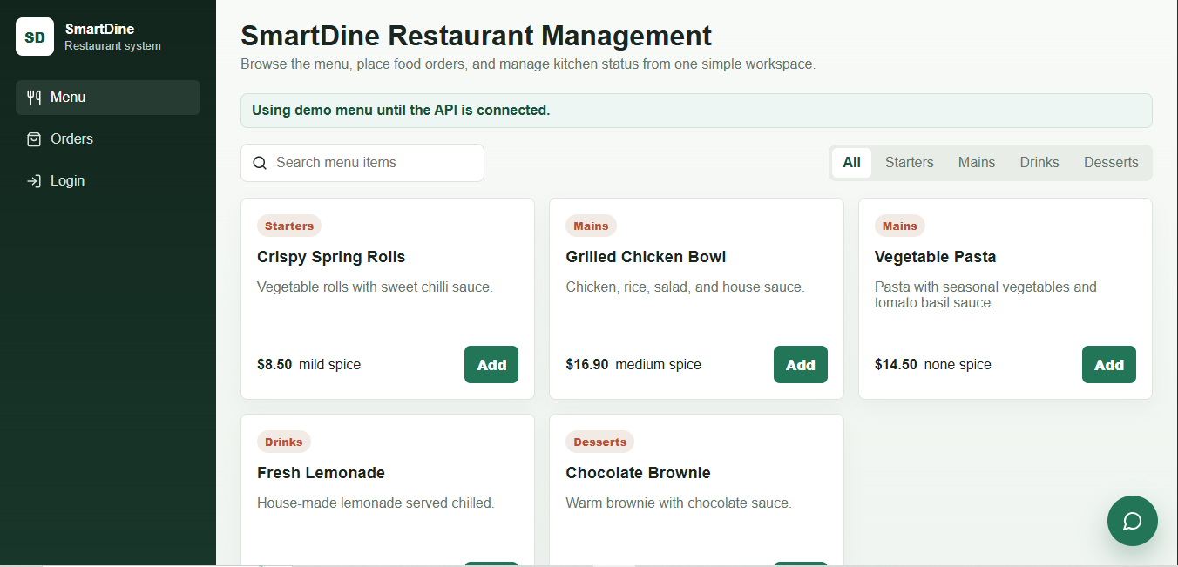

Customer login
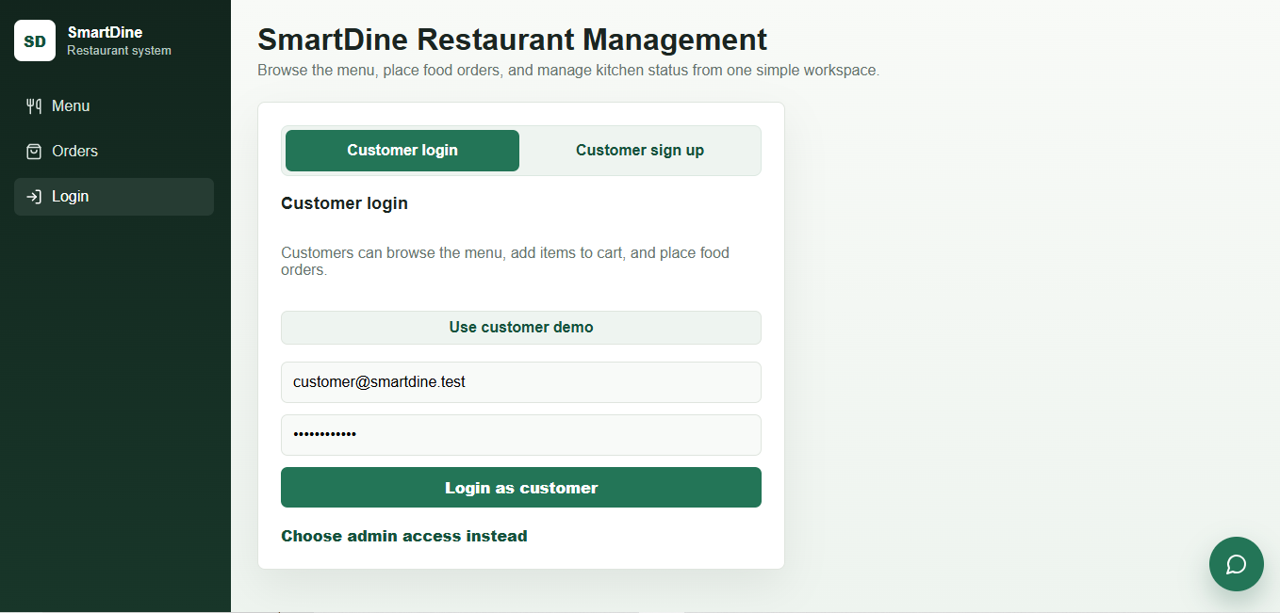

Customer placing order
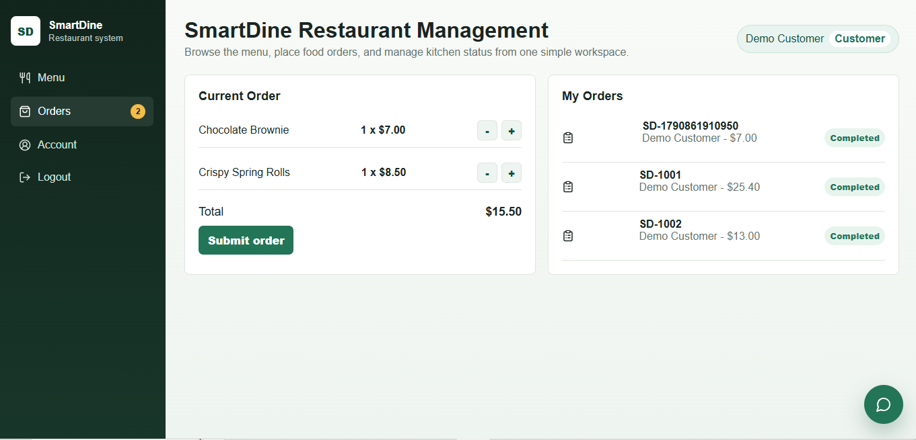

Admin dashboard
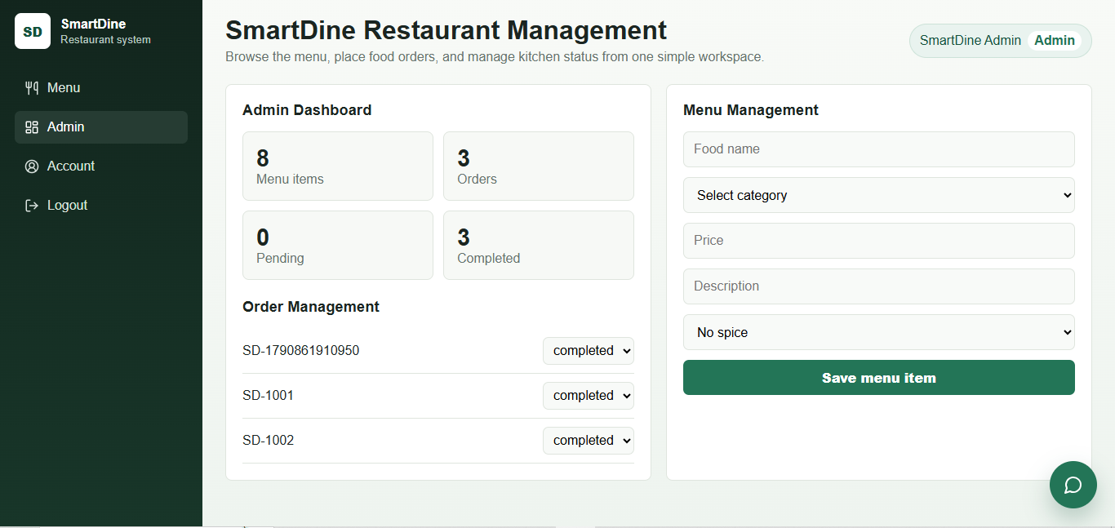

Admin updating order status
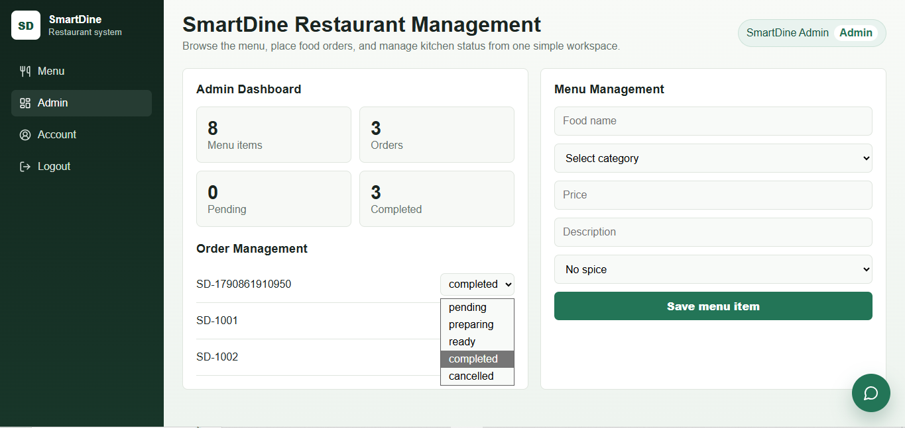

Chatbot recommendation
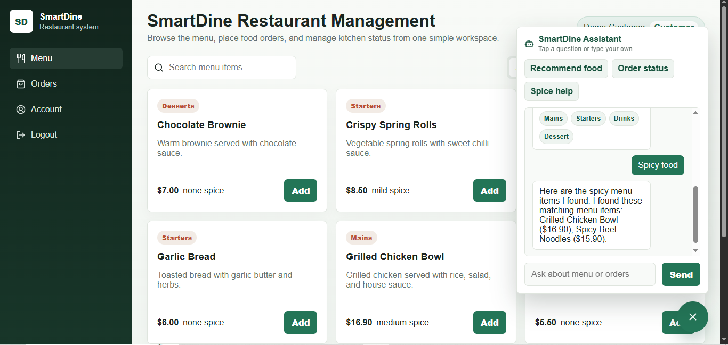

GitHub branches commits PR merge
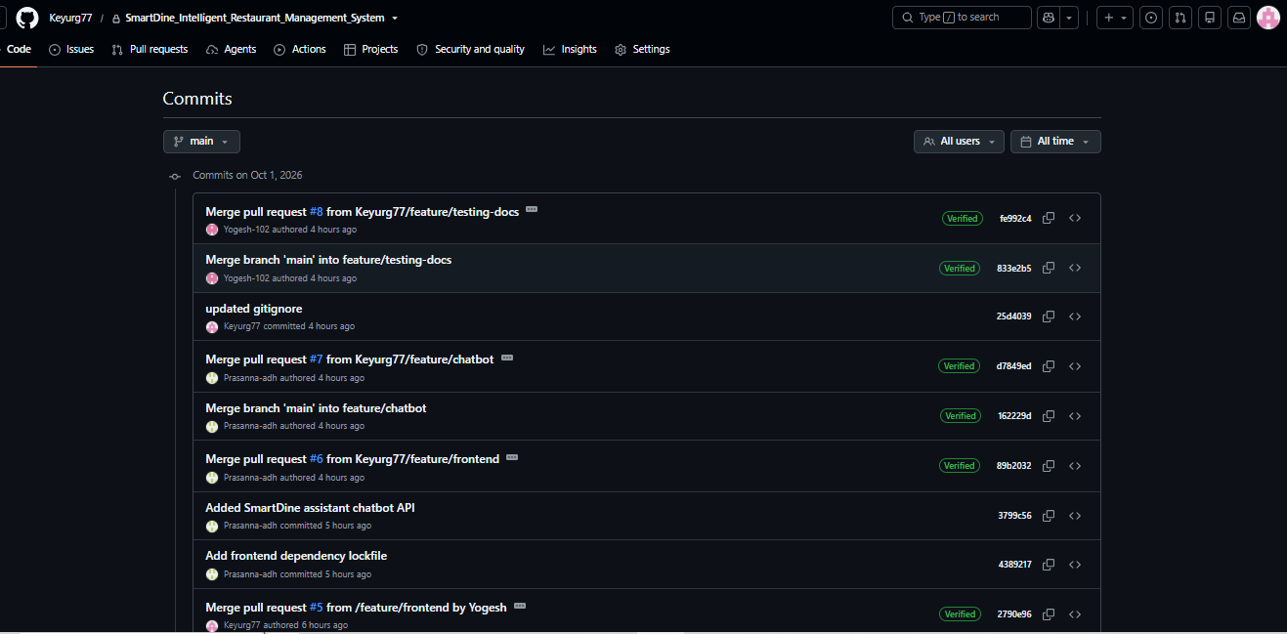

02-chatbot-pr-merged
