SmartDine System Design
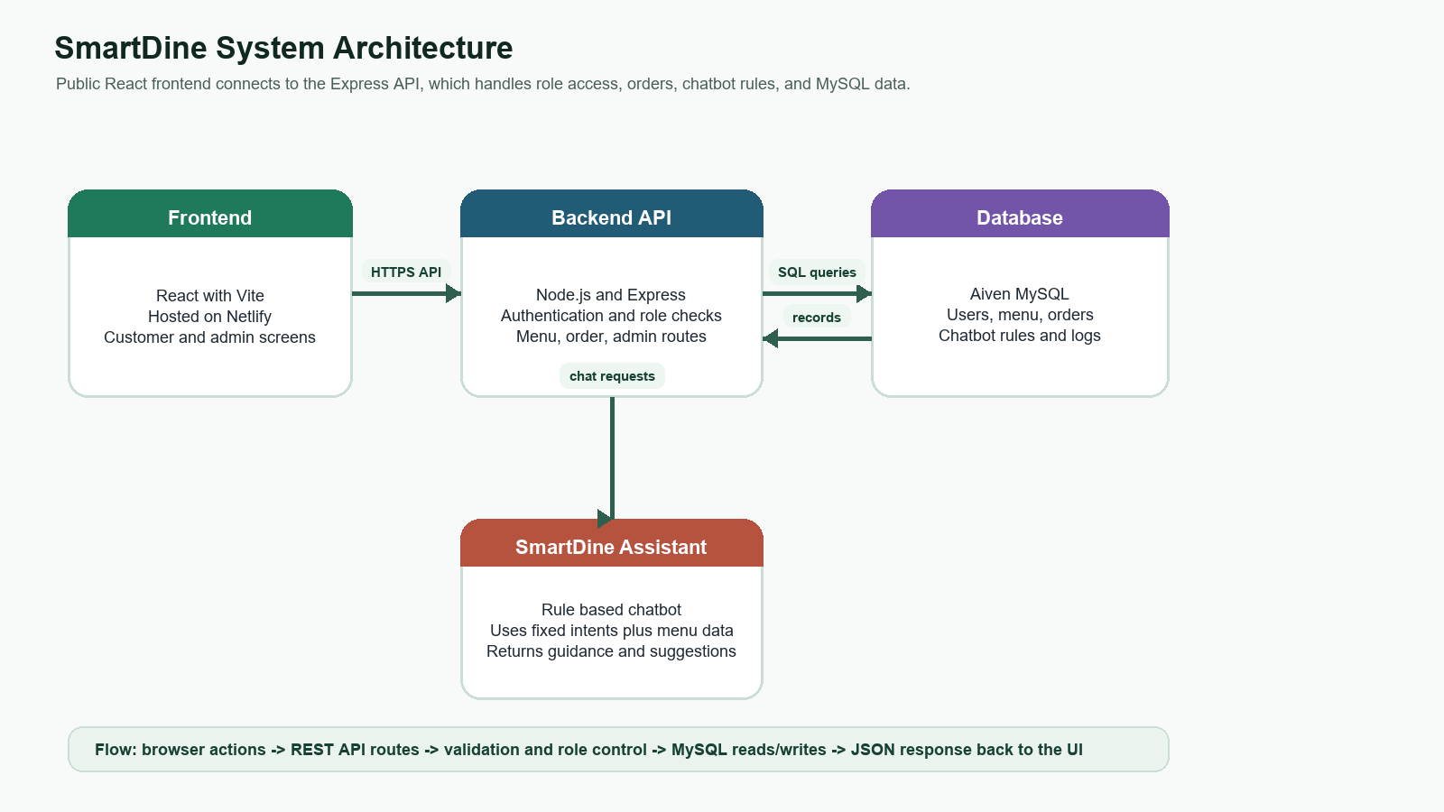
Figure 1. SmartDine client server database architecture.
The architecture diagram is an illustration of how the SmartDine system can be integrated, operating as a full stack connected system. The React user-facing app is accessed by customers and admins via browser. The Express backend API handles login, role based access, menu actions, orders, and chatbot messages, with requests sent to Express by the frontend. The backend reads the data in and out of the MySQL database that holds users, menu categories, menu items, orders, order items, activity logs and chatbot rules. The frontend gets the answer back as JSON, which is used to update the screen with the latest menu, order, admin or assistant information.

This document explains the architecture of the system, design of relational database, and API Endpoints in SmartDine application.

1. Architecture Diagram
SmartDine is an application that is built in a client server (3 tiers) database system. The React part of the UI is deployed on Netlify. This is deployed on Render with a backend API called the Express backend API. MySQL is on Aiven.
Client | Server | Database
React frontend on Netlify  https://smartdine7.netlify.app | Node.js and Express API on Render  https://smartdine-api-c2k7.onrender.com | Aiven MySQL  smartdine_db

2. Request Flow
- The user is provided with the Netlify URL to open the React frontend.
- The frontend makes the API calls to the configured base URL of the API service hosted by the Render backend.
- Express handles all routes including authentication, menu order, admin and chatbot routes.
- The backend communicates with and interacts with the Aiven MySQL database.
- Frontend shows the response to the customer/admin user.

3. ERD
The diagram below is a representation of the ERD that is used by the SmartDine system.

4. API Endpoints List
Method | Endpoint | Purpose
GET | /api/health | Takes an API check to verify whether the backend API is up and running.
POST | /api/auth/register | Gives initial credit to the account for a customer.Sets up Customer Account.
POST | /api/auth/login | Log – is in a customer user or an admin user.
POST | /api/auth/logout | Logs out the currently logged-in user.
GET | /api/auth/me | Gets the currently logged in user.
GET | /api/menu/categories | Returns menu categories.
GET | /api/menu/items | Gives back items on menu.
POST | /api/menu/items | Allows an administrator to make a menu item.
GET | /api/orders | Retests orders from the current Admin/ User's perspective.
POST | /api/orders | Allows a customer to create an order.
PATCH | /api/orders/:id/status | Gives an Administrator the ability to change the associated order status.
POST | /api/chatbot/message | Responds to a SmartDine Assistant response.

5. Deployment Links
Frontend: https://smartdine7.netlify.app
Backend API: https://smartdine-api-c2k7.onrender.com

