|  |  |
| --- | --- |
|  | **2018 FIFA World Cup Russia™** |
| **Group D** | **Team Tracking Statistics** |
| **Argentina** | **- Iceland 1 : 1 ( 1 : 1 )** |



**# 7 16 JUN 2018 16:00 Moscow / Spartak Stadium / RUS**

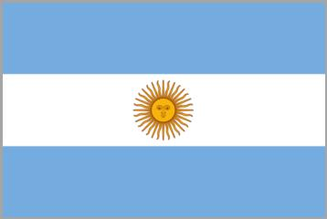

**Argentina**

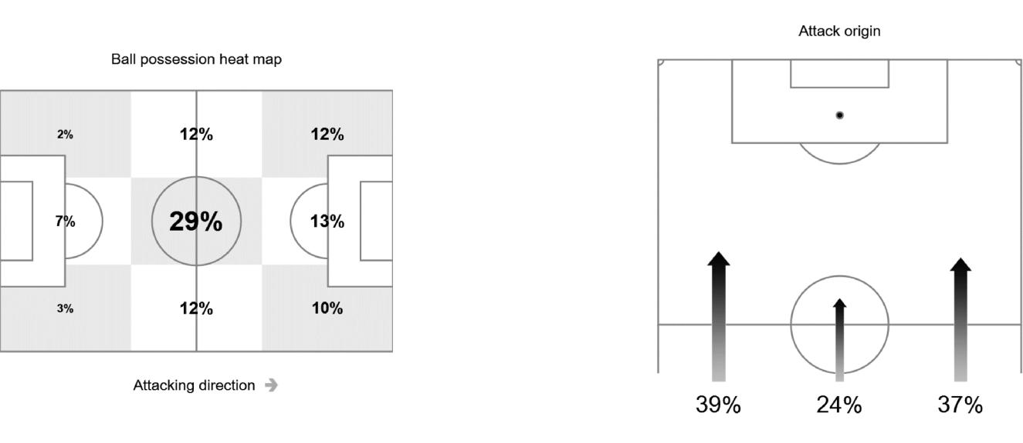

|  |  |  |  |  |  |  |  |  |  |  |  |  |  |  |  |  |  |  |
| --- | --- | --- | --- | --- | --- | --- | --- | --- | --- | --- | --- | --- | --- | --- | --- | --- | --- | --- |
| **#** | **Name** | **Time** | **Distance covered (metres)** | | |  | **Time spent** | | |  | **SP** | **T.S.** |  | **Activity time spent** | | |  |  |
|  | Total | In Poss | Not in Poss | O.H. |  | A.3rd |  | P.A. |  |  | Zone 1 | Zone 2 | Zone 3 | Zone 4 | Zone 5 |  |
|  |  |  |  |  |  |  |  |
|  |  |  |  |  |  |  |  |  |  |  |  |  |  |  |  |  |  |  |
| 23 | CABALLERO | 96'11" | 4,298 | 2,172 | 1,013 |  |  |  |  |  |  | 15.30 | 95% | 5% |  |  |  |  |
| 3 | TAGLIAFICO | 96'11" | 10,399 | 5,612 | 2,674 | 60% |  | 39% |  | 9% | 30 | 27.43 | 65% | 27% | 6% | 2% |  |  |
| 5 | BIGLIA | 54'21" | 6,036 | 3,536 | 1,569 | 59% |  | 26% |  | 4% | 5 | 25.56 | 63% | 31% | 5% | 1% |  |  |
| 10 | MESSI | 96'11" | 7,617 | 4,722 | 1,420 | 82% |  | 52% |  | 6% | 17 | 25.02 | 83% | 13% | 3% | 1% |  |  |
| 11 | DI MARIA | 76'03" | 7,918 | 4,641 | 1,708 | 77% |  | 56% |  | 8% | 25 | 29.23 | 69% | 25% | 3% | 2% | 1% |  |
| 13 | MEZA | 84'49" | 9,239 | 5,352 | 2,089 | 71% |  | 49% |  | 9% | 34 | 27.90 | 65% | 27% | 6% | 2% |  |  |
| 14 | MASCHERANO | 96'11" | 9,771 | 5,337 | 2,640 | 60% |  | 19% |  | 1% | 22 | 29.48 | 66% | 28% | 5% | 1% |  |  |
| 16 | ROJO | 96'11" | 9,529 | 5,215 | 2,435 | 41% |  | 13% |  | 6% | 24 | 27.00 | 70% | 23% | 6% | 1% |  |  |
| 17 | OTAMENDI | 96'11" | 9,542 | 5,030 | 2,366 | 45% |  | 12% |  | 6% | 21 | 27.90 | 68% | 25% | 6% | 1% |  |  |
| 18 | SALVIO | 96'11" | 10,216 | **5,730** | 2,656 | 56% |  | 32% |  | 2% | 39 | 31.72 | 65% | 27% | 5% | 2% | 1% |  |
| 19 | AGUERO | 96'11" | 9,313 | 5,449 | 2,048 | 81% |  | 59% |  | 18% | 27 | 27.68 | 71% | 23% | 5% | 1% |  |  |
|  |  |  |  |  |  |  |  |  |  |  |  |  |  |  |  |  |  |  |
| 7 | BANEGA | 41'50" | 4,364 | 2,503 | 970 | 72% |  | 40% |  | 3% | 8 | 23.76 | 67% | 26% | 6% | 1% |  |  |
| 9 | HIGUAIN | 11'22" | 1,043 | 587 | 175 | 92% |  | 62% |  | 14% | 2 | 24.84 | 77% | 18% | 4% | 1% |  |  |
| 22 | PAVON | 20'08" | 1,961 | 1,118 | 373 | 85% |  | 51% |  | 6% | 10 | 30.38 | 77% | 16% | 4% | 2% | 1% |  |

|  |  |  |  |  |  |
| --- | --- | --- | --- | --- | --- |
| In Poss: | Team in possession | O.H: | In opposite half | Zone 1: 0-7 km/h | Bold values: top performing in the match |
| Not In Poss: | Opposite team in possession | A.3rd: | In attacking third | Zone 2: 7-15 km/h |  |
|  |  | Pen. Area: | In penalty area | Zone 3: 15-20 km/h |  |
|  |  | SP: | Sprints | Zone 4: 20-25 km/h |  |
|  |  | T.S.: | Top speed | Zone 5: > 25 km/h |  |
| *FIFA does not vouch for the accuracy of techinical statistics compiled in association with its competition results system partner.* | | | | |  |
|  | |  |  |  |  |
| SAT 16 JUN 2018 18:53 CET / 19:53 Local time | | - Version 1 |  |  | Page 1 / 1 |

