|  |  |
| --- | --- |
|  | **2018 FIFA World Cup Russia™** |
| **Group D** | **Team Tracking Statistics** |
| **Argentina** | **- Croatia 0 : 3 ( 0 : 0 )** |



**# 23 21 JUN 2018 21:00 Nizhny Novgorod / Nizhny Novgorod Stadium / RUS**



**Argentina**

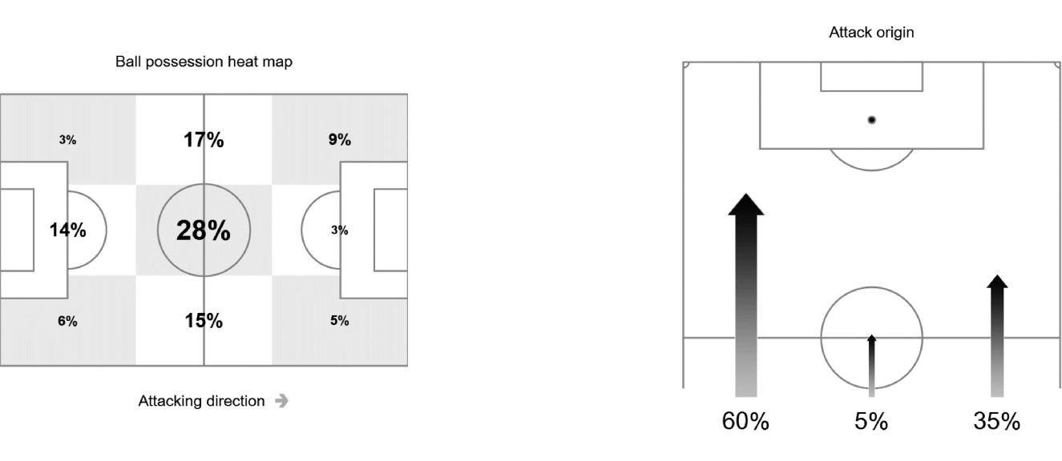

|  |  |  |  |  |  |  |  |  |  |  |  |  |  |  |  |  |  |  |
| --- | --- | --- | --- | --- | --- | --- | --- | --- | --- | --- | --- | --- | --- | --- | --- | --- | --- | --- |
| **#** | **Name** | **Time** | **Distance covered (metres)** | | |  | **Time spent** | | |  | **SP** | **T.S.** |  | **Activity time spent** | | |  |  |
|  | Total | In Poss | Not in Poss | O.H. |  | A.3rd |  | P.A. |  |  | Zone 1 | Zone 2 | Zone 3 | Zone 4 | Zone 5 |  |
|  |  |  |  |  |  |  |  |
|  |  |  |  |  |  |  |  |  |  |  |  |  |  |  |  |  |  |  |
| 23 | CABALLERO | 96'15" | 4,576 | 1,823 | 1,474 |  |  |  |  |  | 1 | 19.94 | 92% | 7% | 1% |  |  |  |
| 2 | MERCADO | 96'15" | 9,247 | 3,488 | 3,501 | 29% |  | 9% |  | 3% | 34 | 29.92 | 72% | 22% | 4% | 2% |  |  |
| 3 | TAGLIAFICO | 96'15" | 10,063 | **3,988** | 3,533 | 27% |  | 8% |  | 3% | 26 | 27.68 | 66% | 27% | 6% | 1% |  |  |
| 8 | ACUNA | 96'15" | 9,865 | 3,774 | 3,482 | 45% |  | 19% |  | 1% | 33 | 30.38 | 68% | 25% | 5% | 1% | 1% |  |
| 10 | MESSI | 96'15" | 7,624 | 3,217 | 2,651 | 72% |  | 29% |  | 4% | 29 | 27.43 | 84% | 11% | 4% | 1% |  |  |
| 13 | MEZA | 96'15" | 9,824 | 3,785 | 3,664 | 60% |  | 26% |  | 3% | 41 | 28.37 | 70% | 22% | 6% | 2% |  |  |
| 14 | MASCHERANO | 96'15" | 9,458 | 3,660 | 3,952 | 41% |  | 7% |  |  | 33 | 25.56 | 67% | 27% | 4% | 2% |  |  |
| 15 | E. PEREZ | 69'47" | 8,070 | 3,172 | 2,988 | 47% |  | 13% |  | 1% | 27 | 26.28 | 60% | 31% | 7% | 2% |  |  |
| 17 | OTAMENDI | 96'15" | 10,040 | 3,900 | 3,740 | 21% |  | 6% |  | 3% | 28 | 27.90 | 65% | 28% | 5% | 2% |  |  |
| 18 | SALVIO | 57'41" | 6,519 | 2,306 | 2,583 | 52% |  | 23% |  | 2% | 30 | **32.62** | 63% | 27% | 6% | 3% | 1% |  |
| 19 | AGUERO | 55'31" | 5,738 | 2,156 | 2,228 | 80% |  | 43% |  | 11% | 24 | 27.43 | 68% | 24% | 5% | 2% | 1% |  |
|  |  |  |  |  |  |  |  |  |  |  |  |  |  |  |  |  |  |  |
| 9 | HIGUAIN | 40'44" | 3,561 | 1,573 | 1,138 | 73% |  | 39% |  | 9% | 11 | 26.28 | 76% | 19% | 4% | 1% |  |  |
| 21 | DYBALA | 26'28" | 2,878 | 1,410 | 873 | 59% |  | 31% |  | 7% | 8 | 22.86 | 64% | 28% | 6% | 2% |  |  |
| 22 | PAVON | 38'34" | 3,236 | 1,360 | 968 | 64% |  | 35% |  | 3% | 15 | 32.40 | 77% | 18% | 3% | 1% | 1% |  |

|  |  |  |  |  |  |
| --- | --- | --- | --- | --- | --- |
| In Poss: | Team in possession | O.H: | In opposite half | Zone 1: 0-7 km/h | Bold values: top performing in the match |
| Not In Poss: | Opposite team in possession | A.3rd: | In attacking third | Zone 2: 7-15 km/h |  |
|  |  | Pen. Area: | In penalty area | Zone 3: 15-20 km/h |  |
|  |  | SP: | Sprints | Zone 4: 20-25 km/h |  |
|  |  | T.S.: | Top speed | Zone 5: > 25 km/h |  |
| *FIFA does not vouch for the accuracy of techinical statistics compiled in association with its competition results system partner.* | | | | |  |
|  | |  |  |  |  |
| THU 21 JUN 2018 22:56 CET / 23:56 Local time | | - Version 1 |  |  | Page 1 / 1 |

