**User Manual for the single worm tracking software package.**

This is the user manual for the 1.0 version of the single worm tracking software package: worm_BBQ. This package can process single worm video and provide the location of the worm skeleton and angles along the worm’s body. The software can deal with fast moving worms, coiling worms. The codes are written in matlab, and need –mex to run some of the functions. Please follow the instruction below to run the codes.

@Copyright: Kezhi Li, CSC, MRC, Imperial College, London, 13/04/15

**************************************************************************

This software package is for tracking a single worm from a video captured from a camera

**************************************************************************

If the original video contains multiple worms, the whole operation consists 3 steps (if a single worm video is ready at hand, please jump to the 2nd step directly).

1. Run ‘Create_Test.m’ to create the single worm test video. (around 20-60 seconds)

The ‘workingDir’ and ‘filename’ should be changed accordingly to read the input video from the right path. After seeing a frame from the video, the user can crop part of the image to generate a single worm video with smaller size and shorter length. The cropped video will be save as a name as ‘['Sample_Video\Video_',date,'.avi' ]’.

1. Run ‘Generate_Frenet_1.m’ to generate the skeleton data of the worm in the first frame image. (less than 5 seconds)

The path ‘addpath’ function and the input video ‘fname’ should be uniform with the cropped video obtained in step 1. ‘Generate_Frenet_1.m’ will show the first frame of the video, its binary image, the curvature of the contour of the worm, and finally save the skeleton and Frenet dataset ‘Frenet_Pt’ into the ‘.mat’ file shown in the last line of the code.

1. Run ‘Main_TwoLayers.m’ as the main function to track the single worm (approximately 2~3 seconds per frame, total time depends on the frame number of the video). The result is a tracking video with ‘.tif’ format saved in the ‘results’ folder.

‘addpat’ is the local folder of ‘Main_TwoLayers.m’. ‘vr’ is the input video same as ‘fname’ in 2nd step. We need to ‘load’ the ‘.mat’ dataset saved in the 2nd step.

*******************************************************

Parameters in ‘Main_TwoLayers.m’

*******************************************************

*File parameters need to be changed accordingly:*

|  |  |
| --- | --- |
| Name: | Value |
| addpath | current working folder |
| filename | the file to save current tracking video |
| fname | the avi file to save current video |
| load …. ‘.mat’ | load the dataset obtained previously for the first several frame of video |

*Model parameters can be changed according to the input video:*

|  |  |  |
| --- | --- | --- |
| Name: | Value | Default |
| N_particles | number of particles (hypotheses) are saved after each iteration. It is also the number of hypotheses saved after 1st layer and 2nd layer. | 10 |
| sub_num_1 | number of sub-particles generated in the 1st layer, should >=100 | 100 |
| Sub_num_2 | number of sub-particles generated in the 2nd layer, should >=50 | 50 |
| **seg_len** | the length (pixels) of each segment of the skeleton (this value should be equal to ‘seg_len’ in ‘Generate_Frenet_1.m’) | 8 |
| **Xstd_rgb** | estimated variance of the image. Use large value if the variance of the image is large. This value relates to the probability calculated for each hypotheses | 40~80 |
| **var_speed** | estimated variance of the speed, in terms of pixels per frame | 2~10 |
| var_len | estimated variance of the length of the worm, utilized in the 1st layer, in terms of pixel per frame | 10 |
| **width** | the half width of the worm (no. pixel = width * 2) | 3 or 3.5 |
| **para_thre** | the threshold parameter for segmenting the contour | 0.7~1 |
| len_max | the maximum length estimated | ~100 |
| len_min | the minimum length esimtated | ~70 |
| fps | video rate of the .avi file generated | 10 |
| tt | weighted average several best hypotheses to generate the estimated skeleton. | 3 |
| ii | show best several hypotheses in the result video, from red to pink | 5:-1:1 |

*Eg. Parameters for some test videos:*

N_partiles: 10; sub_num_1 = 100; sub_num_2 = 50; seg_len = 8; var_len = 10;

|  |  |  |  |  |
| --- | --- | --- | --- | --- |
| load source file (.mat) | Frent_Coil | Frent_Pt_full | Frenet_1903 | Frenet_0904 |
| vr (.avi) | Video_coil | Video_coil_full | Video_Test1 | Video_Test2 |
| Xst_rgb | 40 | 40 | 40 | 75 |
| var_speed | 5 | 5 | 4 | 4 |
| var_len | 10 | 10 | 10 | 10 |
| len_max | 105 | 105 | 85 | 85 |
| len_min | 85 | 85 | 70 | 70 |

*******************************************************

Parameters Explanation in other functions

*******************************************************

|  |  |  |  |
| --- | --- | --- | --- |
| parameter name | in which function | Explanation | default |
| var_ske_direc | Hypo_1st | middle point variance along tangent direction | 0 |
| var_direct | Hypo_1st | middle point random noise | 0 |
| var_mid | Hypo_1st | position variance of middle point | 0.25 |
| para_1_2 | Hypo_1st | probability of ordinary length change model, also means (1-para_1_2) probability in double length change model | 0.9 |
| scenario | Hypo_2nd | no. of hypo for different scenario | [4,5,7,2,12] |
| var_len_tail | Hypo_2nd | variance of change of tail segment | 1 |
| var_len_head | Hypo_2nd | variance of change of head segment | 1 |
| t, ts | calc_log_likelihood_Worm_1st/2nd | step points | about m_fre_pt |
| op | calc_log_likelihood_Worm_1st/2nd | overlap penalty, added in the D | 20 or 25 |
| se | calc_log_likelihood_Worm_1st/2nd | ‘imclose’ or ‘imopen’ parameter, the area disk | [0 1 0;1 1 1;0 1 0] |
| img_ratio | calc_log_likelihood_Worm_1st/2nd | estimated pixels in the worm body, in order to normalize D making it close to 1. Do not need to be accurate | eg. ~700 |
| thre | ang2ang_1st, ang2ang_2nd, ang2ang_1st_narrow | the threshold/maximum absolute angle change of two adjacent segments on skeleton. | 1.4 |
| ang_head_chg | ang2ang_1st | angle change near the head | ang_head_i * [0.15,0.25,0.4,0.55]' |
| ang_tail_chg | ang2ang_1st | angle change near the tail | ang_tail_i * [0.75,0.55,0.4,0.2]' |
| distr | ang2ang_1st, ang2ang_1st_narrow | random angle change magnitude distribution | exp(-0.5*(len_ang-(1:len_ang))) |
| var_case{1,2,3,4,5} | ang2ang_2nd | variance of the change magnitudes for different scenarios/cases {1,2,3,4,5} | var_case1 = 0.5;  var_case2 = 0.2;  var_case3 = 0.3;  var_case4 = 0.25;  var_case5 = 0.2; |
| num_pt | ang2ang_2nd | number of points considered in case 1, in which 2 points near tail, others near head | 6 |

*******************************************************

Hypotheses indexes corresponding to ‘hypo_1st.m’

*******************************************************

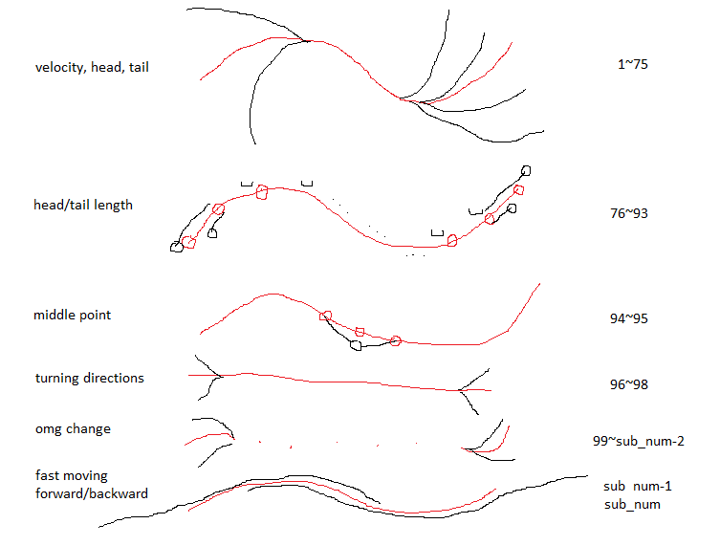

|  |  |
| --- | --- |
| jj=1~100+ | hypotheses meaning |
| 1~75 | They are the combination of velocity, head angle and tail angle: jj = 1 ~ 75 (5*5*3 = 75). The locomotion represents obvious turning directions, but the length of worm stays the same.  Velocities: -2, -1, 0 ,1, 2  Head angles: -2, -1, 0, 1, 2  Tail angles: -1, 0, 1  eg. jj = 15 means velocity =-2, head angle = 2, tail angle = 1. |
| 76~93 | They are the combination of angles and length changes. (3*6=18)  angles = -1,0,1 length changes = {head/tail/all, increase/decrease}  jj = 76~81: angles = -1  jj = 82~87: angles = 0  jj = 88~93: angles = 1  In each sub-slot, jjj = mod((jj-75),6)  jjj = 1: head segment length increase jjj = 2: head segment length decrease  jjj = 3: tail segment length increase jjj = 4: tail segment length decrease  jjj = 5: all segment length increase jjj = 6: all segment length decrease  In addition, for each jjj, there are 10% probability that a double length change are implemented in 2 segments near head/tail. |
| 94~95 | middle point shift (MPS)  MPS should change the angle and middle point location accordingly. Here, the angle change is completed in function ‘mid_pt_chg’. The location shift is completed by shifting a distance ‘[X_mid, Y_mid]’. |
| 96~98 | Turning direction dramatically. 50% probability head turns and 50% tail. The angle change is completed in the function ‘ang2ang_1st_narrow’. |
| 99~sub_num-2 | omg randomly changes |
| sub_num -1 | moving fast backwards, with length of 2 segments |
| sub_num | moving fast forwards, with length of 2 segments |

*******************************************************

Hypotheses indexes corresponding to ‘hypo_2nd.m’

*******************************************************

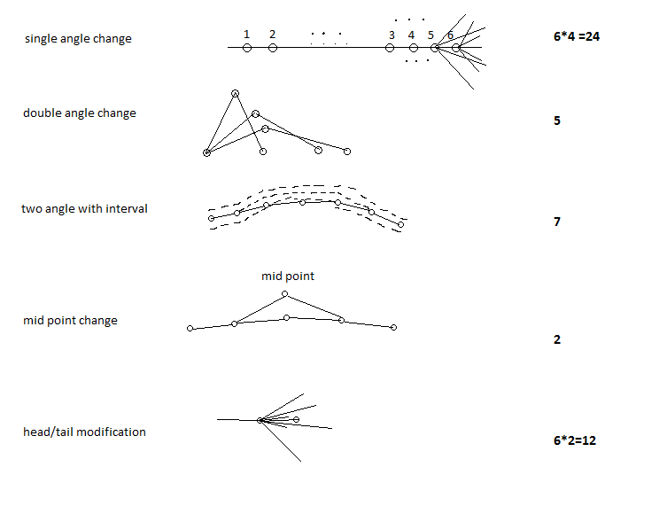

|  |  |
| --- | --- |
| jj | hypotheses meaning |
| 1~24 | single angle change (6*4 = 24)  6 points on skeleton in total, in which 4 points near head and 2 points near tail. for each point, 4 angle changes are generated randomly. |
| 25~29 | double adjacent angle change  randomly choose 2 adjacent points on skeleton, and change their angles at the same time with one plus and the other minus, |
| 30~36 | two angles change with interval  randomly choose 2 points on skeleton expect for points near head/tail, change their angles at the same time with one plus and the other minus |
| 37~38 | middle point change  change the position of middle point, need to change the 2 adjacent angles at the same time |
| 39~50 | head/tail special modification |