

Database Requirement

Specification Document



September 11, 2018

Akeem Blackman

University of Guyana

Faculty of Natural Science

CSE 2102

Table Of Contents

|  |  |
| --- | --- |
| Content | Page Number |
| Introduction | 2 - 3 |
| Overall Description | 4 - 8 |
| System Features | 9 |
| External Interface Requirements | 10 |
| Nonfunctional Requirements | 11 |
| Reference | 12 |

Introduction

* PURPOSE

The purpose of this document is to build an online system to manage and record local cricket player statistics whether it's Local, Regional or International tournaments.

By implementing such system, finding and selecting players based on performances would be faster and more efficient.

* DOCUMENT CONVENTIONS

This document uses the following conventions.

|  |  |
| --- | --- |
| DB | Database |
| DDB | Distributed Database |

* INTENDED AUDIENCE AND READING SUGGESTIONS

This project is basically for cricketers located in Guyana and also overseas.

There are no restrictions based on who'll be able to access the information since it will be distributed for Read-only-access only.

This project will both be beneficial to the players and the management team.

* PROJECT SCOPE

The purpose of the online management system is to ease the management of player statistics and create a convenient and easy-to-use application for the players and

anyone who wants to view the statistics whether they’re a family, friend, fan or selector.

The system will be based on the player performance in various tournaments over a selected period.

Finally, for players or outsiders to view the information will totally be free of cost as we work to provide a comfortable user experience.

Overall Description

The database system will store the following information:

Player Description/Information

This category includes: Name, Birthday (Age), Height, Weight, Current & Past Teams, Short description of their interest.

Player Statistics

Batting

Sub Category: Local, Regional, International (each category caries another sub category: Test, ODI's & T20)

Bowling

Sub Category: Local, Regional, International (each category caries another sub category: Test, ODI's & T20)

* USER CLASS and CHARACTERISTICS

Users of the system will be based on two categories: Management & Players/Fans.

The Management will have Read & Write permissions which allows them to edit/update the players information and statistics.

However, Players/Fans only have Read Only permission which means they'll only have access in viewing the information.

This then limits the chances of having falsified information in the database.

* DESIGN and IMPLEMENTATION

The diagram below demonstrates the design of the Graphical User Interface (GUI). Meaning, this is what the Players/Fans would see.

Mobile View (Profile)

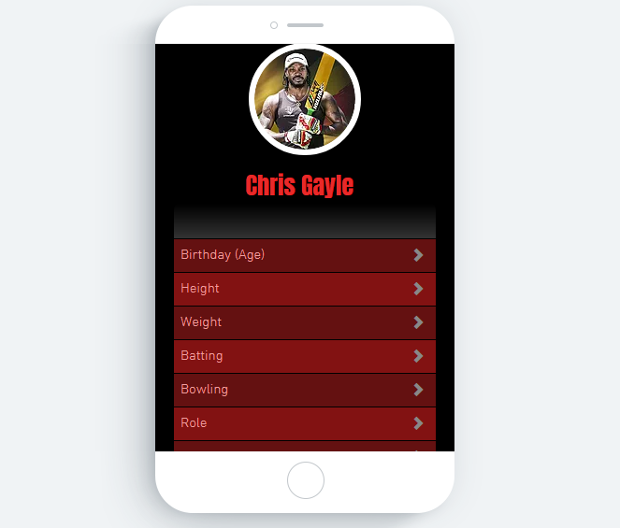

Desktop View (Profile)

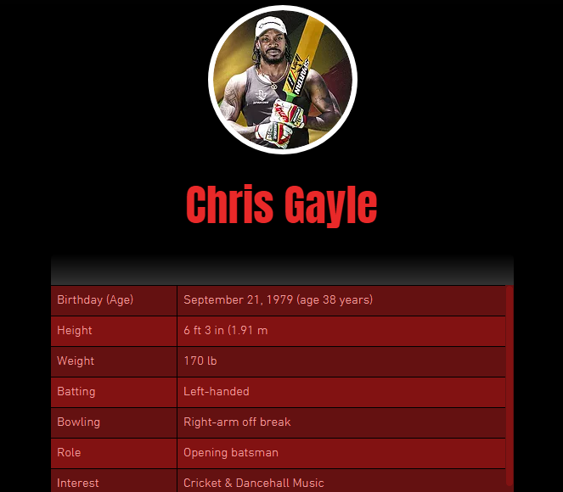

Statistics (Desktop) View

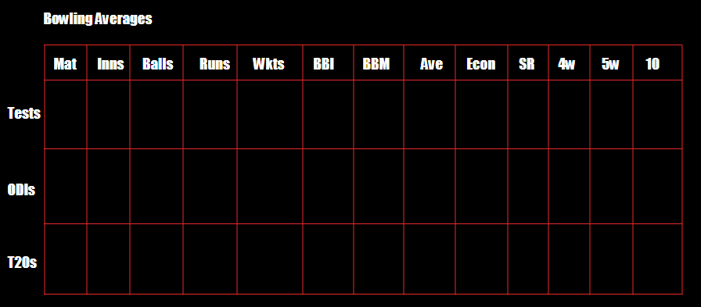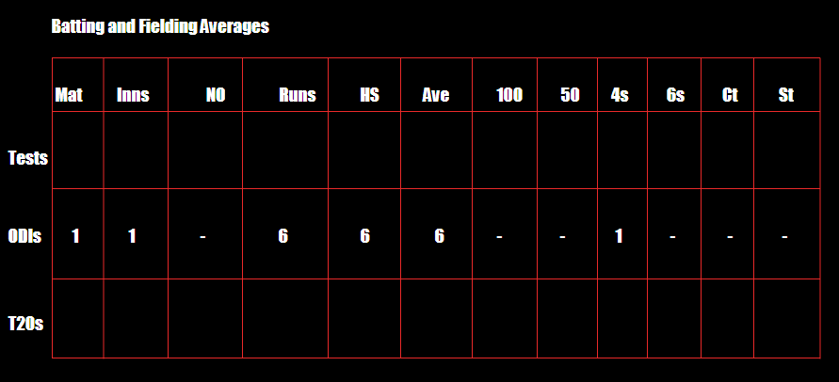

System Features

DISTRIBUTED DATABASE:

Distributed database implies that a single application should be able to operate transparently on data that is spread across a variety of different databases and connected by a communication network.

This means a member of the Management Team won't need to be physically present to update the information, he/she could have it done weather they're home or overseas.

External Interface Requirements

* HARDWARE INTERFACES

Windows.

A browser which supports CGI, HTML & Javascript.

* SOFTWARE INTERFACES

Below are the software used to develop the Cricket Players Database

|  |  |
| --- | --- |
| Software Used | Description |
| Operating system | We have chosen Windows operating system for its best support and user-friendliness. |
| Database | To save the flight records, passengers records we have chosen SQL+ database. |
| Android Studio | Used to implement the application into an Android App to provide user-friendliness. |

* COMMUNICATION INTERFACES

This project supports all types of web browsers and android devices since Read-Only access is granted to persons outside the Management Team.

Nonfunctional Requirements

* SAFETY REQUIREMENTS

The database will be a cloud database so this means higher security and the risk of lost or damaged information due to natural disasters or disk crash would not be a concern.

* SECURITY REQUIREMENTS

The Database contains sensitive information so encryption are done according to PCI standards, to add additional protection of personally identifiable information. Our encryption methods renders this information unreadable without a cryptographic key.

Multiple layer security architecture to help protect against 0-day security issues.

Login services are completed through a secure server and secured via HTTPS/ SSL communication.

Cryptography hash functions to protect your information. Your password is stored as a hash digest and, in the event of a security breach, your original password cannot be recovered from our servers.

REFERENCES

* https://krazytech.com/projects/sample-software-requirements-specificationsrs-report-airline-database