CS 255 System Design Document Template

UML Diagrams

UML Use Case Diagram
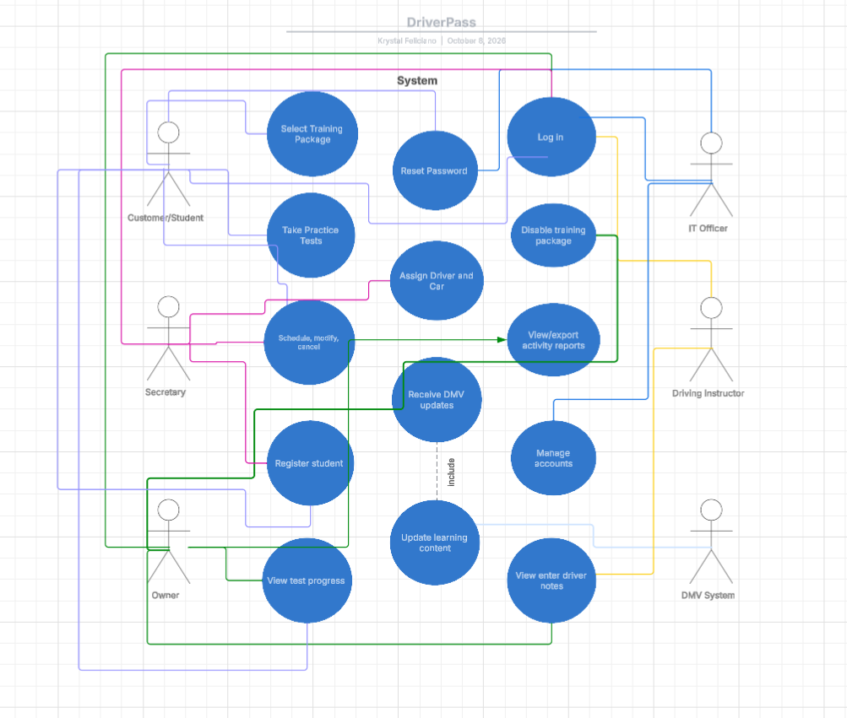

UML Activity Diagrams
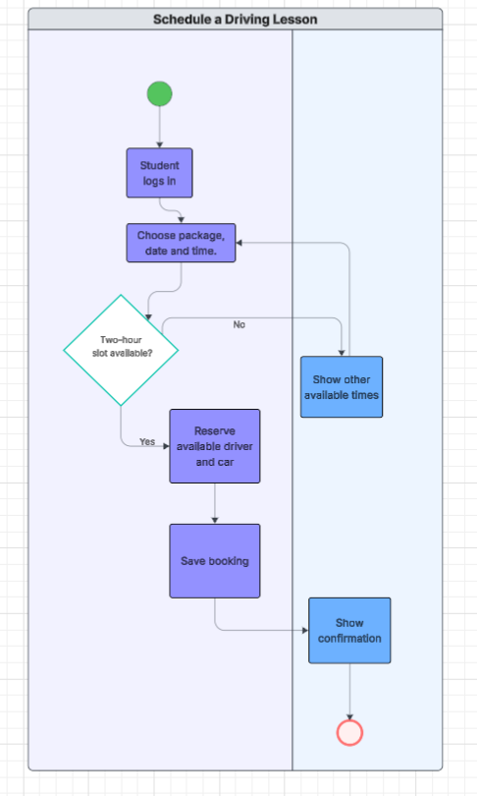

Shows the steps for booking a two-hour driving lesson, including checking availability and assigning a driver and car.

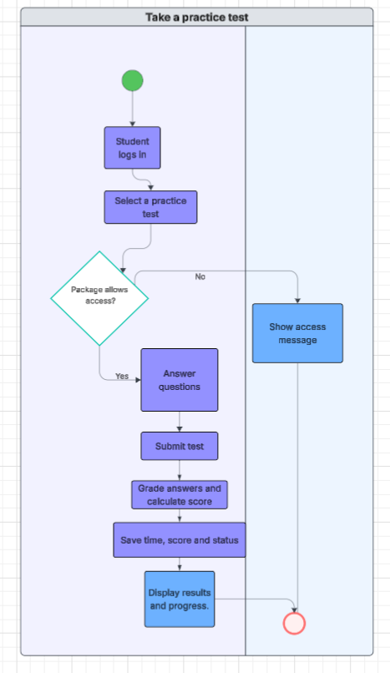

Shows how an eligible student takes a practice test and has the score and progress saved.

UML Sequence Diagram
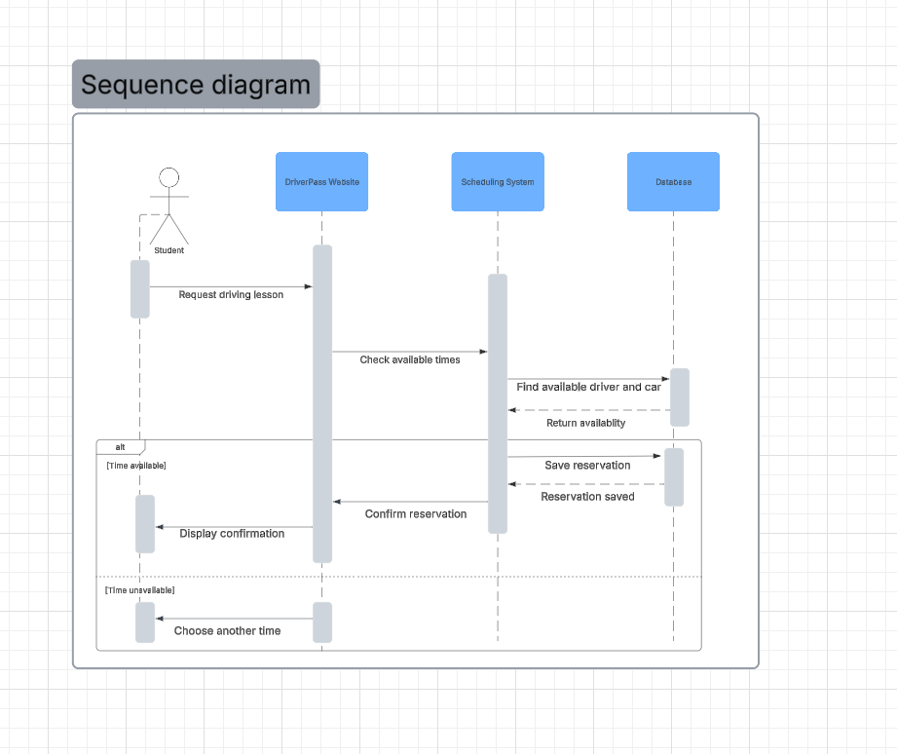

UML Class Diagram
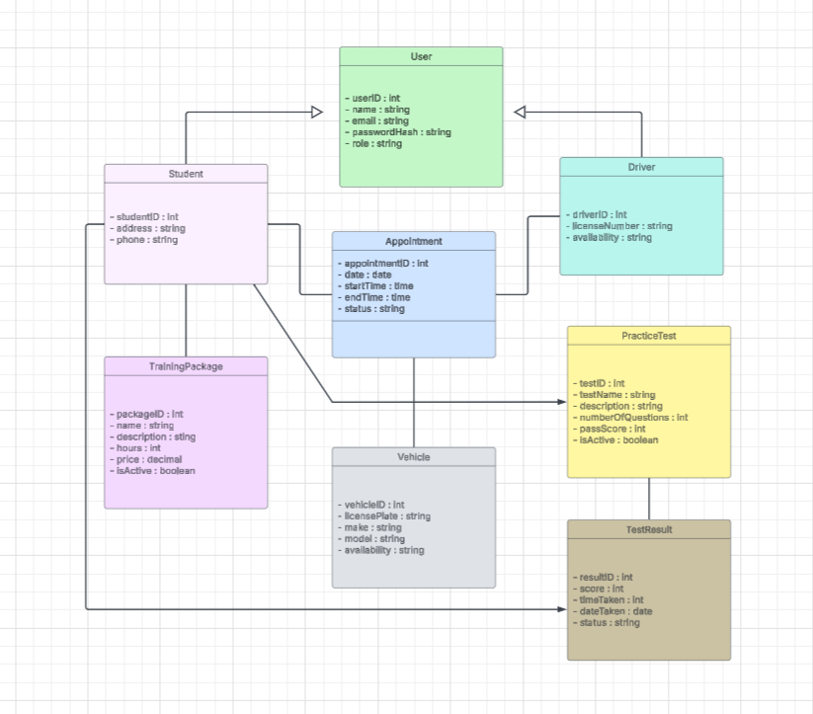

Technical Requirements
The DriverPass system will be web-based and hosted in the cloud so customers and employees can access it from computers, tablets, and smartphones. Users will need a device with an internet connection and a web browser.

The system will use a database to store customer information, appointments, training packages, driver and vehicle details, and practice test results. Developers will use tools such as Lucidchart to design the system and programming tools to build and maintain the website.

To protect customer information, the system will use secure logins, password protection, and different access levels based on each user’s role. The cloud service will provide backups and support system security. The system will also need a way to receive DMV updates so that training materials and practice tests stay current.

