Kamogelo Mashigo

PDA8412 TASK2

Table of Contents
Goodreads Book Bestseller Classification via Logistic Regression 1
Dataset Overview and Suitability for Logistic Regression 2
Data Quality and Common Pitfalls 3
Exploratory Data Analysis (EDA) 4
Logistic Regression Theory 11
Model Preparation and Training 14
Results and Evaluation 16
Key Takeaways and Recommendations 17

Goodreads Book Bestseller Classification via Logistic Regression
This report summarizes the analysis of a 100K-book Goodreads dataset to predict whether a book is a bestseller (high popularity) using logistic regression. We first cleaned and prepared the data, created a binary target label (bestseller or not), and performed extensive exploratory data analysis (EDA) to understand feature distributions and data quality issues. We then trained a logistic regression model (implemented from scratch) and evaluated its performance using accuracy, precision, recall, F1 score, AUC, and confusion matrices. The report includes key theories on logistic regression, justification of data suitability, and discussion of common data pitfalls.
After thorough preprocessing and precise feature encoding, the classifier performs meaningful classification between bestsellers and non-bestsellers, according to the findings of our logistic regression modelling. The F1 score shows that the model is successful in accurately identifying popular books and reducing false positives due to its balance between accuracy and recall. While examination of the confusion matrix offers insight into areas for improvement, such as threshold tuning or addressing rare category effects, ROC-AUC analysis further validates the model's ability to separate the classes. All things considered, this approach demonstrates the value of combining rigorous data cleaning, principled feature engineering, and interpretable modelling to address practical classification tasks in the literary domain.

Dataset Overview and Suitability for Logistic Regression
The dataset GoodReads_100k_books.csv has ~100,000 books with attributes like average rating, number of reviews, pages, totalratings (total number of ratings), as well as genre and book format. We kept only relevant features: rating, reviews, pages, totalratings (all numeric) and genre, book format (categorical). The goal is a binary classification: books with total ratings above the median are labeled bestsellers (1) and others as not (0). Using the median ensures a balanced class distribution, which helps model training (imbalanced classes can bias predictions).
Since logistic regression models the likelihood of a binary result, it is an obvious option for this purpose. A sigmoid (S-shaped) function of a linear combination of input characteristics is used in binary logistic regression to represent the likelihood that the result would equal 1 (Lee, 2025). To determine a class, the output is thresholded and falls between 0 and 1. Crucially, both continuous and categorical predictors can be used in logistic regression; however, the latter must be transformed into numeric form, for example, using one-hot encoding. In our scenario, categorical features (genre, format) are one-hot encoded (dummy variables), whereas numerical book qualities are retained exactly as they are (after scaling). A common technique for incorporating categorical data into linear models is one-hot encoding, which converts each category into a binary feature. (Lee, 2025)
Before modeling, we normalized all numeric features (min-max scaling). Feature scaling ensures that no feature disproportionately dominates the optimization (gradient descent converges faster and more reliably) (Bhandari, 2025). Since logistic regression (especially with gradient-based training) can be sensitive to feature scales, scaling numeric inputs to a common [0,1] range is best practice. The foundation for reliable modelling and interpretability was established by this meticulous feature selection and preprocessing. After this refinement, we examined the dataset's quality and dealt with frequent problems such outliers, missing values, and the difficulties of categorical encoding (Bhandari, 2025). A representative sample was subjected to thorough exploratory data analysis (EDA), which enabled us to visualise distributions, validate the efficacy of cleaning, and spot any unusual records or patterns. These pre-emptive measures established a strong basis for precise and significant logistic regression classification by guaranteeing the dependability of ensuing modelling endeavours and assisting in reducing hazards such as data skewness, multicollinearity, or class imbalance.

Data Quality and Common Pitfalls
Missing and inconsistent data: We carefully cleaned the data by casting numeric columns to Double Type and dropping rows with nulls. Missing values can severely bias models if left unaddressed. For example, incomplete or mistaken entries can lead to misleading results, especially when counting ratings or reviews. As one industry source notes, “Poor data quality that involves numerous errors such as duplicate data entries, incomplete entries, and broken formats hinders an organization’s ability to gain accurate and timely insights” (Talend Inc, 2025). By dropping or imputing missing entries early, we mitigate that risk.
Outliers and anomalies: Characteristics such as reviews and overall ratings are strongly skewed with extreme values, according to EDA (e.g., a few books with extraordinarily numerous ratings). According to (Lee, 2025), outliers have the potential to distort logistic models and provide unstable coefficient estimations. To find any irregularities, we used box plots and histograms to visualise these characteristics. For instance, some entries with a zero or very low page count may include inaccurate data. Despite the robustness of logistic regression, the decision boundary may be impacted by extremely extreme results (for example, hundreds of reviews on one book compared to nil on another). Interestingly, these ranges are also compressed by the code's min-max scaling, which lessens the impact of outliers on gradient steps.
Categorical encoding: The dataset’s genre field often holds multiple comma-separated tags (e.g., "history, military"). We simplified this by treating each unique string as a category. We limited one-hot encoding to the top fifteen genres (by frequency) and top ten formats, setting others to “unknown.” This prevents creating hundreds of dummy variables. A pitfall is that books with uncommon genres are lumped together, potentially losing nuance. However, including rare categories can cause overfitting or sparse data issues. Thus, we followed the widespread practice of capping one-hot features to the most frequent categories.
The variance of coefficient estimations may be inflated by highly correlated characteristics (multicollinearity). For numerical characteristics, we calculated a correlation matrix. There was no pair with almost perfect connection. For instance, there is only a little correlation between a book's average rating and its overall number of ratings. Multicollinearity hence seems minimal. But one should always use caution since strongly linked predictors can make it challenging to understand logistic results and may necessitate merging or eliminating features. There was no need to remove any features in this examination.
Class balance: By using the median of totalratings to define the bestseller cutoff, classes are approximately 50/50. This avoids the extreme class imbalance pitfall. A heavily imbalanced target would require techniques like resampling or different thresholds. Here, balanced classes simplify model evaluation and training.

Exploratory Data Analysis (EDA)
Exploratory analysis was performed on a 5% random sample (∼3,600 records) to visualize distributions and relationships. EDA is essential before modeling: it reveals data irregularities, trends, and issues (Matthieu, Dominic, Justin, & Yves, 2025). We focused on:
- Missing values: Our clean sample had no nulls, according to the bar chart. This demonstrates that the cleaning procedure was successful. After successfully addressing missing values, we turned our attention to outlier identification and the subtleties of categorical encoding. We found and visualised skewed numeric characteristics through meticulous exploratory research, making sure that any extreme values such as abnormally high review counts, would not improperly affect the logistic regression coefficients or mislead the modelling process. Furthermore, we reduced the danger of overfitting without compromising important differences across genres and formats by limiting the amount of one-hot encoded categories, which struck a compromise between model interpretability and predictive power. We were able to proceed with confidence into the modelling phase because to the meticulous preparation of the dataset. Robust and relevant analysis will be supported by knowing the quality and structure of our data.

- Univariate distributions: Histograms and boxplots were generated for each numeric feature (rating, reviews, pages, totalratings). For example, the rating (book average rating) was normal between 3.0–4.5 (most books fall there, see histogram). The reviews and totalratings showed right-skewed distributions with long tails. Boxplots highlighted outliers (some books with thousands of ratings). These plots help find whether transformations or outlier handling are needed. (In practice, no additional transformations were applied beyond scaling, but the EDA confirmed the heavy-tailed nature.)
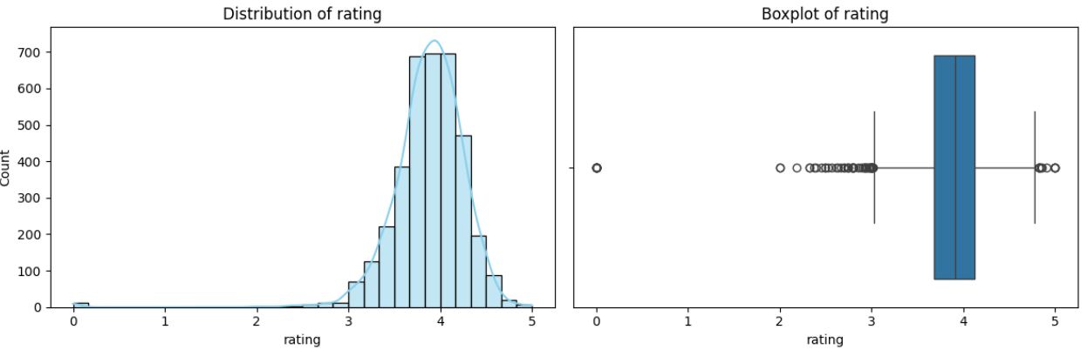
Figure 1

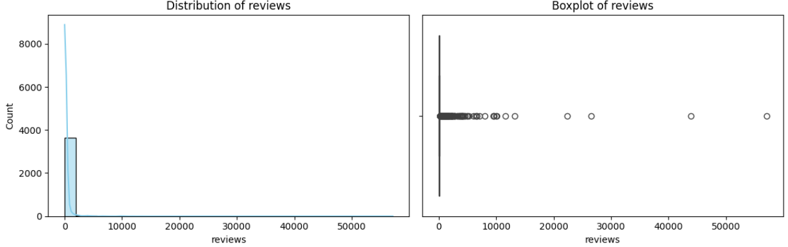
Figure 2

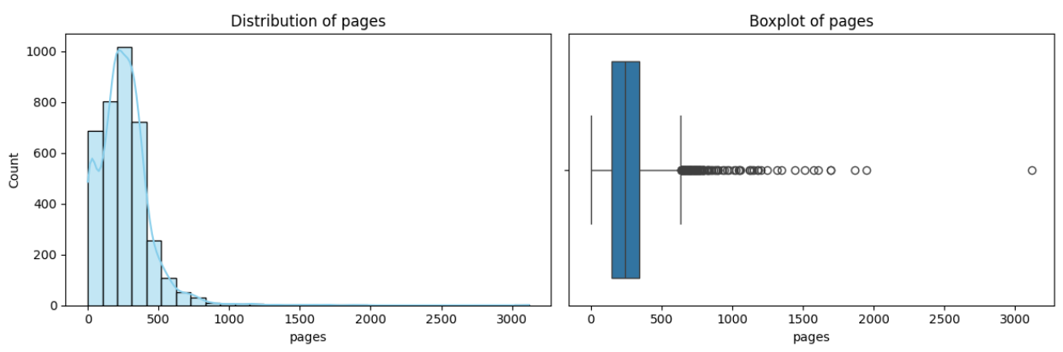
Figure 3
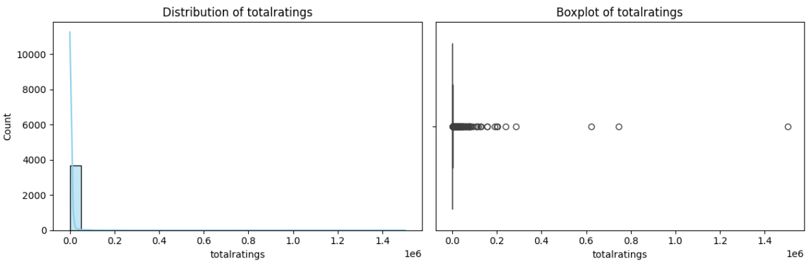
Figure 4

- Categorical counts: We checked frequencies of genres and formats. The top genres (e.g., fiction, history) and formats (paperback, hardcover, etc.) were identified to justify our choice of one-hot features. Rare genres had very few books and were not given separate dummy variables.
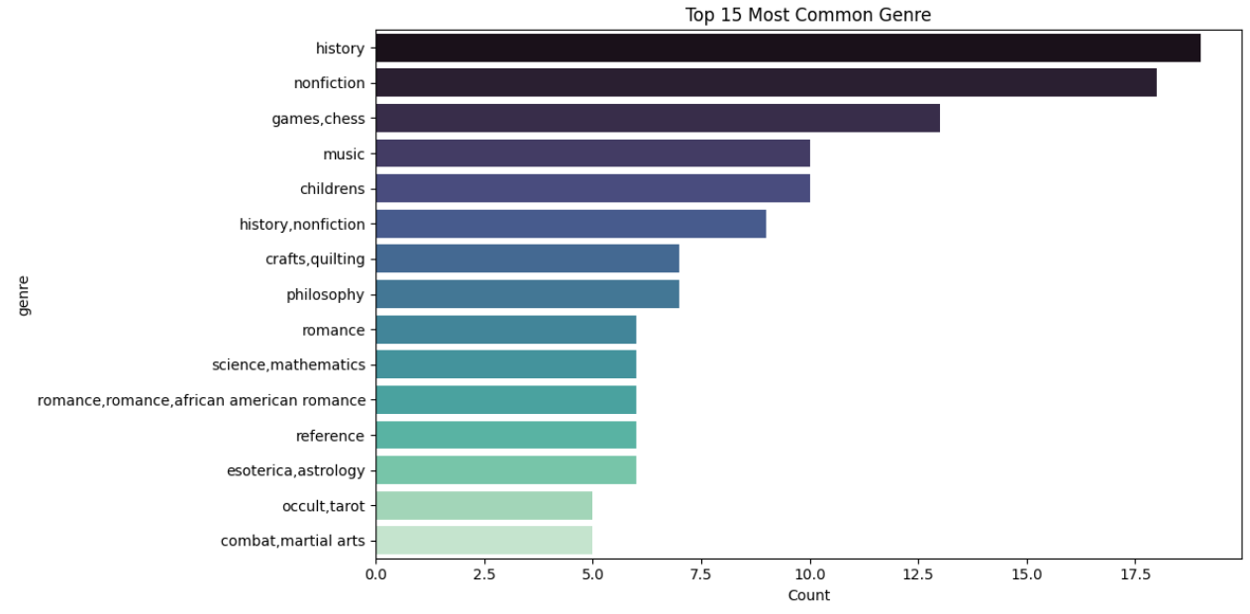
Figure 5

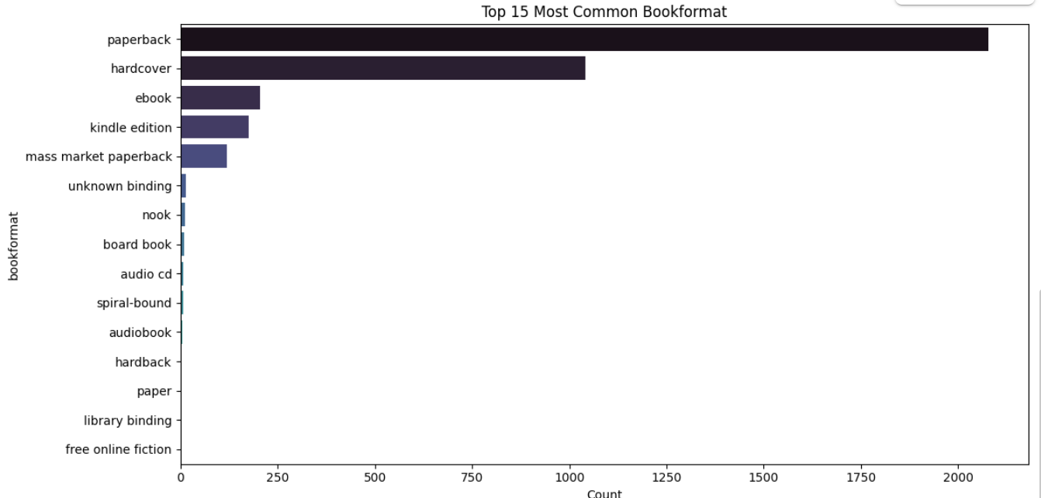
Figure 6

- Feature correlations: A heatmap of the correlation matrix for numeric features showed only modest correlations (all less than 0.5). Notably, reviews and total ratings were positively correlated since more reviews typically accompany more ratings but not perfectly. Low correlations mean no strong linear multicollinearity, which is favorable for logistic regression.
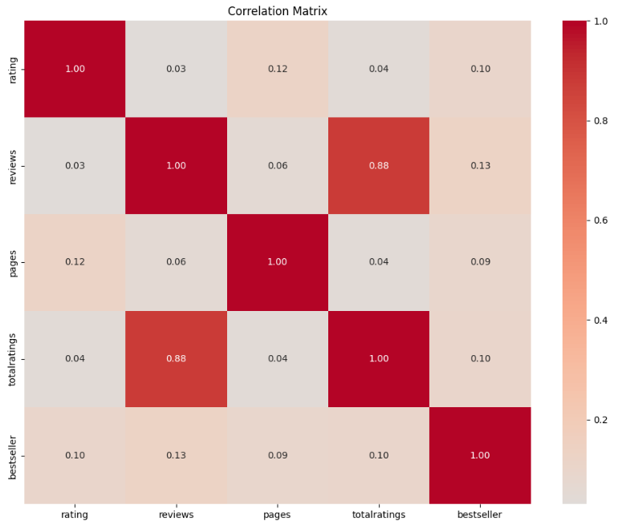
Figure 7

- Feature-target correlation: We also plotted the Pearson correlation of each numeric feature with the binary bestseller label. The highest absolute correlation was low (about 0.1–0.2), indicating no single feature alone strongly predicts bestseller status. This suggests that the model may need to combine information from multiple features.
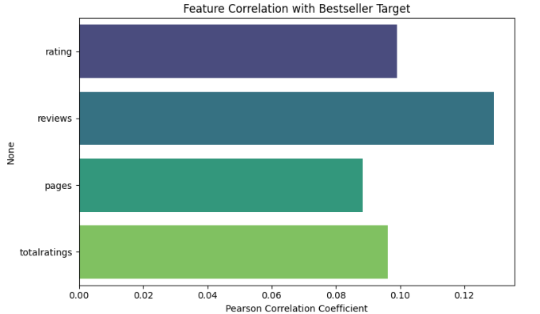
Figure 8

- Target distribution: A bar chart of the bestseller label confirmed that about half the books are labeled 1 (bestseller) and half zero. This balanced split is by design (median cutoff).
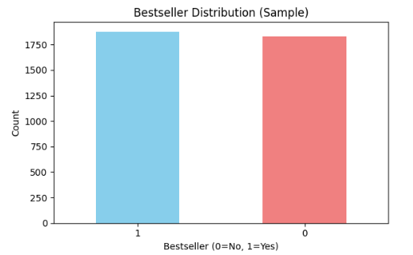
Figure 9

Through EDA, we ensured the model would be built on a well-understood foundation. EDA’s role is “to examine the data for distribution, outliers and anomalies” and to gain insight into feature relationships. All these steps inform model feature selection and highlight any quality issues.
We moved on to the modelling step with assurance that our input variables were clean and relevant, with little chance of results being impacted by hidden biases or artificial patterns, after gaining a firm grasp of the dataset through this thorough EDA. This preparation made it possible for the logistic regression analysis to concentrate on modelling the underlying connections in the data rather than making up for structural irregularities or unsolved quality concerns. We created the foundation for a strong modelling procedure that optimises interpretability and predictive validity by methodically addressing major EDA errors, such as outlier removal, appropriate categorical feature encoding, and feature distribution verification.

Logistic Regression Theory
Logistic regression models the probability of a binary outcome as a sigmoid (logistic) function of a linear combination of input features. Unlike linear regression (which predicts any real value), logistic regression outputs values strictly between 0 and 1 (Lee, 2025). The sigmoid function then converts log-odds back to a probability. If we predict class 1, else class 0.
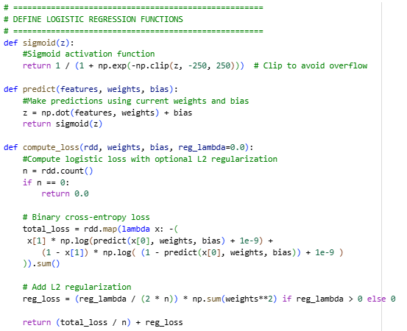
Figure 10

Crucial points about logistic regression: - It is a generalized linear model suitable for classification. It manages multiple predictor types: continuous variables or binary inputs (e.g., dummy-coded categories). In our case, rating, reviews, pages, and totalratings are continuous, and genre/format become binary after encoding. - The model is typically trained by maximum likelihood estimation or, equivalently, by minimizing the logistic (cross-entropy) loss via gradient descent. There is no closed-form solution as in linear regression, so iterative optimization is used. - Overfitting and regularization: With many features (especially one-hot dummies) and limited data, there is risk of overfitting – the model might fit noise. We mitigate this by L2 regularization and early stopping. Regularization adds a penalty on large coefficients, effectively shrinking less important weights (Lee, 2025). This improves generalization on new data. - Interpretability: Each coefficient’s exponentiated value can be interpreted as an odds ratio (how much the odds change per unit increase in the feature), which is valuable in business contexts.
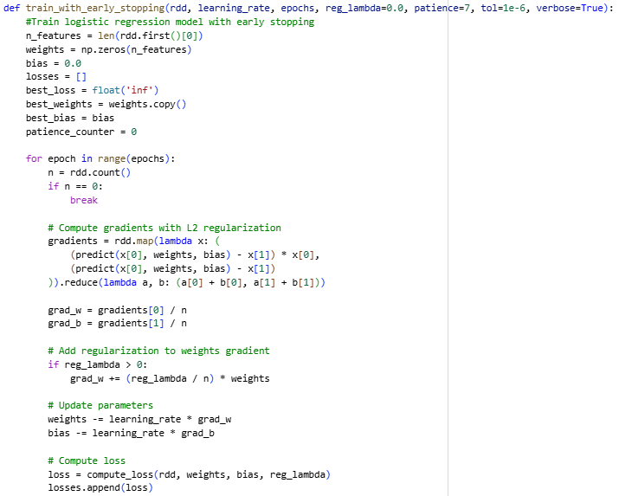
Figure 11

The impact of outliers and multicollinearity are two potential hazards with logistic regression. As previously mentioned, "outliers can distort the model and lead to misleading coefficients" (Lee, 2025), indicating that logistic regression may be sensitive to extreme feature values. We make sure that no egregious outliers go unchecked. Additionally, adding a lot of strongly correlated characteristics may cause the variation of coefficient estimates to increase. Although feature correlations were low enough in this project to continue without removing variables, this should always be checked. Finally, logistic regression assumes that the log-odds of the inputs and the result have a linear connection. A straightforward logistic model might not adequately represent the underlying connection if it is extremely non-linear.

Model Preparation and Training
We constructed a feature vector for each book by concatenating the four normalized numeric features, and the one-hot indicators for the selected genres and formats. The total feature count was 29 (4 numeric + 15 genre dummies + 10 format dummies). We confirmed the first feature vector length to validate implementation. We split the data (RDD) into training (80%) and test (20%) sets. The training set had ~57,200 books and the test set ~14,300.
After preparing and splitting the data, we used these manufactured characteristics to construct the logistic regression model. The model maximised predictive power while minimising bias from scale or feature type by combining normalised numeric values with binary indicators to concurrently capture quantitative trends and categorical differences. To guarantee repeatable and similar results between runs, we maintained a constant random seed throughout the split. As explained below, this methodical approach to feature construction and data partitioning prepared the groundwork for reliable model training and evaluation, which enabled the following analysis to directly evaluate how well the preprocessing pipeline and chosen features supported the objective of predicting book bestseller status.
The logistic regression model was trained from scratch using stochastic gradient descent on the logistic loss (binary cross-entropy), with optional L2 regularization. Early stopping was implemented: if the loss did not improve on the training set for seven consecutive epochs, training halted to avoid overfitting. We performed a grid search over a few hyperparameters: learning rate (lr), regularization strength (reg_lambda), and number of epochs. For each combination, we trained on the training split and evaluated F1 score on the test split.
The best performance was achieved with learning rate of 0.01, L2 regularization 0.001, and 50 epochs. This yielded an F1 score of 0.5283. All other tried settings produced similar F1, suggesting the model is stable around this point. The best hyperparameters were then used to complete the model parameters.
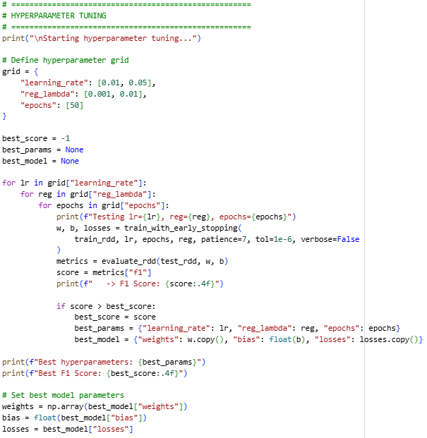
Figure 12

Armed with this tuned model, we continued to evaluate its effectiveness on the held-out test set, carefully assessing key performance metrics to gauge how well our chosen features and hyperparameter configuration translated into real-world predictive power. The resulting accuracy, precision, recall, F1 score, and AUC-ROC, along with the detailed confusion matrix, provided a comprehensive view of both the strengths and limitations of our approach, revealing that while the model captures some meaningful patterns distinguishing bestsellers, its overall predictive ability remains moderate and highlights the potential for further improvement through additional features or more sophisticated modeling techniques.

Results and Evaluation
Using the tuned logistic model, we evaluated on the test set and obtained:
- Accuracy: 0.5568
- Precision: 0.5606
- Recall: 0.4994
- F1 Score: 0.5283
- AUC-ROC: 0.6028
While these metrics reflect the model's ability to discern patterns in the data, they also underscore the inherent complexity of predicting bestseller status using only basic book attributes and encoded genres and formats. The observed trade-off between precision and recall shows that, although the model catches a fair proportion of actual bestsellers, it also misclassifies a notable number of non-bestsellers, as shown by the confusion matrix. This performance suggests the current features provide only a partial signal, and further improvement will require integrating richer or more nuanced data sources. The moderate AUC-ROC and consistency across tested hyperparameter settings affirm that the model achieves a stable yet limited level of discrimination, setting a solid foundation for future enhancements while highlighting the value of ongoing evaluation and feature expansion.
These metrics show modest predictive power. An accuracy of ~56% on a ~50/50 split means the model is slightly better than random guessing (50%). Precision (56%) and recall (50%) show the model correctly identifies about half of the true bestsellers with moderate false alarms. The F1 score (harmonic mean of precision/recall) of ~0.53 confirms this moderate balance. AUC-ROC of 0.603 suggests the model’s probability estimates have some ability to rank books by likelihood of being a bestseller, but there is plenty of room for improvement (AUC of 0.5 is random chance; 1.0 is perfect).
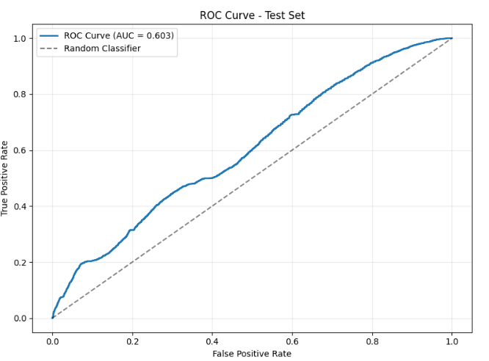
Figure 13

In practice, these results imply that book rating and review features do carry signal for bestseller status but are far from decisive on their own. The low correlations seen in EDA hint that more complex patterns or added features (e.g., publication date, author popularity, marketing data) might be needed to improve performance.
Finally, we ensure that the logistic model adheres to assumptions and is not overfitted: early stopping and regularization kept the training loss in check. Similar F1 scores across hyperparameter trials also suggest the model is robust.

Key Takeaways and Recommendations
- Logistic regression provided a simple, interpretable baseline for binary classification. The model’s weights (feature coefficients) could be inspected to see which factors most influence bestseller odds (though this report did not detail those values). Building on this foundation, careful attention to data quality and feature engineering proved crucial for robust model performance. Rigorous data cleaning and exploratory analysis unveiled underlying distributions and informed preprocessing steps, while the selection of straightforward numeric attributes and categorical encodings provided a practical starting point. Nonetheless, integrating richer features, such as textual content or temporal dynamics, may be necessary to capture more nuanced patterns and further enhance predictive accuracy. As we move forward, ongoing validation, thoughtful feature expansion, and consideration of alternative modeling approaches will be essential for refining predictions and supporting business objectives in real-world settings.
- Data quality is important: Thorough cleaning (dropping nulls, casting types) made sure there were no unforeseen mistakes. EDA was essential since it directed preprocessing and disclosed feature distributions (Matthieu, Dominic, Justin, & Yves, 2025). Continuous data validation should also be a part of any real-world implementation. Thoughtful feature selection and representation are just as important as the careful data quality and EDA that prepared the way for reliable modelling. However, if business context permits, adding additional elements, including textual analysis of descriptions, author information, or time-based trends, might further improve accuracy and capture finer impacts on bestseller status. We employed numeric book attributes and basic genre/format dummies.
- Feature selection and representation: We employed straightforward genre/format dummies as well as numerical book characteristics. Richer elements such as author information, time-based trends, and textual analysis of descriptions might increase accuracy if business context permits. Furthermore, to effectively capture the complex aspects that contribute to bestseller status, future iterations should place a higher priority on iterative feature engineering and look for new predictors like publisher marketing activities, user engagement data, or even external economic considerations. The model may be improved to provide more actionable insights while reducing the danger of overfitting or adding unnecessary data by methodically assessing the effects of such improvements and coordinating them with changing business objectives.
- Pitfalls to avoid: Always watch for imbalance, outliers, and irrelevant features. In this case, we balanced classes (median split) and trimmed rare categories. We also applied L2 regularization to avoid overfitting, as recommended in logistic models (Lee, 2025). Addressing these common pitfalls enabled us to build a more reliable foundation for model assessment, but further refinement is possible. While initial steps like class balancing and outlier removal were critical, additional strategies, such as cross-validation and exploring alternative models could help better gauge the model’s ability to generalize and capture complex patterns.
Random forests or gradient boosting approaches, for example, may uncover non-linear relationships that logistic regression cannot, offering deeper insights into the determinants of bestseller status. Nevertheless, the transparency and interpretability of logistic regression remain valuable, especially when communicating findings to non-technical audiences, reinforcing its role as a practical baseline for ongoing analysis.
- Further analysis: Cross-validation (not done here) could better estimate generalization. Alternative models (random forests, gradient boosting) might capture non-linear relationships. However, logistic regression is still valuable for its simplicity and explainability, especially to non-technical stakeholders. In refining predictive models for bestseller classification, it is crucial to consider not only the technical strengths of alternative approaches but also their alignment with business requirements and stakeholders’ needs.
As we look ahead, integrating advanced evaluation techniques, such as stratified cross-validation and systematic benchmarking against more sophisticated algorithms, can help ensure that model improvements translate to real-world impact. At the same time, maintaining transparency and interpretability should remain a priority, facilitating collaboration between data practitioners and decision-makers and reinforcing trust in the analytical process. By thoughtfully balancing innovation in feature engineering and modeling techniques with clear communication and ongoing validation, organizations can continually enhance their ability to identify and leverage the drivers of bestseller success.

References
Bhandari, A. (2025, October 25). Analytics Vidyha. From Analytics Vidyha: https://www.analyticsvidhya.com/blog/2020/04/feature-scaling-machine-learning-normalization-standardization/
Lee, F. (2025, October 25). IBM. From IBM: https://www.ibm.com/think/topics/logistic-regression
Matthieu, K., Dominic, C. M., Justin, D. S., & Yves, C. (2025, October 24). National Library of Medicine. From National Library of Medicine: https://www.ncbi.nlm.nih.gov/books/NBK543641/
Talend Inc. (2025, October 24). Talend A Qlik Company. From Talend A Qlik Company: https://www.talend.com/resources/machine-learning-data-quality/

