Assignment_4

Kevin Gardner

Due 3/20/2022

# ————————————————

# Following is the link to my GitHub account:

# <https://github.com/Kgardner22/64060_-kgardner>

# ————————————————

IMPORT AND PREPARE DATA:

Import the Pharmaceuticals.csv file

Pharmaceuticals <- read.table('C:/R/MyData/Pharmaceuticals.csv', header = T, sep = ',')   
  
summary(Pharmaceuticals)

## Symbol Name Market_Cap Beta   
## Length:21 Length:21 Min. : 0.41 Min. :0.1800   
## Class :character Class :character 1st Qu.: 6.30 1st Qu.:0.3500   
## Mode :character Mode :character Median : 48.19 Median :0.4600   
## Mean : 57.65 Mean :0.5257   
## 3rd Qu.: 73.84 3rd Qu.:0.6500   
## Max. :199.47 Max. :1.1100   
## PE_Ratio ROE ROA Asset_Turnover Leverage   
## Min. : 3.60 Min. : 3.9 Min. : 1.40 Min. :0.3 Min. :0.0000   
## 1st Qu.:18.90 1st Qu.:14.9 1st Qu.: 5.70 1st Qu.:0.6 1st Qu.:0.1600   
## Median :21.50 Median :22.6 Median :11.20 Median :0.6 Median :0.3400   
## Mean :25.46 Mean :25.8 Mean :10.51 Mean :0.7 Mean :0.5857   
## 3rd Qu.:27.90 3rd Qu.:31.0 3rd Qu.:15.00 3rd Qu.:0.9 3rd Qu.:0.6000   
## Max. :82.50 Max. :62.9 Max. :20.30 Max. :1.1 Max. :3.5100   
## Rev_Growth Net_Profit_Margin Median_Recommendation Location   
## Min. :-3.17 Min. : 2.6 Length:21 Length:21   
## 1st Qu.: 6.38 1st Qu.:11.2 Class :character Class :character   
## Median : 9.37 Median :16.1 Mode :character Mode :character   
## Mean :13.37 Mean :15.7   
## 3rd Qu.:21.87 3rd Qu.:21.1   
## Max. :34.21 Max. :25.5   
## Exchange   
## Length:21   
## Class :character   
## Mode :character   
##   
##   
##

Load required libraries

library(tidyverse) #for data manipulation  
library(factoextra) #for clustering and visualization  
library(flexclust)

Use cluster analysis to explore and analyze the given dataset as follows:

REQUIREMENTS A and B:

Use only the numerical variables (1 to 9) to cluster the 21 firms. Justify the various choices made in conducting the cluster analysis, such as weights for different variables, the specific clustering algorithm(s) used, the number of clusters formed, and so on.

First, we create the data.frame with only the numerical variables 1 to 9

set.seed(64060)  
  
df <- Pharmaceuticals[,c(3:11)]  
  
summary(df)

## Market_Cap Beta PE_Ratio ROE   
## Min. : 0.41 Min. :0.1800 Min. : 3.60 Min. : 3.9   
## 1st Qu.: 6.30 1st Qu.:0.3500 1st Qu.:18.90 1st Qu.:14.9   
## Median : 48.19 Median :0.4600 Median :21.50 Median :22.6   
## Mean : 57.65 Mean :0.5257 Mean :25.46 Mean :25.8   
## 3rd Qu.: 73.84 3rd Qu.:0.6500 3rd Qu.:27.90 3rd Qu.:31.0   
## Max. :199.47 Max. :1.1100 Max. :82.50 Max. :62.9   
## ROA Asset_Turnover Leverage Rev_Growth   
## Min. : 1.40 Min. :0.3 Min. :0.0000 Min. :-3.17   
## 1st Qu.: 5.70 1st Qu.:0.6 1st Qu.:0.1600 1st Qu.: 6.38   
## Median :11.20 Median :0.6 Median :0.3400 Median : 9.37   
## Mean :10.51 Mean :0.7 Mean :0.5857 Mean :13.37   
## 3rd Qu.:15.00 3rd Qu.:0.9 3rd Qu.:0.6000 3rd Qu.:21.87   
## Max. :20.30 Max. :1.1 Max. :3.5100 Max. :34.21   
## Net_Profit_Margin  
## Min. : 2.6   
## 1st Qu.:11.2   
## Median :16.1   
## Mean :15.7   
## 3rd Qu.:21.1   
## Max. :25.5

Before we can begin cluster analysis, we must first scale the data.

# Scaling the data frame (z-score)   
df <- scale(df)  
  
summary(df)

## Market_Cap Beta PE_Ratio ROE   
## Min. :-0.9768 Min. :-1.3466 Min. :-1.3404 Min. :-1.4515   
## 1st Qu.:-0.8763 1st Qu.:-0.6844 1st Qu.:-0.4023 1st Qu.:-0.7223   
## Median :-0.1614 Median :-0.2560 Median :-0.2429 Median :-0.2118   
## Mean : 0.0000 Mean : 0.0000 Mean : 0.0000 Mean : 0.0000   
## 3rd Qu.: 0.2762 3rd Qu.: 0.4841 3rd Qu.: 0.1495 3rd Qu.: 0.3450   
## Max. : 2.4200 Max. : 2.2758 Max. : 3.4971 Max. : 2.4597   
## ROA Asset_Turnover Leverage Rev_Growth   
## Min. :-1.7128 Min. :-1.8451 Min. :-0.74966 Min. :-1.4971   
## 1st Qu.:-0.9047 1st Qu.:-0.4613 1st Qu.:-0.54487 1st Qu.:-0.6328   
## Median : 0.1289 Median :-0.4613 Median :-0.31449 Median :-0.3621   
## Mean : 0.0000 Mean : 0.0000 Mean : 0.00000 Mean : 0.0000   
## 3rd Qu.: 0.8430 3rd Qu.: 0.9225 3rd Qu.: 0.01828 3rd Qu.: 0.7693   
## Max. : 1.8389 Max. : 1.8451 Max. : 3.74280 Max. : 1.8862   
## Net_Profit_Margin   
## Min. :-1.99560   
## 1st Qu.:-0.68504   
## Median : 0.06168   
## Mean : 0.00000   
## 3rd Qu.: 0.82364   
## Max. : 1.49416

We’ll compute and visualize the distance matrix between rows using get_dist() and fviz_dist()

distance <- get_dist(df)  
fviz_dist(distance)

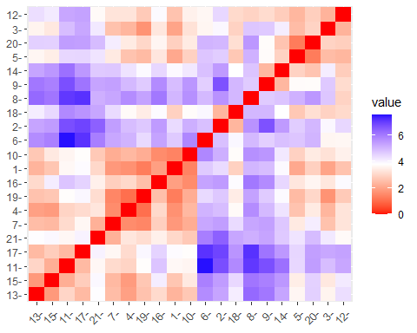 The above graph shows the distance between firms.

I’ll run the k-means algorithm to cluster the firms, choosing an initial random value of k = 4.

set.seed(64060)  
k4 <- kmeans(df, centers = 4, nstart = 25) # k = 4, number of restarts = 25  
  
# the following will help us Visualize the output  
  
k4$centers # output the centers

## Market_Cap Beta PE_Ratio ROE ROA Asset_Turnover  
## 1 -0.03142211 -0.4360989 -0.3172485 0.1950459 0.4083915 1.729746e-01  
## 2 1.69558112 -0.1780563 -0.1984582 1.2349879 1.3503431 1.153164e+00  
## 3 -0.82617719 0.4775991 -0.3696184 -0.5631589 -0.8514589 -9.994088e-01  
## 4 -0.52462814 0.4451409 1.8498439 -1.0404550 -1.1865838 1.480297e-16  
## Leverage Rev_Growth Net_Profit_Margin  
## 1 -0.2744931 -0.7041516 0.5569544  
## 2 -0.4680782 0.4671788 0.5912425  
## 3 0.8502201 0.9158889 -0.3319956  
## 4 -0.3443544 -0.5769454 -1.6095439

k4$size # Number of firms in each cluster

## [1] 8 4 6 3

fviz_cluster(k4, data = df) # Visualize the output

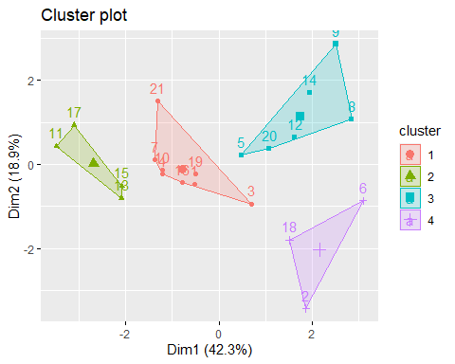 This produces similar size clusters (8,4,6,3)

# Other Distances

I’ll rerun the example using other distance measures to compare the results

set.seed(64060)  
  
k4M = kcca(df, k=4, kccaFamily("kmedians")) #kmedians uses Manhattan distance  
k4M

## kcca object of family 'kmedians'   
##   
## call:  
## kcca(x = df, k = 4, family = kccaFamily("kmedians"))  
##   
## cluster sizes:  
##   
## 1 2 3 4   
## 3 12 5 1

k4E = kcca(df, k=4, kccaFamily("kmeans")) #kmeans uses Euclidean distance  
k4E

## kcca object of family 'kmeans'   
##   
## call:  
## kcca(x = df, k = 4, family = kccaFamily("kmeans"))  
##   
## cluster sizes:  
##   
## 1 2 3 4   
## 12 4 2 3

k4A = kcca(df, k=4, kccaFamily("angle")) #angle uses angle between observation and centroid  
k4A

## kcca object of family 'angle'   
##   
## call:  
## kcca(x = df, k = 4, family = kccaFamily("angle"))  
##   
## cluster sizes:  
##   
## 1 2 3 4   
## 4 4 11 2

# We won't use Jaccard distance as this is primarily used for categorical data which is not applicable.

In reviewing these results, we see the cluster sizes using kmedians (Manhattan), kmeans (Euclidean) and angle produce similar results.

Let’s take a look at the images of each of these results:

image(k4M) # Manhattan distance

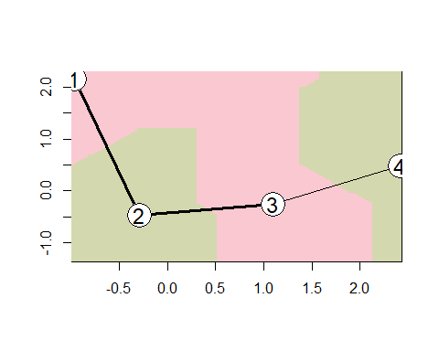

image(k4E) # Euclidean distance

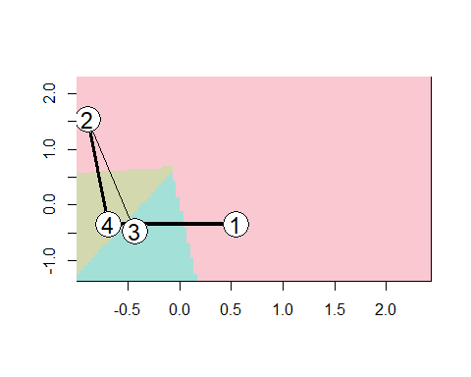

image(k4A) # angle

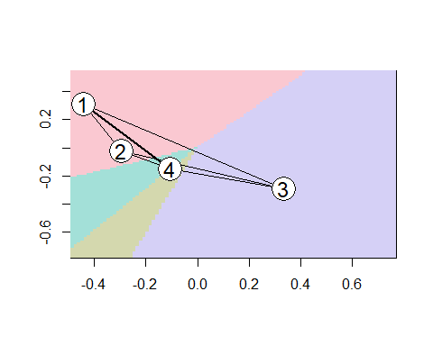 These images clearly show the various distance measures make a huge difference in the clustering results. It’s clear that k4M, which is using Manhattan distance (kmedians), produces better results since the distance between the centroids is maximized in comparison to the other results.

This is also confirmed by looking at the centers:

dist(k4M@centers)

## 1 2 3  
## 2 3.838654   
## 3 5.233264 2.754097   
## 4 6.025978 4.677079 2.397111

dist(k4E@centers)

## 1 2 3  
## 2 4.169374   
## 3 4.306065 4.093207   
## 4 3.319190 3.018190 3.847236

dist(k4A@centers)

## 1 2 3  
## 2 1.253136   
## 3 1.872258 1.823885   
## 4 1.158538 1.373808 1.743565

As shown in this data, the distance measure producing the maximum distance between centroids is Manhattan distance (k4M)

I’ll now apply the predict function to k4M which uses Manhattan Distance

set.seed(64060)  
clusters_index4 <- predict(k4M)  
dist(k4M@centers)

## 1 2 3  
## 2 3.838654   
## 3 5.233264 2.754097   
## 4 6.025978 4.677079 2.397111

image(k4M)  
points(df, col=clusters_index4, pch=19, cex=0.3)

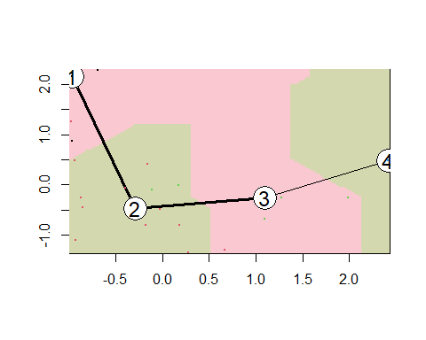

But is a K of 4 really the best choice? After all, this was just a random choice. Let’s use a K of 3 and examine the results.

set.seed(64060)  
k3 <- kmeans(df, centers = 3, nstart = 25) # k = 3, number of restarts = 25  
  
# the following will help us Visualize the output  
  
k3$centers # output the centers

## Market_Cap Beta PE_Ratio ROE ROA Asset_Turnover  
## 1 0.6733825 -0.3586419 -0.2763512 0.6565978 0.8344159 0.4612656  
## 2 -0.8261772 0.4775991 -0.3696184 -0.5631589 -0.8514589 -0.9994088  
## 3 -0.6125361 0.2698666 1.3143935 -0.9609057 -1.0174553 0.2306328  
## Leverage Rev_Growth Net_Profit_Margin  
## 1 -0.3331068 -0.2902163 0.6823310  
## 2 0.8502201 0.9158889 -0.3319956  
## 3 -0.3592866 -0.5757385 -1.3784169

k3$size # Number of firms in each cluster

## [1] 11 6 4

fviz_cluster(k3, data = df) # Visualize the output

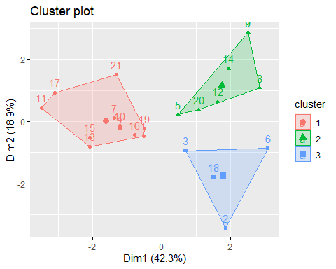 # Other Distances

I’ll rerun the example using other distance measures to compare the results

set.seed(64060)  
  
k3M = kcca(df, k=3, kccaFamily("kmedians")) #kmedians uses Manhattan distance  
k3M

## kcca object of family 'kmedians'   
##   
## call:  
## kcca(x = df, k = 3, family = kccaFamily("kmedians"))  
##   
## cluster sizes:  
##   
## 1 2 3   
## 3 12 6

k3E = kcca(df, k=3, kccaFamily("kmeans")) #kmeans uses Euclidean distance  
k3E

## kcca object of family 'kmeans'   
##   
## call:  
## kcca(x = df, k = 3, family = kccaFamily("kmeans"))  
##   
## cluster sizes:  
##   
## 1 2 3   
## 10 7 4

k3A = kcca(df, k=3, kccaFamily("angle")) #angle uses angle between observation and centroid  
k3A

## kcca object of family 'angle'   
##   
## call:  
## kcca(x = df, k = 3, family = kccaFamily("angle"))  
##   
## cluster sizes:  
##   
## 1 2 3   
## 6 4 11

# We won't use Jaccard distance as this is primarily used for categorical data which is not applicable.

Let’s take a look at the images of each of these results:

image(k3M) # Manhattan distance

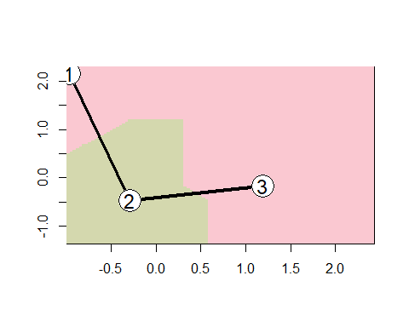

image(k3E) # Euclidean distance

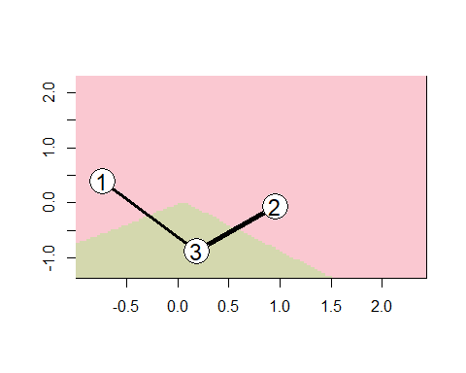

image(k3A) # angle

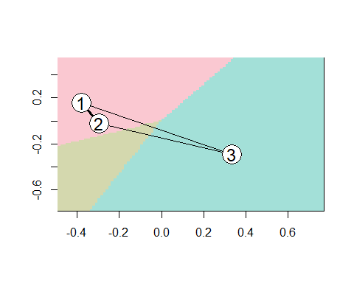 Once again, using Manhattan distance produces better results with the clustering. There is a greater distance between centroids of the clusters than using Euclidean or Angle.

This is also confirmed by looking at the centers:

dist(k3M@centers)

## 1 2  
## 2 3.838654   
## 3 5.334439 2.990655

dist(k3E@centers)

## 1 2  
## 2 3.921756   
## 3 2.918545 2.236172

dist(k3A@centers)

## 1 2  
## 2 1.276399   
## 3 1.898562 1.823885

Let’s apply the predict function to k3M which uses Manhattan Distance

set.seed(64060)  
clusters_index3 <- predict(k3M)  
dist(k3M@centers)

## 1 2  
## 2 3.838654   
## 3 5.334439 2.990655

image(k3M)  
points(df, col=clusters_index3, pch=19, cex=0.3)

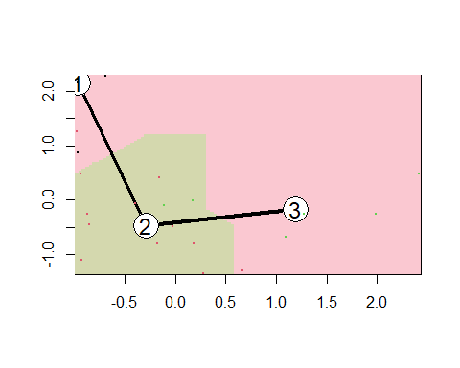

Before we make any conclusions with these results, let’s try a K of 5 and analyze the results:

set.seed(64060)  
k5 <- kmeans(df, centers = 5, nstart = 25) # k = 5, number of restarts = 25  
  
# the following will help us Visualize the output  
  
k5$centers # output the centers

## Market_Cap Beta PE_Ratio ROE ROA Asset_Turnover  
## 1 -0.87051511 1.3409869 -0.05284434 -0.6184015 -1.1928478 -0.4612656  
## 2 -0.43925134 -0.4701800 2.70002464 -0.8349525 -0.9234951 0.2306328  
## 3 -0.76022489 0.2796041 -0.47742380 -0.7438022 -0.8107428 -1.2684804  
## 4 -0.03142211 -0.4360989 -0.31724852 0.1950459 0.4083915 0.1729746  
## 5 1.69558112 -0.1780563 -0.19845823 1.2349879 1.3503431 1.1531640  
## Leverage Rev_Growth Net_Profit_Margin  
## 1 1.36644699 -0.6912914 -1.320000179  
## 2 -0.14170336 -0.1168459 -1.416514761  
## 3 0.06308085 1.5180158 -0.006893899  
## 4 -0.27449312 -0.7041516 0.556954446  
## 5 -0.46807818 0.4671788 0.591242521

k5$size # Number of firms in each cluster

## [1] 3 2 4 8 4

fviz_cluster(k5, data = df) # Visualize the output

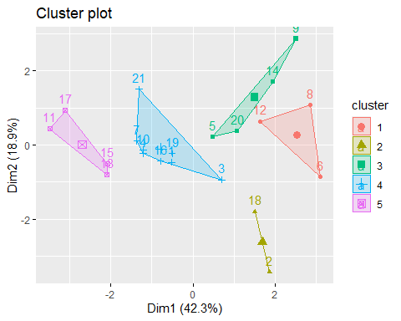

# Other Distances

I’ll rerun the example using other distance measures to compare the results

set.seed(64060)  
  
k5M = kcca(df, k=5, kccaFamily("kmedians")) #kmedians uses Manhattan distance  
k5M

## kcca object of family 'kmedians'   
##   
## call:  
## kcca(x = df, k = 5, family = kccaFamily("kmedians"))  
##   
## cluster sizes:  
##   
## 1 2 3 4 5   
## 3 6 5 1 6

k5E = kcca(df, k=5, kccaFamily("kmeans")) #kmeans uses Euclidean distance  
k5E

## kcca object of family 'kmeans'   
##   
## call:  
## kcca(x = df, k = 5, family = kccaFamily("kmeans"))  
##   
## cluster sizes:  
##   
## 1 2 3 4 5   
## 5 1 9 1 5

k5A = kcca(df, k=5, kccaFamily("angle")) #angle uses angle between observation and centroid  
k5A

## kcca object of family 'angle'   
##   
## call:  
## kcca(x = df, k = 5, family = kccaFamily("angle"))  
##   
## cluster sizes:  
##   
## 1 2 3 4 5   
## 8 4 4 3 2

# We won't use Jaccard distance as this is primarily used for categorical data which is not applicable.

Let’s take a look at the images of each of these results:

image(k5M) # Manhattan distance

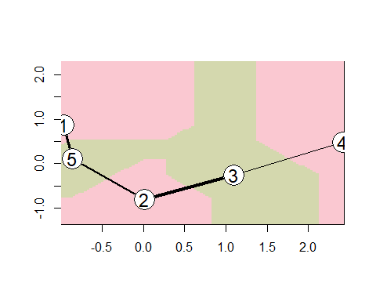

image(k5E) # Euclidean distance

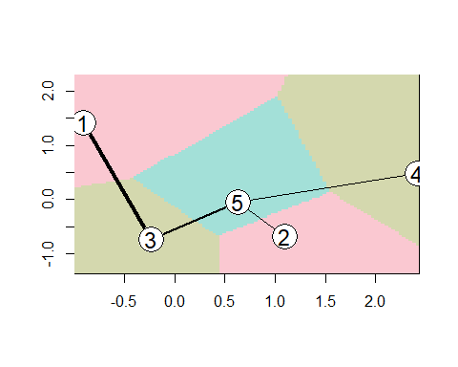

image(k5A) # angle

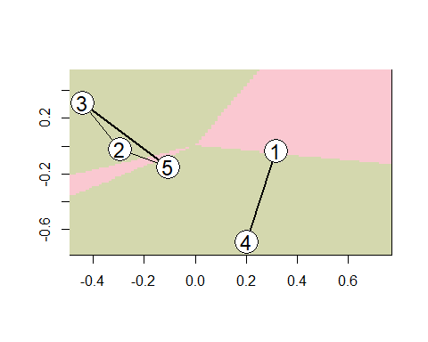 This is a little more interesting. It seems with the K of 5, the Euclidean distance may be producing a better result

Let’s take a closer look at the centers:

dist(k5M@centers)

## 1 2 3 4  
## 2 3.721628   
## 3 4.689876 2.194249   
## 4 5.698767 3.925905 2.397111   
## 5 2.931609 2.762659 3.804627 5.718298

dist(k5E@centers)

## 1 2 3 4  
## 2 6.108448   
## 3 3.091631 4.400111   
## 4 5.789244 2.447177 4.465604   
## 5 4.177287 2.502227 2.448221 2.791316

dist(k5A@centers)

## 1 2 3 4  
## 2 1.822650   
## 3 1.840575 1.253136   
## 4 1.163136 1.635111 1.732785   
## 5 1.776303 1.373808 1.158538 1.508880

It appears that the Euclidean distance (k5E) is producing better results as can be seen in both the image and the data for the centers. This seems to maximize the distance between the cluster centroids.

Let’s apply the predict function to k5E which uses Euclidean Distance

set.seed(64060)  
clusters_index5 <- predict(k5E)  
dist(k5E@centers)

## 1 2 3 4  
## 2 6.108448   
## 3 3.091631 4.400111   
## 4 5.789244 2.447177 4.465604   
## 5 4.177287 2.502227 2.448221 2.791316

image(k5E)  
points(df, col=clusters_index5, pch=19, cex=0.3)

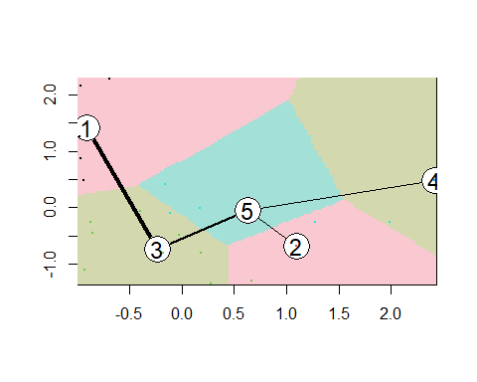

CHOOSING THE BEST K Let’s use some tools to help us determine the best K value

We’ll first review an “elbow chart” to determine k

fviz_nbclust(df, kmeans, method = "wss")

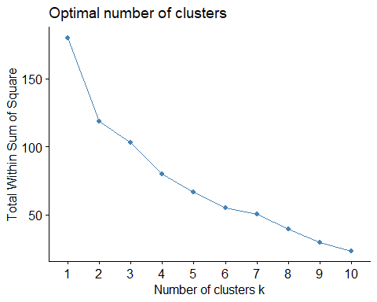 In reviewing the “elbow chart” (WSS), it is a little unclear as to what the optimal number of clusters (k) should be since there is not a clearly visible “knee point” in the results plot. The total WSS has a substantial drop from 1 to 2, less of a drop from 2 to 3, and then another larger drop from 3 to 4. From 4 to 5 and 5 to 6, the decrease is similar and then from 6 to 7, there is little drop. My first thought is the knee point is either at 4 or 6. Honestly, it is difficult to make a reliable determination of the optimal number of clusters (k) using this method (WSS) for this particular set of data. Therefore, I need to confirm this using a different method (Silhouette Method).

Next, we’ll use the Silhouette Method to determine the number of clusters (k)

fviz_nbclust(df, kmeans, method = "silhouette")

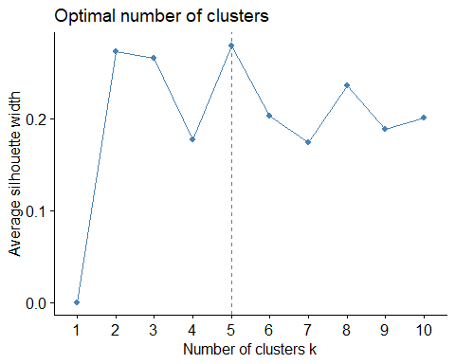 In using the Silhouette Method, it is clear that the optimal number of clusters (k) is 5.

SUMMARY OF REQUIREMENT A:

When clustering, our objective is to minimize the similarity within the cluster and maximize the dissimilarity between the clusters. Meaning, we want the clusters to be as tight as possible with the distance between the clusters to be as great as possible. Also, it is preferable to have the size of the clusters similar.

k3$size

## [1] 11 6 4

k4$size

## [1] 8 4 6 3

k5$size

## [1] 3 2 4 8 4

We have 21 observations. For 3 clusters, the average size would be 7. For 4 clusters, the average size would be 5.25. For 5 clusters, the average size would be 4.2. In reviewing the results of our cluster sizes, the results of our 5 clusters seem to remain closer to the average.

image(k3M)



image(k4M)



image(k5E)

 In reviewing these images, the image with the k of 5 seems to be producing more desirable results. The clusters are “tighter” (more tightly grouped) with the distance between clusters maximized.

dist(k3M@centers)

## 1 2  
## 2 3.838654   
## 3 5.334439 2.990655

dist(k4M@centers)

## 1 2 3  
## 2 3.838654   
## 3 5.233264 2.754097   
## 4 6.025978 4.677079 2.397111

dist(k5E@centers)

## 1 2 3 4  
## 2 6.108448   
## 3 3.091631 4.400111   
## 4 5.789244 2.447177 4.465604   
## 5 4.177287 2.502227 2.448221 2.791316

The above statement is also confirmed by reviewing the centers

Using the silhouette method in determining k, it confirmed the optimal k value is 5.

WEIGHTING THE VARIABLES In reviewing the data, it’s logical to think Market_Cap and PE_Ratio would be more substantial in differentiating the various firms. Going with this assumption, let’s place more weight on these variables than on the others.

Let’s create the data frame we’ll use for the weighted results

set.seed(64060)  
  
df_weighted <- Pharmaceuticals[,c(3:11)]  
  
summary(df_weighted)

## Market_Cap Beta PE_Ratio ROE   
## Min. : 0.41 Min. :0.1800 Min. : 3.60 Min. : 3.9   
## 1st Qu.: 6.30 1st Qu.:0.3500 1st Qu.:18.90 1st Qu.:14.9   
## Median : 48.19 Median :0.4600 Median :21.50 Median :22.6   
## Mean : 57.65 Mean :0.5257 Mean :25.46 Mean :25.8   
## 3rd Qu.: 73.84 3rd Qu.:0.6500 3rd Qu.:27.90 3rd Qu.:31.0   
## Max. :199.47 Max. :1.1100 Max. :82.50 Max. :62.9   
## ROA Asset_Turnover Leverage Rev_Growth   
## Min. : 1.40 Min. :0.3 Min. :0.0000 Min. :-3.17   
## 1st Qu.: 5.70 1st Qu.:0.6 1st Qu.:0.1600 1st Qu.: 6.38   
## Median :11.20 Median :0.6 Median :0.3400 Median : 9.37   
## Mean :10.51 Mean :0.7 Mean :0.5857 Mean :13.37   
## 3rd Qu.:15.00 3rd Qu.:0.9 3rd Qu.:0.6000 3rd Qu.:21.87   
## Max. :20.30 Max. :1.1 Max. :3.5100 Max. :34.21   
## Net_Profit_Margin  
## Min. : 2.6   
## 1st Qu.:11.2   
## Median :16.1   
## Mean :15.7   
## 3rd Qu.:21.1   
## Max. :25.5

We need to scale this data frame before we can proceed.

# Scaling the data frame (z-score)   
df_weighted <- scale(df_weighted)  
  
summary(df_weighted)

## Market_Cap Beta PE_Ratio ROE   
## Min. :-0.9768 Min. :-1.3466 Min. :-1.3404 Min. :-1.4515   
## 1st Qu.:-0.8763 1st Qu.:-0.6844 1st Qu.:-0.4023 1st Qu.:-0.7223   
## Median :-0.1614 Median :-0.2560 Median :-0.2429 Median :-0.2118   
## Mean : 0.0000 Mean : 0.0000 Mean : 0.0000 Mean : 0.0000   
## 3rd Qu.: 0.2762 3rd Qu.: 0.4841 3rd Qu.: 0.1495 3rd Qu.: 0.3450   
## Max. : 2.4200 Max. : 2.2758 Max. : 3.4971 Max. : 2.4597   
## ROA Asset_Turnover Leverage Rev_Growth   
## Min. :-1.7128 Min. :-1.8451 Min. :-0.74966 Min. :-1.4971   
## 1st Qu.:-0.9047 1st Qu.:-0.4613 1st Qu.:-0.54487 1st Qu.:-0.6328   
## Median : 0.1289 Median :-0.4613 Median :-0.31449 Median :-0.3621   
## Mean : 0.0000 Mean : 0.0000 Mean : 0.00000 Mean : 0.0000   
## 3rd Qu.: 0.8430 3rd Qu.: 0.9225 3rd Qu.: 0.01828 3rd Qu.: 0.7693   
## Max. : 1.8389 Max. : 1.8451 Max. : 3.74280 Max. : 1.8862   
## Net_Profit_Margin   
## Min. :-1.99560   
## 1st Qu.:-0.68504   
## Median : 0.06168   
## Mean : 0.00000   
## 3rd Qu.: 0.82364   
## Max. : 1.49416

CHOOSING THE BEST K Let’s review an “elbow chart” to determine k

fviz_nbclust(df_weighted, kmeans, method = "wss")

 Again, these results are a little unclear, so let’s defer to the Silhouette method.

Now, let’s use the Silhouette Method to determine the number of clusters (k)

fviz_nbclust(df_weighted, kmeans, method = "silhouette")



This shows the optimal number of clusters is 5

Now, we’ll place more weight on Market_Cap (1st variable) and PE_Ratio (3rd variable)

set.seed(64060)  
  
k5_weighted <- cclust(df_weighted, k=5, save.data=TRUE, weights = c(1,0.5,1,0.5,0.5,0.5,0.5,0.5,0.5), method = "hardcl")  
  
k5_weighted

## kcca object of family 'kmeans'   
##   
## call:  
## cclust(x = df_weighted, k = 5, method = "hardcl", weights = c(1,   
## 0.5, 1, 0.5, 0.5, 0.5, 0.5, 0.5, 0.5), save.data = TRUE)  
##   
## cluster sizes:  
##   
## 1 2 3 4 5   
## 8 2 4 3 4

Let’s now visualize our results:

image(k5_weighted)

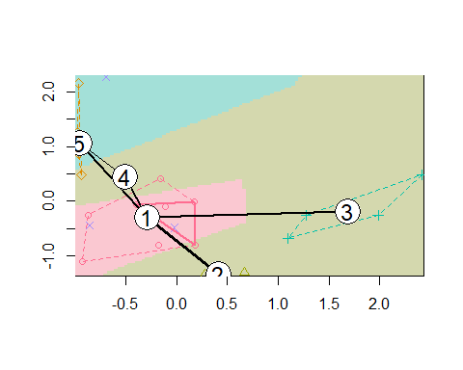

dist(k5_weighted@centers)

## 1 2 3 4  
## 2 1.903477   
## 3 2.887223 3.278427   
## 4 3.498740 4.355677 5.326741   
## 5 3.045587 4.188404 5.101772 3.548789

CONCLUSIONS: My hypothesis regarding the weight placed on each variable may be incorrect. When reviewing the images of the original k5E and the weighted k5_weighted, k5E produces better cluster results which doesn’t seem entirely logical. To get better results with the weighted variables, we would need better estimations of the actual weighted importance of each variable.

REQUIREMENT C:

Is there a pattern in the clusters with respect to the non-numerical variables (10 to 12)?

First, we’ll add a column to Pharmaceuticals called “Cluster_No” and set the values equal to the cluster which each observation has been assigned to.

Pharmaceuticals$Cluster_No = k5E@cluster

We’ll first compare the Cluster_No to the Median_Recommendation (variable 10)

table(Cluster=Pharmaceuticals$Cluster_No, Median_Recommendation=Pharmaceuticals$Median_Recommendation)

## Median_Recommendation  
## Cluster Hold Moderate Buy Moderate Sell Strong Buy  
## 1 2 2 1 0  
## 2 1 0 0 0  
## 3 4 3 1 1  
## 4 0 1 0 0  
## 5 2 1 2 0

In reviewing the distribution of observations of the Median_Recommendation compared to each Cluster, we’ll disregard clusters 2 and 4 since these have only 1 observation.

Cluster 1, 40% are Hold, 40% are Moderate Buy, and 20% are Moderate Sell.  
 Cluster 3, 44% are Hold, 33% are Moderate Buy, and 11% are Moderate Sell.  
 Cluster 5, 40% are Hold, 20% are Moderate Buy, and 40% are Moderate Sell.

Therefore, there does NOT seem to be any strong correlation between this variable (variable 10) and the clusters to which they were assigned.

Next, we’ll compare the Cluster_No to the Location (variable 11)

table(Cluster=Pharmaceuticals$Cluster_No, Location=Pharmaceuticals$Location)

## Location  
## Cluster CANADA FRANCE GERMANY IRELAND SWITZERLAND UK US  
## 1 0 0 1 1 0 0 3  
## 2 0 0 0 0 0 1 0  
## 3 1 1 0 0 1 1 5  
## 4 0 0 0 0 0 0 1  
## 5 0 0 0 0 0 1 4

In reviewing the distribution of observations of the Location compared to each Cluster, again, we’ll disregard Clusters 2 and 4 since these have only 1 observation.

Cluster 1, 20% are Germany, 20% are Ireland, and 60% are US.  
Cluster 3, 11% are Canada, 11% are France, 11% are Switzerland, 11% are UK, and 55% are US  
Cluster 5, 20% are UK and 80% are US

From the raw data, we know that 62% of the firms in the observations are from the US.

While a larger percentage of firms in each Cluster are from the US, the percentage of US firms in each cluster is not much different than the overall average number of firms in the US. Therefore, there does not seem to be a strong correlation between Cluster and Location.

Now, we’ll compare the Cluster_No to the Exchange (variable 12)

table(Cluster=Pharmaceuticals$Cluster_No, Exchange=Pharmaceuticals$Exchange)

## Exchange  
## Cluster AMEX NASDAQ NYSE  
## 1 1 1 3  
## 2 0 0 1  
## 3 0 0 9  
## 4 0 0 1  
## 5 0 0 5

In reviewing the distribution of observations of the Exchange compared to each Cluster, again, we’ll disregard Clusters 2 and 4 since these have only 1 observation.

Cluster 1, 20% are AMEX, 20% are NASDAQ, and 60% are NYSE  
Cluster 3, 100% are NYSE  
Cluster 5, 100% are NYSE

However, we know from the raw data that of the 21 firms listed, only 1 are on the AMEX and only 1 are on the NASDAQ. All remaining 19 firms are on the NYSE.

Since the one firm on the AMEX and the one firm on the NASDAQ are both listed in the same cluster (Cluster 1) together with 3 firms on the NYSE, it seems there is no correlation between Cluster and Exchange.

REQUIREMENT D:

Provide an appropriate name for each cluster using any or all of the variables in the dataset.

For this, I’ll use 2 key variables for simplification: Market_Cap and PE_Ratio

set.seed(64060)  
  
d_df <- Pharmaceuticals[,c(3,5)]  
  
summary(d_df)

## Market_Cap PE_Ratio   
## Min. : 0.41 Min. : 3.60   
## 1st Qu.: 6.30 1st Qu.:18.90   
## Median : 48.19 Median :21.50   
## Mean : 57.65 Mean :25.46   
## 3rd Qu.: 73.84 3rd Qu.:27.90   
## Max. :199.47 Max. :82.50

We’ll scale the data frame

# Scaling the data frame (z-score)   
d_df <- scale(d_df)  
  
summary(d_df)

## Market_Cap PE_Ratio   
## Min. :-0.9768 Min. :-1.3404   
## 1st Qu.:-0.8763 1st Qu.:-0.4023   
## Median :-0.1614 Median :-0.2429   
## Mean : 0.0000 Mean : 0.0000   
## 3rd Qu.: 0.2762 3rd Qu.: 0.1495   
## Max. : 2.4200 Max. : 3.4971

CHOOSING THE BEST K Let’s review an “elbow chart” to determine k

fviz_nbclust(d_df, kmeans, method = "wss")

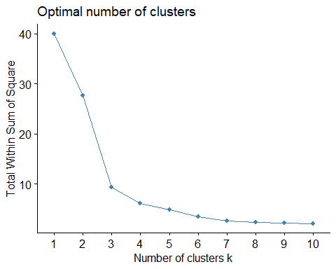 This chart clearly shows the knee point at 3, indicating the optimal number of clusters is 3

Now, let’s use the Silhouette Method to determine the number of clusters (k)

fviz_nbclust(d_df, kmeans, method = "silhouette")

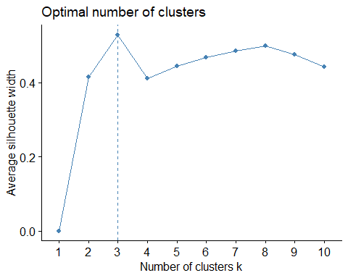 This is also showing the optimal number of clusters is 3.

I’ll run the k-means algorithm to cluster the firms and then visualize the output

set.seed(64060)  
  
d_k3 <- kmeans(d_df, centers = 3, nstart = 25) # k = 3, number of restarts = 25  
  
fviz_cluster(d_k3, data = d_df) # Visualize the output

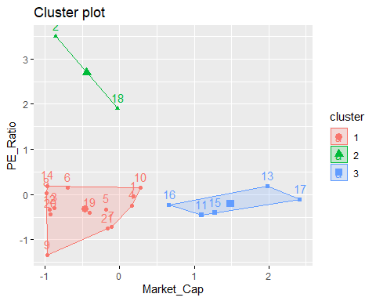 Here, we see there are three (3) clusters:

Cluster 1: Has low PE_Ratio and small Market_Cap Cluster 2: Has high PE_Ratio and small Market_Cap Cluster 3: Has low PE_Ratio and large Market_Cap

In general, Market_Cap corresponds to the firm’s stage in its business development. Large cap stocks are considered more conservative, less risky and less growth potential.

Also, high PE Ratios suggest investors are willing to pay more because they are expecting higher earnings growth in the future. But it could also be an indication that the stock is overvalued. A low PE Ratio is better for investors as it could be an indication that the stock is currently undervalued.

Therefore, I would name each cluster as follows:

Cluster 1: Growth Potential Investments Cluster 2: Riskier Investments Cluster 3: Conservative Investments