**Data Factory Project**

**Submitted by – Gaurav Kulmethe**

Dt. 2 feb 2024

**Task 1-Copy file from input container to output container by using azure data factory.**

1. **Creating resource grp**

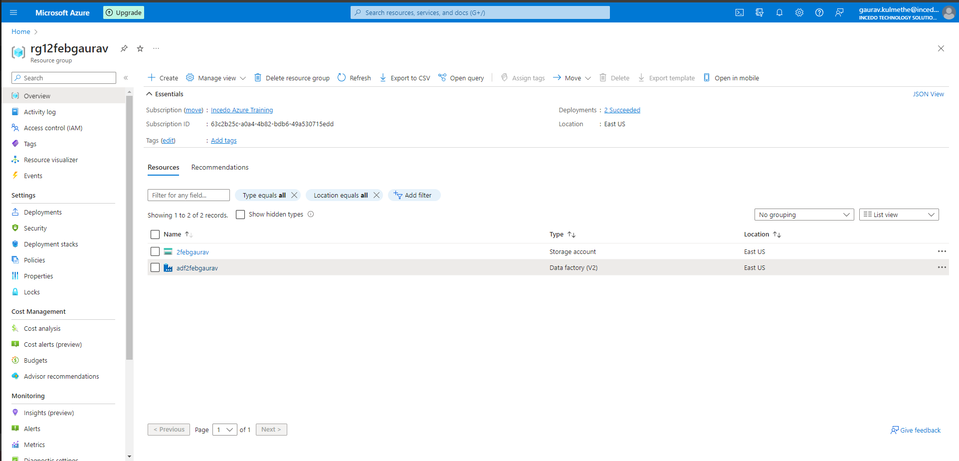

1. **Creating storage accounts**

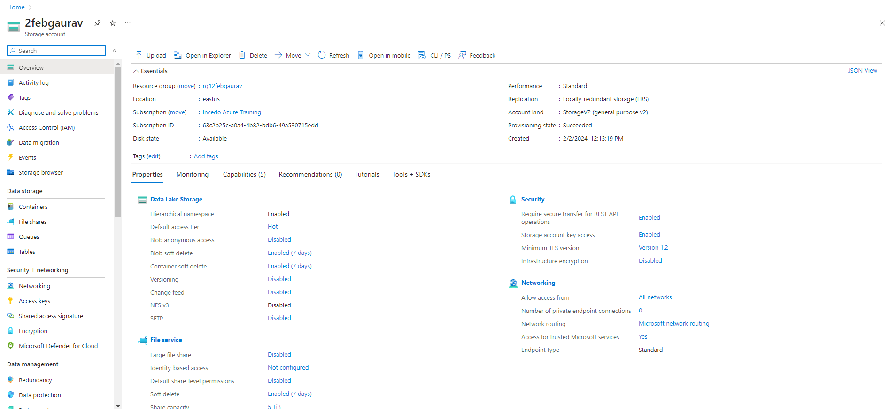

1. **Creating container**

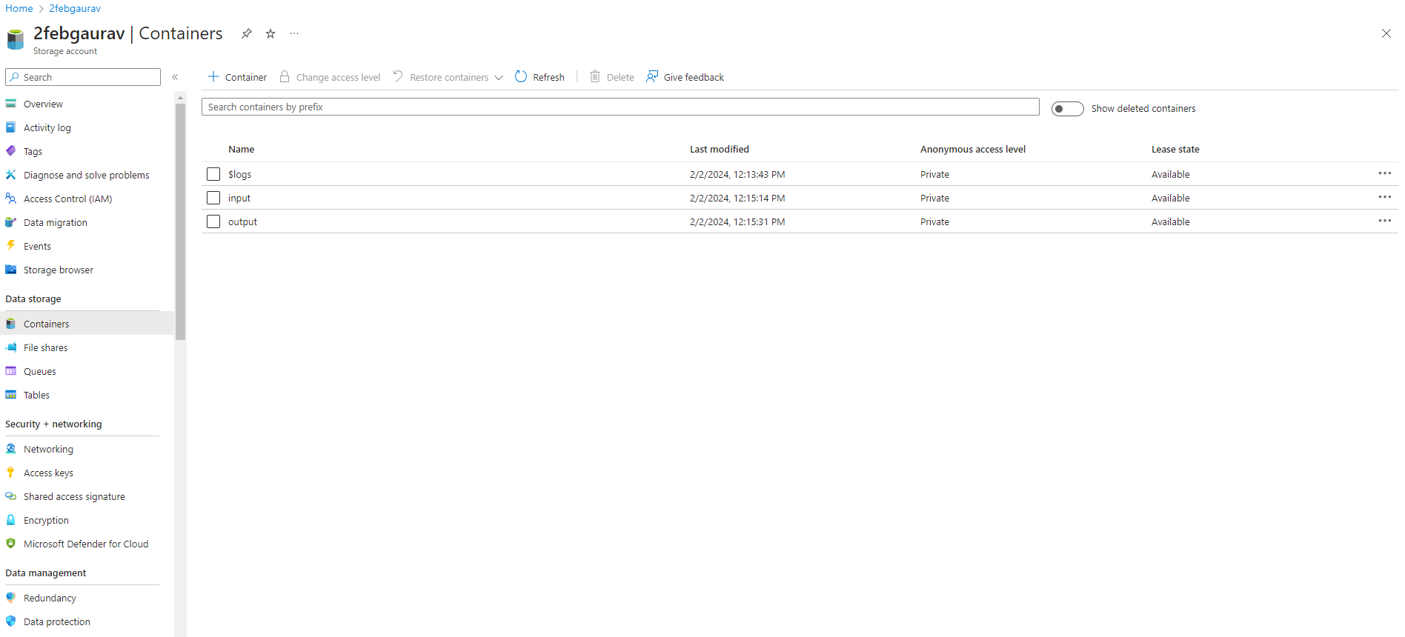

1. **Input container**

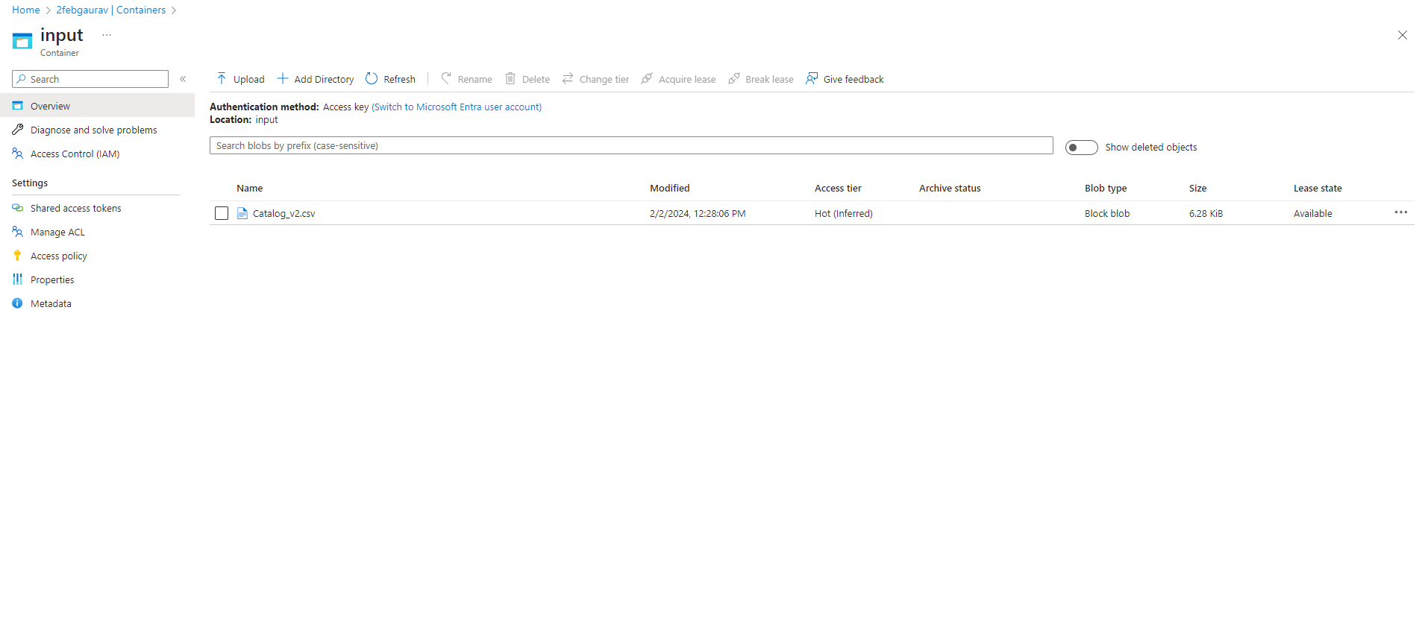

1. **Data Factory Studio**

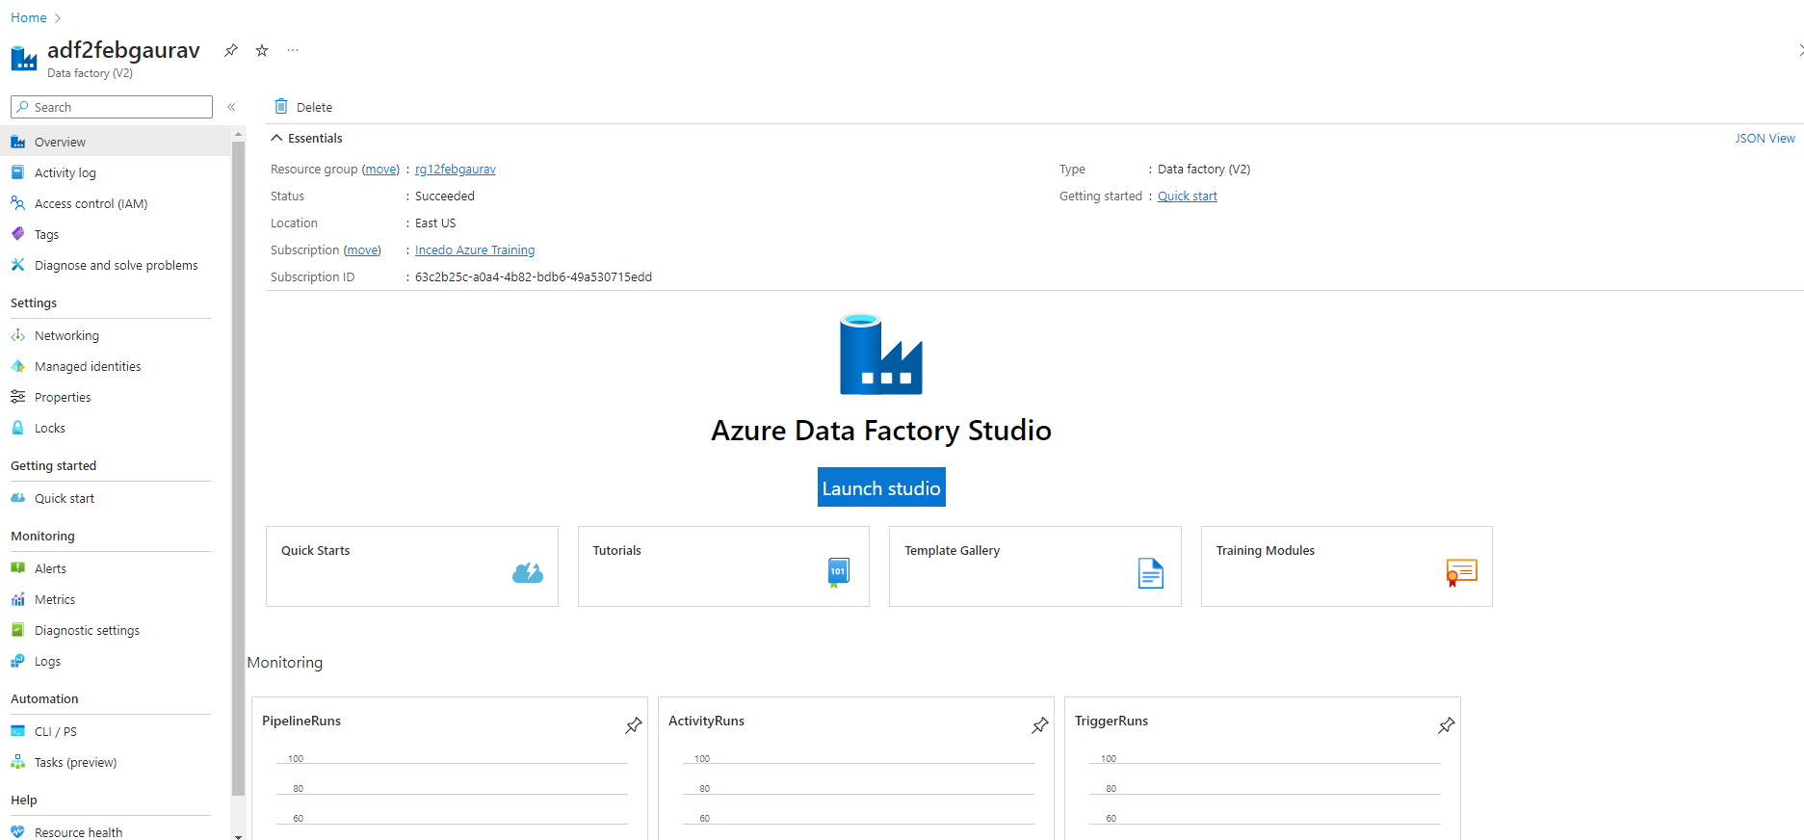

1. **Linked Service**

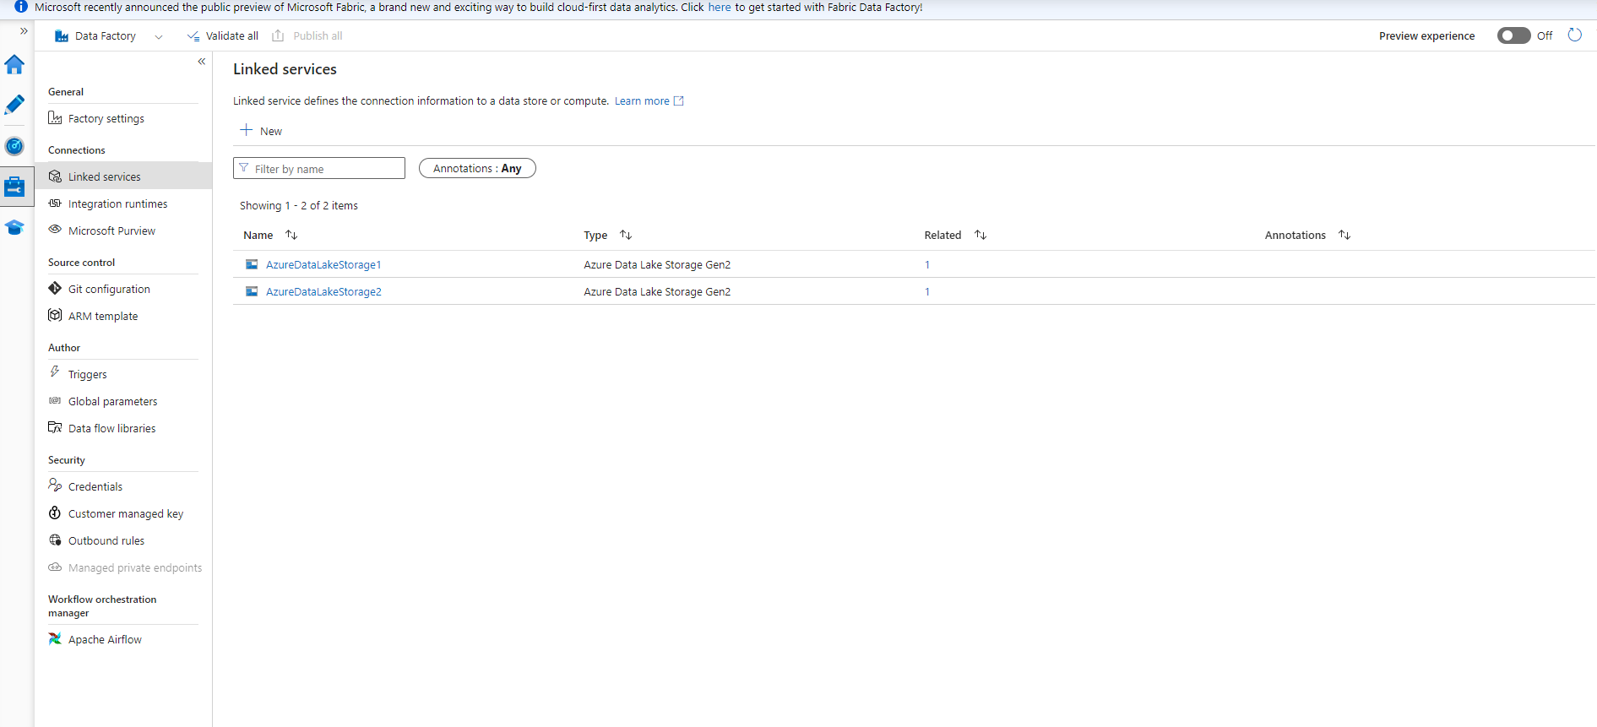

1. **Factory Resources**

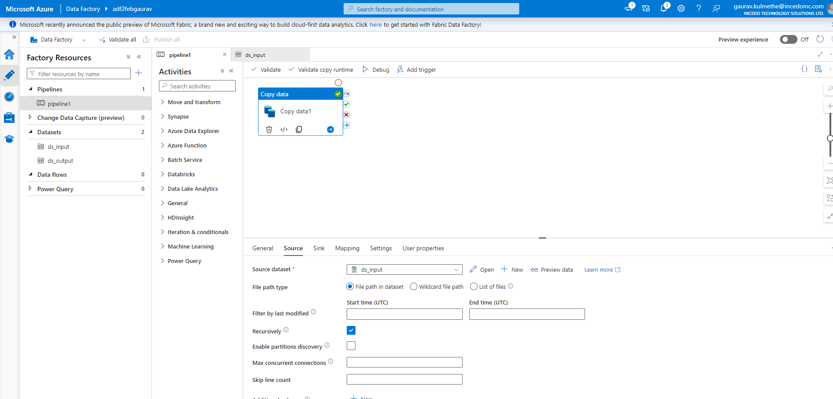

1. **Sink path**

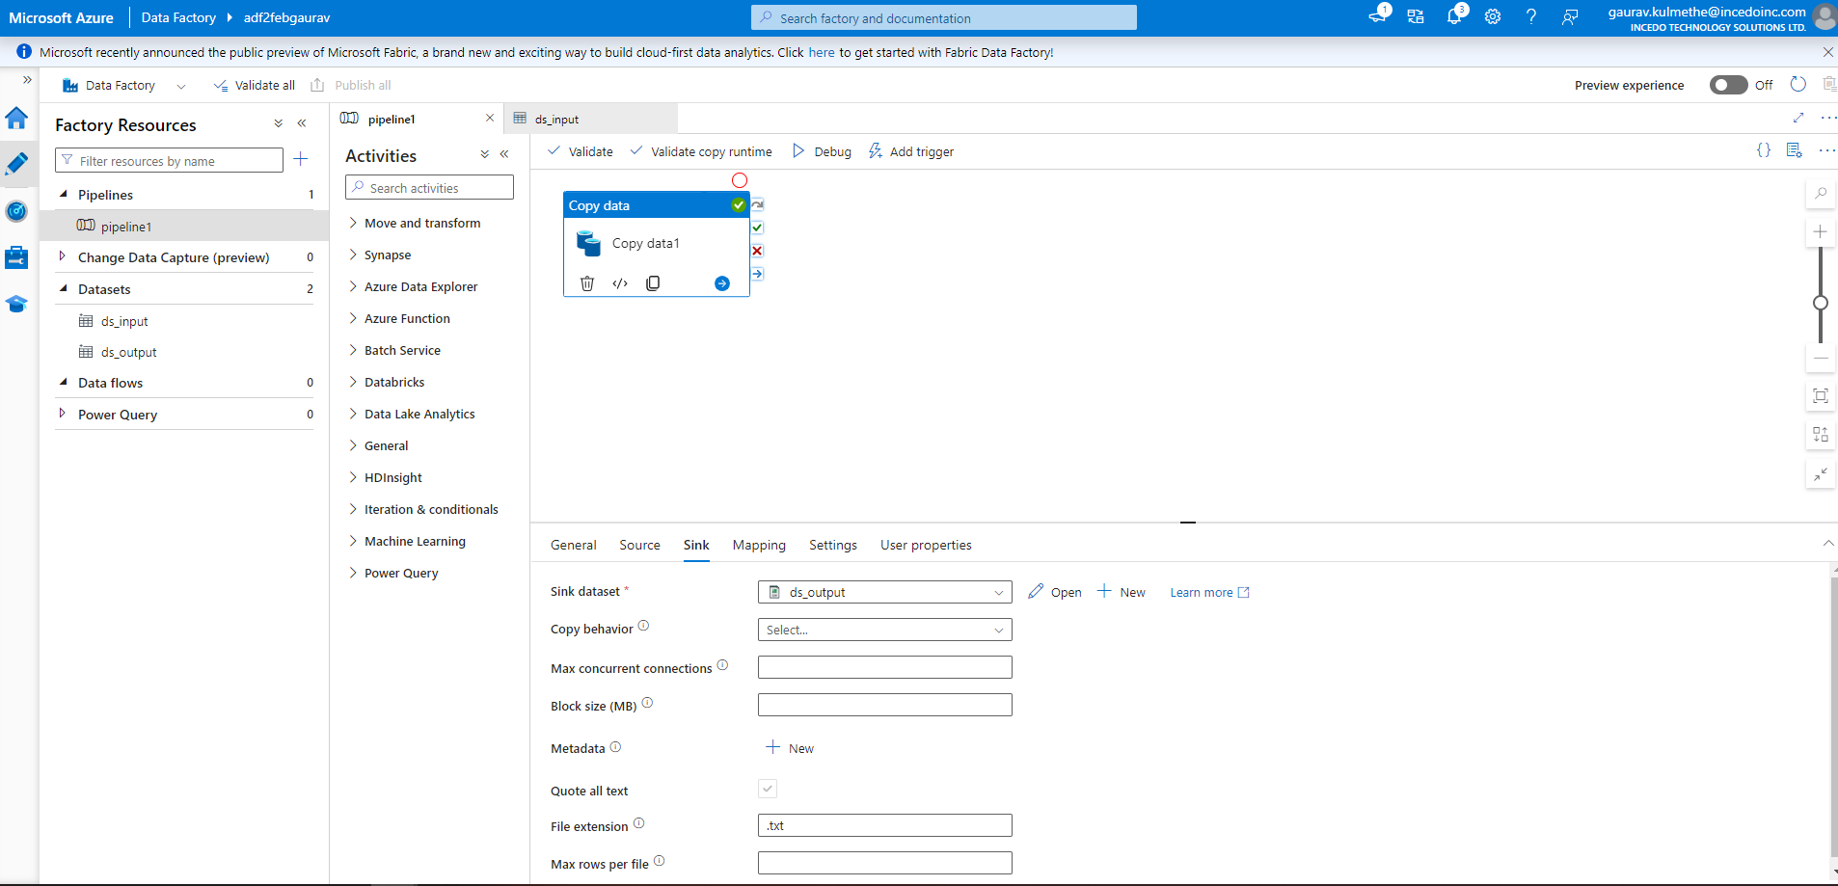

1. **DsInput**

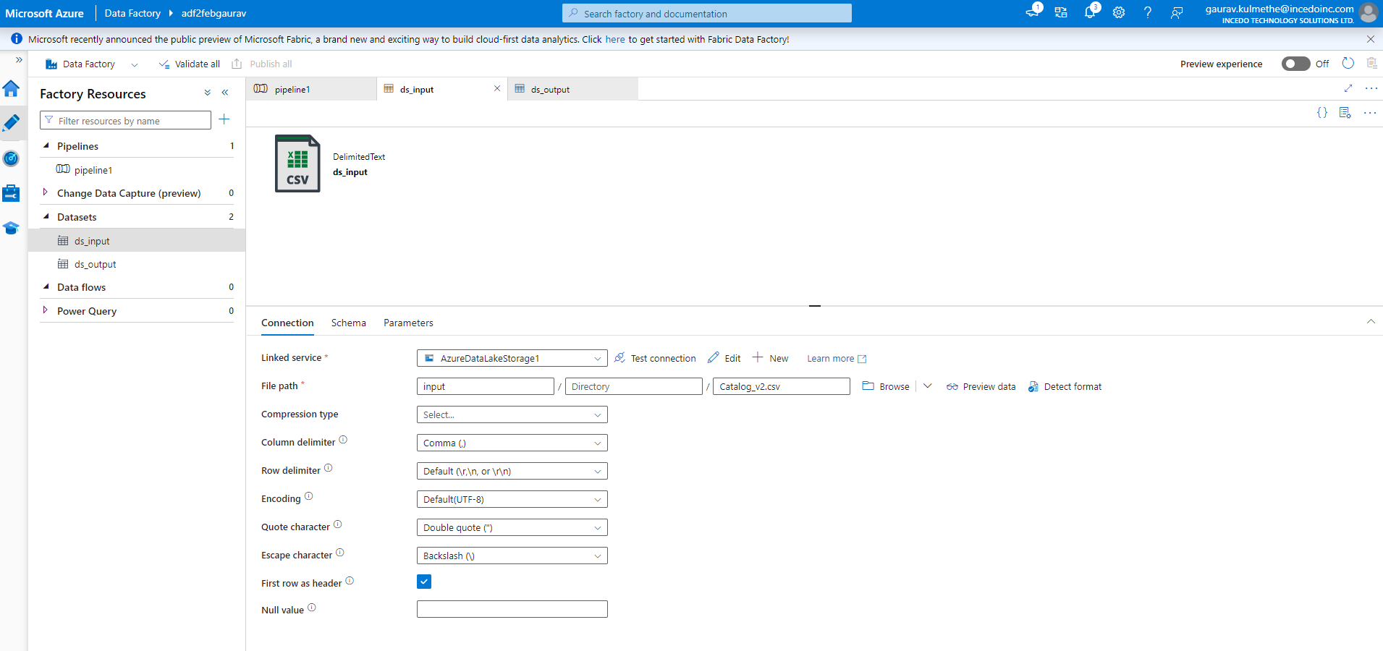

1. **Dsoutput**

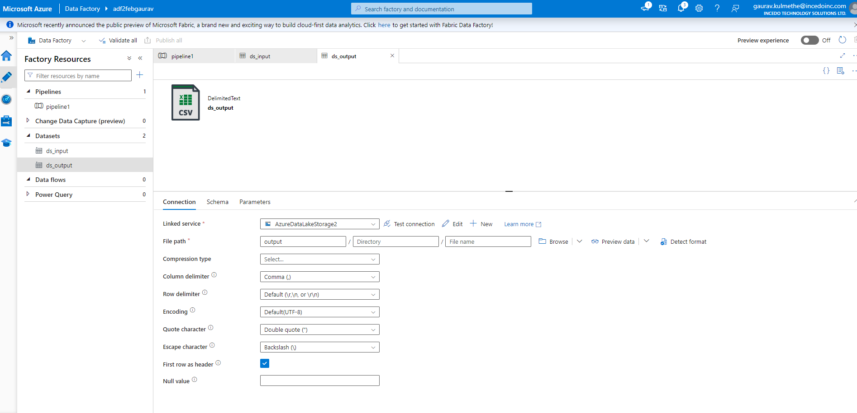

1. **Output Container**

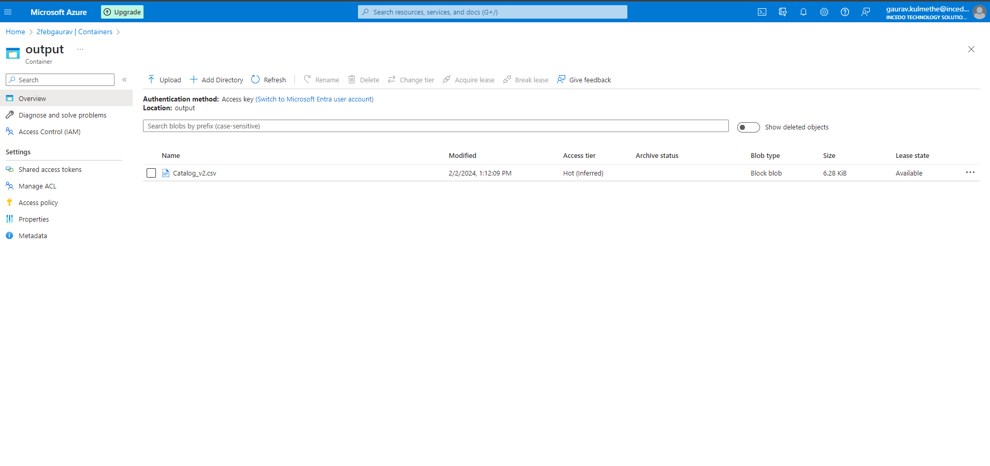

**Task 2 - Copy data from Azure Blob storage to a database in Azure SQL Database by using Azure Data Factory**

1. **Sql database query**

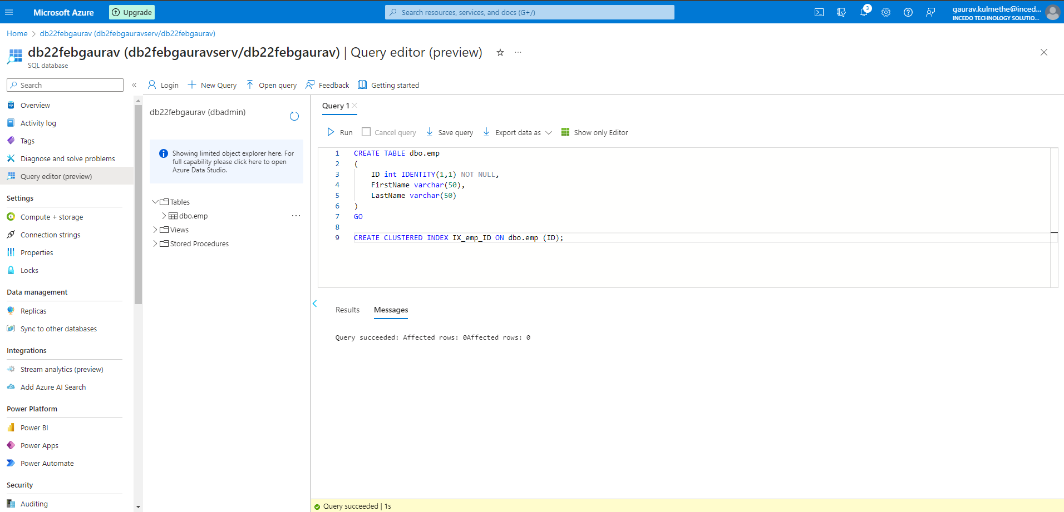

1. **Resource Group**

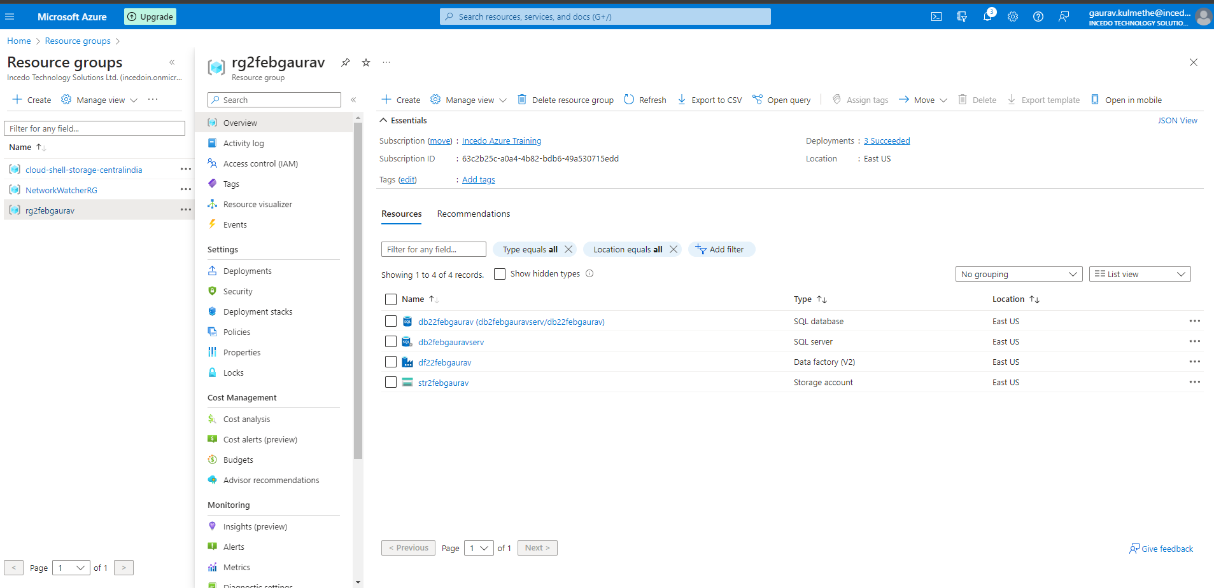

1. **Storage Account**

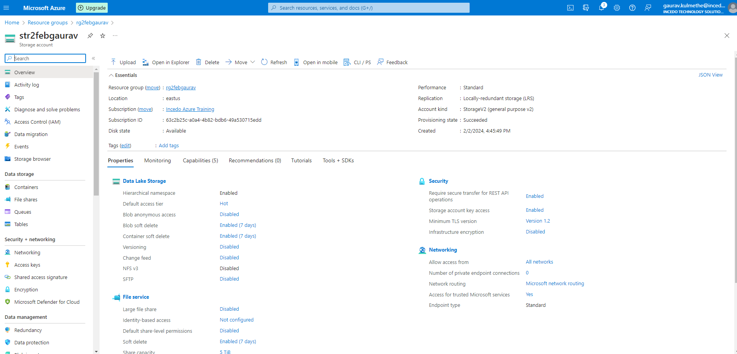

1. **Database Server**

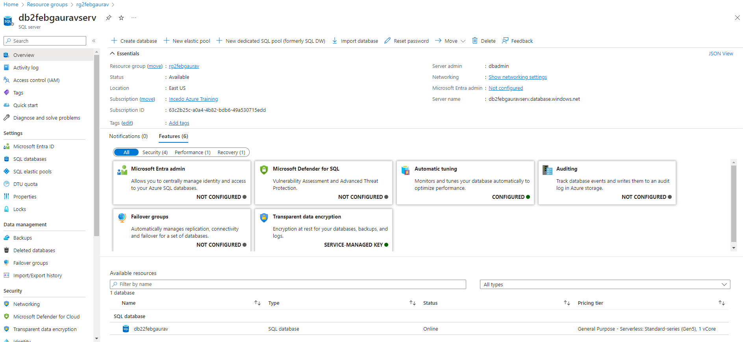

1. **Database**

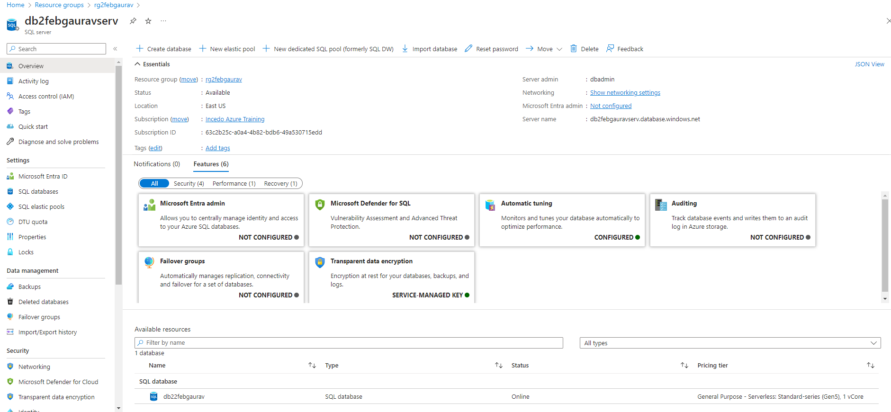

1. **Datafactory Dashboard**

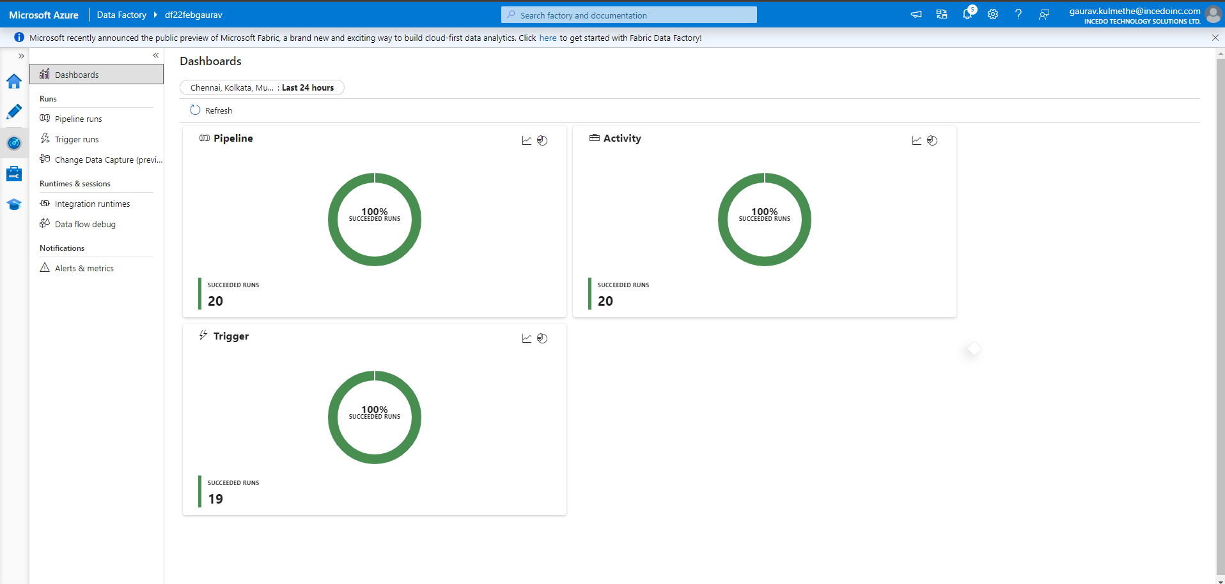

1. **Triggered Runs**

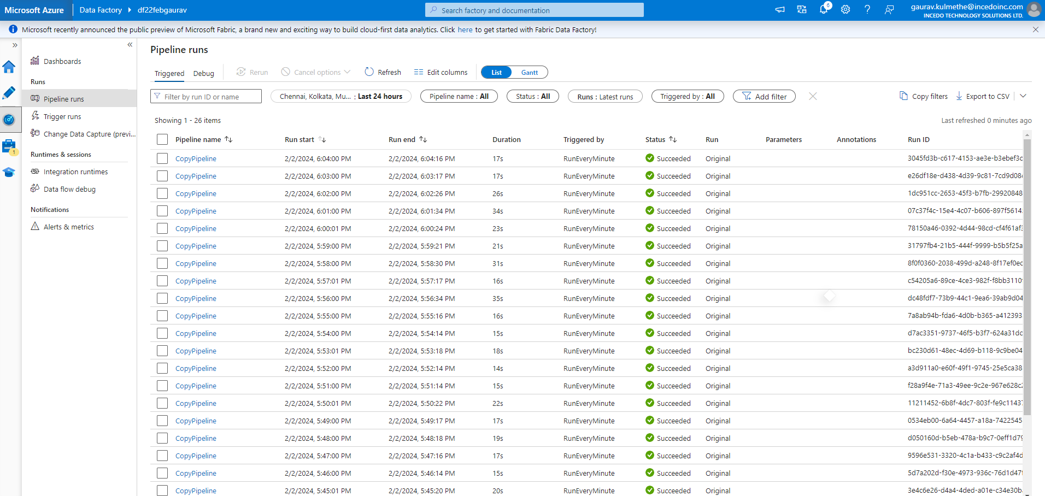

1. Debug

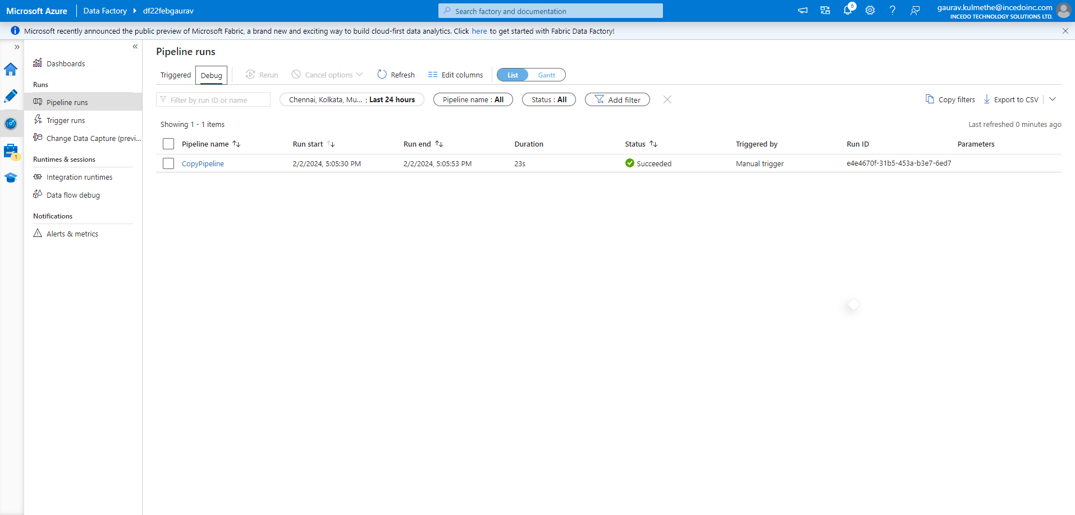

1. **Linked Service**

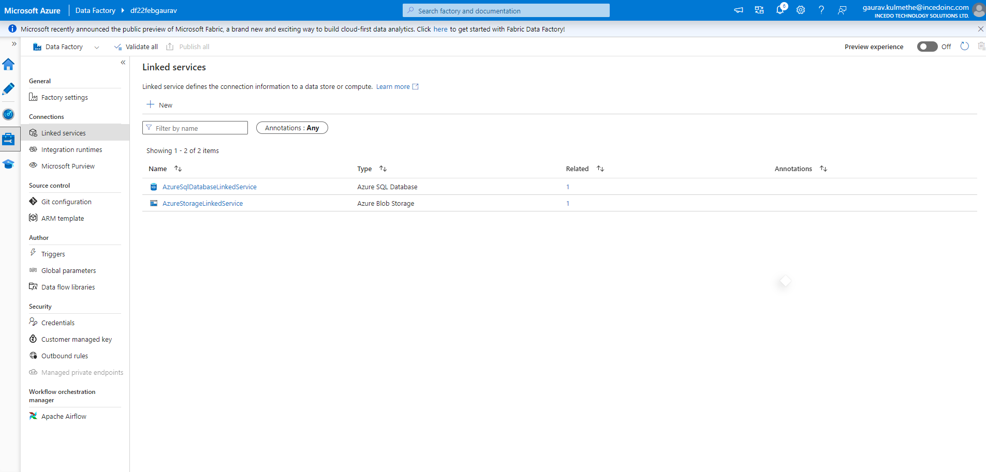

1. **Output SQL dataset**

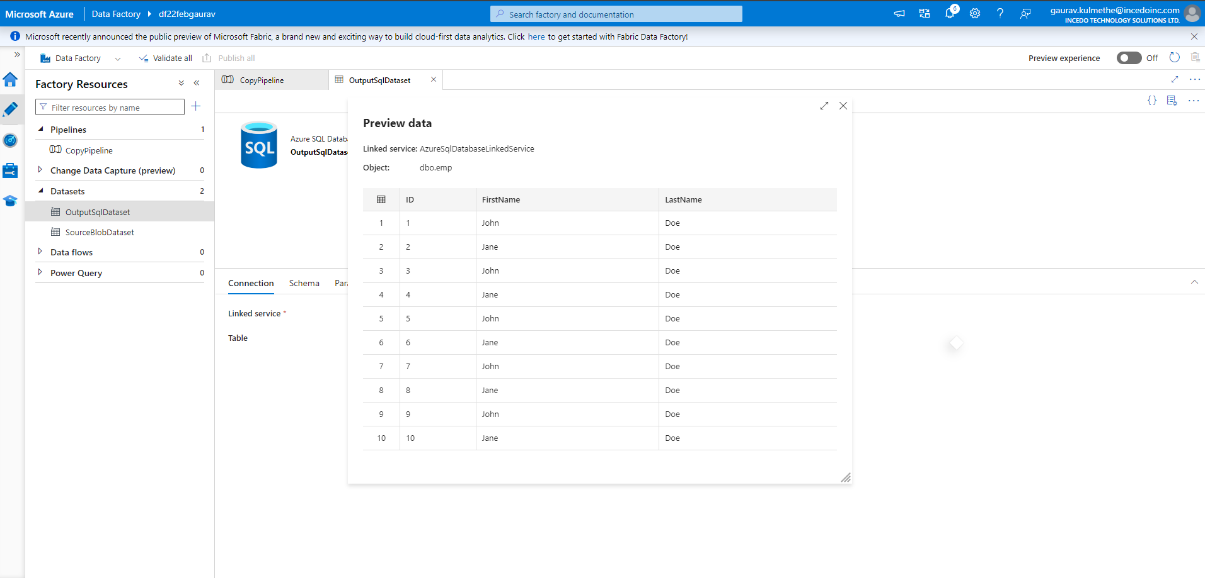

1. **Sourceblobdatasets**

