**Efficient Django Deployment : Dockerized Application on Azure vm**

Submitted by – Gaurav Kulmethe

1. **Django Sample Application azure_training run in local environment:**

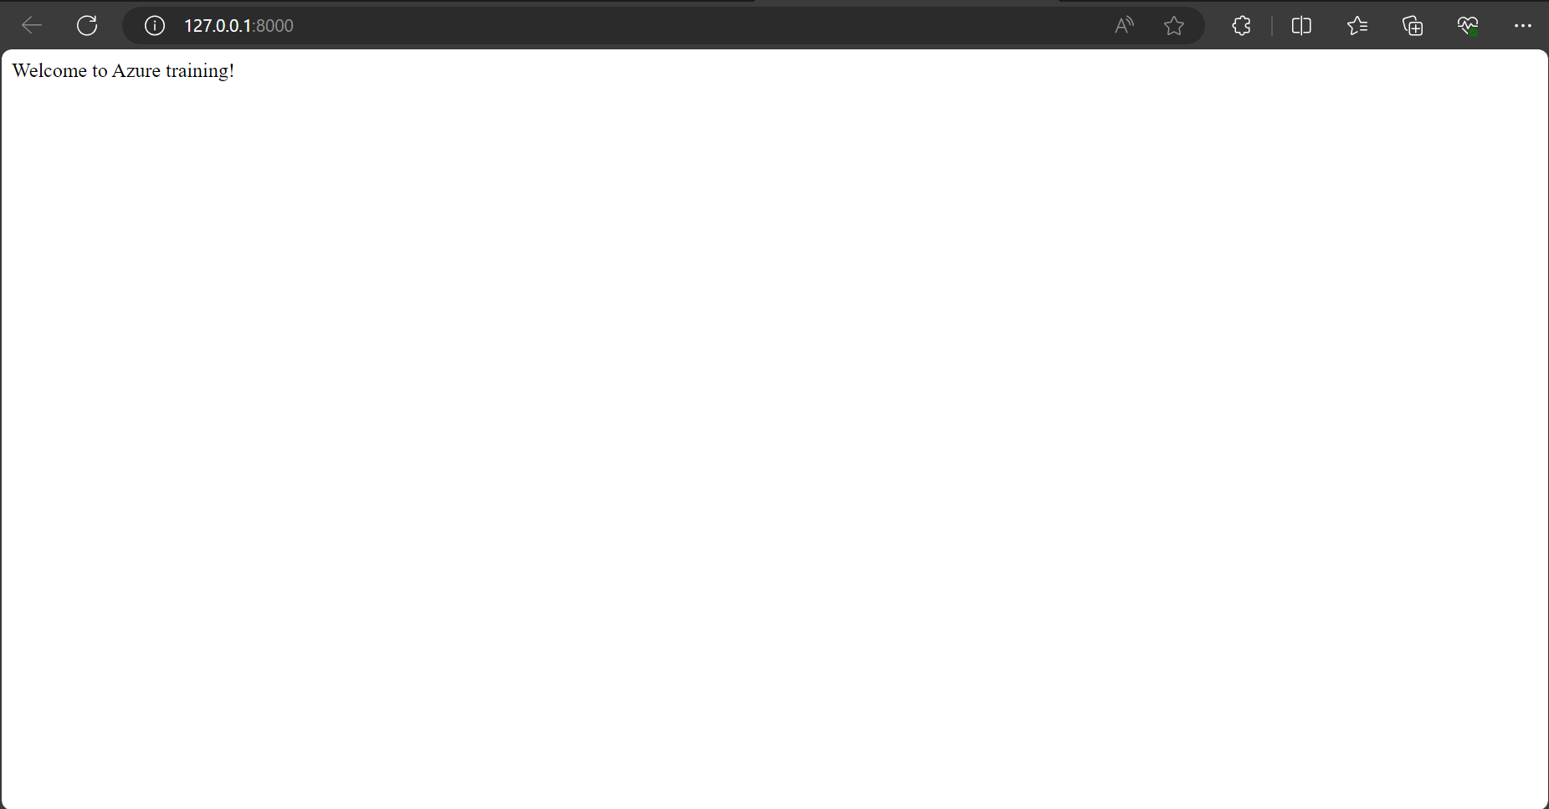

1. **Creating Resource Group**

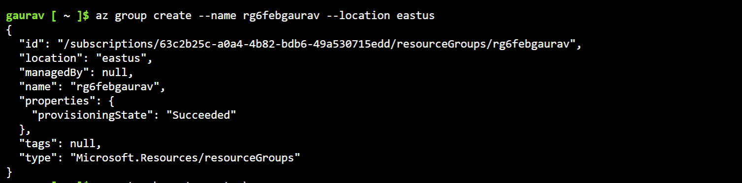

1. **Creating Vnet Network**

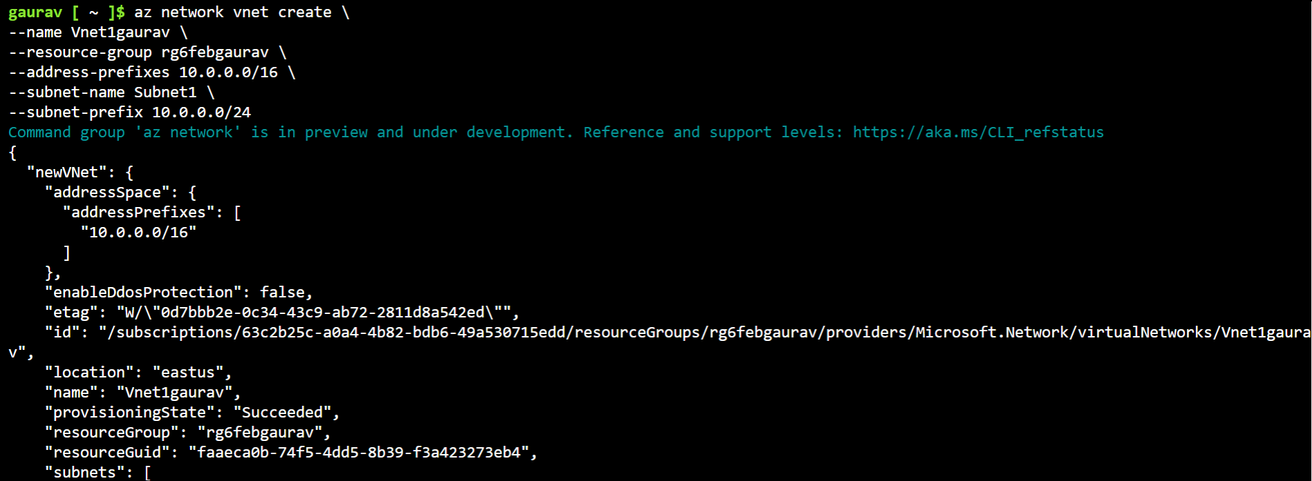

1. **Creating VM on Azure**

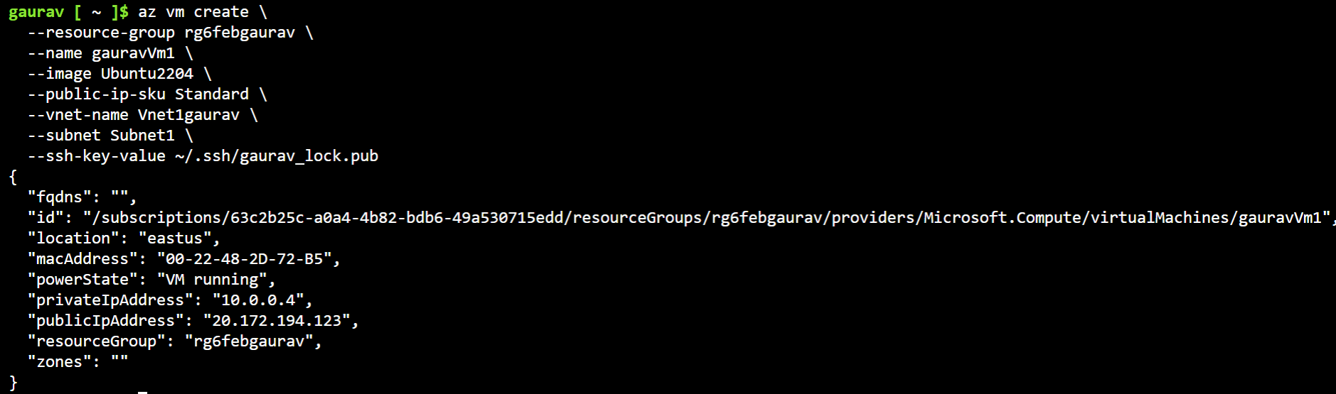

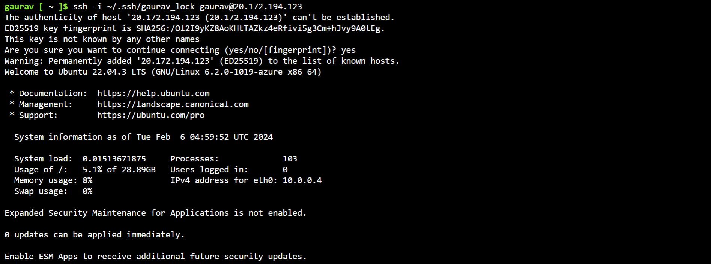

1. **Installing Docker on Azure VM:**
   1. sudo apt-get update
   2. sudo apt-get install apt-transport-https ca-certificates curl software-properties-common
   3. curl -fsSL https://download.docker.com/linux/ubuntu/gpg | sudo apt-key add -
   4. sudo apt-key fingerprint 0EBFCD88
   5. sudo add-apt-repository "deb [arch=amd64] https://download.docker.com/linux/ubuntu $(lsb_release -cs) stable"
   6. sudo apt-get update
   7. sudo apt-get install docker-ce docker-ce-cli containerd.io
   8. sudo usermod -aG docker $USER
   9. sudo docker run hello-world

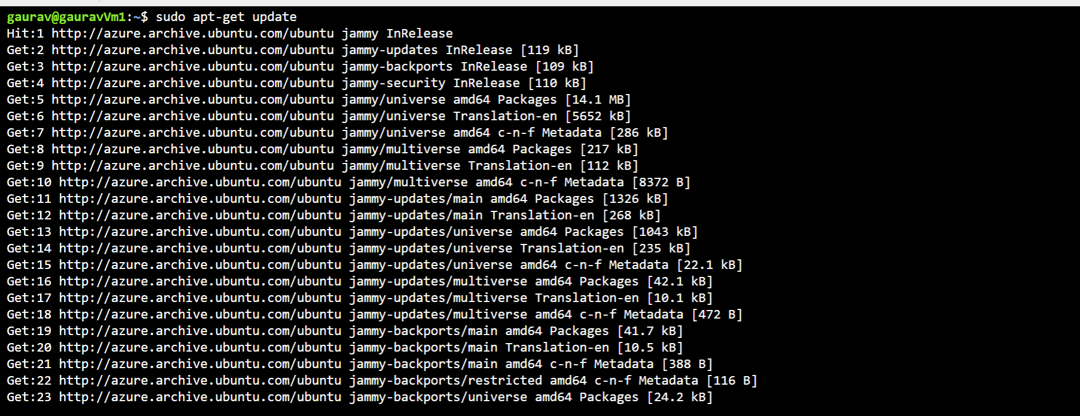

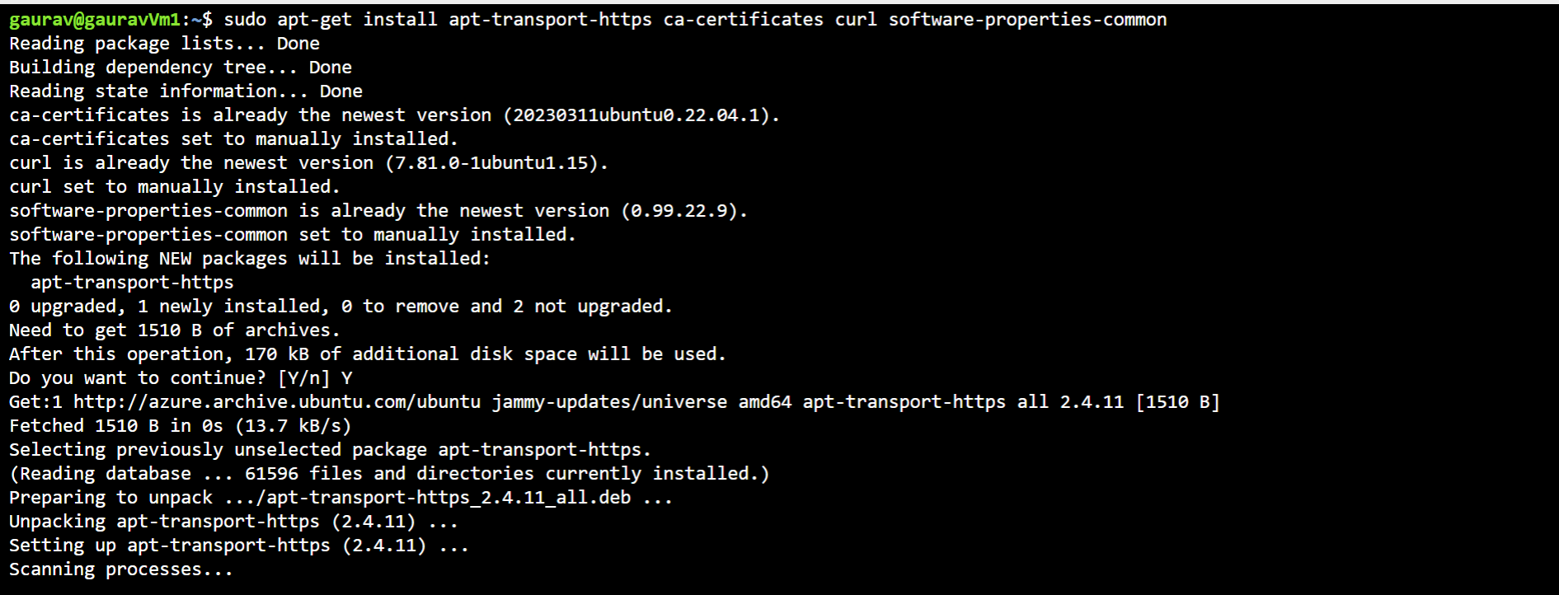

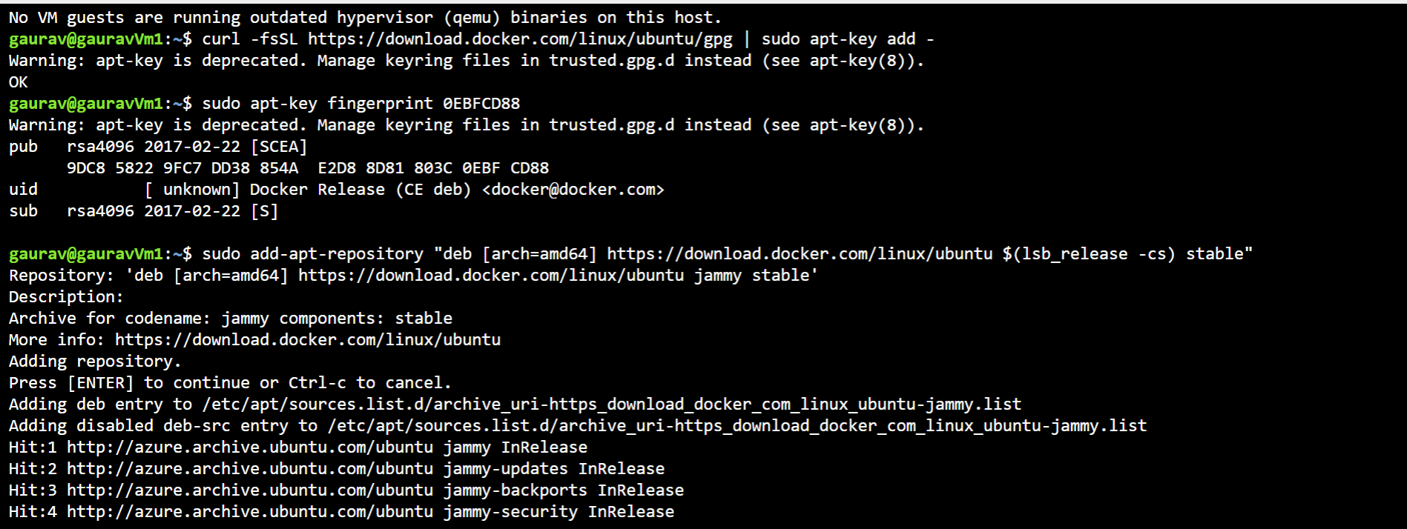

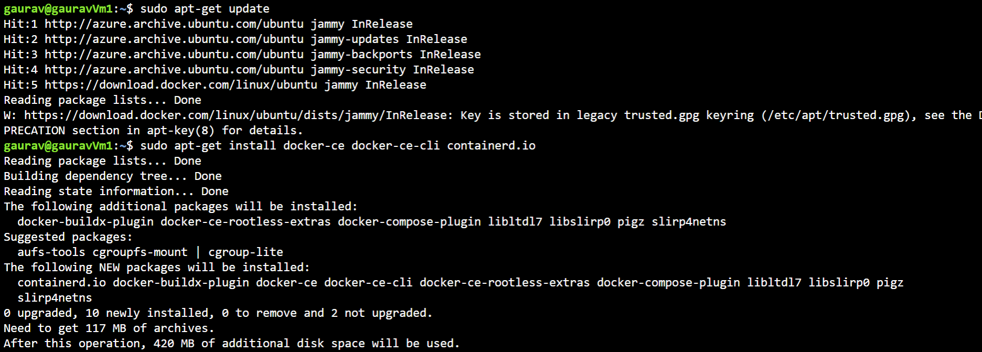

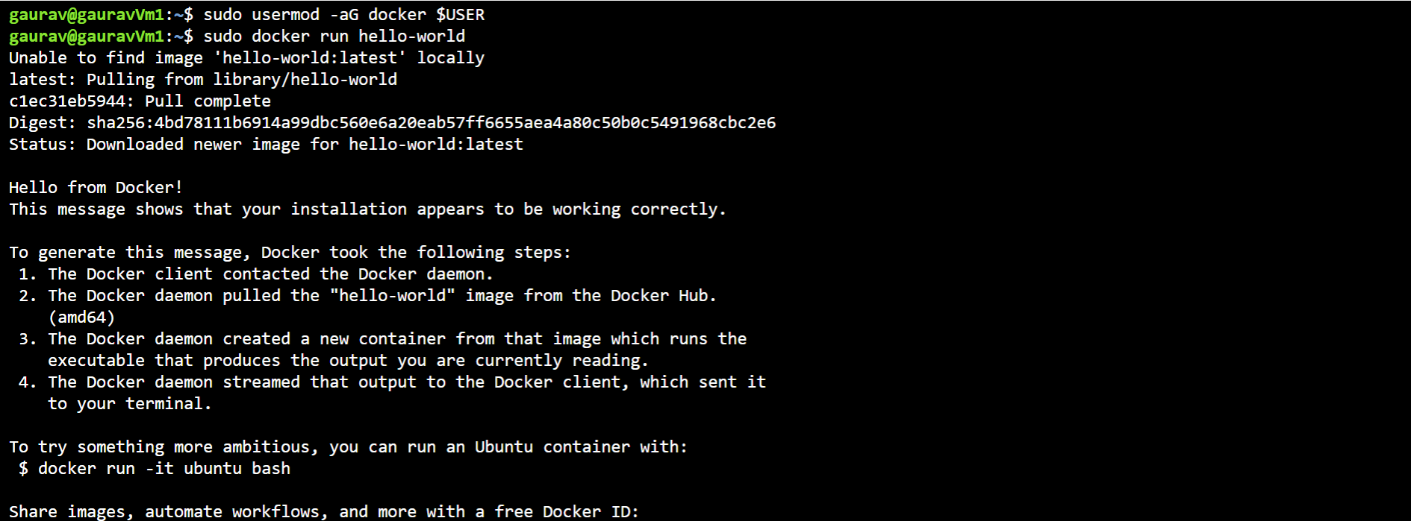

1. **Resource Group**

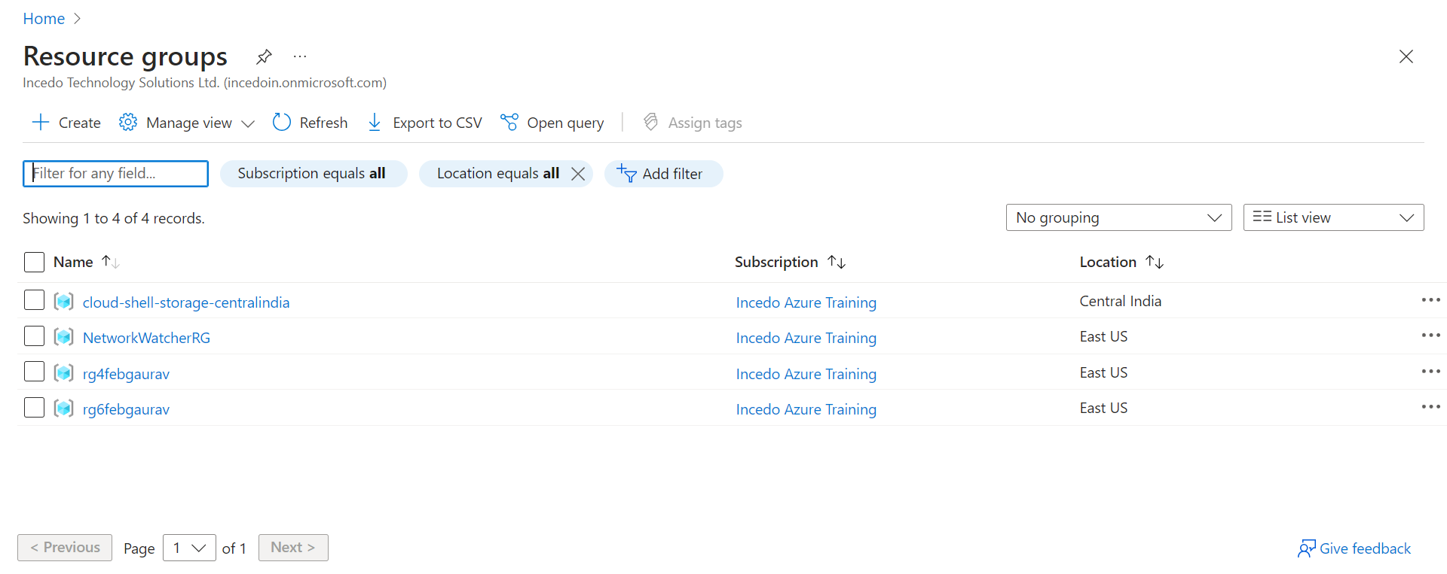

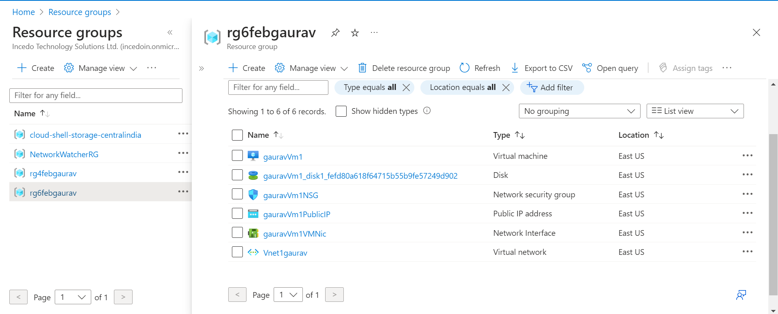

1. **Django Application Dockerization using Dockerplayground:**
   1. Git clone <https://github.com/Kgaurav729/MsAzureActivity_Gaurav.git>
   2. Cd MsAzureActivity_Gaurav
   3. Cd azure_training
   4. Docker build –t sampleimage .
   5. Docker run –p 8000:8000 sampleimage
2. **Docker Image**

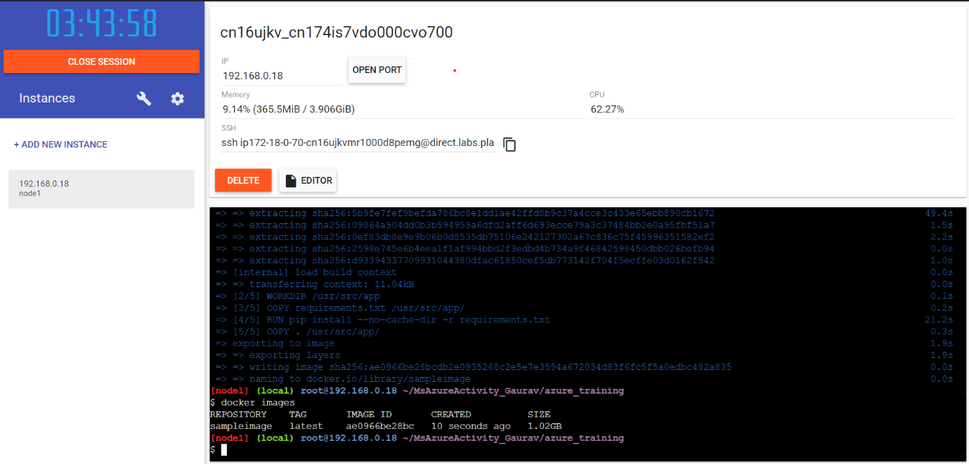

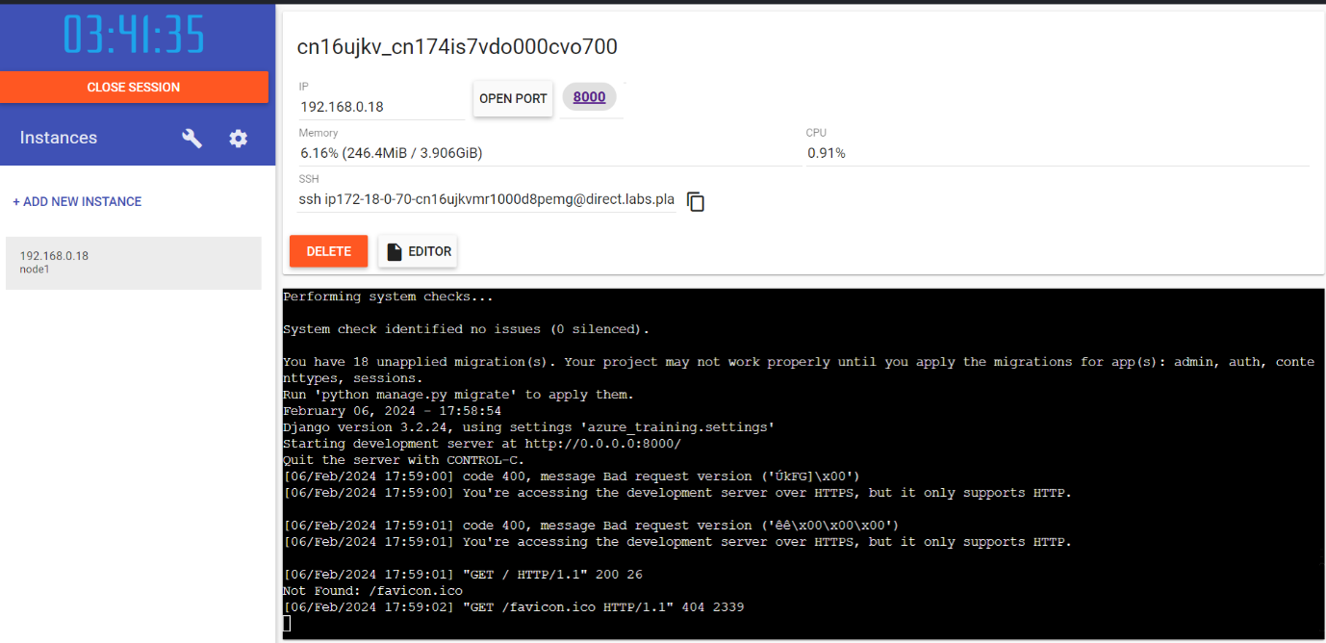

1. **Output**

