**SQL Project  
Submitted by – Gaurav Kulmethe**

**Module 1 :**

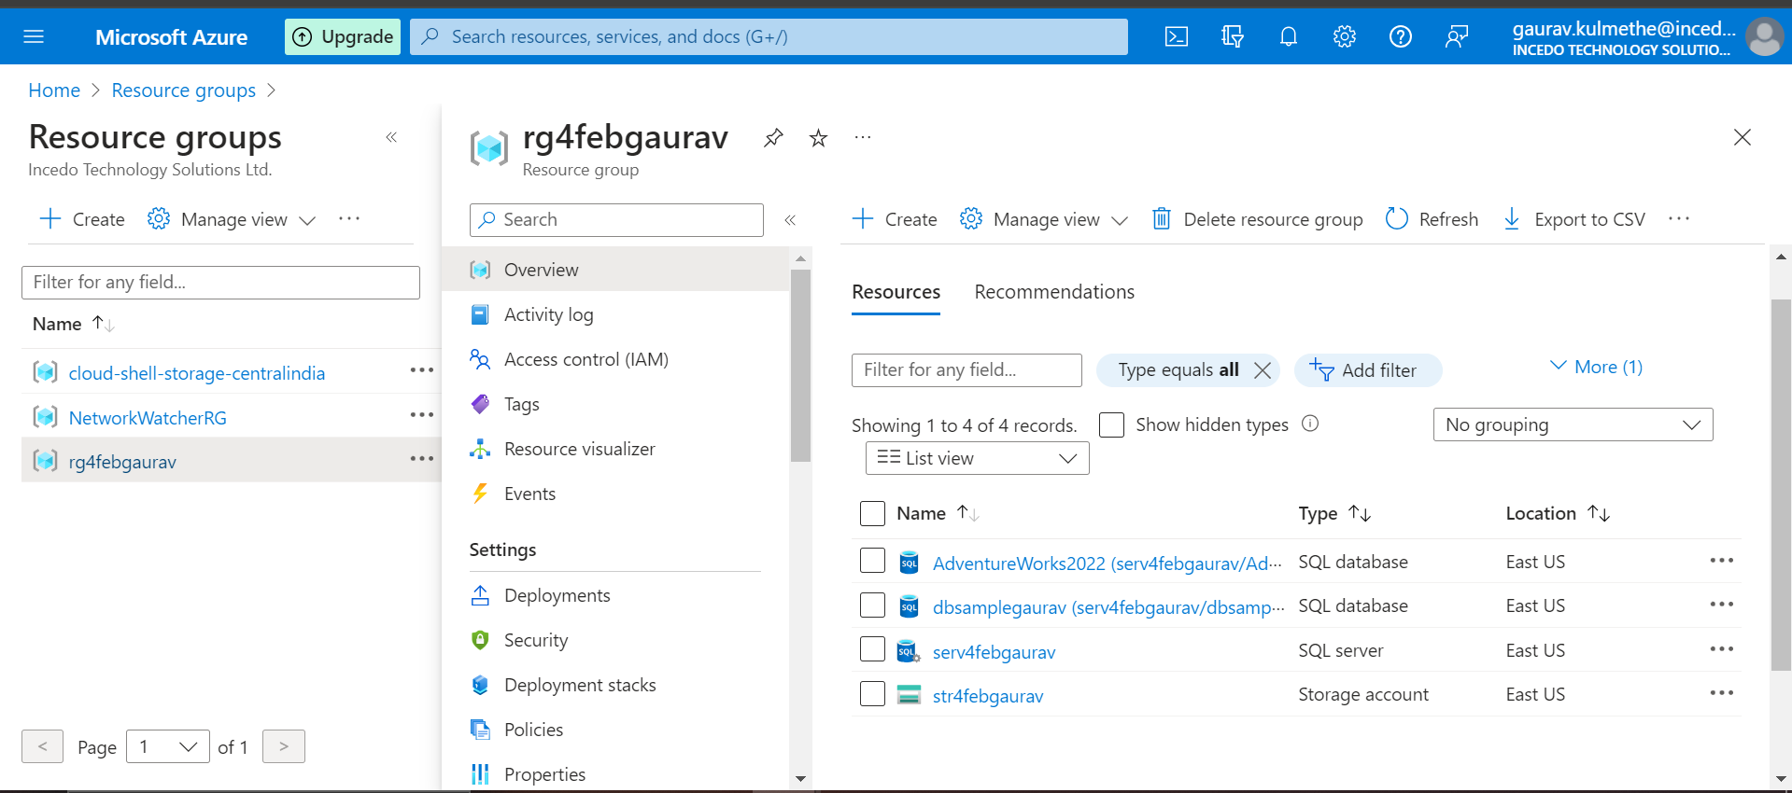

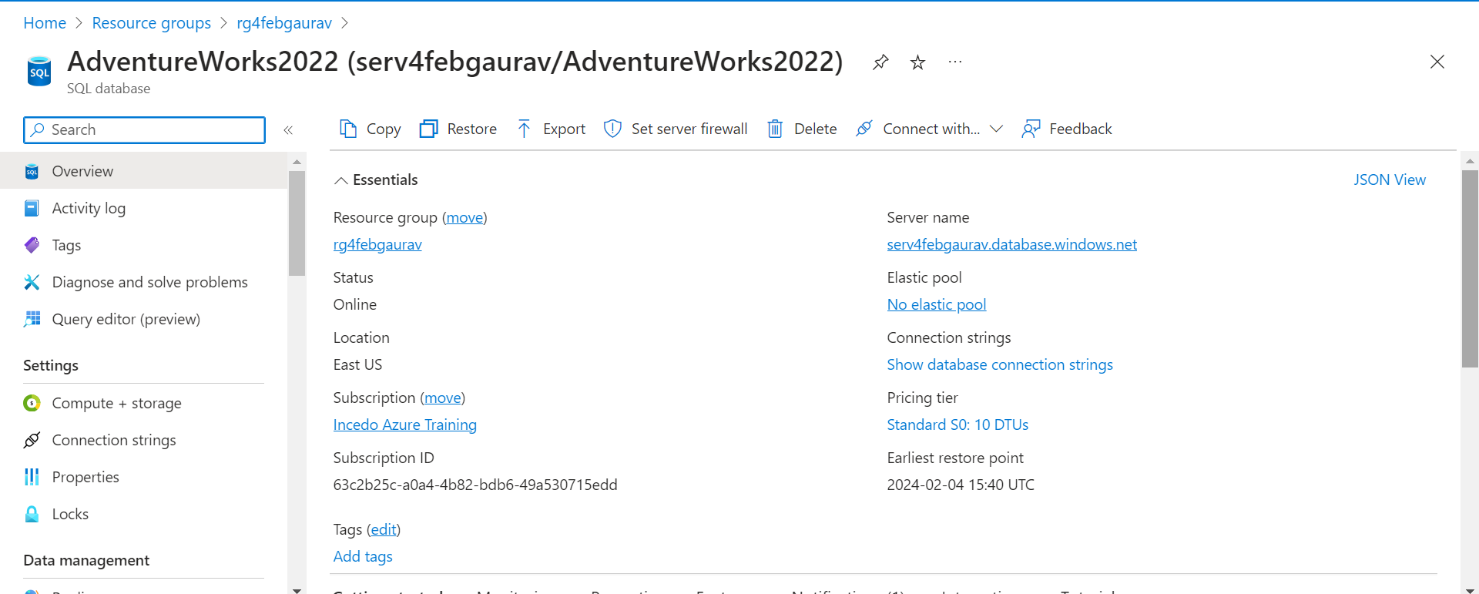

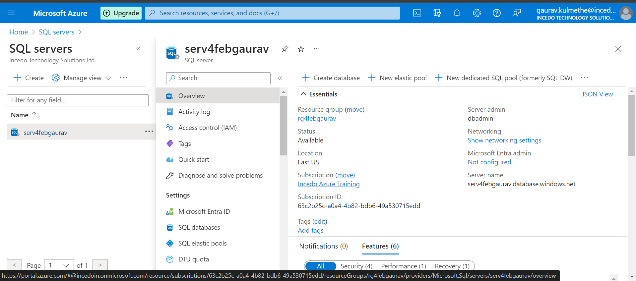

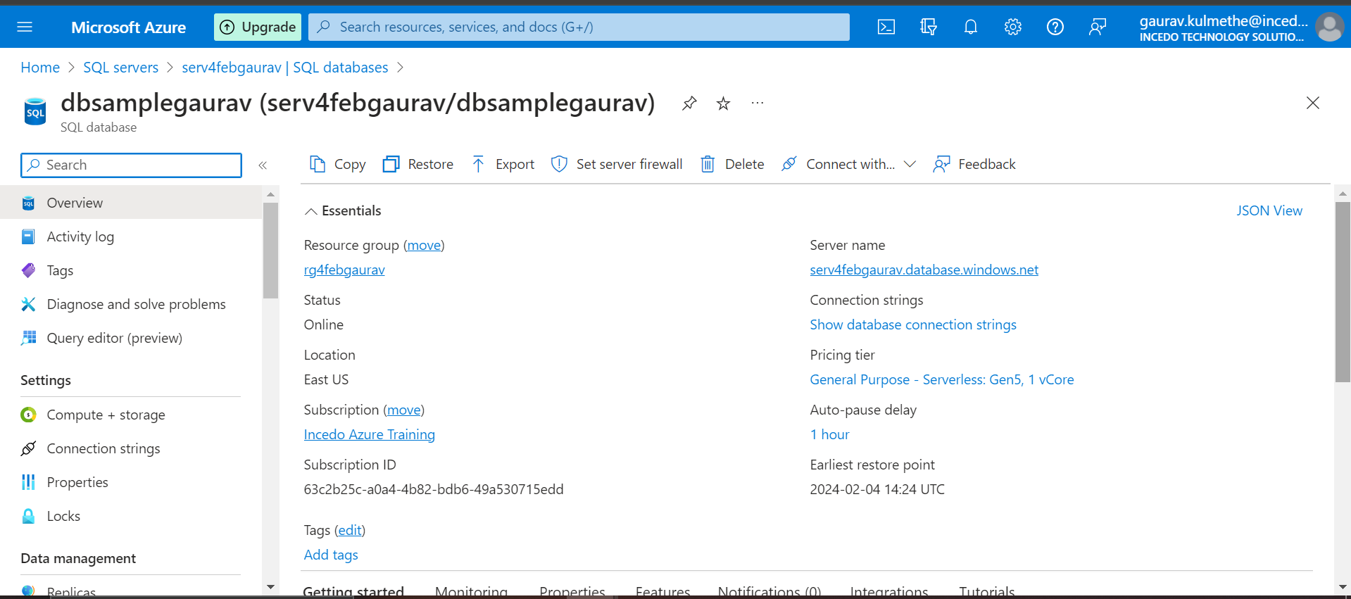

**Module 2: Perform T-SQL Operations on Restored Database (50 Marks)**

**Basic = 50 Marks Below are 30 scenario questions we have you need to select any 25 and solve them, that cover various advanced SQL concepts like joins, subqueries, unions, and more. make sure you have the database setup before attempting these queries.**

**Joins:**

1. **Retrieve a list of customers along with their total order amounts.**

SELECT

cust.CustomerID,

cust.FirstName,

cust.LastName,

SUM(ord.TotalDue) AS TotalOrderAmount

FROM

SalesLT.Customer cust

JOIN

SalesLT.SalesOrderHeader ord ON cust.CustomerID = ord.CustomerID

GROUP BY

cust.CustomerID, cust.FirstName, cust.LastName

ORDER BY

cust.CustomerID;

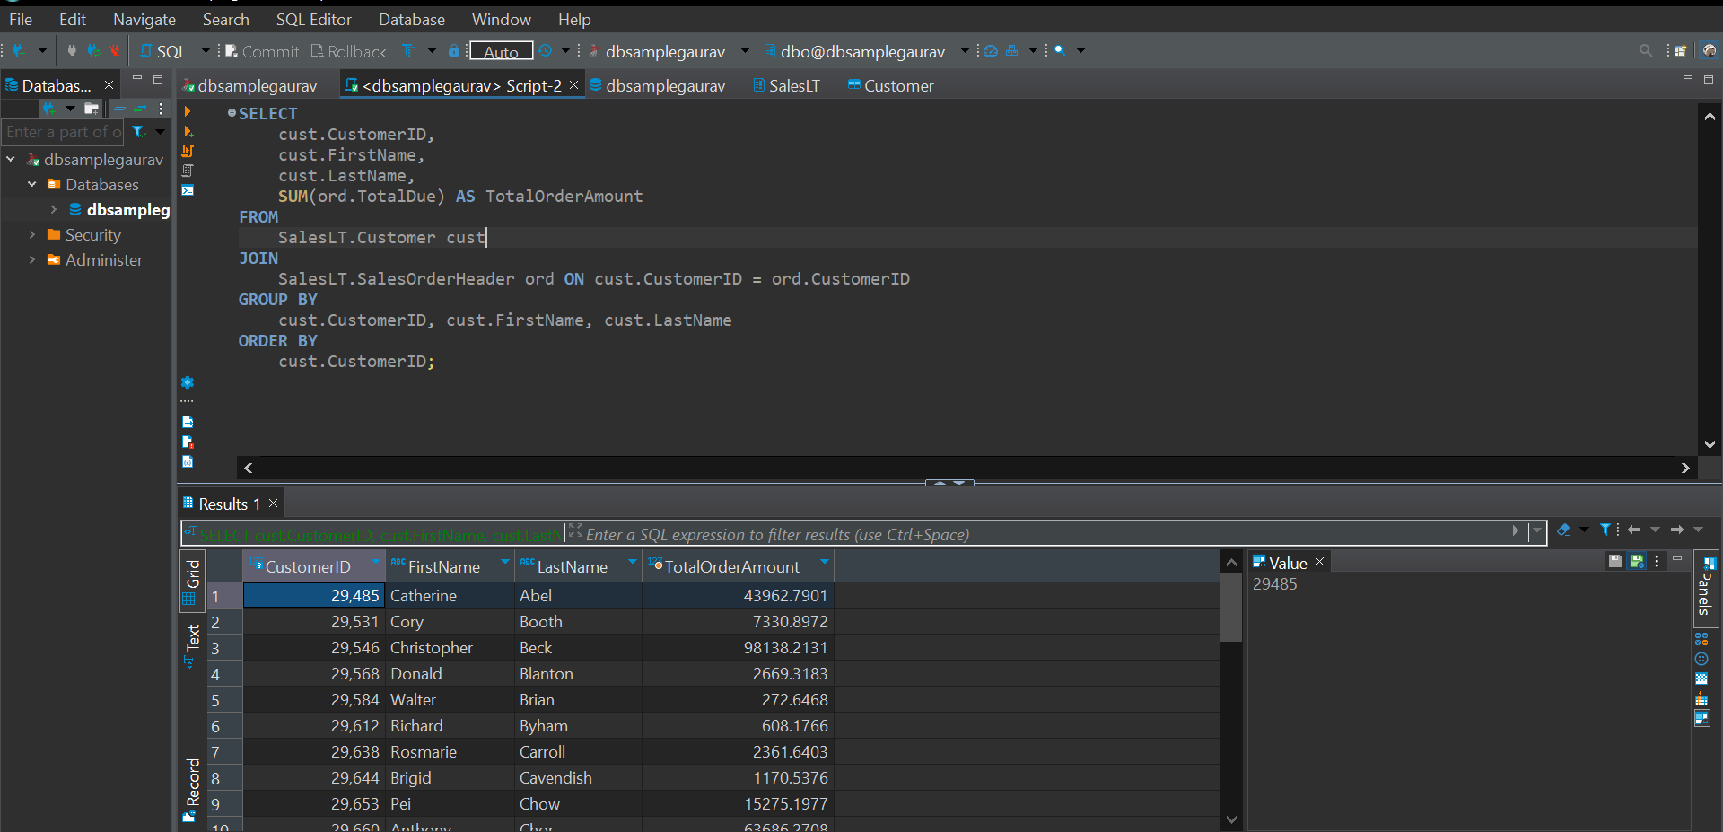

1. **Display product information along with the number of units sold for each product.**

SELECT

pro.ProductID,

pro.Name AS ProductName,

pro.ProductNumber,

pro.Color,

SUM(ordd.OrderQty) AS TotalUnitsSold

FROM

SalesLT.Product pro

JOIN

SalesLT.SalesOrderDetail ordd ON pro.ProductID = ordd.ProductID

JOIN

SalesLT.SalesOrderHeader soh ON ordd.SalesOrderID = soh.SalesOrderID

GROUP BY

pro.ProductID, pro.Name, pro.ProductNumber, pro.Color

ORDER BY

pro.ProductID;

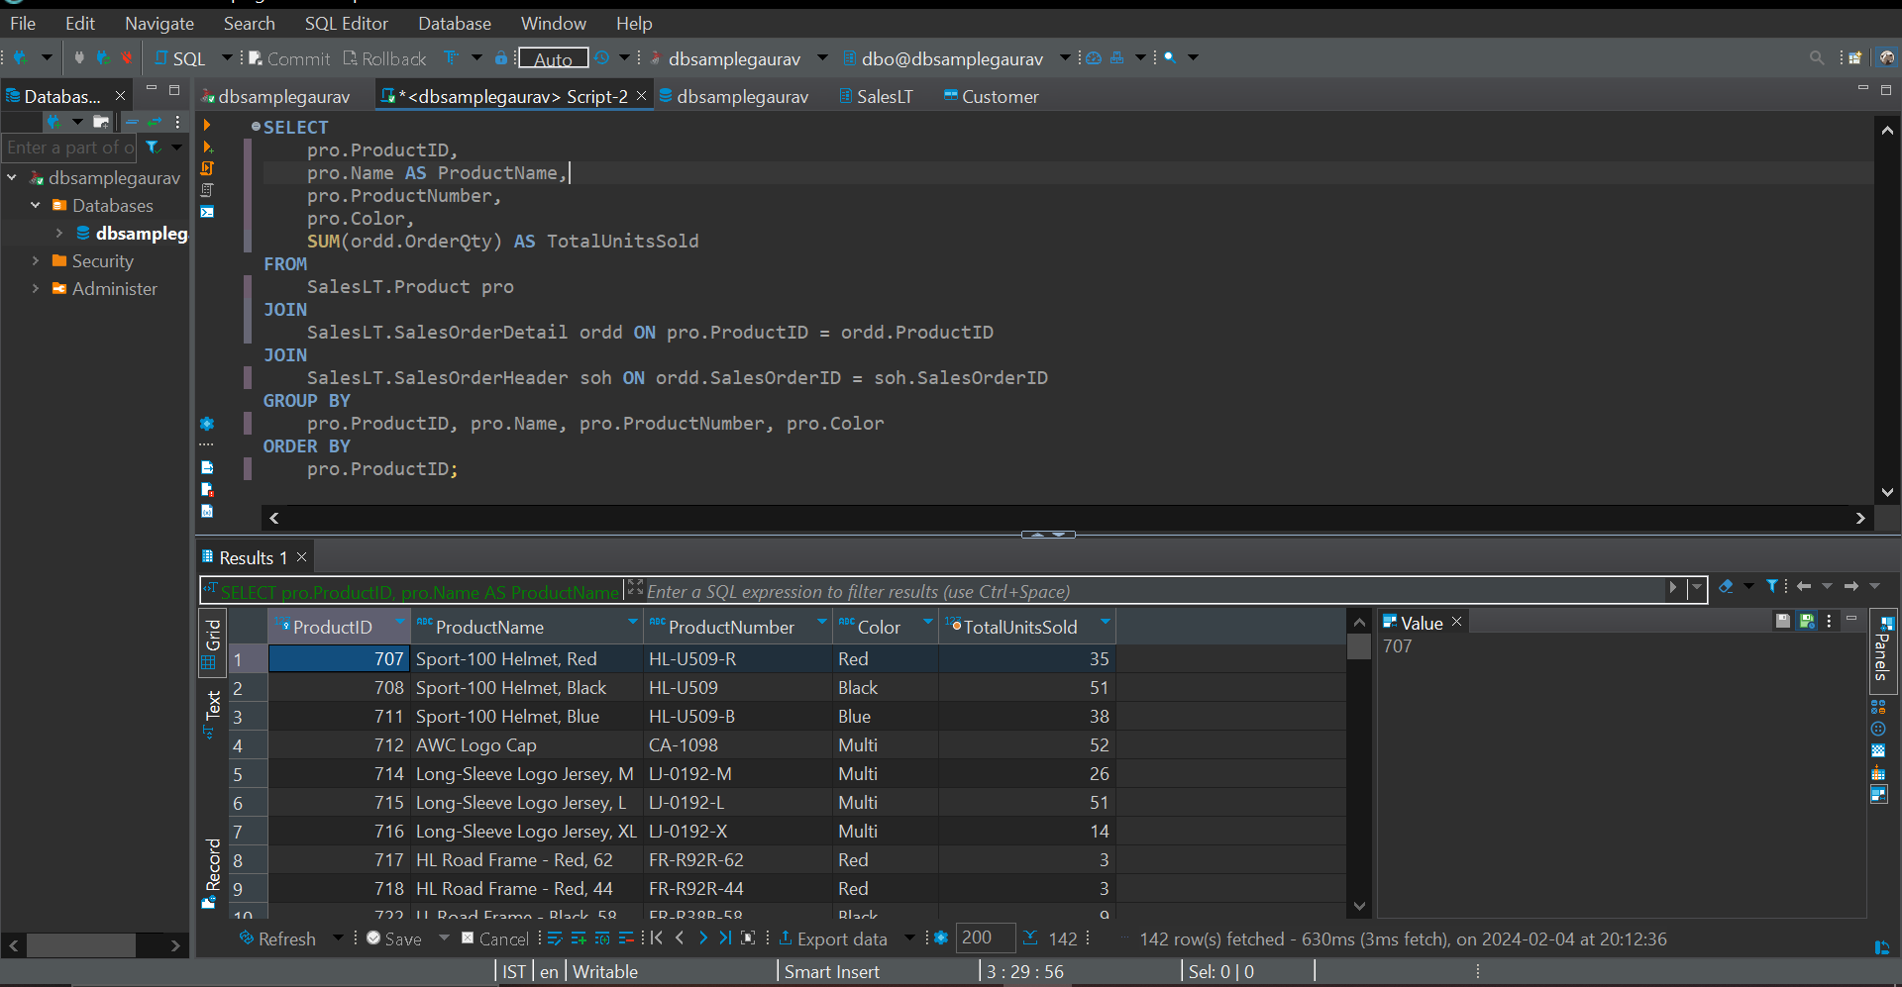

1. **Find employees who have the same manager**

Data not available

1. **List all customers who have never placed an order.**

SELECT  
    cust.CustomerID,  
    cust.FirstName,  
    cust.LastName  
FROM  
    SalesLT.Customer cust  
LEFT JOIN  
    SalesLT.SalesOrderHeader soh ON cust.CustomerID = soh.CustomerID  
WHERE  
    soh.CustomerID IS NULL;

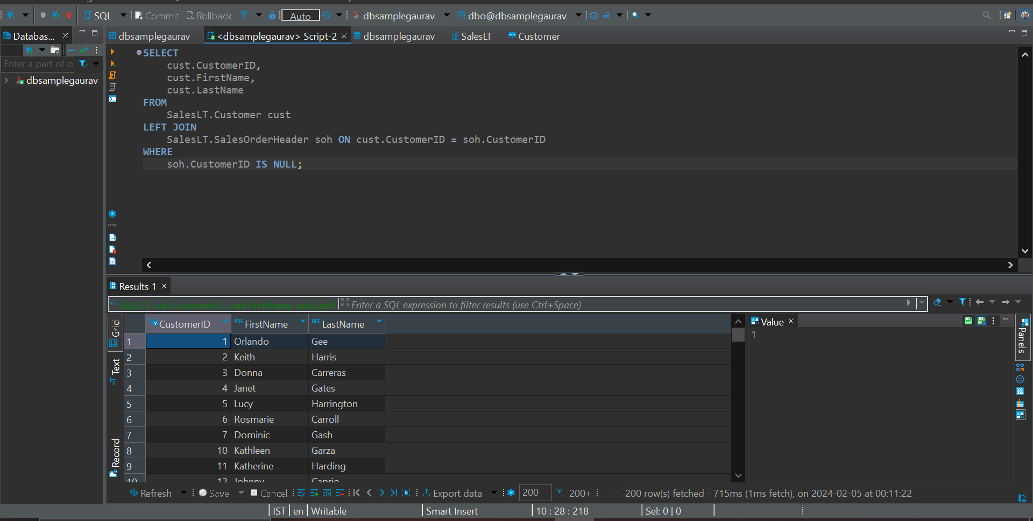

1. **Retrieve the total sales amount for each product category.**

SELECT  
    pc.ProductCategoryID,  
    pc.Name AS CategoryName,  
    SUM(ordd.OrderQty * ordd.UnitPrice) AS TotalSalesAmount  
FROM  
    SalesLT.ProductCategory pc  
JOIN  
    SalesLT.Product pro ON pc.ProductCategoryID = pro.ProductCategoryID  
JOIN  
    SalesLT.SalesOrderDetail ordd ON pro.ProductID = ordd.ProductID  
JOIN  
    SalesLT.SalesOrderHeader soh ON ordd.SalesOrderID = soh.SalesOrderID  
GROUP BY  
    pc.ProductCategoryID, pc.Name  
ORDER BY  
    pc.ProductCategoryID;

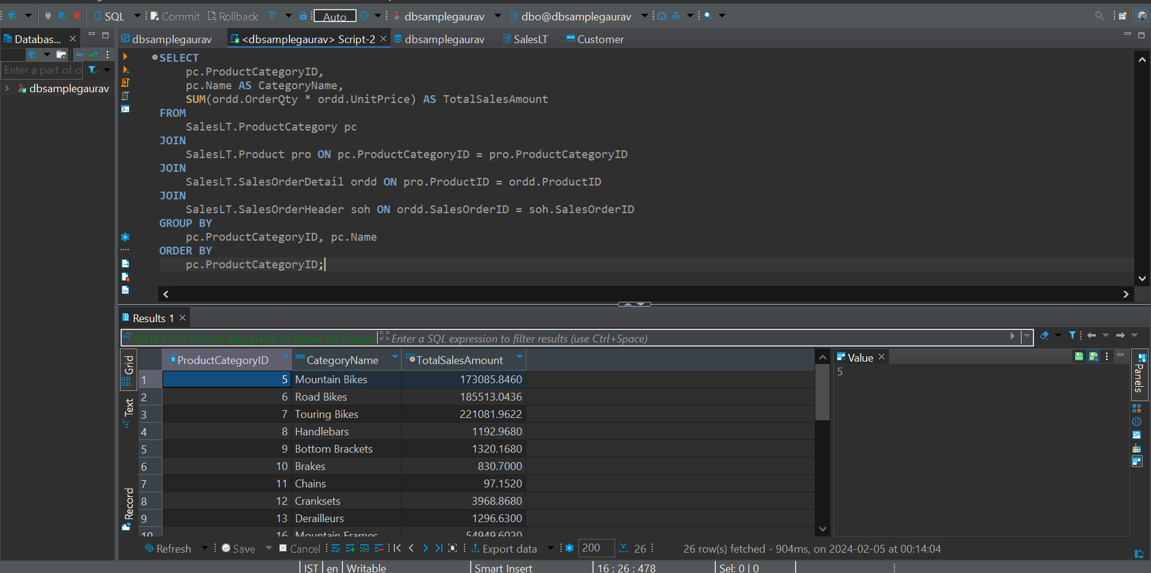

1. **Display the names of employees and their direct managers**

Data not available

1. **Show the order details with product names for a specific customer**

SELECT

soh.SalesOrderID,

ordd.ProductID,

pro.Name AS ProductName,

ordd.OrderQty,

ordd.UnitPrice,

ordd.LineTotal

FROM

SalesLT.Customer cust

JOIN

SalesLT.SalesOrderHeader soh ON cust.CustomerID = soh.CustomerID

JOIN

SalesLT.SalesOrderDetail ordd ON soh.SalesOrderID = ordd.SalesOrderID

JOIN

SalesLT.Product pro ON ordd.ProductID = pro.ProductID

WHERE

cust.CustomerID = 29485;

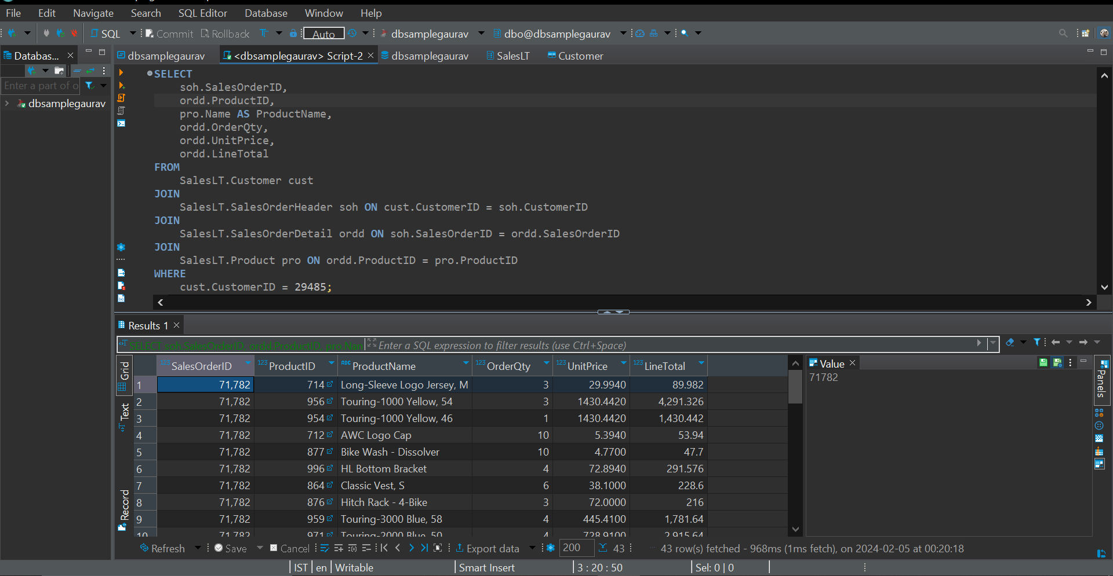

1. **List customers who have made purchases in the last 30 days.**

SELECT DISTINCT

cust.CustomerID,

cust.FirstName,

cust.LastName

FROM

SalesLT.Customer cust

JOIN

SalesLT.SalesOrderHeader soh ON cust.CustomerID = soh.CustomerID

WHERE

soh.OrderDate >= DATEADD(day, -30, GETDATE());

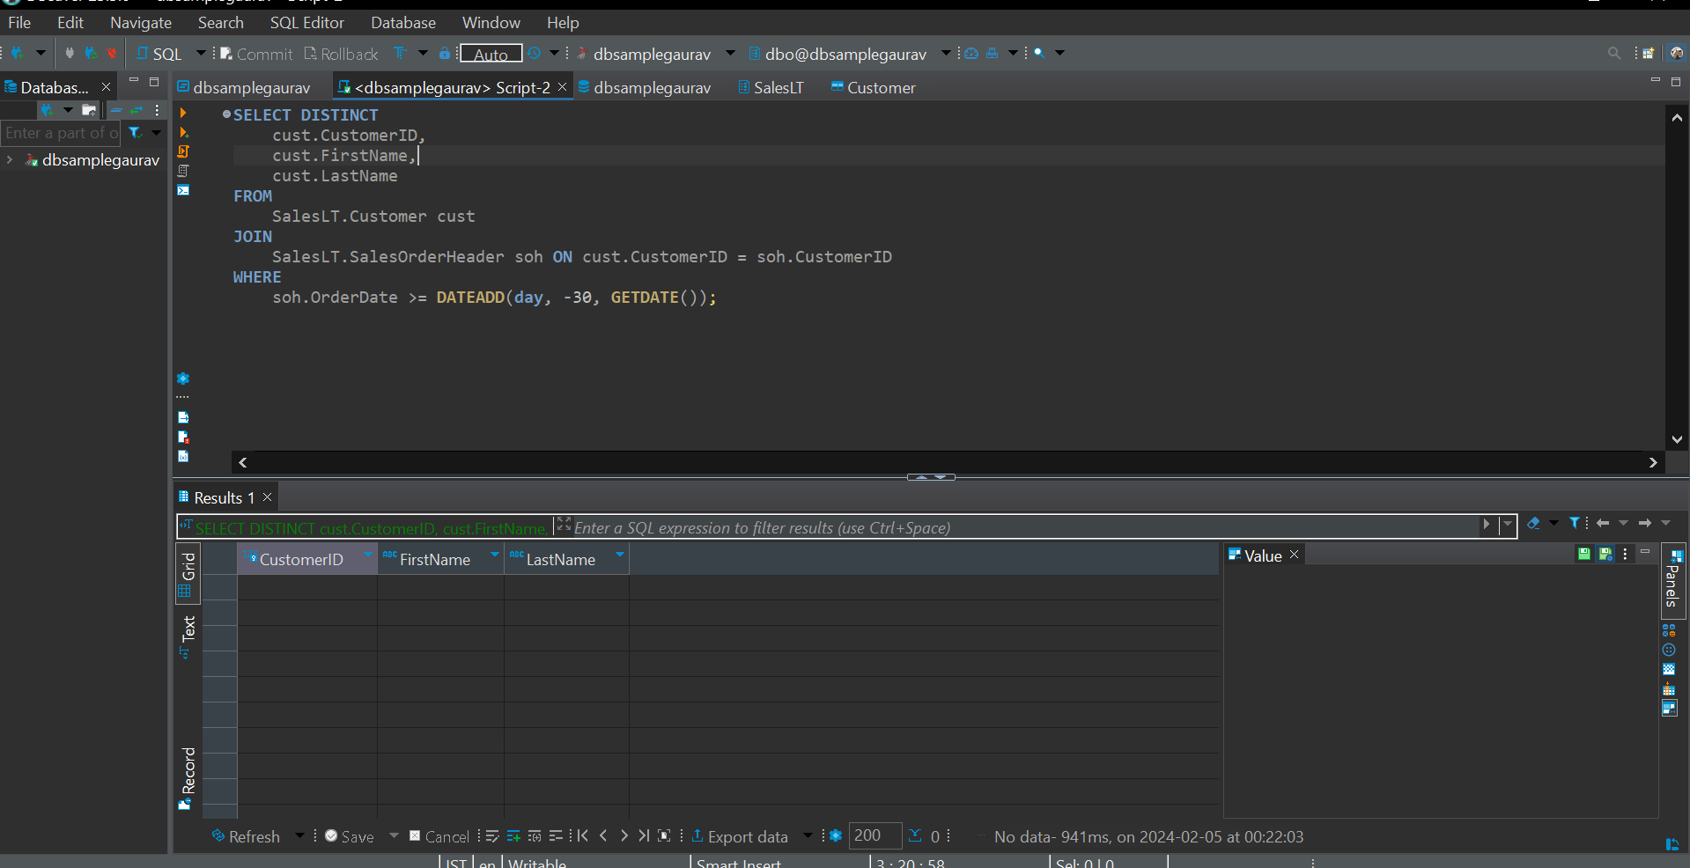

1. **Find employees who do not have any direct reports.**

Data Not available

1. **Retrieve all products along with their average selling prices.**

SELECT

pro.ProductID,

pro.Name AS ProductName,

AVG(ordd.UnitPrice) AS AverageSellingPrice

FROM

SalesLT.Product pro

JOIN

SalesLT.SalesOrderDetail ordd ON pro.ProductID = ordd.ProductID

GROUP BY

pro.ProductID, pro.Name

ORDER BY

pro.ProductID;

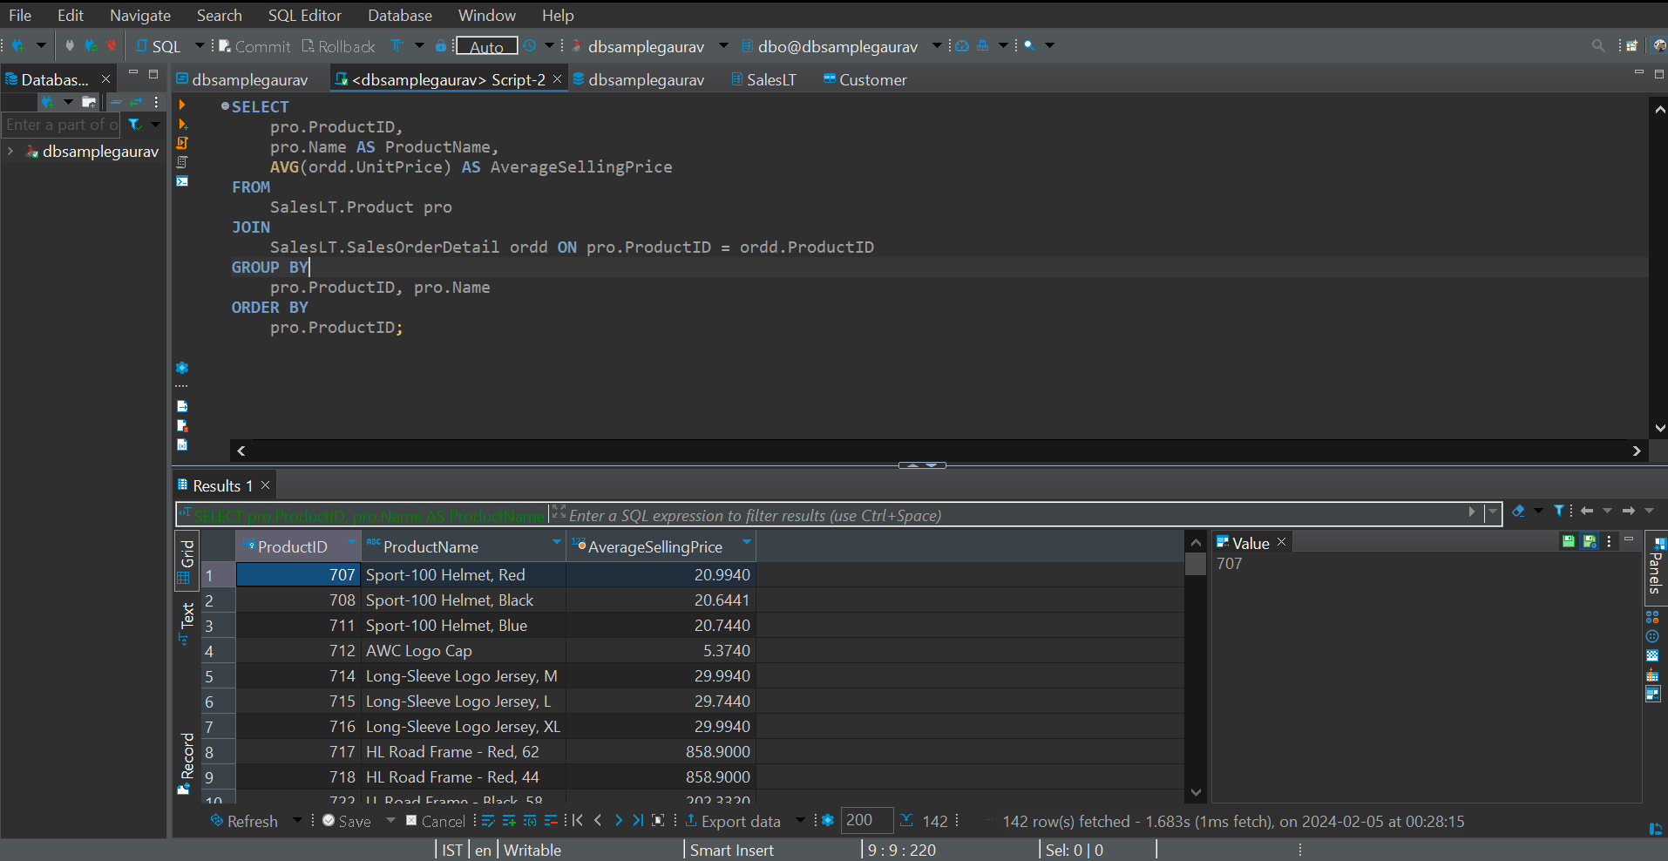

**Subqueries**

1. **Find the order with the highest total amount.**

SELECT TOP 1

soh.SalesOrderID,

soh.OrderDate,

SUM(ordd.LineTotal) AS TotalAmount

FROM

SalesLT.SalesOrderHeader soh

JOIN

SalesLT.SalesOrderDetail ordd ON soh.SalesOrderID = ordd.SalesOrderID

GROUP BY

soh.SalesOrderID, soh.OrderDate

ORDER BY

TotalAmount DESC;

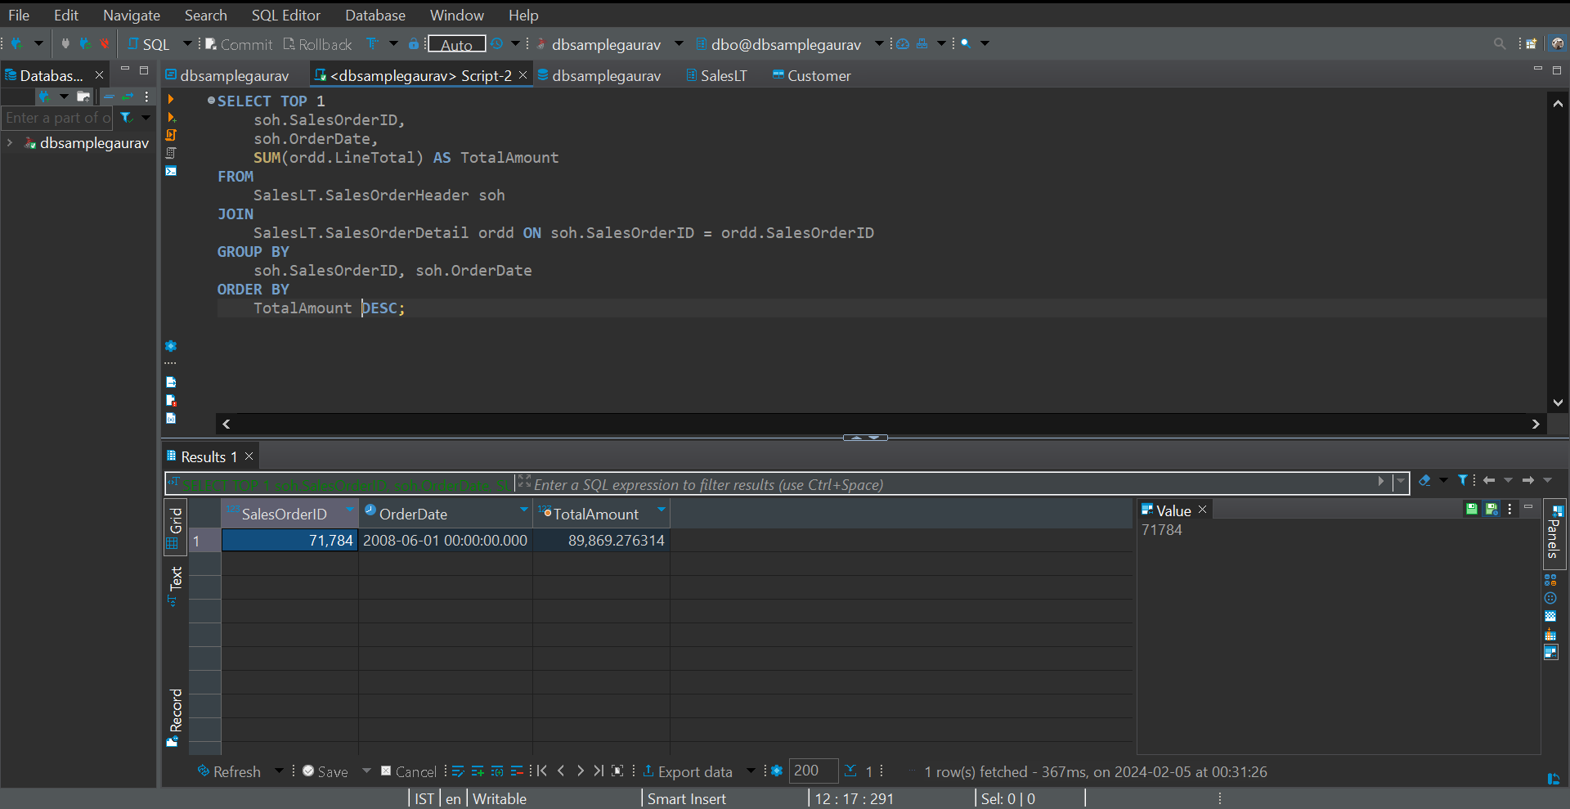

1. **Display customers who have placed orders with a total amount greater than the average.**

**SELECT**

cust.CustomerID,

cust.FirstName,

cust.LastName,

SUM(ordd.LineTotal) AS TotalAmount

FROM

SalesLT.Customer cust

JOIN

SalesLT.SalesOrderHeader soh ON cust.CustomerID = soh.CustomerID

JOIN

SalesLT.SalesOrderDetail ordd ON soh.SalesOrderID = ordd.SalesOrderID

GROUP BY

cust.CustomerID, cust.FirstName, cust.LastName

HAVING

SUM(ordd.LineTotal) > (SELECT AVG(TotalAmount) FROM (

SELECT

SUM(ordd.LineTotal) AS TotalAmount

FROM

SalesLT.Customer cust

JOIN

SalesLT.SalesOrderHeader soh ON cust.CustomerID = soh.CustomerID

JOIN

SalesLT.SalesOrderDetail ordd ON soh.SalesOrderID = ordd.SalesOrderID

GROUP BY

cust.CustomerID, cust.FirstName, cust.LastName

) AS AvgTotalAmount);

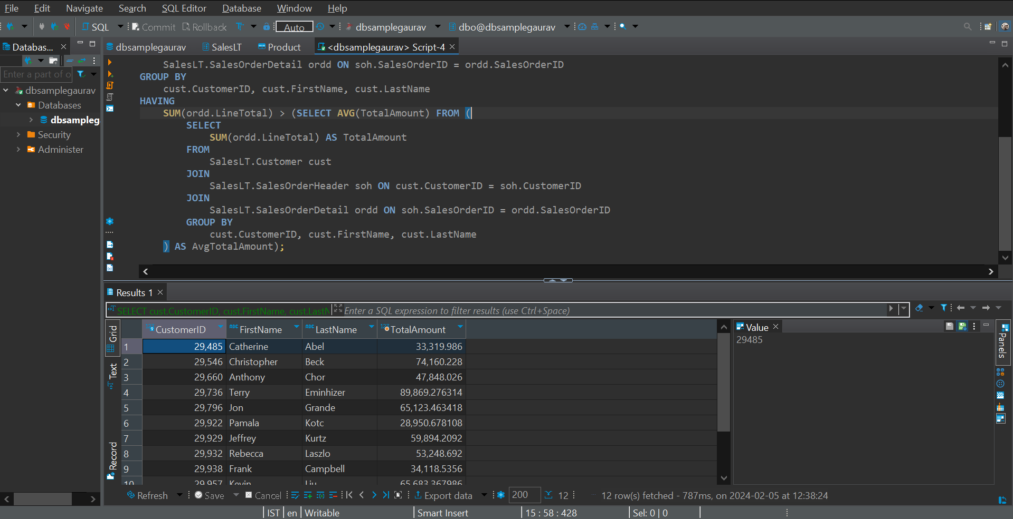

1. **.List products with prices higher than the average product price.**

SELECT

ProductID,

ProductName,

ListPrice

FROM

(

SELECT

ProductID,

Name AS ProductName,

ListPrice

FROM

SalesLT.Product

) AS ProductPrices

WHERE

ListPrice > (SELECT AVG(ListPrice) FROM SalesLT.Product);

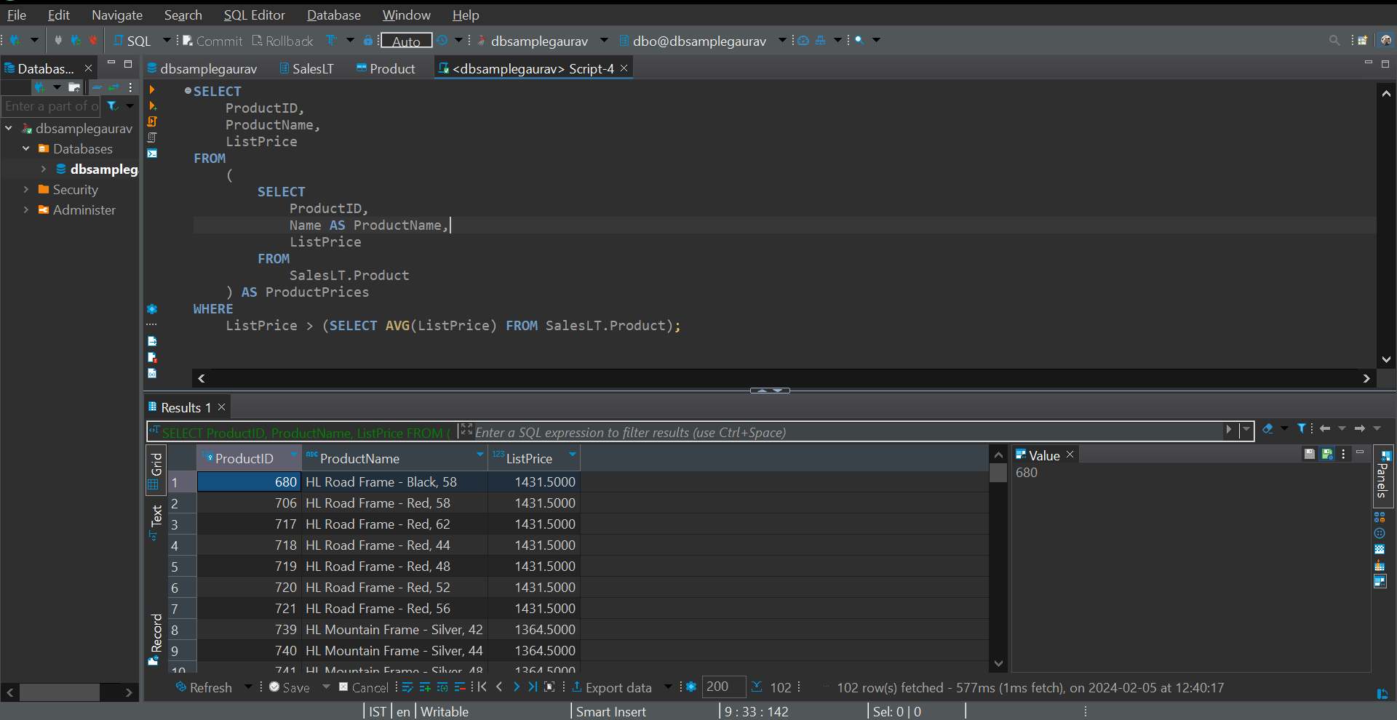

1. **Retrieve orders placed by employees who have a specific job title**

No data available

1. **Display customers who have placed orders for a specific product category.**

SELECT

cust.CustomerID,

cust.FirstName,

cust.LastName

FROM

SalesLT.Customer cust

JOIN

SalesLT.SalesOrderHeader soh ON cust.CustomerID = soh.CustomerID

JOIN

SalesLT.SalesOrderDetail ordd ON soh.SalesOrderID = ordd.SalesOrderID

JOIN

SalesLT.Product pro ON ordd.ProductID = pro.ProductID

JOIN

SalesLT.ProductCategory pc ON pro.ProductCategoryID = pc.ProductCategoryID

WHERE

pc.ProductCategoryID = 22;

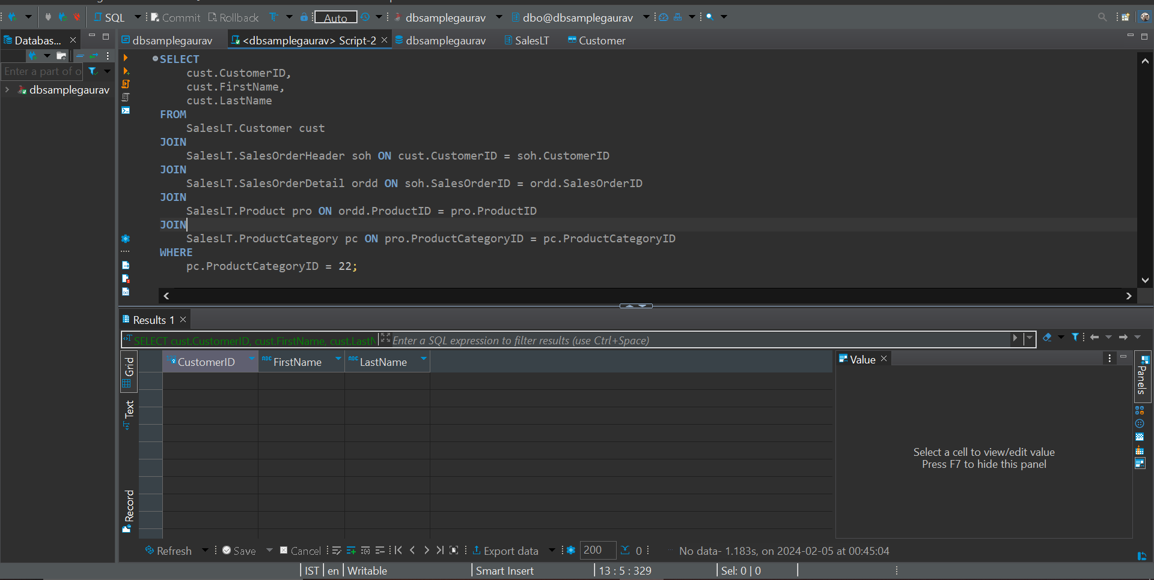

1. **Find employees with salaries greater than the average salary in their department.**

Data Not available

1. **List customers who have placed orders before a specific date.**

Not enough data

SELECT DISTINCT

cust.CustomerID,

cust.FirstName,

cust.LastName

FROM

SalesLT.Customer cust

JOIN

SalesLT.SalesOrderHeader soh ON cust.CustomerID = soh.CustomerID

WHERE

soh.OrderDate < 2008-07-02;

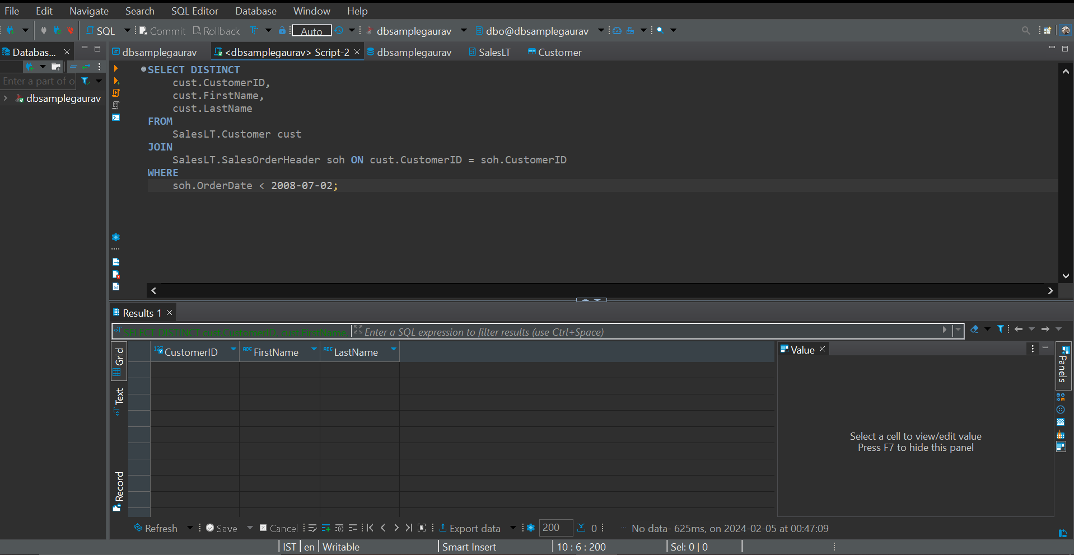

1. **Retrieve the order with the highest quantity of a specific product.**

SELECT TOP 1

ordd.SalesOrderID,

ordd.ProductID,

pro.Name AS ProductName,

SUM(ordd.OrderQty) AS TotalQuantity

FROM

SalesLT.SalesOrderDetail ordd

JOIN

SalesLT.Product pro ON ordd.ProductID = pro.ProductID

WHERE

ordd.ProductID = 714

GROUP BY

ordd.SalesOrderID, ordd.ProductID, pro.Name

ORDER BY

TotalQuantity DESC;

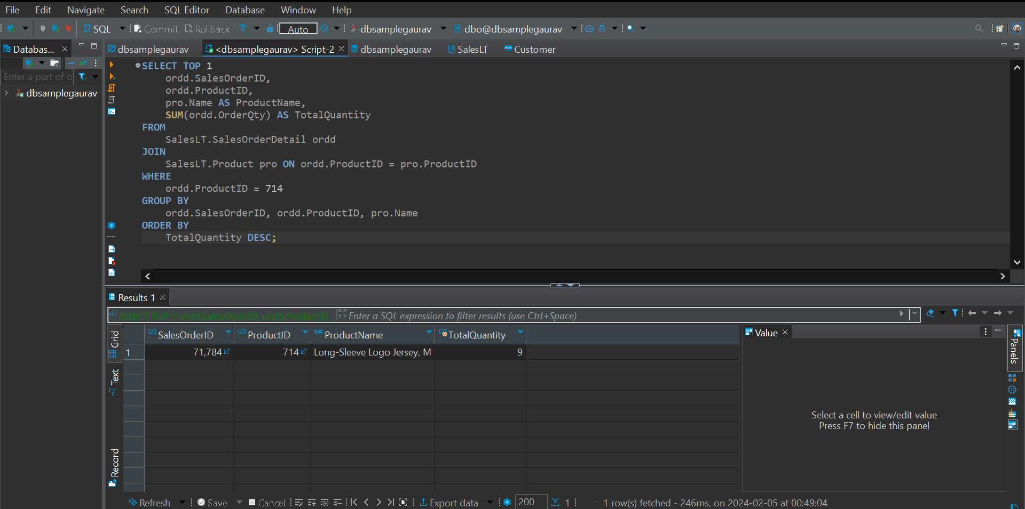

1. **Display products with prices lower than the lowest product price in a specific category**

SELECT

ProductID,

ProductName,

ListPrice

FROM (

SELECT

pro.ProductID,

pro.Name AS ProductName,

pro.ListPrice

FROM

SalesLT.Product pro

JOIN

SalesLT.ProductCategory pc ON pro.ProductCategoryID = pc.ProductCategoryID

WHERE

pc.ProductCategoryID = 11

) AS ProductPrices

WHERE

ListPrice < (SELECT MIN(ListPrice) FROM (

SELECT

pro.ListPrice

FROM

SalesLT.Product pro

JOIN

SalesLT.ProductCategory pc ON pro.ProductCategoryID = pc.ProductCategoryID

WHERE

pc.ProductCategoryID = 11

) AS MinPrice);

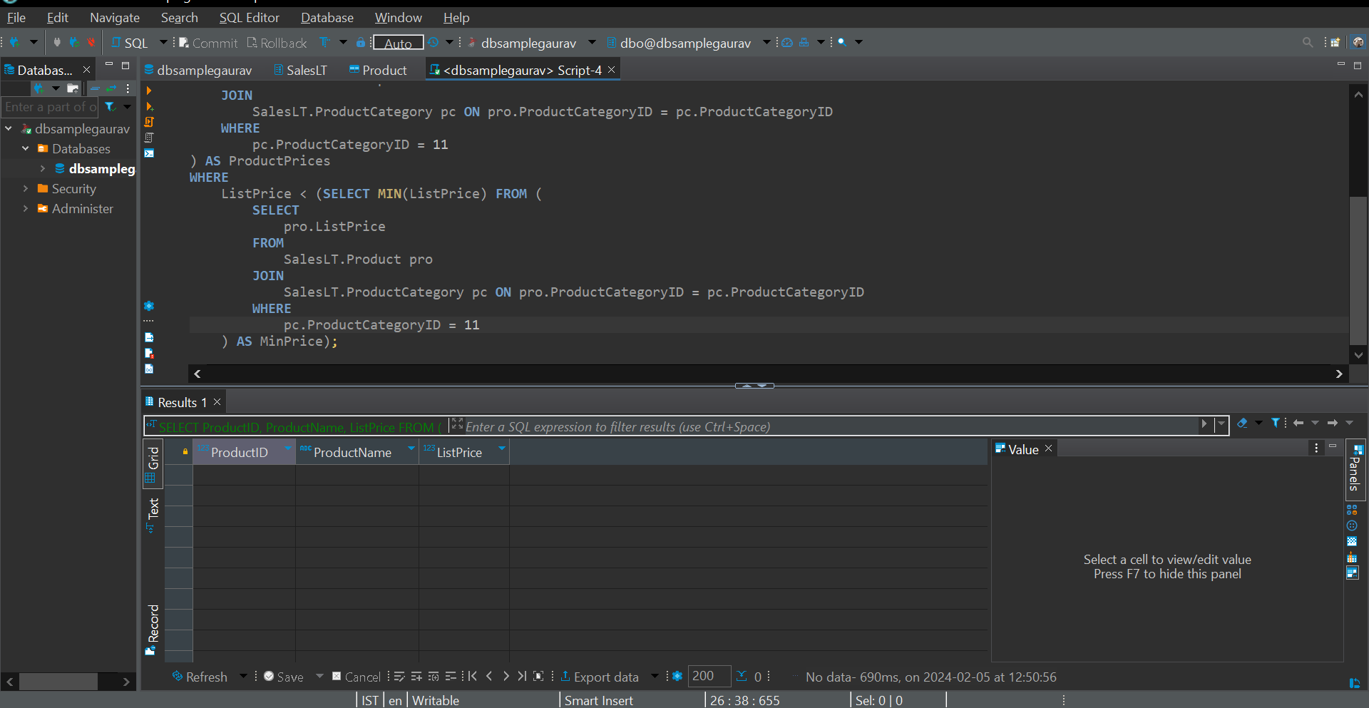

1. **Find employees who have the same job title as their manager.**

Data not available

1. **Combine results from two queries to get a list of unique customer and employee names.**

Data Not Available

1. **Retrieve product names that are common in two different product categories.**

Not enough data

SELECT  
    pro.Name AS ProductName  
FROM  
    SalesLT.Product pro  
JOIN  
    SalesLT.ProductCategory pc1 ON pro.ProductCategoryID = pc1.ProductCategoryID  
JOIN  
    SalesLT.ProductCategory pc2 ON pro.ProductCategoryID = pc2.ProductCategoryID  
WHERE  
    pc1.ProductCategoryID <> pc2.ProductCategoryID;

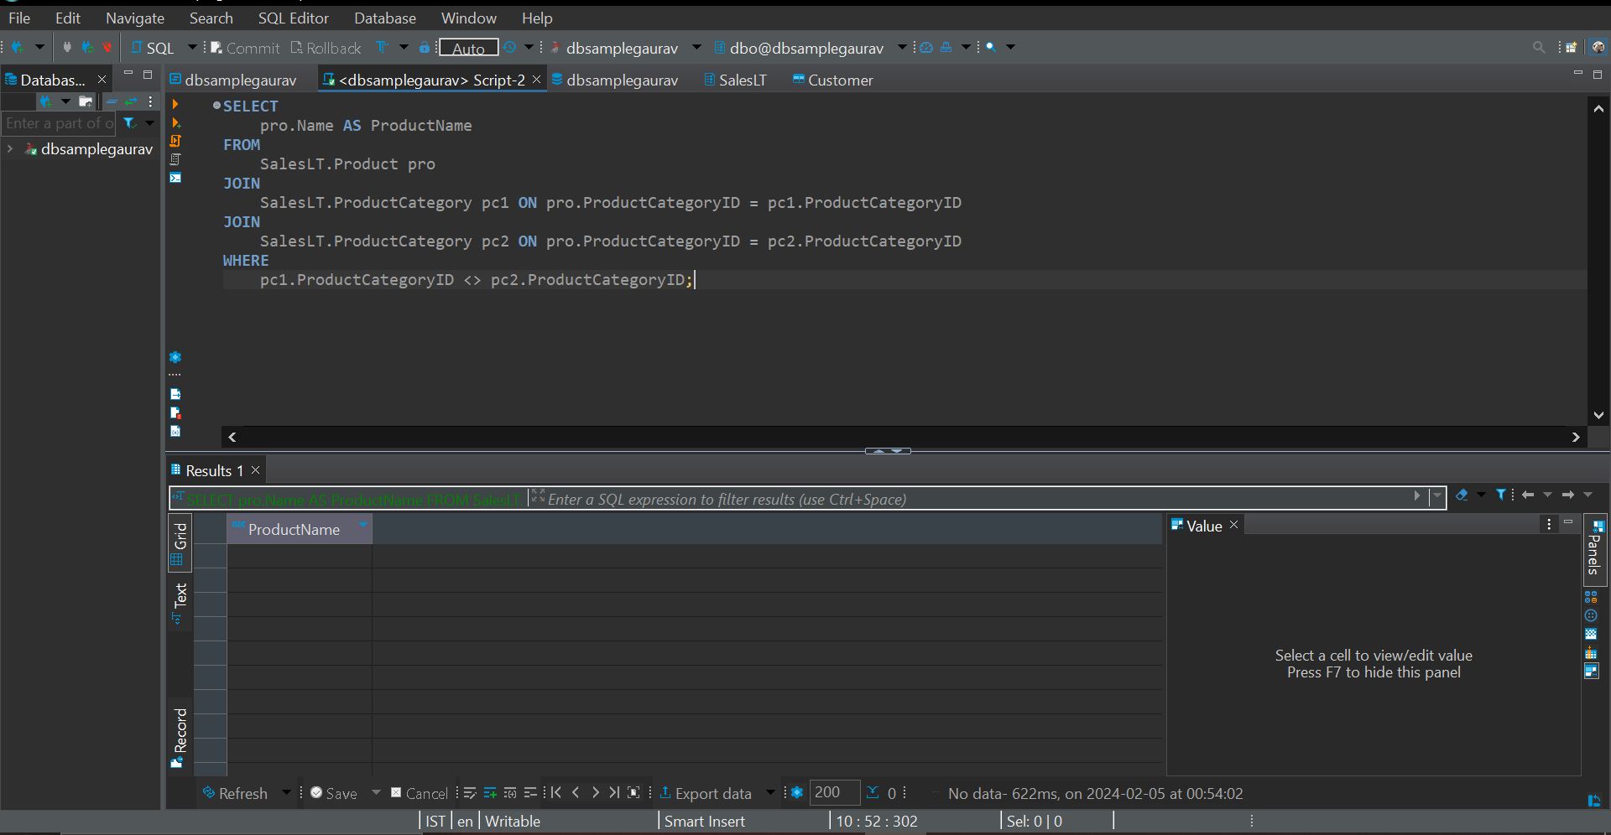

1. **Display the names of employees and customers in a single result set**

Data insufficient

1. **List products that are in stock or have been discontinued.**

Data insufficient

1. **Combine the results of two queries to find unique products ordered by a specific customer.**

SELECT DISTINCT

pro.ProductID,

pro.Name AS ProductName

FROM

SalesLT.Product pro

JOIN

SalesLT.SalesOrderDetail ordd ON pro.ProductID = ordd.ProductID

JOIN

SalesLT.SalesOrderHeader soh ON ordd.SalesOrderID = soh.SalesOrderID

WHERE

soh.CustomerID = 29485

UNION

SELECT DISTINCT

pro.ProductID,

pro.Name AS ProductName

FROM

SalesLT.Product pro

JOIN

SalesLT.SalesOrderDetail ordd ON pro.ProductID = ordd.ProductID

ORDER BY

ProductID;

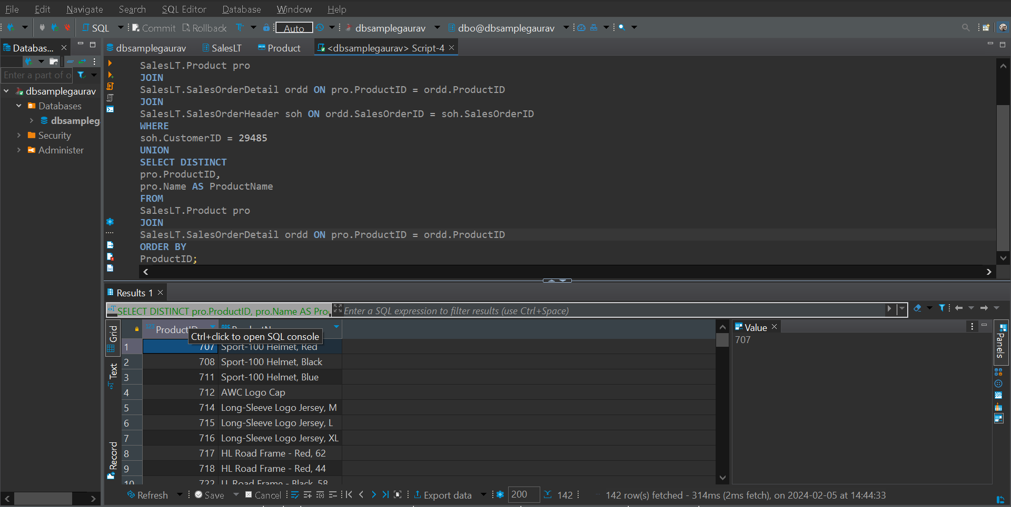

1. **Retrieve orders placed by customers and employees in a single result set**

Data not available

1. **Display products that are either in a specific category or have a specific safety stock level.**

Data Not Available

1. **List customers who have placed orders and employees who have direct reports in a single result set.**

Data Not Available

1. .**Retrieve products that are in stock in one location and out of stock in another.**

Data Not Available

1. **Combine information about employees who are managers and employees who have managers**

Data Not available

**Joins:**

1. **Retrieve a list of customers along with the names of the products they have purchased.**

SELECT

cust.CustomerID,

cust.FirstName,

cust.LastName,

pro.Name AS ProductName

FROM

SalesLT.Customer cust

JOIN

SalesLT.SalesOrderHeader soh ON cust.CustomerID = soh.CustomerID

JOIN

SalesLT.SalesOrderDetail ordd ON sroh.SalesOrderID = ordd.SalesOrderID

JOIN

SalesLT.Product pro ON ordd.ProductID = pro.ProductID

ORDER BY

cust.CustomerID, pro.ProductID;

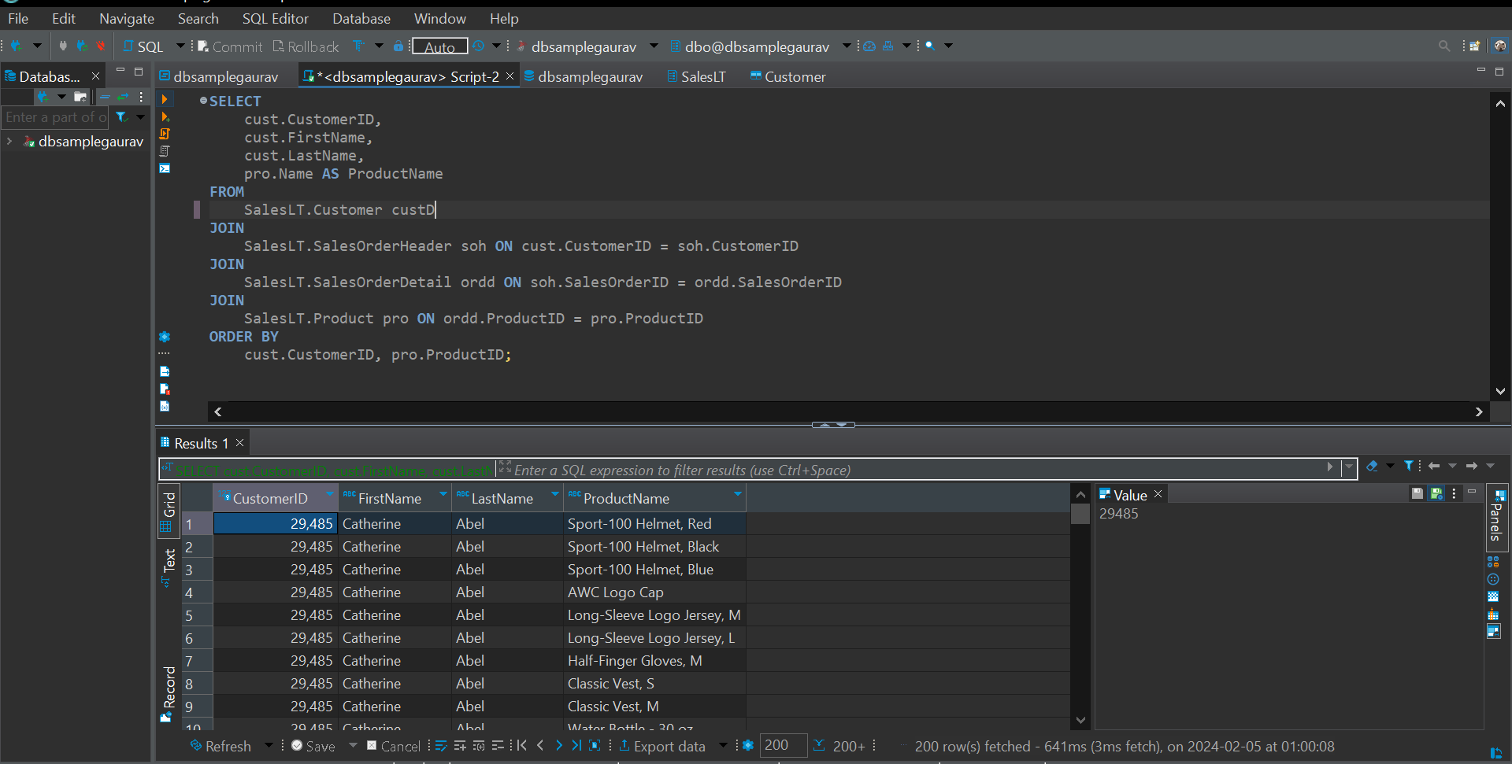

1. **Display employees who have the same manager, including indirect reports.**

Data not available

1. .**Find orders with multiple products and display the product names.**

SELECT

soh.SalesOrderID,

COUNT(DISTINCT ordd.ProductID) AS NumberOfProducts,

STRING_AGG(pro.Name, ', ') AS ProductNames

FROM

SalesLT.SalesOrderHeader soh

JOIN

SalesLT.SalesOrderDetail ordd ON soh.SalesOrderID = ordd.SalesOrderID

JOIN

SalesLT.Product pro ON ordd.ProductID = pro.ProductID

GROUP BY

soh.SalesOrderID

HAVING

COUNT(DISTINCT ordd.ProductID) > 1;

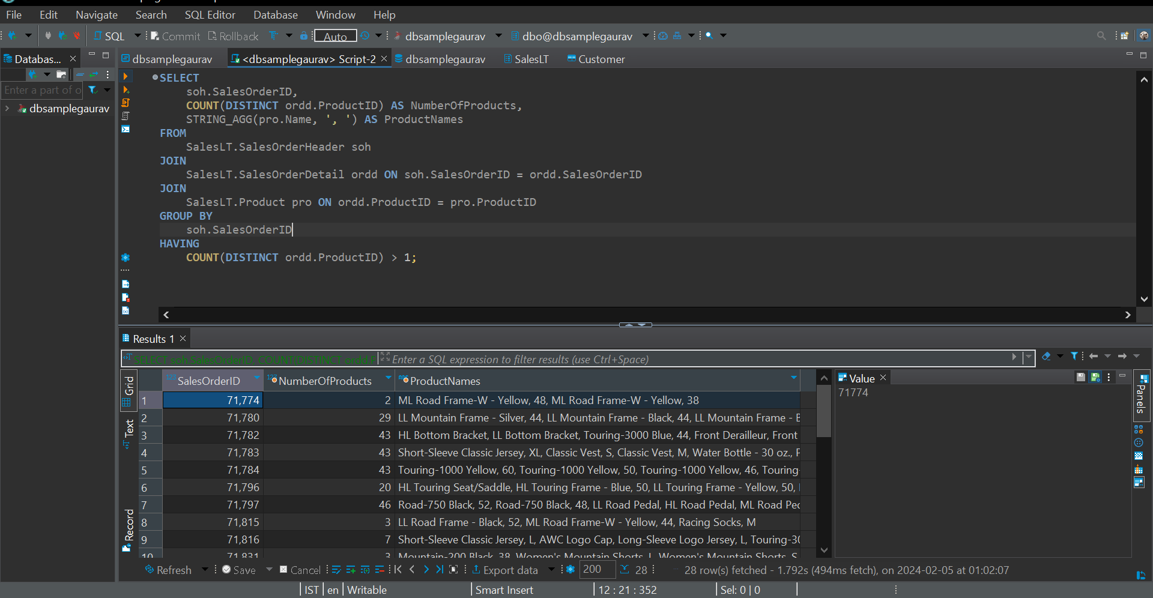

1. **.List customers along with the names of the salespeople who handled their orders.**

Data not available

1. **Retrieve a list of products along with the names of suppliers**.

Data Not available

1. **Display customers who have placed orders and the products they have purchased, including product details**.

SELECT

cust.CustomerID,

cust.FirstName,

cust.LastName,

soh.SalesOrderID,

pro.ProductID,

pro.Name AS ProductName,

ordd.OrderQty,

ordd.UnitPrice

FROM

SalesLT.Customer cust

JOIN

SalesLT.SalesOrderHeader soh ON cust.CustomerID = soh.CustomerID

JOIN

SalesLT.SalesOrderDetail ordd ON soh.SalesOrderID = ordd.SalesOrderID

JOIN

SalesLT.Product pro ON ordd.ProductID = pro.ProductID

ORDER BY

cust.CustomerID, soh.SalesOrderID, pro.ProductID;

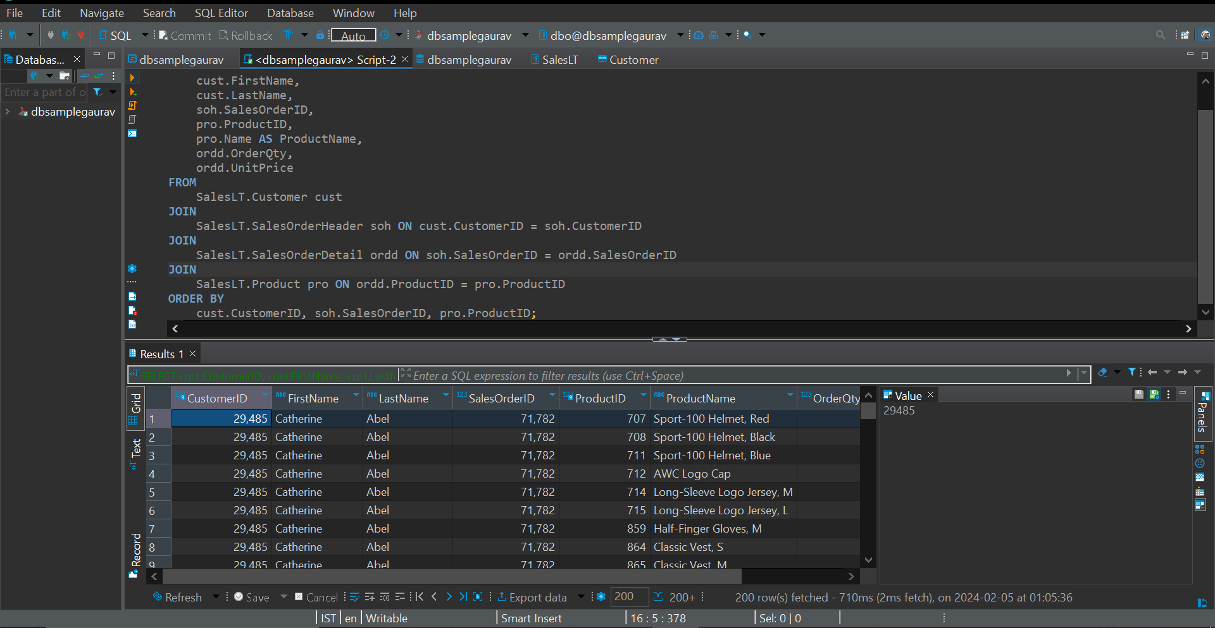

1. **Find orders where multiple employees were involved, showing the employee names**

Data Not Available

1. **List products that have similar names but belong to different categories**.

Not Enough data

1. .**Retrieve a list of employees along with their training courses and training dates**

Data not available

1. **Display customers who have placed orders and the total quantity of each product ordered.**

SELECT

cust.CustomerID,

cust.FirstName,

cust.LastName,

pro.ProductID,

pro.Name AS ProductName,

SUM(ordd.OrderQty) AS TotalQuantity

FROM

SalesLT.Customer cust

JOIN

SalesLT.SalesOrderHeader soh ON cust.CustomerID = soh.CustomerID

JOIN

SalesLT.SalesOrderDetail ordd ON soh.SalesOrderID = ordd.SalesOrderID

JOIN

SalesLT.Product pro ON ordd.ProductID = pro.ProductID

GROUP BY

cust.CustomerID, cust.FirstName, cust.LastName, pro.ProductID, pro.Name

ORDER BY

cust.CustomerID, pro.ProductID;

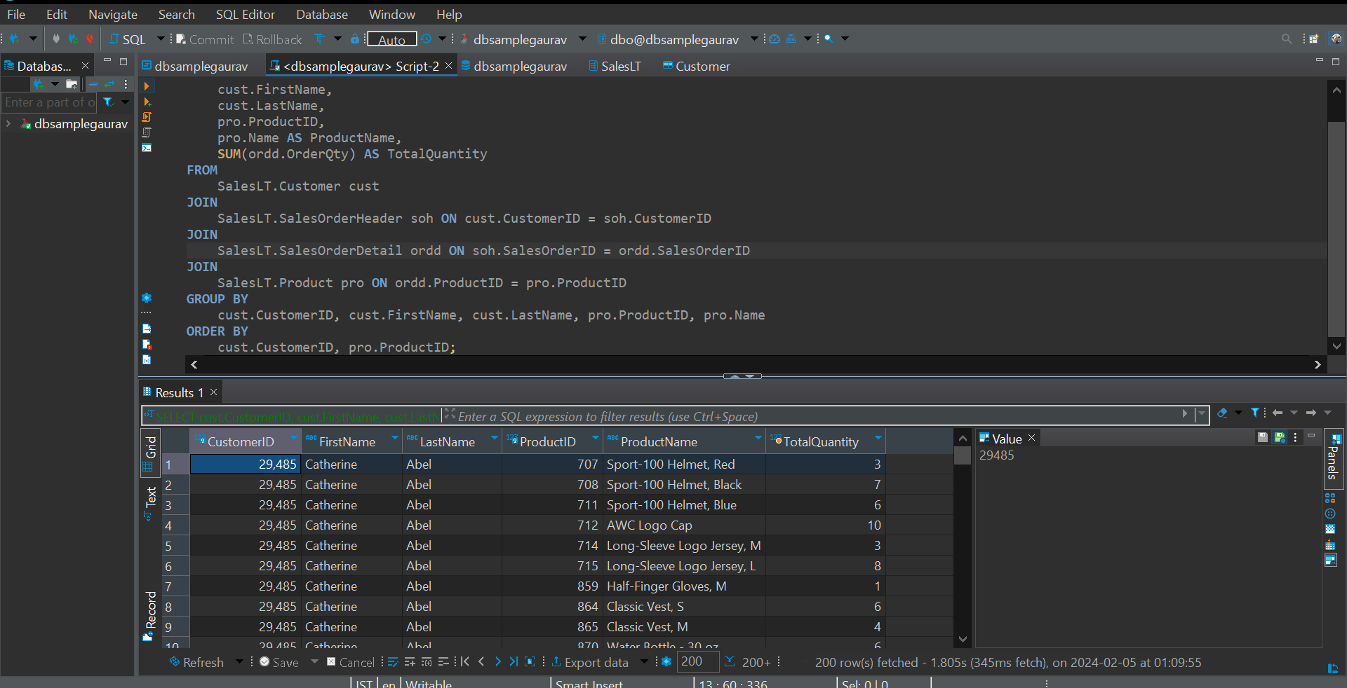

1. **Find customers who have made more purchases than the average number of purchases**

SELECT

cust.CustomerID,

cust.FirstName,

cust.LastName,

cust.EmailAddress,

cust.Phone,

cust.CompanyName

FROM

SalesLT.Customer cust

JOIN (

SELECT

soh.CustomerID,

COUNT(DISTINCT soh.SalesOrderID) AS PurchaseCount

FROM

SalesLT.SalesOrderHeader soh

JOIN

SalesLT.SalesOrderDetail ordd ON soh.SalesOrderID = ordd.SalesOrderID

GROUP BY

soh.CustomerID

) AS CustomerPurchaseCounts ON cust.CustomerID = CustomerPurchaseCounts.CustomerID

WHERE

CustomerPurchaseCounts.PurchaseCount > (

SELECT AVG(PurchaseCount)

FROM (

SELECT

COUNT(DISTINCT soh.SalesOrderID) AS PurchaseCount

FROM

SalesLT.SalesOrderHeader soh

JOIN

SalesLT.SalesOrderDetail ordd ON soh.SalesOrderID = ordd.SalesOrderID

GROUP BY

soh.CustomerID

) AS AvgPurchaseCounts

);

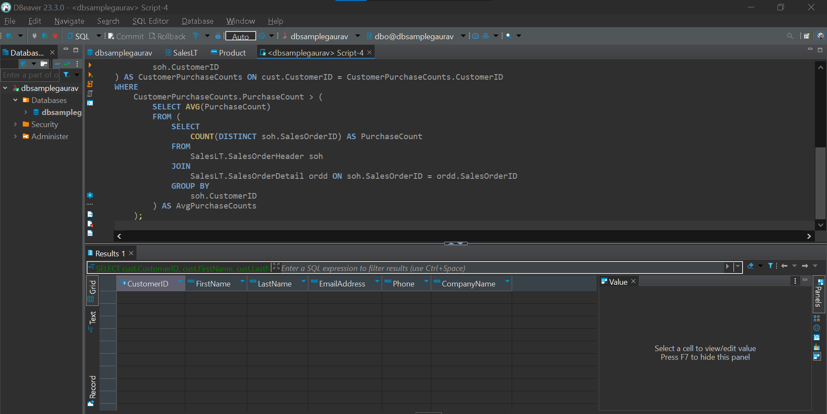

1. **Display products that have been ordered more than the average number of times.**

SELECT

pro.ProductID,

pro.Name AS ProductName,

COUNT(ordd.SalesOrderID) AS OrderCount

FROM

SalesLT.Product pro

JOIN

SalesLT.SalesOrderDetail ordd ON pro.ProductID = ordd.ProductID

GROUP BY

pro.ProductID, pro.Name

HAVING

COUNT(ordd.SalesOrderID) > (SELECT AVG(OrderCount) FROM (

SELECT

pro.ProductID,

pro.Name AS ProductName,

COUNT(ordd.SalesOrderID) AS OrderCount

FROM

SalesLT.Product pro

JOIN

SalesLT.SalesOrderDetail ordd ON pro.ProductID = ordd.ProductID

GROUP BY

pro.ProductID, pro.Name

) AS subquery);

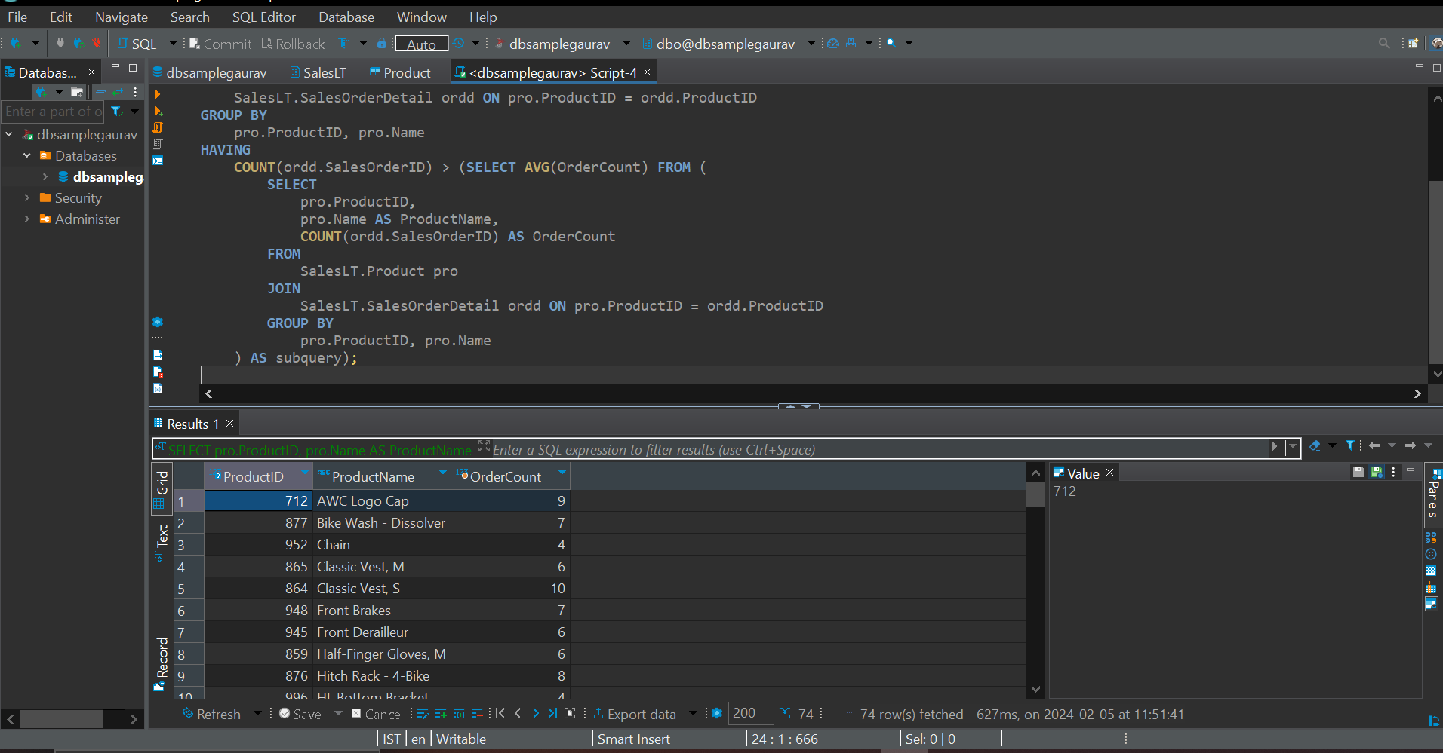

1. **Retrieve orders placed by employees who have completed a specific training course**.

Data Not Available

1. **List employees who have a higher salary than at least one employee in another department.**

Data Not Available

1. **Display products that have not been ordered in the last 60 days.**

Data Not Available

1. **Find employees who have the same job title as the employee with the highest salary.**

Data Not Available

1. **List customers who have placed orders with a total amount greater than the total amount of a specific order.**

Data insufficient

1. **Retrieve products that have been ordered by customers with the same shipping address.**

WITH CustomerShippingAddresses AS (

SELECT

CA.CustomerID,

CA.AddressID,

a.AddressLine1,

a.AddressLine2,

a.City,

a.StateProvince,

a.CountryRegion,

a.PostalCode

FROM

SalesLT.CustomerAddress CA

JOIN

SalesLT.Address a ON CA.AddressID = a.AddressID

)

SELECT

pro.ProductID,

pro.Name AS ProductName,

ordd.SalesOrderID,

csa.CustomerID,

csa.AddressID,

csa.AddressLine1,

csa.AddressLine2,

csa.City,

csa.StateProvince,

csa.CountryRegion,

csa.PostalCode

FROM

SalesLT.Product pro

JOIN

SalesLT.SalesOrderDetail ordd ON pro.ProductID = ordd.ProductID

JOIN

SalesLT.SalesOrderHeader soh ON ordd.SalesOrderID = soh.SalesOrderID

JOIN

(

SELECT

CA.CustomerID,

CA.AddressID,

a.AddressLine1,

a.AddressLine2,

a.City,

a.StateProvince,

a.CountryRegion,

a.PostalCode

FROM

SalesLT.CustomerAddress CA

JOIN

SalesLT.Address a ON CA.AddressID = a.AddressID

) csa ON soh.CustomerID = csa.CustomerID

WHERE

soh.ShipToAddressID IN (

SELECT

ShipToAddressID

FROM

SalesLT.SalesOrderHeader

GROUP BY

ShipToAddressID

HAVING

COUNT(DISTINCT CustomerID) > 1

);

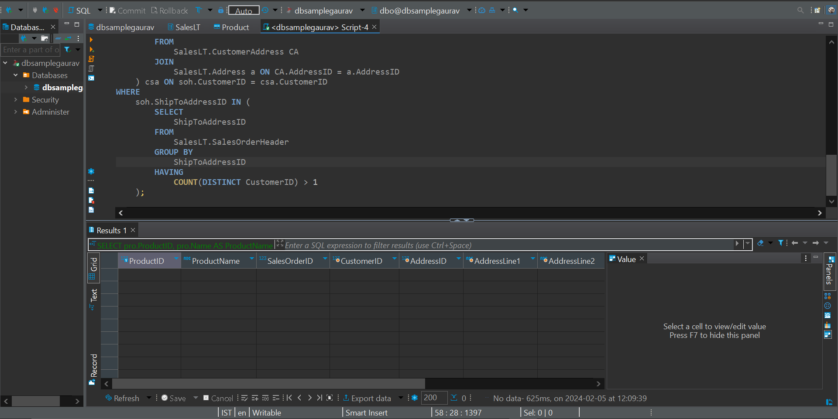

1. **Display orders with quantities higher than the average quantity for a specific product.**

SELECT

ordd.SalesOrderID,

ordd.ProductID,

pro.Name AS ProductName,

ordd.OrderQty

FROM

SalesLT.SalesOrderDetail ordd

JOIN

SalesLT.Product pro ON ordd.ProductID = pro.ProductID

JOIN

(

SELECT

ProductID,

AVG(OrderQty) AS AvgQuantity

FROM

SalesLT.SalesOrderDetail

GROUP BY

ProductID

) avgQ ON ordd.ProductID = avgQ.ProductID

WHERE

ordd.OrderQty > avgQ.AvgQuantity

ORDER BY

ordd.SalesOrderID, ordd.ProductID;

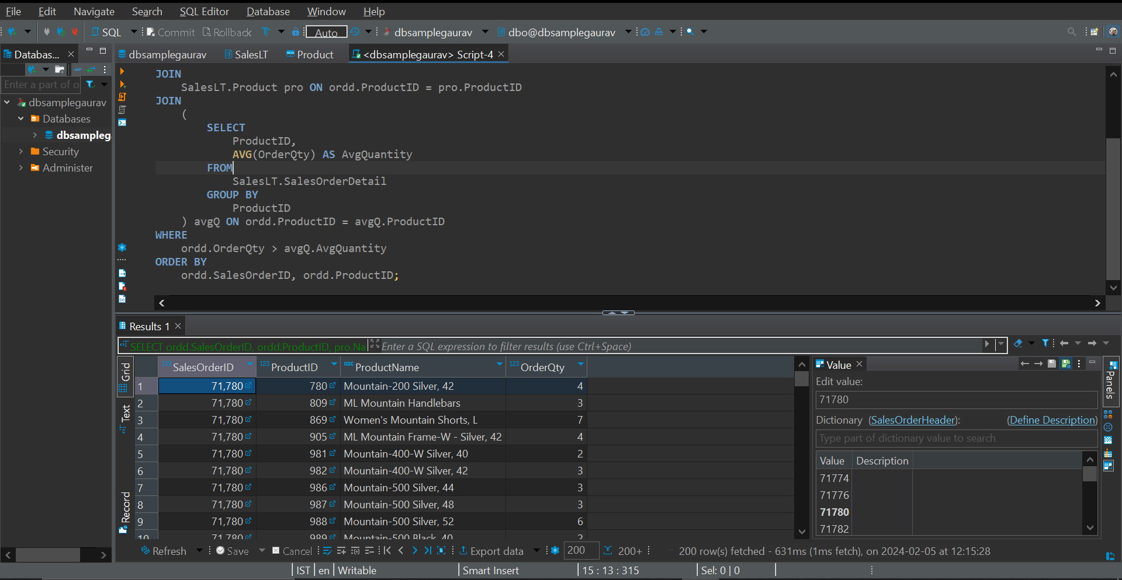

1. **Find customers who have placed orders for products that have not been ordered by any other customer**

SELECT

cust.CustomerID,

cust.FirstName,

cust.LastName,

soh.SalesOrderID,

pro.ProductID,

pro.Name AS ProductName

FROM

SalesLT.Customer cust

JOIN

SalesLT.SalesOrderHeader soh ON cust.CustomerID = soh.CustomerID

JOIN

SalesLT.SalesOrderDetail ordd ON soh.SalesOrderID = ordd.SalesOrderID

JOIN

SalesLT.Product pro ON ordd.ProductID = pro.ProductID

WHERE

pro.ProductID NOT IN (

SELECT DISTINCT ordd.ProductID

FROM SalesLT.SalesOrderDetail ordd

)

ORDER BY

cust.CustomerID, soh.SalesOrderID, pro.ProductID;

