QP Data Analysis

Diana Sanchez

August 2022

rm(list = ls(all.names = TRUE)) #clear R environment

# Load libraries

#Analysis of all_data ## Tidy all_data all_data df includes all 58 participants, two groups. Only total correct responses are included for each experimental task (flanker, stroop, backward).

##Data Visualization of all participants with ggplot

#all_data plot  
p1 <- ggplot(all_data1, aes(x = age_z, y=flanker_correct,color=factor(group_language)))+  
 #geom_jitter(width = .2)  
 geom_point(size = 1) +  
 ggtitle("Language Plot") + geom_smooth(method = "lm") + labs(color = "Language Group")+scale_color_manual(labels = c("NonLanguage","Language"),values = c("red","blue"))  
  
  
p2<- ggplot(all_data1, aes(x = iq_z, y=flanker_correct,color=factor(group_language)))+  
 #geom_jitter(width = .2)  
 geom_point(size = 1) +  
 ggtitle("Language Plot") + geom_smooth(method = "lm") + labs(color = "Language Group")+scale_color_manual(labels = c("NonLanguage","Language"),values = c("red","blue"))  
 #facet_grid(language~backward_correct)  
  
p3 <- ggplot(all_data1, aes(x = stroop_correct, y=flanker_correct,color=factor(group_language)))+  
 #geom_jitter(width = .2)  
 geom_point(size = 1) +  
 ggtitle("Language Plot") + geom_smooth(method = "lm") + labs(color = "Language Group")+scale_color_manual(labels = c("NonLanguage","Language"),values = c("red","blue"))  
  
  
p4 <- ggplot(all_data1, aes(x = backward_correct, y=flanker_correct,color=factor(group_language)))+  
 #geom_jitter(width = .2)  
 geom_point(size = 1) +  
 ggtitle("Language Plot") + geom_smooth(method = "lm") + labs(color = "Language Group")+scale_color_manual(labels = c("NonLanguage","Language"),values = c("red","blue"))  
  
p5 <- ggplot(all_data1, aes(x = IQ, y=flanker_correct,color=factor(group_language)))+  
 #geom_jitter(width = .2)  
 geom_point(size = 1) +  
 ggtitle("Language Plot") + geom_smooth(method = "lm") + labs(color = "Language Group")+scale_color_manual(labels = c("NonLanguage","Language"),values = c("red","blue"))  
  
  
p6 <- ggplot(all_data1, aes(x = age, y=flanker_correct,color=factor(group_language)))+  
 #geom_jitter(width = .2)  
 geom_point(size = 1) +  
 ggtitle("Language Plot") + geom_smooth(method = "lm") + labs(color = "Language Group")+scale_color_manual(labels = c("NonLanguage","Language"),values = c("red","blue"))  
  
  
library(patchwork)  
p1+p2+p3+p4+p5+p6 + plot_layout(ncol = 2,heights = 2)

## `geom_smooth()` using formula 'y ~ x'  
## `geom_smooth()` using formula 'y ~ x'  
## `geom_smooth()` using formula 'y ~ x'  
## `geom_smooth()` using formula 'y ~ x'  
## `geom_smooth()` using formula 'y ~ x'  
## `geom_smooth()` using formula 'y ~ x'

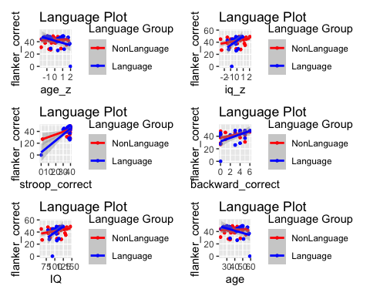

# Analsyis by groups

Data Analysis for nonLanguage Group {.tabset} The nonLanguage group consist of the teachers who only use one language in their professional work setting.

## Linear regression model for nonLanguage BACKWARD task

data(nonLanguage)

## Warning in data(nonLanguage): data set 'nonLanguage' not found

head(nonLanguage)

## participant age IQ backward_correct flanker_correct stroop_correct  
## 1 adnm2 36 135 5 45 39  
## 2 bjfc1 40 108 4 44 38  
## 3 buzt0 30 146 5 49 39  
## 4 bwat2 34 128 1 46 39  
## 5 cbky9 49 135 4 48 40  
## 6 cfug6 34 63 0 27 2  
## language  
## 1 NonLanguage  
## 2 NonLanguage  
## 3 NonLanguage  
## 4 NonLanguage  
## 5 NonLanguage  
## 6 NonLanguage

##plot  
plot(backward_correct ~ age + IQ, data = nonLanguage, pch=16)

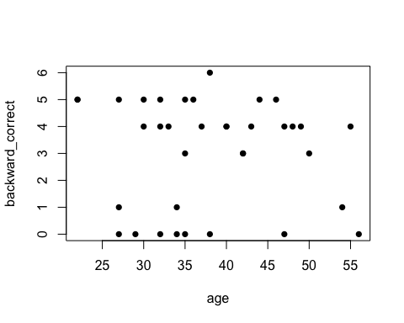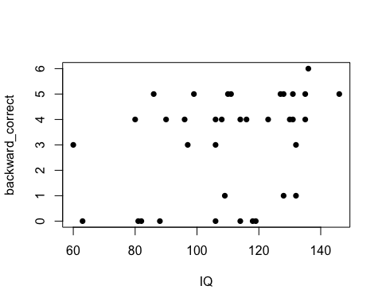

#linear model  
backward_model_nonLanguage <- lm(backward_correct ~ age + IQ, data = nonLanguage)  
#abline(backward_model_nonLanguage)  
  
my_results <- tidy(backward_model_nonLanguage)  
my_results

## # A tibble: 3 × 5  
## term estimate std.error statistic p.value  
## <chr> <dbl> <dbl> <dbl> <dbl>  
## 1 (Intercept) -0.194 2.35 -0.0828 0.934   
## 2 age -0.00622 0.0366 -0.170 0.866   
## 3 IQ 0.0316 0.0154 2.05 0.0482

backward_model_nonLanguage

##   
## Call:  
## lm(formula = backward_correct ~ age + IQ, data = nonLanguage)  
##   
## Coefficients:  
## (Intercept) age IQ   
## -0.194378 -0.006223 0.031591

summary(backward_model_nonLanguage)

##   
## Call:  
## lm(formula = backward_correct ~ age + IQ, data = nonLanguage)  
##   
## Residuals:  
## Min 1Q Median 3Q Max   
## -3.3658 -2.0974 0.6713 1.3846 2.6145   
##   
## Coefficients:  
## Estimate Std. Error t value Pr(>|t|)   
## (Intercept) -0.194378 2.346418 -0.083 0.9345   
## age -0.006223 0.036562 -0.170 0.8659   
## IQ 0.031591 0.015400 2.051 0.0482 *  
## ---  
## Signif. codes: 0 '***' 0.001 '**' 0.01 '*' 0.05 '.' 0.1 ' ' 1  
##   
## Residual standard error: 1.934 on 33 degrees of freedom  
## Multiple R-squared: 0.1174, Adjusted R-squared: 0.06393   
## F-statistic: 2.195 on 2 and 33 DF, p-value: 0.1273

par(mfrow = c(2,2))   
plot(backward_model_nonLanguage)

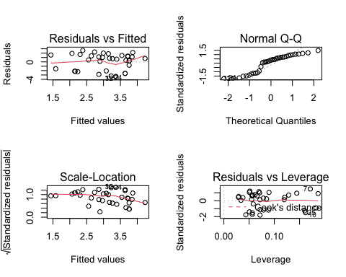

AIC(backward_model_nonLanguage)

## [1] 154.5309

BIC(backward_model_nonLanguage)

## [1] 160.865

## Linear regression model for nonLanguage FLANKER task

data(nonLanguage)

## Warning in data(nonLanguage): data set 'nonLanguage' not found

head(nonLanguage)

## participant age IQ backward_correct flanker_correct stroop_correct  
## 1 adnm2 36 135 5 45 39  
## 2 bjfc1 40 108 4 44 38  
## 3 buzt0 30 146 5 49 39  
## 4 bwat2 34 128 1 46 39  
## 5 cbky9 49 135 4 48 40  
## 6 cfug6 34 63 0 27 2  
## language  
## 1 NonLanguage  
## 2 NonLanguage  
## 3 NonLanguage  
## 4 NonLanguage  
## 5 NonLanguage  
## 6 NonLanguage

##plot  
plot(flanker_correct ~ age + IQ, data = nonLanguage, pch=16)

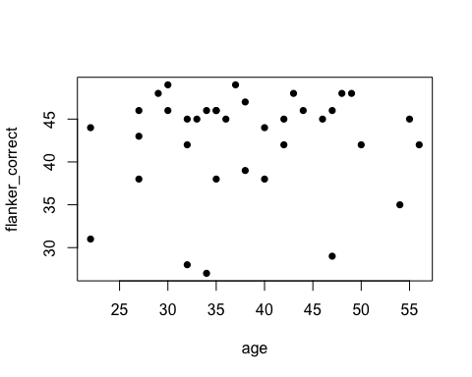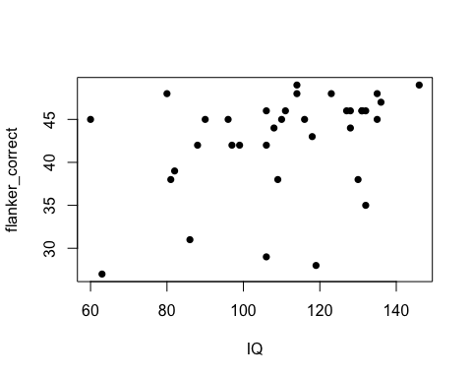

#linear model  
flanker_model_nonLanguage <- lm(flanker_correct ~ age + IQ, data = nonLanguage)  
#abline(flanker_model_nonLanguage)  
  
my_results <- tidy(flanker_model_nonLanguage)  
my_results

## # A tibble: 3 × 5  
## term estimate std.error statistic p.value  
## <chr> <dbl> <dbl> <dbl> <dbl>  
## 1 (Intercept) 28.1 6.91 4.07 0.000278  
## 2 age 0.0766 0.108 0.711 0.482   
## 3 IQ 0.104 0.0454 2.30 0.0282

flanker_model_nonLanguage

##   
## Call:  
## lm(formula = flanker_correct ~ age + IQ, data = nonLanguage)  
##   
## Coefficients:  
## (Intercept) age IQ   
## 28.11861 0.07663 0.10418

summary(flanker_model_nonLanguage)

##   
## Call:  
## lm(formula = flanker_correct ~ age + IQ, data = nonLanguage)  
##   
## Residuals:  
## Min 1Q Median 3Q Max   
## -14.9680 -0.4283 1.4999 3.2503 8.2520   
##   
## Coefficients:  
## Estimate Std. Error t value Pr(>|t|)   
## (Intercept) 28.11861 6.91314 4.067 0.000278 ***  
## age 0.07663 0.10772 0.711 0.481859   
## IQ 0.10418 0.04537 2.296 0.028156 *   
## ---  
## Signif. codes: 0 '***' 0.001 '**' 0.01 '*' 0.05 '.' 0.1 ' ' 1  
##   
## Residual standard error: 5.699 on 33 degrees of freedom  
## Multiple R-squared: 0.1419, Adjusted R-squared: 0.08992   
## F-statistic: 2.729 on 2 and 33 DF, p-value: 0.08002

par(mfrow = c(2,2))   
plot(flanker_model_nonLanguage)

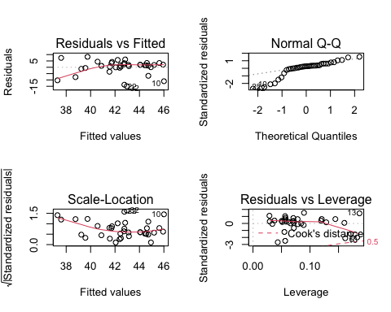

AIC(flanker_model_nonLanguage)

## [1] 232.3294

BIC(flanker_model_nonLanguage)

## [1] 238.6635

## Linear regression model for nonLanguage STROOP task

data(nonLanguage)

## Warning in data(nonLanguage): data set 'nonLanguage' not found

head(nonLanguage)

## participant age IQ backward_correct flanker_correct stroop_correct  
## 1 adnm2 36 135 5 45 39  
## 2 bjfc1 40 108 4 44 38  
## 3 buzt0 30 146 5 49 39  
## 4 bwat2 34 128 1 46 39  
## 5 cbky9 49 135 4 48 40  
## 6 cfug6 34 63 0 27 2  
## language  
## 1 NonLanguage  
## 2 NonLanguage  
## 3 NonLanguage  
## 4 NonLanguage  
## 5 NonLanguage  
## 6 NonLanguage

##plot  
plot(stroop_correct ~ age + IQ, data = nonLanguage, pch=16)

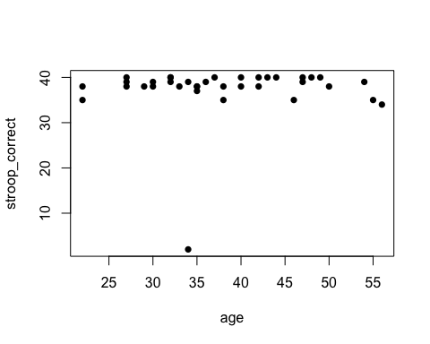

#linear model  
stroop_model_nonLanguage <- lm(stroop_correct ~ age + IQ, data = nonLanguage)  
abline(stroop_model_nonLanguage)

## Warning in abline(stroop_model_nonLanguage): only using the first two of 3  
## regression coefficients

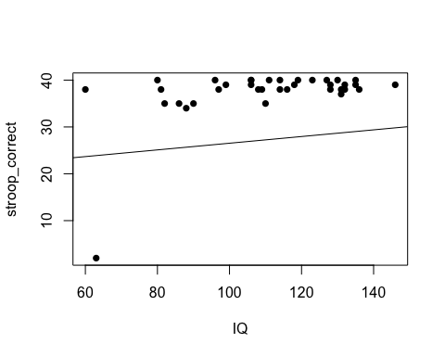

my_results <- tidy(stroop_model_nonLanguage)  
my_results

## # A tibble: 3 × 5  
## term estimate std.error statistic p.value  
## <chr> <dbl> <dbl> <dbl> <dbl>  
## 1 (Intercept) 19.4 6.94 2.79 0.00863  
## 2 age 0.0714 0.108 0.660 0.514   
## 3 IQ 0.138 0.0456 3.03 0.00474

stroop_model_nonLanguage

##   
## Call:  
## lm(formula = stroop_correct ~ age + IQ, data = nonLanguage)  
##   
## Coefficients:  
## (Intercept) age IQ   
## 19.38713 0.07142 0.13802

summary(stroop_model_nonLanguage)

##   
## Call:  
## lm(formula = stroop_correct ~ age + IQ, data = nonLanguage)  
##   
## Residuals:  
## Min 1Q Median 3Q Max   
## -28.5108 -1.5472 0.5263 2.1878 7.3319   
##   
## Coefficients:  
## Estimate Std. Error t value Pr(>|t|)   
## (Intercept) 19.38713 6.94219 2.793 0.00863 **  
## age 0.07142 0.10817 0.660 0.51370   
## IQ 0.13802 0.04556 3.029 0.00474 **  
## ---  
## Signif. codes: 0 '***' 0.001 '**' 0.01 '*' 0.05 '.' 0.1 ' ' 1  
##   
## Residual standard error: 5.723 on 33 degrees of freedom  
## Multiple R-squared: 0.2191, Adjusted R-squared: 0.1718   
## F-statistic: 4.63 on 2 and 33 DF, p-value: 0.01689

par(mfrow = c(2,2))   
plot(stroop_model_nonLanguage)

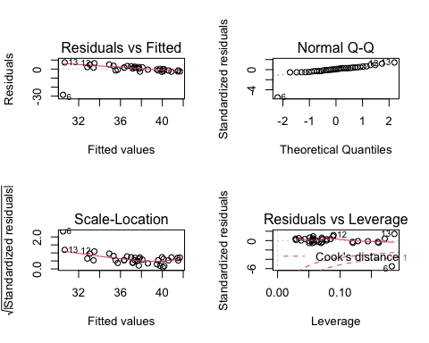

AIC(stroop_model_nonLanguage)

## [1] 232.6312

BIC(stroop_model_nonLanguage)

## [1] 238.9653

# Data Analysis for Language Group

The language group consist of the teachers who use more than one language in their professional work setting.

## Linear regression model for language BACKWARD

data(language)

## Warning in data(language): data set 'language' not found

head(language)

## participant age IQ backward_correct flanker_correct stroop_correct language  
## 37 bi_ajli0 35 94 4 45 38 Language  
## 38 bi_dckv1 30 105 4 49 38 Language  
## 39 bi_dvyf7 58 105 5 37 39 Language  
## 40 bi_evur7 42 93 0 40 34 Language  
## 41 bi_giah0 23 102 5 44 39 Language  
## 42 bi_igsy3 50 120 6 49 39 Language

#plot Language  
plot(backward_correct ~ age + IQ, data = language, pch=16)

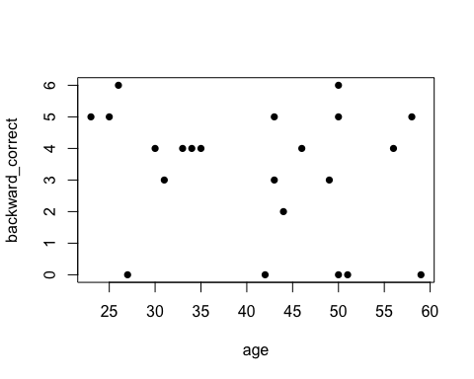

#linear model  
backward_model_language <- lm(backward_correct ~ age + IQ, data = language)  
abline(backward_model_language)

## Warning in abline(backward_model_language): only using the first two of 3  
## regression coefficients

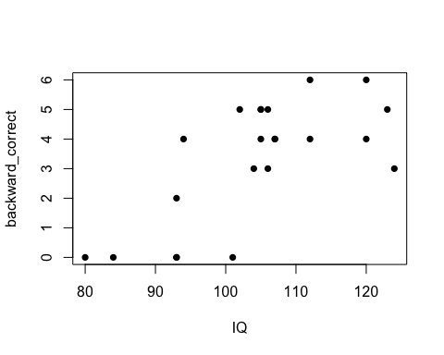

my_results <- tidy(backward_model_language)  
my_results

## # A tibble: 3 × 5  
## term estimate std.error statistic p.value  
## <chr> <dbl> <dbl> <dbl> <dbl>  
## 1 (Intercept) -7.69 2.80 -2.75 0.0128   
## 2 age -0.0609 0.0269 -2.27 0.0352   
## 3 IQ 0.129 0.0258 5.00 0.0000795

backward_model_language

##   
## Call:  
## lm(formula = backward_correct ~ age + IQ, data = language)  
##   
## Coefficients:  
## (Intercept) age IQ   
## -7.69311 -0.06092 0.12908

summary(backward_model_language)

##   
## Call:  
## lm(formula = backward_correct ~ age + IQ, data = language)  
##   
## Residuals:  
## Min 1Q Median 3Q Max   
## -2.32845 -0.81186 -0.07596 0.90055 2.67241   
##   
## Coefficients:  
## Estimate Std. Error t value Pr(>|t|)   
## (Intercept) -7.69311 2.79829 -2.749 0.0128 *   
## age -0.06092 0.02687 -2.267 0.0352 *   
## IQ 0.12908 0.02582 5.000 7.95e-05 ***  
## ---  
## Signif. codes: 0 '***' 0.001 '**' 0.01 '*' 0.05 '.' 0.1 ' ' 1  
##   
## Residual standard error: 1.375 on 19 degrees of freedom  
## Multiple R-squared: 0.5937, Adjusted R-squared: 0.5509   
## F-statistic: 13.88 on 2 and 19 DF, p-value: 0.0001923

par(mfrow = c(2,2))   
plot(backward_model_language)

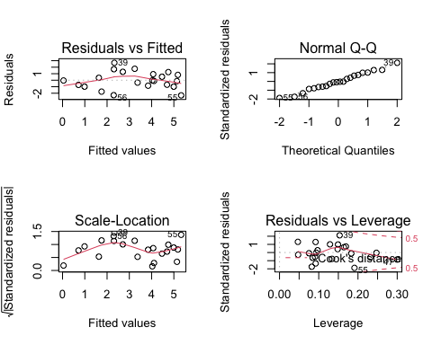

AIC(backward_model_language)

## [1] 81.20737

BIC(backward_model_language)

## [1] 85.57154

## Linear regression model for language FLANKER

data(language)

## Warning in data(language): data set 'language' not found

head(language)

## participant age IQ backward_correct flanker_correct stroop_correct language  
## 37 bi_ajli0 35 94 4 45 38 Language  
## 38 bi_dckv1 30 105 4 49 38 Language  
## 39 bi_dvyf7 58 105 5 37 39 Language  
## 40 bi_evur7 42 93 0 40 34 Language  
## 41 bi_giah0 23 102 5 44 39 Language  
## 42 bi_igsy3 50 120 6 49 39 Language

#plot Language  
plot(flanker_correct ~ age + IQ, data = language, pch=16)

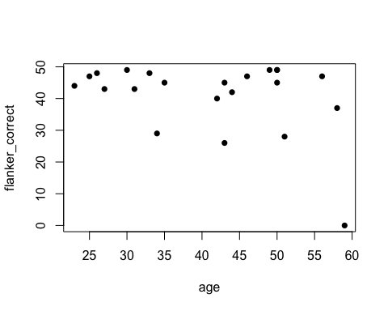

#linear model  
flanker_model_language <- lm(flanker_correct ~ age + IQ, data = language)  
abline(flanker_model_language)

## Warning in abline(flanker_model_language): only using the first two of 3  
## regression coefficients

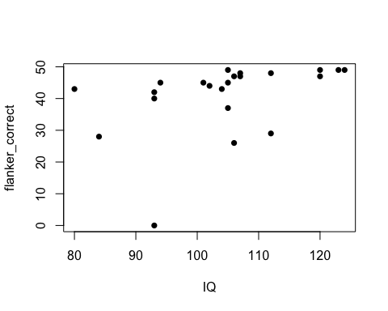

my_results <- tidy(flanker_model_language)  
my_results

## # A tibble: 3 × 5  
## term estimate std.error statistic p.value  
## <chr> <dbl> <dbl> <dbl> <dbl>  
## 1 (Intercept) 12.1 20.1 0.605 0.552   
## 2 age -0.425 0.193 -2.21 0.0399  
## 3 IQ 0.443 0.185 2.39 0.0271

flanker_model_language

##   
## Call:  
## lm(formula = flanker_correct ~ age + IQ, data = language)  
##   
## Coefficients:  
## (Intercept) age IQ   
## 12.1411 -0.4251 0.4432

summary(flanker_model_language)

##   
## Call:  
## lm(formula = flanker_correct ~ age + IQ, data = language)  
##   
## Residuals:  
## Min 1Q Median 3Q Max   
## -28.278 -1.917 2.854 4.847 11.242   
##   
## Coefficients:  
## Estimate Std. Error t value Pr(>|t|)   
## (Intercept) 12.1411 20.0687 0.605 0.5523   
## age -0.4251 0.1927 -2.207 0.0399 *  
## IQ 0.4432 0.1851 2.394 0.0271 *  
## ---  
## Signif. codes: 0 '***' 0.001 '**' 0.01 '*' 0.05 '.' 0.1 ' ' 1  
##   
## Residual standard error: 9.858 on 19 degrees of freedom  
## Multiple R-squared: 0.3319, Adjusted R-squared: 0.2616   
## F-statistic: 4.719 on 2 and 19 DF, p-value: 0.02168

par(mfrow = c(2,2))   
plot(flanker_model_language)

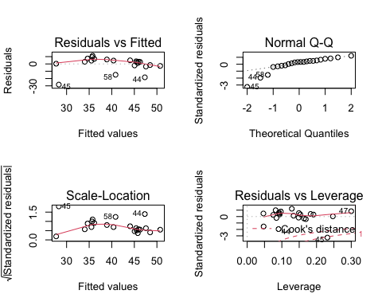

AIC(flanker_model_language)

## [1] 167.8941

BIC(flanker_model_language)

## [1] 172.2582

## Linear regression model for language STROOP

data(language)

## Warning in data(language): data set 'language' not found

head(language)

## participant age IQ backward_correct flanker_correct stroop_correct language  
## 37 bi_ajli0 35 94 4 45 38 Language  
## 38 bi_dckv1 30 105 4 49 38 Language  
## 39 bi_dvyf7 58 105 5 37 39 Language  
## 40 bi_evur7 42 93 0 40 34 Language  
## 41 bi_giah0 23 102 5 44 39 Language  
## 42 bi_igsy3 50 120 6 49 39 Language

#plot Language  
par(mfrow = c(2,2))  
plot(stroop_correct ~ age + IQ, data = language, pch=16)  
  
#linear model  
stroop_model_language <- lm(stroop_correct ~ age + IQ, data = language)  
  
par(mfrow = c(2,2))

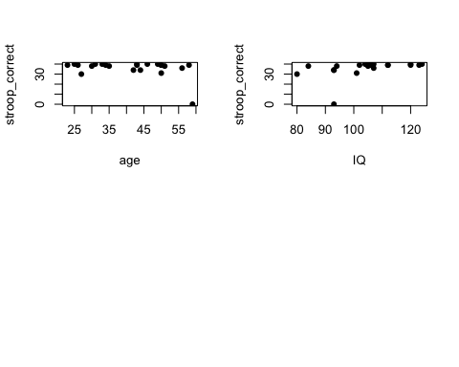

plot(stroop_model_language)  
  
my_results <- tidy(stroop_model_language)  
my_results

## # A tibble: 3 × 5  
## term estimate std.error statistic p.value  
## <chr> <dbl> <dbl> <dbl> <dbl>  
## 1 (Intercept) 13.6 14.9 0.914 0.372   
## 2 age -0.313 0.143 -2.18 0.0417  
## 3 IQ 0.338 0.138 2.45 0.0240

stroop_model_language

##   
## Call:  
## lm(formula = stroop_correct ~ age + IQ, data = language)  
##   
## Coefficients:  
## (Intercept) age IQ   
## 13.6334 -0.3127 0.3376

summary(stroop_model_language)

##   
## Call:  
## lm(formula = stroop_correct ~ age + IQ, data = language)  
##   
## Residuals:  
## Min 1Q Median 3Q Max   
## -26.5774 -1.6728 0.3679 2.9557 11.9590   
##   
## Coefficients:  
## Estimate Std. Error t value Pr(>|t|)   
## (Intercept) 13.6334 14.9160 0.914 0.3722   
## age -0.3127 0.1432 -2.184 0.0417 *  
## IQ 0.3376 0.1376 2.453 0.0240 *  
## ---  
## Signif. codes: 0 '***' 0.001 '**' 0.01 '*' 0.05 '.' 0.1 ' ' 1  
##   
## Residual standard error: 7.327 on 19 degrees of freedom  
## Multiple R-squared: 0.3359, Adjusted R-squared: 0.266   
## F-statistic: 4.805 on 2 and 19 DF, p-value: 0.02048

par(mfrow = c(2,2))   
plot(stroop_model_language)

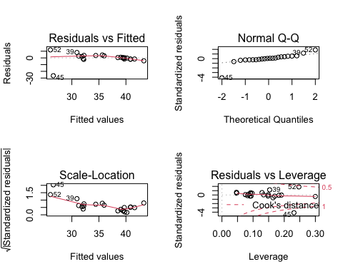

AIC(stroop_model_language)

## [1] 154.8383

BIC(stroop_model_language)

## [1] 159.2025

#ADDITIONAL ANALYSIS

## Histogram to observe results

attach(all_data) #using objects in df all_data

## The following object is masked _by_ .GlobalEnv:  
##   
## language

hist(backward_correct) #this could be considered "normal"

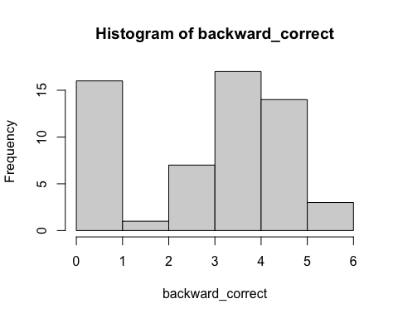

hist(flanker_correct) #not normal

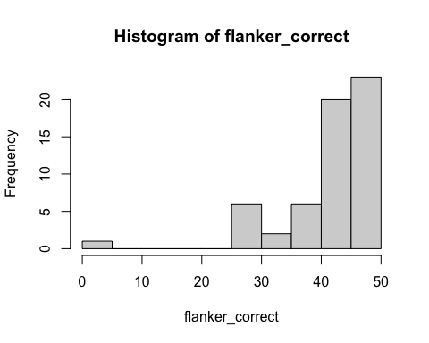

hist(stroop_correct) #not normal

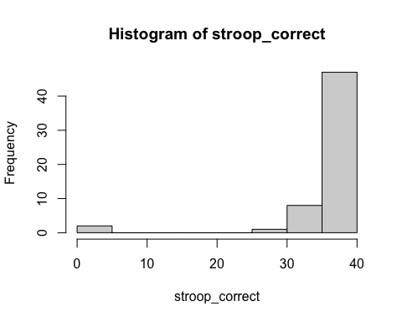

summary(all_data)

## participant age IQ backward_correct  
## Length:58 Min. :22.00 Min. : 60.00 Min. :0.000   
## Class :character 1st Qu.:32.00 1st Qu.: 96.25 1st Qu.:1.000   
## Mode :character Median :38.00 Median :107.00 Median :4.000   
## Mean :39.19 Mean :108.09 Mean :3.138   
## 3rd Qu.:47.00 3rd Qu.:122.25 3rd Qu.:5.000   
## Max. :59.00 Max. :146.00 Max. :6.000   
## flanker_correct stroop_correct language   
## Min. : 0.00 Min. : 0.00 Length:58   
## 1st Qu.:40.50 1st Qu.:38.00 Class :character   
## Median :45.00 Median :39.00 Mode :character   
## Mean :41.91 Mean :36.83   
## 3rd Qu.:47.00 3rd Qu.:40.00   
## Max. :49.00 Max. :40.00

# normalize data

Attempted to normalize data to see if it would make a difference.

attach(all_data)

## The following object is masked _by_ .GlobalEnv:  
##   
## language

## The following objects are masked from all_data (pos = 3):  
##   
## age, backward_correct, flanker_correct, IQ, language, participant,  
## stroop_correct

scaledflank <- scale(flanker_correct)  
scaledstroop <- scale(stroop_correct)  
scaledback <- scale(backward_correct)  
  
lang = substring(participant,1,3)=="bi_"  
biling = rep("false",length(lang)) #make this variable all FALSE  
  
biling[lang]="true" #  
data <- data.frame(age,IQ,scaledflank,scaledstroop,scaledback,biling)  
#colnames(data)=c("age","IQ","scaledflank","scaledstroop","scaledback","biling") #not needed but may use later  
  
hist(scaledback)

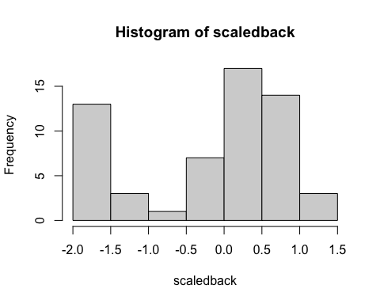

hist(scaledstroop)

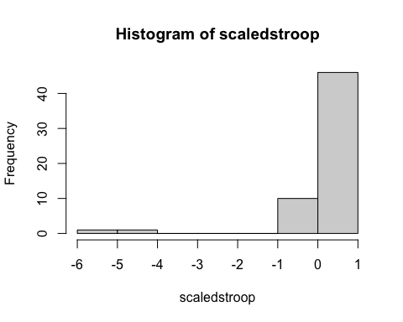

hist(scaledflank)

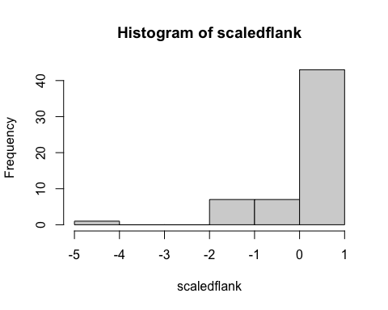

#——————————————## TESTING Additional plots

ggplot(data = all_data) +  
 geom_point(mapping = aes(x = backward_correct, y = IQ, color = age))

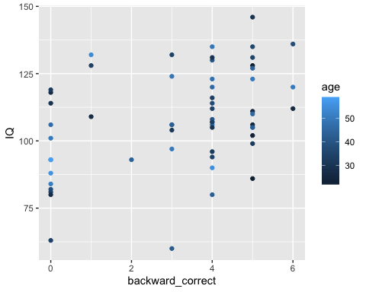

scatterplot3d(  
 all_data[1:4], pch = 19, color = "steelblue",  
 grid = TRUE, box = FALSE,  
 mar = c(3, 3, 0.5, 3)  
)

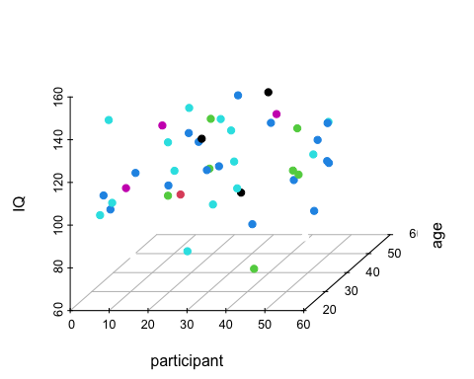

# nonLanguage Scatterplot  
ggplot(nonLanguage, aes(backward_correct, IQ)) +  
 geom_point(fill = "dark green", color = "black",  
 size = 5, shape = 21) +  
 ggtitle("LanguagePlot")

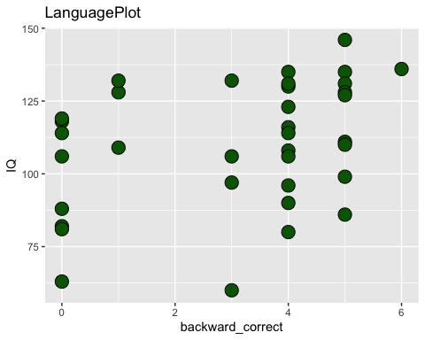

#————————————————————————#

# Removing 1 data (45) which may be an outlier. This was done just to observe if it would result in a difference in results.

##Removing line 45

#created new data with deleted row 45  
new_all_data <- all_data[-c(45),]  
  
#created new language group (-45)  
new_language <- new_all_data[37:58, ]  
  
  
#plot Language  
plot(flanker_correct ~ age + IQ, data = new_language, pch=16)

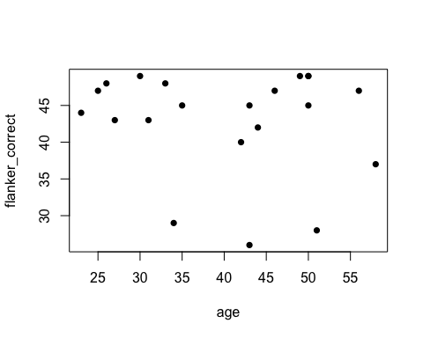

#linear model  
flanker_model_language <- lm(flanker_correct ~ age + IQ, data = new_language)  
abline(flanker_model_language)

## Warning in abline(flanker_model_language): only using the first two of 3  
## regression coefficients

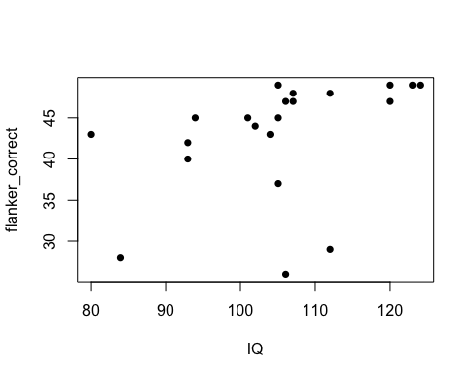

my_results <- tidy(flanker_model_language)  
my_results

## # A tibble: 3 × 5  
## term estimate std.error statistic p.value  
## <chr> <dbl> <dbl> <dbl> <dbl>  
## 1 (Intercept) 21.2 13.8 1.54 0.141   
## 2 age -0.155 0.142 -1.09 0.290   
## 3 IQ 0.266 0.131 2.03 0.0573

flanker_model_language

##   
## Call:  
## lm(formula = flanker_correct ~ age + IQ, data = new_language)  
##   
## Coefficients:  
## (Intercept) age IQ   
## 21.2068 -0.1552 0.2660

summary(flanker_model_language)

##   
## Call:  
## lm(formula = flanker_correct ~ age + IQ, data = new_language)  
##   
## Residuals:  
## Min 1Q Median 3Q Max   
## -16.7273 -0.7667 2.4163 3.6353 6.0239   
##   
## Coefficients:  
## Estimate Std. Error t value Pr(>|t|)   
## (Intercept) 21.2068 13.7539 1.542 0.1405   
## age -0.1552 0.1423 -1.090 0.2899   
## IQ 0.2660 0.1310 2.031 0.0573 .  
## ---  
## Signif. codes: 0 '***' 0.001 '**' 0.01 '*' 0.05 '.' 0.1 ' ' 1  
##   
## Residual standard error: 6.693 on 18 degrees of freedom  
## (1 observation deleted due to missingness)  
## Multiple R-squared: 0.2021, Adjusted R-squared: 0.1135   
## F-statistic: 2.28 on 2 and 18 DF, p-value: 0.131

par(mfrow = c(2,2))   
plot(flanker_model_language)

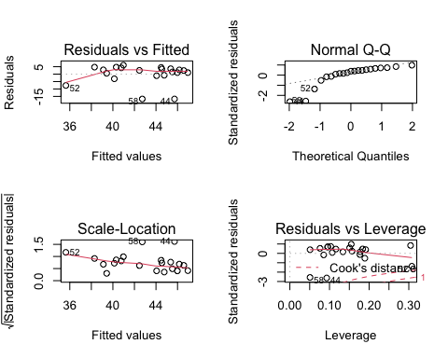

##  
#plot Language  
par(mfrow = c(2,2))  
plot(stroop_correct ~ age + IQ, data = new_language, pch=16)  
  
#linear model  
stroop_model_language <- lm(stroop_correct ~ age + IQ, data = new_language)  
  
par(mfrow = c(2,2))

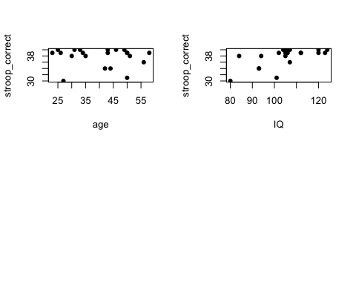

plot(stroop_model_language)

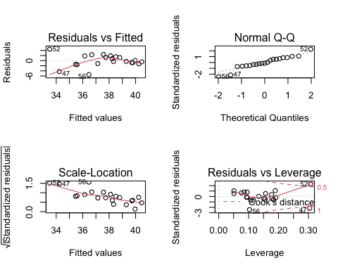

my_results <- tidy(stroop_model_language)  
my_results

## # A tibble: 3 × 5  
## term estimate std.error statistic p.value  
## <chr> <dbl> <dbl> <dbl> <dbl>  
## 1 (Intercept) 22.2 4.87 4.55 0.000250  
## 2 age -0.0590 0.0504 -1.17 0.257   
## 3 IQ 0.171 0.0464 3.69 0.00169

stroop_model_language

##   
## Call:  
## lm(formula = stroop_correct ~ age + IQ, data = new_language)  
##   
## Coefficients:  
## (Intercept) age IQ   
## 22.15387 -0.05899 0.17098

summary(stroop_model_language)

##   
## Call:  
## lm(formula = stroop_correct ~ age + IQ, data = new_language)  
##   
## Residuals:  
## Min 1Q Median 3Q Max   
## -5.4736 -1.1456 -0.2982 1.4977 4.4921   
##   
## Coefficients:  
## Estimate Std. Error t value Pr(>|t|)   
## (Intercept) 22.15387 4.87196 4.547 0.00025 ***  
## age -0.05899 0.05041 -1.170 0.25715   
## IQ 0.17098 0.04639 3.686 0.00169 **   
## ---  
## Signif. codes: 0 '***' 0.001 '**' 0.01 '*' 0.05 '.' 0.1 ' ' 1  
##   
## Residual standard error: 2.371 on 18 degrees of freedom  
## (1 observation deleted due to missingness)  
## Multiple R-squared: 0.4325, Adjusted R-squared: 0.3695   
## F-statistic: 6.86 on 2 and 18 DF, p-value: 0.006101