**Assignment-02.**

**Name.- Ghansham A. Kamble.**

**S.no.- 47.**

**Que.01-** Write a program to find sum   
of all integers greater than 100 and less than 200 that are divisible by 7.   
**Ans.-**

**public class Question01 {**

**public static void main(String[] args) {**

**int a, Sum=0, count=0;**

**for(a=101;a<200;a++) {**

**if(a%7==0) {**

**Sum=Sum+a;**

**count++;**

**}**

**}**

**System.out.println(" Sum "+ Sum);**

**}**

**}**

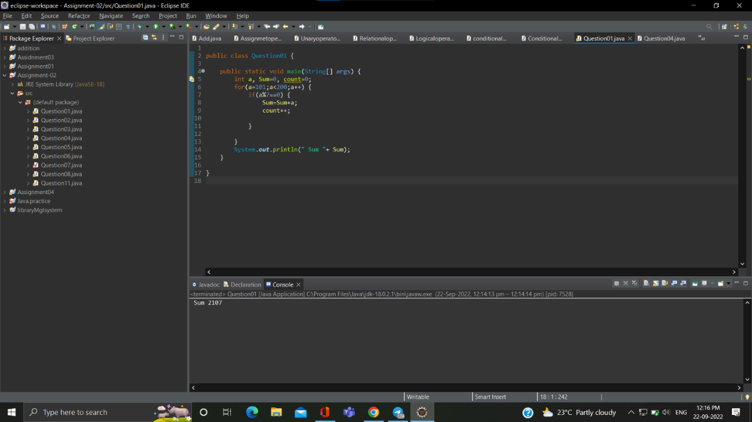

**Que.02-**  Write a program in java that ask three numbers from  
user and print the greatest among three .  
3. WAP to find  ASCII value of a character .

**Ans.-** **import java.util.*;**

**public class Question02 {**

**public static void main(String[] args) {**

**System.out.println("Enter three numbers");**

**Scanner g=new Scanner(System.in);**

**int x=g.nextInt();**

**int y=g.nextInt();**

**int z=g.nextInt();**

**if(x>y && x>z) System.out.println(x + " is greater than" + " "+y+" and "+z);**

**else if(y>x && y>z)System.out.println(y + " is greater than" + " "+x+" and "+z);**

**else if(z>x && z>y)System.out.println(z + " is greater than" + " "+x+" and "+y);**

**}**

**}**

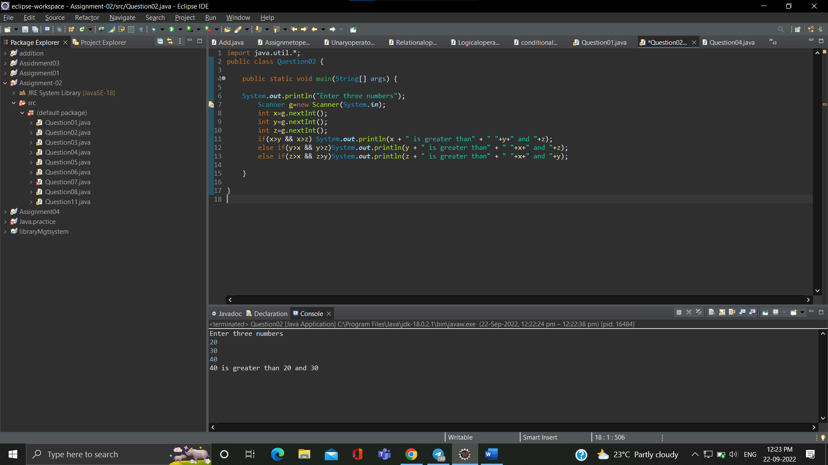

**Que.03-** Write a java program to find  ASCII value of a character.

**Ans.-** **import java.util.*;**

**public class Question03 {**

**public static void main(String[] args) {**

**System.out.println("Enter any character ");**

**Scanner p=new Scanner(System.in);**

**char ch1= p.next().charAt(0);**

**char ch2= p.next().charAt(0);**

**int asciiValue1= ch1;**

**int asciiValue2= ch2;{**

**System.out.println("ascii value of char ch1 is "+ asciiValue1);**

**System.out.println("ascii value of char ch2 is "+ asciiValue2);**

**}**

**}**

**}**

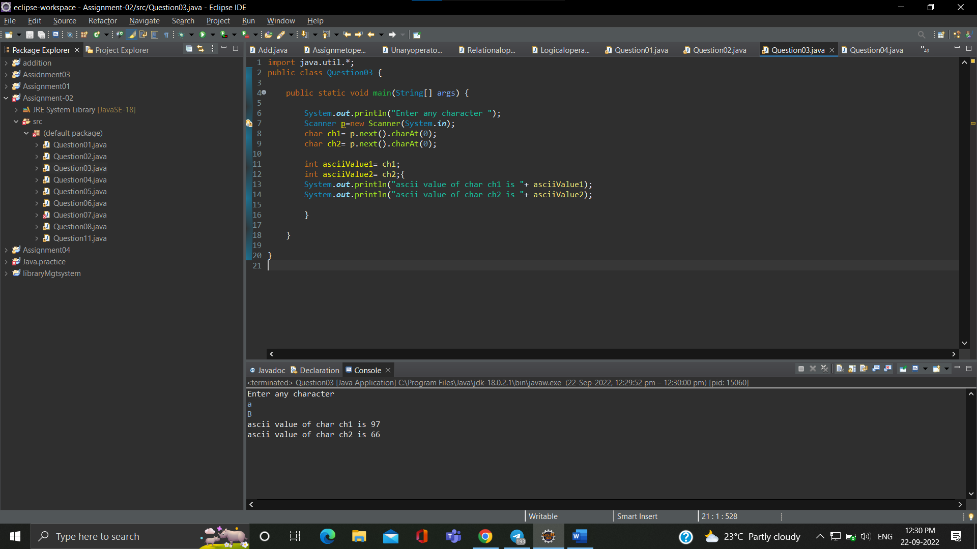

**Que.04-** write a Java Program to Check Whether an Alphabet is Vowel or Consonant

**Ans.-**

**import java.util.*;**

**public class Question04 {**

**public static void main(String[] args)**

**{**

**System.out.println("Enter a character ");**

**Scanner b = new Scanner(System.in);**

**char ch = b.next().charAt(0);**

**switch (ch)**

**{**

**case 'a':**

**case 'A': System.out.println(ch+" is vowels");break;**

**case 'e':**

**case 'E': System.out.println(ch+" is vowels");break;**

**case 'i':**

**case 'I': System.out.println(ch+" is vowels");break;**

**case 'o':**

**case 'O': System.out.println(ch+" is vowels");break;**

**case 'u':**

**case 'U': System.out.println(ch+" is vowels");break;**

**default:System.out.println(ch+" is consonant");**

**}**

**}**

**}**

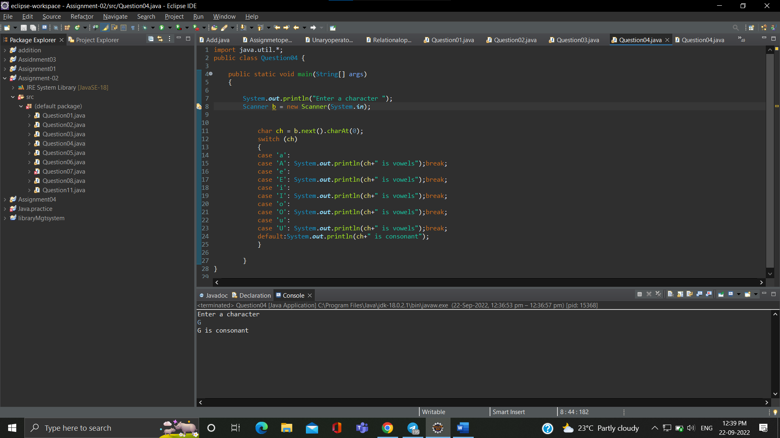

**Que.05-** Check if a Number is Positive or Negative using if else

**Ans.- import java.util.*;**

**public class Question05 {**

**public static void main(String[] args) {**

**System.out.println("Enter three number ");**

**Scanner w=new Scanner(System.in);**

**int d=w.nextInt();**

**if(d>0) System.out.println(d+" is possitive number");**

**else if(d<0) System.out.println(d+" is negative number");**

**else if(d==0) System.out.println(d+" is neither +ve or -ve");**

**}**

**}**

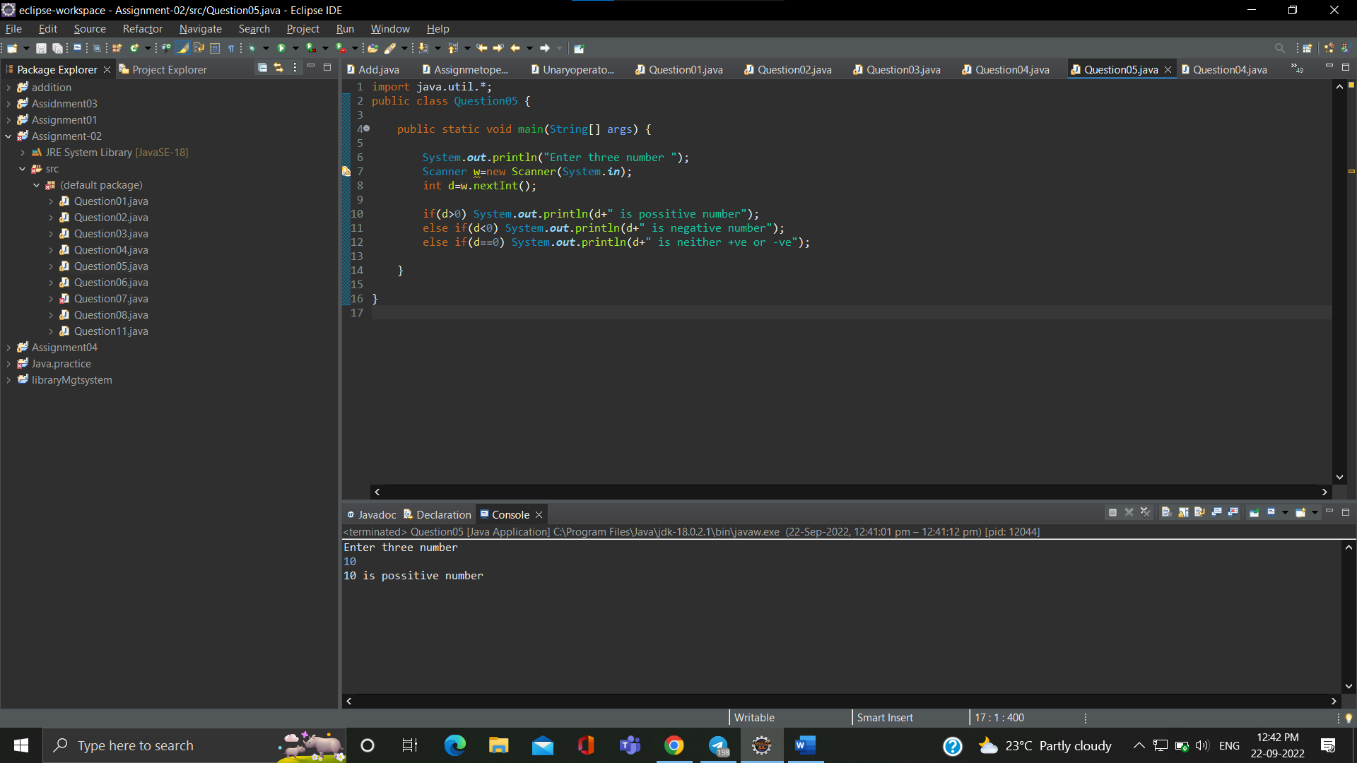

**Que.06-** WAP for swapping two numbers without using third variable

**Ans.-**

**import java.util.*;**

**public class Question06 {**

**public static void main(String[] args) {**

**System.out.println("enter any two numbers ");**

**Scanner f=new Scanner(System.in);**

**int k=f.nextInt();**

**int l=f.nextInt();**

**System.out.println("Befor swapping "+k+" and "+l);**

**k=k+l;**

**l=k-l;**

**k=k-l;**

**System.out.println("After swapping "+k+" and "+l);**

**}**

**}**

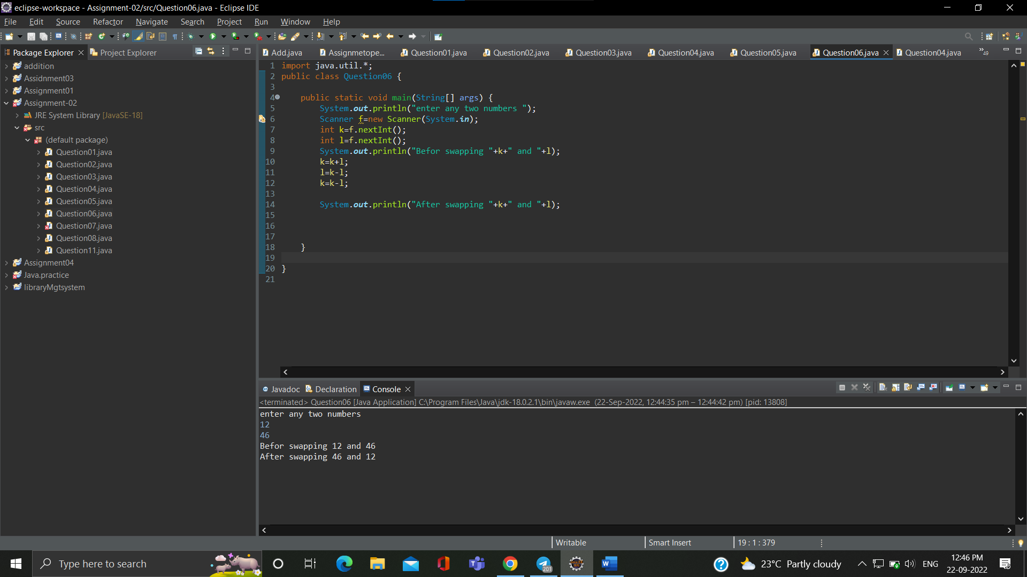

**Que.07-**Write a program that would print the information (name,  
year of joining, salary, address) of three employees by creating a class named  
'Employee'. The output should be as follows:  
  
  
Name           Year of joining        Address  
  
Ashish          1994       64C- WallsStreat  
  
Sam                2000                    68D- WallsStreat  
  
John               1999                26B- WallsStreat 

**Ans.-**

**Que.08-**WAP to input basic salary of an employee and calculate its  
Gross salary according to following:  
Basic Salary <= 10000 : HRA = 20%, DA = 80%  
Basic Salary <= 20000 : HRA = 25%, DA = 90%  
Basic Salary > 20000 : HRA = 30%, DA = 95%

**Ans.-** **import java.util.*;**

**public class Question08 {**

**public static void main(String[] args) {**

**float hr1,da1,H,D,GS;**

**System.out.println("Enter salary of employee ");**

**Scanner z = new Scanner(System.in);**

**float b=z.nextFloat();**

**if(b<10000) {**

**hr1=30f;da1=70f;**

**H=((b*hr1)/100);**

**D=((b*da1)/100);**

**GS=H+D+b;**

**System.out.println("gross salary of an employee is "+GS);**

**}**

**else if(b>10000 && b<=20000) {**

**hr1=25f;da1=90f;**

**H=((b*hr1)/100);**

**D=((b*da1)/100);**

**GS=H+D+b;**

**System.out.println("gross salary of an employee is "+GS);**

**}**

**else if(b>20000) {**

**hr1=30f;da1=95f;**

**H=((b*hr1)/100);**

**D=((b*da1)/100);**

**GS=H+D+b;**

**System.out.println("gross salary of an employee is "+GS);**

**}**

**}**

**}**

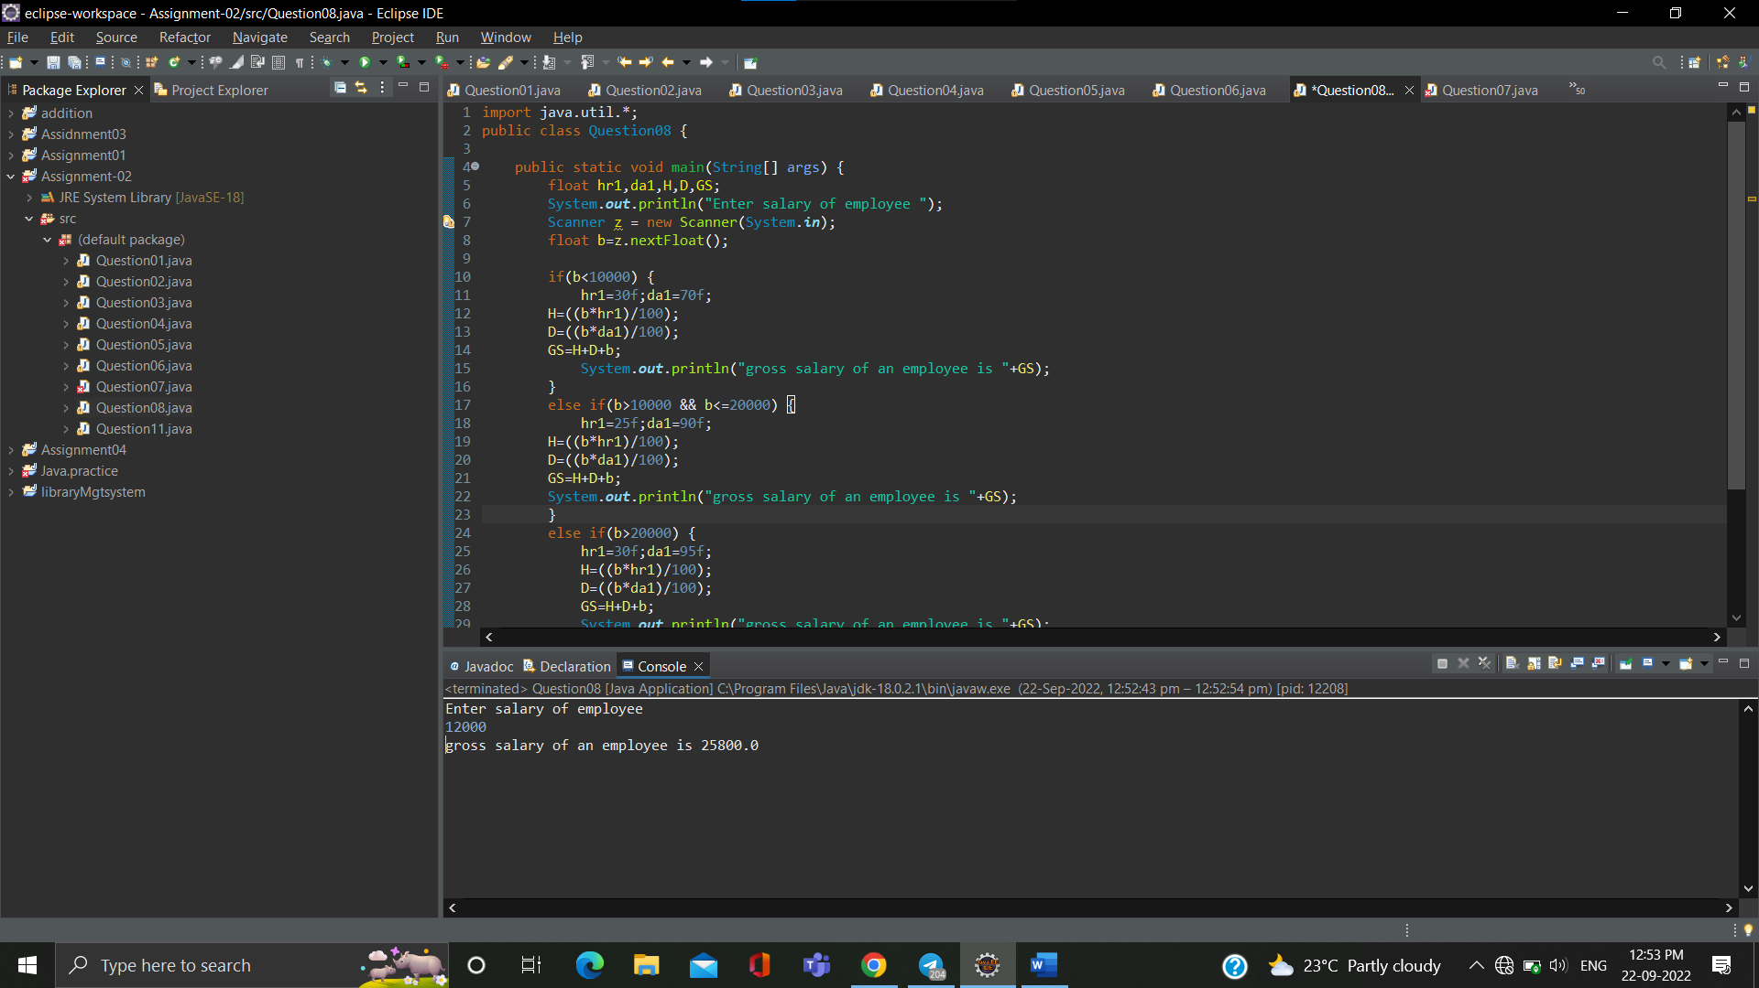

**Que.09-** wap to print even numbers between 10 to 20

**Ans.-** **public class Question09 {**

**public static void main(String[] args) {**

**for (int i = 10; i <=20; i = i+2)**

**System.out.println(i);**

**}**

**}**

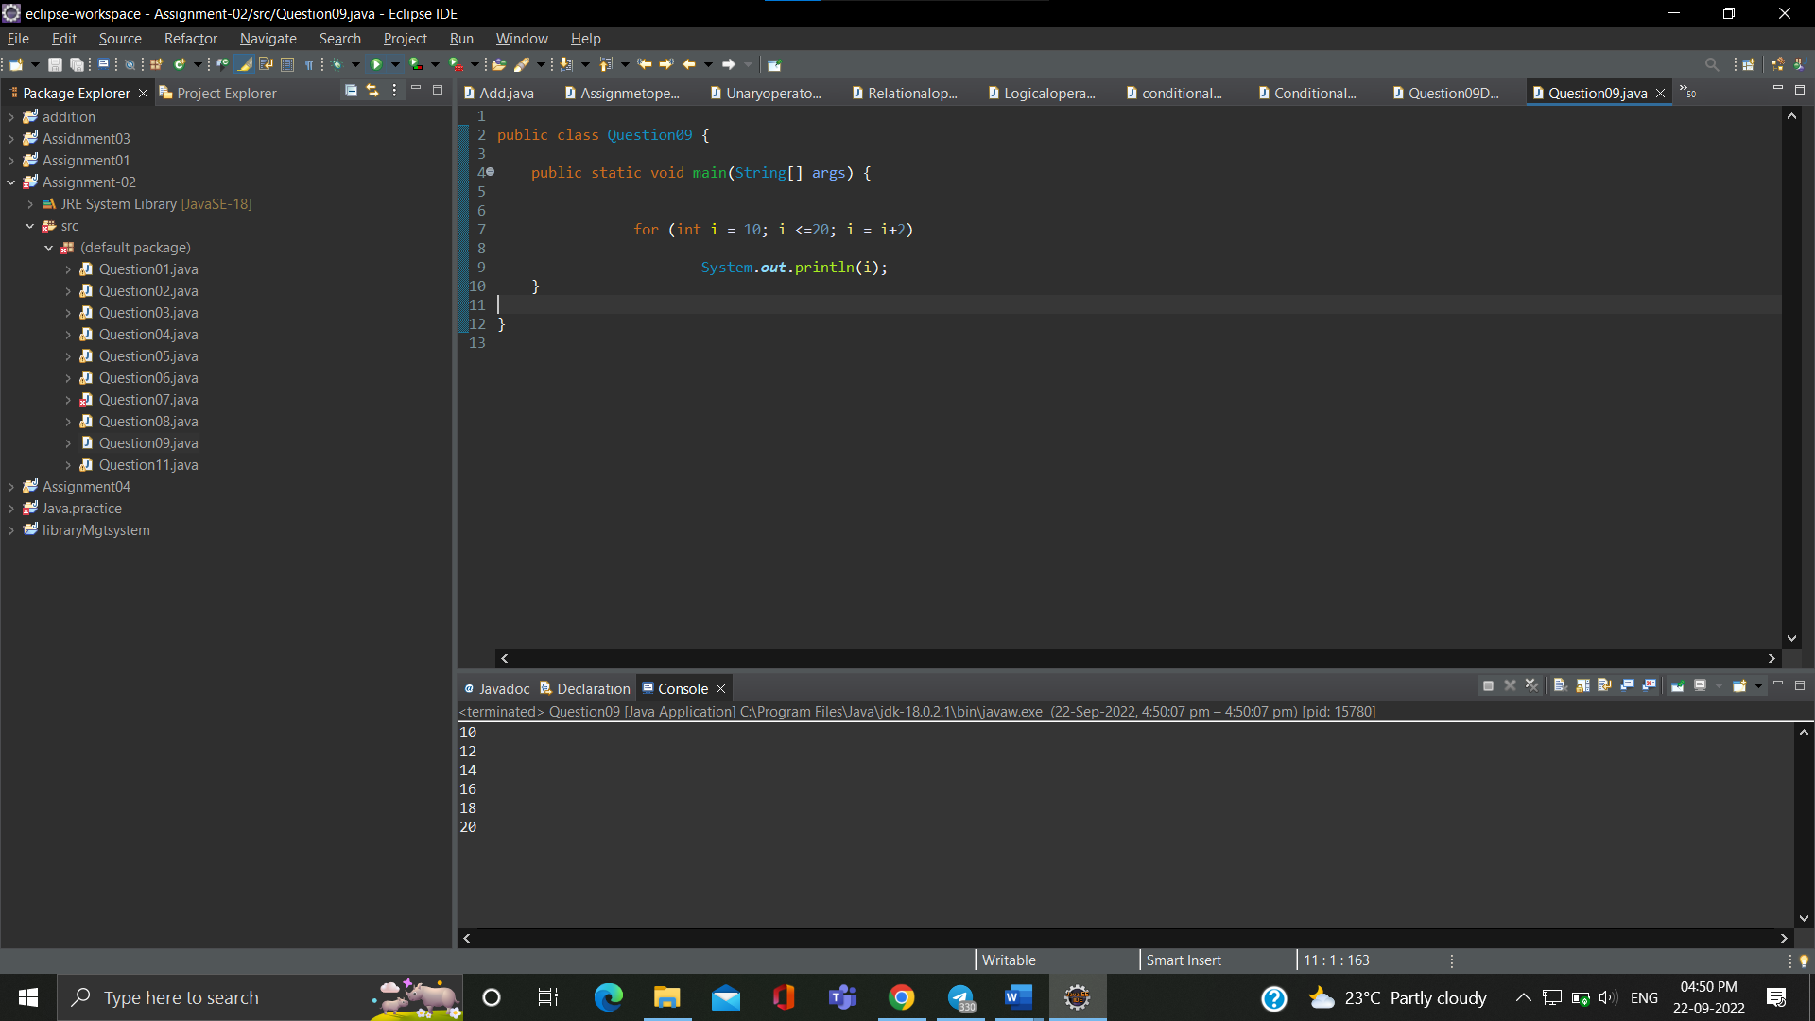

**Que.10-**  wap to check if a number is prime or not

**Ans.-**

**import java.util.*;**

**public class Question10 {**

**public static void main(String[] args) {**

**Scanner s = new Scanner(System.in);**

**int num1;**

**System.out.println("Write a number");**

**num1 = s.nextInt();**

**int test=0;**

**for(int i=2;i<num1/2;i++)**

**{**

**if(num1 % i ==0)**

**{**

**test=1;**

**break;**

**}**

**}**

**if(test==0) System.out.println("Number is prime");**

**else System.out.println("Number is not prime:");**

**}**

**}**

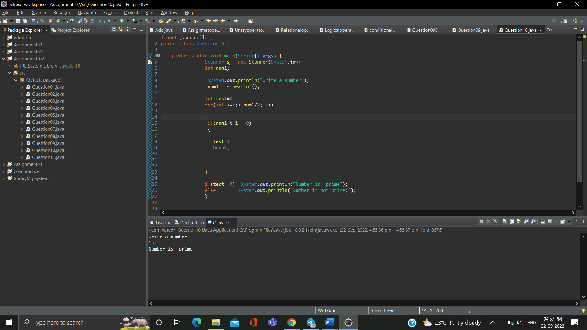

**Que.11-**wap to reverse a given digit   123   321

**Ans.-**

**import java.util.*;**

**public class Question11 {**

**public static void main(String[] args) {**

**System.out.println("Enter number ");**

**Scanner w= new Scanner(System.in);**

**int num=w.nextInt();**

**System.out.println("Number before reversing the digit "+num);**

**int rev=0;**

**int rem;**

**for(;num!=0;num=num/10) {**

**rem= num%10;**

**rev=rev*10+rem;**

**} System.out.println("the reverse of the given number is "+rev);**

**}**

**}**

