**Assignment No.- 04**

**Name- Ghansham A. kamble.**

**S.No.- 47.**

**Que.- 01 Write a java program to  initialize  
string by assigning value in program  and display it**.

**Ans.-** **public class Question01 {**

**public static void main(String[] args) {**

**String name1 = "Ghansham ";**

**String name2 = "Kamble.";**

**System.out.println("first name- "+name1+" Last name- "+name2);**

**}**

**}** 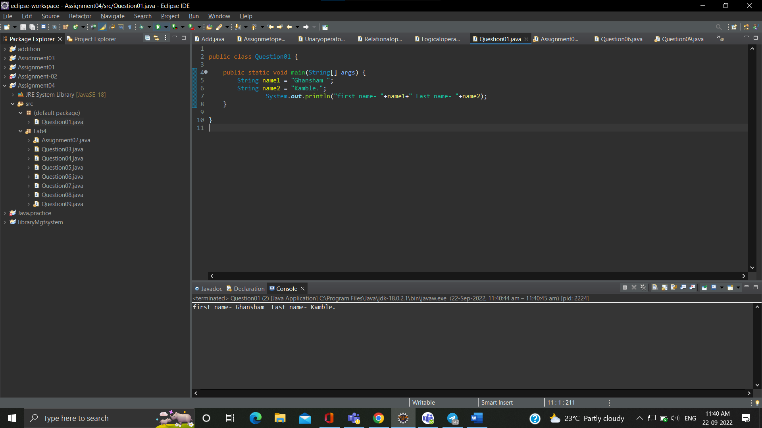

**Que.02- Write a program to ask two string  
values from user and check if they are equal or not**.

**Ans.- package Lab4;**

**import java.util.Scanner;**

**public class Assignment02 {**

**public static void main(String[] args) {**

**String s1, s2;**

**Scanner x=new Scanner(System.in);**

**System.out.println("Enter first string ");**

**s1=x.nextLine();**

**System.out.println("Enter second string ");**

**s2=x.nextLine();**

**if(s1.equals(s2))**

**System.out.println(" Equal strings");**

**else System.out.println(" Not equal strings");**

**}**

**Question.02- Answer.**

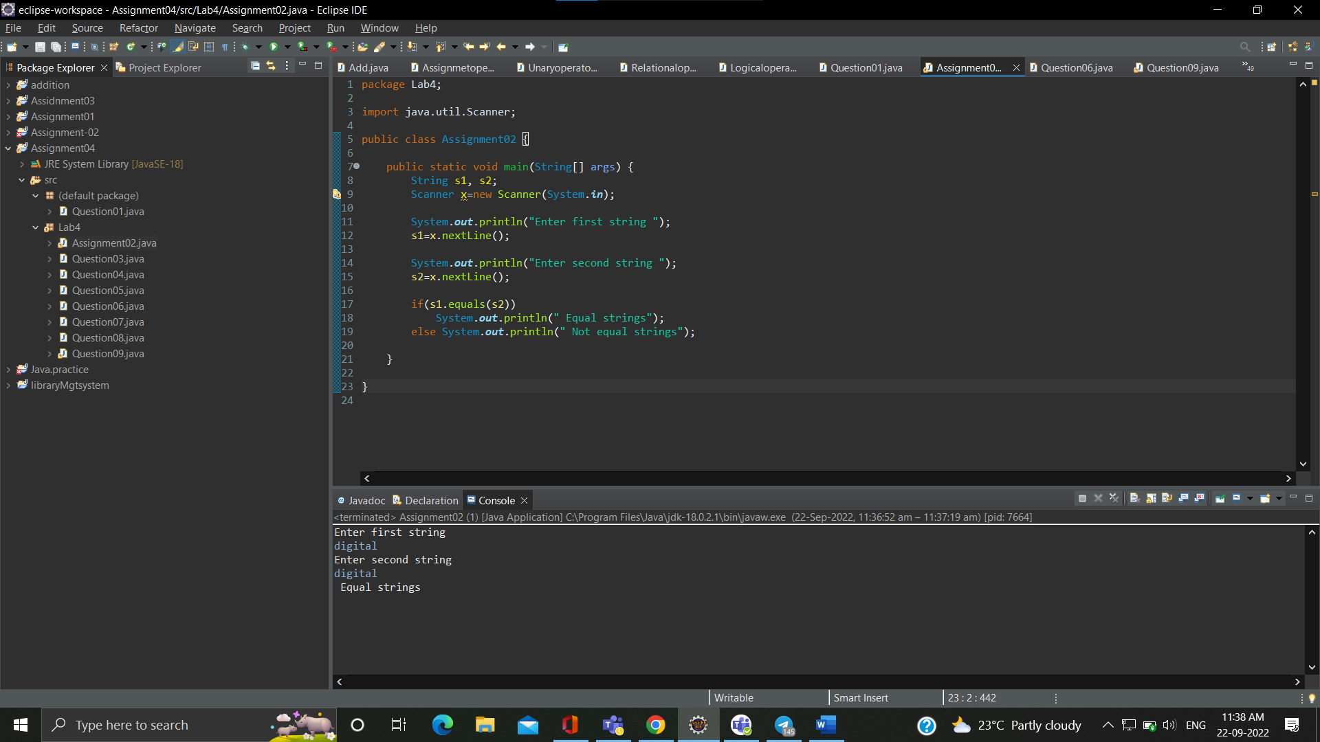

**Que.03- Write a java program to compare two  
strings**

**Ans.- package Lab4;**

**public class Question03 {**

**public static void main(String[] args) {**

**String p1= "ghansham";**

**String p2= "ghansham";**

**if(p1==p2)**

**System.out.println("two strings "+ p1 +" and "+ p2 +" are equal");**

**else System.out.println(" strings are not equal");**

**}**

**}**

**Que.03- Answer.**

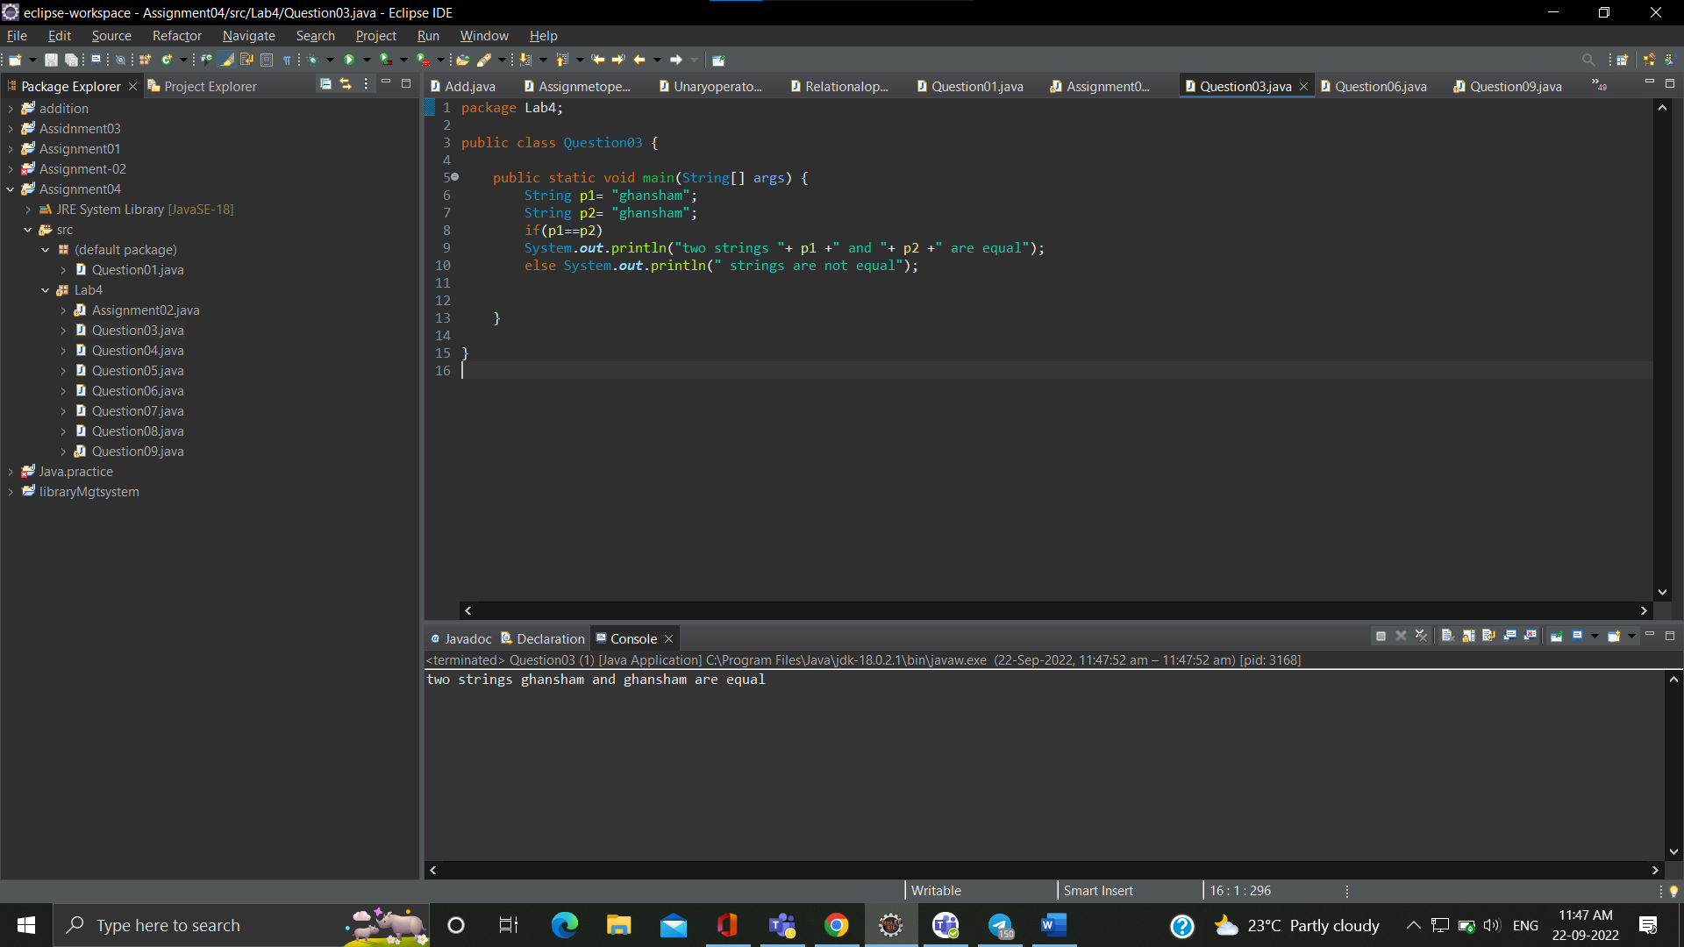

**Que.04- Write a java program to print string  
character by character**

**Ans.-**

**package Lab4;**

**public class Question04 {**

**public static void main(String[] args) {**

**String s= "hello";**

**System.out.println("Individual characters from given string: ");**

**for(int i = 0; i <s.length(); i++){**

**System.out.print(s.charAt(i) + ", "); }**

**}**

**}**

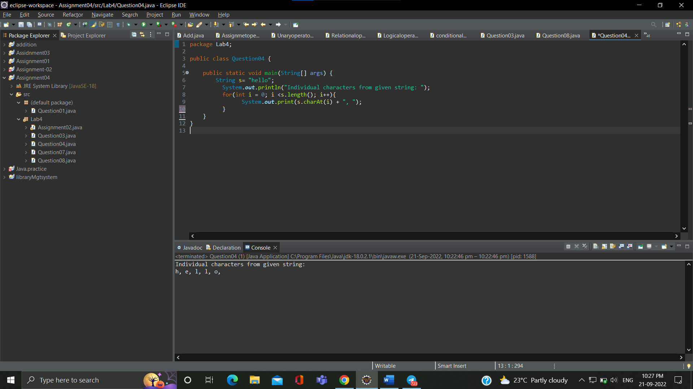

**Que.05- Write a java program to check if string is  
palindrome or not.**

**Ans.-**

**package Lab4;**

**public class Question05 {**

**public static void main(String[] args) {**

**String s = new String("MADAM");**

**int i;**

**int l=s.length()/2;**

**int j=s.length()-1;**

**for(i=0;i<l;i++,j--) {**

**if(s.charAt(i)!=s.charAt(j)) {**

**System.out.println("String is not palindrom");**

**break;**

**}**

**} if(i==l)**

**System.out.println("string is palindrom");**

**}**

**}**

**Que.05- Answer**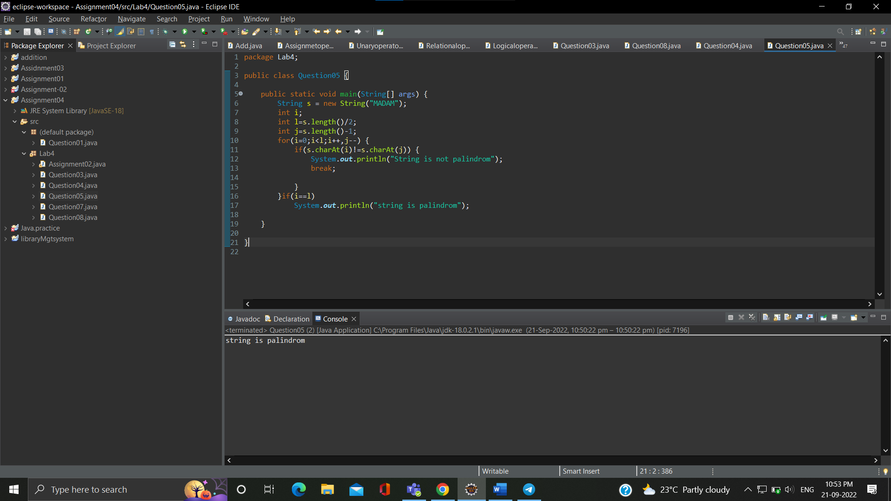

**Que.06- Write a program to count number of  
vowels and consonants in string**

**Ans.-**

**package Lab4;**

**public class Question06 {**

**public static void main(String[] args) {**

**int Count = 0, flag = 0;**

**String str = "I Love my india";**

**str = str.toLowerCase();**

**for(int i = 0; i < str.length(); i++) {**

**if(str.charAt(i) == 'a' str.charAt(i) == 'e' str.charAt(i) == 'i' str.charAt(i) == 'o' str.charAt(i) == 'u') {**

**Count++;**

**}**

**else if(str.charAt(i) >= 'a' && str.charAt(i)<='z') {**

**flag++;**

**}**

**}**

**System.out.println("Number of vowels: " + Count);**

**System.out.println("Number of consonants: " + flag);**

**}**

**}**

**Que.06-Answer.**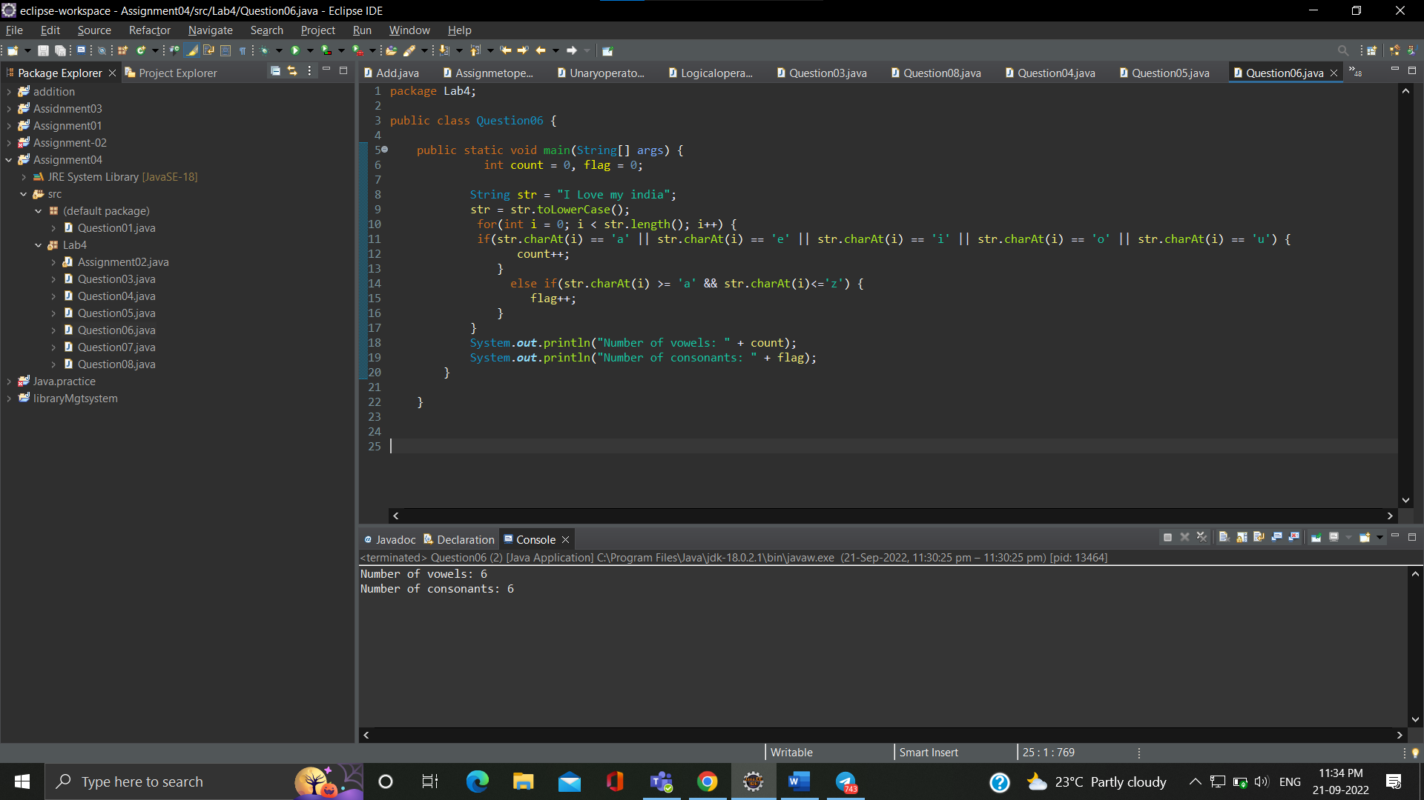

**Que.07- Write a java program** **to to count number of**  
**words in given string.**

**Ans.-**

**package Lab4;**

**public class Question07 {**

**public static void main(String[] args) {**

**String d= "stranger";**

**System.out.println(d.length());**

**}**

**}**

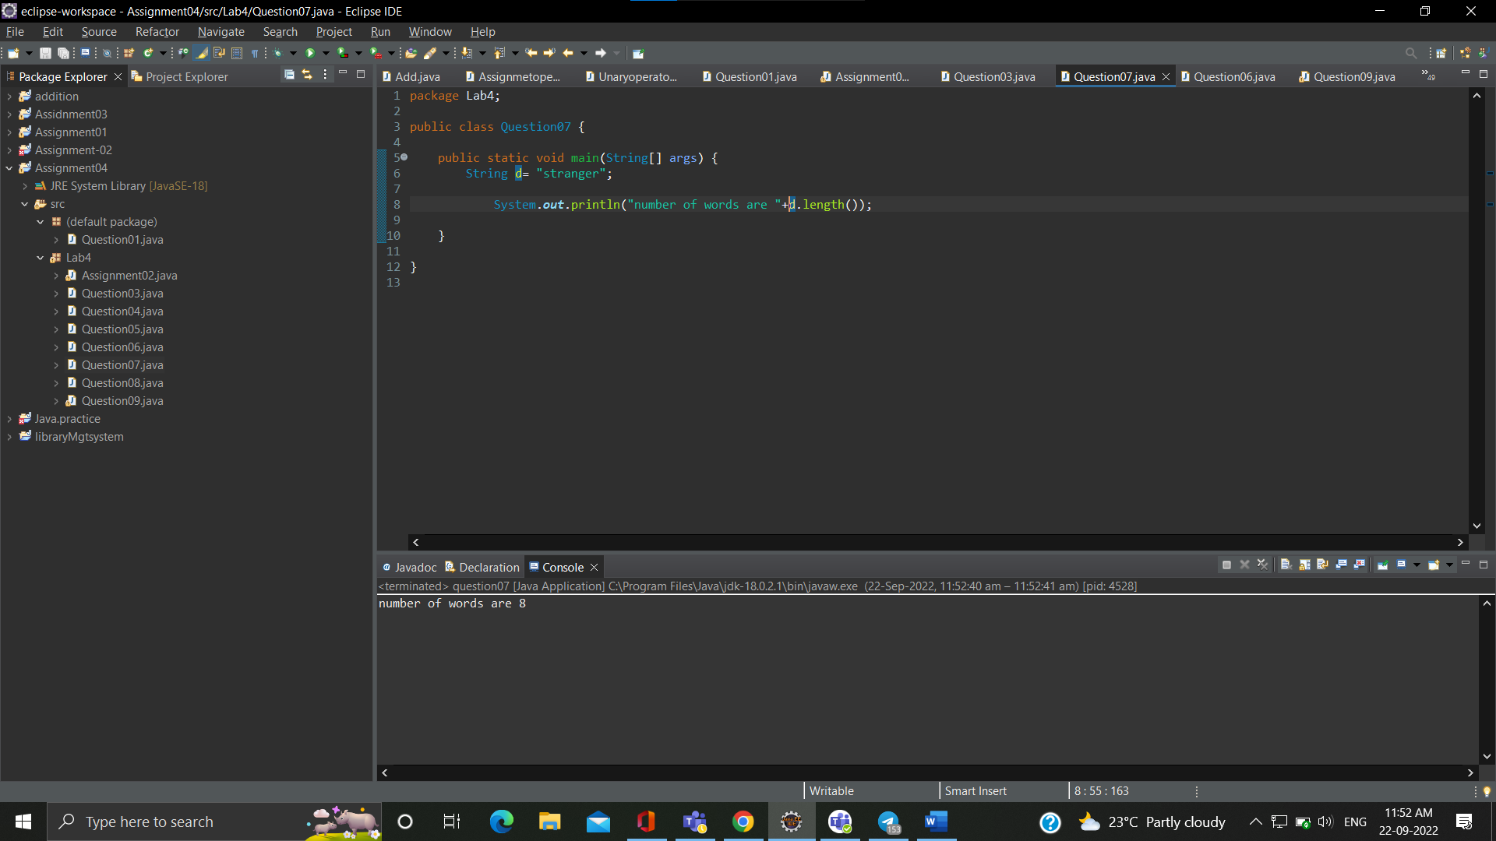

**Que.08- Write a program to reverse word in given string.**

Ans.- package Lab4;

public class Question08 {

public static void main(String[] args) {

String s="Asiangames";

StringBuilder s1=new StringBuilder();

s1.append(s);

s1.reverse();

System.out.println(s1);

}

}

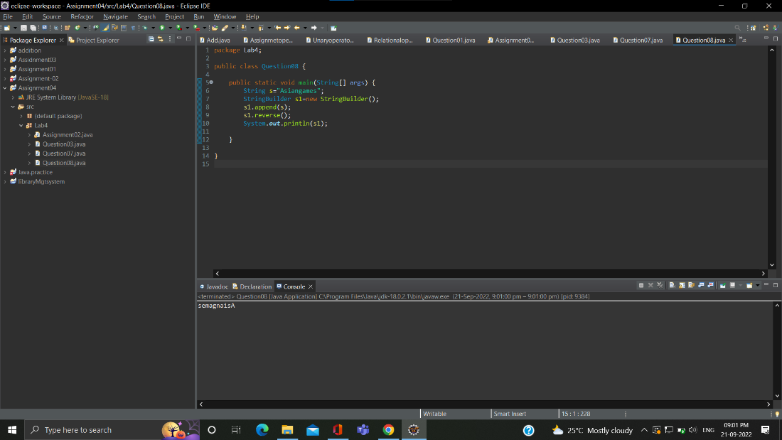

Que.09- Write a java program  **ask string from user and search for particular character in given string  .if found print " Found message " else print “not found"**

Ans.- package Lab4;

import java.util.Scanner;

public class Question09 {

public static void main(String[] args) {

System.out.println(" Enter a string = ");

Scanner s = new Scanner(System.in);

String s1 = s.next();

char ch = 'a';

for(int i=0;i<s1.length();i++) {

if(ch==s1.charAt(i))

{

System.out.println("character "+ch+" is found");break;

}

else System.out.println("char is not found");

}

}

}

