**Assignment-03**

**Name.- Ghansham A. Kamble.**

**S.No.- 47**

**Que.-**  wap to print number 1 to 100.

**Ans.-**

**public class Question01 {**

**public static void main(String[] args) {**

**int n = 100;**

**System.out.print("Numbers from 1 to "+n+" are: ");**

**for (int i = 1; i <= n; i++) {**

**System.out.print(i + " ");**

**}**

**}**

**}**

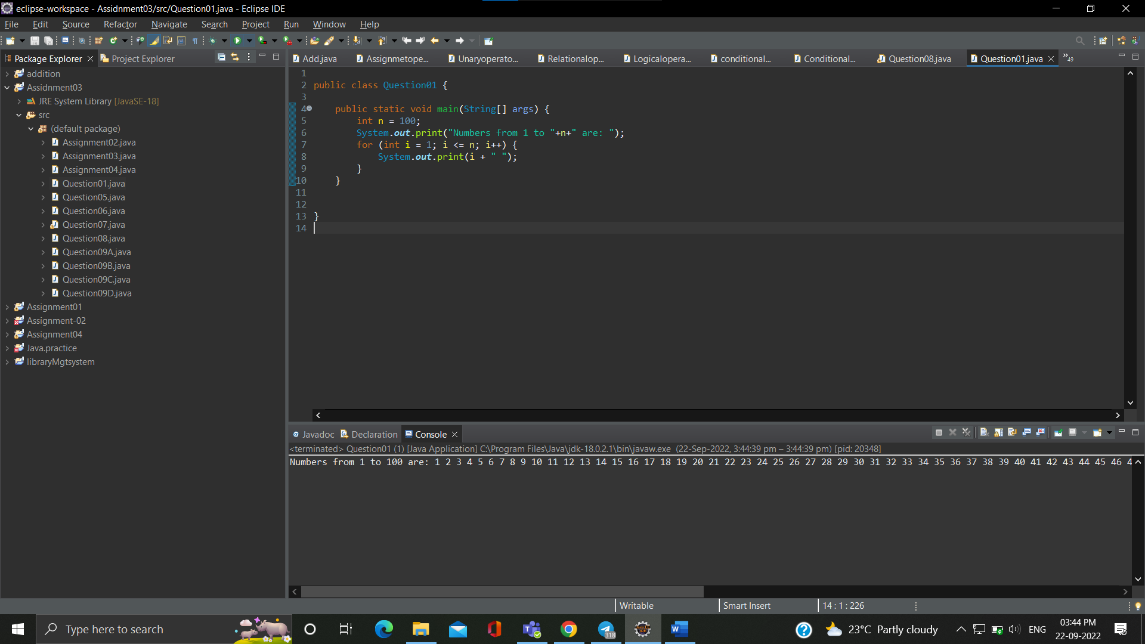

**Que.-** wap to print even numbers between 1 to 20

**Ans.-**

**public class Assignment02 {**

**public static void main(String[] args) {**

**int j;**

**for(j=1;j<=20;j++) {**

**if(j%2==0)**

**System.out.print(" "+j);**

**}**

**}**

**}**

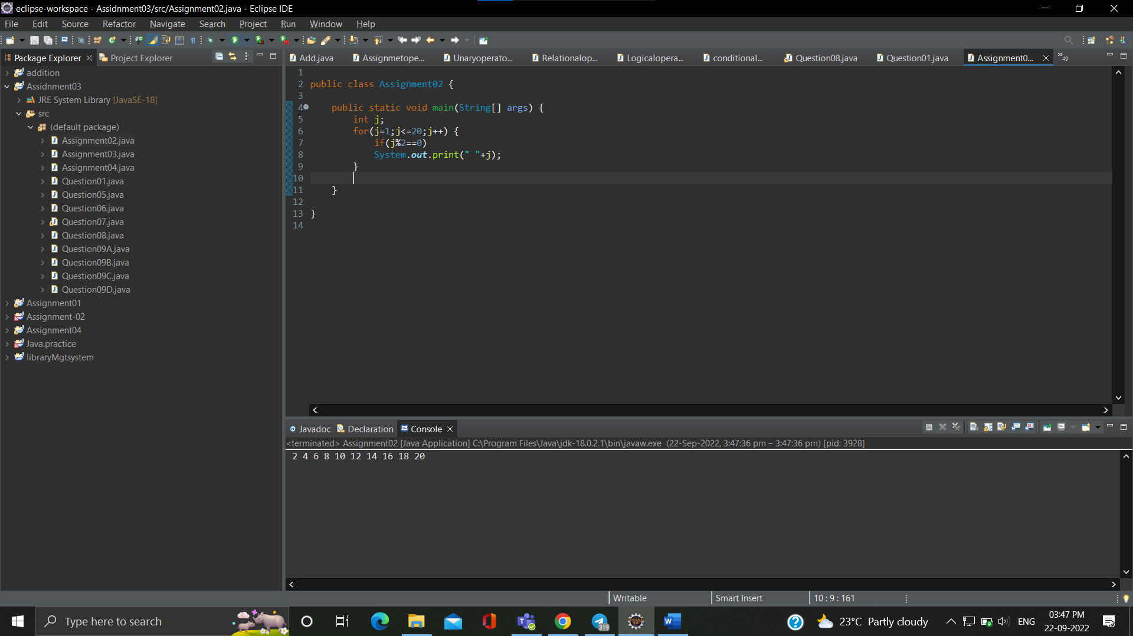

**Que.-** wap to print cube of 1 to 5 number.

**Ans.-**

**public class Assignment03 {**

**public static void main(String[] args) {**

**int d;**

**for(d=1;d<=5;d++) {**

**System.out.print(" "+d*d*d);**

**}**

**}**

**}**

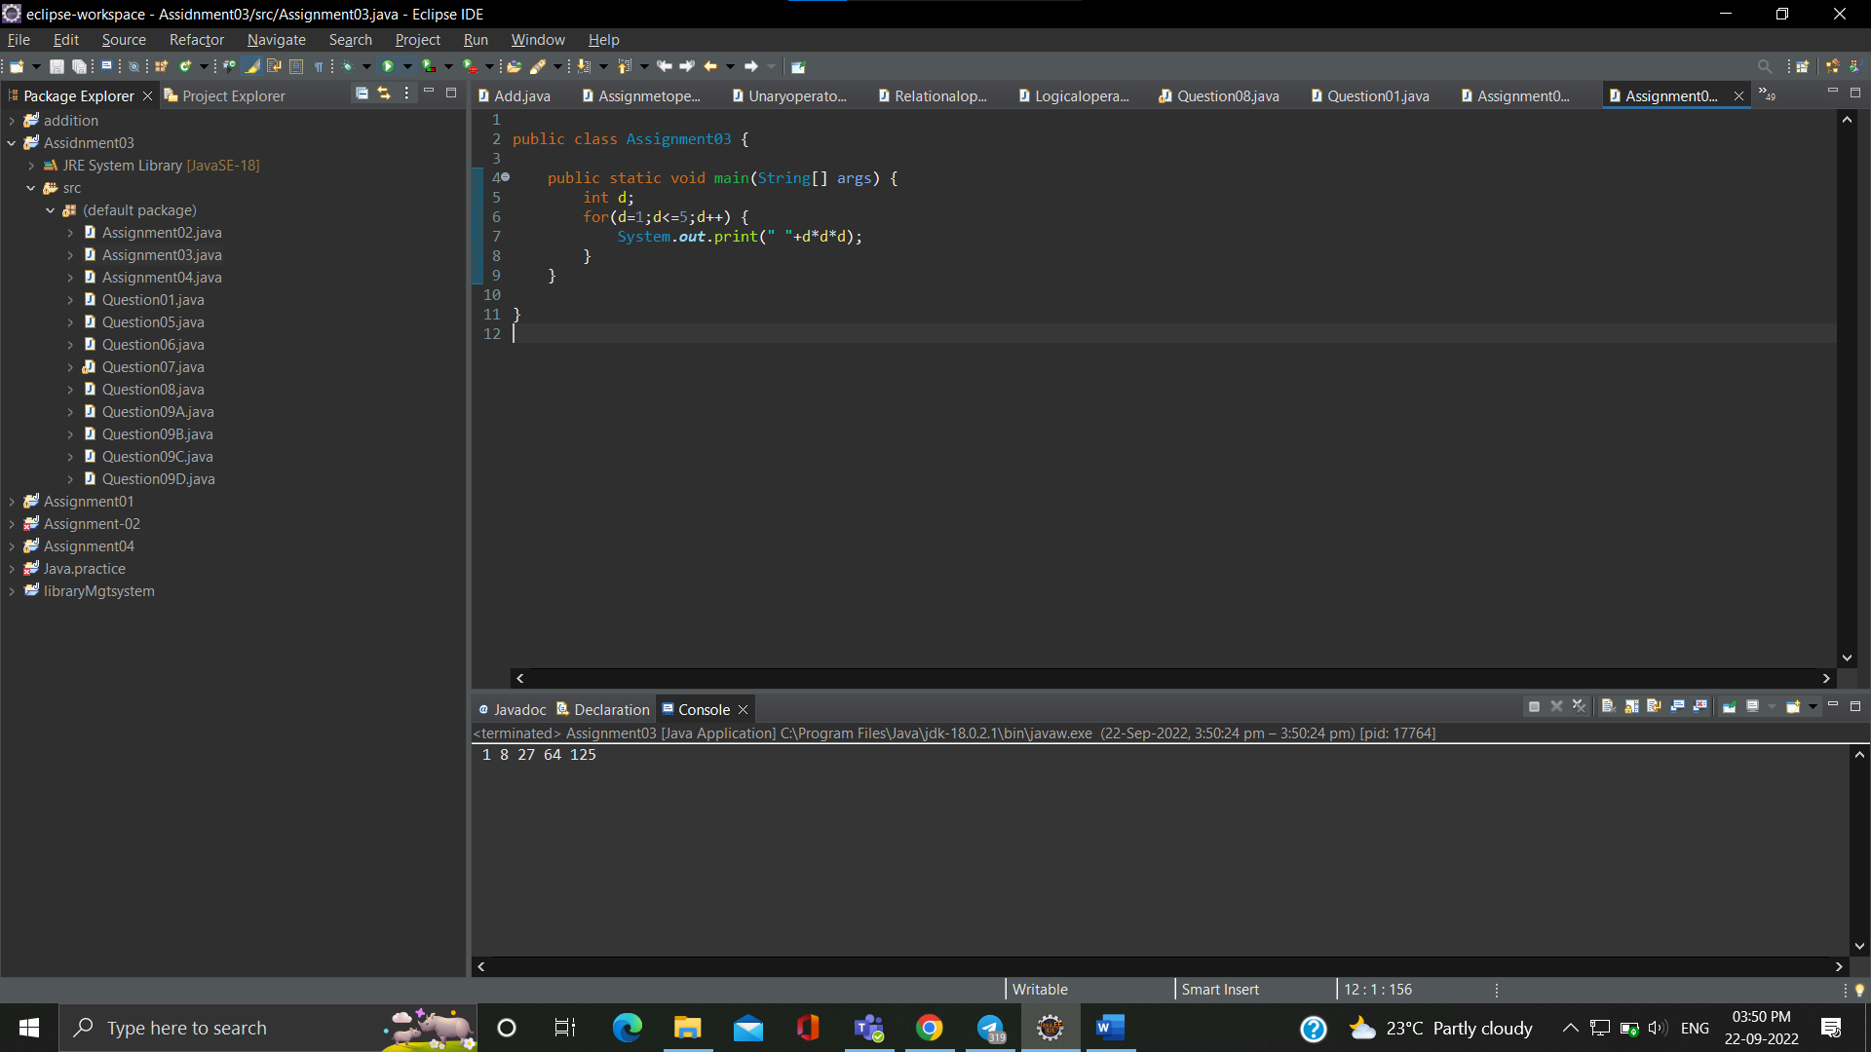

**Que.04-**wap to check if a number is prime or not .

**Ans.-**

**public class Assignment04 {**

**public static void main(String[] args) {**

**int a =23, i;**

**int flag =0;**

**for(i=2;i<a/2;i++) {**

**if(a%i==0) {**

**flag=1;**

**break;**

**}**

**}**

**if(flag==0)System.out.println(a + " is a prime number");**

**else System.out.println(a + " is not a prime number");**

**}**

**}**

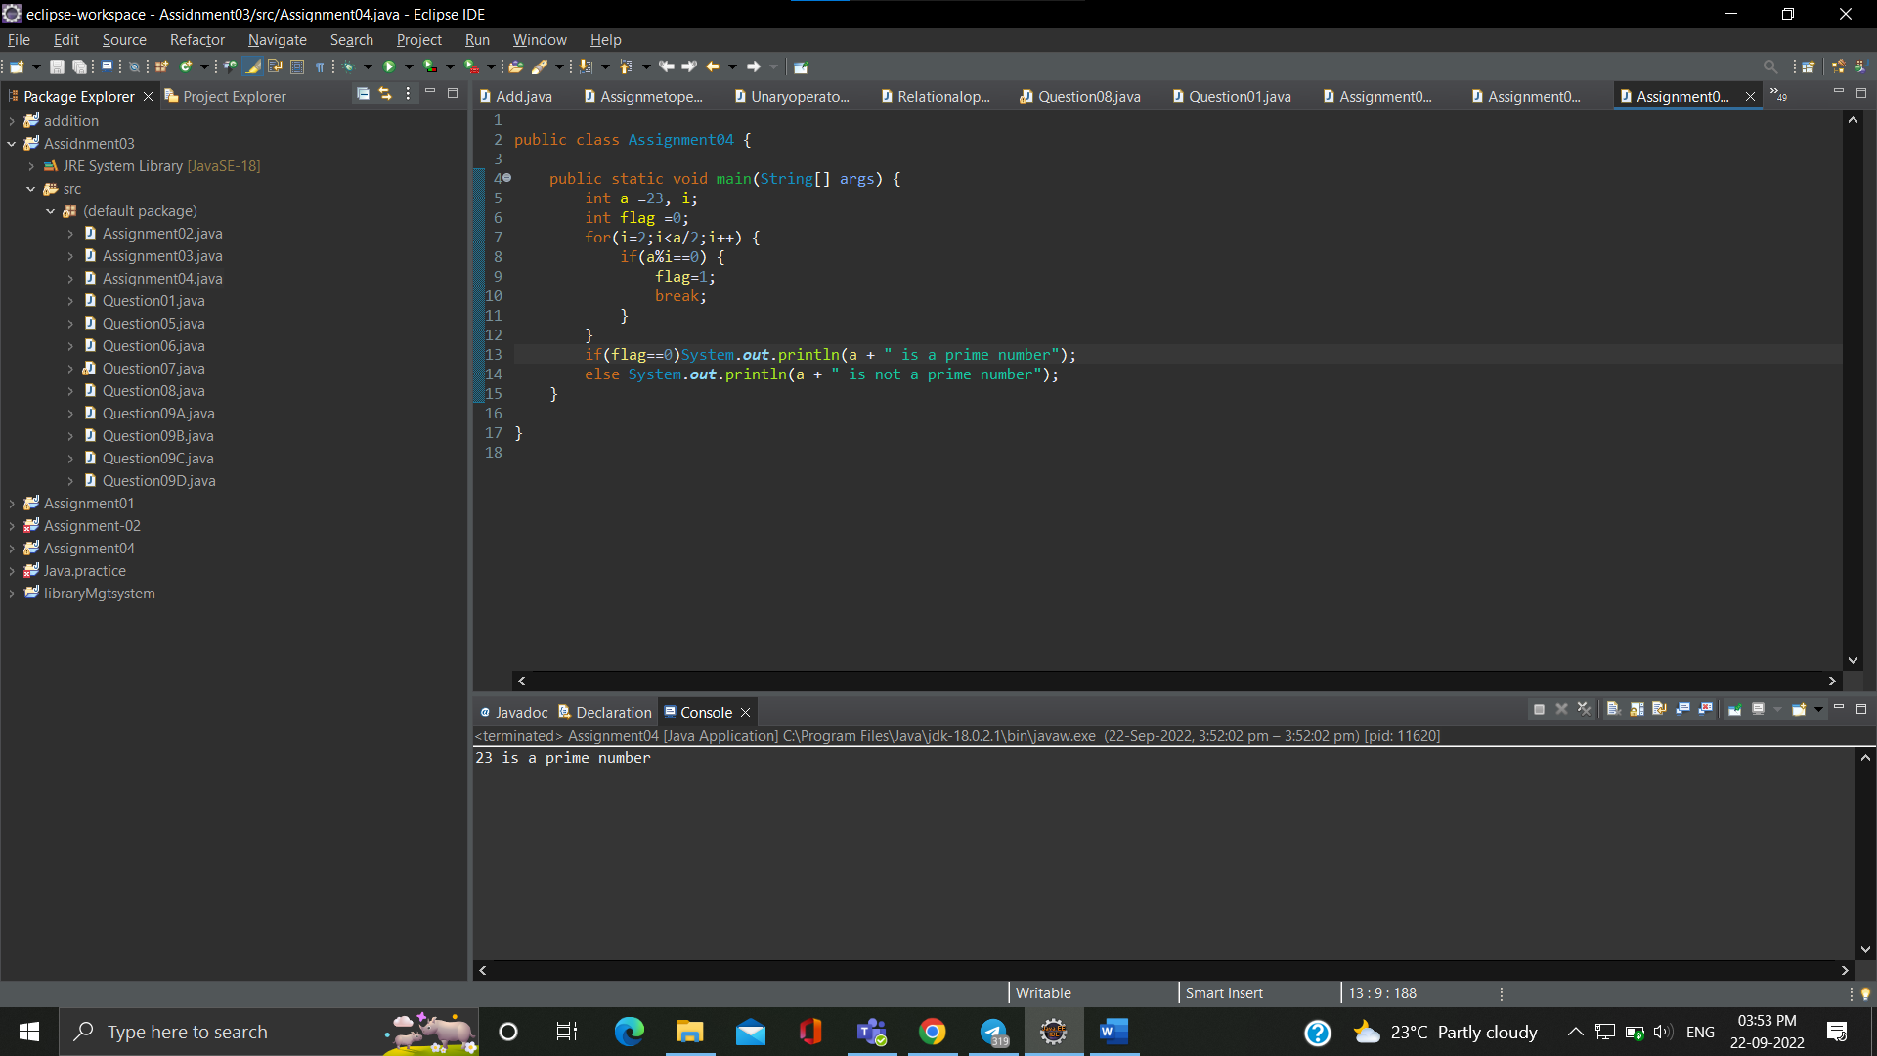

**Que.05-** wap to print fibonacci series using for loop i.e adding last two results  
ex  0 1 1 2 3 5 8 13 21 34

**Ans.-**

**public class Question05 {**

**public static void main(String[] args) {**

**int n1=0, n2=1, n3, i, count=10;**

**System.out.print(n1+" "+n2);**

**for(i=2;i<=count;i++) {**

**n3=n1+n2;**

**System.out.print(" "+n3);**

**n1=n2;**

**n2=n3;**

**}**

**}**

**}**

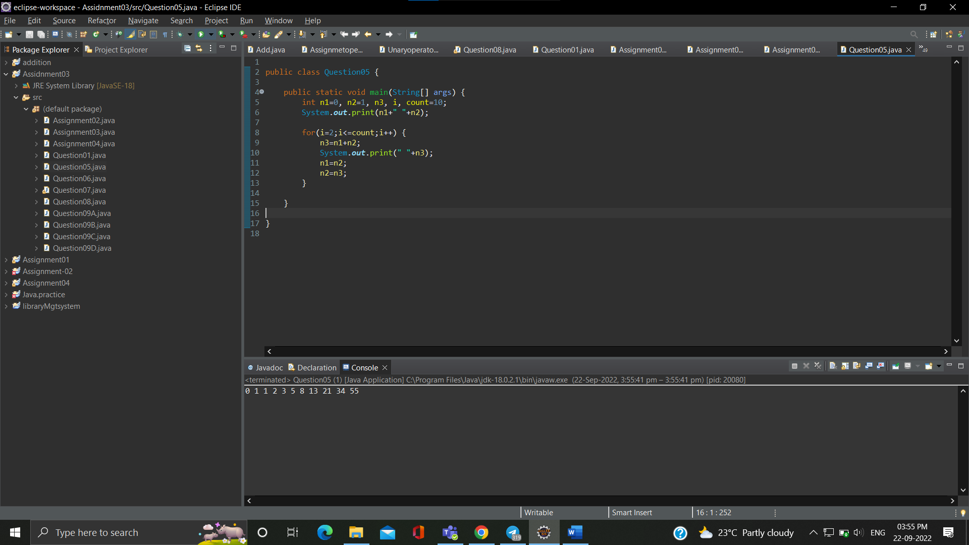

**Que.06-** wap to print factorial of a number  
   5*4*3*2*1

**Ans.-**

**public class Question06 {**

**public static void main(String[] args) {**

**int i, num=5, fact=1;**

**for(i=num;i>=1;i--) {**

**fact=fact*i;**

**}**

**System.out.println("factorial of "+num+" is "+fact);**

**}**

**}**

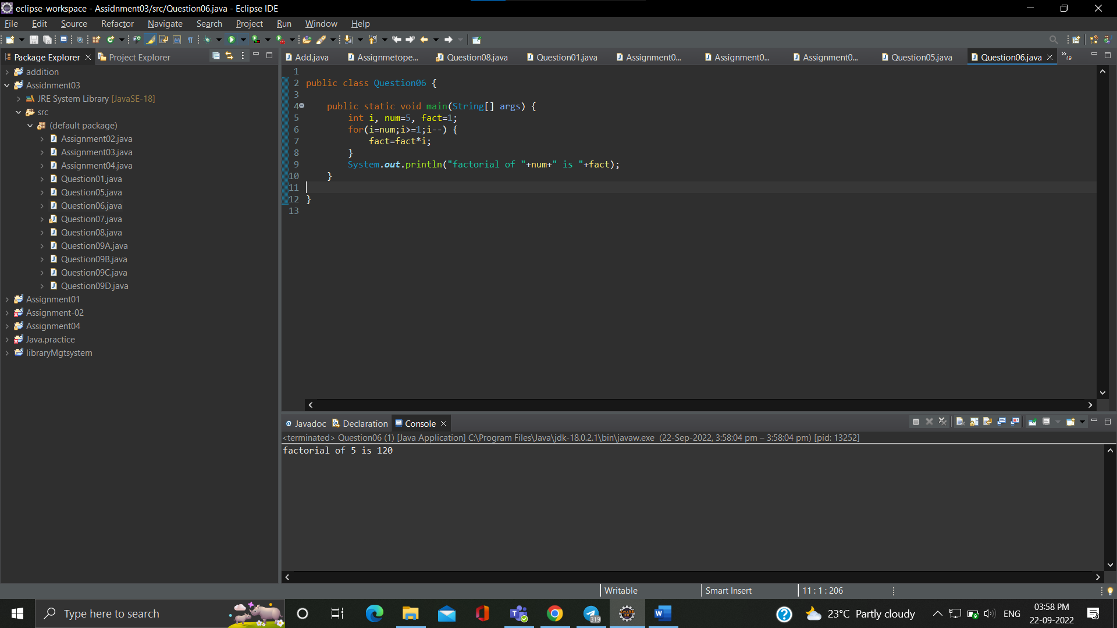

**Que.07-** wap to ask a number from user and print table of that number

**Ans.-**

**import java.util.*;**

**public class Question07 {**

**public static void main(String[] args) {**

**System.out.println("Enter a number ");**

**Scanner z = new Scanner(System.in);**

**int i = z.nextInt();**

**for(int j=1;j<=10;j++) {**

**int k=i*j;**

**System.out.print(" "+k);**

**}**

**}**

**}**

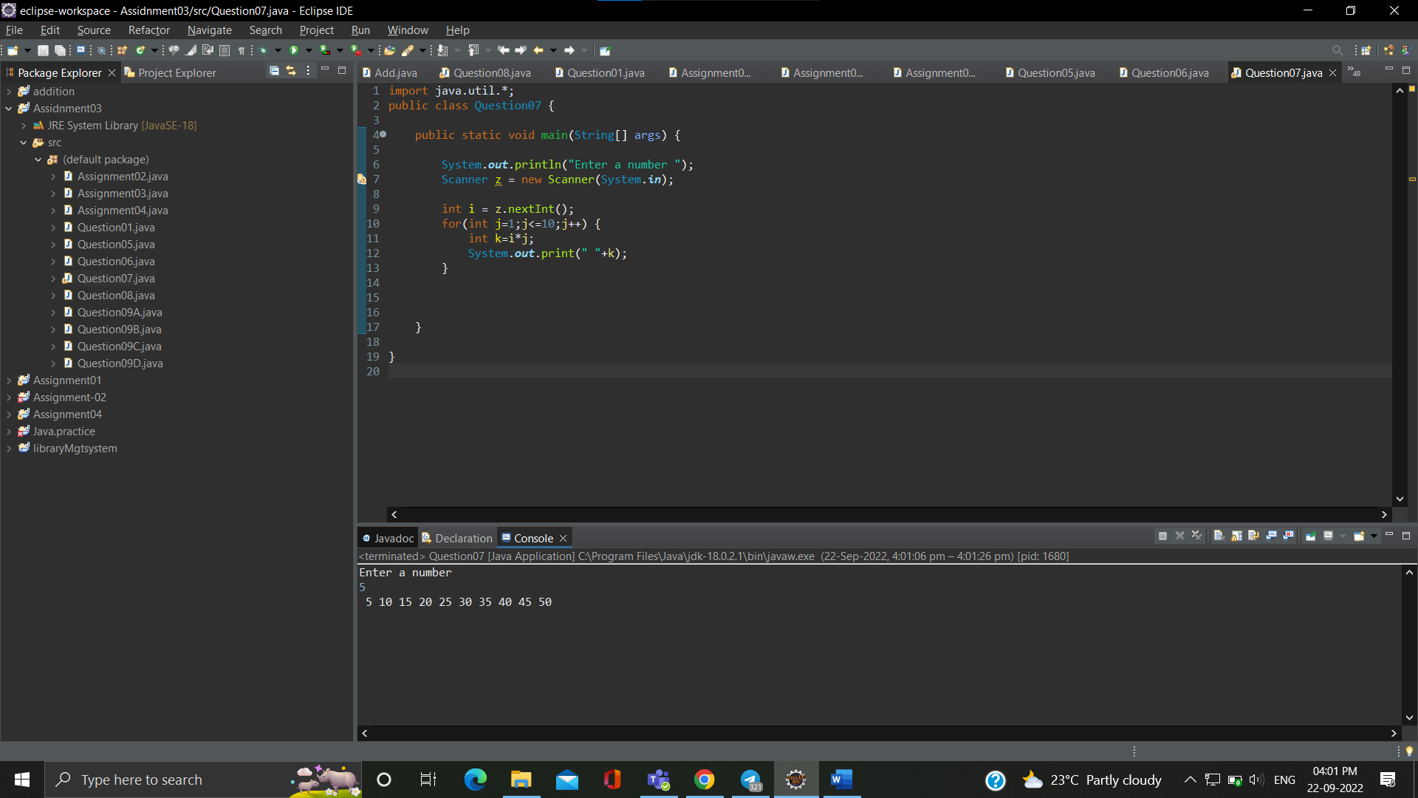

**Que.08-**wap to print prime numbers between 2 to 20

**Ans.-**

**public class Question08 {**

**public static void main(String[] args) {**

**int num=20, count;**

**for(int i=1;i<=num;i++) {**

**count=0;**

**for(int j=2;j<=i/2;j++) {**

**if(i%j==0) {**

**count++;**

**break;**

**}**

**} if(count==0)**

**System.out.print(i+" ");**

**}**

**}**

**}**

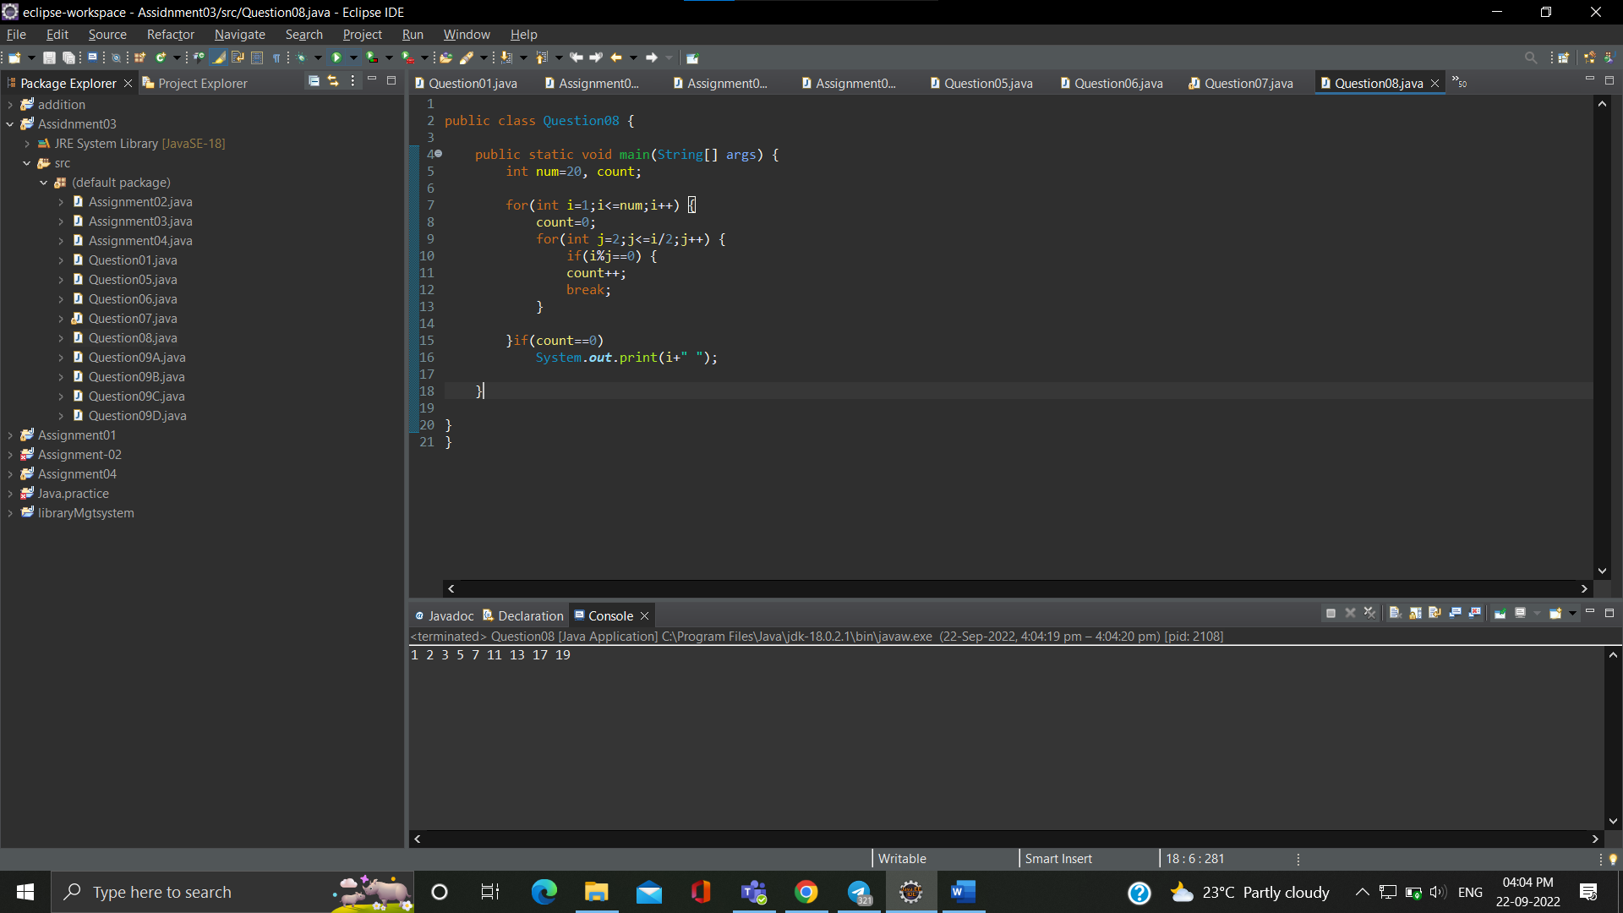

**Que.09-print patterns like   
 *  
 **   
 ***  
 ****  
 \*\*\*\*\***

**Ans.-**

**public class Question09A {**

**public static void main(String[] args) {**

**int i, j;**

**for(i=1;i<=4;i++) {**

**for(j=1;j<=i;j++) {**

**System.out.print(" * ");**

**}System.out.println();**

**}**

**}**

**}**

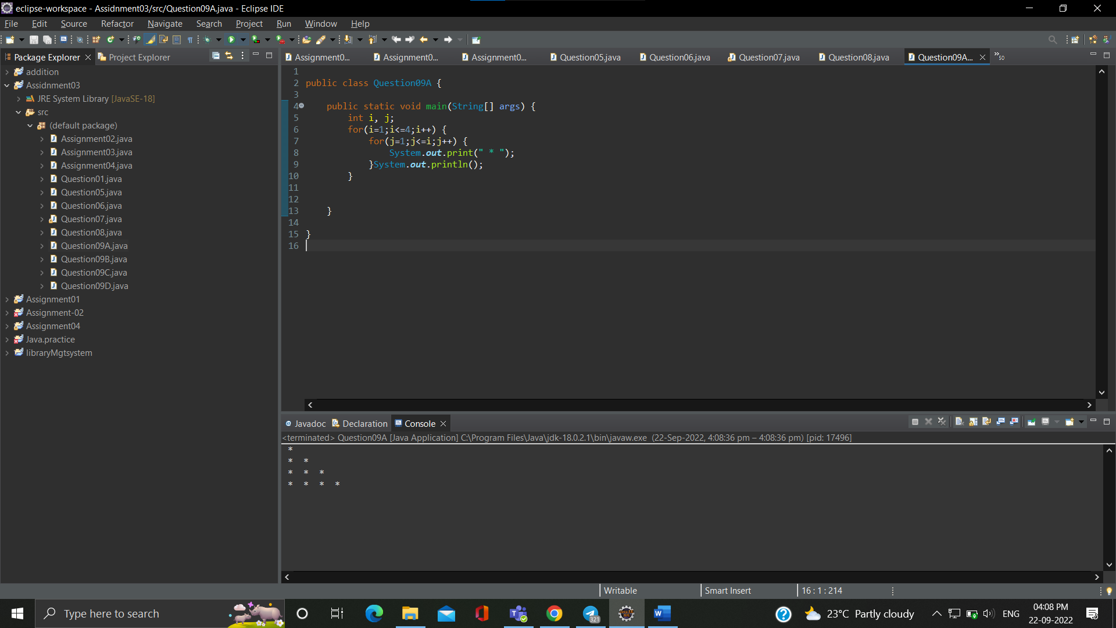

**Que.-** 1  
      1 2   
      1 2 3   
    1 2 3 4  
    1 2 3 4 5

**Ans.-**

**public class Question09B {**

**public static void main(String[] args) {**

**int i,j;**

**for(i=1;i<=5;i++) {**

**for(j=1;j<=i;j++){**

**System.out.print(j);**

**}System.out.println( );**

**}**

**}**

**}**

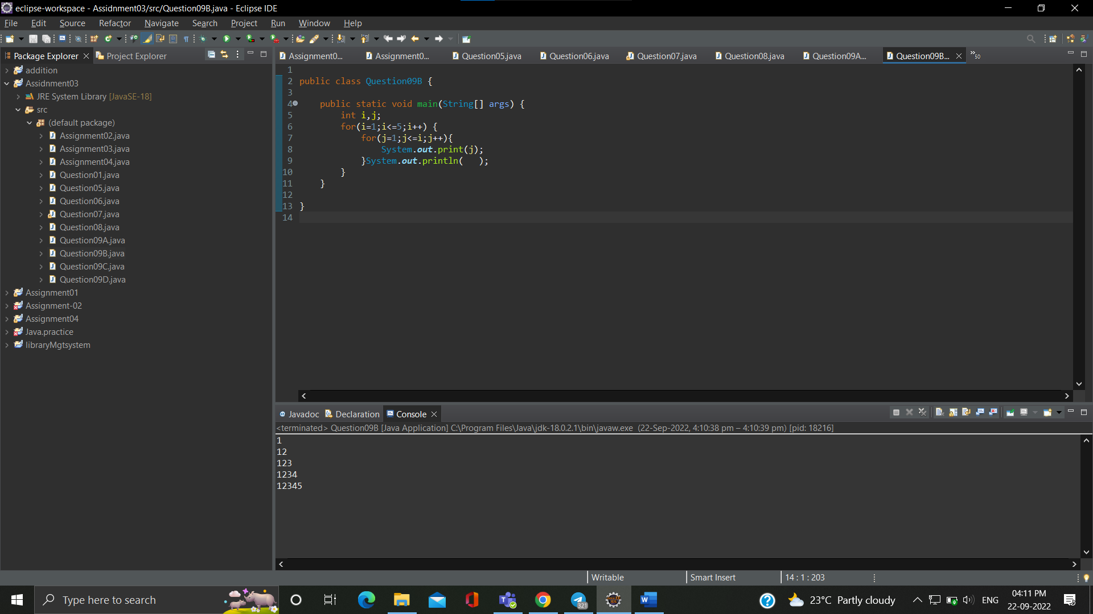

**Que.-C** A B  C D  
    A B  C  
    A  B   
    A

**Ans.-**

**public class Question09C {**

**public static void main(String[] args) {**

**int i, j;**

**int ch =65;**

**for (i = 0; i <4; i++)**

**{**

**for (j = 0; j <4-i; j++)**

**{**

**System.out.print((char)(ch+j) + " ");**

**}**

**System.out.print("\n");**

**} } }**

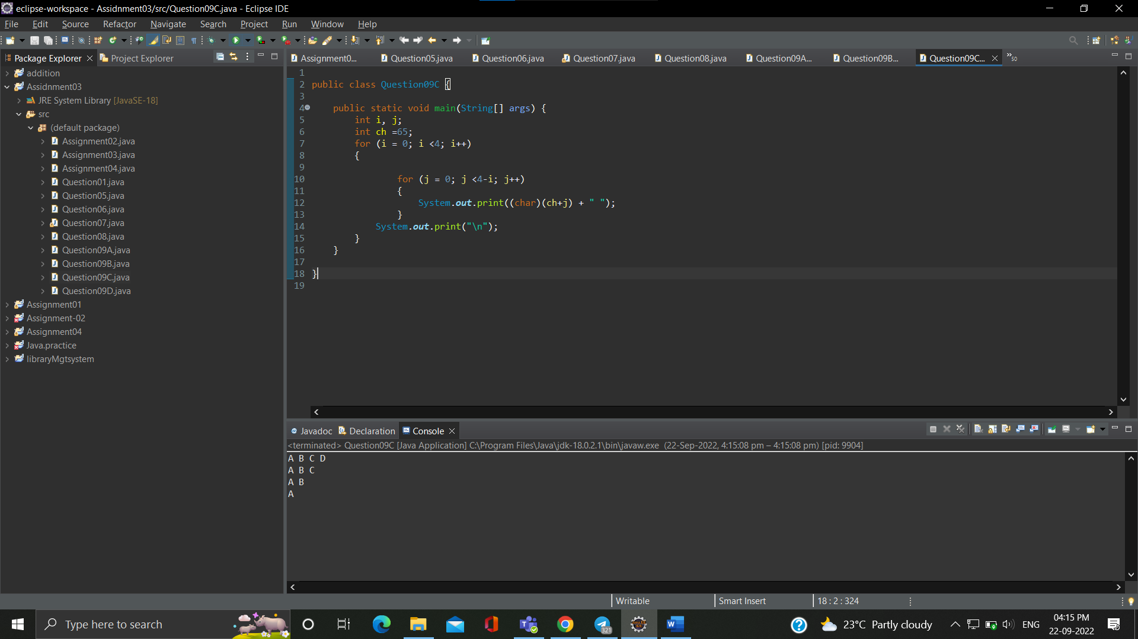

**Que.D-**  A B C D  D C B A  
      A B C         C B A   
     A B                 B A  
   A                        A

**Ans.-**

**public class Question09D {**

**public static void main(String[] args) {**

**int i,j;**

**char r = 'A';**

**int space=0;**

**for(i=1;i<=4;i++) {**

**r='A';**

**for(j=4;j>=i;j--) {**

**System.out.print(r);**

**r++;**

**}**

**for(int l=0;l<space;l++)System.out.print(" ");**

**for(j=4;j>=i;j--) {**

**System.out.print(r);**

**r--;**

**}**

**space=space+2;**

**System.out.println();**

**}**

**}**

**}**

