# System User Manual

## Student Transportation System

The bus management system is designed to help TUT students and management of transportation.

The system will allow students to book/reserve a bus seat in advance ahead. The student will be allowed to view their booking history and even make changes if a mistake has been made.

The bus administration will be allowed to view the booking history, and also be allowed to add/call another bus in cases of bus-full especially during exams whereas a morning bus is full & student need to get to campus. It will allow them to know which number of people to expect at a certain time at a certain bus terminal.

The softwares used to build this website is

* Visual Studio Code
* XAMMP

The languages used for this website is

* HTML
* CSS
* JAVASCRIPT
* PHP
* MYSQL

**Login section**

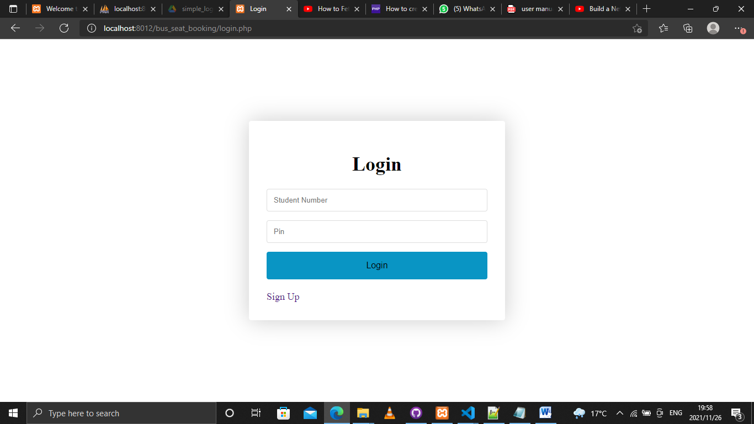

**Singup section**

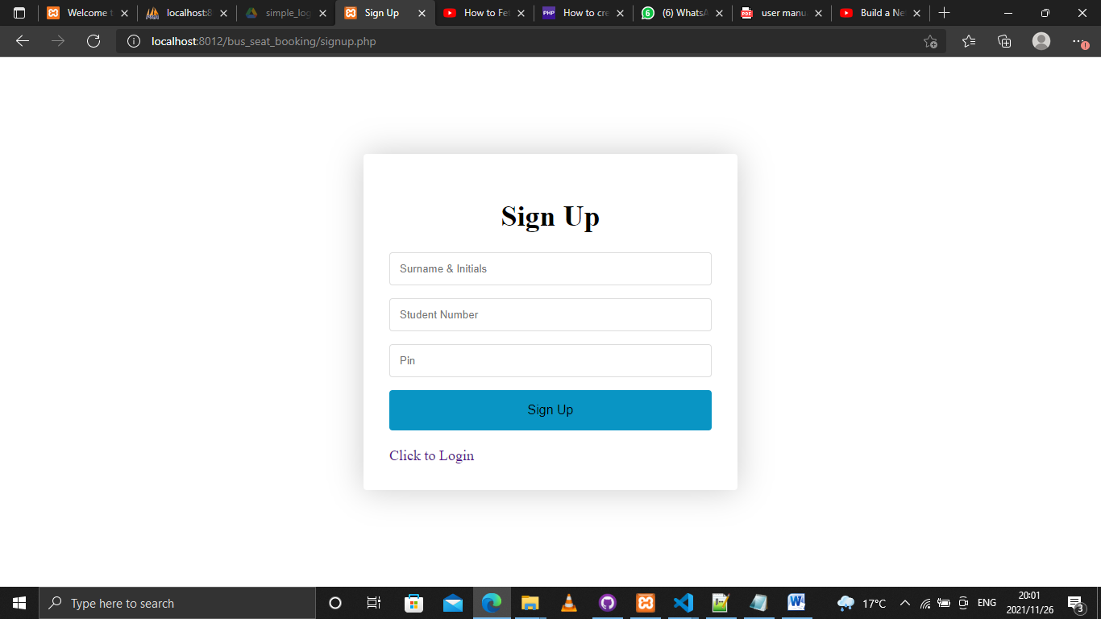

**Booking Section**

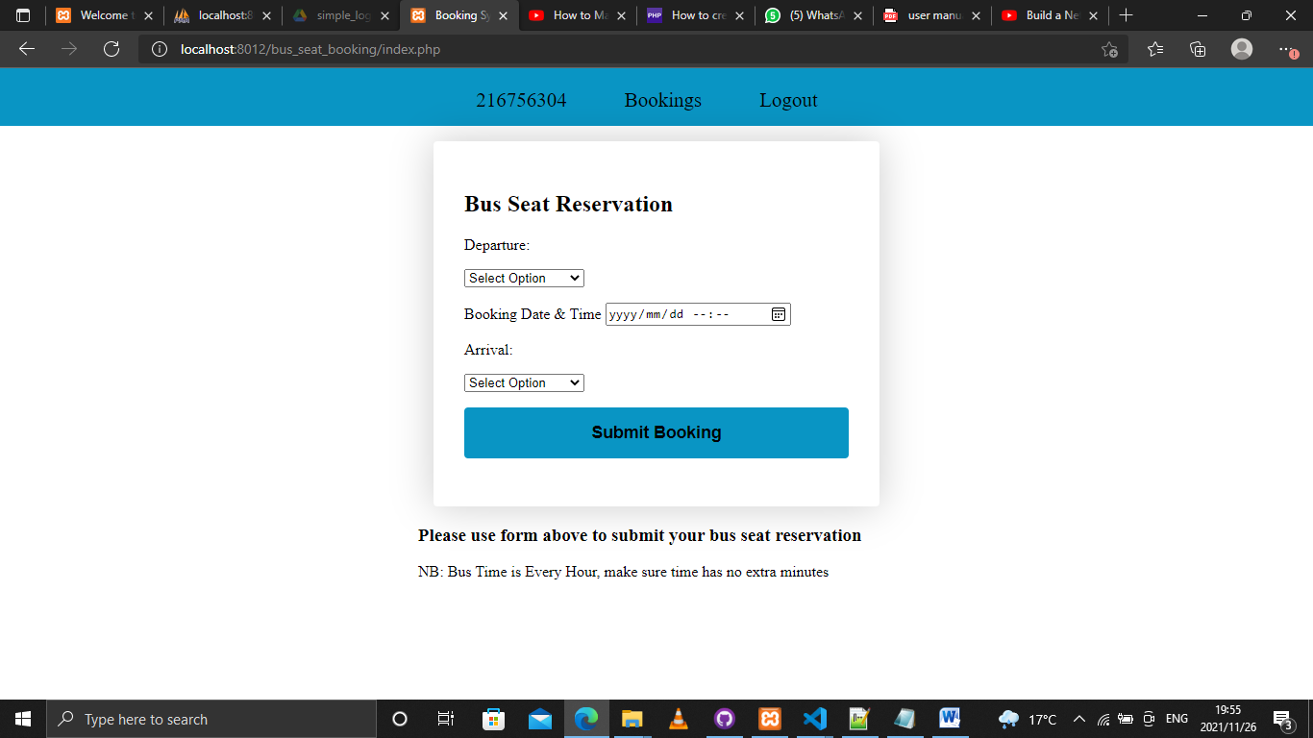

**Student’s Booking history**

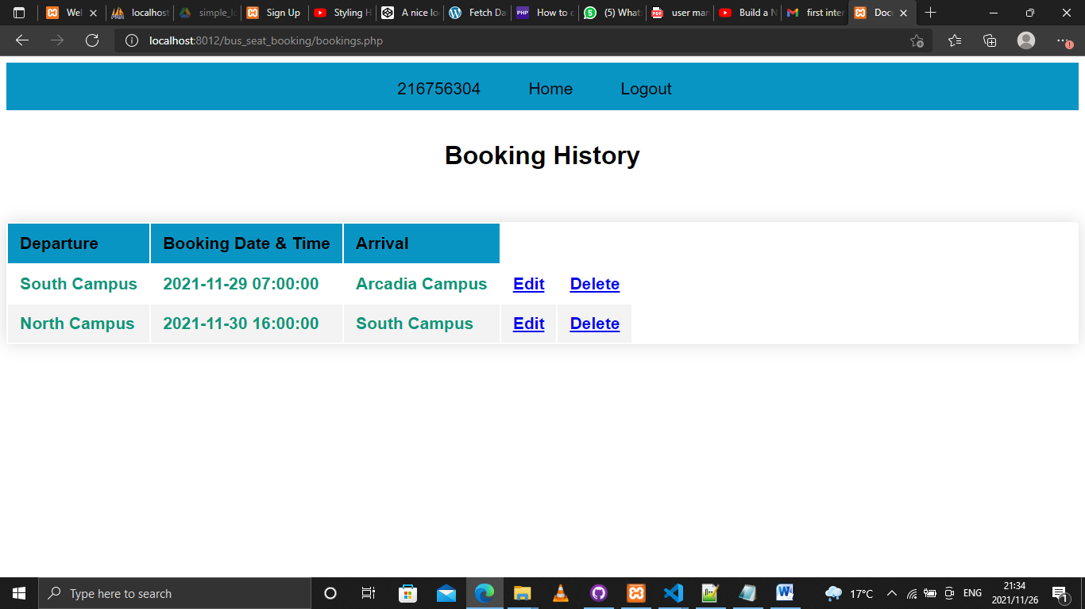

**Databases**

