KB_Molekoa_223006728_Graded_Lab_1

Link: <https://github.com/KgopotsoK/Graded_Lab_1.git>

**Before**

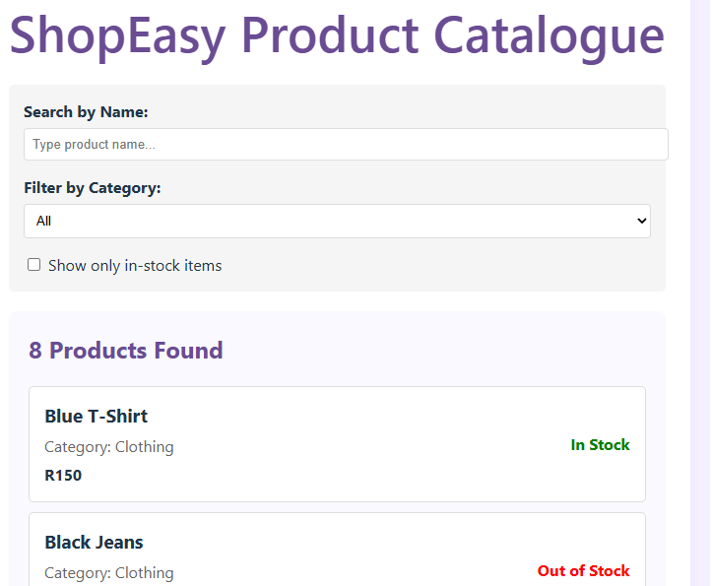

**After**

