We do map coloring with 3 colors {red, green, blue} such that adjacent regions must be assigned different colors. Can this Constraint Satisfaction Problem (CSP) be solved with the current assignment?

**A**

Yes

**B**

No

@@@@@@@@@@@@@@

We do map coloring with 3 colors {red, green, blue} such that adjacent regions must be assigned different colors. Can this Constraint Satisfaction Problem (CSP) be solved with the current assignment?

**A**

Yes

**B**

No

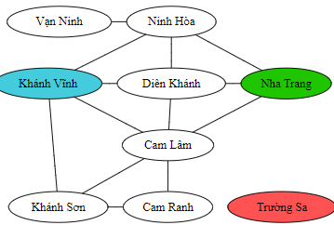

@@@@@@@@@@@@@@@@@@@@@@@@@@@

After coloring Cam Lâm green, we perform Forward Checking. Which of the following statement is correct?

**A**

The domain of the variable Nha Trang is {red, blue}.

**B**

The domain of the variable Khánh Sơn is empty.

**C**

The CSP can't be solved with the current color assignment.

**D**

All of the above are correct.

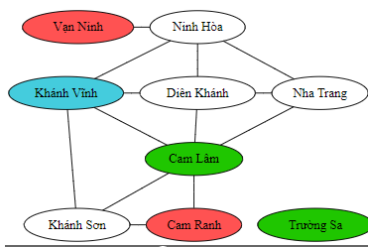

@@@@@@@@@@@@@@@@@@@@

We do map coloring with 3 colors {red, green, blue}. According to the Least-Constraining-Value ordering, which color should we choose to try for the node "Nha Trang" first?

**A**

Red

**B**

Green

**C**

Blue

**D**

Any of the above.

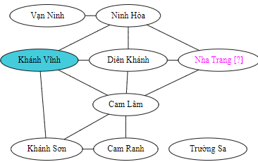

@@@@@@@@@@@@@@

According to the Minimum-Remaining-Value ordering, which variable should be chosen to be colored next?

**A**

Ninh Hòa

**B**

Diên Khánh

**C**

Cam Lâm

**D**

Khánh Sơn

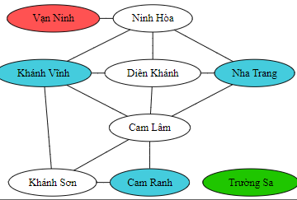

@@@@@@@@@@@@@@

Which method can help us detect failure early in the current color assignment?

**A**

Forward Checking

**B**

AC-3

**C**

Minimum Remaining Value

**D**

Least Constraining Value

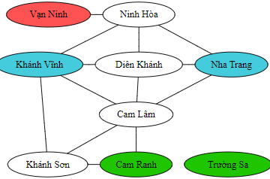

@@@@@@@@@@@@@@@@@@@@

According to the Minimum-Remaining-Value ordering, which variable should be chosen to color next?

**A**

Vạn Ninh

**B**

Khánh Sơn

**C**

Nha Trang

**D**

Diên Khánh

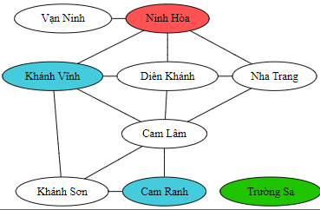

@@@@@@@@@@@@@@@@@@@@

According to the Least-Constraining-Value ordering, which color should we choose to try for the node Vạn Ninh first?

**A**

Red

**B**

Green

**C**

Blue

**D**

Any of the above.

@@@@@@@@@@@@@@@@@@@

After enforcing arc consistency for the whole graph, which color must be used for Ninh Hòa?

**A**

Red

**B**

Green

**C**

Blue

**D**

Red or Blue

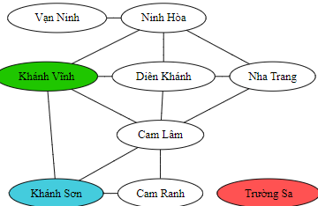

@@@@@@@@@@@@@@@@@@@@@

What is the smallest cutset in the following graph?

**A**

{A}

**B**

{B}

**C**

{A,B}

**D**

{A,B,C,D}

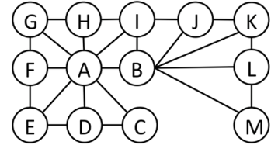

@@@@@@@@@@@@@

For tree-structured CSP, if all parent->child arcs are consistent, which of the following statement is correct.

**A**

Value assignments for variables can be done in the top-down order (from root to leaf nodes) without backtracking.

**B**

All child->parent arcs are also consistent.

**C**

Value assignment for variables can be done in the bottom-up order (from leaf nodes to root) without backtracking.

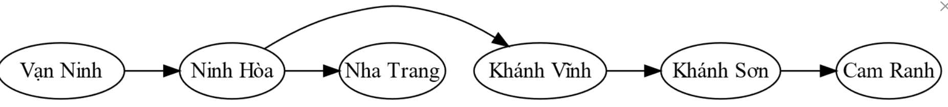

@@@@@@@@@@@@@@@@@@@@

For tree-structured CSPs, why don't we enforce arc consistency for parent->child arcs in the top-down order?

**A**

Because all child->parent arcs can't then be made consistent automatically while the bottom-up traversing can enforce that indirectly.

**B**

Because all parent->child arcs can't then be made consistent in just one top-down pass.

**C**

Because some nodes can have multiple children, and consistency can't be ensured for all parent->child arcs.

