Triangle nodes indicates the MAX player, while inverse triangle nodes indicate the MIN player. What is the Minimax value at node n0?

**A**

14

**B**

12

**C**

28

**D**

42

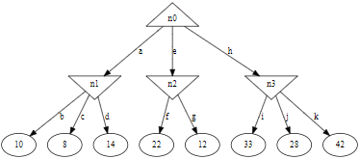

@@@@@@@@@@@@@@@

Using Alpha-Beta pruning, which branches can be pruned?

**A**

g

**B**

h

**C**

j

**D**

No branch can be pruned.

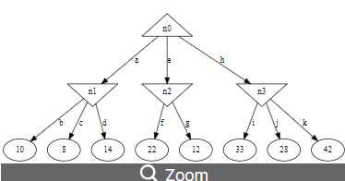

@@@@@@@@@@@@@@@@@@

Using Alpha-Beta pruning, which branches can be pruned?

**A**

g

**B**

h

**C**

g and h

**D**

g, j, and k

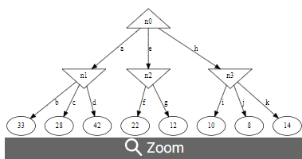

@@@@@@@@@@@@@@@@@@@@@

What is the Minimax value at node n0?

**A**

28

**B**

45

**C**

78

**D**

14

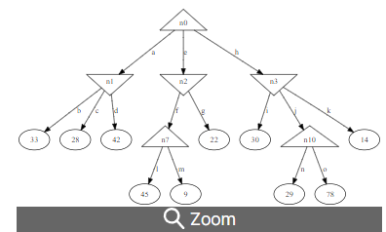

@@@@@@@@@@@@@@@@@

Using Alpha-Beta pruning, which branches can be pruned?

**A**

g

**B**

g, j, and k

**C**

g, o, and k

**D**

No branch can be pruned.

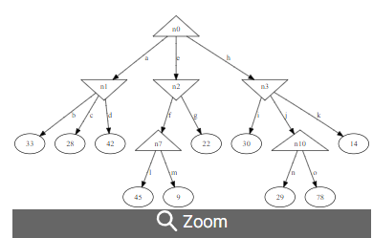

@@@@@@@@@@@@@@@@@@

Using Alpha-Beta pruning, which branches can be pruned?

**A**

f

**B**

f and j

**C**

f, j, and k

**D**

No branch can be pruned.

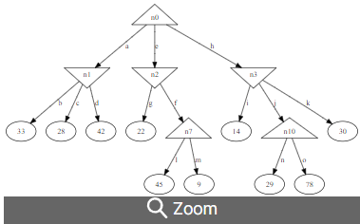

@@@@@@@@@@@@@@@@@@@@@@@@@@

Can Alpha-Beta pruning change the Minimax value at the root node?

**A**

Yes

**B**

No

@@@@@@@@@@@@@@@@@@@@@@@@@@

What is the search algorithm underlying Minimax search?

**A**

Depth-first search

**B**

Breadth-first search

**C**

Greedy search

**D**

Uniform-cost search