### Question 1[¶](https://cf-courses-data.static.labs.skills.network/jupyterlite/2.5.5/lab/index.html?mode=learn&env_type=jupyterlite&notebook_url=https://cf-courses-data.static.labs.skills.network/IBMDeveloperSkillsNetwork-DA0101EN-SkillsNetwork/labs/Module_6/House_Sales_in_King_Count_USA-20231003-1696291200.jupyterlite.ipynb&file_path=DA0101EN/labs/Module+6/House_Sales_in_King_Count_USA.ipynb" \l "Question-1" \t "https://cf-courses-data.static.labs.skills.network/jupyterlite/2.5.5/lab/_self)

Display the data types of each column using the function dtypes. Take a screenshot of your code and output. You will need to submit the screenshot for the final project.

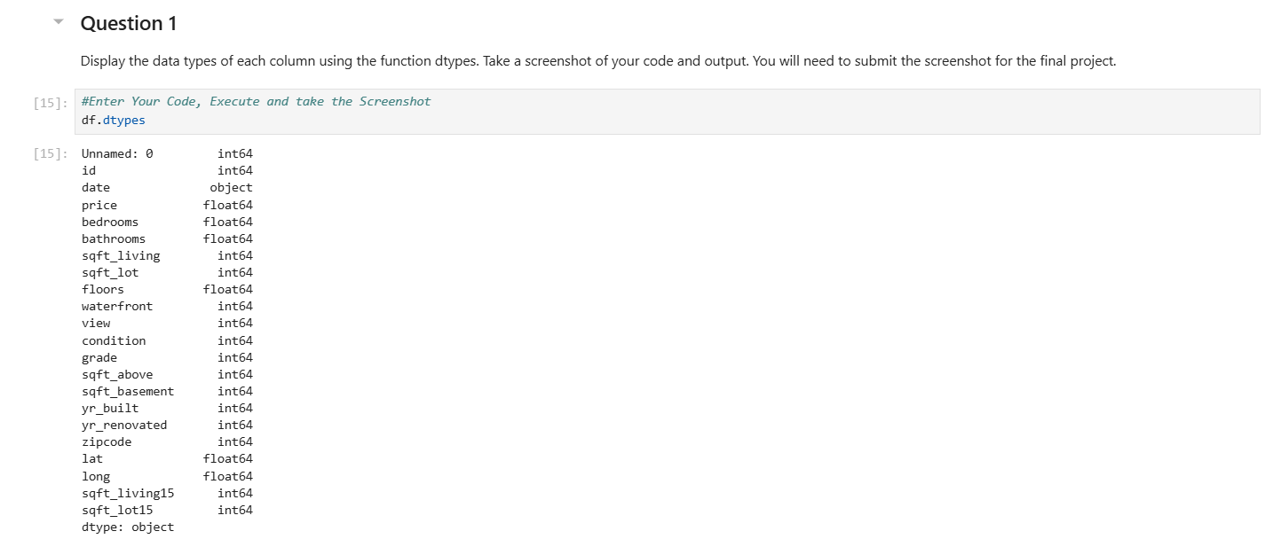

### Question 2

Drop the columns "id" and "Unnamed: 0" from axis 1 using the method drop(), then use the method describe() to obtain a statistical summary of the data. Make sure the inplace parameter is set to True. Take a screenshot of your code and output. You will need to submit the screenshot for the final project.

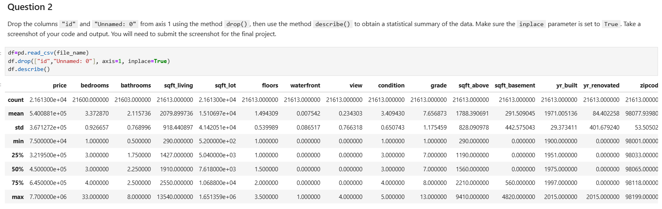

### Question 3

Use the method value_counts to count the number of houses with unique floor values, use the method .to_frame() to convert it to a data frame. Take a screenshot of your code and output. You will need to submit the screenshot for the final project.

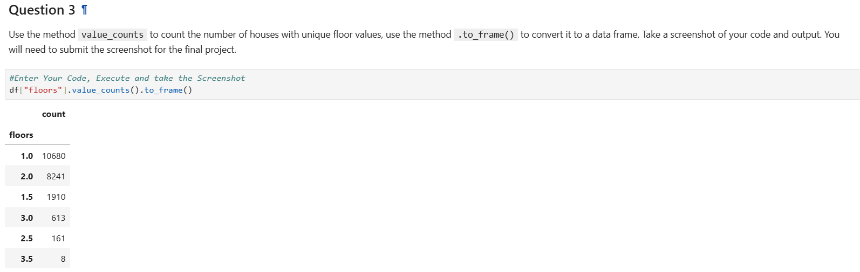

### Question 4

Use the function boxplot in the seaborn library to determine whether houses with a waterfront view or without a waterfront view have more price outliers. Take a screenshot of your code and boxplot. You will need to submit the screenshot for the final project.

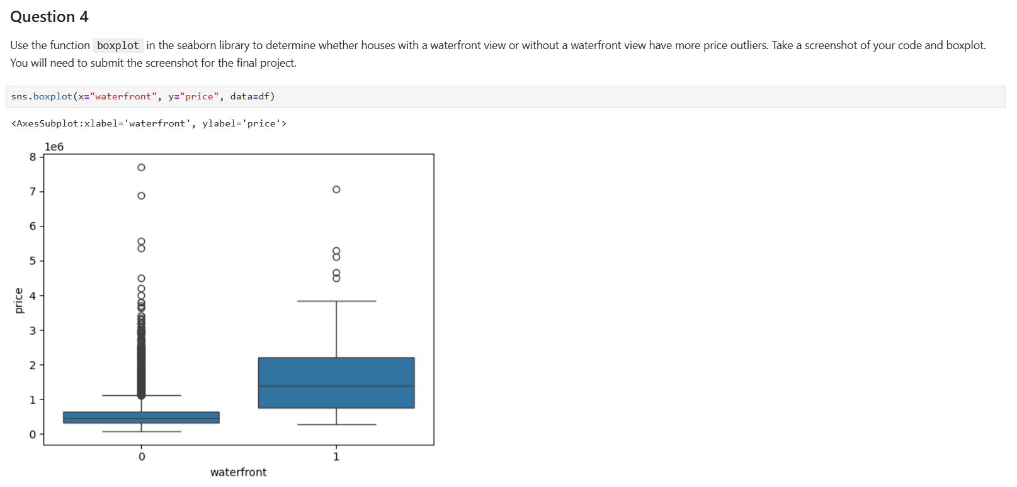

### Question 5

Use the function regplot in the seaborn library to determine if the feature sqft_above is negatively or positively correlated with price. Take a screenshot of your code and scatterplot. You will need to submit the screenshot for the final project.

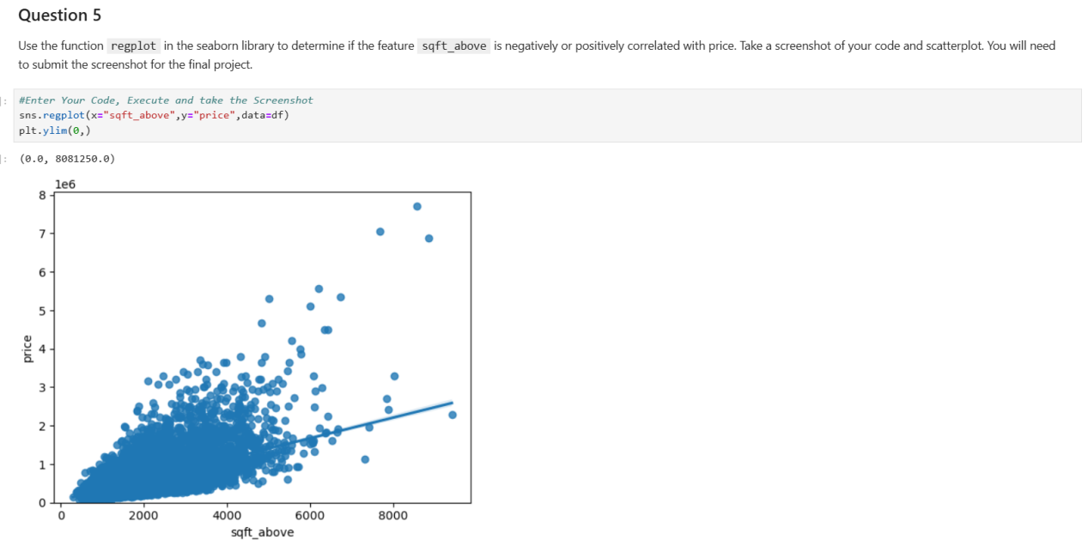

### Question 6

Fit a linear regression model to predict the 'price' using the feature 'sqft_living' then calculate the R^2. Take a screenshot of your code and the value of the R^2. You will need to submit it for the final project.

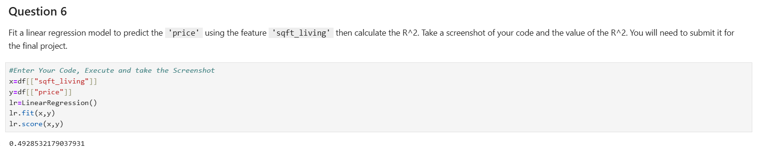

### Question 7[¶](https://cf-courses-data.static.labs.skills.network/jupyterlite/2.5.5/lab/index.html?mode=learn&env_type=jupyterlite&notebook_url=https://cf-courses-data.static.labs.skills.network/IBMDeveloperSkillsNetwork-DA0101EN-SkillsNetwork/labs/Module_6/House_Sales_in_King_Count_USA-20231003-1696291200.jupyterlite.ipynb&file_path=DA0101EN/labs/Module+6/House_Sales_in_King_Count_USA.ipynb" \l "Question-7" \t "https://cf-courses-data.static.labs.skills.network/jupyterlite/2.5.5/lab/_self)

Fit a linear regression model to predict the 'price' using the list of features:

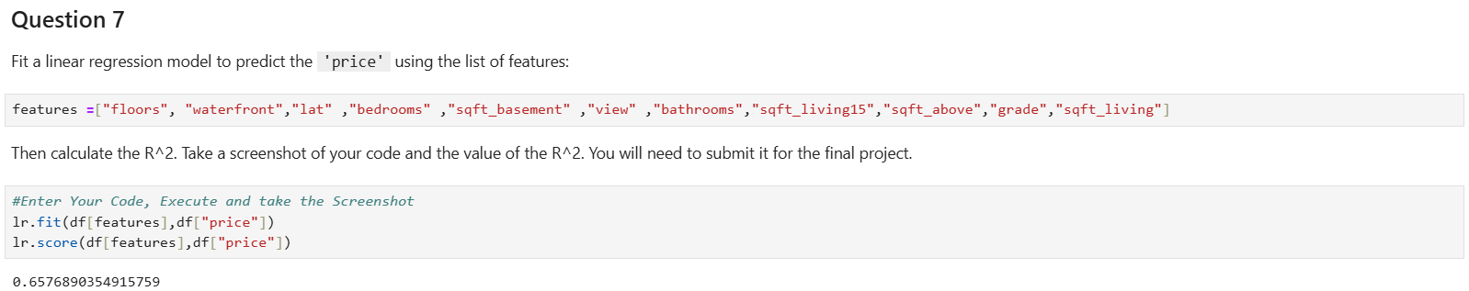

### Question 8[¶](https://cf-courses-data.static.labs.skills.network/jupyterlite/2.5.5/lab/index.html?mode=learn&env_type=jupyterlite&notebook_url=https://cf-courses-data.static.labs.skills.network/IBMDeveloperSkillsNetwork-DA0101EN-SkillsNetwork/labs/Module_6/House_Sales_in_King_Count_USA-20231003-1696291200.jupyterlite.ipynb&file_path=DA0101EN/labs/Module+6/House_Sales_in_King_Count_USA.ipynb" \l "Question-8" \t "https://cf-courses-data.static.labs.skills.network/jupyterlite/2.5.5/lab/_self)

Use the list to create a pipeline object to predict the 'price', fit the object using the features in the list features, and calculate the R^2. Take a screenshot of your code and the value of the R^2. You will need to submit it for the final project.

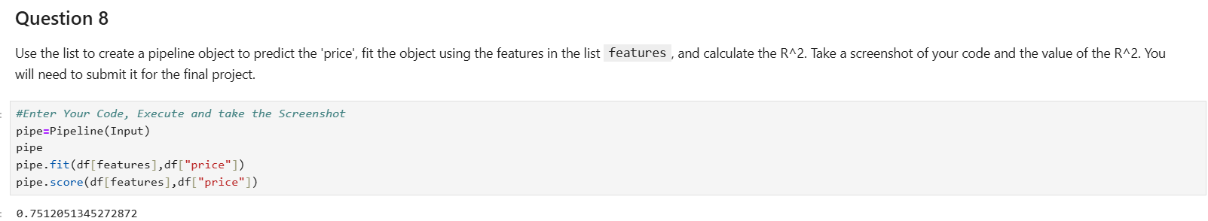

### Question 9[¶](https://cf-courses-data.static.labs.skills.network/jupyterlite/2.5.5/lab/index.html?mode=learn&env_type=jupyterlite&notebook_url=https://cf-courses-data.static.labs.skills.network/IBMDeveloperSkillsNetwork-DA0101EN-SkillsNetwork/labs/Module_6/House_Sales_in_King_Count_USA-20231003-1696291200.jupyterlite.ipynb&file_path=DA0101EN/labs/Module+6/House_Sales_in_King_Count_USA.ipynb" \l "Question-9" \t "https://cf-courses-data.static.labs.skills.network/jupyterlite/2.5.5/lab/_self)

Create and fit a Ridge regression object using the training data, set the regularization parameter to 0.1, and calculate the R^2 using the test data. Take a screenshot of your code and the value of the R^2. You will need to submit it for the final project.

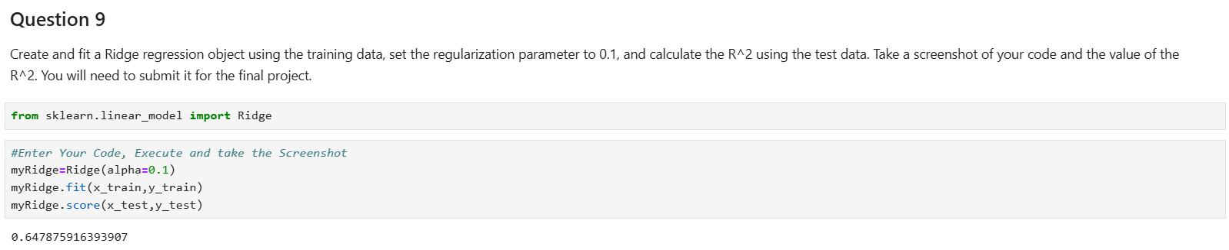

### Question 10

Perform a second order polynomial transform on both the training data and testing data. Create and fit a Ridge regression object using the training data, set the regularisation parameter to 0.1, and calculate the R^2 utilising the test data provided. Take a screenshot of your code and the R^2. You will need to submit it for the final project.

