Intro2SE - Project Proposal - GroupID

Project Name

The student team is required to complete the Project Proposal documentation for the assigned course project, following the attached template.


Software Engineering Department
Faculty of Information and Technology
VNU-HCMUS

Table of Contents
Objectives 1
1 Member Contribution Assessment 2
2 Preliminary Problem Statement 3
3 Proposed Solution 4
4 Development Plan 5
5 Human Resources & Costing Plan 7
6 Tools setup 8
7 AI Usage Declaration 10
8 Presentation 11
9 Reflective Report 12

Project Proposal

Objectives
This document focus on the following topics:
- Completing the Project Proposal document with the following sections:
  - Preliminary Problem Statement
  - Proposed Solution
  - Development Plan
  - Human Resources & Costing Plan
- Understanding the Project Proposal document.
- This document will be used as input for AI tools to verify the quality of subsequent project artifacts.

All project artifacts must remain consistent and synchronized.
For example, if the project proposal is modified during this phase, a new version of the proposal must be documented.
By the conclusion of the project, all versions of every artifact must be submitted to demonstrate the evolution of your work.

Member Contribution Assessment

StudentID 1 - Fullname 1 - Contribution (%)
- Task Evidence: Provide a comprehensive list of tasks managed via Jira / Git (or a similar project management tool). For each entry, include: Task Details: Task name and a descriptive summary of the work performed. Visual Evidence: Clear screenshots that explicitly show the Task Name, Assignee, Status, Assigned Date, and Completion Date.
StudentID 2 - Fullname 2 - Contribution (%)
- Task Evidence

Each task must be assigned to and completed by only one student.
The sum of all student contributions is less than or equal to 100%.
The project tasks includes report writing, self-training, and implementation tasks.

Preliminary Problem Statement
Please include the ID and full name of the student who authored, reviewed, or updated this section.
Written by:
Edited by:
Reviewed by:

- Students describe the project here, providing an approximately 1-2 page(s) business description of the software problem, including the operating environment (e.g., Web browser supporting HTML5, server: Apache…) and design & implementation constraints (e.g., Java programming language, Oracle database, documentation standards…).
  - Note: In this section, students should only state the problem at a preliminary level. A detailed problem statement will be presented in the analysis document.
  - Examples:
    - https://hackmd.io/@nndkhoa9/se-onlineauction-spec
    - https://hackmd.io/@nndkhoa9/se-healthmonitor-spec

Proposed Solution

Software

Features
Please include the ID and full name of the student who authored, reviewed, or updated this section.
Written by:
Edited by:
Reviewed by:

The student team should utilize user story mapping to justify the necessity of the features to be implemented, and will also list the software functionalities along with any relevant constraints (if applicable).
Example: 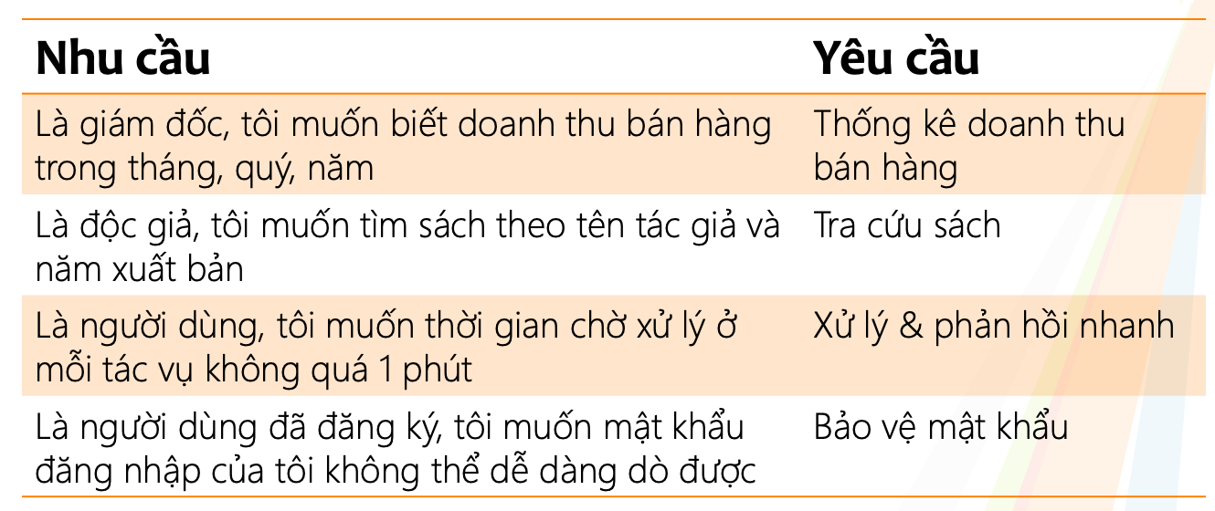

Software Architecture
Please include the ID and full name of the student who authored, reviewed, or updated this section.
Written by:
Edited by:
Reviewed by:

The student team should present the overall architecture of the software system that the team will build to fulfill the list of functionalities outlined in section 3.1.1.

Hardware
Please include the ID and full name of the student who authored, reviewed, or updated this section.
Written by:
Edited by:
Reviewed by:

The student team should describe the hardware and equipment requirements necessary for the software to operate.

Development Plan

Please include the ID and full name of the student who authored, reviewed, or updated this section.
Written by:
Edited by:
Reviewed by:

The student team should present a detailed software development plan, along with the specific deliverables for each phase.

Requirements Analysis

Software Design

Implementation

Testing

Deployment and Maintainance

Human Resources & Costing Plan

Please include the ID and full name of the student who authored, reviewed, or updated this section.
Written by:
Edited by:
Reviewed by:

The student team should present the personnel structure for the entire project or each development phase and list the anticipated costs.

Tools setup
Please include the ID and full name of the student who authored, reviewed, or updated this section.
Written by:
Edited by:
Reviewed by:

One of the main goals of this project assignment is to help you practice teamwork for professional software development. We'll assess and evaluate your effectiveness in team collaboration. Everyone is required to work closely with others in the group to deliver results, and we'll use tools to monitor and assess each group’s teamwork performance.
You are required to use the following tools:
- Moodle: Used for posting and submitting assignments.
- Slack (or a similar tool like MS Teams or Discord or Telegram): Used for discussions and interactions among group members for each project.
  - TAs will create a Slack project and add all students to it.
  - There will be a general channel for everyone, used for general project discussions.
  - Each group will have a channel linked to Trello. Any updates from Trello will be posted in this channel. Group members must use this channel to discuss their project.
  - Slack has desktop and mobile applications; please open the app and check it frequently.
- JIRA (or a similar tool like Azure Boards): Each group will have one board. Tasks are organized into sprints.
- Bitbucket, GitHub, or another source control tool: Used to store source code and documentation. Each group will belong to a team on the repository and have the following folders:
  - /src: Used to store source code.
  - /docs: Used to store documentation, which has these subfolders:
    - management: Storing planning documents, reports (weekly report, project status report, etc.).
    - requirements: Storing all requirements, including vision documents and use cases.
    - analysis and design: Storing all analysis and design related documents, including software architecture documents, UML models, and UI designs.
    - test: Storing all test documents such as test plans, test cases, and test reports.
  - /pa: Including subfolders to store submissions. Each subfolder contains one PA submission.
- TAs will help set up these tools during the first few lab sessions.
Important note: the effective use of tools to support teamwork is crucial for project success. Thus, using tools effectively is an important criterion for grading. Everyone is required to use the tools chosen by the team regularly.

AI Usage Declaration
Based on the provided AI Usage Guideline document, teams must submit their AI usage declaration here. Students are encouraged to leverage AI tools creatively and effectively in this project.

Presentation
Teams are required to record presentation videos of their work using the provided template.
Every team member must participate in the presentation, specifically covering the sections their contributed to the project.
Videos must not exceed 30 minutes.
Please upload your videos to Youtube (set to either Unlisted or Public).
Provide the Youtube links the the field below.

Reflective Report
Which sections of this template are most helpful for implementation, and which are unnecessary? Provide specific examples to support your reasoning.

