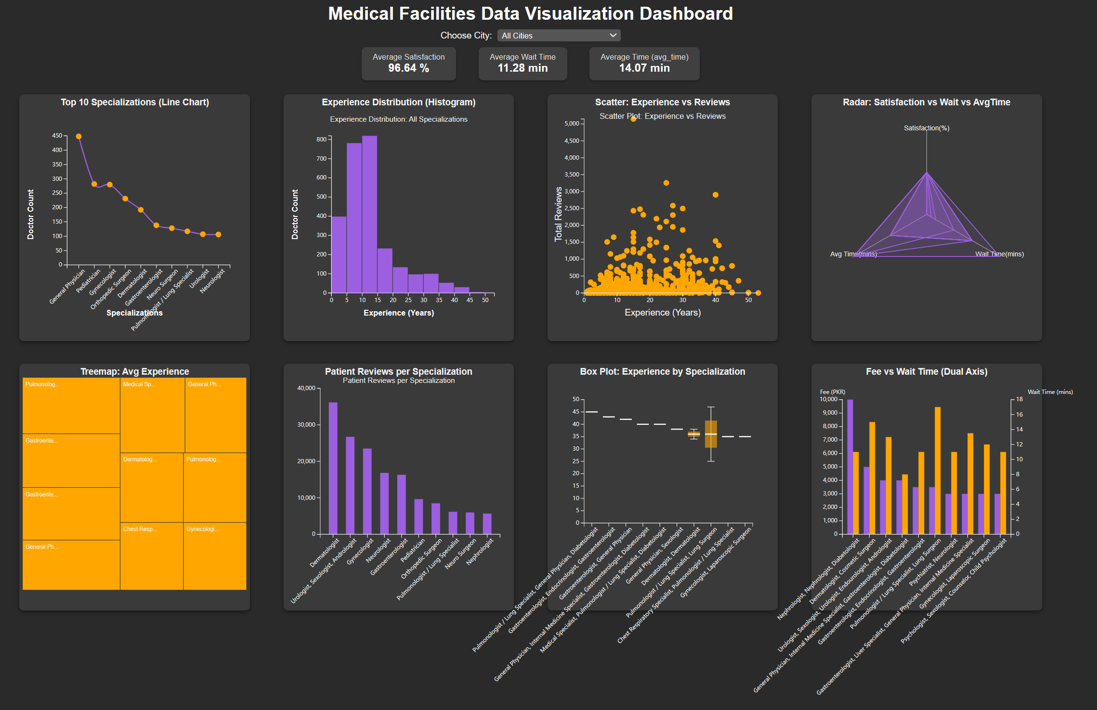

Artefact: Medical Facilities Data Visualization Dashboard

1. Project Overview

The goal of this project is to design and develop an interactive web-based dashboard using JavaScript and the D3.js (v7) library. This dashboard analyzes a dataset of medical facilities and provides insights into key performance indicators and trends.

2. Dataset

File: facilities_data.csv

Description: The dataset includes information on doctors' experience, specialization, patient satisfaction, wait time, average time to patients, fees, and reviews.

Columns Used:

Specialization: Type of medical practice.

Experience (Years): Years of doctors' experience.

Patient Satisfaction Rate (%age): Patient satisfaction percentage.

Wait Time (mins): Average wait time in minutes.

Avg Time to Patients (mins): Average consultation time.

Fee (PKR): Consultation fee in PKR.

Total Reviews: Number of reviews per specialization.

City: City of the medical facility.

3. Features Implemented

Dynamic Filtering:

A city filter allows users to explore data specific to a selected city or all cities.

Key Performance Indicators (KPIs):

Display average metrics for:

Patient Satisfaction.

Wait Time.

Avg Time to Patients.

Interactive Charts: Each team member was responsible for implementing one chart:

Line Chart: Top 10 specializations by doctor count.

Histogram: Distribution of doctors' experience.

Treemap: Average experience per specialization.

Waterfall Chart: Patient reviews per specialization.

Scatter Plot: Relationship between doctors' experience and total reviews.

Box Plot: Experience distribution for top specializations.

Radar Chart: Comparison of satisfaction rate, wait time, and avg time across top specializations.

Grouped Bar Chart (Dual Axis): Comparison of average consultation fees and wait times.

Tooltips and Interactivity:

Hovering on chart elements reveals specific details.

Clicking on line chart points filters the histogram.

4. Technologies Used

HTML5: Layout structure.

CSS3: Styling for responsive and clean design.

JavaScript (ES6): Dynamic functionalities and interactivity.

D3.js v7: Data visualization library for all interactive charts.

1. File Structure

Element 1: Artefact:

facilities_data.csv: Dataset file.

index8.0.html: HTML file with D3.js chart implementations.

Scrum Documentation:

Product backlog.

Sprint planning and retrospectives.

Burndown charts.

Static Chart Prototypes: Early design mockups.

Element 2: Presentation:

presentation.pptx: A PowerPoint presentation detailing:

Project goals and design choices.

Technologies and tools used.

Explanation and demonstration of each chart.

Reflection on the project development process.

6. User Experience

Interactive Interface: Users can interact with visualizations to gain insights.

Clear Visual Representation: Charts are designed to ensure clarity and accessibility for users.

Insights: The dashboard helps identify trends such as:

Most common medical specializations.

Distribution of doctors' experience.

Specializations with high patient reviews and satisfaction.

7. Team Division and Contributions

1. Hnin Wai Khaing:

Line Chart: Visualizes the Top 10 medical specializations by the number of doctors.

Histogram: Displays the distribution of years of experience across doctors.

2. 王美丽:

Treemap: Displays average experience of doctors per specialization, with area size reflecting experience.

Waterfall Chart: Visualizes patient reviews per specialization, showing a clear comparison of review counts.

Grouped Bar Chart (Dual Axis): Compares average consultation fees (left axis) and wait times (right axis) for top specializations.

Box Plot: Shows the distribution of years of experience across top specializations (min, Q1, median, Q3, and max).

3. Xuan:

Scatter Plot: Correlates years of experience with total patient reviews, identifying patterns between experience and review counts.

Radar Chart: Compares patient satisfaction rate, wait time, and average consultation time across top medical specializations.

1. Key insights

The dashboard allows users to:

Identify the most common medical specializations.

Analyze the experience distribution of doctors.

Compare patient reviews and satisfaction rates by specialization.

Observe correlations between doctors' experience and patient feedback.

Evaluate waiting times and consultation fees to locate high-performing medical facilities.

9.Project Management Evidence

1. Project Planning and Scrum Implementation

To ensure efficient team collaboration and project execution, the Scrum methodology was applied. The following steps outline the key project management activities:

1. Sprint Planning:

* Objective: Define the scope of work for each team member and set clear deliverables.
* Duration: 2 weeks (single sprint).
* Tools Used: Google Docs (for documentation), Trello (task management), and Zoom (team meetings).

1. Product Backlog:

Tasks were broken down into smaller deliverables and prioritized based on dependencies and complexity.

Backlog Tasks:

* Define problem statement and dataset.
* Clean and preprocess the dataset.
* Assign visualizations to team members.
* Develop interactive charts using D3.js v7.
* Integrate all visualizations into a cohesive dashboard.
* Perform bug testing and improvements.

|  |  |  |  |
| --- | --- | --- | --- |
| Task | Assigned To | Status | Due Date |
| Define Problem Statement | Hnin Wai Khaing | Completed | Week 1, Day 1 |
| Dataset Cleaning/Preprocessing | Hnin Wai Khaing | Completed | Week 1, Day 2 |
| Develop Line Chart & Histogram | Hnin Wai Khaing | Completed | Week 1, Day 4 |
| Develop Treemap & Waterfall Chart | 王美丽 | Completed | Week 1, Day 6 |
| Develop Bar Chart & Box Plot | 王美丽 | Completed | Week 2, Day 3 |
| Develop Scatter Plot & Radar Chart | Xuan | Completed | Week 2, Day 5 |
| Dashboard Integration | 王美丽 | Completed | Week 2, Day 6 |
| Bug Testing & Finalization | All Members | Completed | Week 2, Day 7 |

2. Team Communication

Zoom: Weekly virtual meetings for sprint planning, progress updates, and issue discussions.

Trello: Task management board to track progress, assign responsibilities, and ensure accountability.

WhatsApp Group: Quick updates and real-time communication.

**Weekly Meeting Schedule**:

| Date | Agenda | Participants |
| --- | --- | --- |
| Week 1 - Day 1 | Project kick-off, task assignment | Hnin Wai Khaing, 王美丽, Xuan |
| Week 1 - Day 4 | Mid-sprint review, dataset verification | Hnin Wai Khaing, 王美丽, Xuan |
| Week 2 - Day 1 | Chart development progress, bug identification | 王美丽, Xuan, Hnin Wai Khaing |
| Week 2 - Day 6 | Integration testing and final improvements | All Members |

1. Sprint Review

Key Achievements:

Successful integration of eight interactive charts using D3.js v7.

Dynamic city-based filtering and KPIs.

Consistent design, interactivity, and performance testing.

Challenges and Solutions:

| Challenge | Solution |
| --- | --- |
| Data inconsistencies during cleaning | Performed data preprocessing using Excel and Python. |
| D3.js learning curve | Team members reviewed official documentation and examples. |
| Chart integration issues | Conducted debugging sessions and peer reviews. |