[EnableCors(origins: "http://localhost:53973,http://localhost:53689", headers: "*", methods: "*")]

Muilti request to API

You Shoud new entitry after you have entity from DB. Because return JSON only know entity new

Add [FromBody] in param for can Post from other URL

T_body_staff have all Node. firstChild is First Node // remove all

while (t_body_staff.firstChild) {

t_body_staff.removeChild(t_body_staff.firstChild);

}

count = 0;

6/5/2018

Nhiberate We are should configuration file Model cs, hbm.xml, config connect and section

Example Model cs:

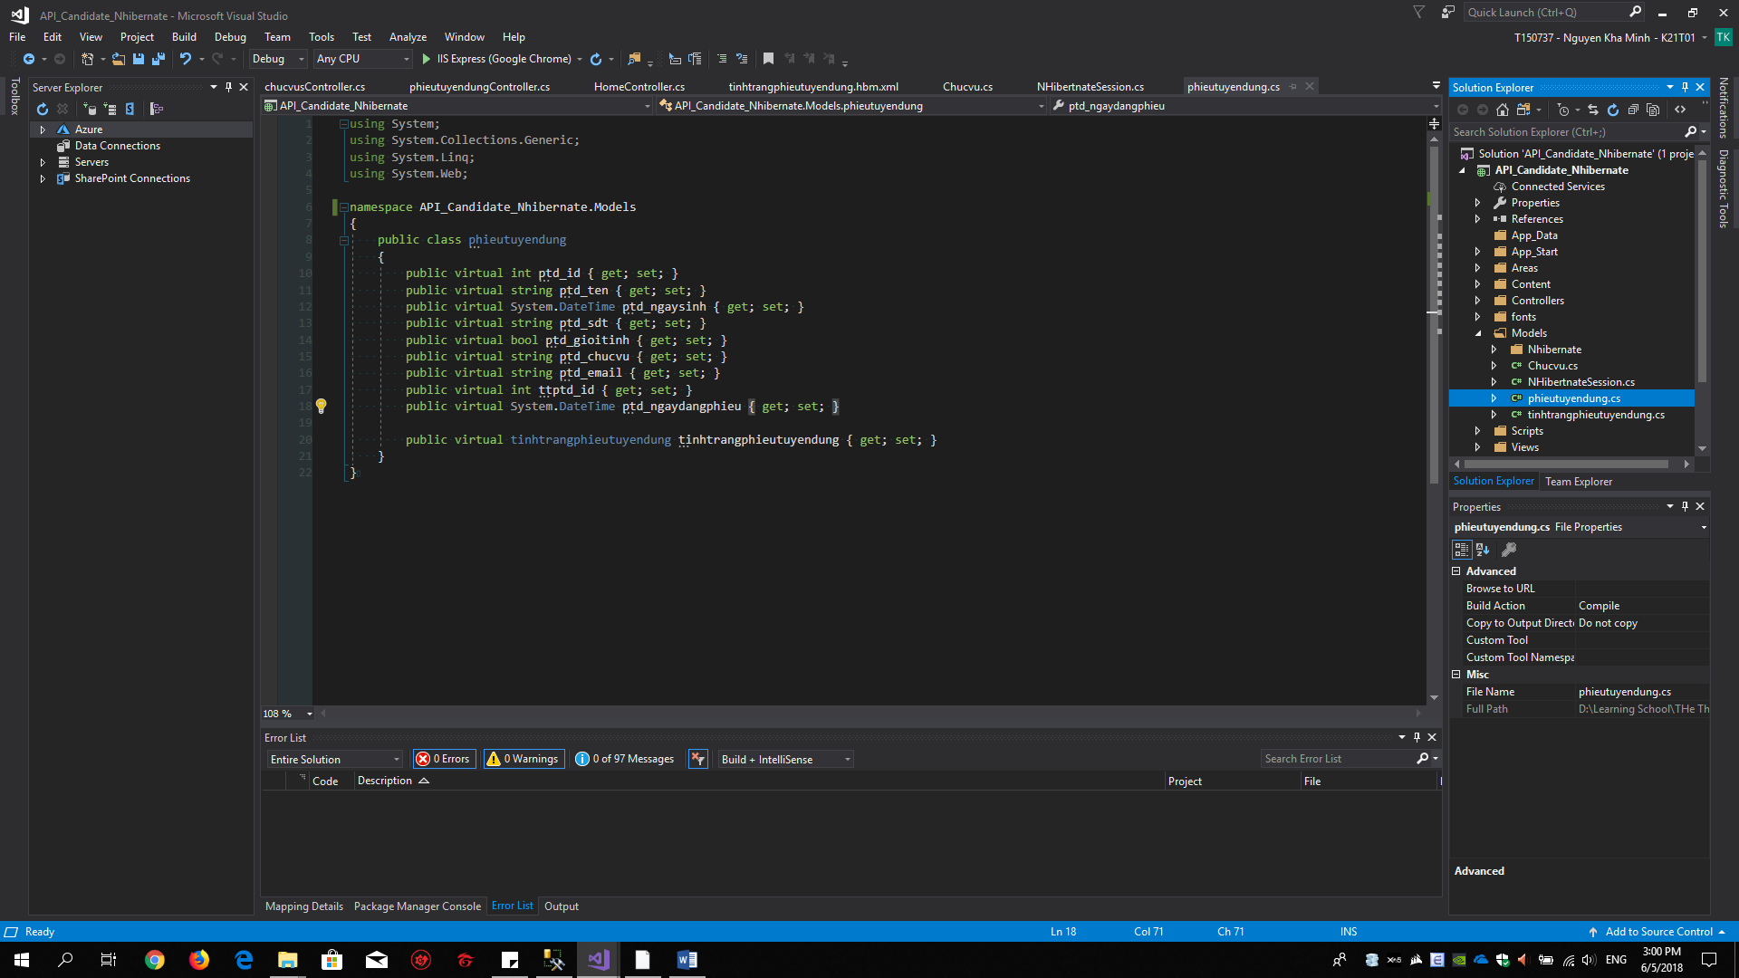

Hbm.xml of Model

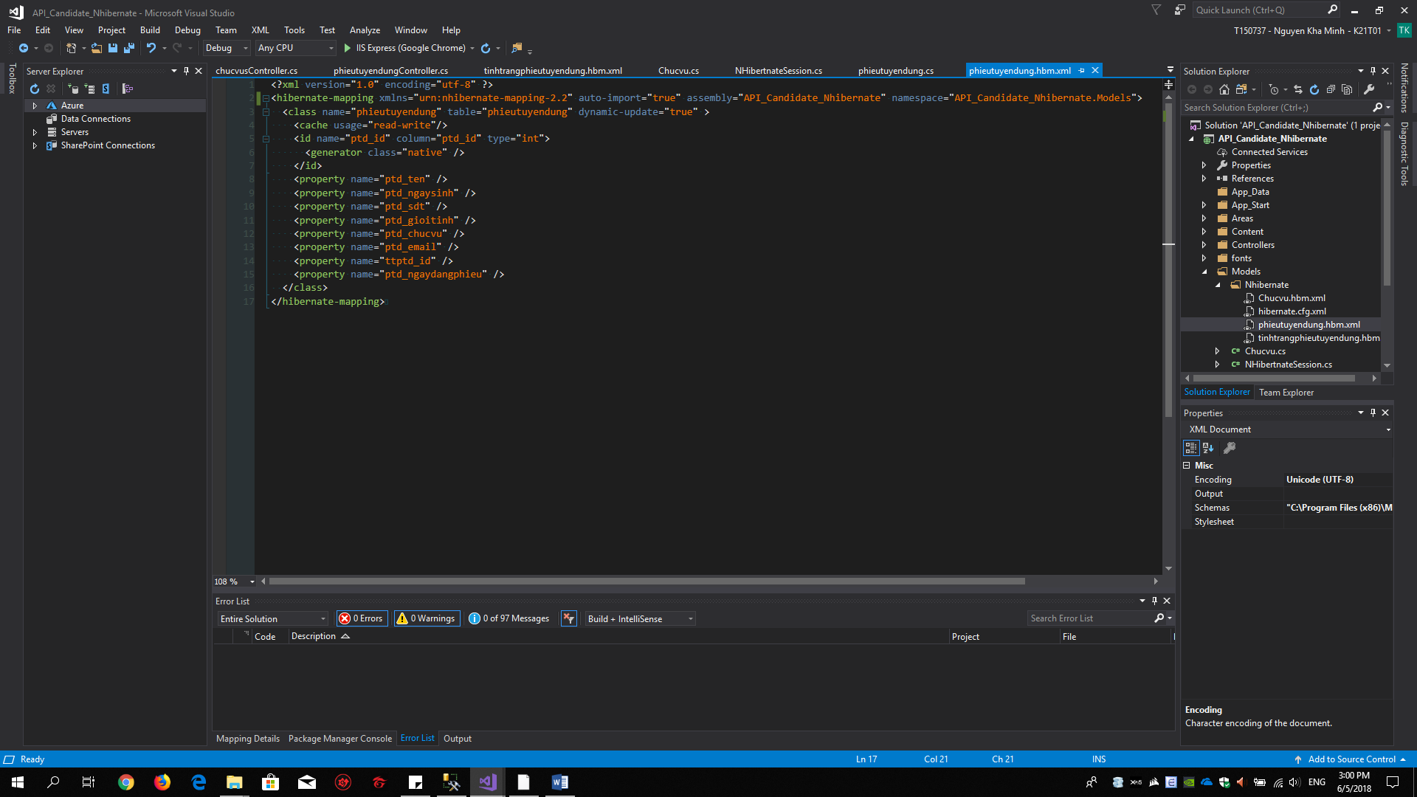

**File config**

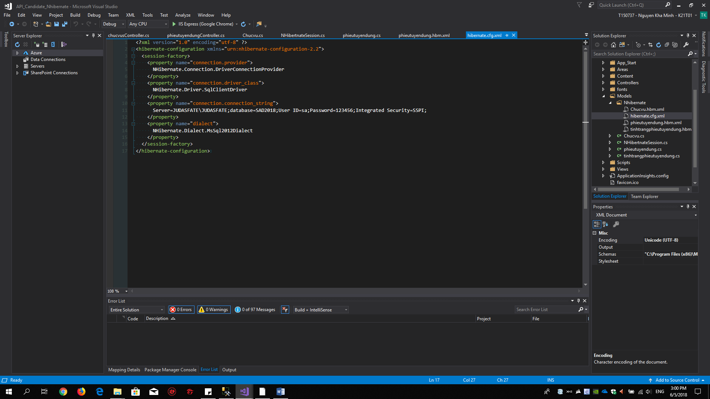

And Sesstion for Run

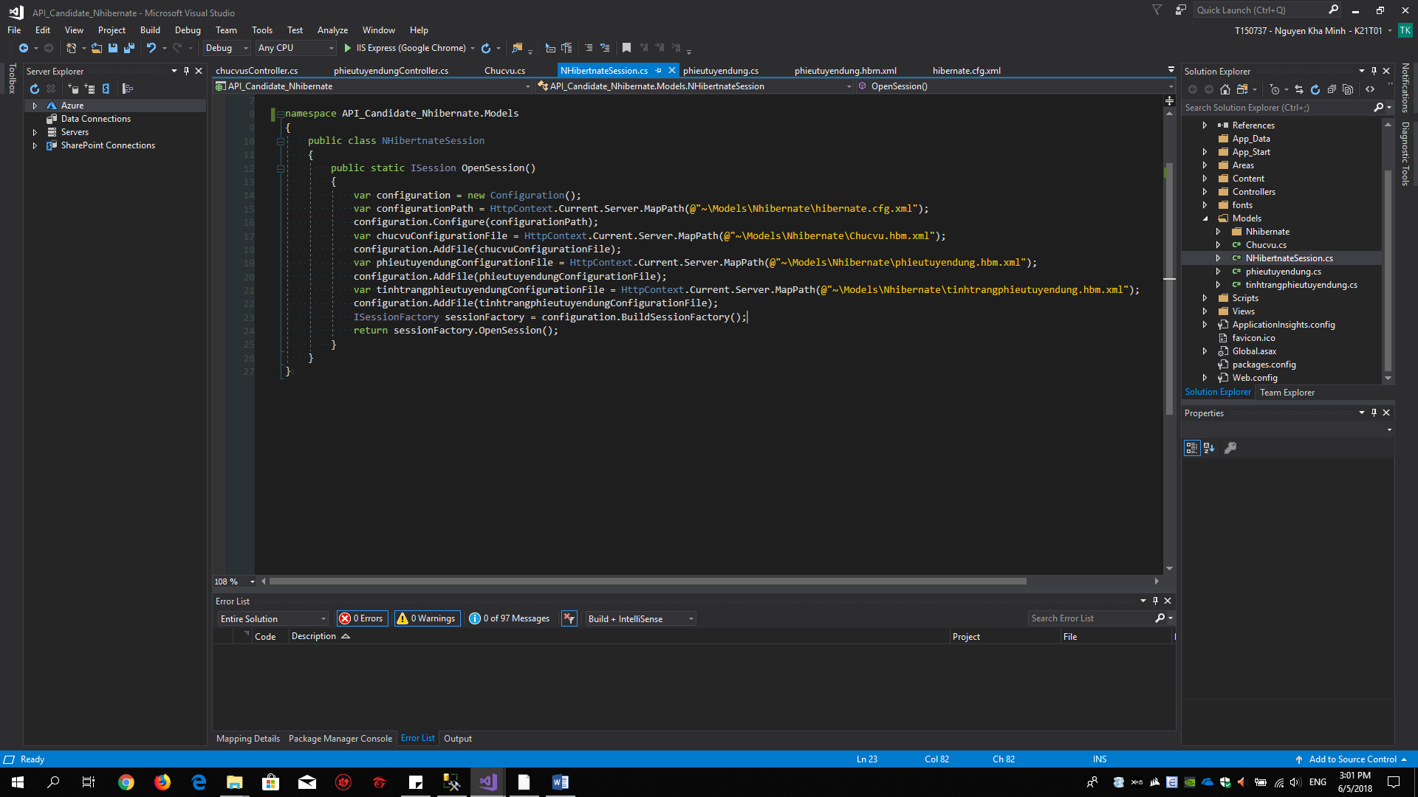

We are have many Model, We are shoud add file config

Example for list data in Model of Action

