NSI Report
Baseline: Baseline1.1 Comparison: 1.1Secondrun Phase offset: 0.000 s
Device assessment: REVIEW

Reason for review
- Phase 1 has 13 strong waveform outlier finding(s).
- Phase 2 has 2 strong waveform outlier finding(s).
- Phase 1 range 3.291-3.989 s: 12 comparison cycles vs expected 12 (difference 0).
- Phase 1 range 5.529-6.202 s: 10 comparison cycles vs expected 11 (difference 1).
- Phase 1 range 7.734-8.407 s: 11 comparison cycles vs expected 11 (difference 0).
- Phase 1 mean peak-to-peak amplitude: comparison 18.78 px; allowed 16.24 to 24.58 px based on baseline mean 20.41, SD 1.389, n=63.
- Phase 1 mean period: comparison 0.05969 s; allowed 0.01778 to 0.0999 s based on baseline mean 0.05884, SD 0.01369, n=32.
- Phase 2 range 3.989-5.024 s: 55 comparison cycles; baseline mean 52.3, SD 2.31; difference 1.15 SD.
- Phase 2 range 6.202-7.184 s: 48 comparison cycles; baseline mean 52.3, SD 2.31; difference 1.88 SD.
- Phase 2 range 8.407-9.438 s: 54 comparison cycles; baseline mean 52.3, SD 2.31; difference 0.72 SD.
- Phase 2 mean peak-to-peak amplitude: comparison 14.61 px; allowed -4.586 to 34.16 px based on baseline mean 14.79, SD 6.457, n=269.
- Phase 2 mean period: comparison 0.01883 s; allowed -0.00718 to 0.04542 s based on baseline mean 0.01912, SD 0.008766, n=155.
- Weighted Fisher-z correlation was 0.977; the passing limit is 0.90 or higher.
Assessment criteria: Phase 1 and Phase 2 only. Phase 1 cycle counts may differ from the expected count by 0–1 (no review) or 2+ (review); 0 expected cycles uses the detected baseline count. Phase 2 cycle counts are compared with the mean and sample SD across selected baseline ranges (at least two ranges are required; within 2 SD requires no review and over 2 SD requires review; the entered Expected cycles value does not override this rule). Mean amplitude and period must be within baseline mean ±3 sample SD; cycle-count and strong waveform outlier findings can require review but do not independently cause failure; amplitude sensitivity 3 σ applies to outliers. The weighted Phase 1/Phase 2 Fisher-z correlation passes at 0.90 or higher, requires review from 0.70 to below 0.90, and fails below 0.70. Phase 3 is excluded.

Phase 1 table
Measurement differences | Baseline | Comparison
Mean pk-pk (px) | 20.411 px | 18.782 px (Δ -1.629 px, -8.0%)
Mean pk-pk (mm) | 2.041 mm | 1.878 mm (Δ -0.163 mm, -8.0%)
Period (s) | 0.059 s | 0.060 s (Δ +0.001 s, +1.5%)
Number of cycles | 34 | 33 (Δ -1, -2.9%)
Number of confirmed outliers | Reference | 13
Correlation score | Reference | 0.981
Phase 1 waveform comparison (time shown relative to the start of each selected range)
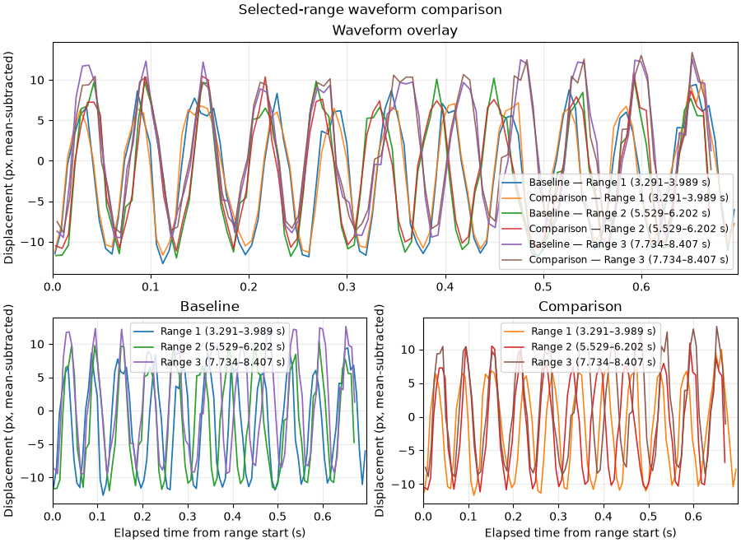
Phase 1 waveform comparison in millimeters (1 mm = 10 px)
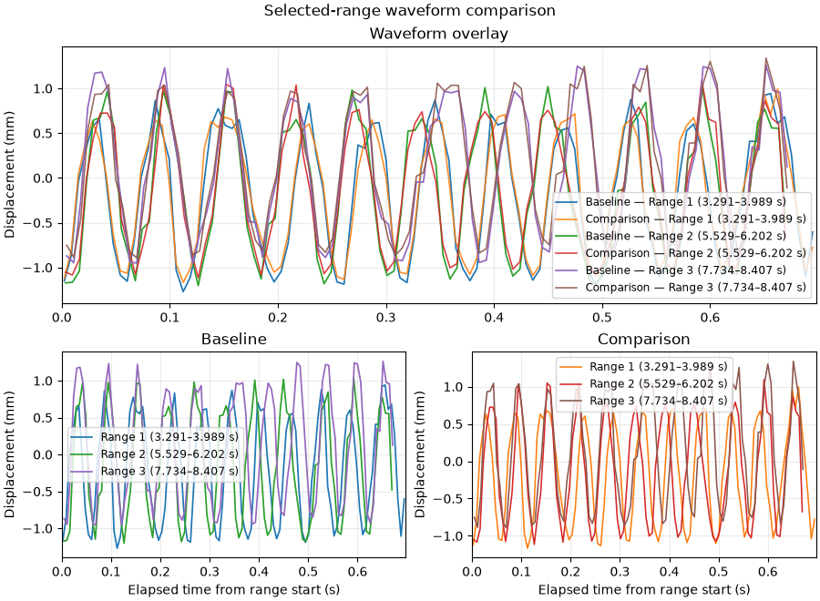
NSI quality assurance notes (Phase 1): ____________________________

Phase 2 table
Measurement differences | Baseline | Comparison
Mean pk-pk (px) | 14.786 px | 14.607 px (Δ -0.179 px, -1.2%)
Mean pk-pk (mm) | 1.479 mm | 1.461 mm (Δ -0.018 mm, -1.2%)
Period (s) | 0.019 s | 0.019 s (Δ -0.000 s, -1.5%)
Number of cycles | 157 | 157 (Δ +0, +0.0%)
Number of confirmed outliers | Reference | 2
Correlation score | Reference | 0.972
Phase 2 waveform comparison (time shown relative to the start of each selected range)
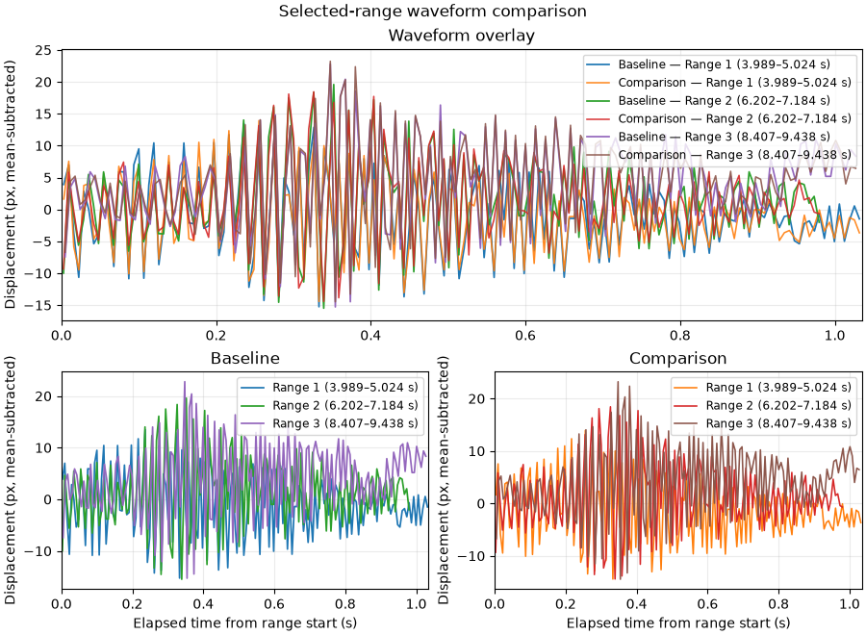
Phase 2 waveform comparison in millimeters (1 mm = 10 px)
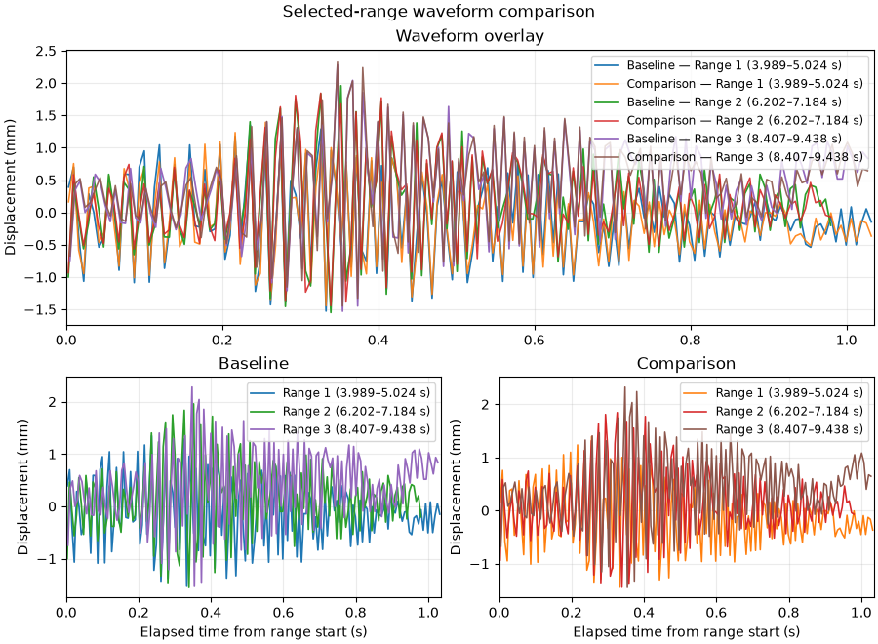
NSI quality assurance notes (Phase 2): ____________________________

Phase 3 table
Measurement differences | Baseline | Comparison
Mean pk-pk (px) | 3.399 px | 2.169 px (Δ -1.230 px, -36.2%)
Mean pk-pk (mm) | 0.340 mm | 0.217 mm (Δ -0.123 mm, -36.2%)
Period (s) | 0.034 s | 0.068 s (Δ +0.034 s, +99.0%)
Number of cycles | 45 | 20 (Δ -25, -55.6%)
Number of confirmed outliers | Reference | 7
Correlation score | Reference | 0.911
Phase 3 waveform comparison (time shown relative to the start of each selected range)
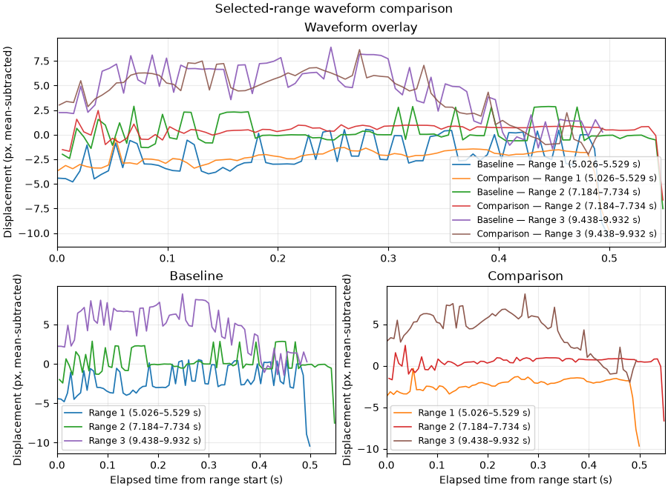
Phase 3 waveform comparison in millimeters (1 mm = 10 px)
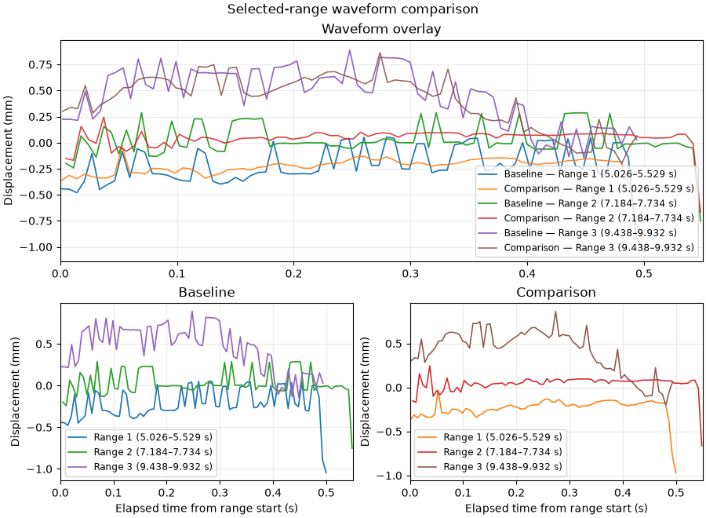
NSI quality assurance notes (Phase 3): Phase III is excluded from the overall weighted correlation.
Overall weighted correlation: 0.977. Pearson correlation is calculated per phase from aligned samples. Comparison differences are relative to the baseline reference. Amplitude values are in pixels.

