NSI Client Report
Baseline: Baseline1.1 Comparison: 1.1Secondrun

Results summary
Some results were close to the acceptance limits and require additional review. Please contact NSI.
The following graphs show the baseline and comparison waveform shapes for 1.1Secondrun against Baseline1.1.

Phase 1 waveform
Phase 1 waveform shape (colors distinguish selected ranges)
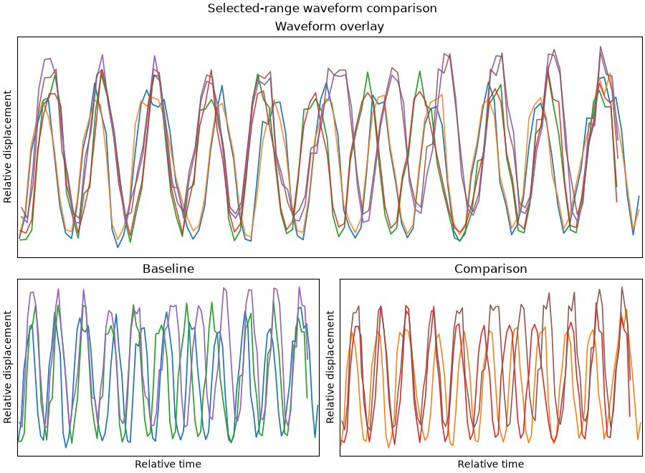
Phase 1 waveform comparison in millimeters (1 mm = 10 px)
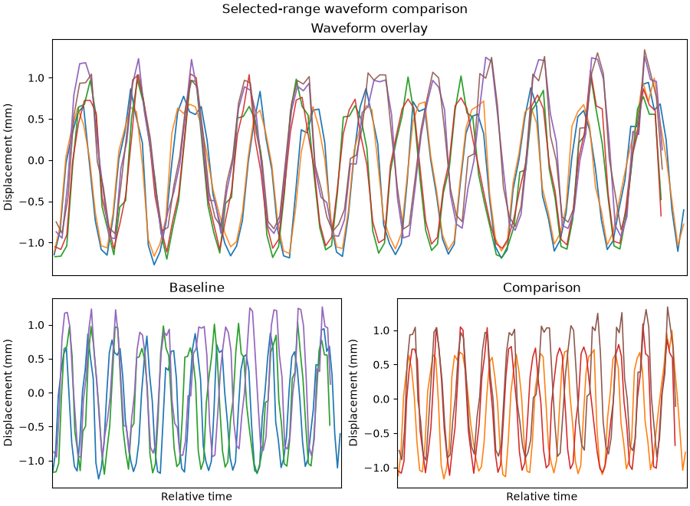

Phase 2 waveform
Phase 2 waveform shape (colors distinguish selected ranges)
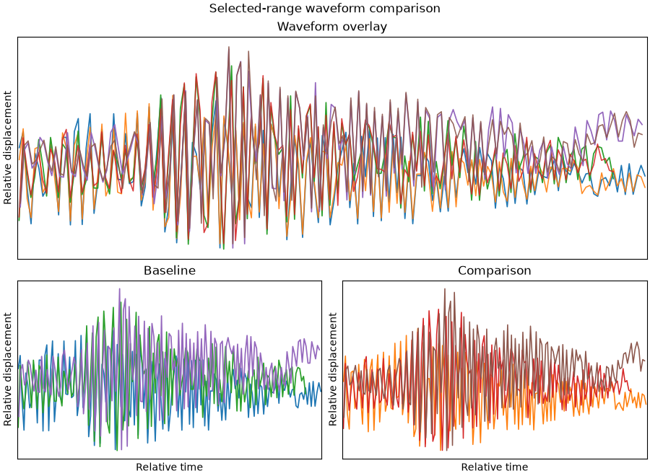
Phase 2 waveform comparison in millimeters (1 mm = 10 px)
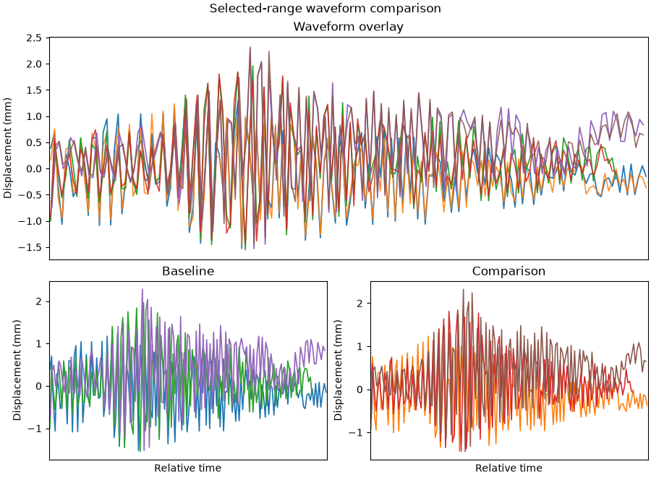

Phase 3 waveform
Phase 3 waveform shape (colors distinguish selected ranges)
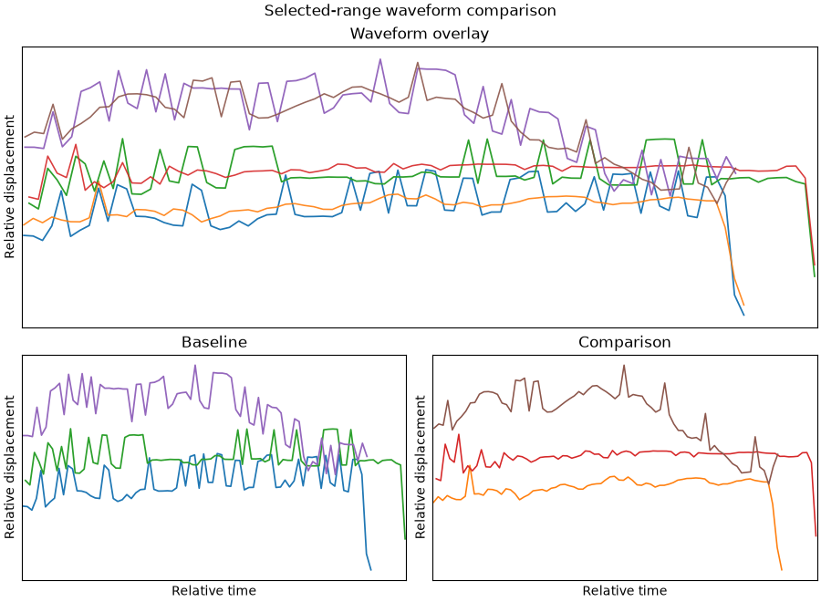
Phase 3 waveform comparison in millimeters (1 mm = 10 px)
