- Bills of Materials

- Simulation and Calculations Report
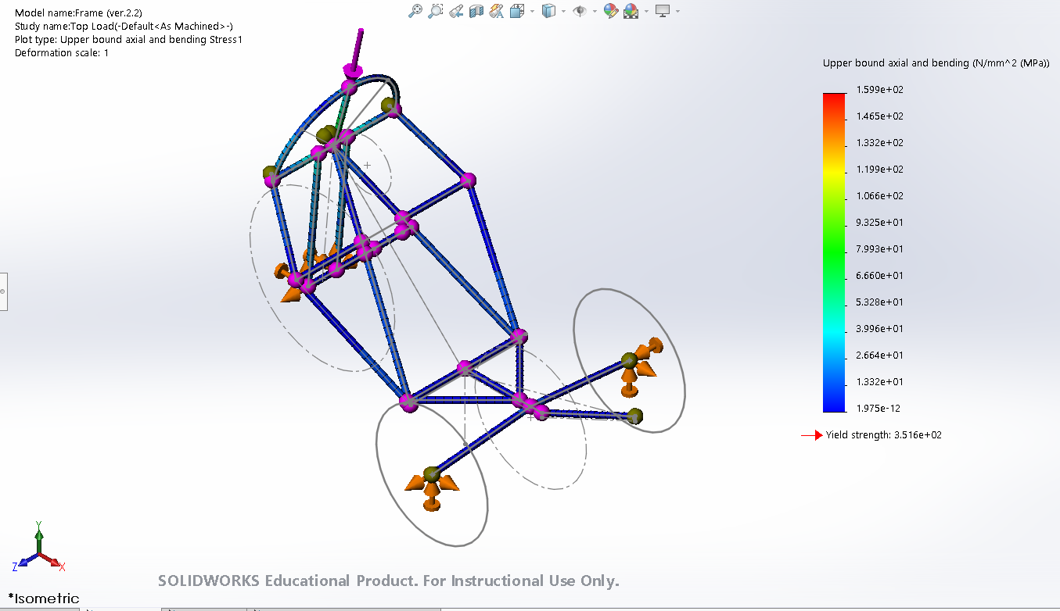
Figure 1: Isometric view of stress analysis resulted from top load simulation
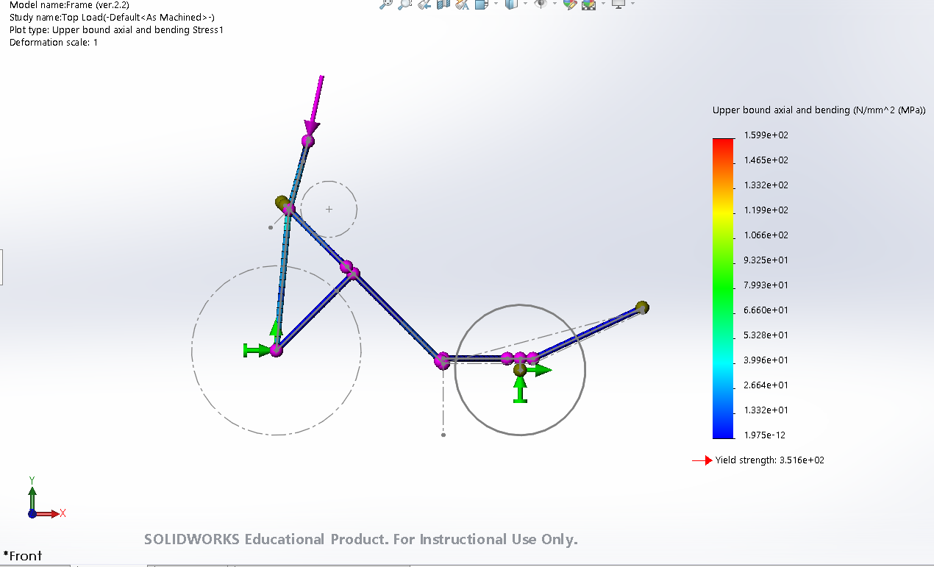
Figure 2: Side view of stress analysis resulted from top load simulation
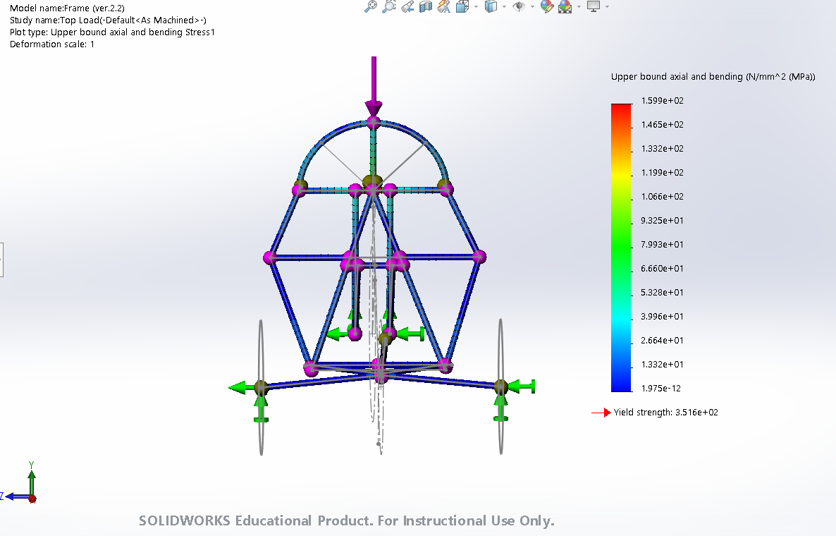
Figure 3: Front view of stress analysis resulted from top load simulation
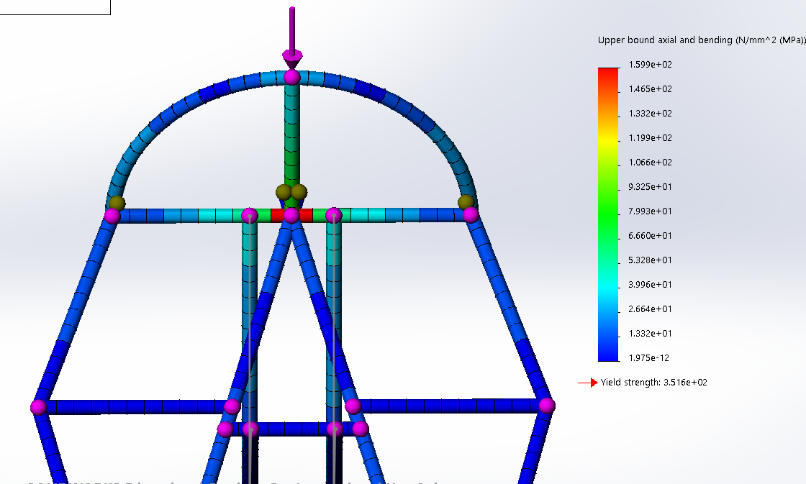
Figure 4: Closed-up front view of stress analysis resulted from top load simulation
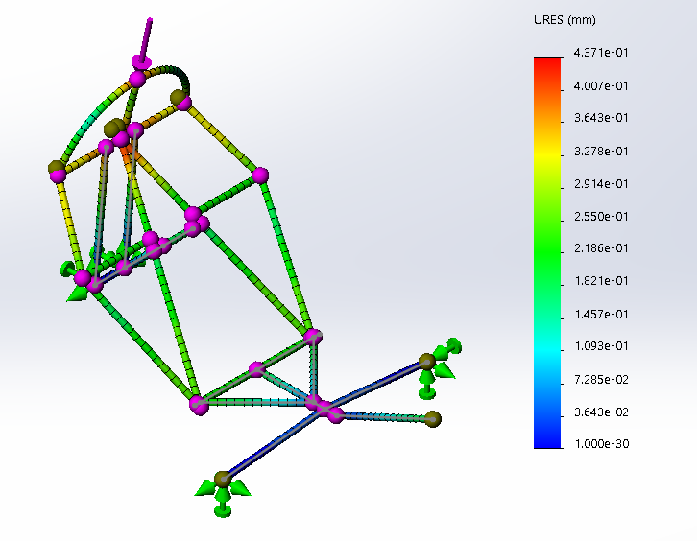
Figure 5: Isometric view of deflection analysis resulted from top load simulation
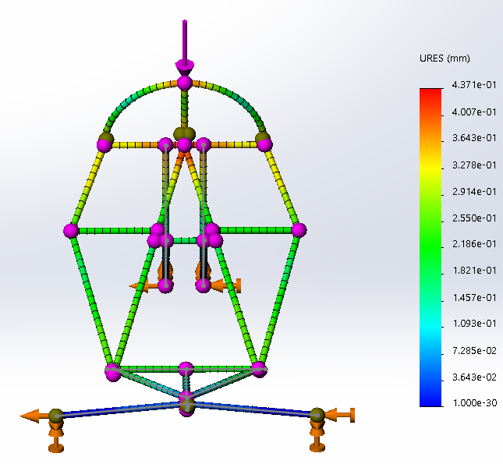
Figure 6: Front view of deflection analysis resulted from top load simulation
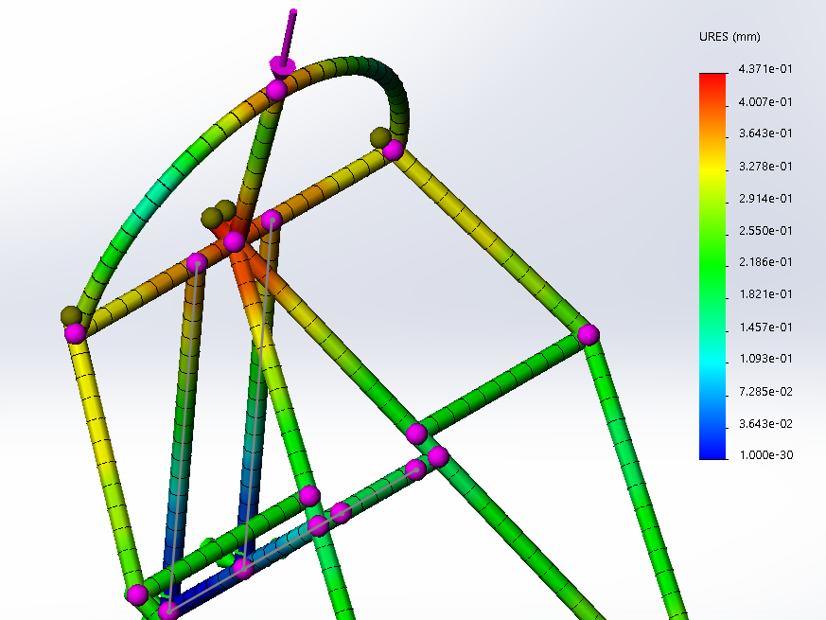
Figure 7: Closed-up isometric view of deflection analysis resulted from top load simulation
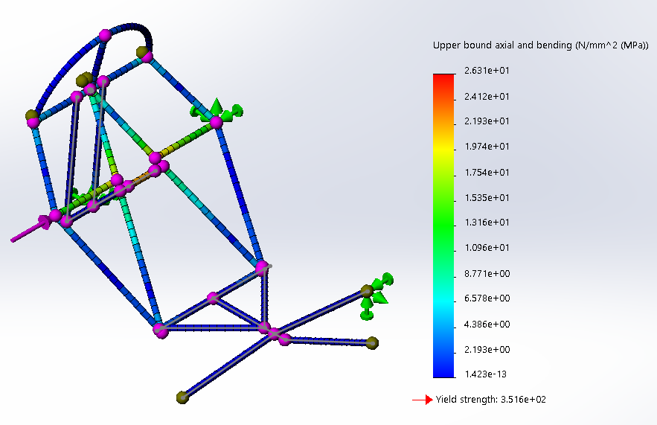
Figure 8: Isometric view of stress analysis resulted from side load simulation (most likely scenario)
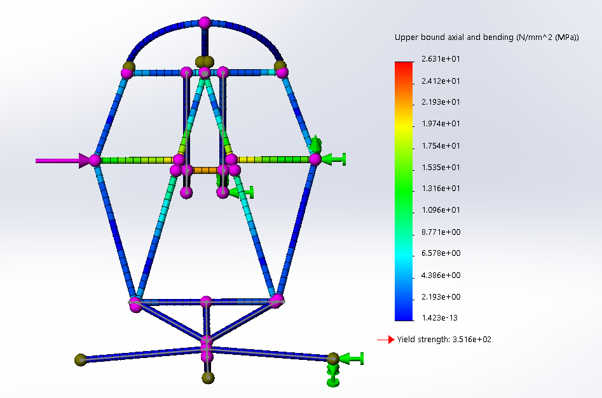
Figure 9: Front view of stress analysis resulted from side load simulation (most likely scenario)
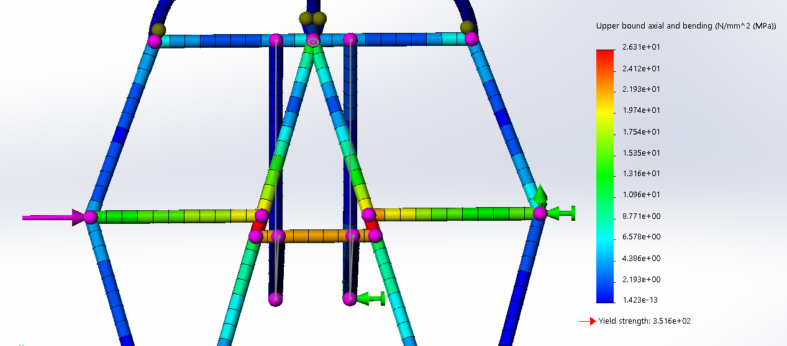
Figure 10: Closed-up front view of stress analysis resulted from side load simulation (most likely scenario)
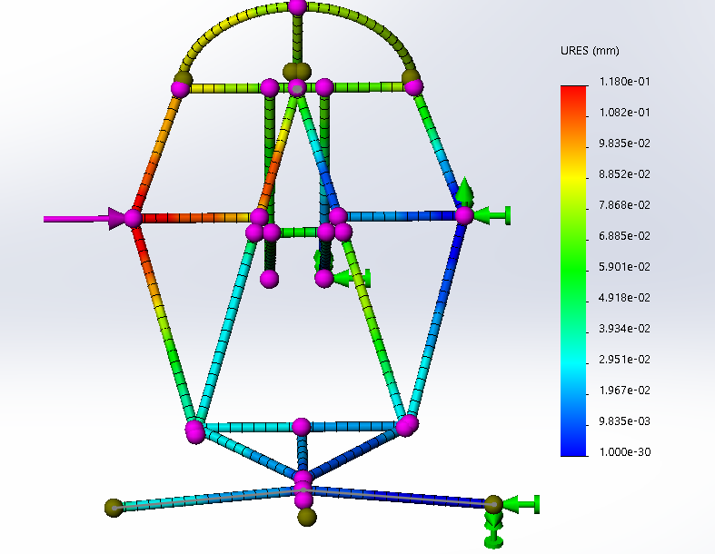
Figure 11: Front view of deflection analysis resulted from side load simulation (most likely scenario)
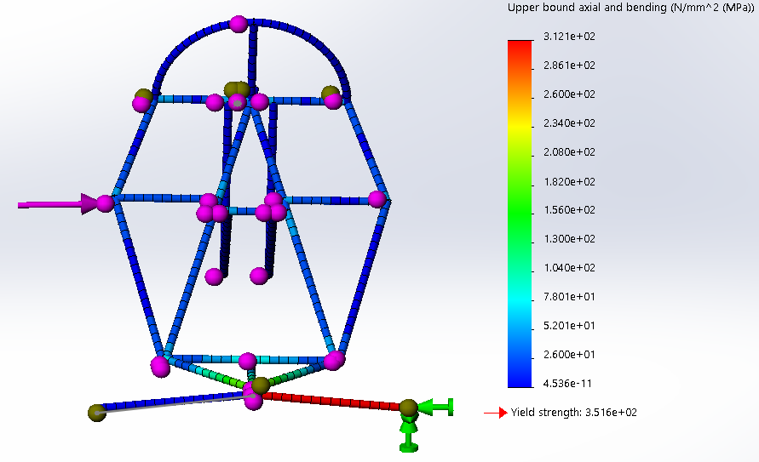
Figure 12: Front view of stress analysis resulted from side load simulation (worst scenario)
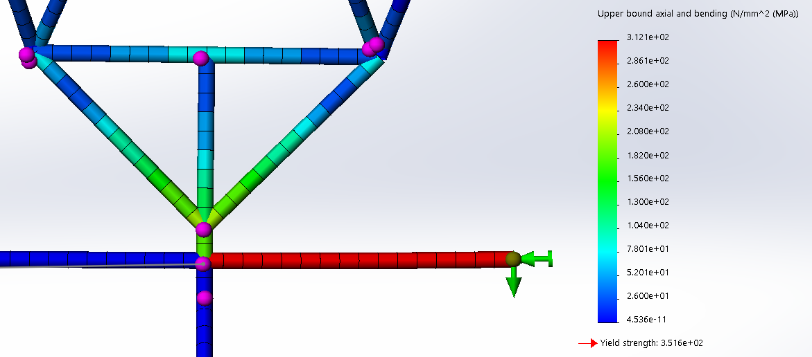
Figure 13: Closed-up top view of stress analysis resulted from side load simulation (worst scenario)
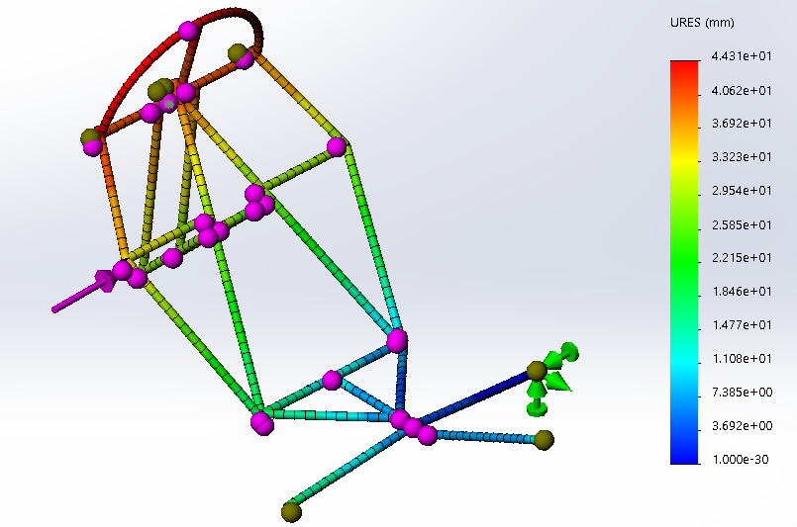
Figure 14: Isometric view of deflection analysis resulted from side load simulation (worst scenario)
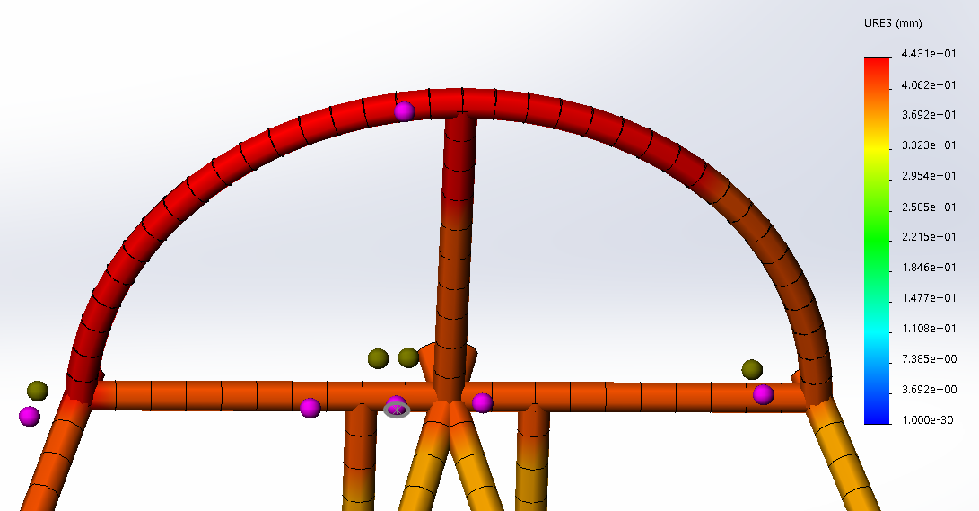
Figure 15: Closed-up front view of deflection analysis resulted from side load simulation (worst scenario)
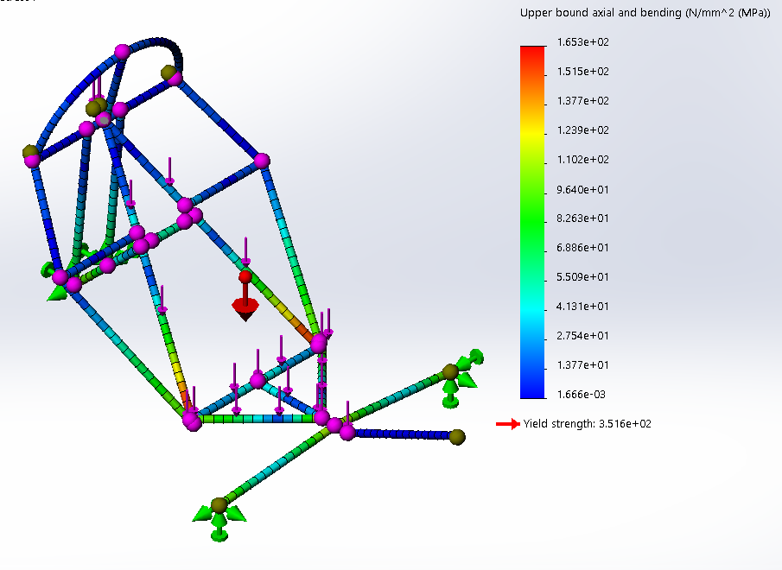
Figure 16: Isometric view of stress analysis resulted from mass load simulation (back and bottom beams)
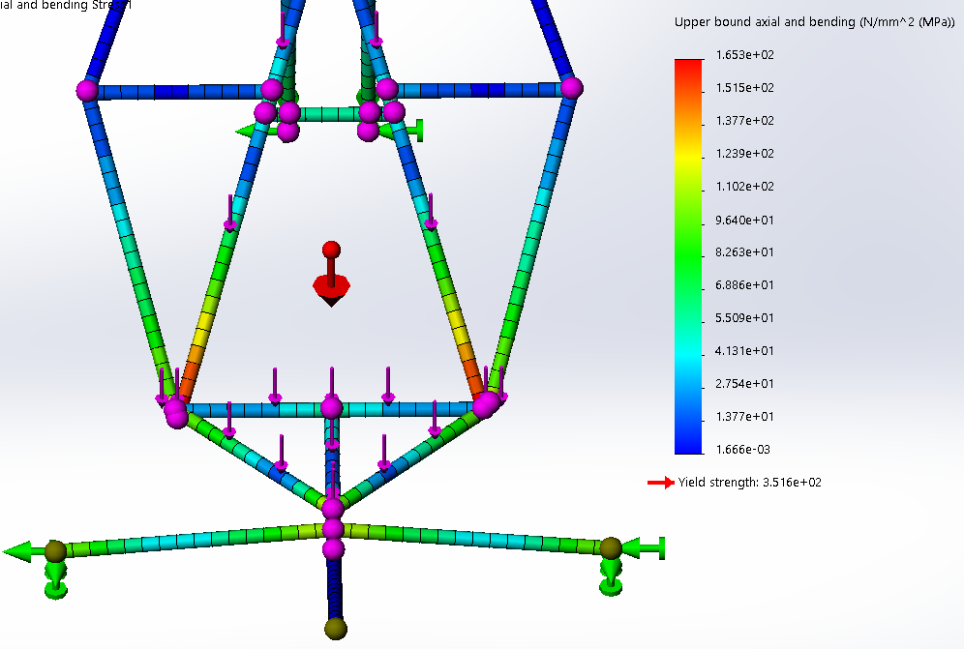
Figure 16: Closed-up front view of stress analysis resulted from mass load simulation on back and bottom beams
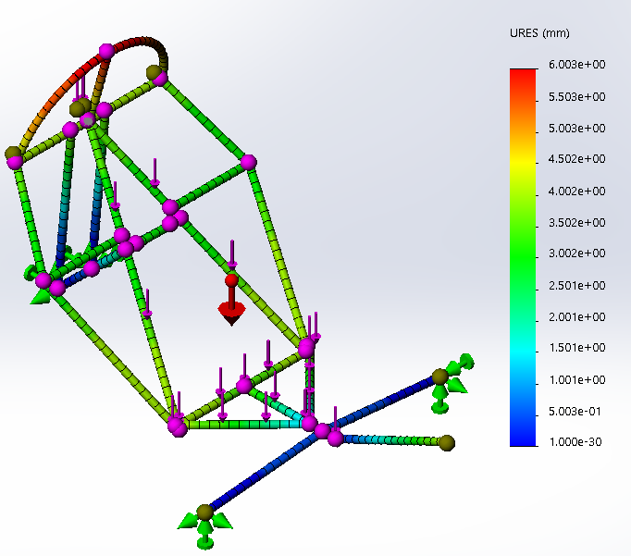
Figure 17: Isometric view of deflection analysis resulted from mass load simulation on back and bottom beams

Table 1: Steel A513 (AISI 1020) Properties

Material | E (GPa) | σ_{yield} (MPa) | σ_{tensile} (MPa)
Steel A513 (AISI 1020) | 200 | 351.571 | 420.507

Table 2: Simulation Results

Load Type | Load (N) | σ_{max} (MPa) | y_{max} (mm) | FoS | Deflection Requirement
Top | 2670 | 159.9 | 0.4362 | 2.20 | satisfied
Side (three fixture locations) | 1330 | 26.31 | 0.118 | 13.36 | satisfied
Side (one fixture location) | 1330 | 312.1 | 44.31 | 1.13 | satisfied
Mass (back and bottom beams) | 1000 | 165.3 | 6.003 | 2.13 | satisfied
Mass (back beams) | 1000 | 99.96 | 3.542 | 3.52 | satisfied

- Changes Reasons

