## **Abstract;**

Decentralized Secure Collaboration (DeSC) is a blockchain-based framework enabling secure, verified collaborations among multiple parties. DeSC facilitates trustless interactions by dividing tasks into atomic "hops," each verified by designated validator sets. This ensures accountability, quality control, and dispute resolution across various industries, including consumer marketing, export/import, healthcare, fast-moving consumer goods, pharmaceuticals, technology, construction, and logistics. By leveraging smart contracts and zero-knowledge proofs, DeSC enhances transparency, efficiency, and security in collaborative projects, mitigating risks of fraud, delays, and disputes.

## **Implementation of Decentralised Secure Collaboration (DeSC) in Various Industries**

The framework of Decentralized Secure Collaboration (DeSC) presents a robust solution for enhancing efficiency and security across various sectors by enabling seamless, verified collaborations among multiple parties. Here’s how the DeSC framework can be implemented in different industries, along with a detailed flow of operations and the potential benefits.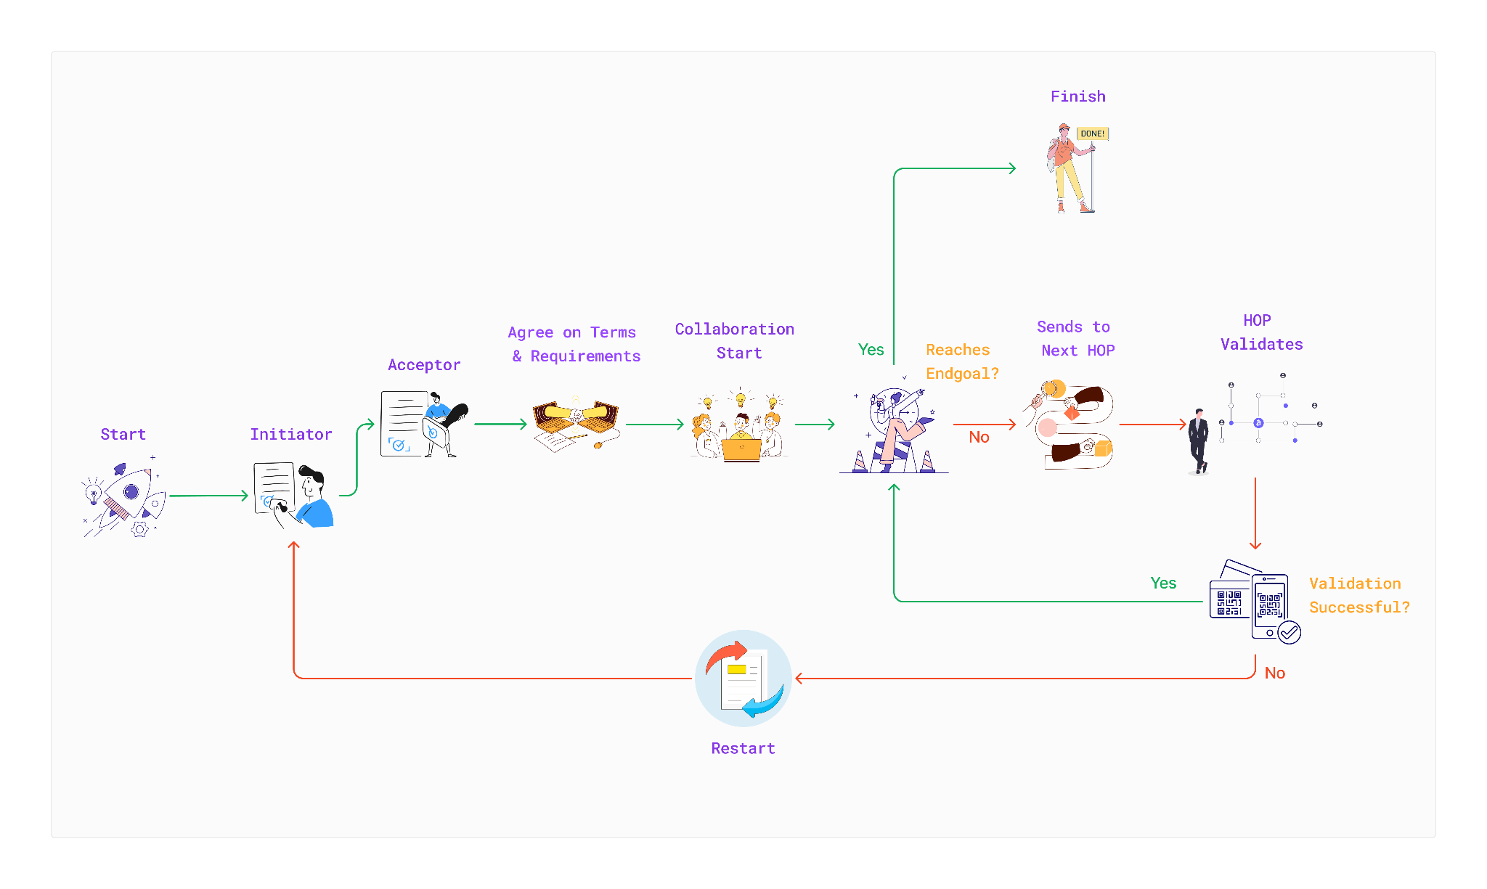

## **1. Consumer Industry**

**Use Case: Influencer Marketing Campaigns**

Scenario: A brand wants to launch a marketing campaign involving multiple influencers.

* **Initiation**: The brand (initiator) creates a collaboration through the Collaboration Smart Contract. If the brand requires funding for the campaign, it triggers the Investor Smart Contract to attract investors.
* **Acceptance**: Influencers (acceptors) review the collaboration details and accept the terms. The Investor Smart Contract allows investors to fund the campaign, ensuring that funds are securely held until the campaign milestones are met.
* **Hops**: The brand and influencers can break the campaign into multiple hops or hops (e.g. content creation, posting, engagement analysis), assigning specific validator Sets for each hop. For example, Hop 1 could involve content creation verified by validator Set A, while Hop 2 involves engagement metrics verified by validator Set B.
* **Validation**: Each hop is verified by its assigned validator set. If any hop fails to meet its criteria, the campaign cannot progress to the next hop, ensuring accountability and quality control.
* **Identity and Privacy:** All parties maintain anonymity unless a zero-knowledge proof is provided for identity verification, enhancing privacy in influencer transactions.

**Efficiency Gains:** This approach mitigates risks of fraud in influencer marketing, where brands often face challenges with fake followers and engagement. By ensuring that payments are tied to verified performance metrics, brands can optimize their marketing spend.

## **2. Export and Import**

**Use Case: Trade Transactions**

Scenario: An exporter and importer engage in a trade transaction involving goods.

* **Initiation:** The importer initiates the collaboration through the Collaboration Smart Contract. The exporter accepts the collaboration request if the required product is available.
* **Investor Participation:** The importer can call the Investor Smart Contract to secure necessary funds if upfront capital is needed to buy bulk goods.
* **Hops:** The transaction is divided into multiple hops (e.g., shipping, customs clearance, delivery), with a validator set assigned to each hop.
* **Validation:** Each atomic hop is verified by its respective validator. For instance, validator Set A verifies that the goods were shipped before customs clearance can begin.
* **Identity Protection:** All parties can maintain anonymity unless identity verification is necessary.

**Efficiency Gains:** This framework enhances trust in international trade by ensuring that payments are only released upon verified completion of each hop, reducing the risk of fraud and disputes.

## **3. Healthcare**

**Use Case: Clinical Trials**

Scenario: A pharmaceutical company conducts clinical trials for a new drug.

* **Initiation:** The company initiates a collaboration through the Collaboration Smart Contract to manage the trial process.
* **Investor Smart Contract**: If additional funding is needed, the company can call the Investor Smart Contract to attract investors for the trial.
* **Hops:** The trial process is divided into multiple hops (e.g., recruitment, treatment, data analysis), with each hop assigned a specific validator Set.
* **Validation:** Each hop must be verified by its respective validator to ensure compliance with regulatory standards.
* **Dispute Resolution:** The validators can address any issues that arise without needing a formal dispute resolution process.

**Efficiency Gains:** This structure enhances the integrity of clinical trials, ensuring that data is verified at each hop, which can lead to faster approvals and reduced costs.

## **4. Fast-Moving Consumer Goods (FMCG)**

**Use Case: Collaborative Product Development and Marketing**

Scenario: A beverage company seeks to develop a new product in collaboration with multiple stakeholders, including suppliers, marketing agencies, and retailers.

* **Initiation**: The beverage company (initiator) initiates a collaboration via the Collaboration Smart Contract to develop and market a new beverage product. If funding is required for research and development, the company calls the Investor Smart Contract to attract investments.
* **Acceptance**: Suppliers and marketing agencies (acceptors) review the collaboration details and accept the terms, agreeing to contribute resources and expertise.
* **Hops**: The project is divided into multiple hops, such as product formulation, packaging design, and marketing strategy. Each hop is assigned a specific validator Set for oversight. For example, Stage 1 (product formulation) could be verified by validator Set A, while Stage 2 (packaging design) is verified by validator Set B.
* **Validation:** Each hop must be verified by its respective validator before moving to the next hop. This ensures that all aspects of the product development process meet quality standards and regulatory requirements.
* **Identity Protection:** All parties maintain anonymity unless a zero-knowledge proof is provided for identity verification, enhancing confidentiality in competitive markets.

**Efficiency Gains:** By using DeSC, the beverage company can ensure that all stakeholders are accountable for their contributions, reducing the risk of miscommunication and enhancing the quality of the final product. This structured approach also allows for better resource allocation and faster time-to-market.

**5. Pharmaceutical Industry**

**Use Case: Clinical Trial Management**

Scenario: A pharmaceutical company conducts clinical trials for a new drug involving multiple research institutions and regulatory bodies.

* **Initiation**: The pharmaceutical company (initiator) initiates a collaboration through the Collaboration Smart Contract to manage the clinical trial process. If additional funding is needed, it calls the Investor Smart Contract to secure investments.
* **Acceptance**: Research institutions and regulatory bodies (acceptors) review and accept the collaboration terms, agreeing to participate in the trial.
* **Hops**: The clinical trial is divided into multiple hops, such as patient recruitment, treatment administration, and data analysis. Each hop has its own validator Set for verification.
* **Verification**: Each hop must be verified by its respective validator. For instance, validator Set A verifies the recruitment process, ensuring that all participants meet the inclusion criteria before moving on to treatment.
* **Dispute Resolution:** If any disputes arise regarding trial protocols or data integrity, the validators can address them proactively without needing a formal dispute resolution call.

**Efficiency Gains**: This structured approach enhances the integrity of clinical trials, ensuring compliance with regulatory standards and reducing the risk of data manipulation. The transparency provided by DeSC can also improve trust among stakeholders, facilitating smoother collaborations.

## 

## **6. Technology Industry**

**Use Case: Software Development Collaboration**

Scenario: A tech startup collaborates with freelance developers and designers to build a new application.

* **Initiation**: The startup (initiator) initiates a collaboration via the Collaboration Smart Contract. If funding is required for development, it calls the Investor Smart Contract to attract investments from angel investors.
* **Acceptance**: Freelancers (acceptors) review the collaboration details and accept the terms, committing to deliver specific features of the application.
* **Hops:** The project is divided into multiple hops, such as UI/UX design, backend development, and testing. Each hop is assigned a specific validator Set for oversight.
* **Validation**: Each hop must be verified by its respective validator before the next hop can commence. For example, validator Set A verifies the UI/UX design before the backend development can begin.
* **Identity Protection**: All parties can remain anonymous unless identity verification is necessary, allowing for a secure collaboration environment.

**Efficiency Gains:** By implementing DeSC, the tech startup can ensure that all contributions are verified and that payments are only released upon successful completion of each hop. This reduces the risk of project delays and enhances the overall quality of the application.

**7. Construction Technology Industry**

**Use Case: Construction Project Management**

Scenario: A construction firm in Metropolitan City is managing a large infrastructure project involving multiple contractors and subcontractors.

* **Initiation**: The construction firm (initiator) initiates a collaboration through the Collaboration Smart Contract. If additional funding is needed for the project, it invokes the Investor Smart Contract to secure investments from financial institutions or private investors.
* **Acceptance**: Contractors and subcontractors (acceptors) review the collaboration details and accept the terms, committing to deliver specific services or materials.
* **Hops:** The project is divided into multiple hops, such as site preparation, foundation work, and structural framing. Each hop is assigned a specific validator Set for oversight. For example, Stage 1 (site preparation) could be verified by validator Set A, while Stage 2 (foundation work) is verified by validator Set B.
* **Validation**: Each hop must be verified by its respective validator before the next hop can commence. This ensures that all work meets quality standards and regulatory requirements.
* **Identity Protection**: All parties maintain anonymity unless a zero-knowledge proof is provided for identity verification, enhancing confidentiality in competitive markets.
* **Dispute Resolution:** If any disputes arise regarding work quality or timelines, the validators can address them proactively, without needing a formal dispute resolution call.

**Efficiency Gains**

* Reduced Delays: By ensuring that each hop is verified before proceeding, the risk of delays due to rework or disputes is minimized.
* Enhanced Accountability: The structured approach fosters accountability among contractors and subcontractors, ensuring that they adhere to agreed-upon standards and timelines.
* Improved Resource Allocation: With clear visibility into the progress of each atomic hop, the construction firm can allocate resources more effectively, optimizing project timelines and costs.
* Trust and Transparency:By utilizing DeSC, all parties can trust that their contributions are verified and that payments are only released upon successful completion of each hop, reducing the risk of fraud.

**8. Logistics & Operations Industry**

**Use Case: Supply Chain Management**  
Scenario: A Buyer and A Seller engage in a trade transaction involving goods ranging from perishable to non-perishable items.

* **Initiation & Acceptance:** The Buyer initiates the collaboration through the Collaboration Smart Contract. The Seller will accept the collaboration request if the items are available to ship.
* **Investor Participation:** If upfront capital is needed for buying in bulk, the buyer can call the Investor Smart Contract to secure the necessary funds.
* **Hops:** The transaction is divided into multiple hops (e.g., shipping, customs clearance, godown management, quality check delivery etc.), with a validator set assigned to each hop for quality and quantity checking.
* **Validation:** Each hop is verified by its respective validator. For instance, validator Set A verifies that the goods were shipped before customs clearance can begin or Set B/C/D verifies that the perishable goods quality is maintained in every hops.
* **Identity Protection:** All parties can maintain anonymity unless identity verification is necessary.

**Efficiency Gains:** This framework enhances trust in international and domestic trade by ensuring that payments are only released upon verified completion of each hop, reducing the risk of fraud, disputes and quality assurance.

**Reference Section**

* Luu, L., et al. (2016). "A Secure Sharding Protocol For Open Blockchains." Proceedings of the 2016 ACM SIGSAC Conference on Computer and Communications Security. (Sharding concept)
* Bhargavan, K., et al. (2018). "Formal Verification of Smart Contracts: Short Paper." Proceedings of the 2018 ACM SIGSAC Conference on Computer and Communications Security. (Smart contract verification)
* Szabo, N. (1994). "Smart Contracts: Building Blocks of a New Society." EXTropy, 16. (Smart contract concept)
* Nakamoto, S. (2008). "Bitcoin: A Peer-to-Peer Electronic Cash System." (Blockchain concept)
* Wood, G. (2014). "Ethereum: A Next-Generation Smart Contract and Decentralized Application Platform." (Smart contract platform)
* Zyskind, G., & Nathan, O. (2015). "Decentralizing Privacy: Using Blockchain to Protect Personal Data." IEEE Security & Privacy. (Data protection)
* Kosba, A., et al. (2016). "Hawk: The Blockchain Model of Cryptography and Two-Party Computation." IEEE Transactions on Information Forensics and Security. (Secure computation)
* Deloitte. (2020). "Blockchain and Distributed Ledger Technology in the Supply Chain." (Supply chain management)
* PwC. (2020). "Blockchain and the Pharmaceutical Industry." (Pharmaceutical industry)
* McKinsey. (2020). "Blockchain in Construction: Opportunities and Challenges." (Construction industry)
* World Economic Forum. (2020). "Blockchain and Distributed Ledger Technology: Use Cases and Applications." (Industry applications)
* Collaboration and Supply Chain Management
* ISO. (2020). "ISO 28000:2007 - Specification for security management systems for the supply chain." (Supply chain security)
* OASIS. (2020). "OASIS Open Standards for Collaborative Technologies." (Collaboration standards)