Dynamic Pricing for European Campsites

Data, Methodology, and Demand Modelling

1. Data Description and Exploratory Analysis

1.1 Dataset Structure
The dataset (simulation_output.csv) is a synthetic but structurally faithful representation of the operator's booking data. It contains 3,130,816 rows across 38 columns, covering arrival weeks from January 2024 through December 2025 across 142 campsites in 8 countries.

The fundamental unit of observation is a booking-curve snapshot: each row records the state of a specific product–market combination at one point in the booking horizon. A product is identified by ReservableOptionMarketGroupId, which encodes a unique combination of campsite, accommodation type, market group, and arrival week. For each product there are up to 53 snapshots — one per value of WeekBeforeArrival from 52 (one year ahead) down to 0 (arrival week). The full dataset is therefore an unbalanced panel of booking curves.

The dataset spans 142 campsites across 8 countries, covering four customer market groups — Domestic, Benelux, DACH, and Rest of Europe — and approximately 59,000 unique booking curves. Accommodations are classified by kind (Mobile, Permanent, Static, Seasonal) and quality range (Budget, Mid, Premium), with five type-range subcategories (Comfort, Romantic, Luxury, Standard, Family). Each booking curve is observed at up to 53 points along the horizon, running from 52 weeks before arrival down to the arrival week itself. Nine distinct special period types and 142 seasonal clusters further segment the product space.

1.4 Demand and Occupancy
The final occupancy rate (total booked nights divided by capacity) is the business-level outcome. Its distribution, shown in Figure 1.5, is right-skewed with a substantial mass at low values. The median occupancy across all products and weeks is approximately 10%, but individual products in peak season reach 85%.
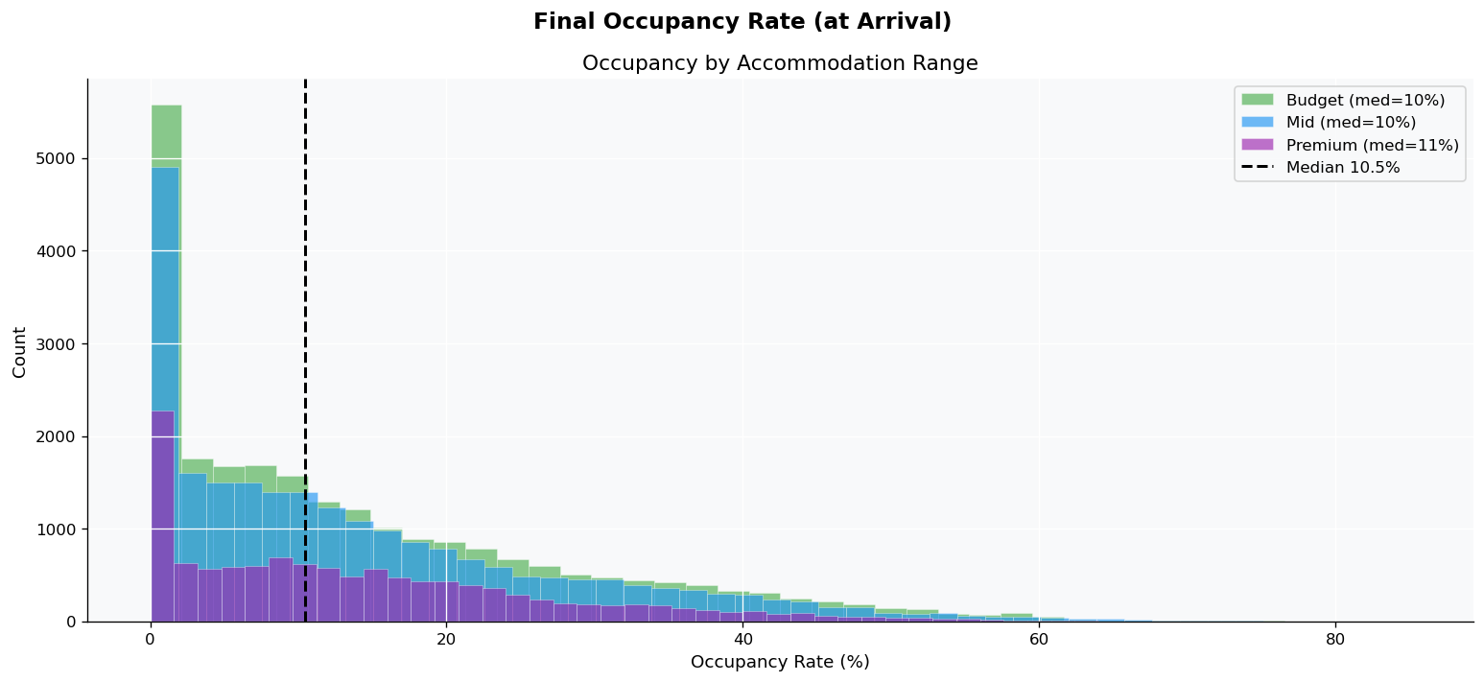
Figure 1.5 — Final occupancy distribution by accommodation

1.5 Seasonal and Special Period Effects
Figure 1.7 shows median occupancy and median price by arrival month across both years (2024 and 2025). Both metrics peak in summer, confirming that price and demand are positively correlated at the seasonal level. This is the basic pricing-power signal: in peak months, both willingness to pay and number of potential guests are elevated.

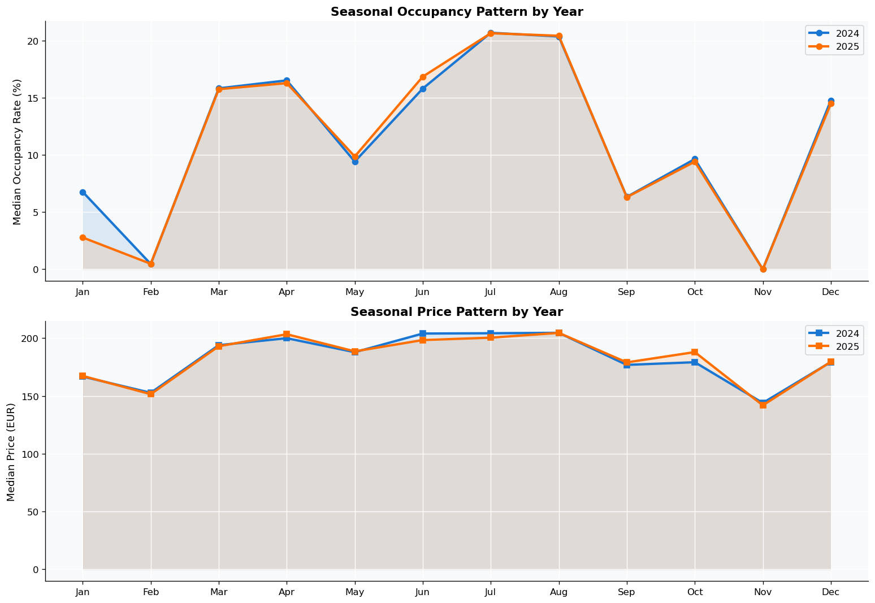
Figure 1.7 — Seasonal occupancy (top) and price (bottom) patterns by year.

1.6 Booking Curve Behaviour
The booking curve describes how demand accumulates over the 52-week horizon. Understanding its shape is central to determining when prices should be adjusted.

Figure 1.10 shows the average cumulative fill rate, broken down by market group (centre) and accommodation range (right). Several patterns are clear:

- Demand is concentrated in the final 13 weeks before arrival. At 26 weeks out, the average product is less than 20% booked.
- Market groups differ in lead time: some segments book further in advance than others, implying that the same product should be priced differently for different markets.
- Premium products fill more slowly than Budget products in percentage terms at early lead times, consistent with their customers planning more carefully before committing.

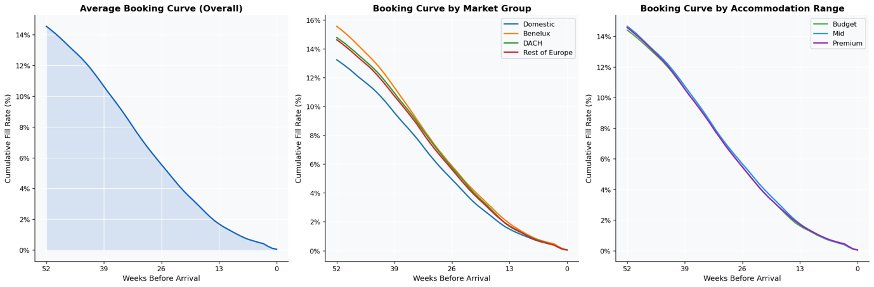
Figure 1.10 — Cumulative fill rate along the booking horizon: overall (left), by market group (centre), by accommodation range (right).

Special periods also shape the booking curve trajectory (Figure 1.12). Festival and holiday weeks attract bookings earlier relative to standard weeks — guests commit further in advance for known calendar events.

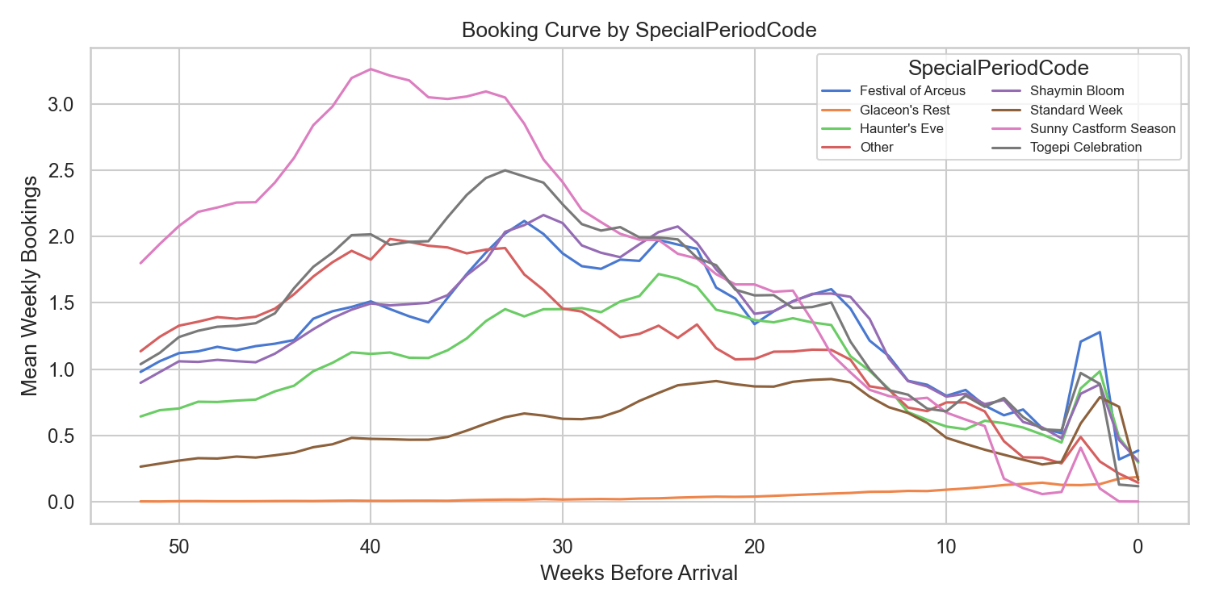
Figure 1.12 — Mean weekly incremental bookings along the horizon by special period type.

1.8 Summary of EDA Findings
The EDA reveals several patterns that directly shape the modelling and pricing strategy. At the most basic level, 74% of weekly booking snapshots record zero demand, meaning the target variable is heavily zero-inflated and cannot be handled by standard regression methods. Demand is strongly seasonal — peaking in June through August and bottoming out in December through February — making a seasonal price ladder a necessity rather than an option. On top of seasonality, special periods such as school holidays and festival weeks command both higher prices and higher occupancy simultaneously, indicating genuine pricing power that standard week rules would fail to capture.
From a timing perspective, roughly half of all bookings arrive in the final 13 weeks before arrival, meaning that late-horizon prices have a disproportionate impact on total revenue. Equally important is the heterogeneity across product clusters: clusters differ sharply in how quickly they fill and when their demand peaks, so any flat pricing rule applied uniformly across all products will systematically under-price some and over-price others.
On price sensitivity, the data show a clear negative relationship between price and bookings even before any modelling — demand is price-elastic, and pricing too high leaves revenue on the table. This elasticity is not uniform: Budget accommodations are more price-sensitive than Premium ones, meaning that discounts drive proportionally more incremental bookings in the lower range, while Premium products can sustain higher prices without significant volume loss. Finally, prices already vary along the booking horizon in the current data, confirming that dynamic pricing is operationally in place — the central question is therefore not whether to price dynamically, but how to set the right price at the right time.

2. Methodology
The solution methodology consists of three sequential analytical stages, each building on the outputs of the previous. A fourth stage produces diagnostic visualisations for model validation and presentation.
Data─► Stage 1: Demand Forecasting Model─► Stage 2: Price Elasticity Estimation ─► Stage 3: Revenue Optimisation─► Stage 4: Diagnostic Plots

2.1 Stage 1 — Demand Forecasting Model
Purpose. Build a predictive model of weekly incremental bookings (HistoricalBookedNights) as a function of price and context. This model is the core engine: by querying it at different hypothetical prices, the optimiser can estimate demand under counterfactual pricing scenarios.

Approach. A HistGradientBoostingRegressor with a Poisson loss is trained on 85% of the data (by arrival date). The Poisson loss is appropriate for count targets with zero-inflation and overdispersion. The model is trained on ~22 features spanning product identity, accommodation characteristics, booking horizon, price (raw and log-transformed), geography, and weather. See Section 3 for the full technical treatment.

Output. A serialised model bundle (models/demand_hgb.joblib) and test-set predictions (models/demand_predictions_test.csv) used in Stages 3 and 4.

2.2 Stage 2 — Price Elasticity Estimation
Purpose. Independently estimate the causal price elasticity of demand using a transparent, interpretable econometric model that does not rely on the black-box gradient booster. This provides a statistically grounded answer to: by how much does a 1% price increase reduce weekly new bookings?

Approach. A Two-Way Fixed Effects (TWFE) panel OLS regression is estimated using linearmodels.PanelOLS:

$$log⁡(1+{\text{NewBookings}}_{it})=β⋅log⁡({\text{Price}}_{it})+α_{i}+γ_{t}+ε_{it}$$

where $α_{i}$ are entity fixed effects (one per ReservableOptionMarketGroupId, absorbing all time-constant product heterogeneity) and $γ_{t}$ are time fixed effects (one per WeekBeforeArrival, absorbing demand patterns common across all products at a given lead time). This design removes the endogeneity bias identified in the EDA by exploiting only within-product, within-horizon price variation.

The outcome NewBookings is the first difference of HistoricalBookedNights within each curve (sorted from week 52 to week 0), representing the flow of new bookings per week rather than the cumulative stock. Standard errors are clustered at the entity level.

Stratified elasticities are estimated by lead-time bucket and seasonal cluster to capture heterogeneity across the booking horizon and product types.

Pooled and stratified results are summarised in the table below. All estimates are highly significant (p < 0.001).

Stratum | Elasticity (β) | Std. Error | Interpretation
Pooled (all weeks) | −1.534 | 0.009 | 1% price rise → −1.53% weekly bookings
Lead-time 27–52w | −1.234 | 0.024 | Earliest bookers, least price-sensitive
Lead-time 13–26w | −1.906 | 0.033 | Most elastic — peak planning window
Lead-time 5–12w | −1.318 | 0.049 | Moderate sensitivity
Lead-time 0–4w | −1.499 | 0.099 | Last-minute, still elastic

Demand is elastic throughout (all |β| > 1), meaning that price increases reduce revenue unless offset by the price increase itself — the optimal price is finite, not "as high as possible."

The 13–26 week window is the most price-sensitive: guests in the medium-term planning phase are actively comparing options and can be won or lost by price. The very early window (27–52w) is least sensitive, consistent with early-bird bargain hunters who are already committed if the price is in range.

Figure 2.1 plots elasticity by lead-time bucket with 95% confidence intervals, and Figure 2.2 shows the distribution across seasonal clusters.

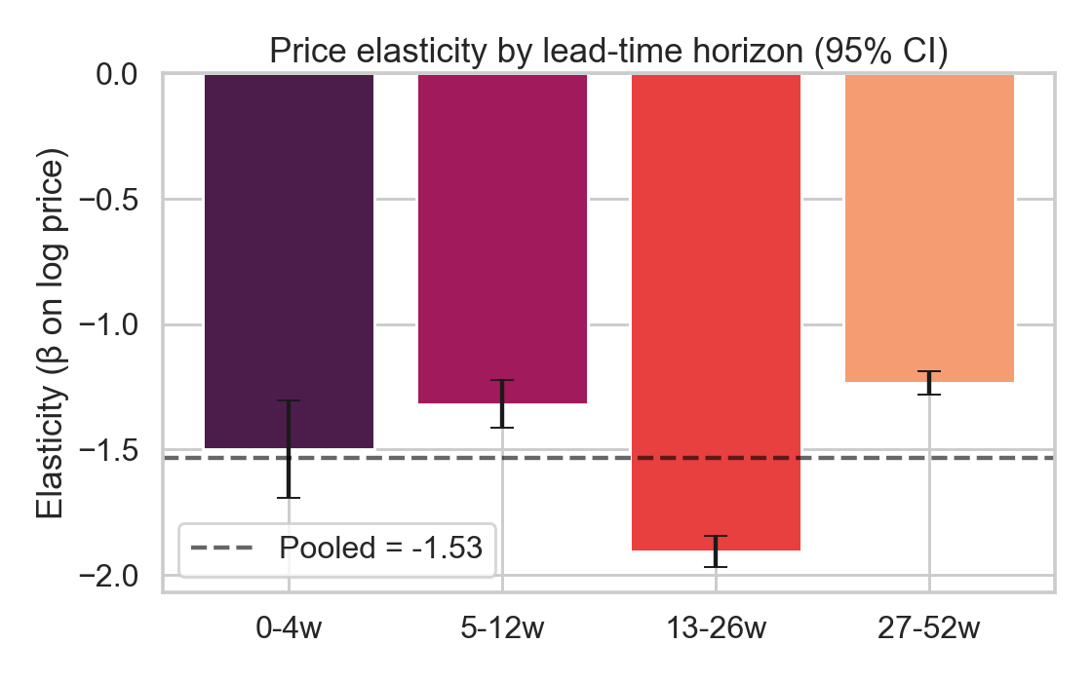
Figure 2.1 — Price elasticity by lead-time bucket (bars) with pooled estimate (dashed line). Errors are 95% CIs.

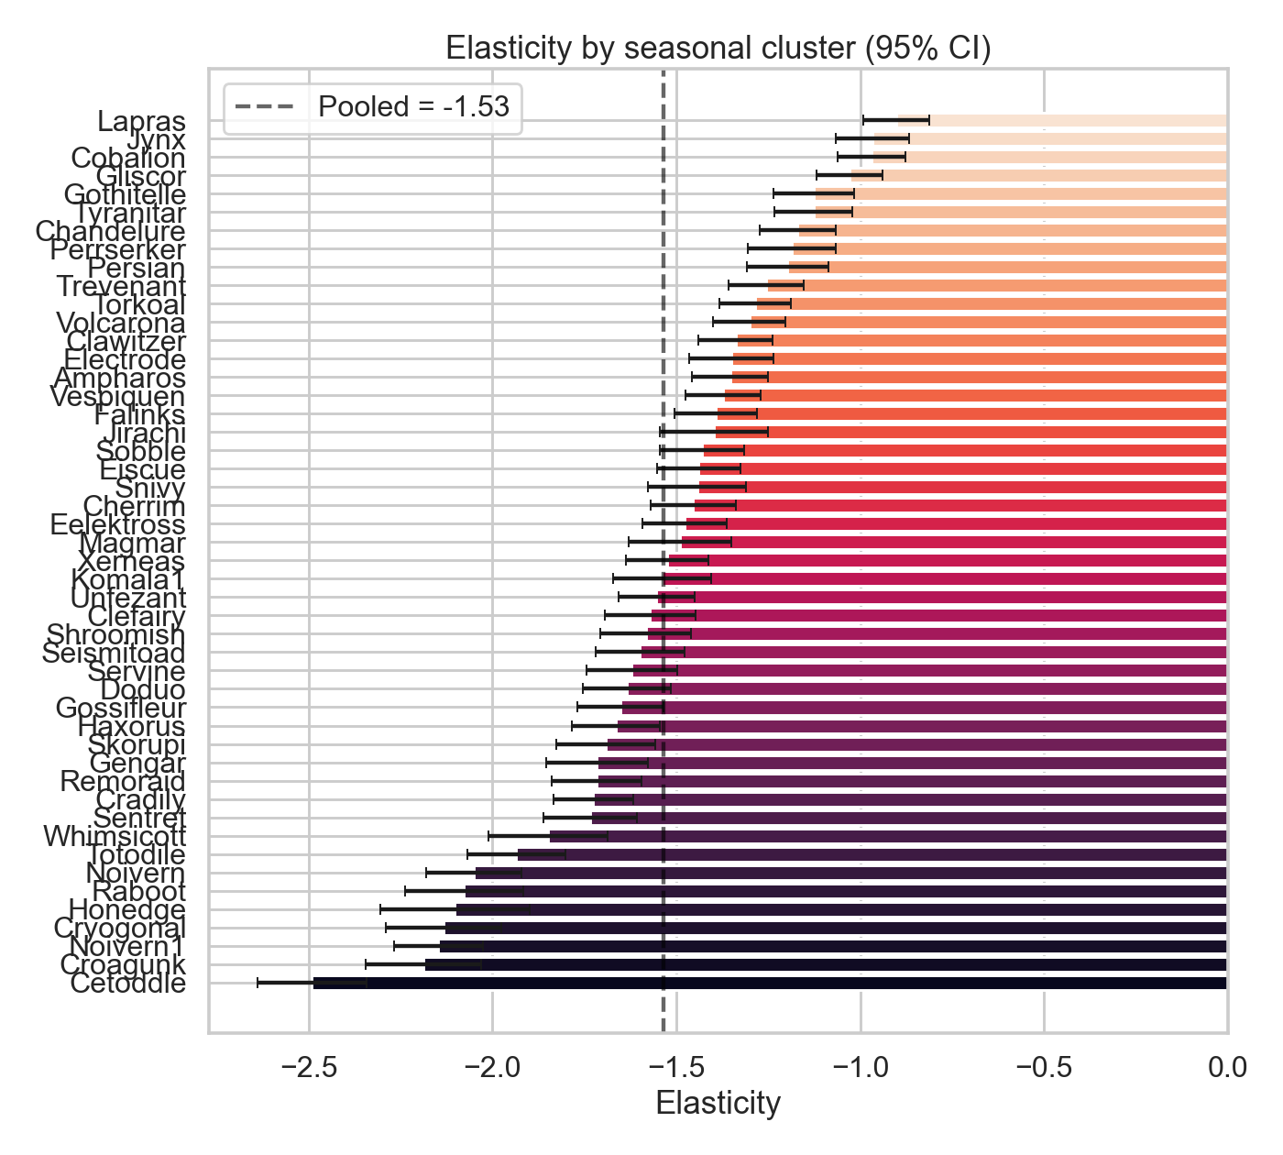
Figure 2.2 — Price elasticity by seasonal cluster. Range from −0.90 (Lapras) to −2.49 (Cetoddle), indicating that pricing strategy must be cluster-specific.

2.3 Stage 3 — Revenue Optimisation
Purpose. For each product in the held-out set, find the price multiplier ladder — one multiplier per lead-time bucket — that maximises expected total revenue over the booking horizon.

Approach. A discrete grid search is performed over price multipliers 0.85, 0.95, 1.00, 1.05, 1.15 $applied independently to each of four lead-time buckets, yielding$ 5^4 = 625 candidate ladders per product. For each candidate:

1. Replace the observed prices with multiplier × baseline_price across all snapshot rows.
2. Score the counterfactual snapshots with the Stage 1 demand model → predicted cumulative bookings.
3. Enforce monotonicity (cumulative bookings cannot decrease over time) and a hard capacity ceiling.
4. Compute revenue as $\sum_{t}{}{\text{Price}}_{t}×\text{Δ}{\text{Bookings}}_{t}$ across all horizon weeks.

The ladder with the highest expected revenue is selected. The optimisation is applied to 200 randomly sampled hold-out product curves.

Results. Figure 2.3 shows the revenue uplift distribution. The median uplift over baseline is +17.6%, with a mean of +36.6% (driven by a right tail of products where the baseline price is far from optimal). The pattern of chosen multipliers (Figure 2.4) is consistent with the elasticity findings: discount early (27–52w: modal multiplier 0.85), charge a premium close-in (0–4w: modal multiplier 1.15).

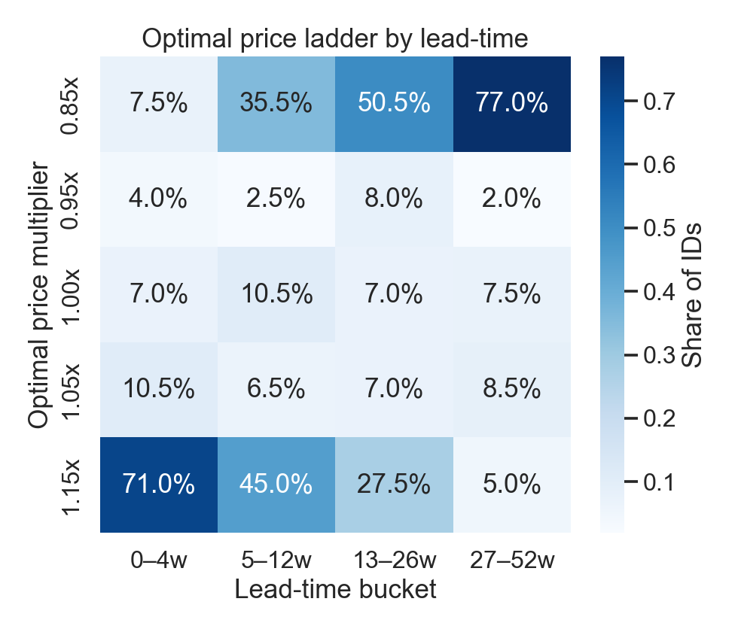
Figure 2.4 — Frequency heatmap of optimal price multipliers by lead-time bucket. Early-horizon discounts and last-minute premiums dominate.

The early-discount, late-premium ladder exploits two mechanisms simultaneously: it stimulates early bookings when demand is elastic and naturally sparse, securing revenue early and filling capacity; it then captures the price-inelastic last-minute demand at a higher margin when the product is nearly full and alternatives are scarcer.

3. Demand Modelling

3.1 Objective
The demand model predicts how many nights will be booked in a given week (HistoricalBookedNights) for a specific product at a specific point in its booking horizon, given the current price and all available context. It must:

- Capture the non-linear effect of price on bookings (including near-zero bookings at high prices).
- Distinguish how demand accumulates at different lead times.
- Generalise across the full product space (142 campsites × 5 acco types × 4 market groups × 3 ranges).
- Serve as a scoring engine for counterfactual price simulation in the optimiser.

3.2 Algorithm
The model is built on a gradient boosting algorithm — a technique that builds many small decision trees one after another, each one correcting the mistakes of the previous, until predictions are as accurate as possible.
The key design choice is using a Poisson loss function, which makes the algorithm well-suited for counting things (like bookings) rather than predicting continuous values like temperature or price. This matters because most weeks record zero bookings, and a standard model would struggle with that — the Poisson approach handles sparse, count-based data naturally.
A few practical settings were tuned to keep the model accurate without overfitting: it learns slowly and carefully (low learning rate), builds deep enough trees to catch complex patterns between features, and automatically stops training early if it stops improving on a held-out validation slice.

3.3 Feature Engineering
Before feeding data into the model, several variables were transformed or created to make patterns easier to learn.
The price was converted to a log scale since the relationship between price and bookings is not linear—a €10 increase matters a lot more at €50 than at €500, and the log scale captures that naturally.
The most important transformation was breaking down how far in advance a booking is made into four behavioral groups. Guests who book 6 to 12 months ahead are early planners — they book in low volumes and are not very sensitive to price. Those booking 3 to 6 months out are the most price-sensitive group, actively comparing options and most likely to be influenced by a price change. Guests in the 1- to 3-month window have largely made up their minds and book in moderate volumes. Finally, last-minute bookers (within a month of arrival) arrive in concentrated bursts and are less deterred by higher prices since their options are limited. Splitting the horizon this way lets the model learn that the same price change has very different effects depending on when in the booking journey it happens.
A few other adjustments were made: year and week-of-year were extracted from the date to capture long-run trends; accommodations missing features like a kitchen or decking were explicitly labeled as "None" so the model treats their absence as meaningful information, and prior-year pricing and booking columns were dropped entirely since they are only available for a subset of products and would have introduced misleading signals for newer products.

3.5 Train–Test Split
A time-based split holds out the most recent 15% of arrival dates for testing, leaving the earlier 85% for training. The cutoff falls roughly at the 85th percentile of WeekStartDate.

Set | Criterion | Approx. size
Training | WeekStartDate ≤ 85th percentile cutoff | ~2.66M rows
Test | WeekStartDate > cutoff | ~0.47M rows

A random split is explicitly avoided: it would allow snapshots from future arrival weeks to appear in the training set alongside snapshots of the same curve from earlier in the booking horizon, creating temporal leakage. The time-based split ensures the model must genuinely generalise to arrival weeks it has not seen at any point during training.

3.6 Model Performance
The model trained to the maximum of 1,000 iterations (early stopping did not trigger), indicating the model continued to improve throughout.

Metric | Value
Test MAE | 0.714
Test RMSE | 1.839
Test R² | 0.268
Mean actual (test) | 0.735
Mean predicted (test) | 0.619
Zero rate — actual | 74.0%
Zero rate — predicted | 69.3%

Contextualising R² = 0.268. An R² of 27% at first appears modest, but must be interpreted in context. The target is dominated by zeros (74% of test rows) and has very high irreducible noise at the individual snapshot level — most of the variance in any given week's bookings is random and unforecastable from product features alone. What matters for the downstream optimiser is that the model correctly captures the relative effect of price and the systematic patterns across the booking horizon and product space. Both are confirmed by the diagnostic plots below.

Predicted vs actual booking curve. Figure 3.1 averages the model's predictions and the actual values by WeekBeforeArrival across the test set. The model reproduces the shape of the booking curve — near-zero at early lead times, rising sharply in the final weeks — with close alignment to the actual mean. Slight under-prediction at the final few weeks reflects the Poisson loss's tendency toward conservative mean estimates.

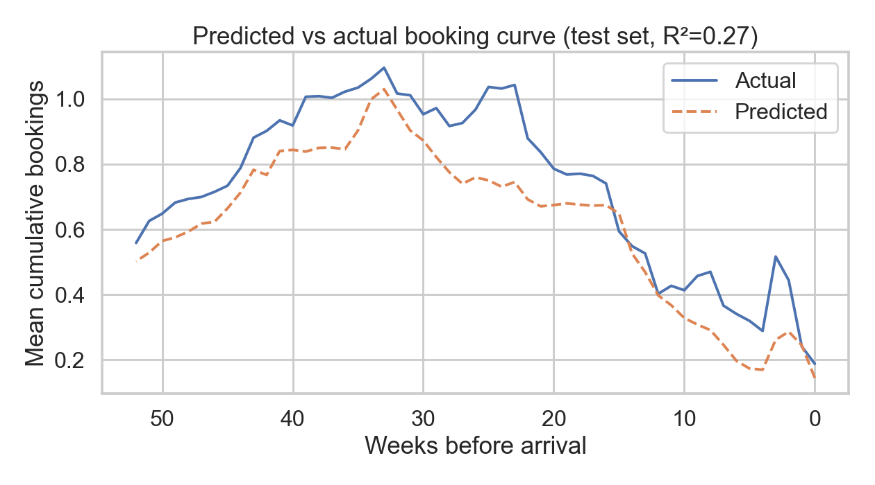
Figure 3.1 — Mean predicted vs mean actual incremental bookings by weeks before arrival (test set).

Calibration. Figure 3.2 confirms that across 20 predicted-value quantile bins, the mean predicted value tracks the mean actual value closely. This is the property that matters most for the price optimiser: the model's predictions are correctly ranked and proportionally scaled, ensuring that the revenue comparison across 625 price ladders is meaningful.

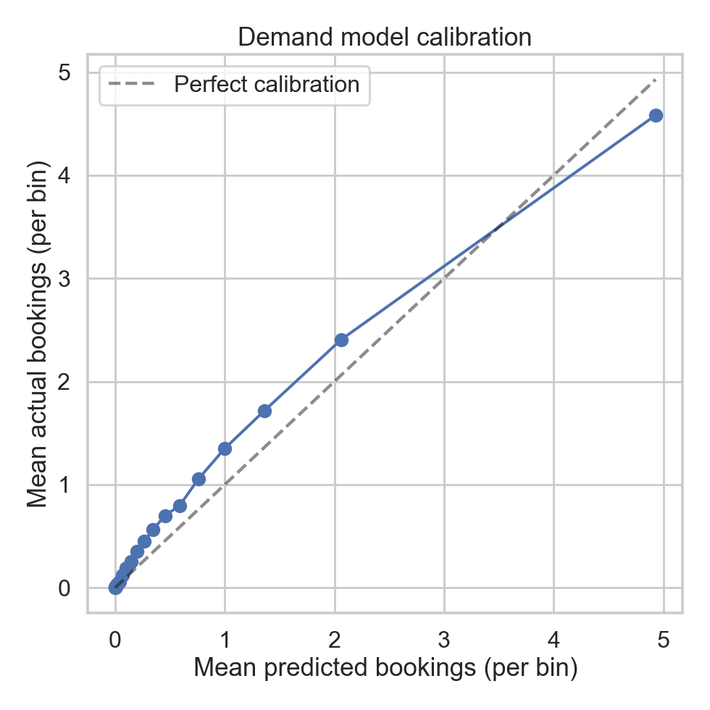
Figure 3.2 — Calibration plot: mean predicted bookings per bin vs mean actual bookings per bin. Points close to the diagonal indicate well-calibrated predictions.

The slight under-prediction of mean bookings (0.619 vs 0.735) and of zero rates (69.3% vs 74.0%) — meaning the model predicts some bookings where there were none — is a known consequence of the Poisson loss, which asymmetrically penalises underestimation of positive counts. For the optimiser, this systematic level shift is inconsequential: revenues are compared relative to baseline across price ladders, so a constant downward bias cancels out.

3.8 Limitations
Endogeneity of price. The EDA reveals a small positive correlation between the current fill rate and subsequent price changes, indicating that prices are sometimes raised in response to strong early demand. The gradient boosting model does not fully account for this: it may partially absorb the effect of strong underlying demand as a price effect, causing it to underestimate the true causal price sensitivity. The TWFE elasticity estimate (Section 2.2) addresses this through entity fixed effects; the optimiser should be understood as providing a relative ranking of price ladders rather than exact revenue forecasts.

Zero-inflation structure. The Poisson loss handles overdispersion but is not a two-part model. An explicit hurdle model — predicting the probability of any booking first, then the expected count conditional on at least one booking — could improve performance on the zero-vs-nonzero classification (current gap: 74.0% actual vs 69.3% predicted).

Excluded prior-year features. DiscountedPriceLastYear and HistoricalBookedNightsLastYear are natural demand anchors that, if properly imputed or modelled, could reduce prediction error for products with stable year-over-year patterns. The current approach conservatively excludes them to avoid missingness-driven bias.

Temporal generalisability. The model is trained on 2024 data and validated on late-2025 arrival weeks. Significant structural shifts between training and deployment — new product launches, macroeconomic shocks, changes in competitor pricing — would degrade accuracy and require periodic retraining (recommended quarterly).

