# CAMUNDA 7 USER DETAILS VALIDATION PROCESS

1. Design and Implement POC on Customer onboarding process using Camunda 7  + Spring Boot  by using following:
2. Pass process variable name & address at the time of initiation of workflow process using Human with task form.
3. Do the following validations first name and last name exist for the given name  and there are no special characters & numeric. For Address  make sure to pass the address fields are  street number (123), street name (Main Street), city (Anytown), state (USA), and zip code (12345)

# IMPLEMENTATION OF ABOVE TASK

**STEP 1:** Start the process by start event. Add user task to the start event. For Taking inputs from the user task, I have created the “user details Camunda forms”.

* Create Camunda form in the Modeler and add the required fields as shown in figure.

* Make sure that we should use the same form reference that we have given in Camunda form to the form Reference in the user task.
* Add the user task to service task to implement java delegate and process these variables.

**STEP 2:** Implement the service task in process definition by adding the Implementation of Java delegate and Java class path.

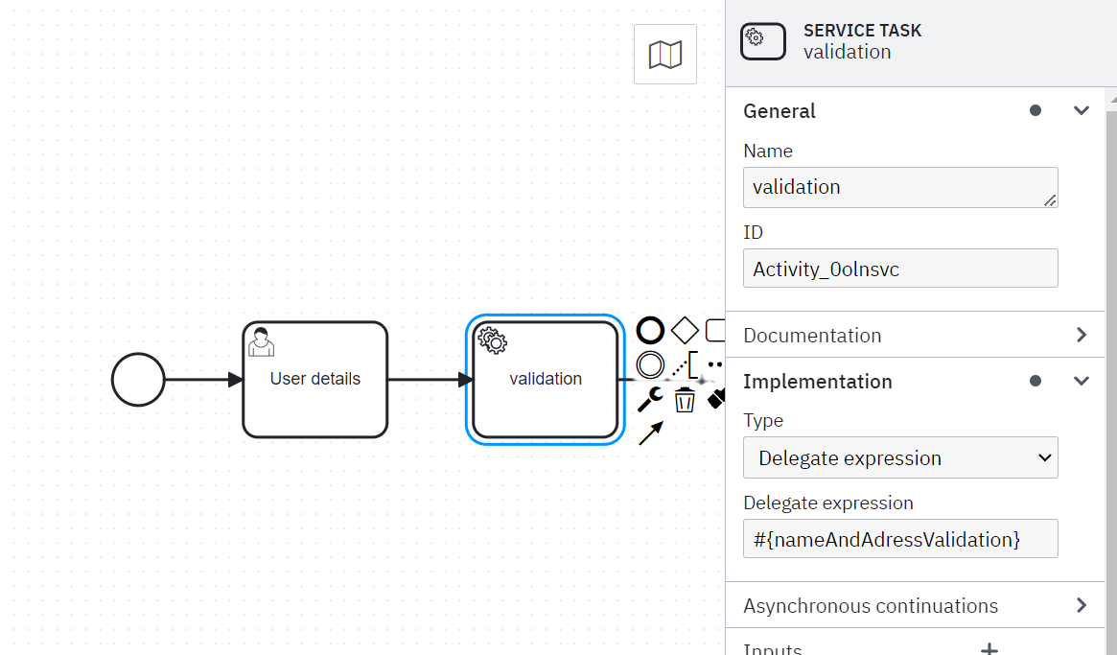

**STEP 3:** Create Camunda spring boot project and Create a Java class and Implement Java delegate.

Once project is created, run the application.java file to check the server is running or not.

For accessing Tasklist use URL: http://localhost:2024/camunda/app/tasklist/default

For accessing Cockpit use URL: http://localhost:2024/camunda/app/cockpit/default

**Application.java file :**

import org.springframework.boot.SpringApplication;

import org.springframework.boot.autoconfigure.SpringBootApplication;

@SpringBootApplication

public class Application {

public static void main(String... args) {

SpringApplication.run(Application.class, args);

}

}

Now, to process the user details we have to implement the java delegate interface in the validation class created in the project.

**Java Code for Implementing Service Task Java delegate Expression :**

import org.camunda.bpm.engine.delegate.DelegateExecution;

import org.camunda.bpm.engine.delegate.JavaDelegate;

import jakarta.inject.Named;

@Named

public class NameAndAdressValidation implements JavaDelegate {

@Override

public void execute(DelegateExecution execution) throws Exception {

//firstName, lastName, streetNumber, streetName, city, state, zipCode

String firstName = (String) execution.getVariable("firstName");

String lastName = (String) execution.getVariable("lastName");

String streetNumber = (String) execution.getVariable("streetNumber");

String streetName = (String) execution.getVariable("streetName");

String city = (String) execution.getVariable("city");

String state = (String) execution.getVariable("state");

String zipCode = (String) execution.getVariable("zipCode");

String name = ""+firstName+" "+lastName;

String address = ""+streetNumber+", "+streetName+", "+city+", "+state+" "+zipCode;

System.out.println("Name: "+name);

System.out.println("Address: "+address);

String status = "";

if (streetNumber.isEmpty()) {

status ="invalid";

}

else{

status ="valid";

}

execution.setVariable("status", status);

}

}

**STEP 4:** Now add exclusive gate way to get the status is true or false as we have declared a status variable according to the validation we did in the code.

* This gateway consists of two paths one which approve the user details by adding the user task and end the process if the status of the variable is True.
* If the validation status is False it return to the false path and it reject the user by using the user task and end the process.

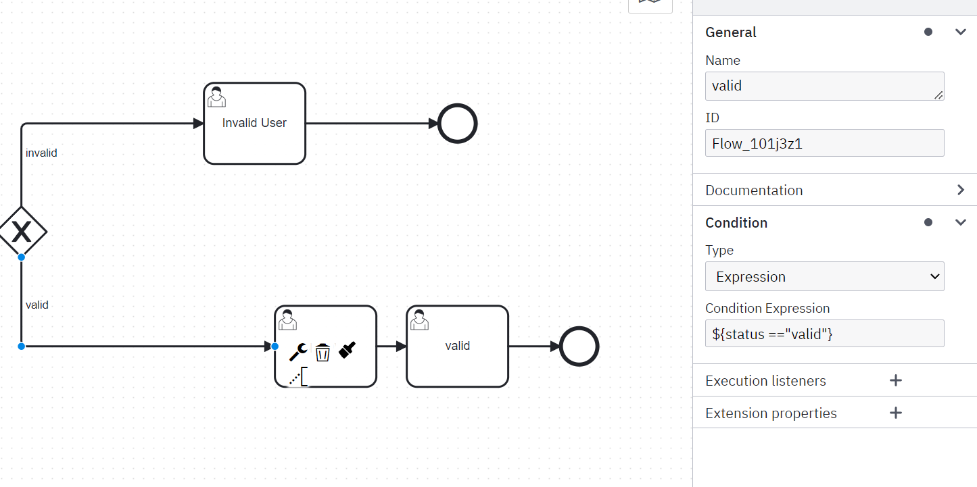

Now add this gateway path to the process definition to run and validate the user details.

**STEP 5:** The process definition of user validation in Camunda 7 is Done.

* The Workflow of the process is designed in Camunda 7.

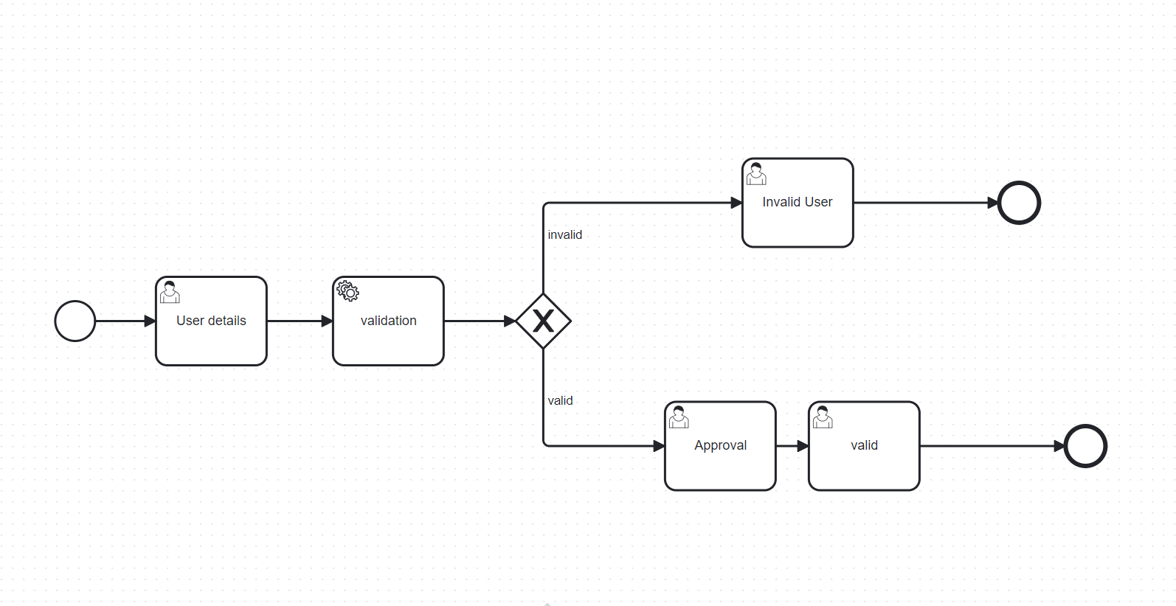

* Once the server started the Task list will ask the user to fill the form of the details that is required for validation.
* Once details entered it will run the process and validate the user is valid or not.
* This implementation is successfully done in Camunda 7

By

SAYYED KHADHAR BABA,

PROGRAMMER ANALYST,

EMPLOYEE ID : 2080519,

EPS IPM CAMUNDA DPO.