React - Weekly Assesment -1

Github PR:- <https://github.com/Khadhiri786/react-training/pull/1>

1. Demonstrate List Rendering in React.  
    - Create Array of employee objects and Render as Table.  
   Output:-  
   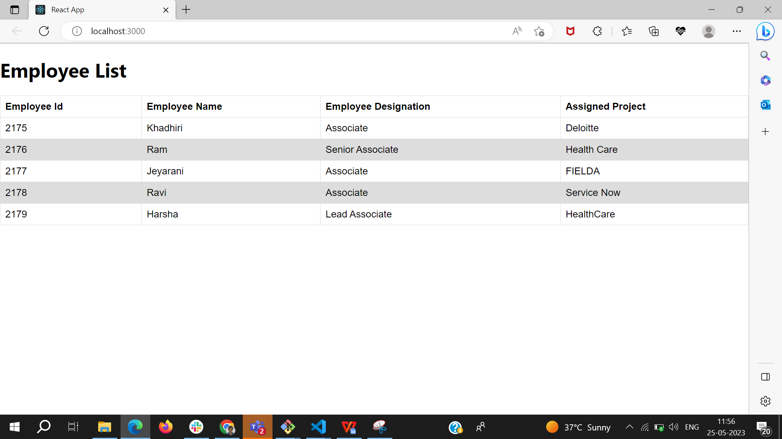  
     
   2) Demonstrate Event Binding both in functional and Class component  
     
   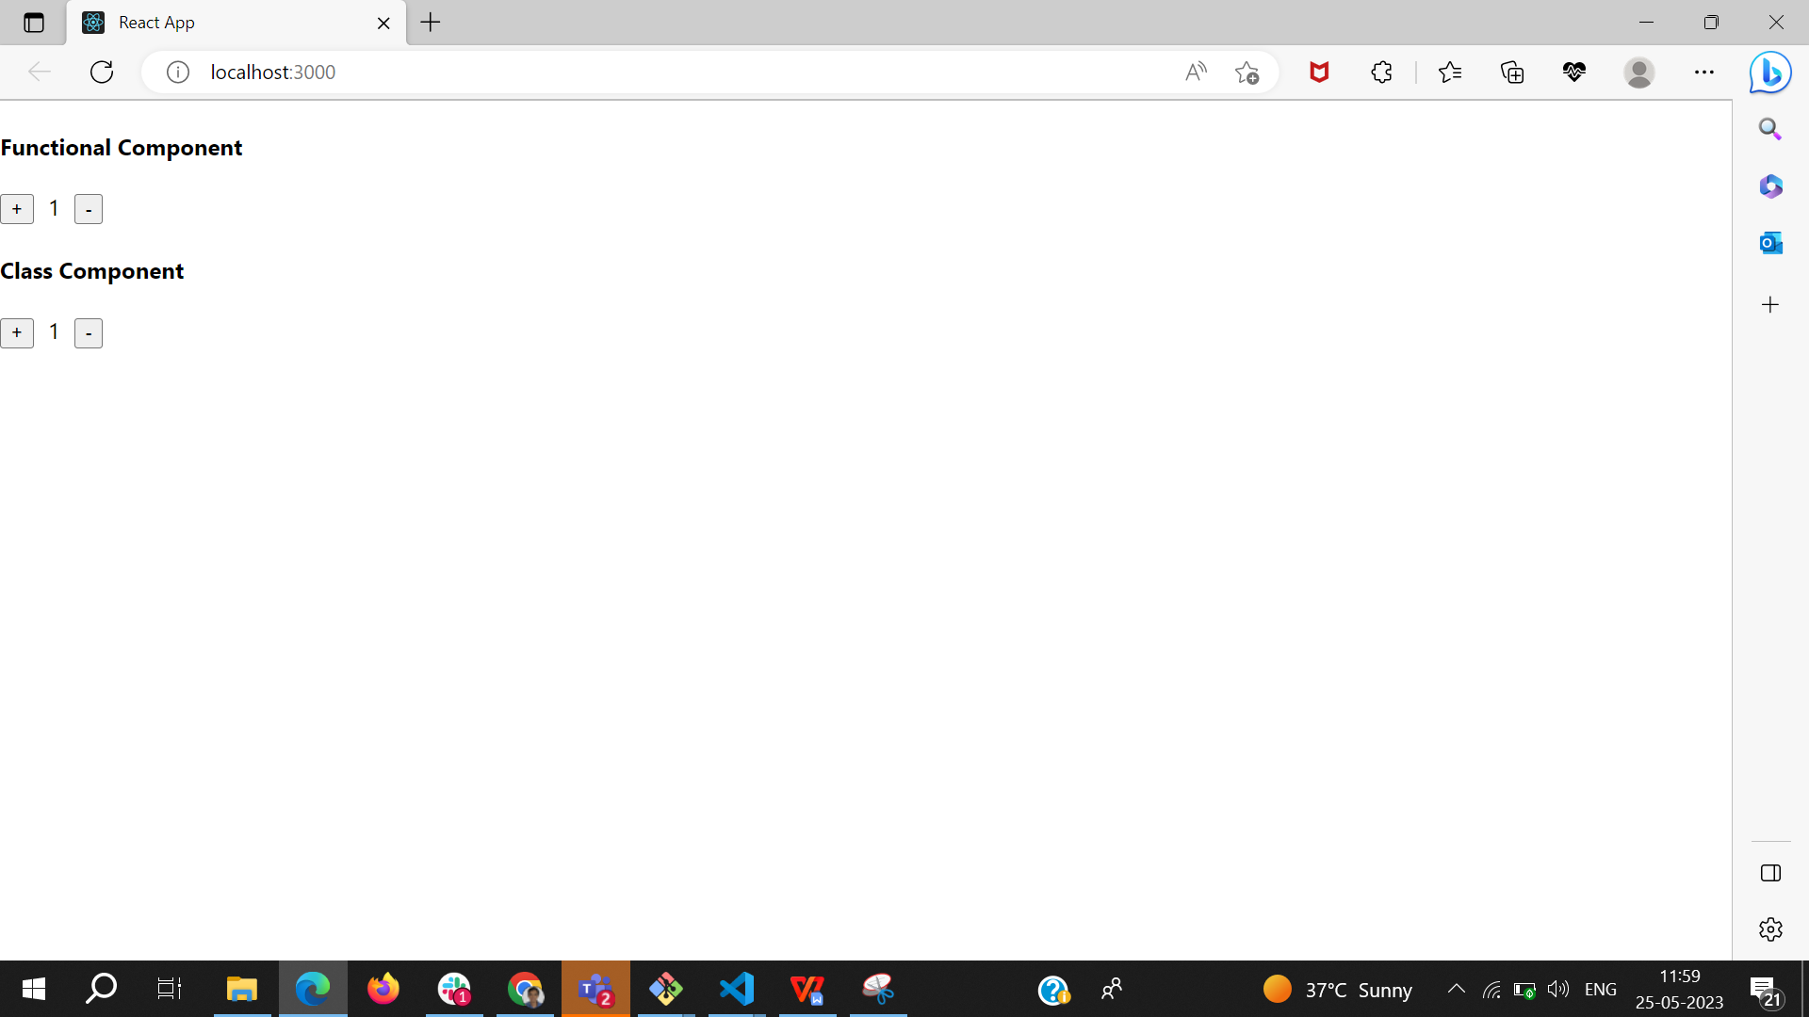  
     
   3) Program to demonstrate Fragments. Have an ordered list in one fragment

component and unorder list in another fragment component and combine both in root (App) component.

Output:-  
