I. Prototype UI
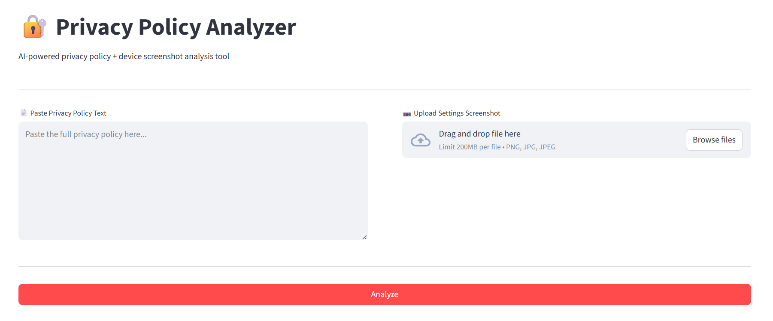
Here is the user interface (UI) for the prototype.

II. Prototype Functionality Example Screenshots

A. Copy and Paste Functionality
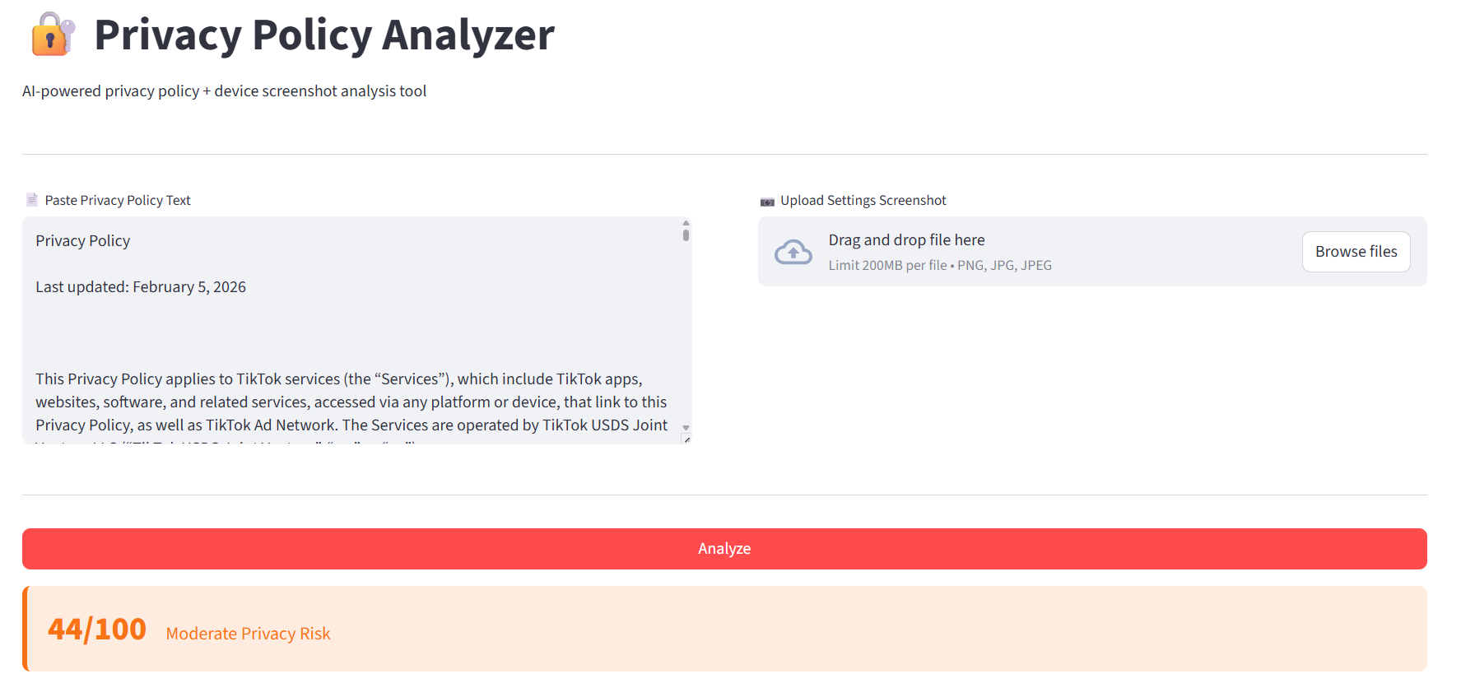
Here, the user can copy and paste the privacy policy they want to input. For these screenshots, the whole Tik Tok privacy policy was used.

B. Data Labels Output Functionality
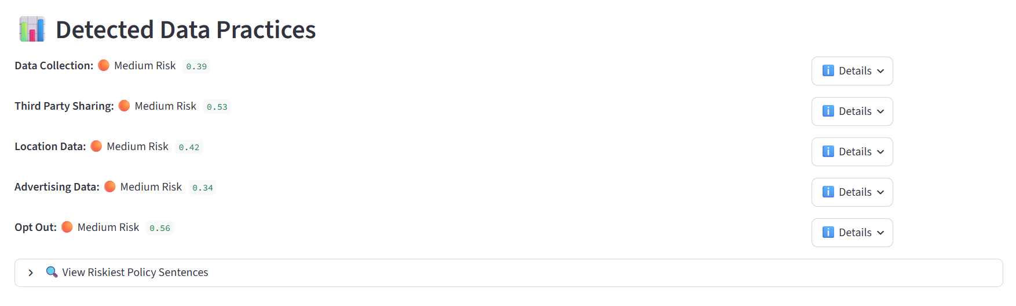
Here shows the risk scores of each label for the given policy.
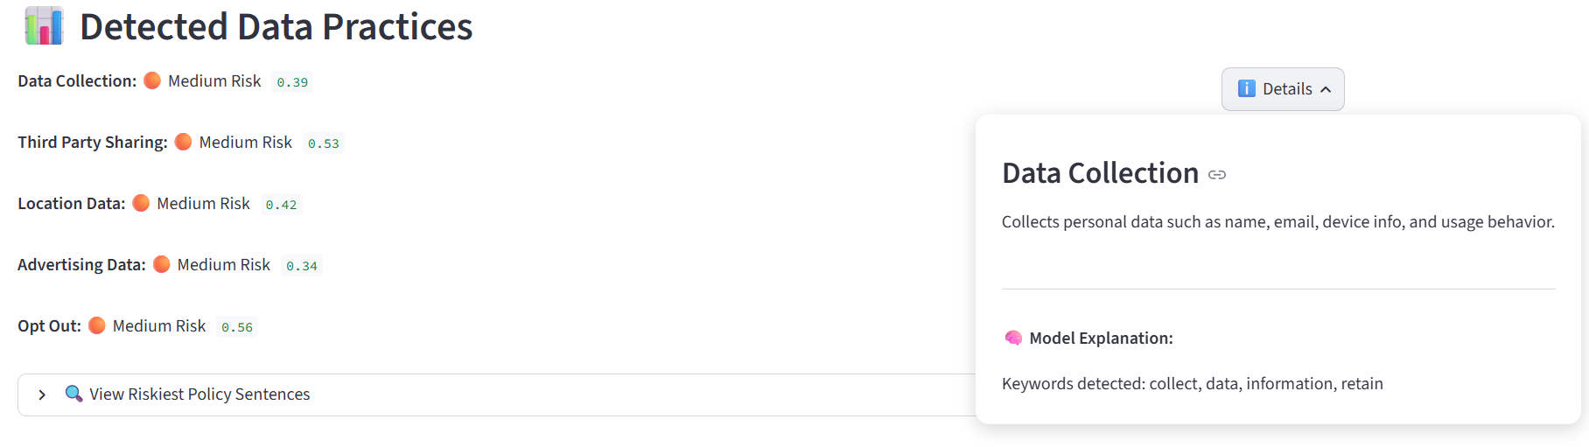
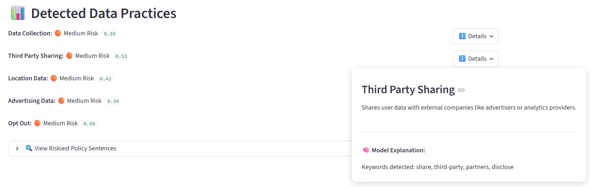
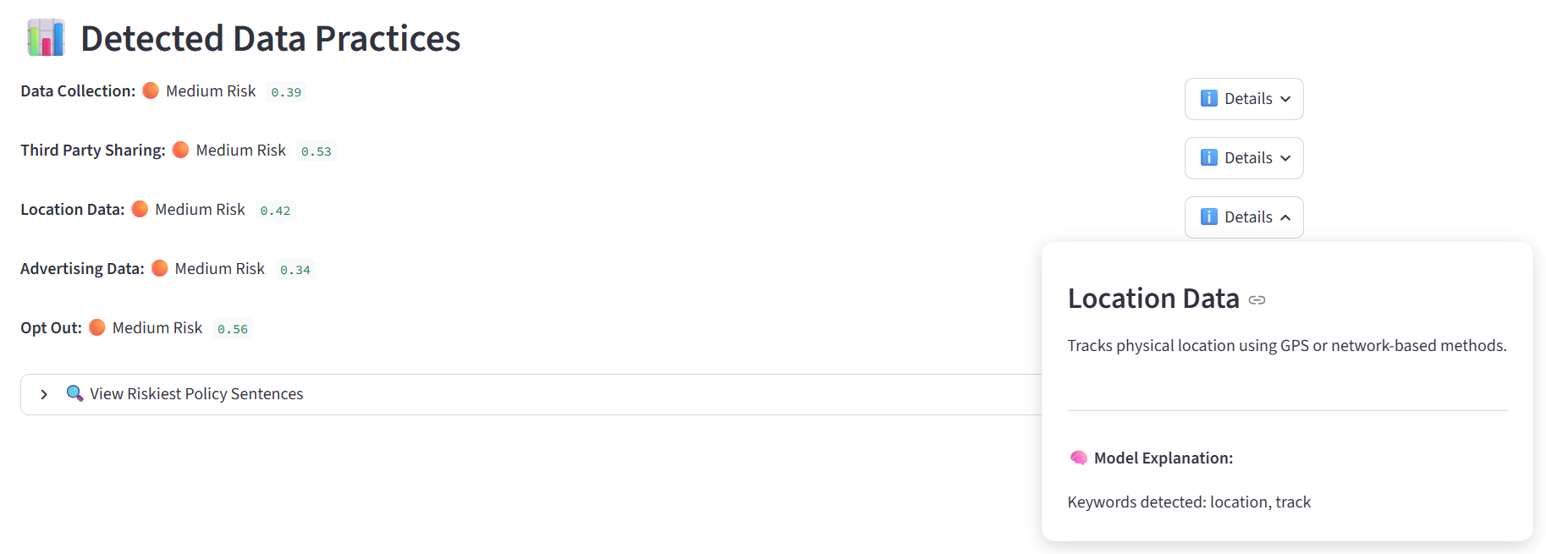
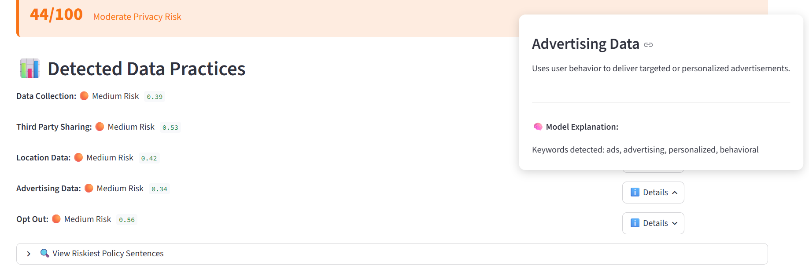
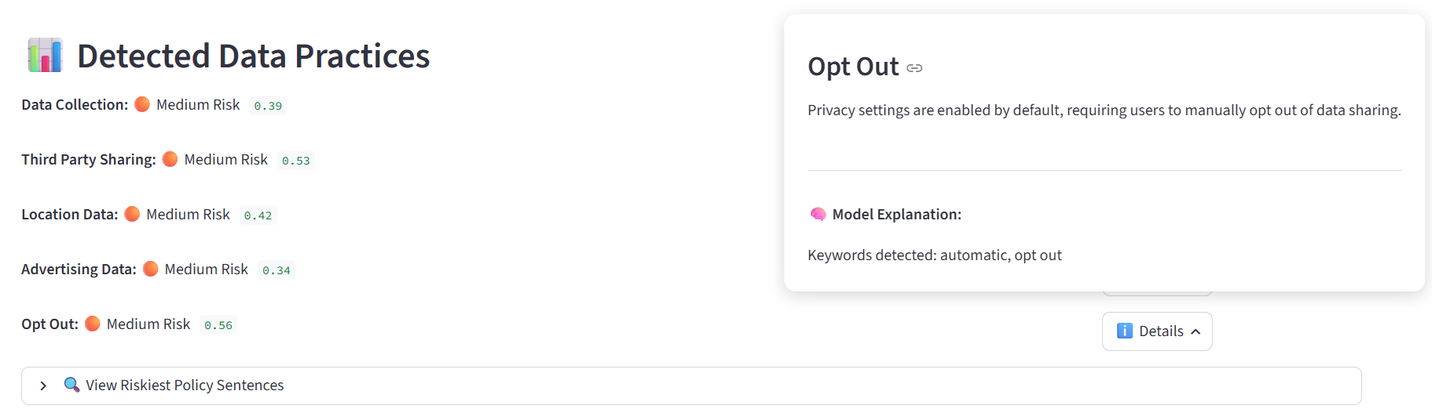
Above shows the information for each “i” icon for each label, and this pop up appears when the user clicks the “i Details” button.

1. Riskiest Sentences Functionality
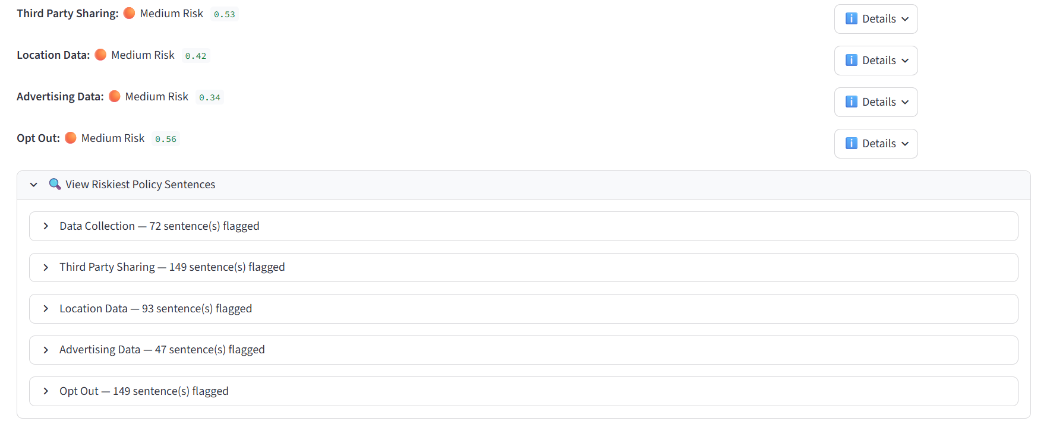
Here shows when the user clicks the “View Riskiest Policy Sentences” button, there is a drop-down menu, giving the user access to the sentences that match the given labels.
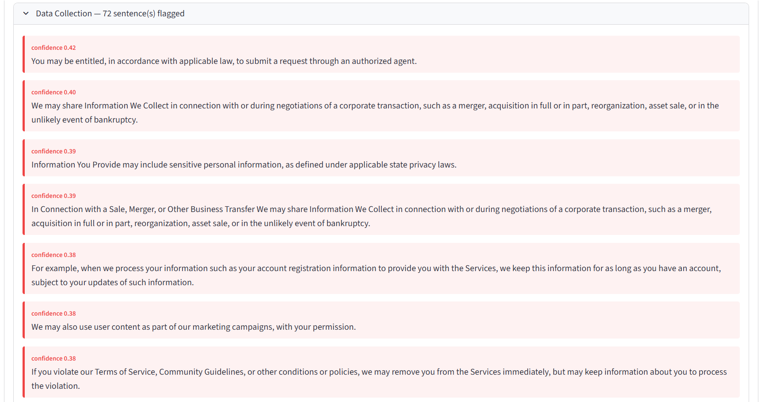
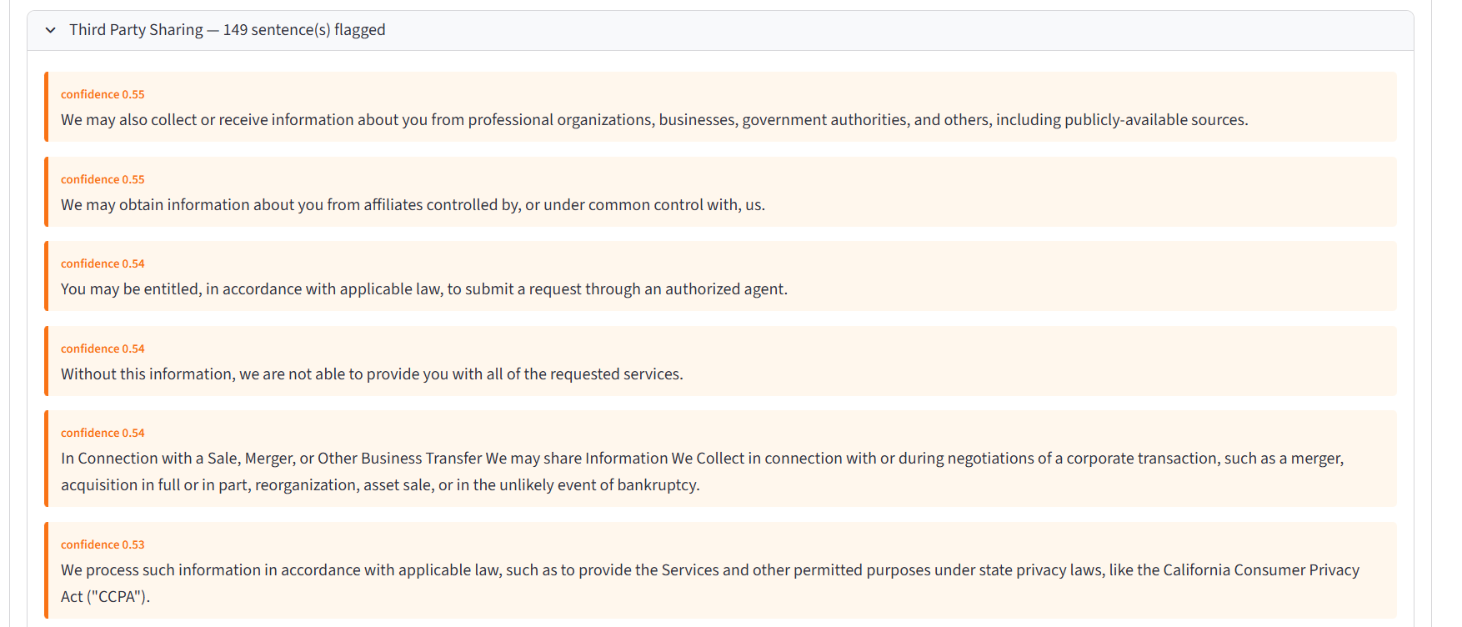
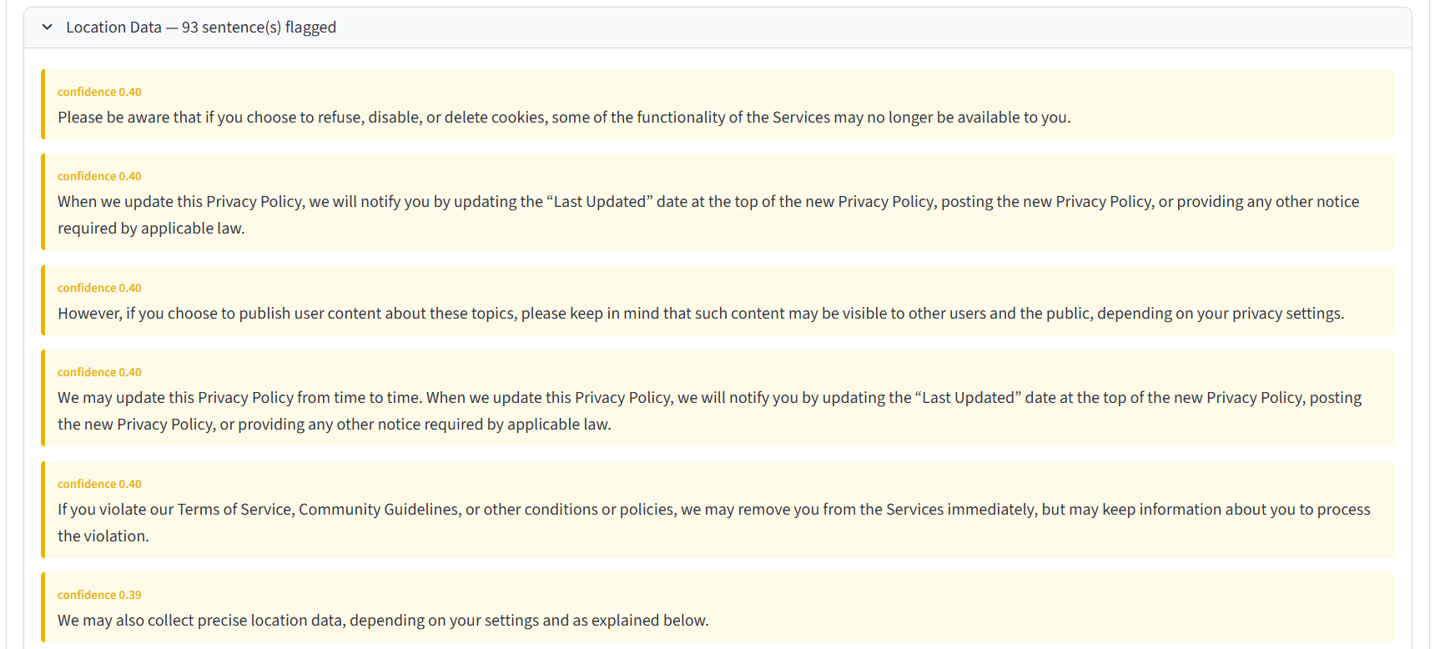
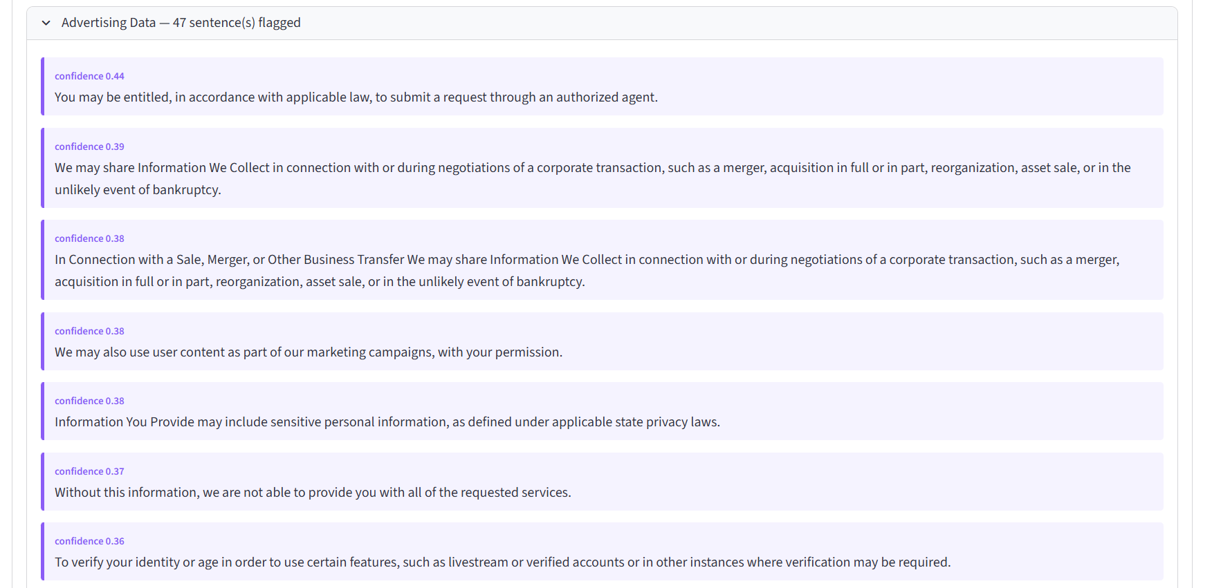
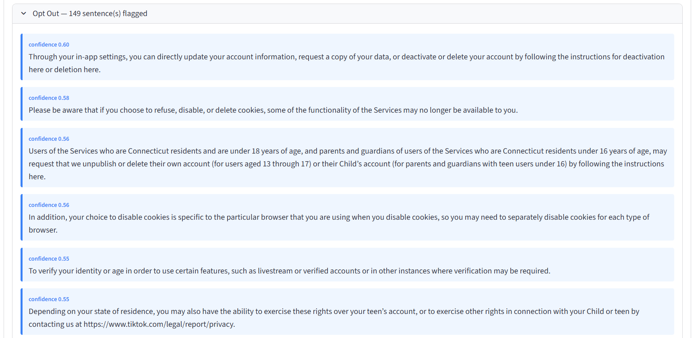
Here are some examples of what is shown under each label.

C. Screenshot Functionality
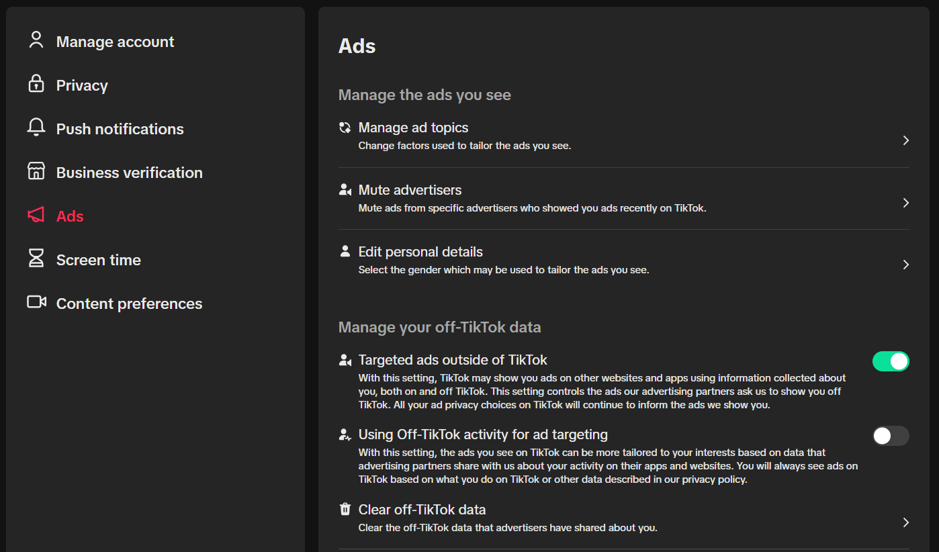
Here is the screenshot used to test screenshot functionality.
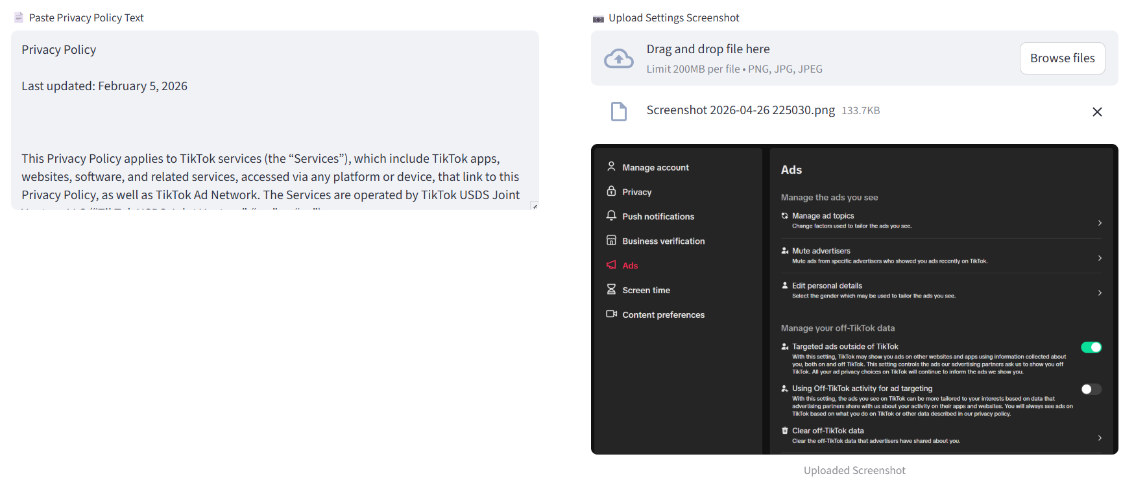
Here, the user just has to press “Browse Files” and input their given screenshot, and then they would click the “Analyze” button.
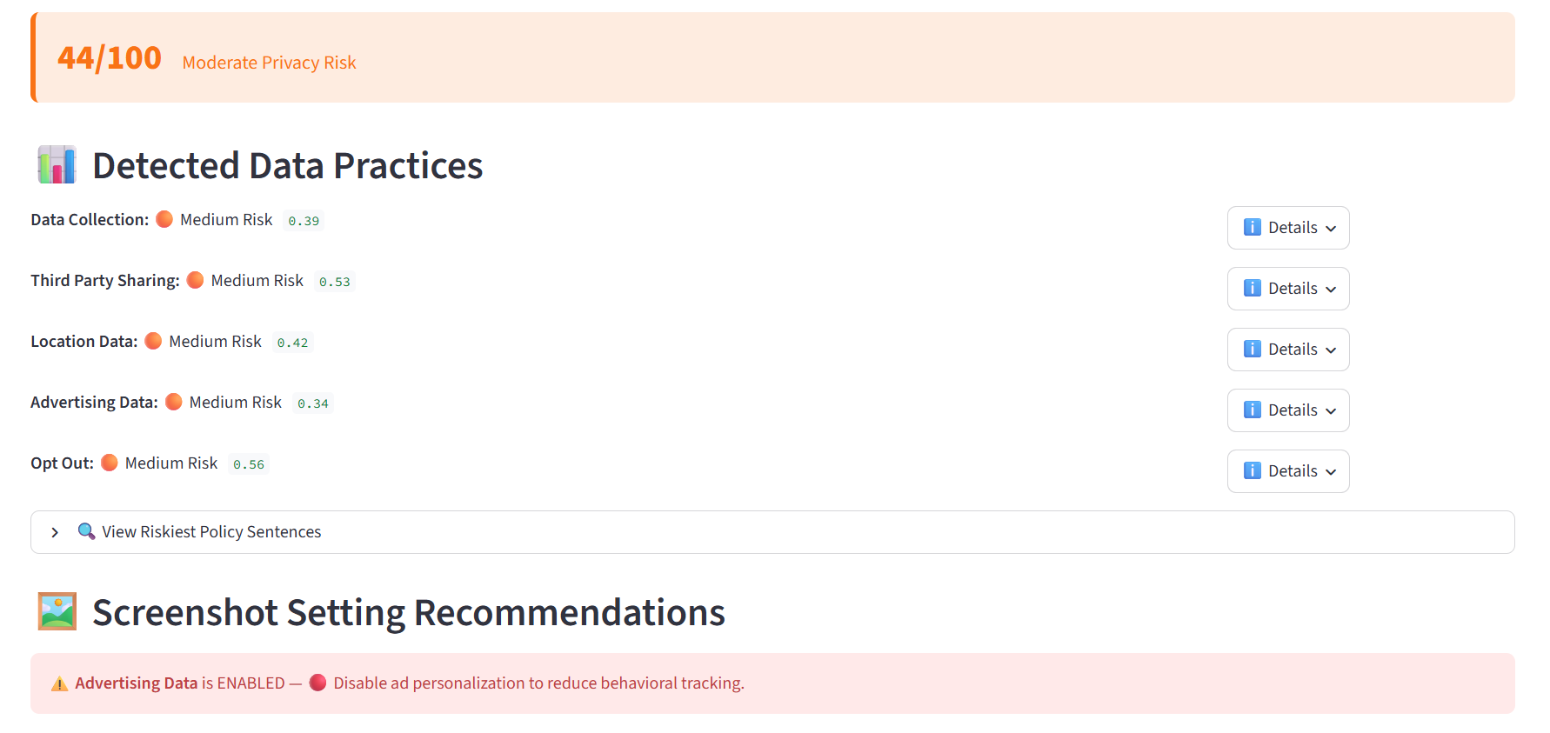
The output is the same with the policy text alone, but now the “Screenshot Setting Recommendation” is now present. It shows what setting is enabled, and then it gives the user a recommendation on what to turn off and why.

