Day 31 – Oracle BIP Reports in Oracle Fusion (Contd…)
Topic: Bursting | Notes and lab screenshots

1. What is Bursting?
Bursting is a BI Publisher feature that splits a single report into multiple documents based on data, and then delivers each document to the appropriate recipient or destination.
Example: a report contains payment information for three suppliers. Instead of sending one report with all three suppliers, Bursting generates a separate PDF for each supplier and emails it to the right recipient.

Three core parts of Bursting
- Split key – the data field used to split the report (e.g. SUPPLIER_ID). It must exist in the data.
- Delivery key – the field used to match each data split to its delivery instructions (e.g. SUPPLIER_ID).
- Delivery query – provides the formatting and delivery instructions (template, output format, channel, recipient, subject, etc.).

2. Lab Steps
- Create a sample data model and report.
- Understand the bursting control fields.
- Configure a bursting definition.
- Split the report using a key such as SUPPLIER_ID.
- Generate separate PDF outputs and configure delivery.
- Test the report and troubleshoot common errors.

3. Sample Data
Create a report with three sample suppliers. It should produce one PDF per supplier and send each PDF to a designated test email address.
Supplier ID | Supplier name | Invoice amount | Test recipient
1001 | Gulf Star LLC | 1,250 | supplier1@example.com
1002 | Muscat Office Supplies | 2,400 | supplier2@example.com
1003 | Oman Tech Services | 3,600 | supplier3@example.com

4. Tools – Reports and Analytics

Step 1: Create the Data Model (SQL query)
SELECT 1001 AS supplier_id,
'Gulf Star LLC' AS supplier_name,
1250 AS invoice_amount
FROM dual
UNION ALL
SELECT 1002, 'Muscat Office Supplies', 2400
FROM dual
UNION ALL
SELECT 1003, 'Oman Tech Services', 3600
FROM dual
ORDER BY 1

For testing: execute the above query in SQL Developer first.

Step 2: Create the report
Create a REPORT based on the data model created above.

Step 3: Create the layout template
Create SUPPLIER_PAYMENT_TEMPLATE.rtf.

Step 4: Edit the Data Model – bursting definition
The bursting definition belongs to the data model.
Configuration | Value for this lab
Bursting name | XX_SUPPLIER_PAYMENT_BURST
Type | SQL Query
Split By | SUPPLIER_ID
Deliver By | SUPPLIER_ID
Template | SUPPLIER_PAYMENT_TEMPLATE
Template format | RTF
Output format | PDF
Delivery channel | EMAIL

Step 5: Create the bursting SQL query
- In the data model editor, select Bursting from the component pane.
- Click Create New Bursting.
- Enter the bursting name and select the appropriate data source.
- Set the Split By and Deliver By elements.
- Enter the delivery query below.

SELECT
'1001' KEY,
'SUPPLIER_PAYMENT_TEMPLATE' TEMPLATE,
'RTF' TEMPLATE_FORMAT,
'en-US' LOCALE,
'PDF' OUTPUT_FORMAT,
'EMAIL' DEL_CHANNEL,
'supplier1@example.com' PARAMETER1,
NULL PARAMETER2,
NULL PARAMETER3,
'Supplier Payment Advice - Gulf Star LLC' PARAMETER4,
'Please find your payment advice attached.' PARAMETER5,
'true' PARAMETER6,
'noreply@example.com' PARAMETER7
FROM dual
UNION ALL
SELECT '1002','SUPPLIER_PAYMENT_TEMPLATE','RTF','en-US','PDF','EMAIL',
'supplier2@example.com',NULL,NULL,
'Supplier Payment Advice - Muscat Office Supplies',
'Please find your payment advice attached.','true','noreply@example.com'
FROM dual
UNION ALL
SELECT '1003','SUPPLIER_PAYMENT_TEMPLATE','RTF','en-US','PDF','EMAIL',
'supplier3@example.com',NULL,NULL,
'Supplier Payment Advice - Oman Tech Services',
'Please find your payment advice attached.','true','noreply@example.com'
FROM dual

Delivery query columns – quick reference
Column | Meaning
KEY | Value matched to the Deliver By element (SUPPLIER_ID)
TEMPLATE / TEMPLATE_FORMAT | Layout name and type (RTF)
LOCALE | en-US
OUTPUT_FORMAT | PDF
DEL_CHANNEL | EMAIL
PARAMETER1 | To address
PARAMETER2 / PARAMETER3 | CC / BCC (NULL here)
PARAMETER4 | Email subject
PARAMETER5 | Email body
PARAMETER6 | Attach output (true)
PARAMETER7 | From address

5. Important Note
Do not assume that clicking View Report or Run in the normal preview automatically performs bursting. Bursting must be supported / configured by your organization, and it is submitted as a scheduled job with bursting enabled.

6. Testing and Common Errors
- Split/Deliver By field name does not match a column in the data model (check spelling and case).
- KEY value in the delivery query does not match the SUPPLIER_ID values (e.g. 1001 vs 1001.0 / text vs number).
- TEMPLATE name does not match the layout name in the report.
- Email delivery server not configured, or recipient/from address invalid.
- Report was only previewed instead of scheduled with bursting enabled.

7. Screenshots – INVENTORY
Figure INV-1: System Administrator navigator – Security > User > Define
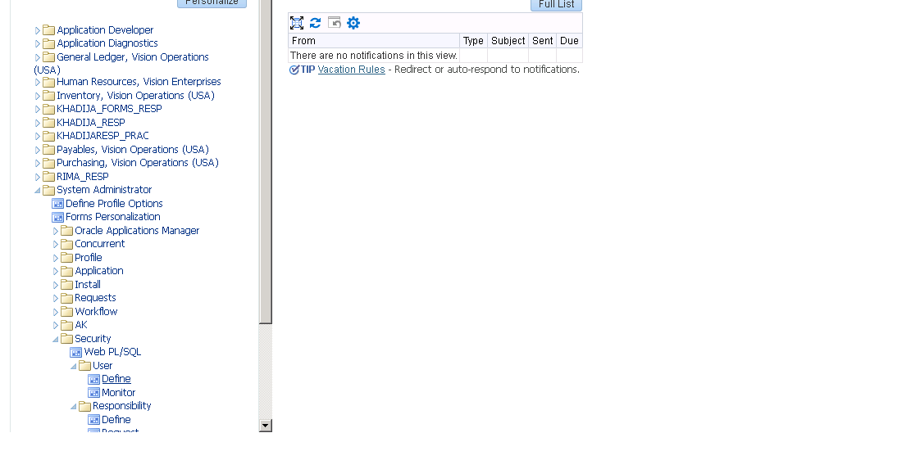
Figure INV-2: Users form – user KHADIJA and direct responsibilities
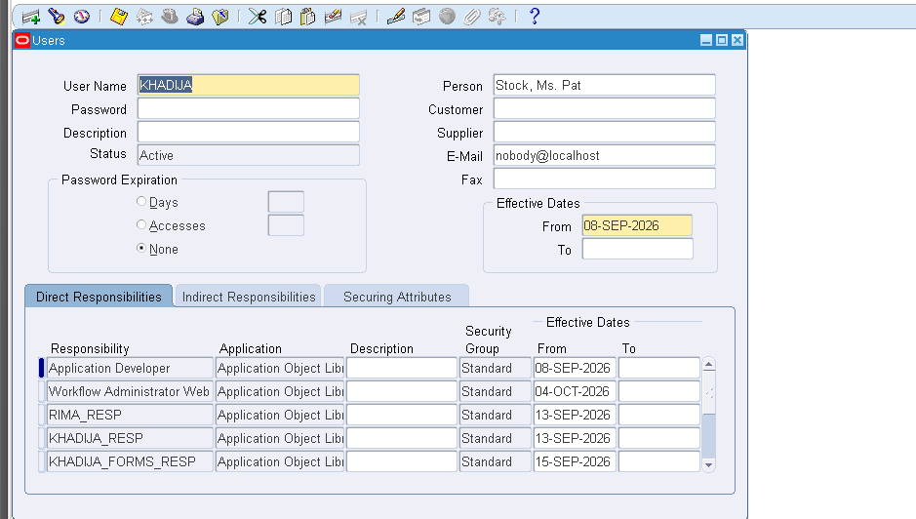
Figure INV-3: Responsibilities assigned – Order Management Super User row
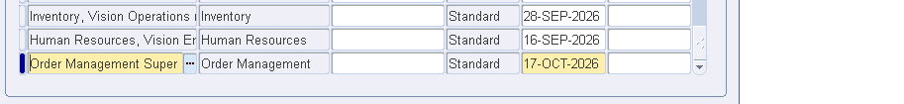
Figure INV-4: Responsibilities search – RECEIVABLE%
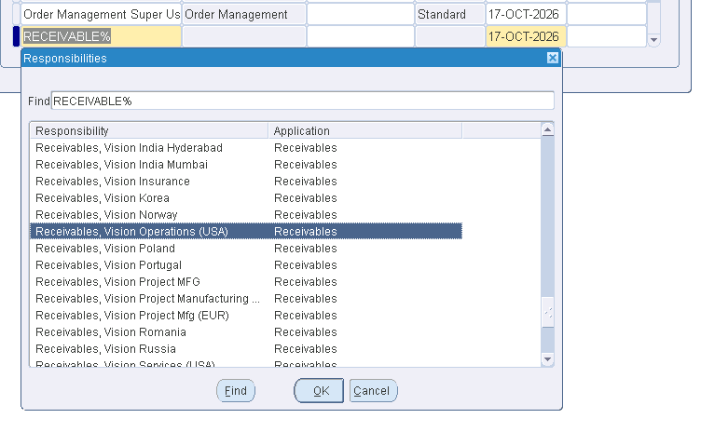
Figure INV-5: Responsibilities list (System Administrator navigator)
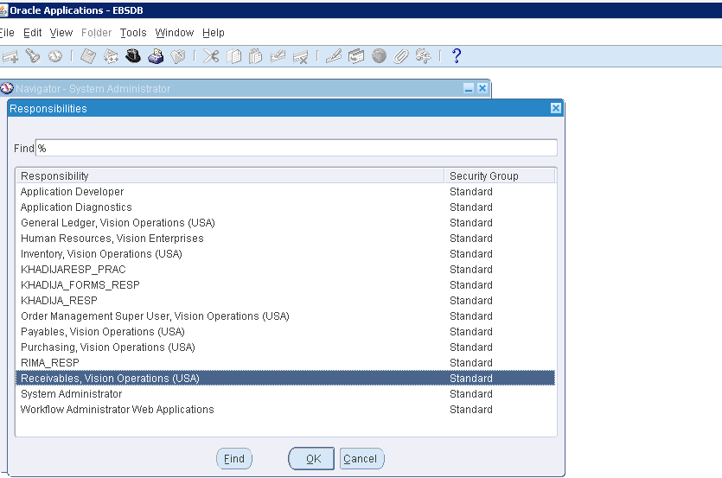
Figure INV-6: Inventory navigator – Material Workbench > On-hand, Availability
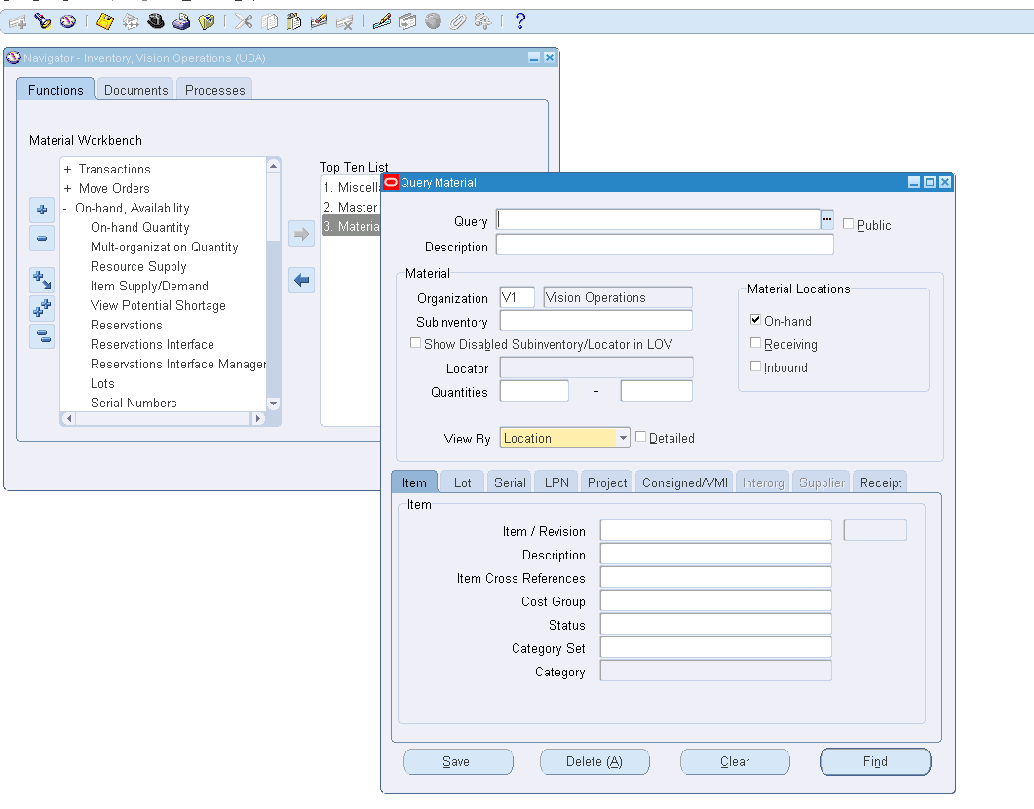
Figure INV-7: Query Material – organization V1, item XX_KHADIJA_LAPTOP
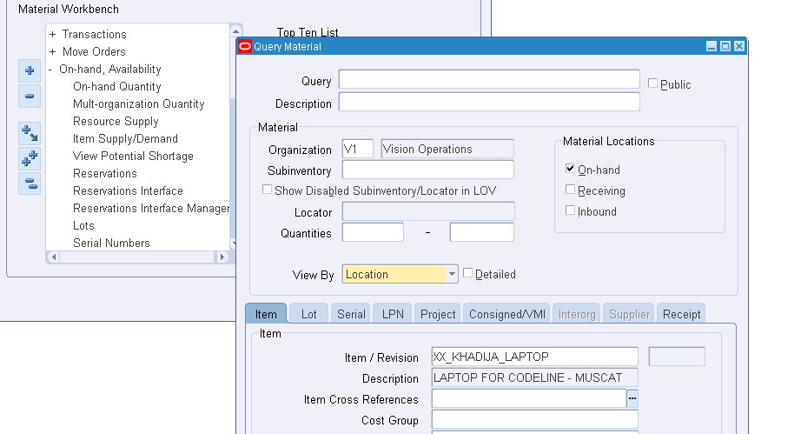
Figure INV-8: Material Workbench – V1 > On-hand > Stores > item
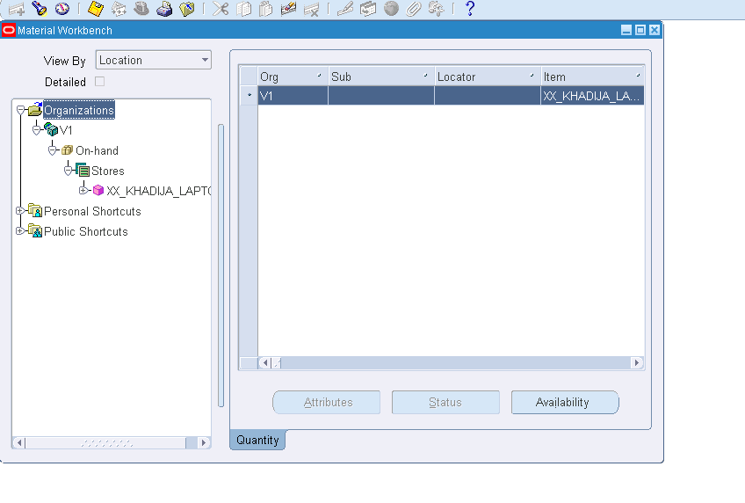
Figure INV-9: Availability window – On-hand, organization V1
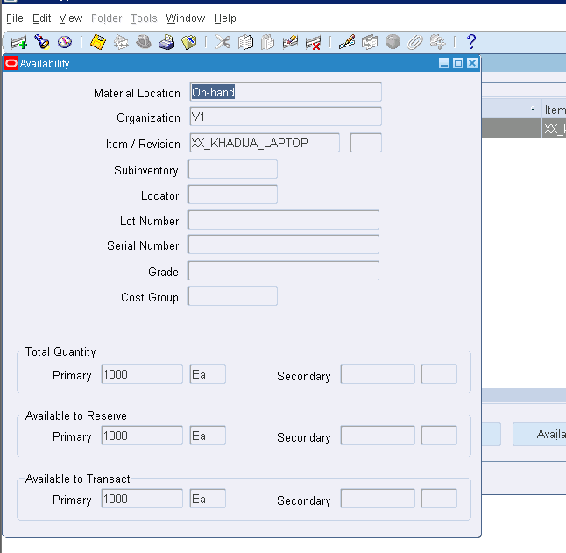
Figure INV-10: Responsibilities list – Order Management Super User selected
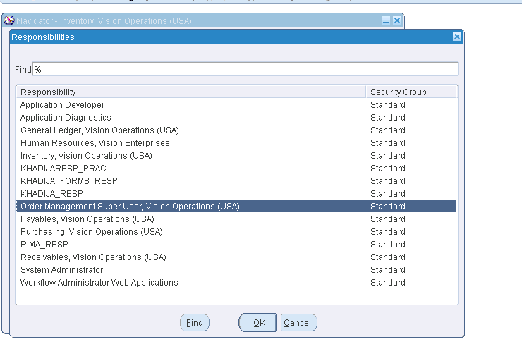
Figure INV-11: Order Management navigator – Sales Orders
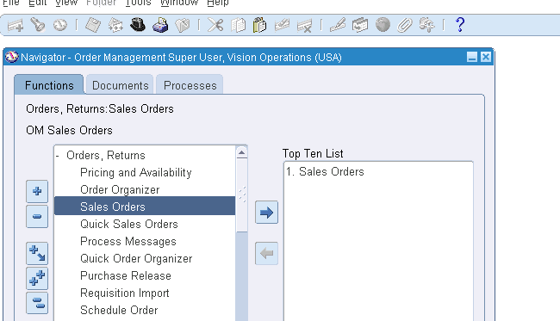
Figure INV-12: Sales Orders – new order for Astro-Energy Systems
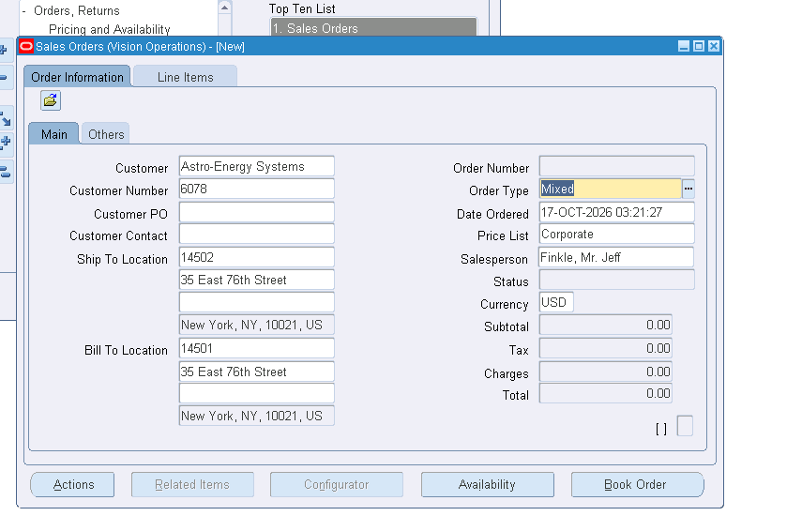
Figure INV-13: Sales Orders – Others tab (payment terms, shipping method, freight terms)
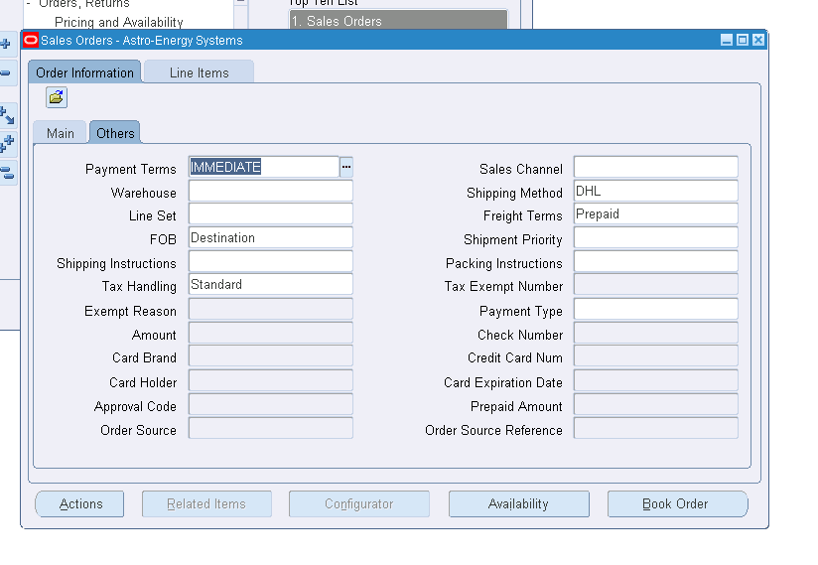
Figure INV-14: Line Items tab – ordered item entered
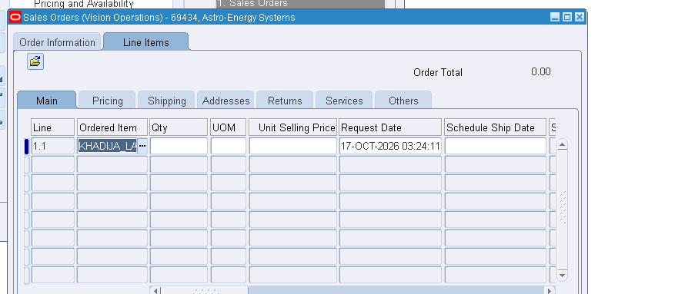
Figure INV-15: Line Items – selling price 100, order total 300
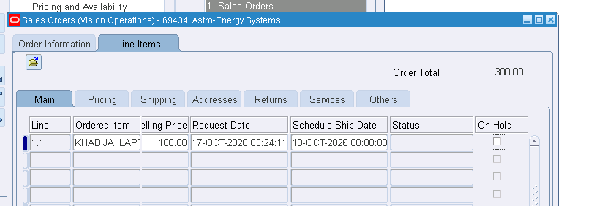
Figure INV-16: Line Items – Shipping tab (qty 3, warehouse V1)
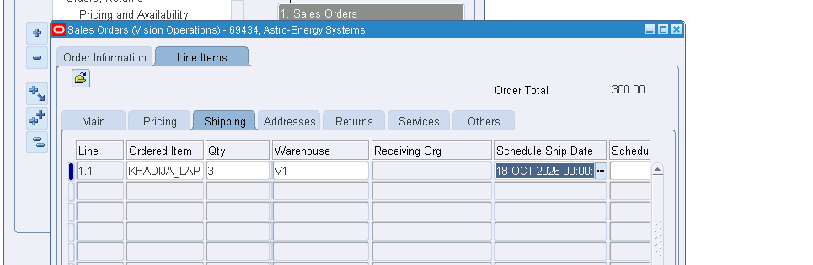
Figure INV-17: Order booked – "Order has been booked" confirmation
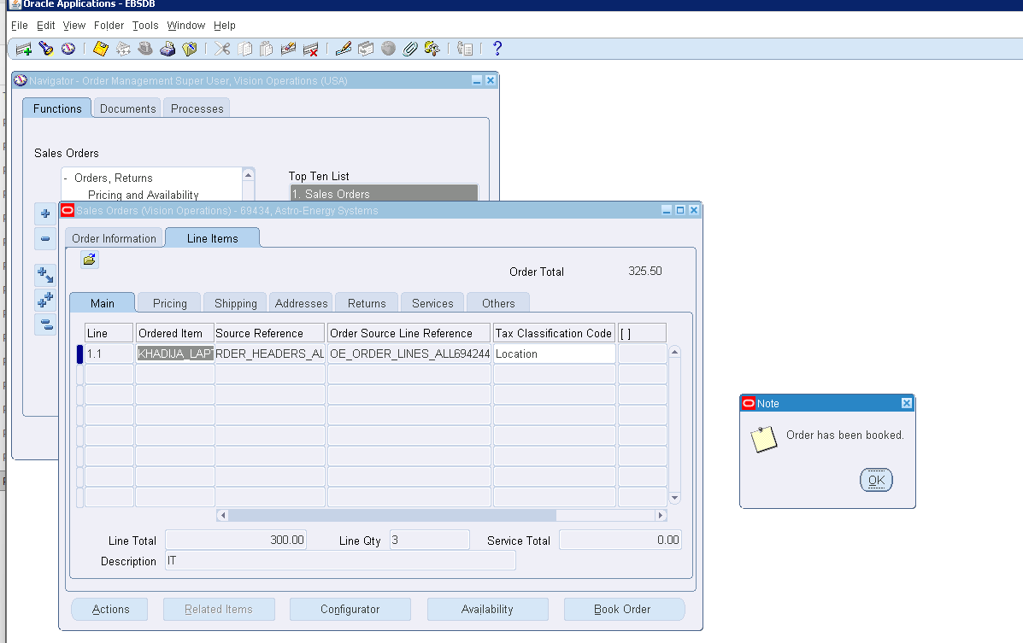
Figure INV-18: Order Number 69434
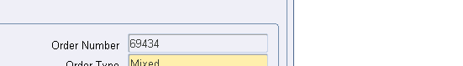
Figure INV-19: Sales Order 69434 – status Booked, total 325.50
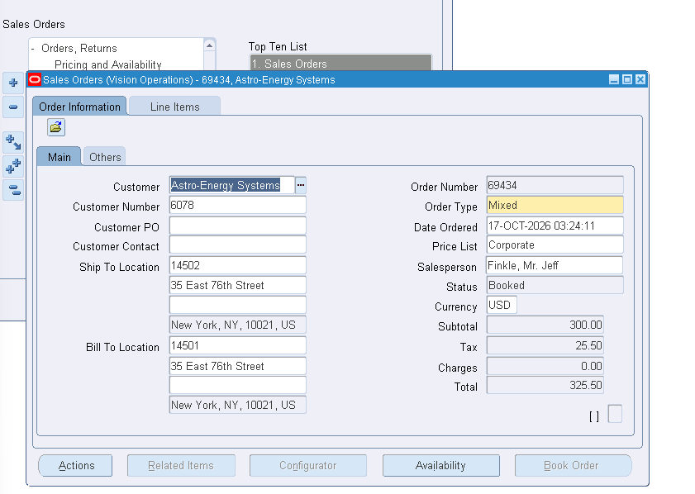
Figure INV-20: SQL Developer – OE_ORDER_HEADERS_ALL for order 69434
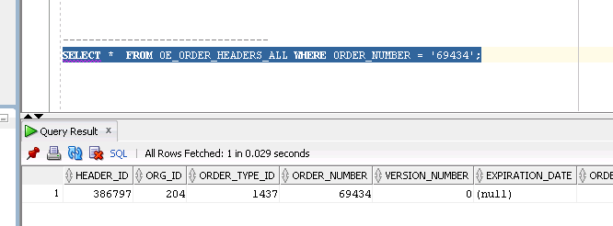
Figure INV-21: SQL Developer – OE_ORDER_LINES_ALL result
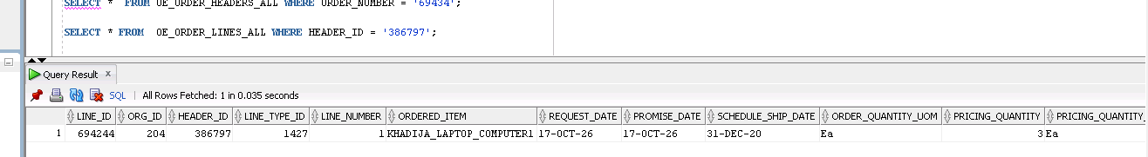
Figure INV-22: Header FLOW_STATUS_CODE = BOOKED
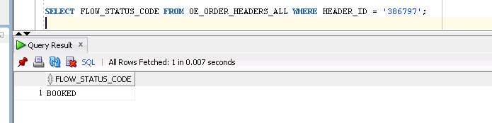
Figure INV-23: Line FLOW_STATUS_CODE = AWAITING_SHIPPING
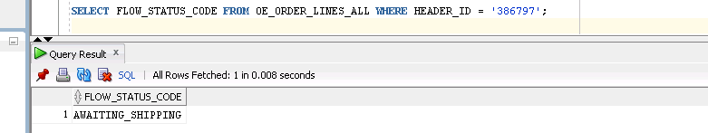
Figure INV-24: Availability – warehouse V1, on-hand qty 3
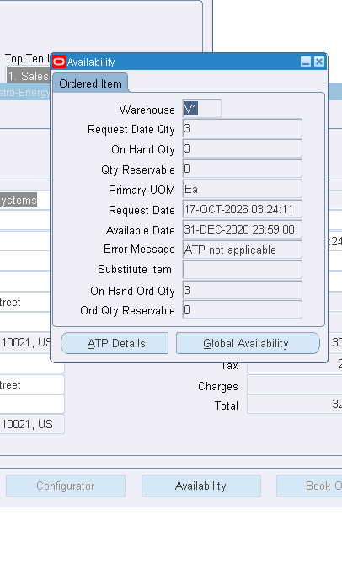

8. Screenshots – ORDERMANAGER
Figure OM-1: Shipping Transactions form opened from Navigator (Shipping > Transactions) with Query Manager
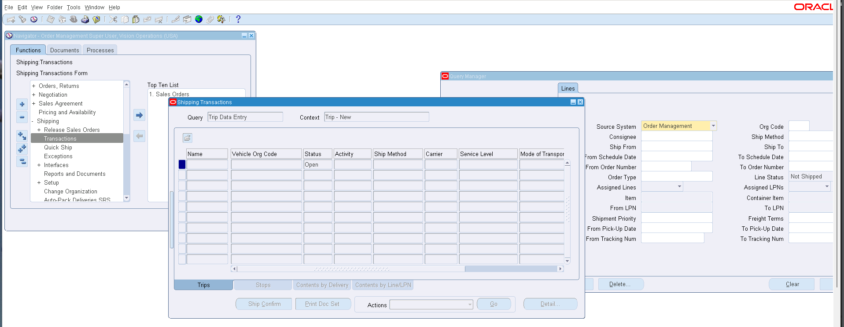
Figure OM-2: Order Management screenshot 2
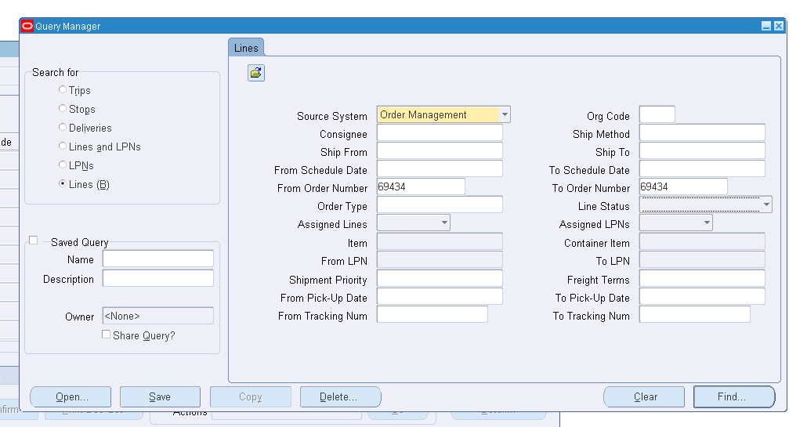
Figure OM-3: Order Management screenshot 3
