Oracle Fusion – Analysis, Data Access and Data Model
- Assign Roles
  - Employee
  - HCM
  - HR
  - Accounts Payables
Fig 1: User roles assigned
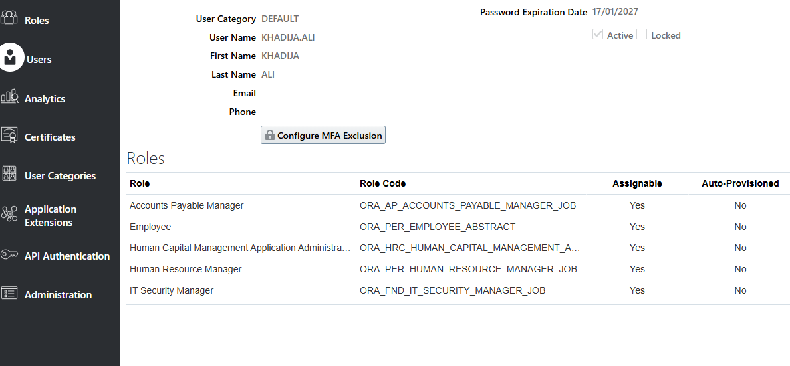
- Provide Data Access
  - Accounts Payables
Fig 2: Manage Data Access for Users
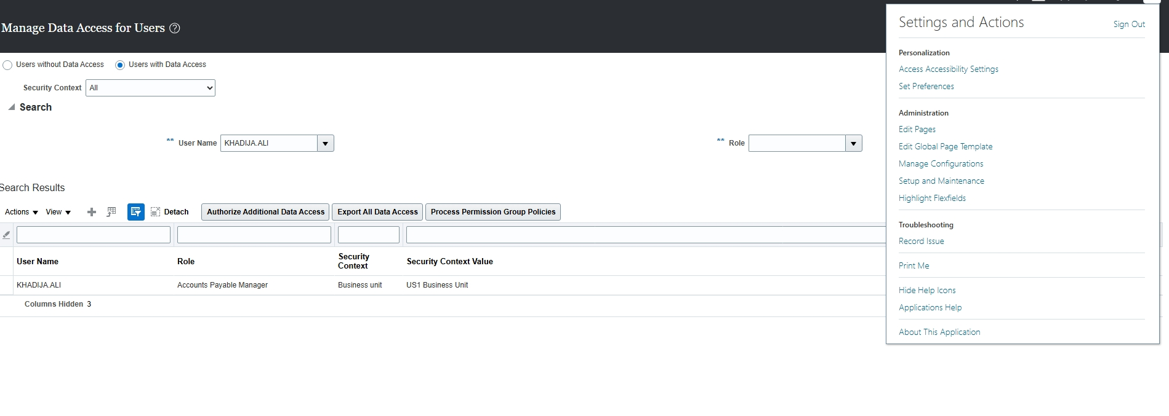
Fig 3: Create Data Access for Users
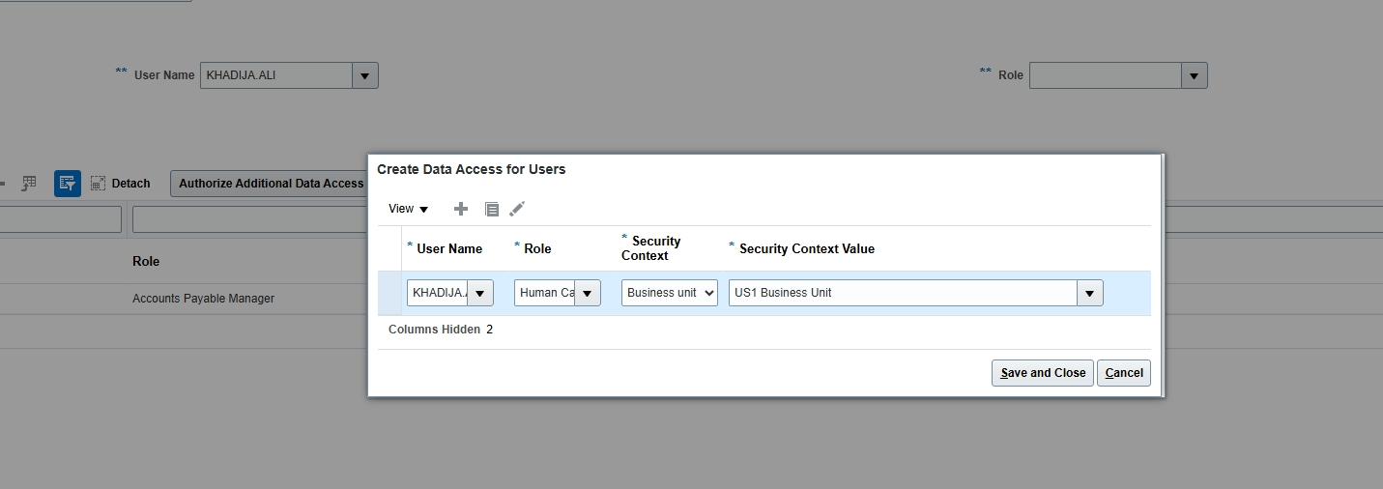
Fig 4: Create Data Access for Users
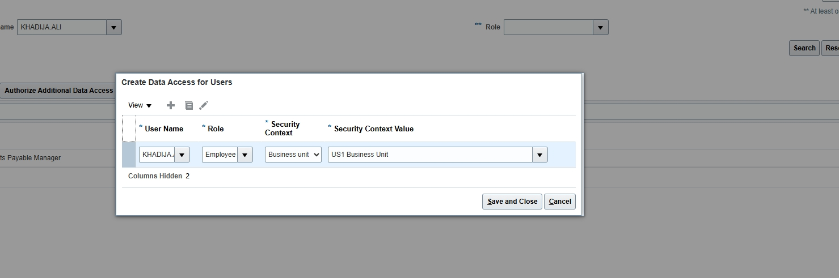
Fig 5: Data access results
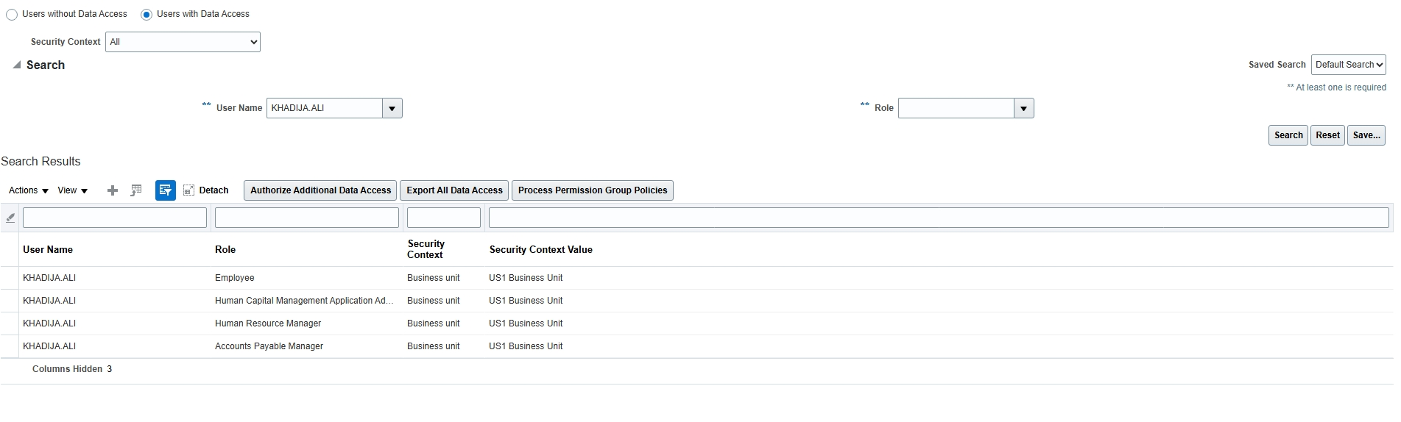
- CREATE ANALYSIS HCM (Human Capital Management)
  - PAYABLES
Fig 6: Create > Analysis
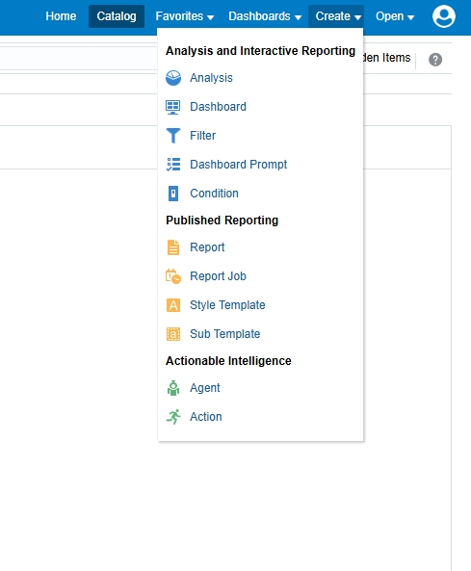
Fig 7: Subject Areas – Criteria
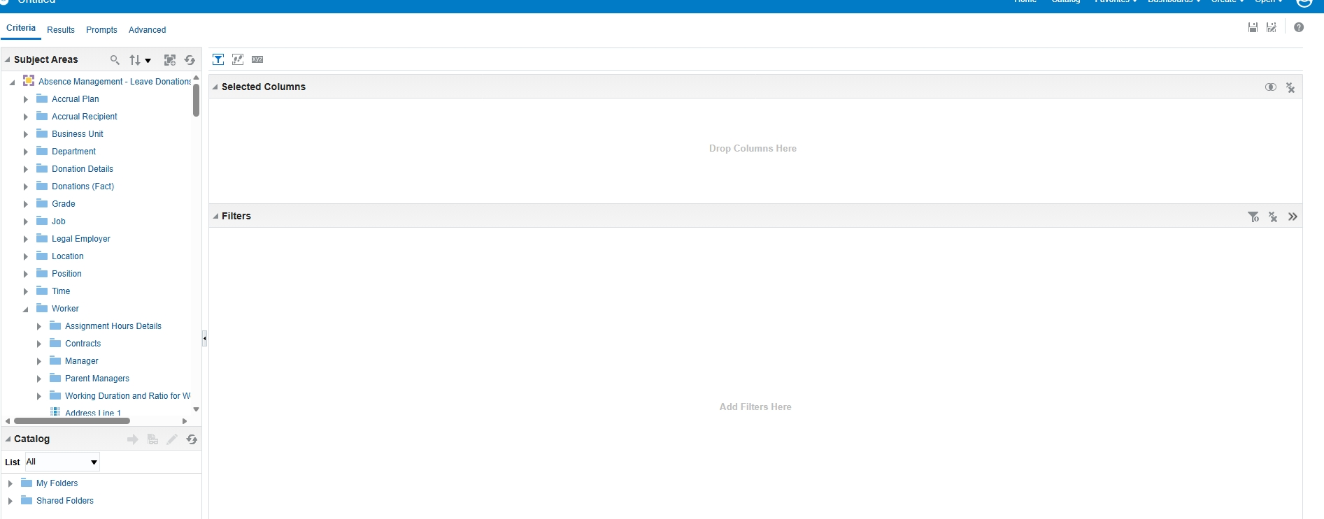
  - Payables Invoices Transaction Real Time
    - Supplier
      - Supplier
      - Supplier Type
      - Supplier Number
  - RESULTS
Fig 8: Results
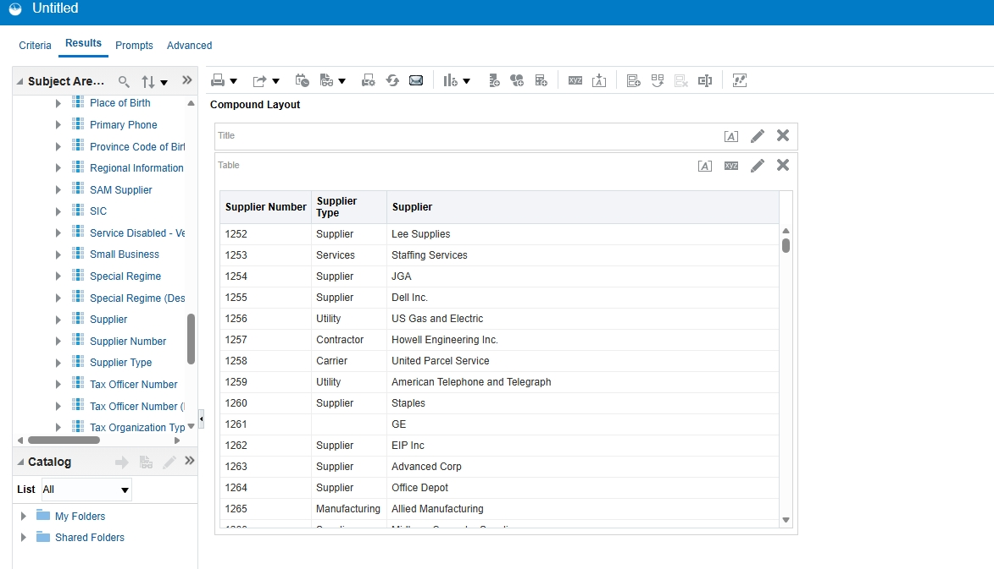
  - Save Analysis >>>> Analysis_Payables_Supplier
- CREATE DATA MODEL BASED ON ANALYSIS
  - Select >>> Analysis
  - Design with the required Columns
  - Save the DM
  - Create a Report based on the DM
  - Save the Report

