Create Analysis with Prompt
A Prompt is a filter based on a prompt parameter with LOV.

Flow
- Create > Analysis
  - Subject Area: Absence Management - Leave Donations Real Time
  - Business Unit
    - Business Unit Id
    - Business Unit Name
    - Business Unit Active Status Code
Fig 1: Criteria – Selected Columns
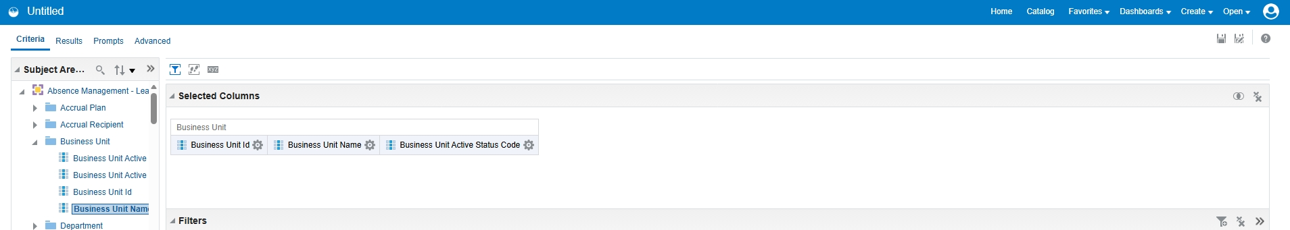
- RESULTS
Fig 2: Results – all Business Units
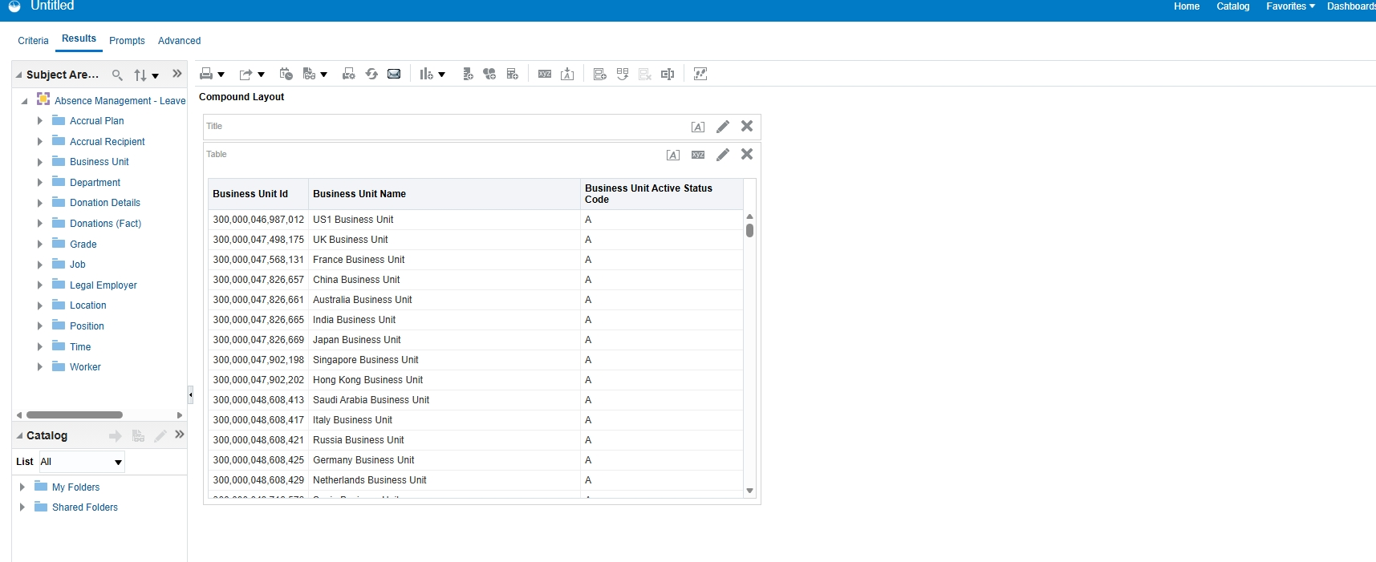
- Prompts > Business Unit Name (LOV)
Fig 3: Prompt on Business Unit Name – value US1 Business Unit
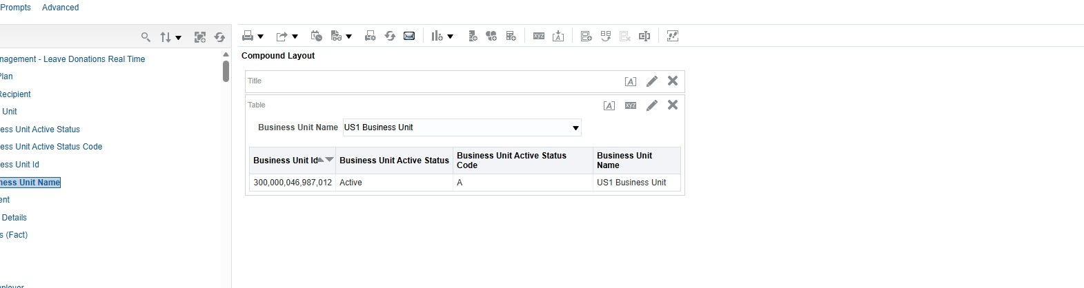
- Save Analysis >>> Analysis_Prompt_BU
- Run the analysis and select the value from the LOV
Fig 4: Analysis_Prompt_BU – Business Unit Name = Taiwan Business Unit
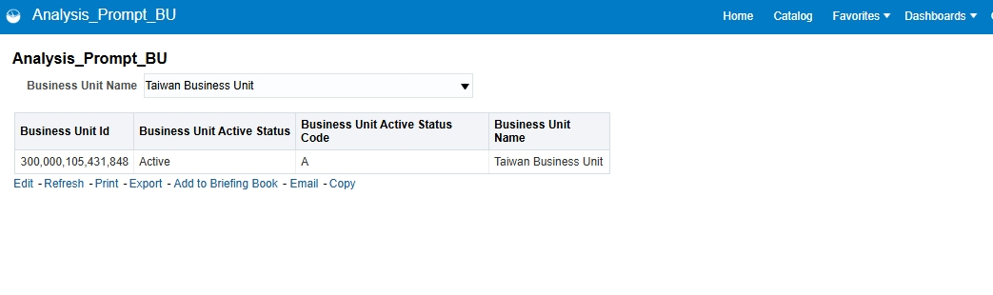

Analysis_Payables_Supplier_Details
- Add to Briefing Book
Fig 5: Save Briefing Book Content
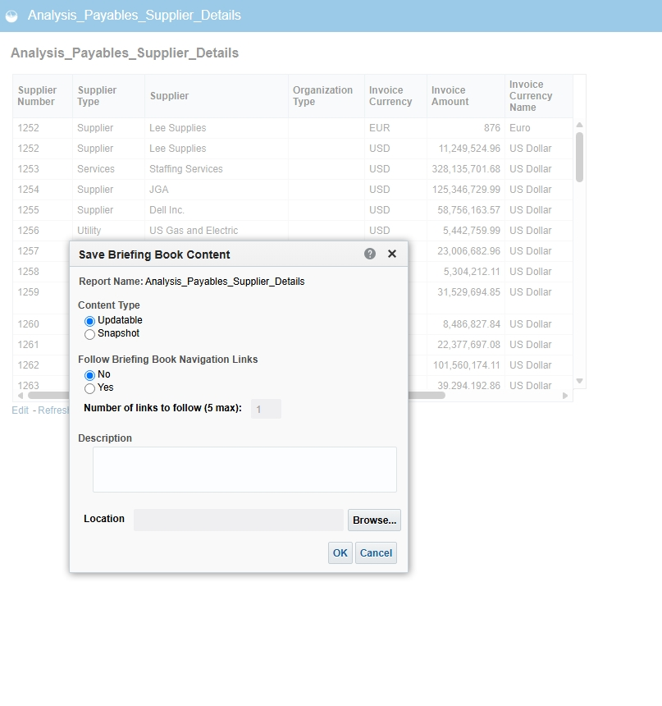
- OK
Fig 6: Successfully added to the Briefing Book
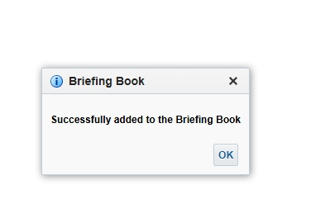
- Results > Views > Graph / Gauge
Fig 7: Views menu
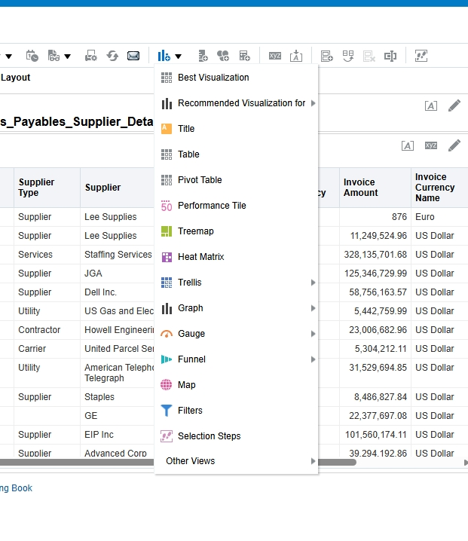
Fig 8: Gauge – Invoice Amount
