Report with Parameter
Parameter Report – Applying a Filter for your Report
LAB
- Edit existing DM to ADD a PARAMETER
- Create a New DM with a PARAMETER

LAB 1 – Edit an Existing DM to ADD a PARAMETER

DM EDIT – Report_Product_Sold_XLS
- Open the Data Model Report_Product_Sold_XLS and click Edit.
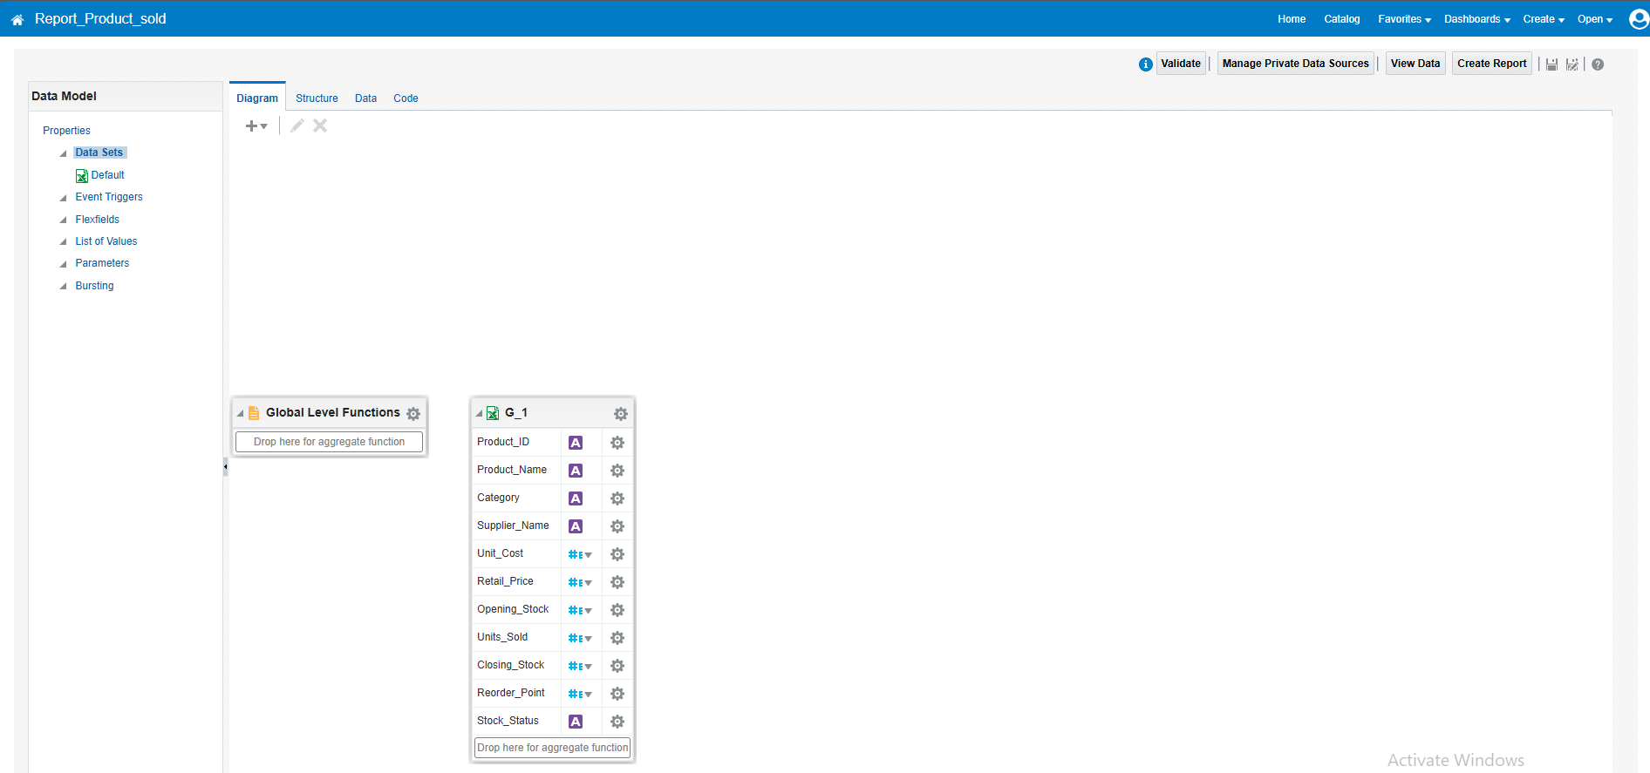
Figure 1: Data Model Report_Product_Sold open for editing
- Click the data set to open Edit Data Set.
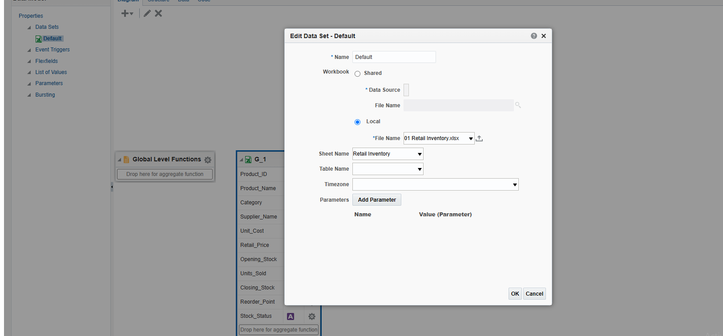
Figure 2: Edit Data Set dialog
- Under Parameters, click Add Parameter.
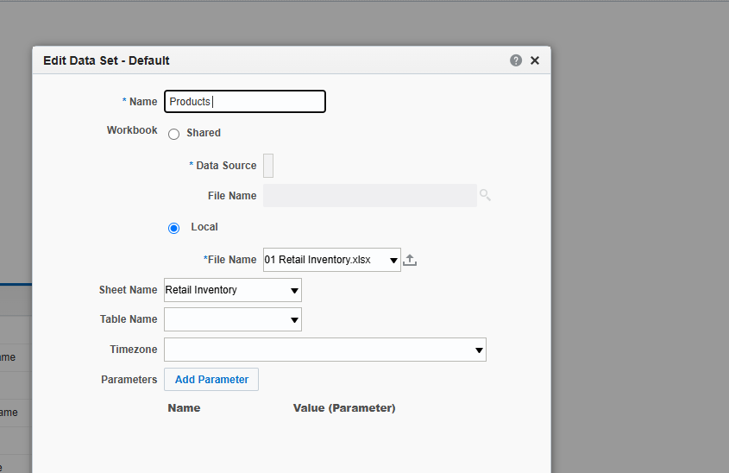
Figure 3: Edit Data Set – Name: Products, Parameters: Add Parameter
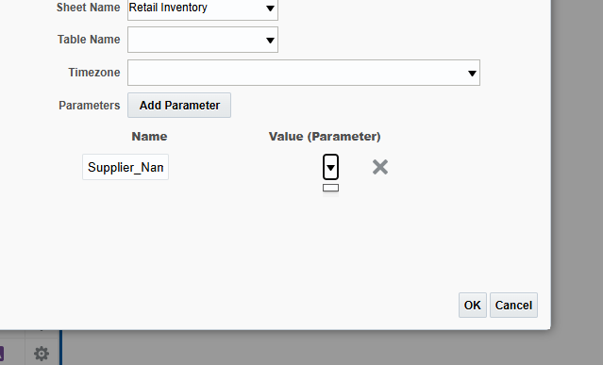
Figure 4: Parameter row added in the data set

Edit the SQL query (Business Unit data model)
Edit the data set query and add the WHERE condition with the bind variable :BU_NAME.
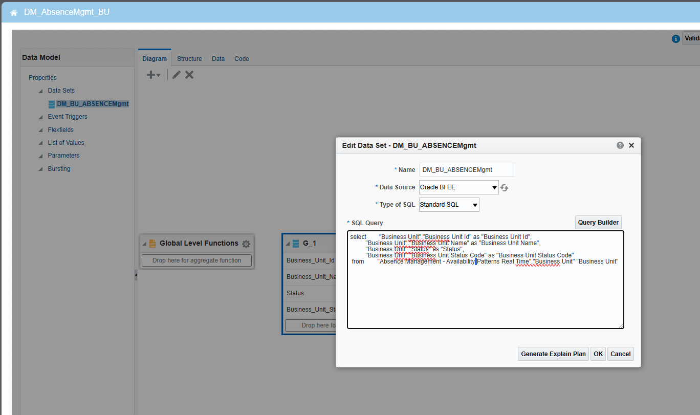
Figure 5: Edit Data Set – DM_BU_ABSENCEMgmt, SQL Query
select "Business Unit"."Business Unit Id" as "Business Unit Id",
"Business Unit"."Business Unit Name" as "Business Unit Name",
"Business Unit"."Status" as "Status",
"Business Unit"."Business Unit Status Code" as "Business Unit Status Code"
from "Absence Management - Availability Patterns Real Time"."Business Unit" "Business Unit"
WHERE "Business Unit"."Business Unit Name" = :BU_NAME
Figure 6: WHERE condition added at the end of the query
- Click OK and the Add Parameter dialog lists the bind variable. Select BU_NAME, then click OK.
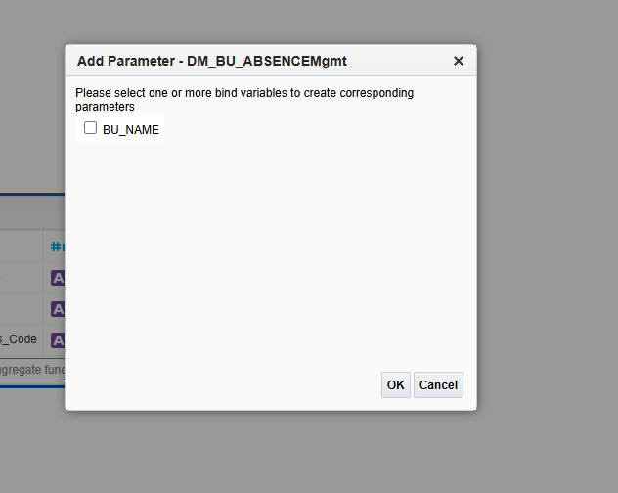
Figure 7: Add Parameter – BU_NAME (before selecting)
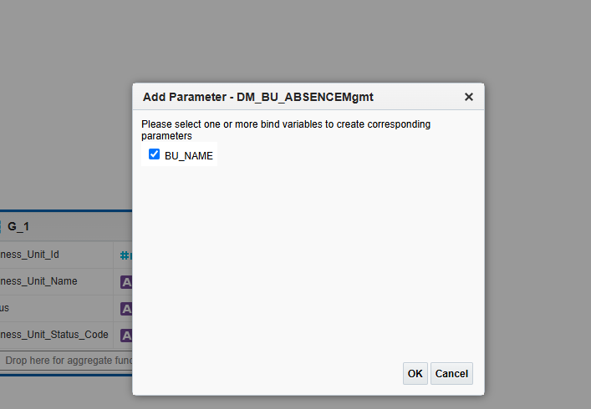
Figure 8: Add Parameter – BU_NAME selected
- Click SAVE.

Open the Report – Report_AbsenceMgmt_BU
Figure 9: Report listed in the Catalog – Open
Pass the Parameter:
- BU_NAME: Qatar Business Unit
- Click APPLY
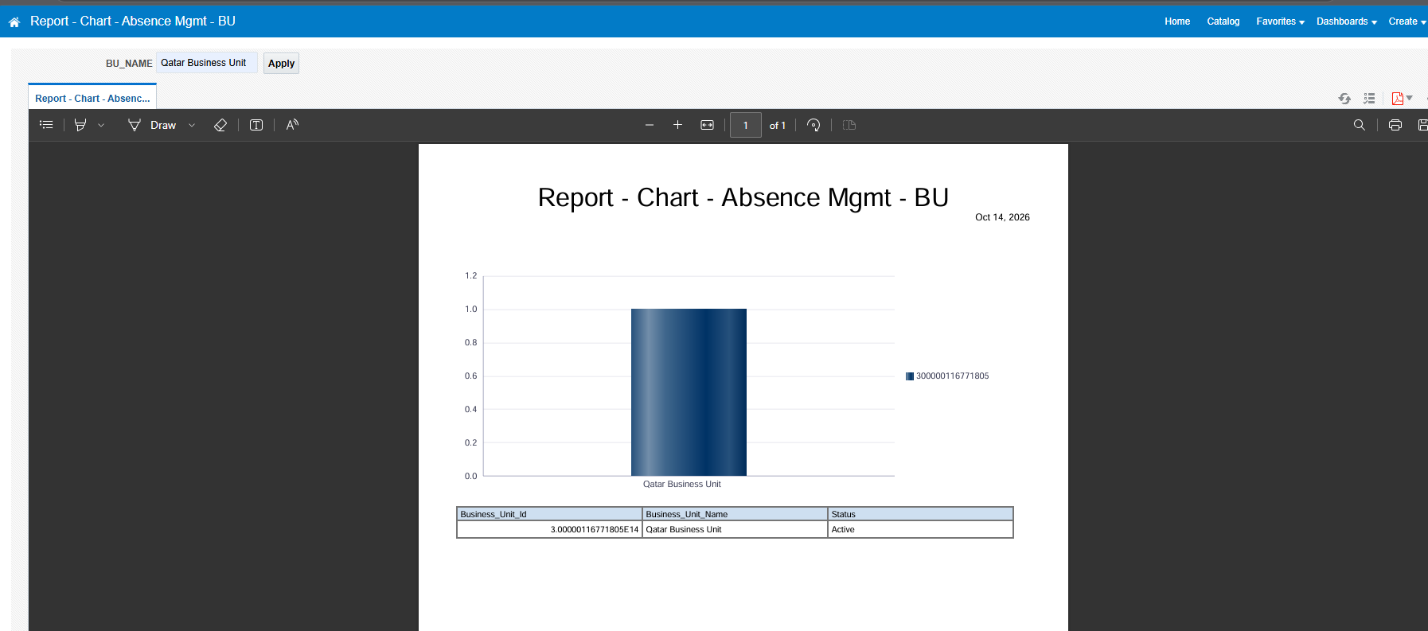
Figure 10: Report displayed after applying BU_NAME = Qatar Business Unit
>>>> Report is Displayed!!

LAB 2 – Create a New DM with a PARAMETER

DATA MODEL
- Click Create > Data Model.
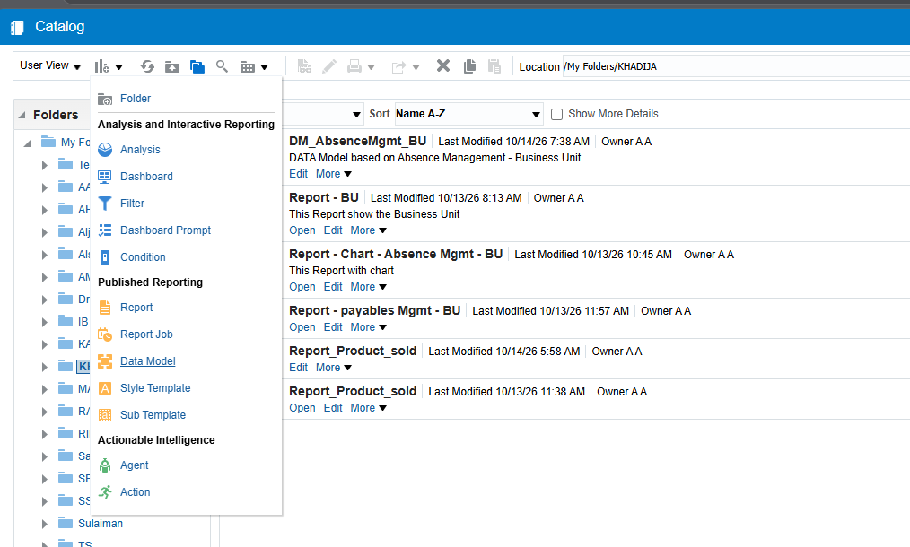
Figure 11: Catalog – Create menu > Data Model
- Create a New Data Set – SQL Query.
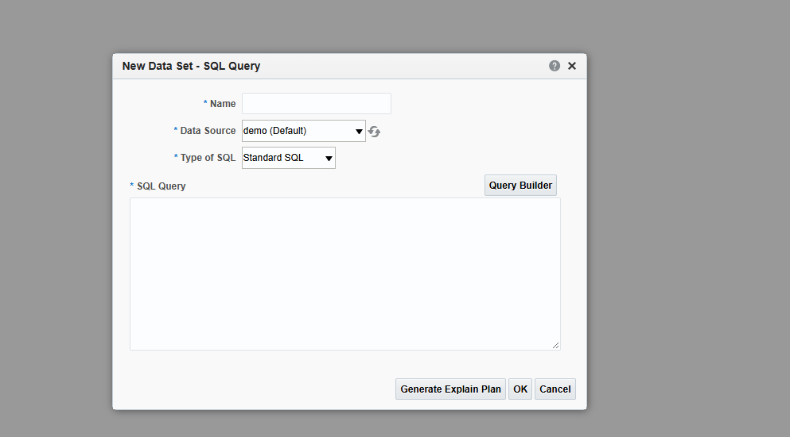
Figure 12: New Data Set – SQL Query
- Enter the Name (DM_DEPARTMENTS), Data Source Oracle BI EE, Type of SQL Standard SQL, then click Query Builder.
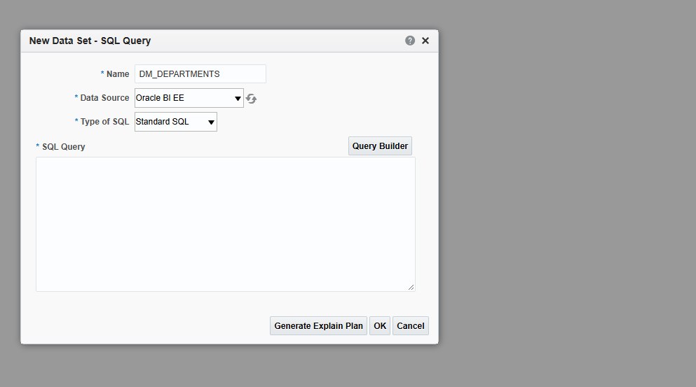
Figure 13: New Data Set – DM_DEPARTMENTS
- In the Model tab select the Department columns: Department Name, Department Address, Location Code, Location Name.
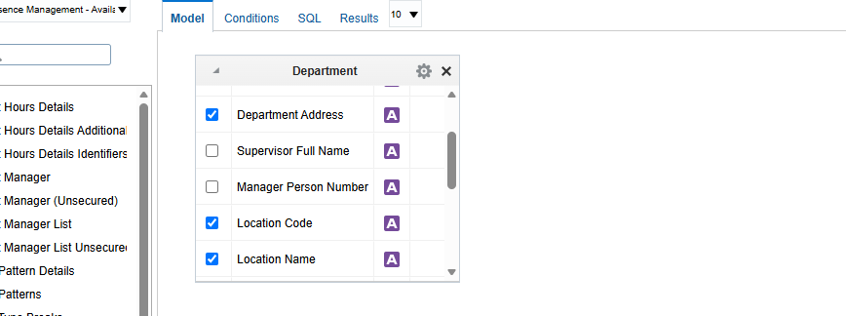
Figure 14: Query Builder – Model tab, Department columns selected
- Open the Conditions tab. Parameter LOC_NAME is also CREATED. Condition: = :LOC_NAME
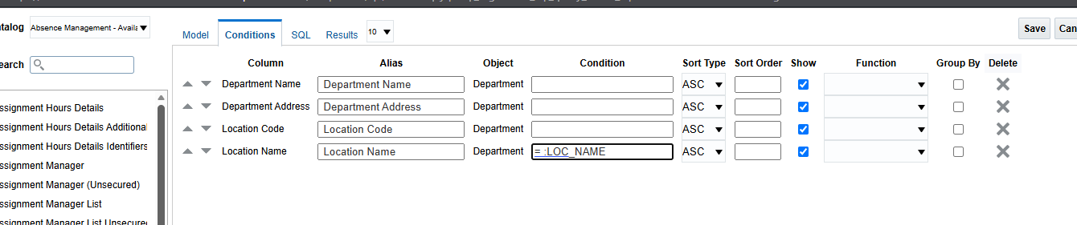
Figure 15: Query Builder – Conditions tab with = :LOC_NAME
- Click SAVE.

SQL
select "Department"."Department Name" as "Department Name",
"Department"."Department Address" as "Department Address",
"Department"."Location Code" as "Location Code",
"Department"."Location Name" as "Location Name"
from "Absence Management - Availability Patterns Real Time"."Department" "Department"
where "Department"."Location Name" = :LOC_NAME
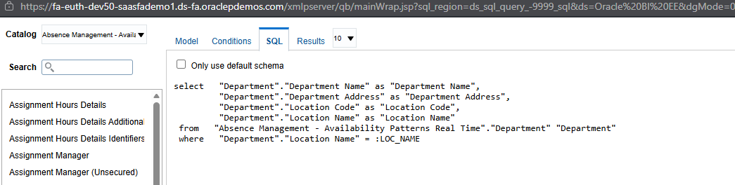
Figure 16: SQL tab showing the generated query
Testing the query: enter a value for the parameter LOC_NAME (for example LONDON) and click OK.
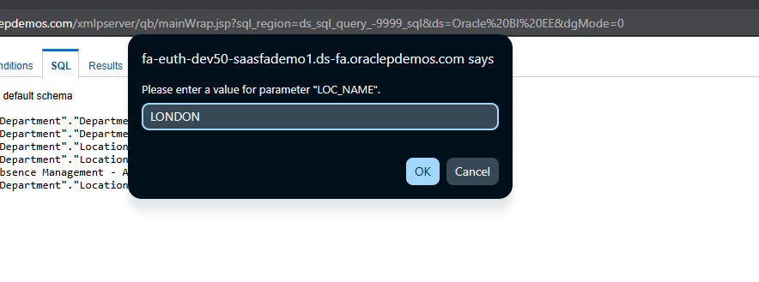
Figure 17: Please enter a value for parameter LOC_NAME
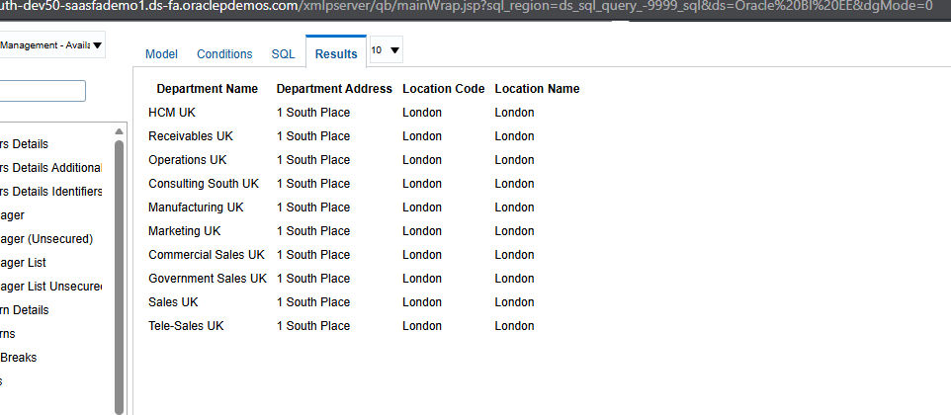
Figure 18: Results tab – departments located in London

REPORT
- Click Create > Report
- Browse DM: DM_PAR_LOV.xdm
- Table & Chart style
- View the Report
Enter a value for LOC_NAME (for example LONDON) and click Apply to filter the report.

