Report with Parameter and LOV
Parameter Report – Applying a Filter, and LOV – List of Values for the Parameter
Parameter Report: Applying a Filter for your Report.
LOV: List of Values for the Parameter defined.

LAB 1 – Add a PARAMETER to the DM, then attach an LOV
Starting point: the data model DM_BU_ABSENCEMgmt with the :BU_NAME parameter (see the Parameter guide for the full steps).
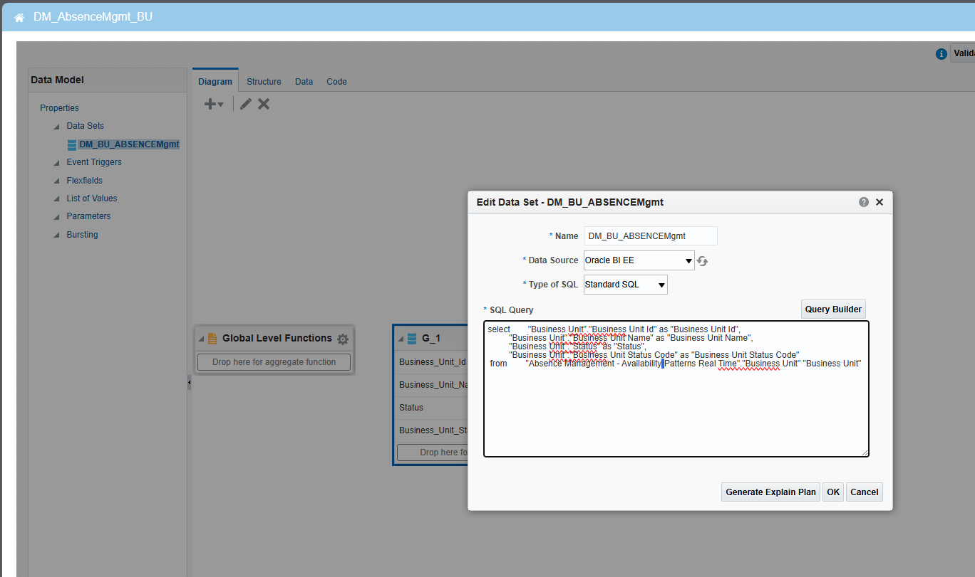
Figure 11: Data set DM_BU_ABSENCEMgmt with the :BU_NAME condition
select "Business Unit"."Business Unit Id" as "Business Unit Id",
"Business Unit"."Business Unit Name" as "Business Unit Name",
"Business Unit"."Status" as "Status",
"Business Unit"."Business Unit Status Code" as "Business Unit Status Code"
from "Absence Management - Availability Patterns Real Time"."Business Unit" "Business Unit"
WHERE "Business Unit"."Business Unit Name" = :BU_NAME
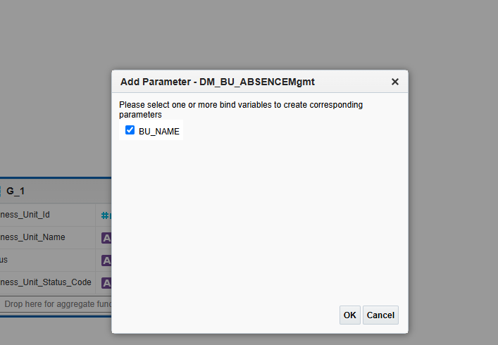
Figure 12: Add Parameter – BU_NAME selected

LOV

Create LOV – Click LOV +
- Name: LOV_BU_NAME
- Type: SQL Query, Data Source: Oracle BI EE
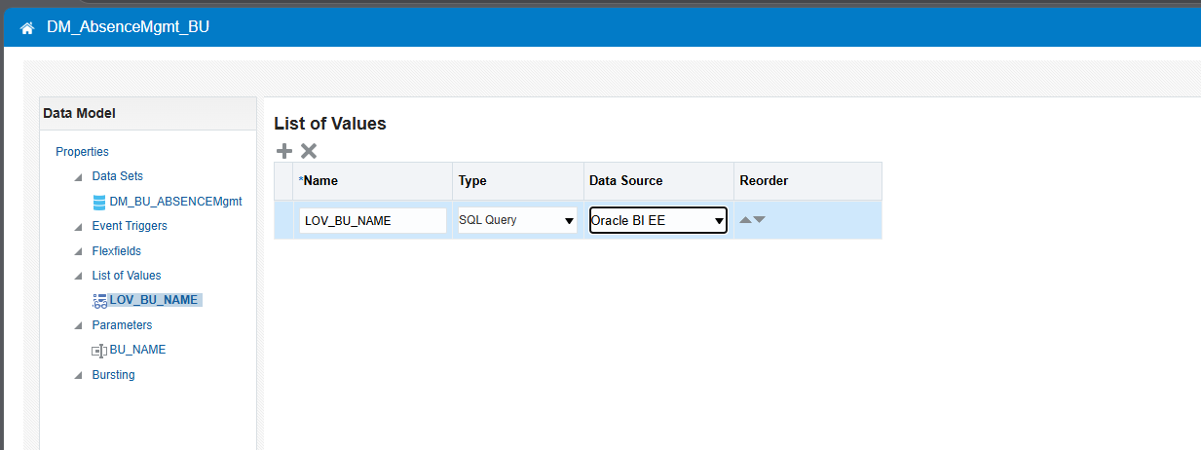
Figure 13: List of Values – LOV_BU_NAME created
- Open the Query Builder
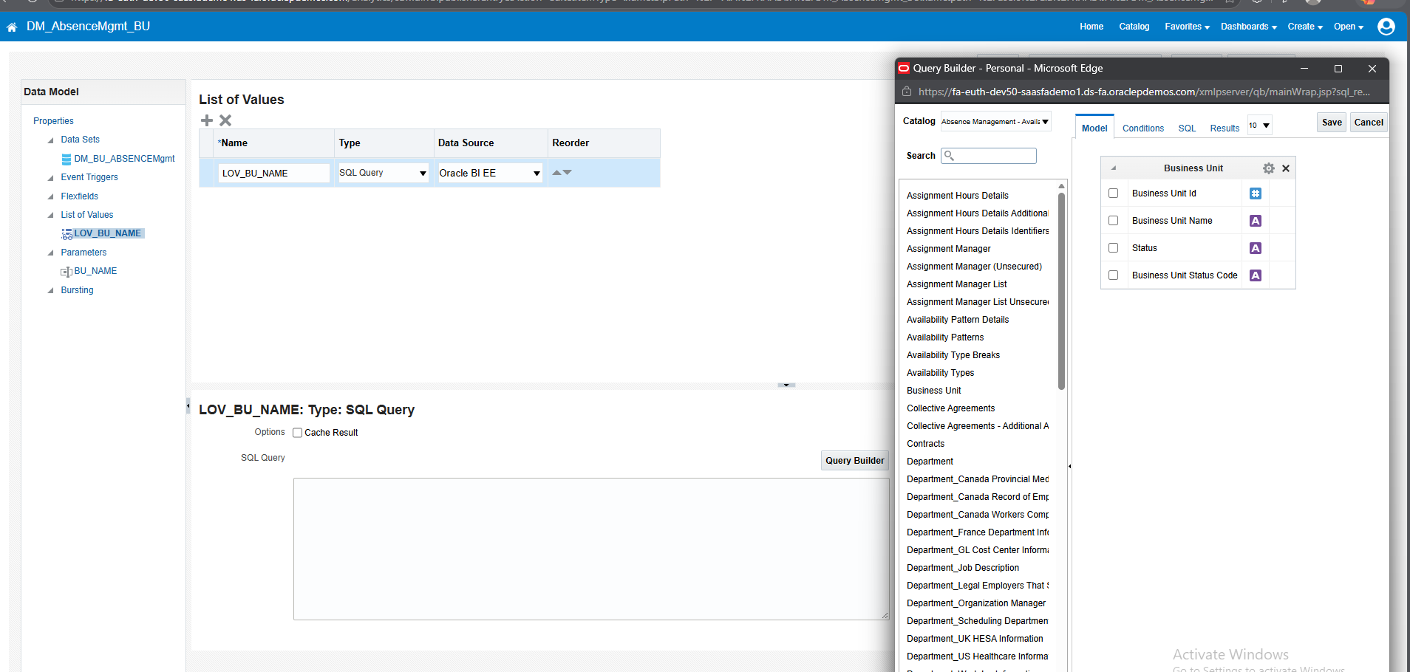
Figure 14: Query Builder opened from the LOV SQL Query box
select "Business Unit"."Business Unit Id" as "Business Unit Id",
"Business Unit"."Business Unit Name" as "Business Unit Name"
from "Absence Management - Availability Patterns Real Time"."Business Unit" "Business Unit"
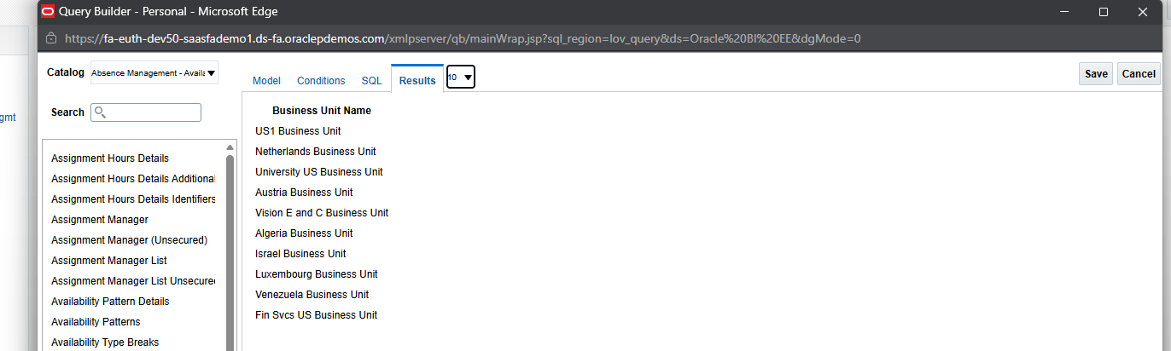
Figure 15: Query Builder – Results tab shows the Business Unit names
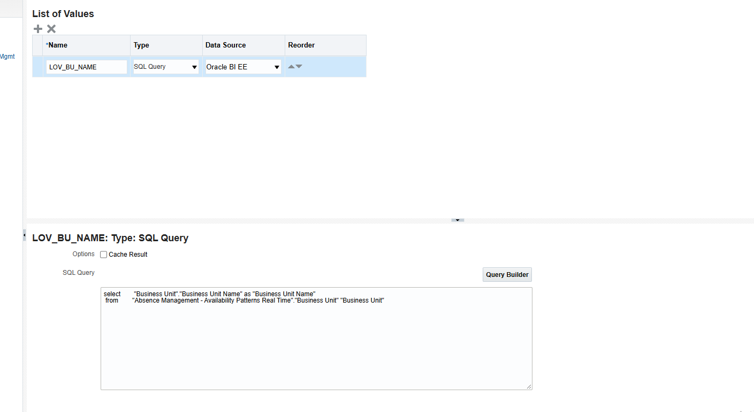
Figure 16: LOV_BU_NAME SQL Query populated
- Click SAVE.

Attach the LOV to the Parameter
- Parameter: >>>> BU_NAME
- Type: MENU
- List of Values: LOV_BU_NAME
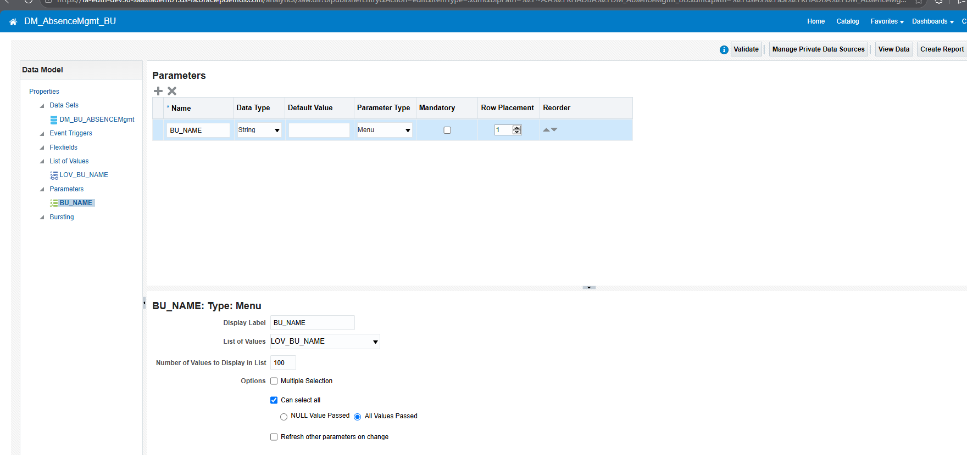
Figure 17: BU_NAME – Type: Menu, List of Values: LOV_BU_NAME
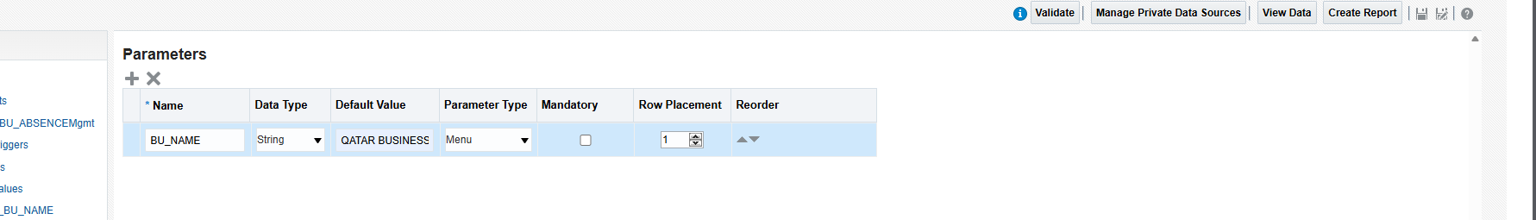
Figure 18: Parameters grid – BU_NAME, String, Menu
- Click SAVE.

CATALOG – Open Report
You can see the LOV displayed.
- SELECT Qatar Business Unit and click APPLY
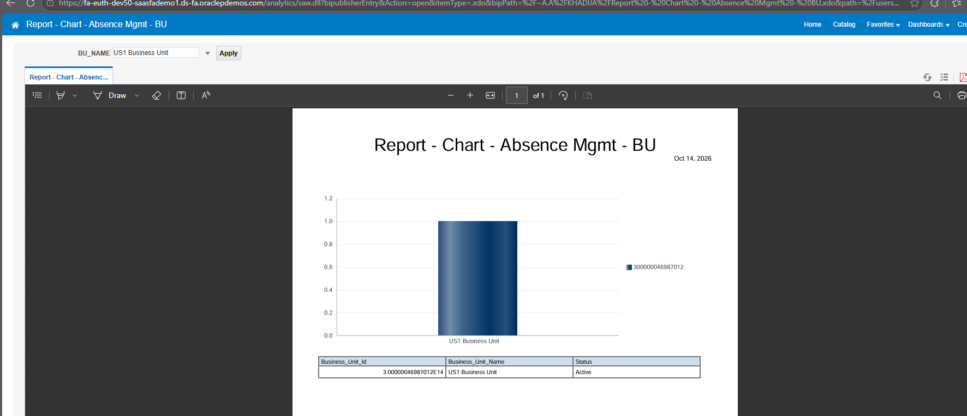
Figure 19: Report with the BU_NAME drop-down (LOV) and the filtered chart

LAB 2 – Create DM along with Parameter and LOV, Then Create Report
Order of work:
- Data Model
- Parameter
- LOV
- Report

DATA MODEL
- Click Create > Data Model.
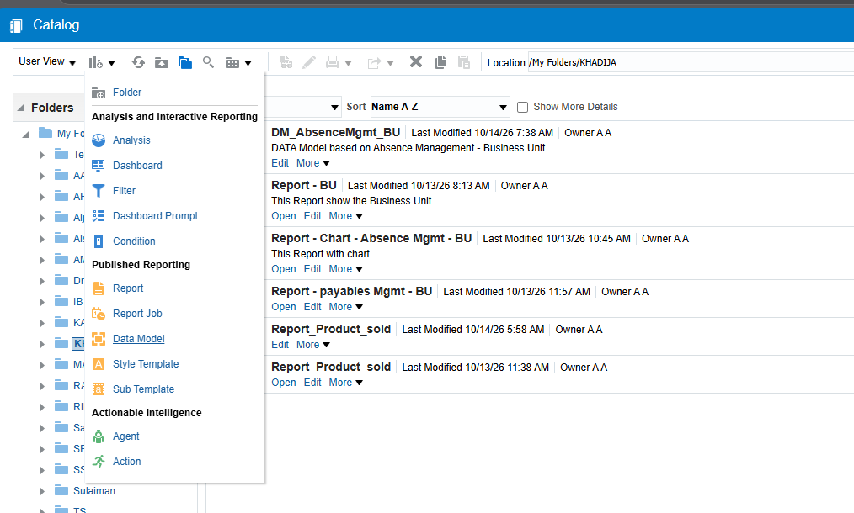
Figure 20: Catalog – Create menu > Data Model
- Create a New Data Set – SQL Query.
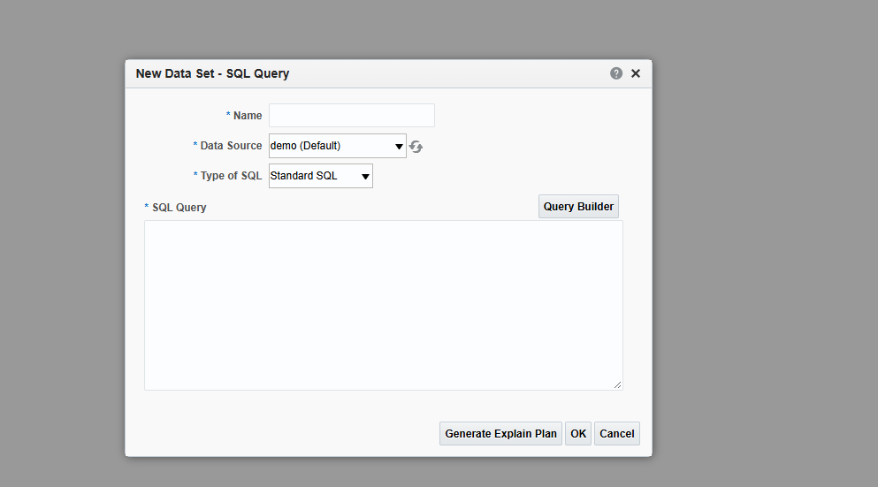
Figure 21: New Data Set – SQL Query
- Enter the Name (DM_DEPARTMENTS), Data Source Oracle BI EE, Type of SQL Standard SQL, then click Query Builder.
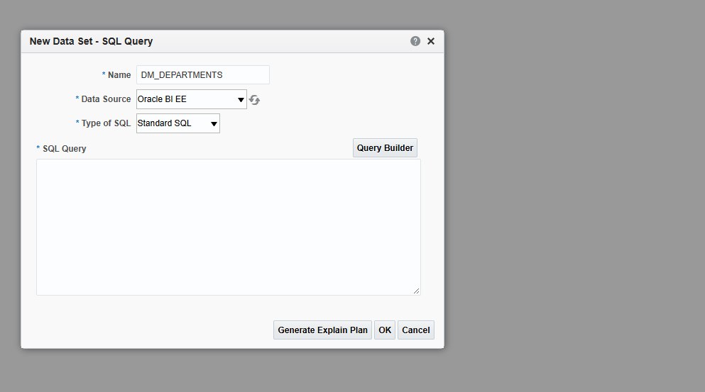
Figure 22: New Data Set – DM_DEPARTMENTS
- In the Model tab select the Department columns: Department Name, Department Address, Location Code, Location Name.
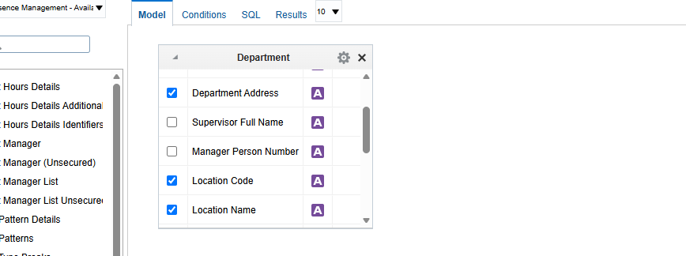
Figure 23: Query Builder – Model tab, Department columns selected
- Open the Conditions tab. Parameter LOC_NAME is also CREATED. Condition: = :LOC_NAME
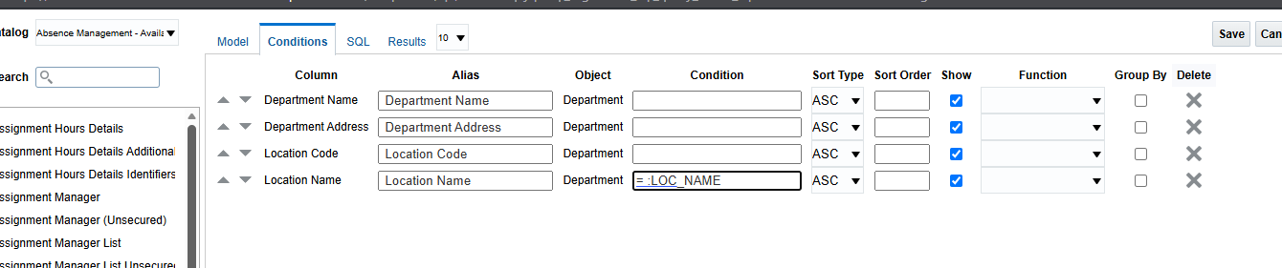
Figure 24: Query Builder – Conditions tab with = :LOC_NAME
- Click SAVE.

SQL
select "Department"."Department Name" as "Department Name",
"Department"."Department Address" as "Department Address",
"Department"."Location Code" as "Location Code",
"Department"."Location Name" as "Location Name"
from "Absence Management - Availability Patterns Real Time"."Department" "Department"
where "Department"."Location Name" = :LOC_NAME
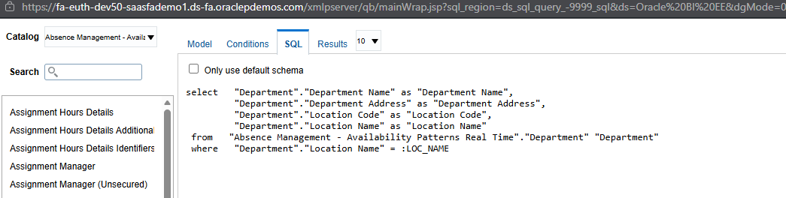
Figure 25: SQL tab showing the generated query
Testing the query: enter a value for the parameter LOC_NAME (for example LONDON) and click OK.
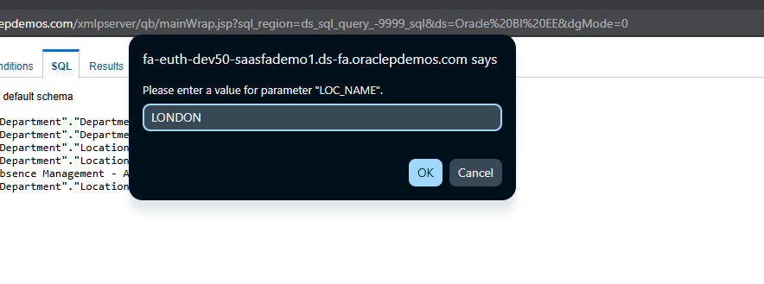
Figure 26: Please enter a value for parameter LOC_NAME
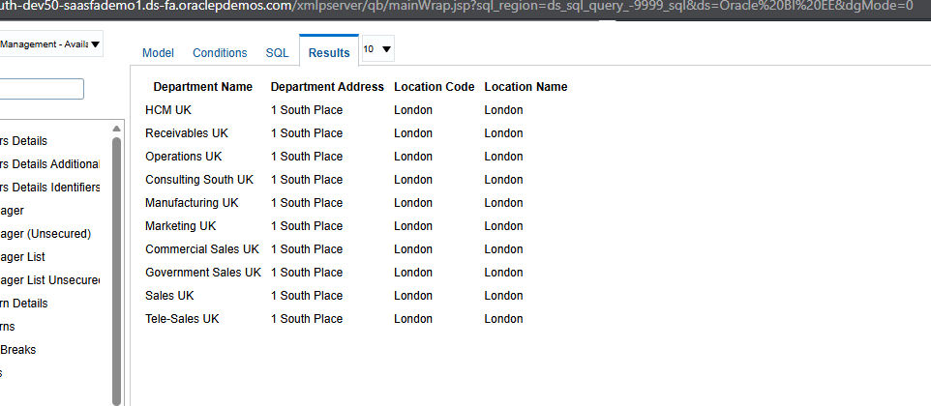
Figure 27: Results tab – departments located in London

Create > LOV
- SQL Query > Query Builder
select "Department"."Location Name" as "Location Name"
from "Absence Management - Availability Patterns Real Time"."Department" "Department"

Attach LOV to the Parameter
- PARAMETER: LOC_NAME
- Parameter Type: MENU
- List of Values: the LOV created above
- Click SAVE.

REPORT
- Click Create > Report
- Browse DM: DM_PAR_LOV.xdm
- Table & Chart style
- View the Report

