Oracle Fusion Cloud
Create a User, Assign Roles and Provide Data Access
Objective: Create a new user, assign the required roles, confirm the user cannot see data without data access, then grant data access (Business Unit US1) and confirm the data is visible in a Payables analysis.

Part 1: Create a User and Assign Roles

Step 1: Open Security Console
- From the Home page, open the Tools tab.
- Click Security Console.
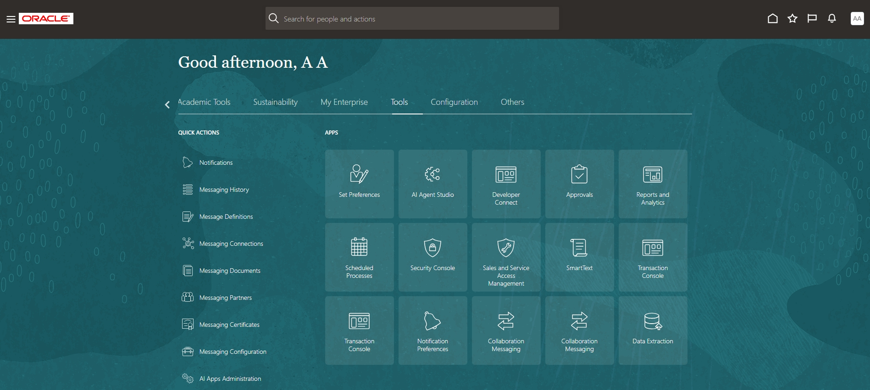
Home > Tools > Security Console

Step 2: Go to Users
- In the left menu, click Users.
- Click Add User Account (from the menu next to Compare Users).
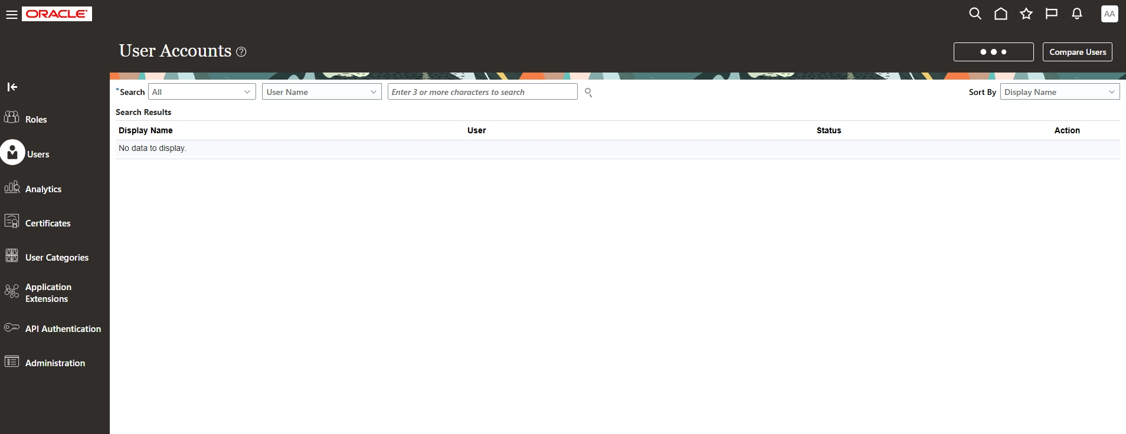
Security Console > Users > User Accounts

Step 3: Enter the user details
- Fill in First Name, Last Name, User Name and Password.
- Re-enter the password in Confirm Password (required).
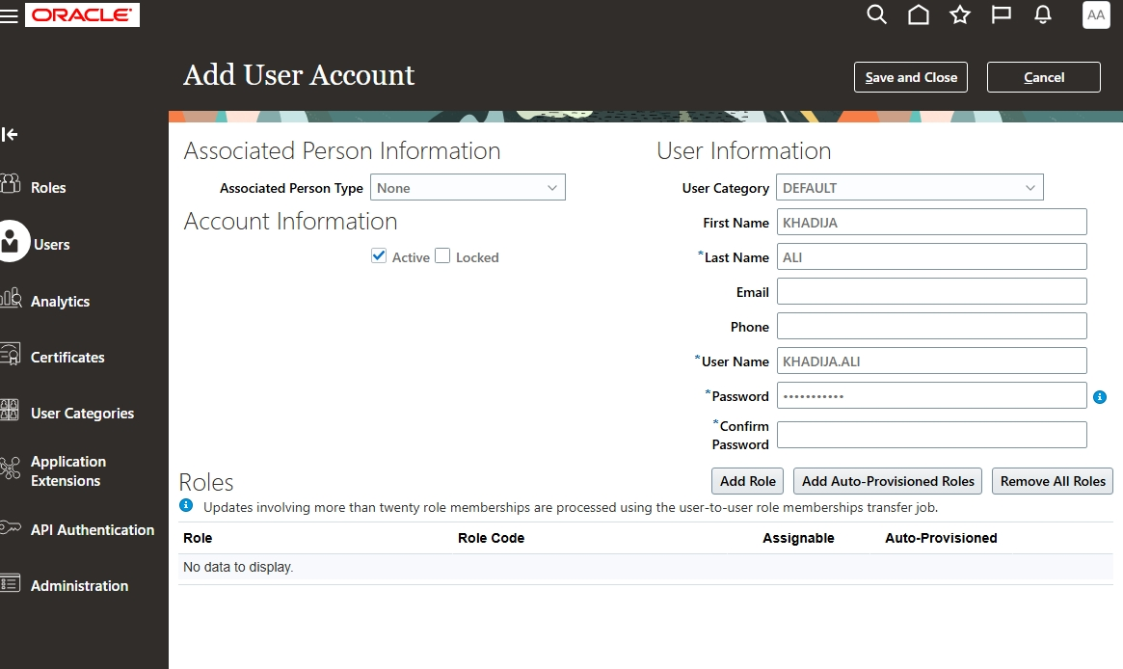
Add User Account: user information

Step 4: Assign the roles
- Click Add Role, search for the role, select it and click Add Role Membership. Repeat for each role:
- IT Security Manager
- Employee
- Accounts Payables Manager
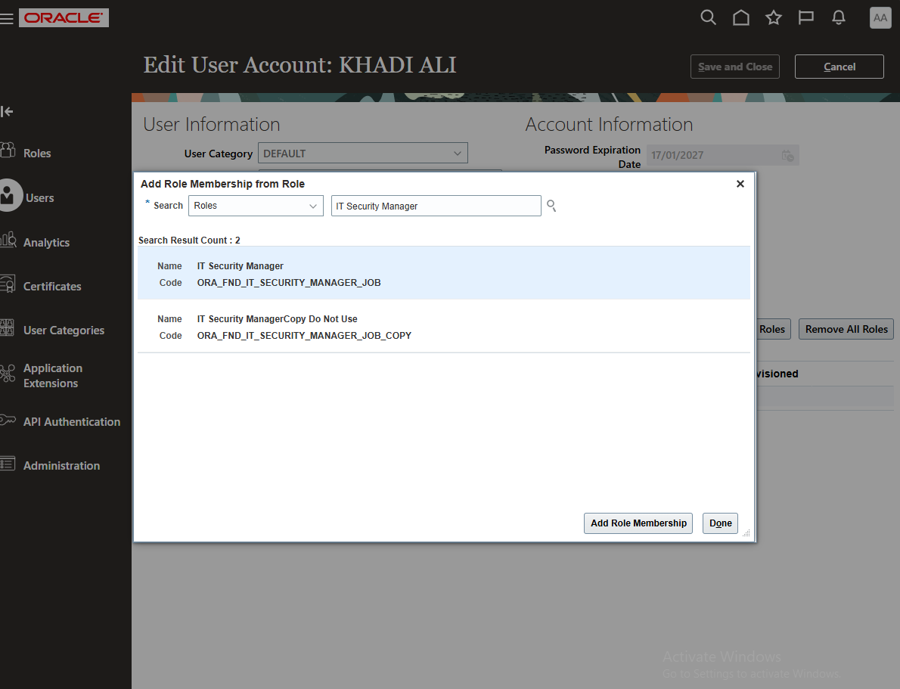
Search and add the IT Security Manager role
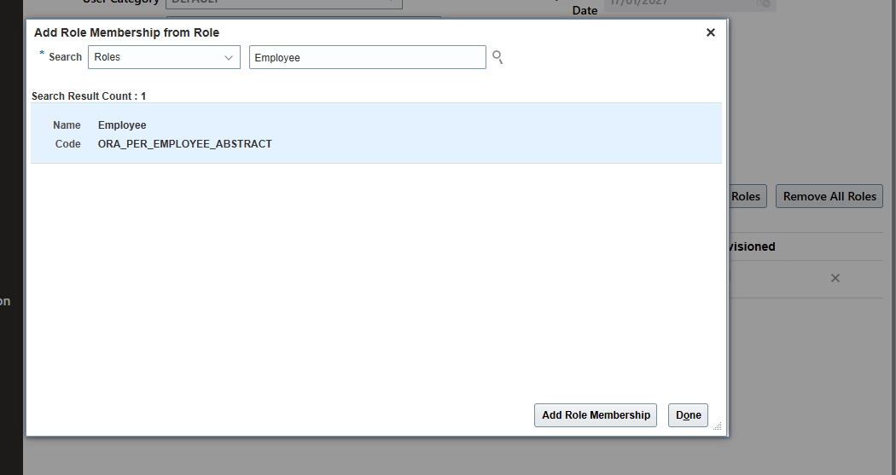
Search and add the Employee role
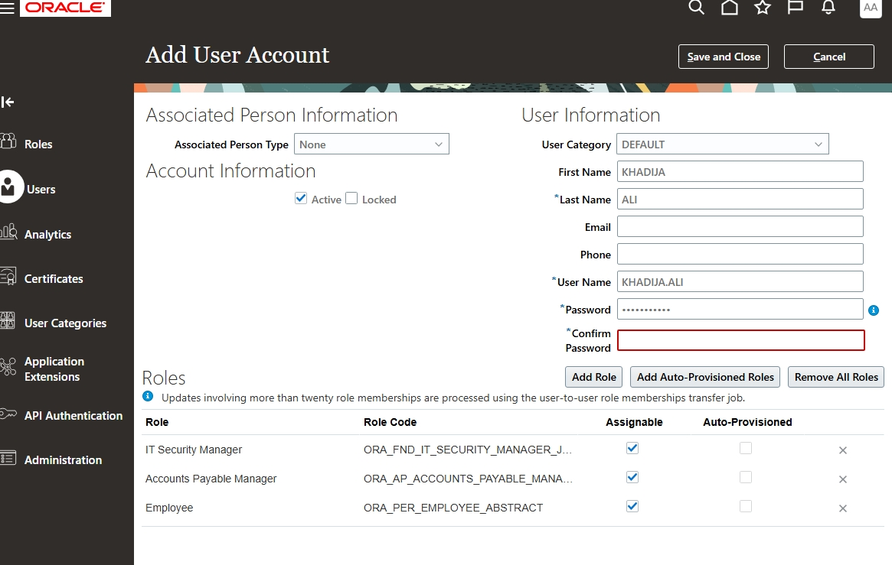
Add User Account: three roles added
Note: The red Confirm Password box in this screenshot means that field must be filled before saving.

Step 5: Save and verify
- Click Save and Close.
- Open the user again to confirm all three roles are listed and Assignable is ticked.
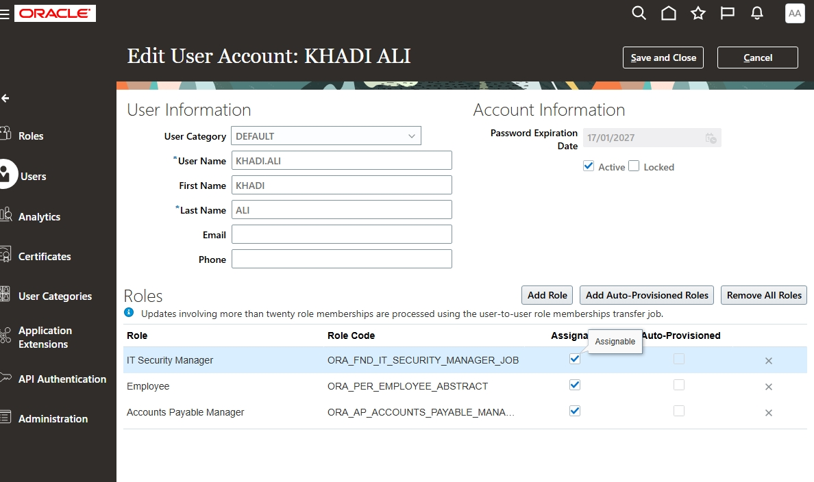
Edit User Account: roles assigned

Part 2: Test as the New User (No Data Access)

Step 6: Sign in as the new user
- Sign in with the new user name and password.
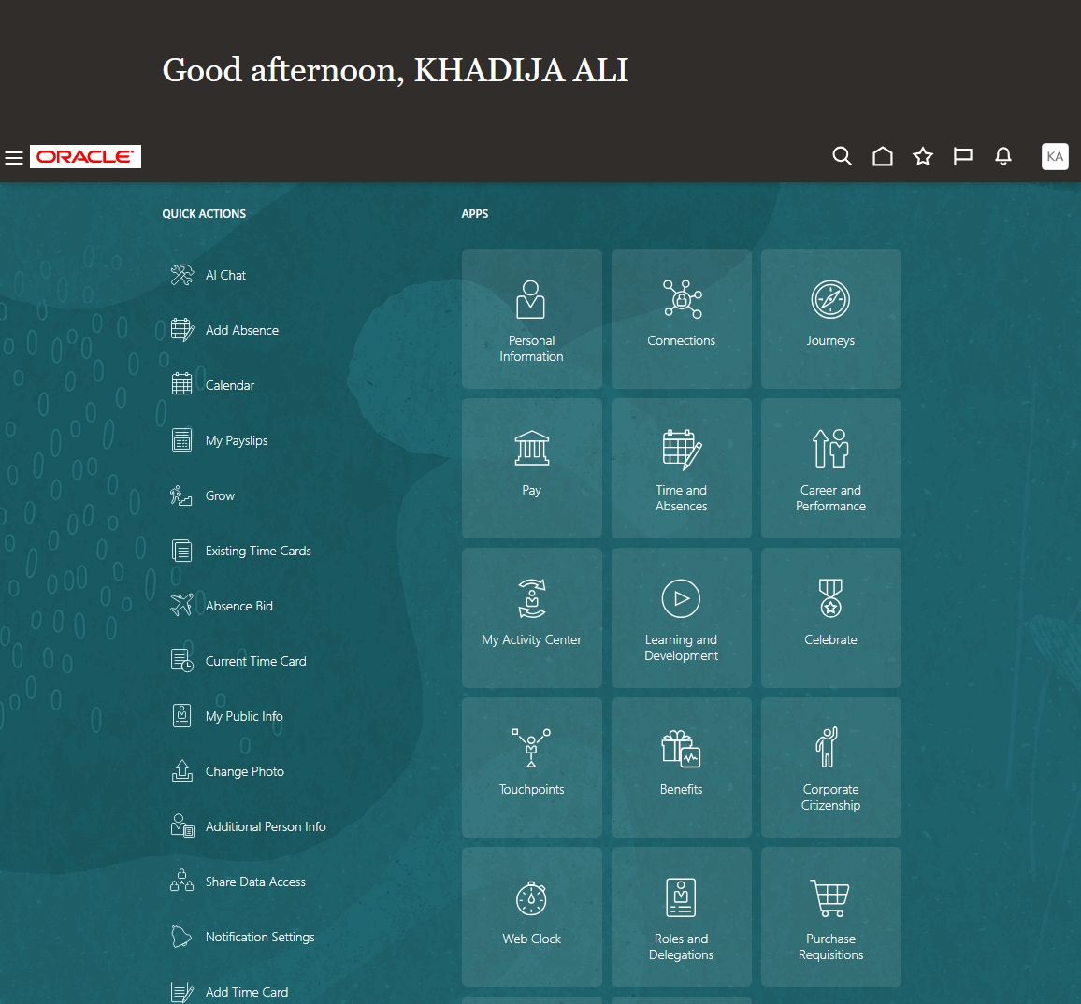
Home page of the new user

Step 7: Open Reports and Analytics
- Go to Tools > Reports and Analytics.
- Click Browse Catalog.
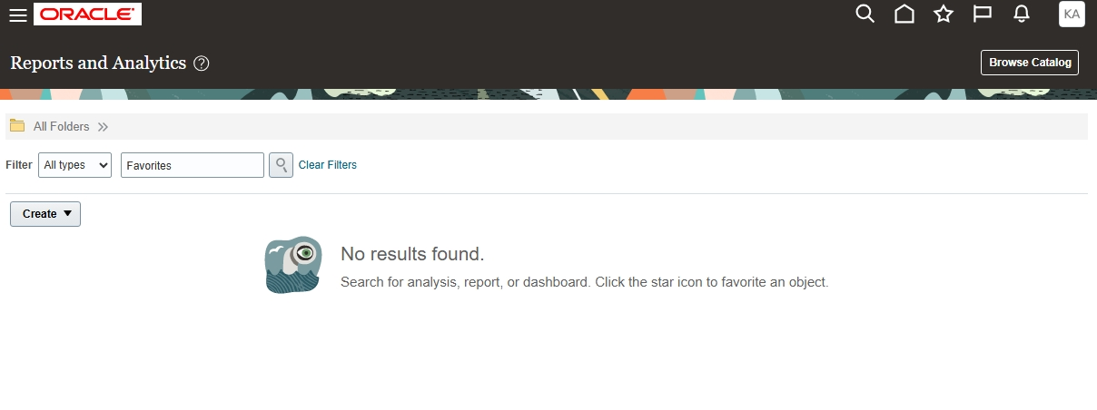
Reports and Analytics > Browse Catalog
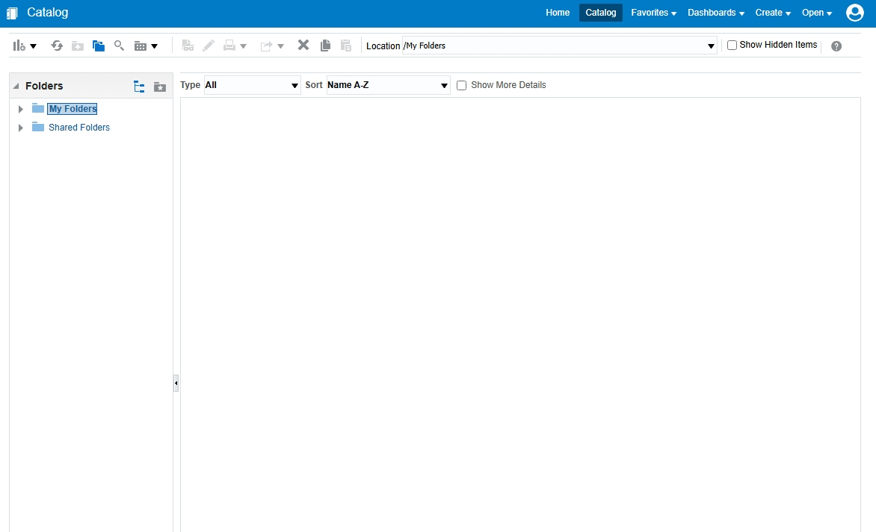
Catalog page

Step 8: Create an Analysis
- Click Create > Analysis.
- In Select Subject Area, search for pay and choose Payables Invoices - Transactions Real Time.
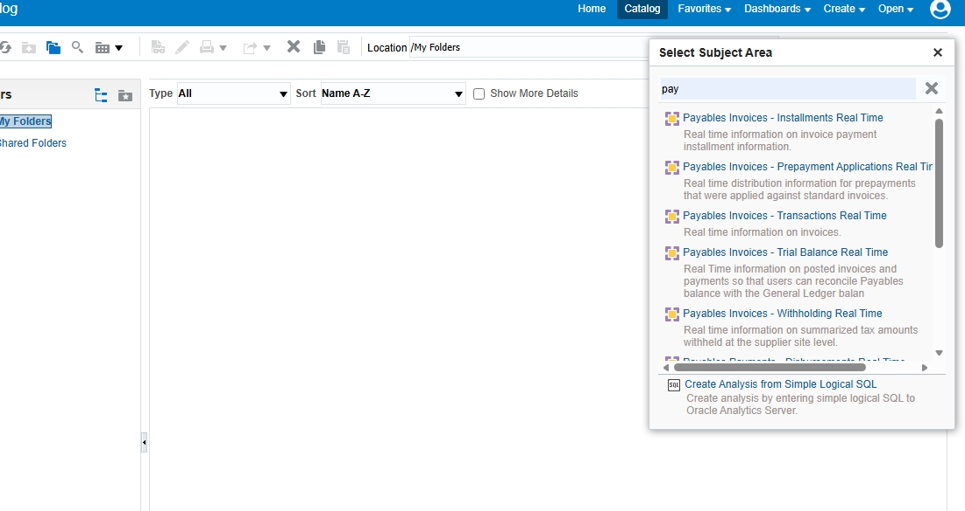
Select Subject Area

Step 9: Select the columns
- Expand Invoice Details > Invoice Amounts and add these columns:
- Invoice Currency
- Invoice Currency Name
- Invoice Amount
- Invoice Amount Paid
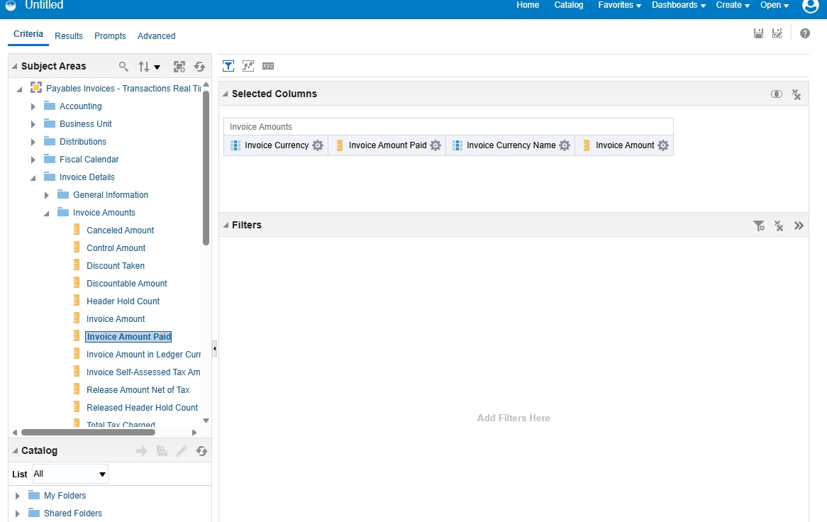
Criteria tab: Selected Columns
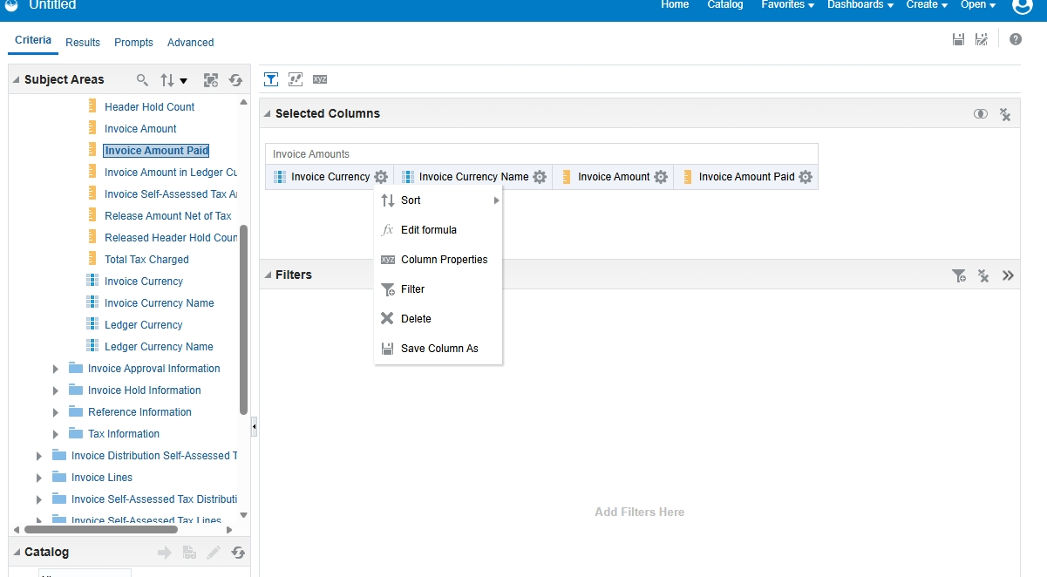
Selected columns (column options menu shown)

Step 10: Check the Results
- Click the Results tab.
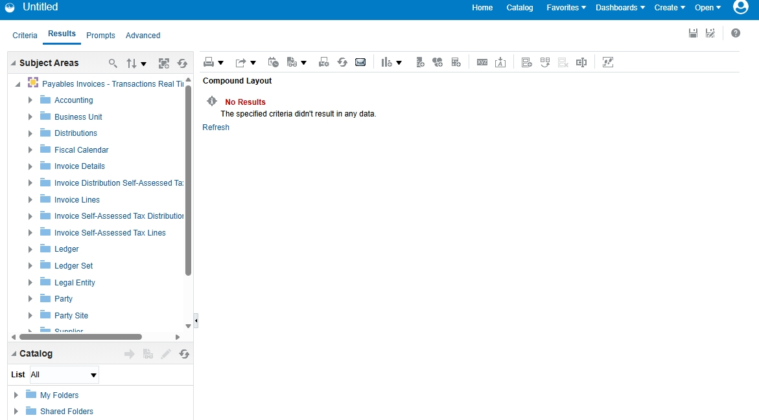
Results: No Results
Result: No data is shown because the user does not have data access.

Part 3: Provide Data Access to the User
Sign in as the administrator for this part.

Step 11: Open Setup and Maintenance
- Click your profile icon (Settings and Actions) and select Setup and Maintenance.
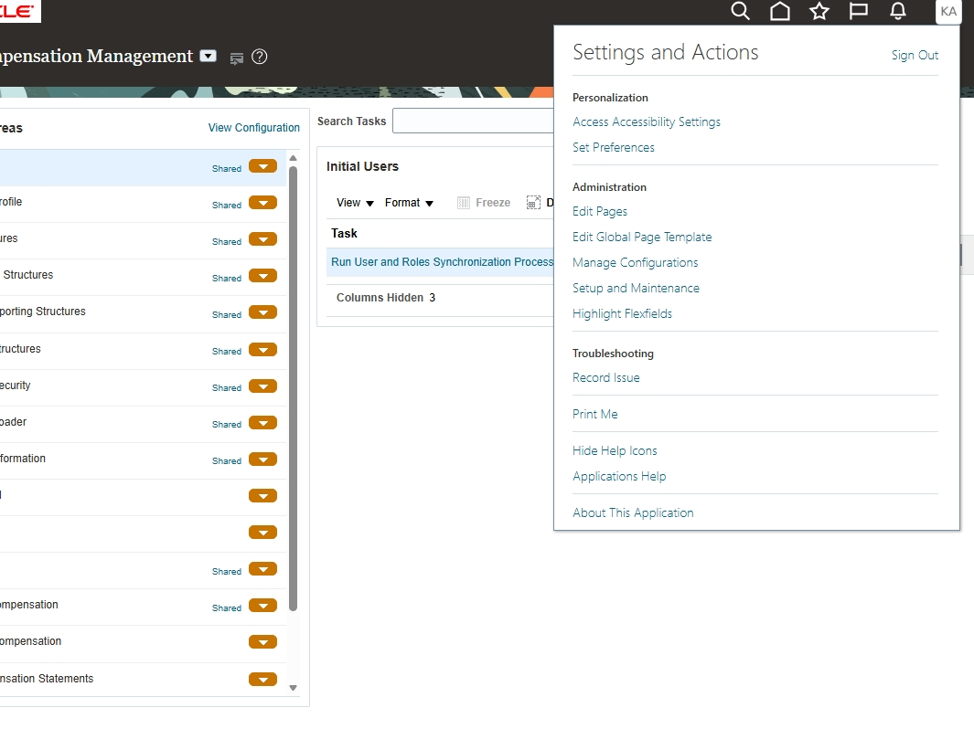
Settings and Actions > Setup and Maintenance

Step 12: Find the Data Access task
- In Search Tasks, type Data access for Users and click Search.
- Open the data access task from the results.
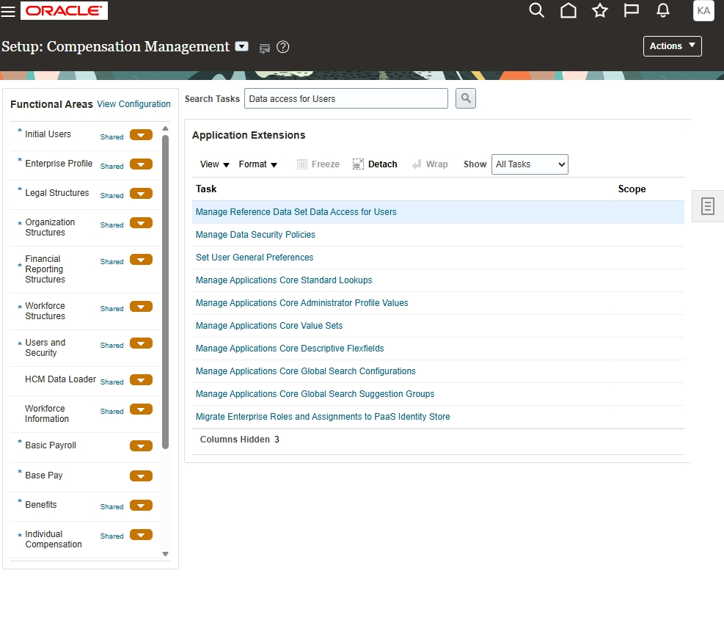
Setup: search task "Data access for Users"

Step 13: Search for the user
- Select Users with Data Access.
- Enter the User Name and click Search.
- No data is displayed, which confirms the user has no data access yet.
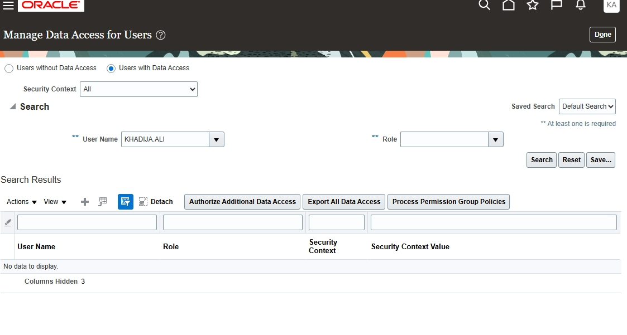
Manage Data Access for Users

Step 14: Create the data access
- Click the + (Create) icon and enter:
- User Name: the new user
- Role: Accounts Payables Manager
- Security Context: Business Unit
- Security Context Value: US1 Business Unit
- Click Save and Close.
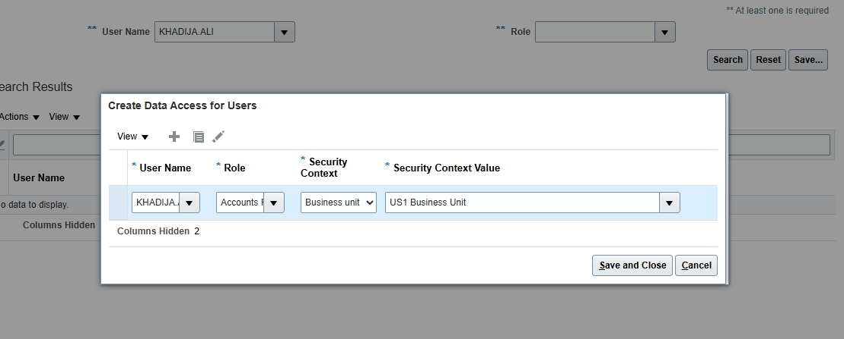
Create Data Access for Users

Part 4: View the Data

Step 15: Repeat the analysis
- Sign in as the new user and go to Tools > Reports and Analytics > Browse Catalog.
- Select Create > Analysis, then the subject area Payables Invoices - Transactions Real Time.
- Add Invoice Currency, Invoice Currency Name, Invoice Amount and Invoice Amount Paid.
- Click the Results tab.
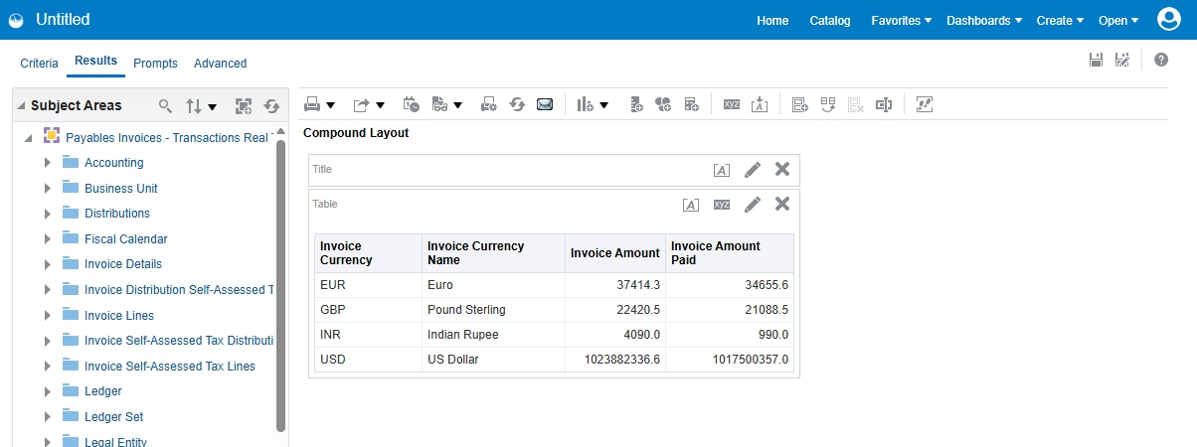
Results: invoice data is now displayed
Result: The user can now view the data, because data access was granted for the US1 Business Unit.

