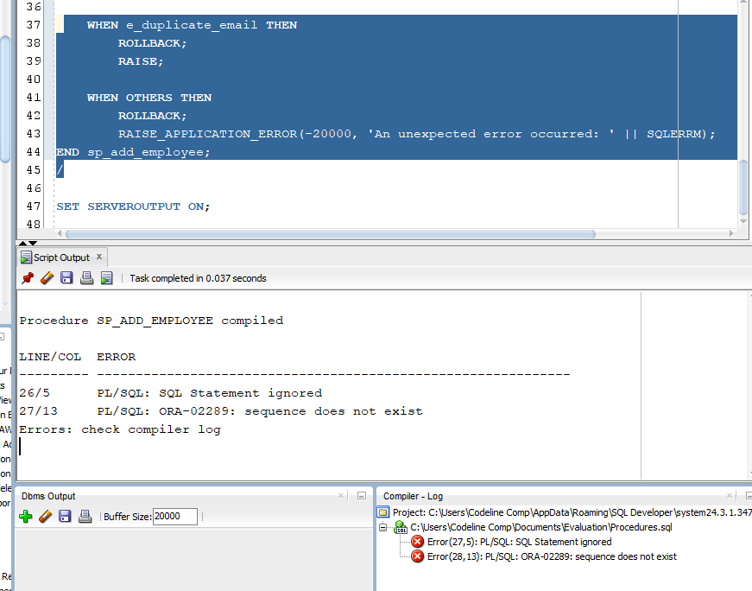
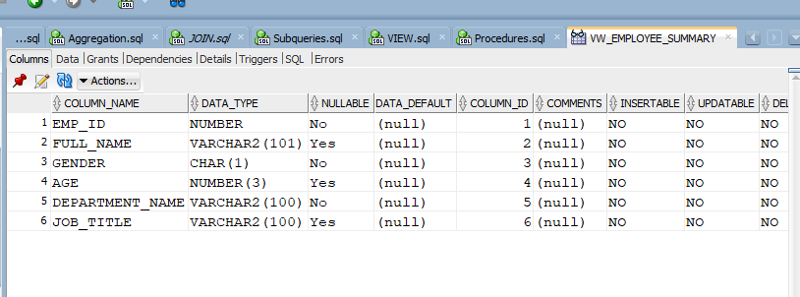
create or replace PROCEDURE sp_add_employee (
p_fname IN VARCHAR2,
p_lname IN VARCHAR2,
p_gender IN CHAR,
p_age IN NUMBER,
p_email IN VARCHAR2,
p_pass IN VARCHAR2,
p_job_id IN NUMBER
) IS
v_count NUMBER;
e_duplicate_email EXCEPTION;
PRAGMA EXCEPTION_INIT(e_duplicate_email, -20010);
BEGIN

SELECT COUNT(*) INTO v_count
FROM employee
WHERE LOWER(emp_email) = LOWER(p_email);

IF v_count > 0 THEN
RAISE_APPLICATION_ERROR(-20010, 'Email already in use: ' || p_email);
END IF;

INSERT INTO employee (emp_id, fname, lname, gender, age, emp_email, emp_pass, job_id)
VALUES (employee_seq.NEXTVAL, p_fname, p_lname, p_gender, p_age, p_email, p_pass, p_job_id);

DBMS_OUTPUT.PUT_LINE('Employee added successfully: ' || p_fname || ' ' || p_lname);
COMMIT;

EXCEPTION
WHEN e_duplicate_email THEN
ROLLBACK;
RAISE;
WHEN OTHERS THEN
ROLLBACK;
RAISE_APPLICATION_ERROR(-20000, 'An unexpected error occurred: ' || SQLERRM);
END sp_add_employee;

create or replace FUNCTION fn_net_salary (
p_emp_id IN NUMBER
) RETURN NUMBER IS
v_net_salary NUMBER;
BEGIN

SELECT amount
INTO v_net_salary
FROM salary_bonus
WHERE emp_id = p_emp_id;

RETURN v_net_salary;
EXCEPTION
WHEN NO_DATA_FOUND THEN
RETURN NULL;
WHEN OTHERS THEN
RETURN NULL;
END fn_net_salary;
Here is a concise and direct English explanation for both the procedure and the function:
1. Procedure sp_add_employee (Add New Employee)
This Procedure handles the secure insertion of a new employee record into the employee table while actively preventing duplicate data.
- Inputs: It accepts the employee's core profile details (First Name, Last Name, Gender, Age, Email, Password, and Job ID).
- Email Validation: Before performing any action, it checks the table to verify whether the provided email is already registered. It wraps the field in LOWER() to ensure the check remains case-insensitive.
- Custom Exception: If the email is a duplicate, it halts execution and fires a custom user-defined application error with the code -20010.
- Insertion & Commit: If the email is unique, it generates a new primary key using a sequence (employee_seq.NEXTVAL), inserts the record into the database, prints a success message, and permanently saves the changes via a COMMIT.
- Exception Handling: If the custom duplicate exception or any unexpected runtime error occurs, it initiates a ROLLBACK to wipe out partial modifications, ensuring transaction safety before passing the error message back to the application.
2. Function fn_net_salary (Get Net Salary)
This Function retrieves the current salary value assigned to a specific employee identifier.
- Inputs: It accepts a single employee identifier (p_emp_id).
- Outputs: It returns a numeric value (RETURN NUMBER) representing that employee's salary.
- Mechanism: It queries the salary_bonus table, looking specifically for the value inside the amount column where the record's emp_id matches the input variable.
- Error Resilience: * If the employee ID cannot be found in the table (NO_DATA_FOUND), the function gracefully handles the missing data by returning a NULL value instead of crashing.
  - For any other unforeseen database exceptions (WHEN OTHERS), it safely returns NULL to guarantee application stability.
2. Trigger
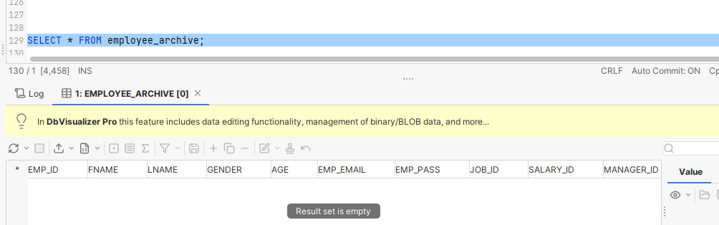
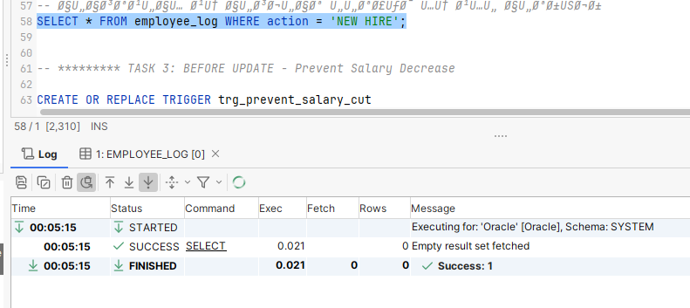
3. Schedular job
