Name: Khadija Butt

Roll No: MCSF19M021

**Lecture 2 24 Feb,2021 Wednesday**

Step 1: Create a Repository

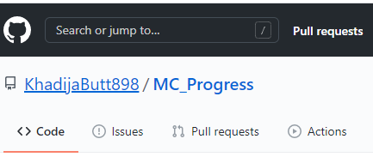

Step 2: Repository link:- https://github.com/KhadijaButt898/MC_Progress

Path to clone a repository

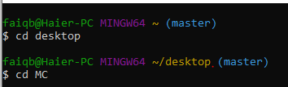

Step 3: Clone a repository

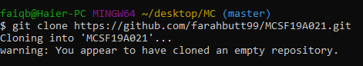

Step 4: Add a file to local repository

First of all I have created a MobileComputingNotebook.docx file in my local repository ("C:\Users\faiqb\Desktop\MC\MCSF19A021\MobileComputingNotebook.docx")

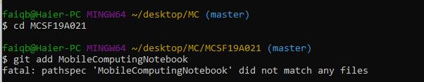

This error occurs due to the wrong file name. I have not added its extension .docx in the command.



Step 5: Commit

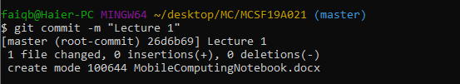

Git Status Command

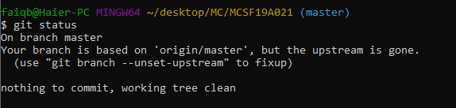

Step 6: Push

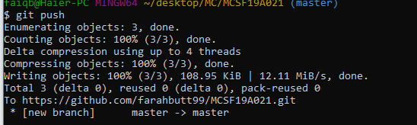

File is added to central repository

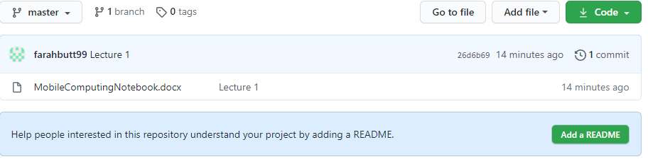

**Lecture 3 1 Mar,2021 Monday**Merge Conflict

Step 1: Add a new File

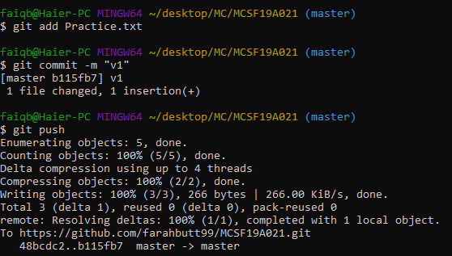

Conflict arises

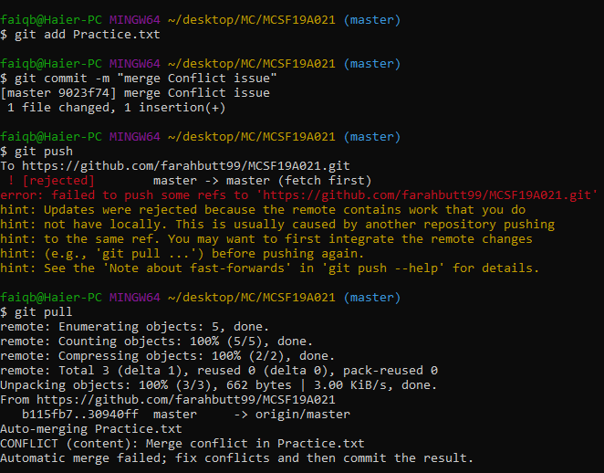

Remove File

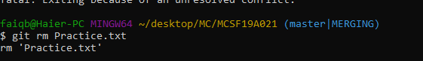

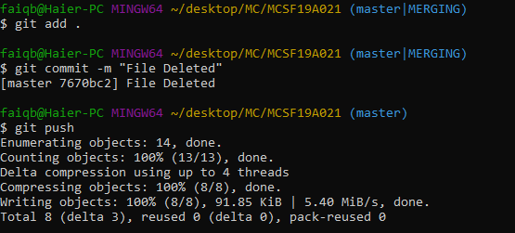

Branching

Branching Command Practice:

1. git branch

2. git checkout

3. git merge

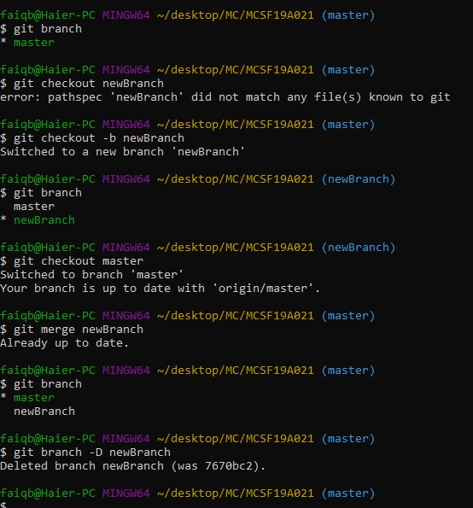

**Lecture 4 3 March,2021 Wednesday**

Android IDE introduction

Ver 1 Image

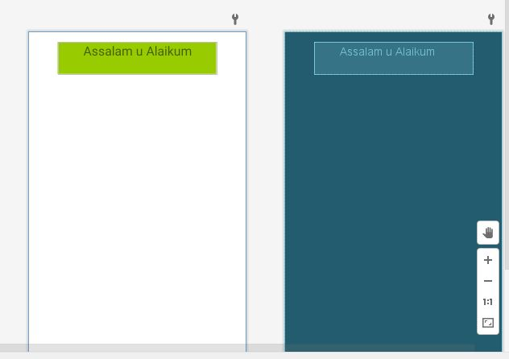

version 2 Image:

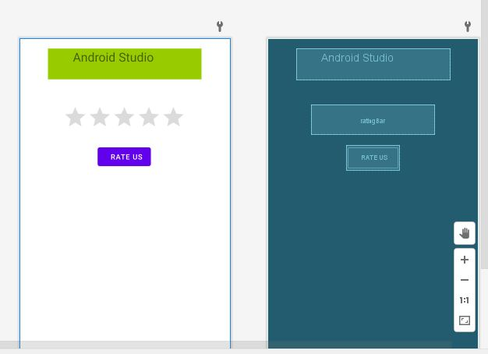

version 3 Image:

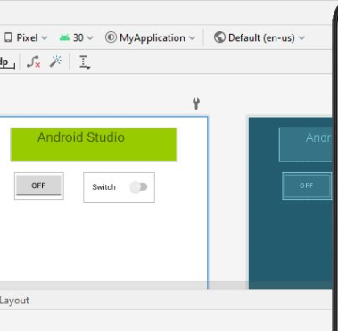

I faced an issue while running a program on android Studio

Every time when I start debugging. The Emulator’s window open and show this message.

“System UI is not responding”

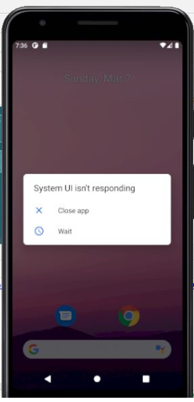

**Lecture 5 8 March,2021 Monday**

Topic: Layouts

Practice on Android Studio

**Linear Layout**

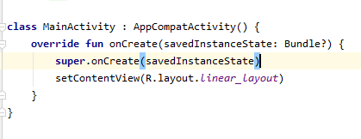

**Emulator**

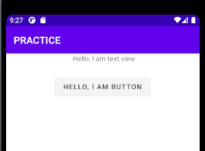

**Adding Image**

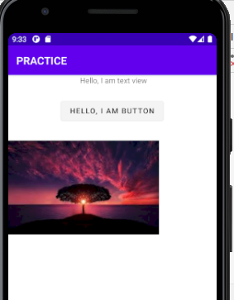

**Code Work**

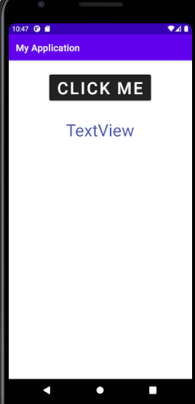

After clicking button

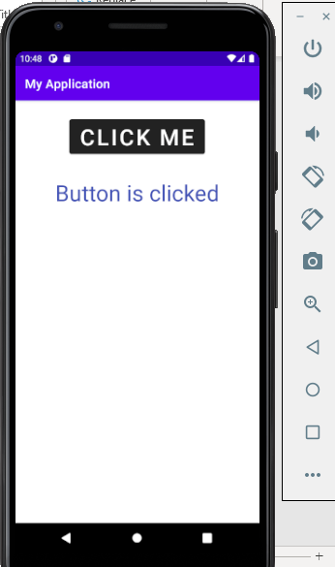

Code for this:

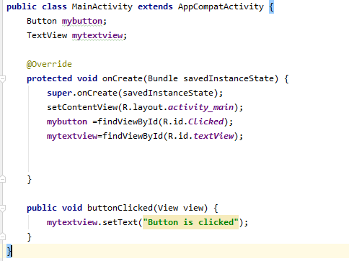

**Lecture 6 10 March,2021 Wednesday**

Class Tasks

Move from main activity 1 to main activity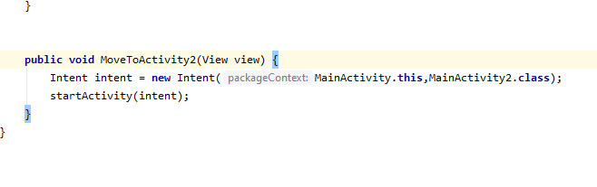image of activity 1:

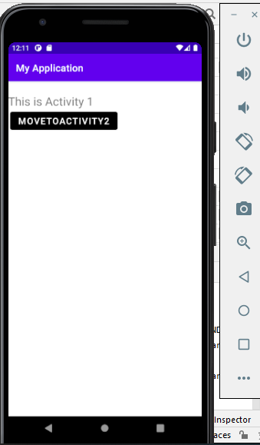

View of Main activity2 is:

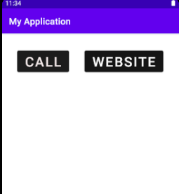

**Implicit intents:**

Code for call intent in mainActivity2.java

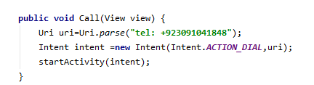

View of Call intent

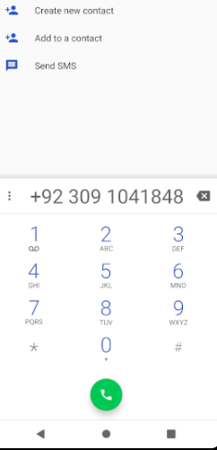

Code for website intent in main activity2.java

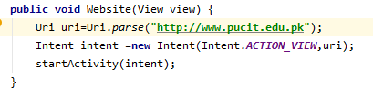

View of website Intent

