**Erg Diagram of E-Commerce Website**

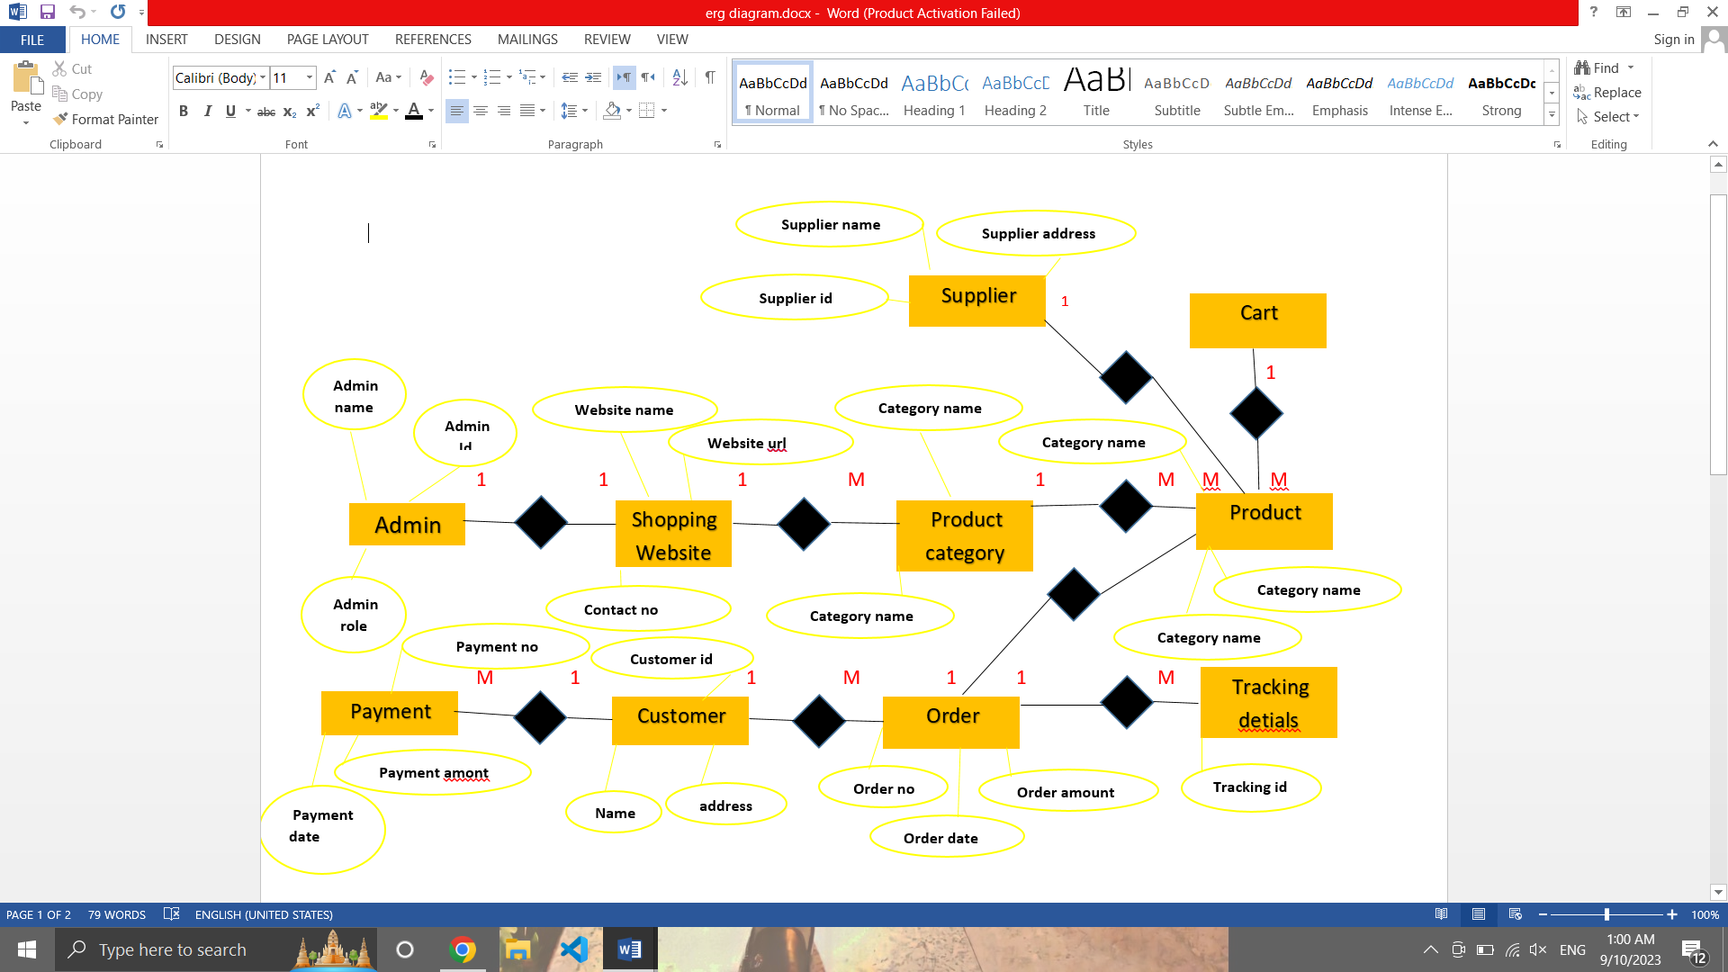

**Class diagram of E-Commerce Website**

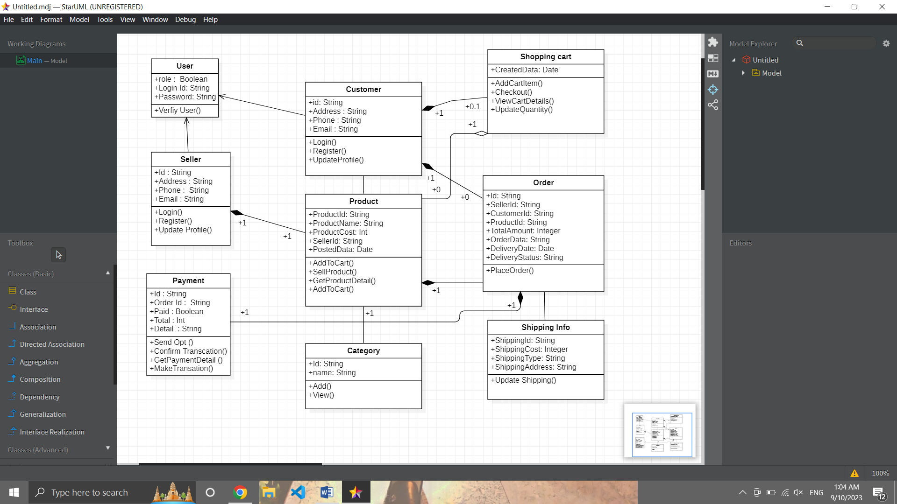

**Use Case Diagram of E-Commerce Website**

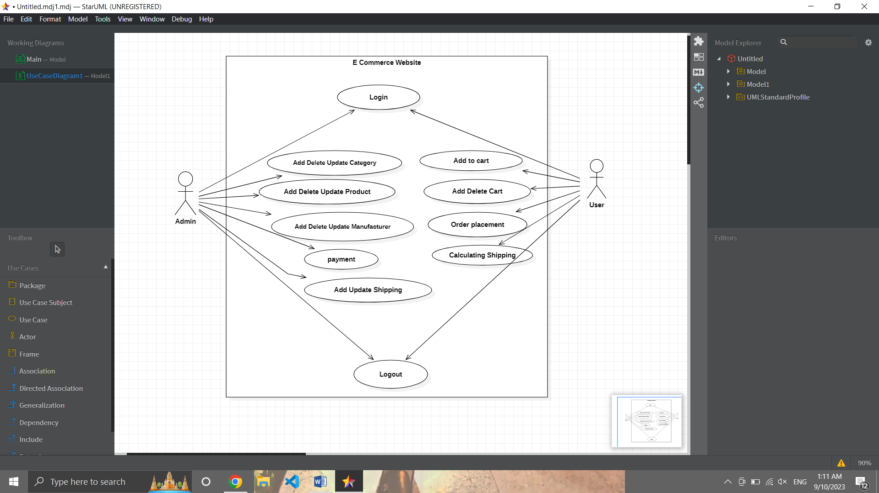

**Description of E-Commerce Website**

**Actor:**

**Customer:**

The primary actor who interacts with the e-commerce website to browse, search for products, make purchases, and manage their account.

**Administer:**

An internal actor responsible for managing the website, including product listings, user accounts, and order processing.

**Use Case:**

**Browse Product:**

The customer can search for products, view product details, and browse various categories.

**Add Cart:**

Customers can add products to their shopping cart.

**Remove Cart:**

Customers can remove items from their cart.

**Checkout:**

Customers can proceed to the checkout process, including providing shipping and payment information.

**Make Payment:**

Customers make payments for their orders through the payment gateway.

**Process Order:**

The system processes the order, updating inventory, generating invoices, and sending confirmation emails.

**Manage Amount:**

Registered customers can log in, view their order history, update their profile, and change their password

**Administer Website:**

Administrators can manage product listings, user accounts, and handle customer inquiries

**Manage Inventory:**

Administrators can update product quantities and availability

**Search Products**:

Users, whether guests or registered, can perform searches for products

**View Recommendations:**

The system suggests products based on user behavior and preferences

Logout:

Users can log out of their accounts

**Associations:**

The Customer actor is associated with various use cases such as Browse Products, Add to Cart, Remove from Cart, Checkout, Make Payment, Manage Account, and View Recommendations

The Administrator actor is associated with Administer Website and Manage Inventory use cases