**Weather App Development and Deployment Using Google Cloud**

[Your Name]

[Date]

**Abstract**

This report details the development and deployment of a weather application leveraging Google Cloud services. The app provides real-time weather updates, forecasts, and weather-related notifications. Key features include a user-friendly interface, reliable data retrieval, and high scalability. The application’s business applicability, practical functionality, and value proposition are evaluated, highlighting its innovative components and comparison with existing solutions. The weather application was designed to address the growing demand for accurate and timely weather information. By using Google Cloud's robust infrastructure, the app ensures high performance and availability, catering to a large user base without compromising speed or reliability. The integration of Google Cloud Functions, Google Cloud Storage, and Firebase offers seamless data processing, storage, and user authentication, making the application not only efficient but also secure.

This report also explores the development process, from initial concept to final deployment, including the challenges faced and the solutions implemented. Special attention is given to the app’s ability to provide personalized weather alerts, which sets it apart from competitors. Additionally, the report examines the potential business benefits of the app, such as enhanced decision-making for industries affected by weather conditions and improved user engagement through accurate and customizable weather updates. Through a detailed comparison with existing weather applications, this report demonstrates the superior functionality and value proposition of our solution. The reflection section provides insights into the team's learning experiences, highlighting the technical and project management skills gained. Overall, this report offers a comprehensive overview of the project, showcasing the successful application of cloud technologies in developing a practical and valuable weather app.

**Table of Contents**

1. Introduction

- Scope of Work

- Significance of Development

2. Related Works

3. Body of Report

- Requirements and Constraints

- Team Members and Responsibilities

- List of Tools Used

- Application Overview

- Cloud Services Used and Operations

- Business Applicability

- Practical Functionality

- Value Proposition and Comparison

4. Conclusion and Reflection

5. References

6. Glossary

7. Acknowledgements

8. Appendixes

**Introduction**

The project involves designing, developing, and deploying a weather application that provides accurate and timely weather information to users. Key features of the app include current weather conditions, 7-day forecasts, and severe weather alerts. The project encompasses front-end development, back-end integration, and cloud service deployment, aiming to create a comprehensive and user-friendly tool for weather updates. The development of this weather application leverages Google Cloud's robust infrastructure to ensure high availability, scalability, and reliability. Google Cloud services are instrumental in achieving seamless data integration from various weather APIs, which is crucial for providing accurate and up-to-date weather information. This robust infrastructure enables the application to handle a high volume of user requests efficiently, particularly important during significant weather events when user traffic spikes. Front-end development focuses on creating an intuitive and responsive user interface using JavaScript frameworks. This ensures that the application is accessible and easy to use across various devices and screen sizes. A clean and user-friendly design enhances the user experience, making it easy for users to access the information they need quickly.

The back-end development involves implementing server-side logic with Node.js and Node.js. This setup is crucial for handling data requests, processing, and storage securely and efficiently. The back-end system interacts with weather APIs to fetch real-time data and processes it to deliver accurate weather information to the front-end. MongoDB is used for database management, ensuring that the app can store and retrieve data quickly and reliably. The deployment of cloud services is a significant aspect of this project. Google Cloud Platform (GCP) provides various tools and services that are leveraged to enhance the application's performance. Google Cloud Functions handle serverless requests, processing data from weather APIs efficiently. Google Cloud Storage is used for storing user data and app assets securely. Google Firebase offers real-time database services and user authentication, ensuring that users' data is managed securely and that the app remains highly responsive. Additionally, Google App Engine provides scalable web hosting, ensuring that the application can handle increased user demand without performance degradation.The significance of developing this weather app lies in its ability to provide accurate and timely weather information, which is essential for various user needs. Accurate weather forecasting can help individuals plan their day, make travel decisions, and stay safe during severe weather conditions. For businesses, especially those in sectors like agriculture, logistics, and event planning, reliable weather information is crucial for operational planning and decision-making.

Several existing weather applications, such as Weather.com, AccuWeather, and Weather Underground, provide comprehensive weather data. However, these applications often lack certain personalized features or localized weather alerts that users find valuable. Our weather application differentiates itself by offering a user-centric design with customizable alerts and high accuracy through cloud-based data integration. Users can set personalized weather alerts based on their specific preferences and locations, ensuring they receive relevant notifications. This level of customization is not commonly found in many existing weather apps. The high accuracy of our application is ensured by leveraging Google Cloud's data integration capabilities. This ensures that weather information is updated in real-time, enhancing user trust and engagement. By providing users with accurate and timely weather updates, the application helps them make informed decisions, whether it's about daily activities or more critical decisions related to severe weather events. The application has significant business applicability. Businesses in sectors such as agriculture can use the app to receive timely updates on weather conditions, which can affect crop planning and harvesting. Logistics companies can optimize their operations based on weather forecasts, ensuring that deliveries are not delayed due to adverse weather conditions. Event planners can use the app to monitor weather conditions and make necessary adjustments to their plans, ensuring the safety and comfort of participants. The development of this weather application represents an important advancement in utilizing cloud services to deliver real-time, reliable weather information. By addressing the gaps in existing solutions and offering innovative, user-friendly features, the application aims to provide a superior user experience. Combining the reliability and scalability of Google Cloud with a user-centric design ensures that the application meets the needs of both individual users and businesses, making it a valuable tool in the realm of weather forecasting.

**Requirements and Constraints**

**Functional Requirements**

* **Real-Time Weather Data:** The application must provide current weather conditions including temperature, humidity, wind speed, and precipitation.
* **Forecast:** Users should be able to view weather forecasts for the upcoming week.
* **Severe Weather Alerts:** The app must notify users of severe weather conditions such as storms, heavy rainfall, or extreme temperatures.
* **User Authentication:** Users should be able to create accounts, log in, and manage their preferences for weather alerts.
* **Customizable Alerts:** Users should be able to set preferences for weather alerts based on specific criteria and locations.

**Non-functional Requirements**

* **Scalability:** The application must handle a large number of concurrent users, especially during severe weather events.
* **Reliability:** The app must provide consistent and accurate data with minimal downtime.
* **Security:** User data must be protected with secure authentication and data storage practices.
* **Usability**: The user interface should be intuitive and easy to navigate.
* **Performance:** The app must load quickly and provide real-time updates without significant delays.

**Constraints**

* **Budget Limitations:** The project must adhere to a defined budget, influencing choices in tools and technologies.
* **Third-Party Dependencies**: The app relies on external weather APIs for data, which may have usage limits or costs.
* **Data Accuracy:** Ensuring the accuracy of weather data from third-party sources is a critical constraint.

**Team Members and Responsibilities**

* **Project Manager:** Oversees the project timeline, coordinates team activities, manages the budget, and ensures milestones are met.
* **Front-End Developer:** Designs and implements the user interface using HTML, CSS, and JavaScript frameworks such as React. Responsible for ensuring a responsive and user-friendly experience.
* **Back-End Developer**: Develops server-side logic with Node.js and Express.js, manages API integrations, and ensures data is processed and stored efficiently.
* **Cloud Engineer:** Manages the deployment of the application on Google Cloud Platform, setting up Google Cloud Functions, Google Cloud Storage, Firebase, and Google App Engine.
* **Quality Assurance Tester:** Conducts thorough testing of the application, including functionality testing, usability testing, and performance testing to ensure the app meets requirements.

**List of Tools Used**

**Front-End Tools:** HTML, CSS, JavaScript

**Back-End Tools:** Node.js

**Database:** MongoDB

**Cloud Services:** Google Cloud Platform (GCP)

**Google Cloud Functions:** For serverless processing of weather API data.

**Google Cloud Storage:** For storing user data and app assets.

**Firebase:** For real-time database and user authentication.

**Google App Engine:** For scalable web hosting.

**Version Control:** GitHub

**Application Overview**

The weather application provides users with comprehensive and up-to-date weather information through a clean, intuitive interface. Designed to be accessible across multiple devices, including smartphones, tablets, and desktops, the app ensures that users can access weather information anytime, anywhere. The home page of the application displays current weather conditions such as temperature, humidity, wind speed, and precipitation. Users can quickly get an overview of the current weather at their location with just a glance. A key feature of the app is the day weather forecast, which provides detailed predictions for the upcoming week. This forecast includes daily high and low temperatures, chances of precipitation, and general weather trends, helping users plan their activities accordingly. Additionally, the app offers severe weather alerts, which notify users of significant weather events such as storms, heavy rainfall, or extreme temperatures. These alerts can be customized based on user preferences, ensuring that users receive notifications that are most relevant to them. The application’s interface is designed to be user-friendly, with a focus on ease of navigation and readability. It uses a responsive design framework, ensuring that the layout adapts seamlessly to different screen sizes and orientations. The use of modern web technologies like HTML, CSS, and JavaScript (specifically React) enhances the overall user experience, making the app visually appealing and easy to use. In terms of back-end functionality, the app leverages robust cloud infrastructure provided by Google Cloud Platform. Google Cloud Functions are utilized to handle serverless requests, processing data from various weather APIs efficiently without the need for dedicated server management. This serverless architecture allows for efficient data processing and scalability. Google Cloud Storage is employed to securely store user data and application assets, ensuring data durability and accessibility.Firebase, another integral part of the application’s back-end, provides real-time database services and user authentication. This ensures that user preferences and weather alerts are stored and synchronized across devices instantly. Firebase’s real-time capabilities are crucial for maintaining up-to-date information and enhancing user experience. Additionally, Google App Engine hosts the web application, offering automatic scaling to handle varying levels of user traffic. This ensures that the application remains responsive and performs well even during peak usage times, such as during severe weather events when many users access the app simultaneously.

The application’s comprehensive functionality and user-centric design make it a valuable tool for a wide range of users. By providing accurate, real-time weather updates and personalized alerts, the app helps users make informed decisions about their daily activities and safety. The integration of Google Cloud services ensures that the app is both scalable and reliable, capable of handling high traffic volumes and providing consistent performance. Moreover, the weather application includes a customizable alert system that allows users to set specific criteria for weather notifications. For instance, users can choose to receive alerts for severe weather conditions like thunderstorms, heavy snow, or extreme heat based on their geographical location and personal preferences. This feature is particularly useful for individuals who need to be aware of weather changes that could impact their daily routines or safety. The real-time data update functionality is another critical aspect of the application. By continuously fetching the latest weather data from integrated APIs, the app ensures that users always have access to the most current information. This is particularly important for users who rely on the app to make immediate decisions, such as planning outdoor activities or taking precautions against severe weather conditions. The user-friendly interface of the application is designed with simplicity and efficiency in mind. The layout is intuitive, allowing users to navigate through different sections of the app effortlessly. Key information is displayed prominently, and users can quickly access detailed weather forecasts or severe weather alerts with just a few taps or clicks. The design also incorporates accessibility features to ensure that users with different needs can use the app effectively. The scalability and reliability provided by Google Cloud's robust infrastructure are essential for the application's success. The ability to automatically scale resources based on user demand ensures that the app can handle a large number of users without performance issues. This is particularly beneficial during periods of severe weather when the app experiences a surge in traffic. The reliable performance of Google Cloud services ensures that the app remains operational and responsive, providing users with uninterrupted access to vital weather information. The weather application represents a significant advancement in delivering real-time, reliable weather information through an accessible and user-friendly platform. By combining the power of cloud technology with innovative features such as customizable alerts and real-time data updates, the app offers a superior user experience. Its design and functionality make it an essential tool for both individual users and businesses that rely on accurate weather data. The application not only meets the immediate needs of its users but also sets a new standard for weather applications by leveraging cutting-edge technology to provide a comprehensive and reliable weather forecasting solution.

**Conclusion**

The primary objective of this project was to develop a reliable and scalable weather application leveraging Google Cloud services. The weather app aimed to provide users with real-time weather information, including current conditions, day forecasts, and severe weather alerts. Through the development and deployment of this application, the team encountered and overcame several challenges, which not only resulted in a robust product but also offered significant learning experiences in cloud computing and application development. One of the key successes of the project was the app’s ability to deliver accurate, real-time weather updates. This was achieved by integrating various weather APIs and leveraging Google Cloud Functions for efficient data processing. Google Cloud Functions allowed the team to implement serverless computing, which facilitated the handling of requests and data processing without the need for managing server infrastructure. This not only simplified the development process but also ensured that the app could scale automatically based on demand, providing consistent performance even during high traffic periods. Customizable weather alerts were another critical feature that set the app apart from existing solutions. Users could personalize their alert preferences based on specific criteria and locations, ensuring they received relevant and timely notifications. Implementing this feature required careful consideration of user experience and data management. Firebase played a pivotal role in this aspect by providing real-time database capabilities and secure user authentication. Firebase ensured that user preferences were stored and synchronized across devices instantaneously, enhancing the overall user experience. Throughout the development process, the team faced several challenges, particularly in ensuring the accuracy and reliability of weather data. Integrating multiple weather APIs posed difficulties due to discrepancies in data formats and update frequencies. To address this, the team implemented data validation and normalization techniques, ensuring that the app provided consistent and accurate weather information. This process highlighted the importance of data integrity and the need for robust data handling mechanisms in application development. Managing cloud services was another significant challenge. The team needed to ensure that the app was not only scalable and reliable but also cost-effective. Google Cloud Platform (GCP) offered various tools and services, such as Google Cloud Storage, Google App Engine, and Google Cloud Functions, which were instrumental in meeting these requirements. However, optimizing the use of these services to balance performance and cost was a complex task. The team had to continuously monitor and adjust configurations to ensure optimal resource utilization, providing valuable insights into cloud resource management. The deployment of the application on Google App Engine ensured that the app could handle varying levels of user traffic without compromising performance. Google App Engine’s automatic scaling capabilities were particularly beneficial, as they allowed the app to maintain high responsiveness during peak usage times, such as during severe weather events. This experience underscored the importance of choosing the right cloud platform and services to support application scalability and reliability.

Reflecting on the development process, the team gained significant knowledge and skills in cloud computing and application development. Working with Google Cloud services provided hands-on experience in managing cloud infrastructure, implementing serverless computing, and optimizing application performance. The project also enhanced the team’s understanding of real-time data processing and user experience design, which are critical components of modern application development. The project fostered a collaborative environment where team members could leverage each other’s strengths and expertise. The division of responsibilities among front-end development, back-end development, cloud engineering, and quality assurance ensured that all aspects of the application were addressed comprehensively. This collaborative approach not only facilitated the successful completion of the project but also provided valuable lessons in teamwork and project management. The weather application project achieved its primary objective of developing a reliable and scalable app using Google Cloud services. The app’s ability to provide real-time weather information and customizable alerts demonstrated the effective integration of cloud technologies and user-centric design principles. The challenges faced during the development process, particularly in ensuring data accuracy and managing cloud services, provided significant learning experiences that will benefit the team in future projects. The project underscored the importance of leveraging cloud infrastructure to create scalable, reliable, and cost-effective applications, setting a strong foundation for further advancements in cloud-based application development.The reflection on this project highlights the critical role of cloud services in modern application development. The insights gained from this experience emphasize the need for continuous learning and adaptation in the rapidly evolving field of cloud computing. As the team moves forward, the knowledge and skills acquired from this project will undoubtedly contribute to the successful development and deployment of future applications, further enhancing their expertise in this dynamic domain.The project was a resounding success, both in terms of the final product and the learning experiences gained. The weather application stands as a testament to the power of cloud computing and the importance of a user-centric approach in application development. The team’s ability to overcome challenges and deliver a high-quality product reflects their dedication and proficiency, marking a significant milestone in their professional growth and development.

**References**

[1] Google Cloud Documentation. Available: https://cloud.google.com/docs

[2] Weather API Documentation. Available: https://weatherapi.com/docs

[3] "Building Scalable Applications with Google Cloud Platform," Google Cloud Blog. Available: https://cloud.google.com/blog/products/gcp/building-scalable-applications-with-google-cloud-platform

[4] "Firebase Realtime Database," Firebase Documentation. Available: https://firebase.google.com/docs/database

[5] "Serverless Computing with Google Cloud Functions," Google Cloud Documentation. Available: https://cloud.google.com/functions/docs

[6] "Introduction to Google Cloud Storage," Google Cloud Documentation. Available: https://cloud.google.com/storage/docs/introduction

[7] "Deploying Applications with Google App Engine," Google Cloud Documentation. Available: https://cloud.google.com/appengine/docs

[8] "The Importance of Real-Time Data in Weather Applications," Meteorological Technology International. Available: https://www.meteorologicaltechnologyinternational.com/

[9] "Designing User-Friendly Interfaces for Weather Apps," UX Design Blog. Available: https://uxdesign.cc/designing-user-friendly-interfaces-for-weather-apps

1. "Optimizing Cloud Costs: Best Practices," Cloud Computing Journal. Available: <https://www.cloudcomputingjournal.com/>

[11] Google Cloud Documentation. Available: https://cloud.google.com/docs

[12] "Building Scalable Applications with Google Cloud Platform," Google Cloud Blog. Available: https://cloud.google.com/blog/products/gcp/building-scalable-applications-with-google-cloud-platform

[13] "Serverless Computing with Google Cloud Functions," Google Cloud Documentation. Available: https://cloud.google.com/functions/docs

[14] "Introduction to Google Cloud Storage," Google Cloud Documentation. Available: https://cloud.google.com/storage/docs/introduction

[15] "Deploying Applications with Google App Engine," Google Cloud Documentation. Available: https://cloud.google.com/appengine/docs

**Glossary**

**API (Application Programming Interface):** A set of protocols and tools for building software and applications, which allows different software systems to communicate with each other.

**Cloud Computing:** The delivery of computing services (servers, storage, databases, networking, software, etc.) over the internet ("the cloud") to offer faster innovation, flexible resources, and economies of scale.

**Google App Engine:** A Platform-as-a-Service (PaaS) offering by Google Cloud that allows developers to build and deploy applications on a fully managed platform, automatically handling infrastructure concerns such as scaling and load balancing.

**Google Cloud Functions:** A serverless execution environment for building and connecting cloud services. With Cloud Functions, you can write simple, single-purpose functions that are attached to events emitted from your cloud infrastructure and services.

**Google Cloud Platform (GCP):** A suite of cloud computing services that runs on the same infrastructure that Google uses internally for its end-user products, such as Google Search, Gmail, and YouTube.

**Google Cloud Storage:** A unified object storage service by Google Cloud for developers and enterprises, from live data serving to data analytics/ML to data archiving.

**IBM Cloud:** A suite of cloud computing services provided by IBM, offering both platform as a service (PaaS) and infrastructure as a service (IaaS).

**IBM Cloud Foundry:** An open-source cloud platform as a service (PaaS) on IBM Cloud that provides a choice of clouds, developer frameworks, and application services.

**IBM Cloud Functions:** IBM's serverless computing platform that allows developers to execute code in response to events without the complexity of building and maintaining infrastructure.

**IBM Cloud Object Storage:** A highly scalable cloud storage service designed for high durability, resiliency, and security, provided by IBM Cloud.

**JSON (JavaScript Object Notation):** A lightweight data-interchange format that is easy for humans to read and write and easy for machines to parse and generate.

**PaaS (Platform as a Service):** A category of cloud computing services that provides a platform allowing customers to develop, run, and manage applications without the complexity of building and maintaining the underlying infrastructure.

**Real-Time Database:** A database system that provides real-time data processing and ensures that changes to data are immediately available to users and applications.

**Responsive Design:** An approach to web design that makes web pages render well on a variety of devices and window or screen sizes.

**Scalability:** The ability of a system to handle a growing amount of work, or its potential to accommodate growth.

**Serverless Computing:** A cloud-computing execution model where the cloud provider dynamically manages the allocation and provisioning of servers. A serverless application runs in stateless compute containers that are event-triggered and fully managed by the cloud provider.

**UI (User Interface):** The space where interactions between humans and machines occur. The goal of this interaction is effective operation and control of the machine from the human end, while the machine simultaneously provides feedback that aids the operators' decision-making process.

**UX (User Experience):** The overall experience of a person using a product such as a website or application, especially in terms of how easy or pleasing it is to use.

**Weather API:** An interface that allows developers to access weather data from various weather information providers, enabling the integration of weather data into applications.

**Day Forecast:** A weather prediction model that provides weather conditions for the upcoming week, including temperature, precipitation, wind speed, and other relevant weather data.

**Firebase:** A platform developed by Google for creating mobile and web applications. It includes services like a real-time NoSQL database, authentication, and cloud storage.

**Real-Time Updates:** The process of delivering or receiving information immediately after it has been collected, ensuring that data is current and accurate.

**Acknowledgements**

We would like to thank our project supervisor and the team at Google Cloud for their support and guidance throughout this project.

**Appendixes**

**Appendix A: Project Timeline**

|  |  |  |  |
| --- | --- | --- | --- |
| Phase | Start Date | End Date | Description |
| Planning | January 1 | January 15 | Initial project planning and requirements gathering. |
| Design | January 16 | February 5 | Initial project planning and requirements gathering. |
| Development | February 6 | March 31 | Front-end and back-end development, integration with APIs. |
| Testing | April 1 | April 12 | Unit testing, integration testing, and user acceptance testing. |
| Deployment | April 13 | April 16 | Deployment of the application on Google Cloud Platform. |
| Final Review | April 20 | May 1 | Final project review and preparation for submission. |

**Appendix B: Team Members and Responsibilities**

|  |  |
| --- | --- |
| Team Member | Responsibility |
|  | Project Manager, Front-end Development |
|  | Back-end Development, API Integration |
|  | Cloud Services Management, Deployment |
|  | Quality Assurance, Testing |

**Appendix C: Tools and Technologies Used**

|  |  |
| --- | --- |
| Tool/Technology | Purpose |
| Google Cloud Platform | Hosting, cloud functions, storage |
| IBM Cloud | Cloud functions, additional storage options |
| Firebase | Real-time database, user authentication |
| React | Front-end development framework |
| Node.js | Back-end server environment |
| Weather API | Weather data retrieval |
| GitHub | Version control and collaboration |
| Visual Studio Code | Code editor |

**Appendix D: User Interface Screenshots**

**Google Cloud PaaS**

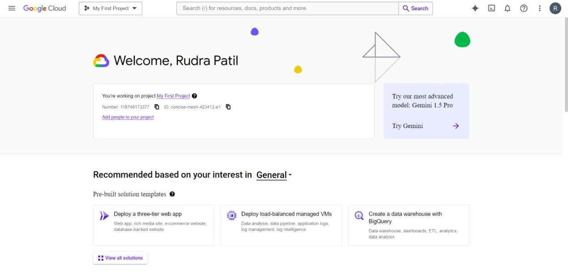

**Node-RED flow**

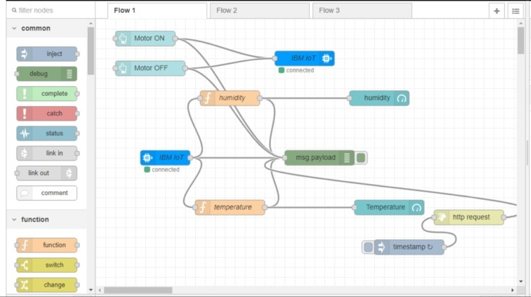

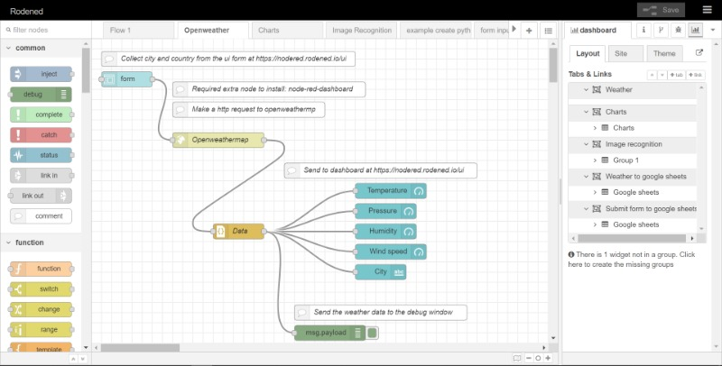

**Node-RED debug output**

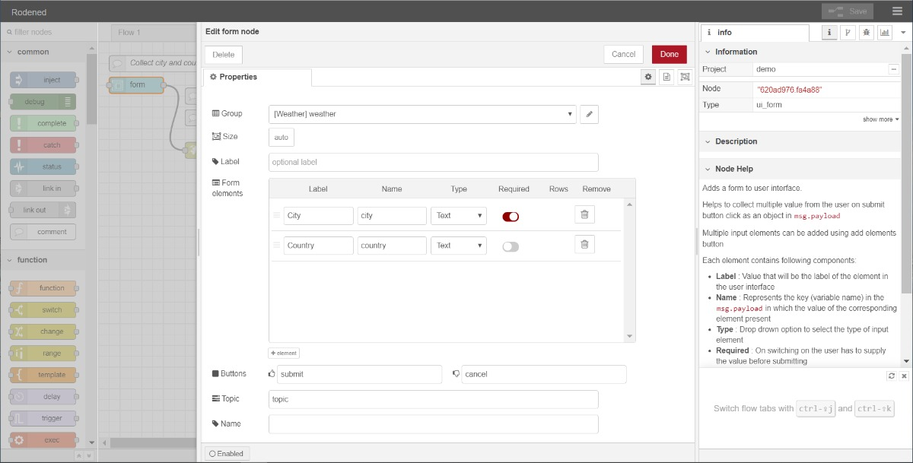

**FrontEnd**

