|  |  |
| --- | --- |
| UWMIN | **Guide to Access MySQL (through phpMyAdmin)** |

Table : MySQL Login Fields

|  |  |
| --- | --- |
| **Your MySQL login name (w+7 digits)** |  |
| **Your MySQL password** |  |
| **Your MySQL default database** |  |

1. **Generate your MySQL account details**
2. Account generation: <https://support.ecs.westminster.ac.uk/mysql/index.php>
3. Copy your MySQL login name, your MySQL password and your MySQL default database and paste them in the above table so that you can access them rapidly every time you need to access MySQL.
4. **Access MySQL (through phpMyAdmin)**
5. phpMyAdmin access: <https://phpmyadmin.ecs.westminster.ac.uk/>

***phpMyAdmin is a free and open source tool written in PHP intended to handle the administration of MySQL with the use of a web browser.***

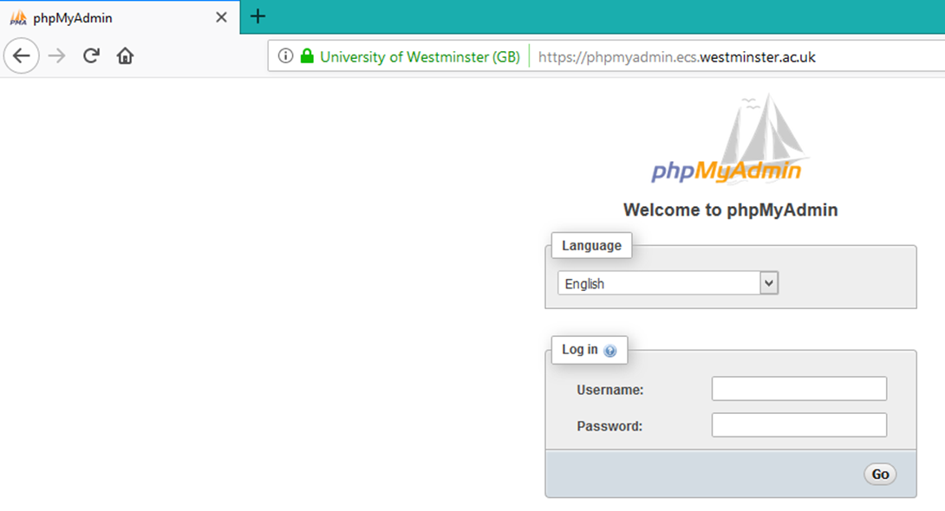

**Enter your MySQL username:**

**w+7digits (w in lower case!)**

**Enter your MySQL password:**

**the random password previously generated**

1. Enter your MySQL login name and access your default database

**CLICK HERE TO ACCESS YOUR LOCAL DATABASE**

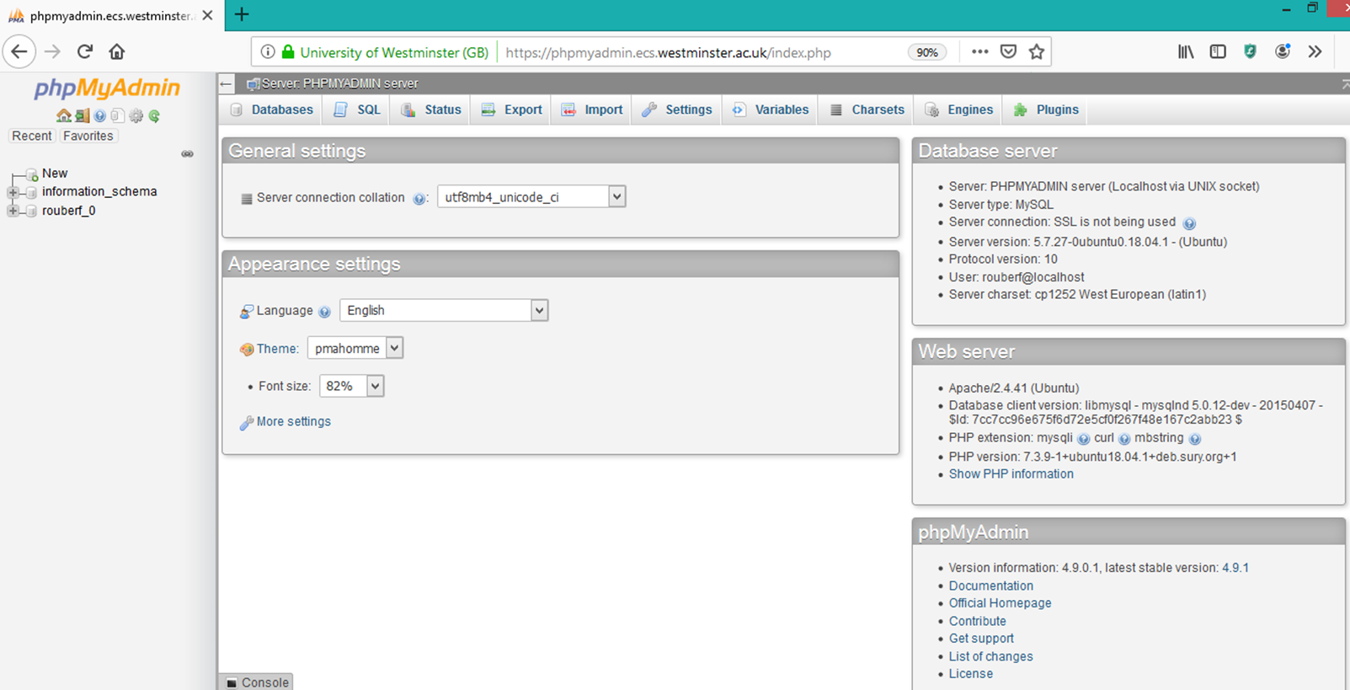

1. Click on the second tab “SQL” (right at the top) to access the SQL editor and enter your SQL statements.