**Name : Khadija Naveed**

**Roll No. : Mcsf19a031**

1. Install “Git”.
2. I work on “Git Bash” instead of “Git Command”.
3. First of all I create an account on github and then a repository to check that how it works.

Here is the link to my repository on github:

[**https://github.com/KhadijaNaveed57/MobileComputing.git**](https://github.com/KhadijaNaveed57/MobileComputing.git)

and here is the screenshot of the link:

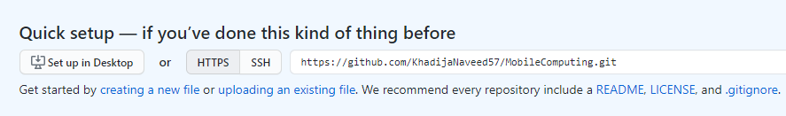

1. Now I create a folder in my computer with name git and create a clone of my central repository in this folder using the command.

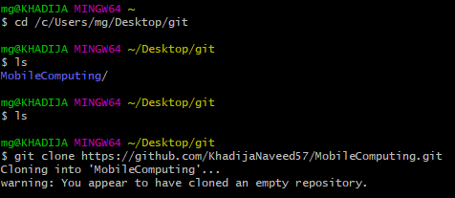

Cloned repository has been created.

1. Now I save a random file in this folder and add using add command.

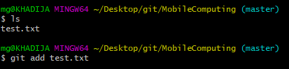

1. I Commit this file after some configuration.

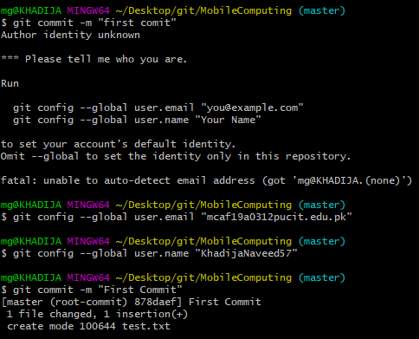

1. We can also check the status of the repository using the command.

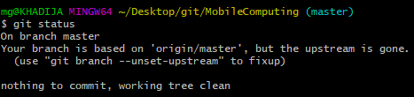

1. Now push the file in the central repository.

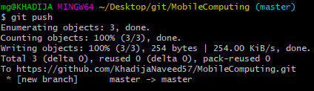

1. After applying some changes in the file we apply the same procedure to update the file in the central repository.

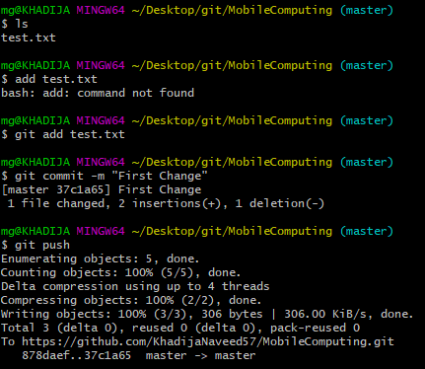

1. If we want to change in the central repository, we apply changings and use pull command to pull that changed file in our local repository.

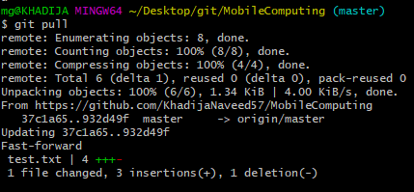

1. If we apply changings in the local repository and the central repository at the same time there may occur the merging conflict. We should remove that conflict first and then save the changings according to our need.
2. We can use the git log commands to get the detail about the commits.

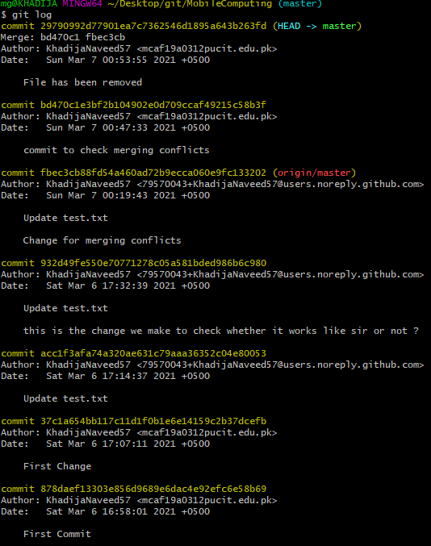

1. Now I’m applying the same procedure to save this file in the folder and then upload that file in the central repository and this fill will work like my notebook.

