

## Subject: Database Administration and Management

## Registration no: 20-NTU-CS-1110

## Submitted by: Khadija Nisar

## BSSE-6th

## Submitted to: Mam Aisha Younas

Table of Contents:

Software Process Model: 4

Advantages of Prototype Model 5

Step 1: Requirements gathering and analysis 5

Step 2: Quick design 5

Step 3: Build a Prototype 5

Step 4: Initial user evaluation 6

Step 5: Refining prototype 6

Step 6: Implement Product and Maintain 6

What Are Project Management Tools? 6

New Project:  7

Adding tasks and Subtasks: 7

Activities: 8

Milestones: 9

Successors: 10

Gantt Chart: 10

Network Diagram: 11

WBS (Work Breakdown Structure): 11

Task Usage: 13

Resources: 14

RBS: 14

Baseline: 14

Project Information: 15

General 15

Statistics 16

Project Preview: 17

Reports: 18

Project Details Report: 18

Resource Information Report: 19

Task Information Report: 19

Who does what Report: 20

## Table of Figures:

Figure 1: Prototype Process Model 4

Figure 2: New Project 6

Figure 3: Requirements Task 6

Figure 4: Design Task 7

Figure 5: Building Prototype Task 7

Figure 6: User Evaluation Task 7

Figure 7: Implementation and Testing Activities 7

Figure 8: Activities1 8

Figure 9:Activities2 8

Figure 10: Setting a task milestone 9

Figure 11: Successor 10

Figure 12: Gantt Chart1 10

Figure 13: Gantt Chart2 11

Figure 14: Network Diagram 11

Figure 15: WBS 1 12

Figure 16: WBS 2 12

Figure 17:WBS 3 12

Figure 18: Task Usage1 13

Figure 19:Task Usage 2 13

Figure 20: Resources 1 14

Figure 21: Resources 2 14

Figure 22: RBS 1 14

Figure 23: RBS 2 14

Figure 24: Setting Baseline Project 15

Figure 25: Project Information General 15

Figure 26: Project Information Statistics 16

Figure 27: Project Detail 1 18

Figure 28: Project Detail 2 18

Figure 29: Resource Information Report 19

Figure 30: Task Information Report 19

Figure 31: Who does what report 20

## Software Process Model:

The best software development which is suited for the projects like mine (Online Attendance System) are preferred to use of the Prototype development methodology as the software development methodology. The Prototyping model is also a popular software development life cycle model. The prototyping model can be considered to be an extension of the Iterative Waterfall model. This model suggests building a working Prototype of the system before the development of the actual software.

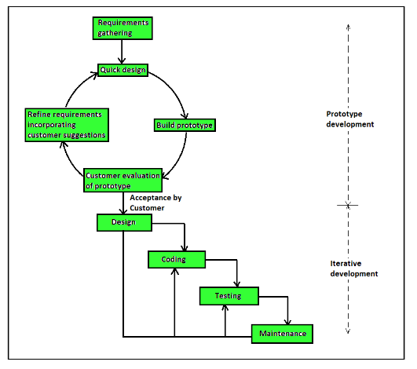

Figure : Prototype Process Model

## Advantages of Prototype Model

Prototype model offers the following benefits-

* Quick client feedback is received which speeds up the development process. Also, it helps the development team to understand the client’s needs.
* Developed prototypes can be used later for any similar projects.
* Any missing functionality and any error can be detected early.
* It is useful when requirements are not clear from the client’s end, even with limited requirements, the development team can start the development process.
* Prototyping Model has following six SDLC phases as follow:

## Step 1: Requirements gathering and analysis

A prototyping model starts with requirement analysis. In this phase, the requirements of the system are defined in detail. During the process, the users of the system are interviewed to know what their expectation from the system is.

## Step 2: Quick design

The second phase is a preliminary design or a quick design. In this stage, a simple design of the system is created. However, it is not a complete design. It gives a brief idea of the system to the user. The quick design helps in developing the prototype.

## Step 3: Build a Prototype

In this phase, an actual prototype is designed based on the information gathered from quick design. It is a small working model of the required system.

## Step 4: Initial user evaluation

In this stage, the proposed system is presented to the client for an initial evaluation. It helps to find out the strength and weakness of the working model. Comment and suggestion are collected from the customer and provided to the developer.

## Step 5: Refining prototype

If the user is not happy with the current prototype, you need to refine the prototype according to the user’s feedback and suggestions.

This phase will not over until all the requirements specified by the user are met. Once the user is satisfied with the developed prototype, a final system is developed based on the approved final prototype.

## Step 6: Implement Product and Maintain

Once the final system is developed based on the final prototype, it is thoroughly tested and deployed to production. The system undergoes routine maintenance for minimizing downtime and prevent large-scale failures.

## What Are Project Management Tools?

Project management tools are specially designed to assist an individual or team in organizing and managing their projects and tasks effectively. The term PM tools usually refers to project management software and project management tools you can either purchase or even use for free online.

## New Project:

## 

Figure : New Project

## Adding tasks and Subtasks:

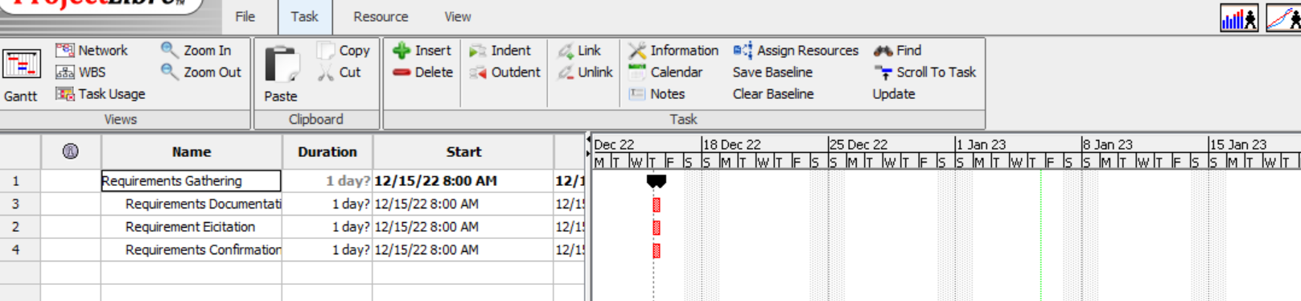

Figure : Requirements Task



Figure : Design Task



Figure : Building Prototype Task

Figure : User Evaluation Task

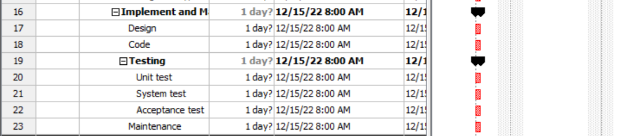

Figure : Implementation and Testing Activities

## Activities:

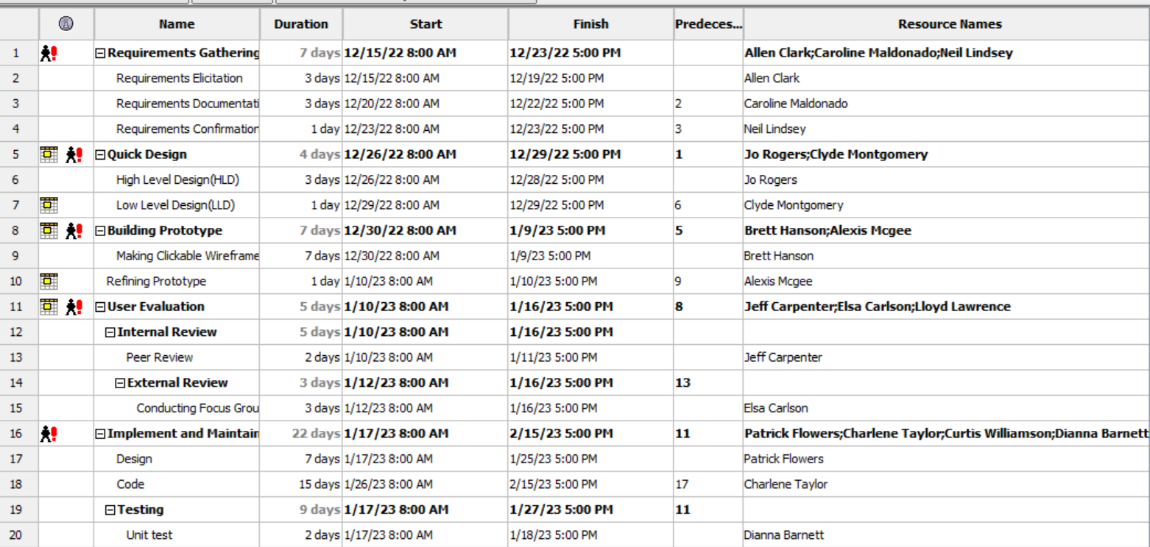

Figure : Activities1

Figure :Activities2

## Milestones:

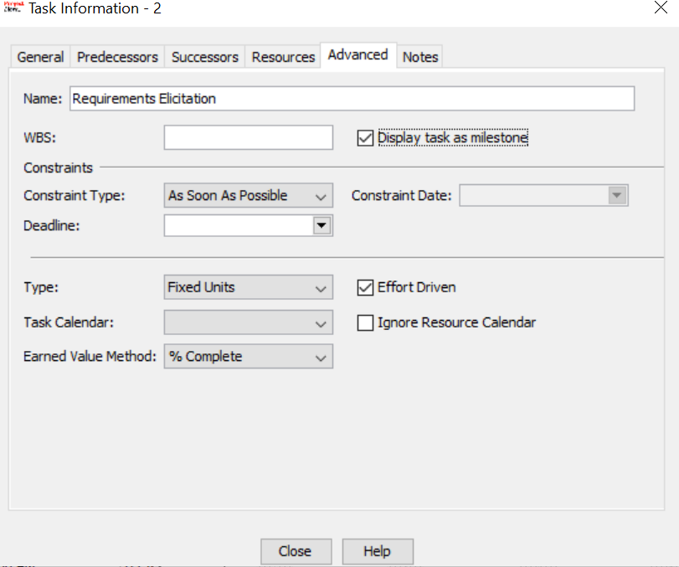

Figure : Setting a task milestone

## Successors:

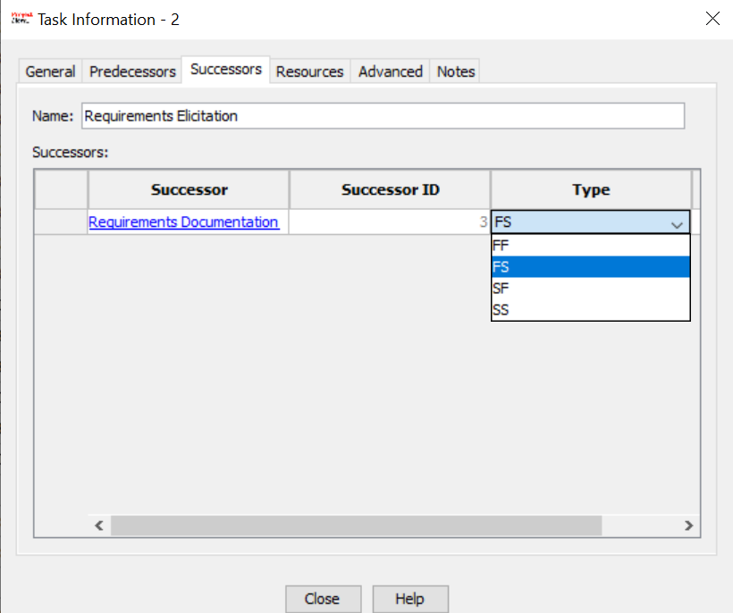

Figure : Successor

## Gantt Chart:

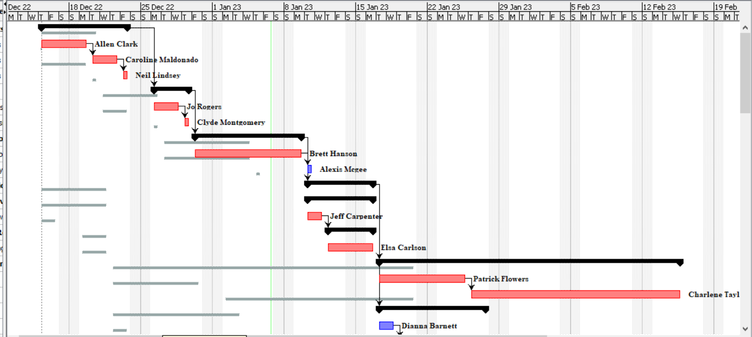

Figure : Gantt Chart1

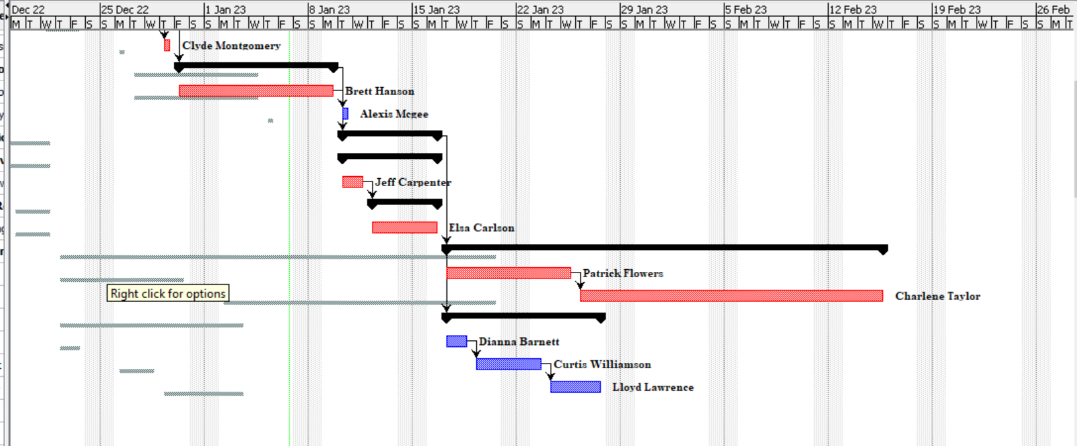

Figure : Gantt Chart2

## Network Diagram:

A project network is a graph that shows the activities, duration, and interdependencies of tasks within your project.

Figure : Network Diagram

## WBS (Work Breakdown Structure):

A work breakdown structure (WBS) is **a visual, hierarchical, and deliverable-oriented deconstruction of a project**. It is a helpful diagram for project managers because it allows them to break down their project scope and visualize all the tasks required to complete their projects.

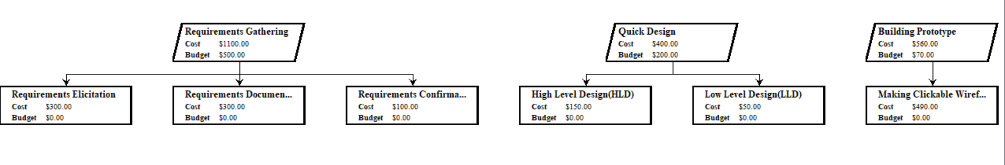

Figure : WBS 1

Figure : WBS 2

Figure :WBS 3

## Task Usage:

The Task Usage view lists for each task the resources assigned to it and the amount of work that each resource has performed over time, whether per day, week, month, or other time increment.

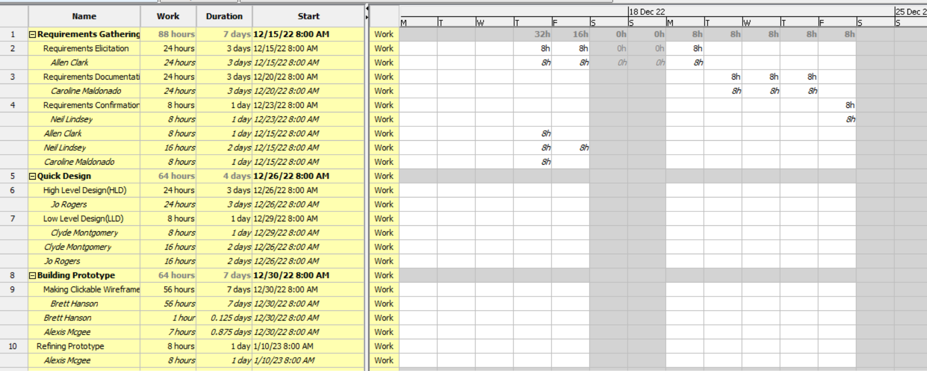

Figure : Task Usage1

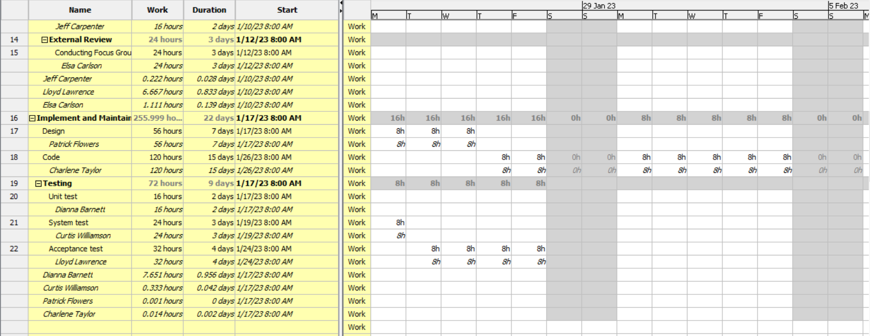

Figure :Task Usage 2

## Resources:

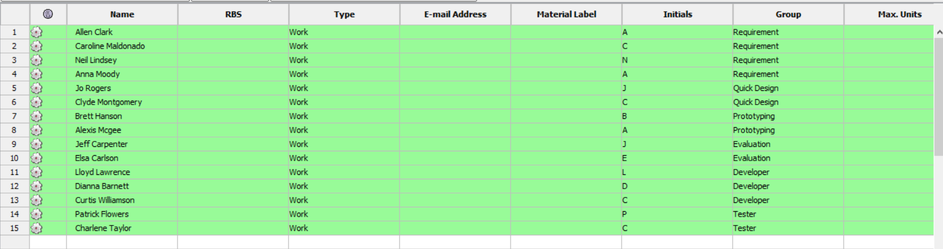

Figure : Resources 1

Figure : Resources 2

## RBS:

A resource breakdown structure is a list of the resources that will be required to execute your project. The list is broken down by function and type, and at the very least will cover the people needed to complete a project successfully.

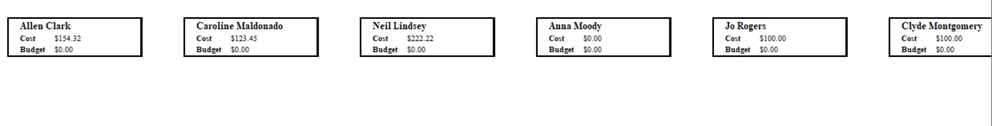

Figure : RBS 1

## 

Figure : RBS 2

## Baseline:

A project baseline is essentially **a defined starting point for your project**. In other words, a baseline is an initial plan you create with stakeholders, defining the project expectations and deliverables, including schedule, scope, and cost.

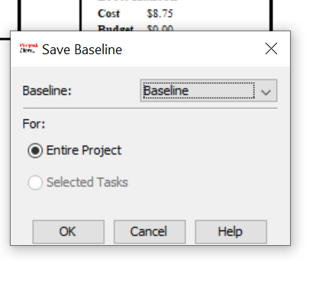

Figure : Setting Baseline Project

## Project Information:

## General

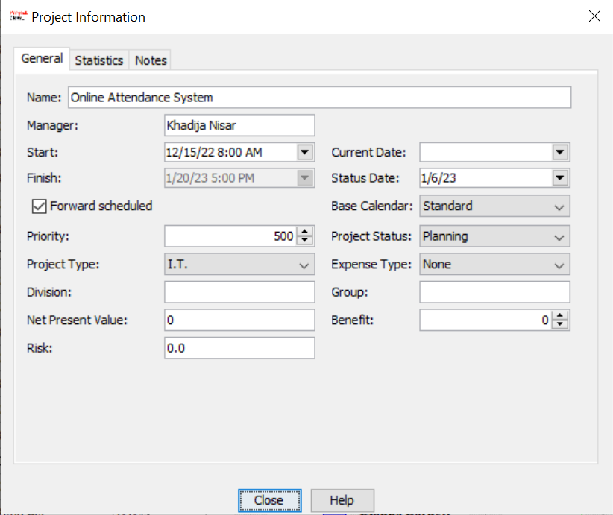

Figure : Project Information General

## Statistics

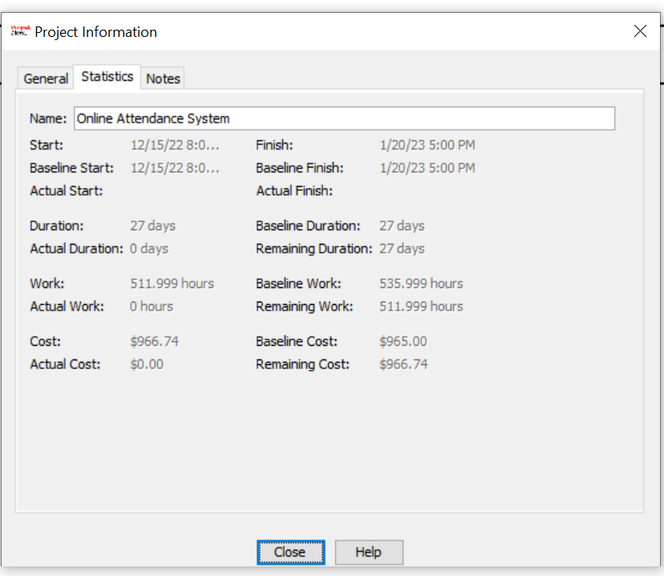

Figure : Project Information Statistics

## Project Preview:

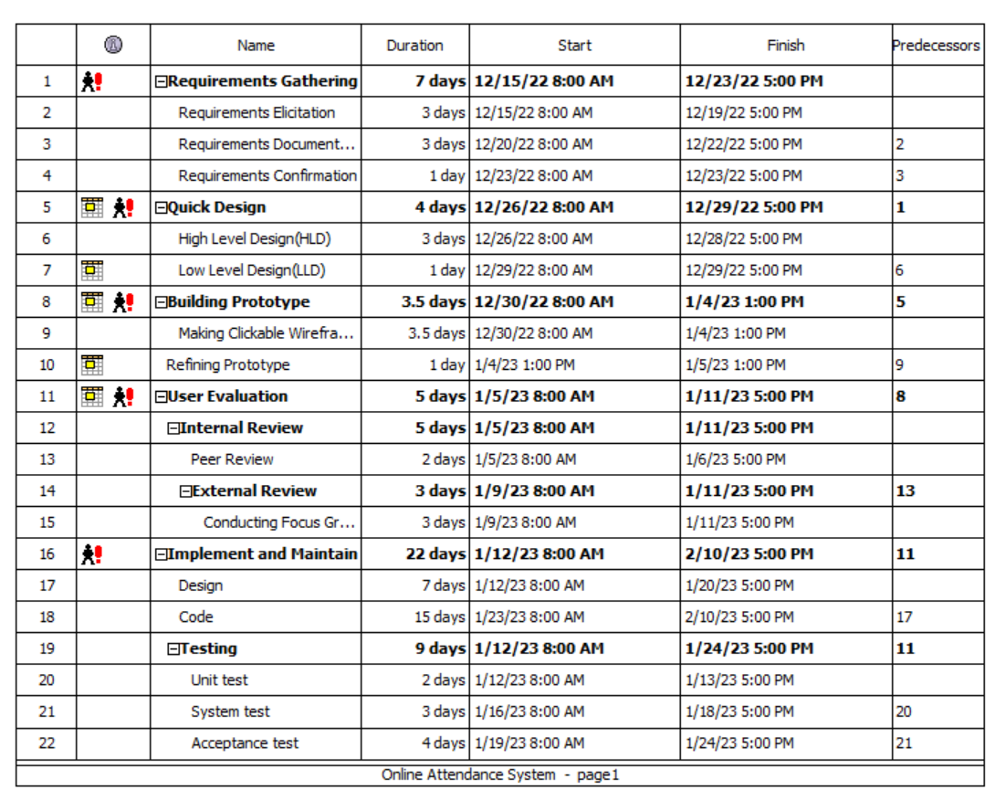

### Reports:

## Project Details Report:

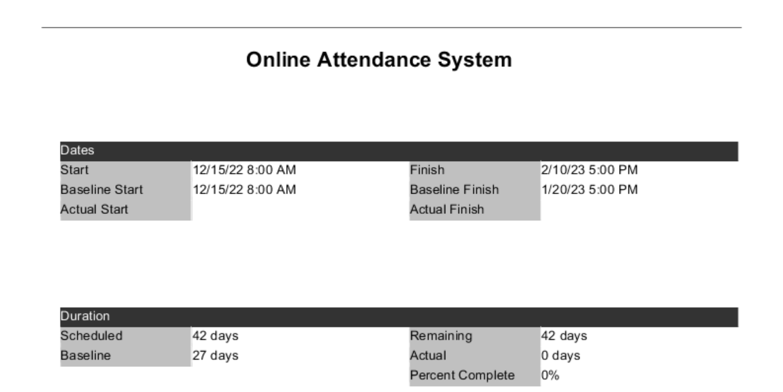

Figure : Project Detail 1

Figure : Project Detail 2

## Resource Information Report:

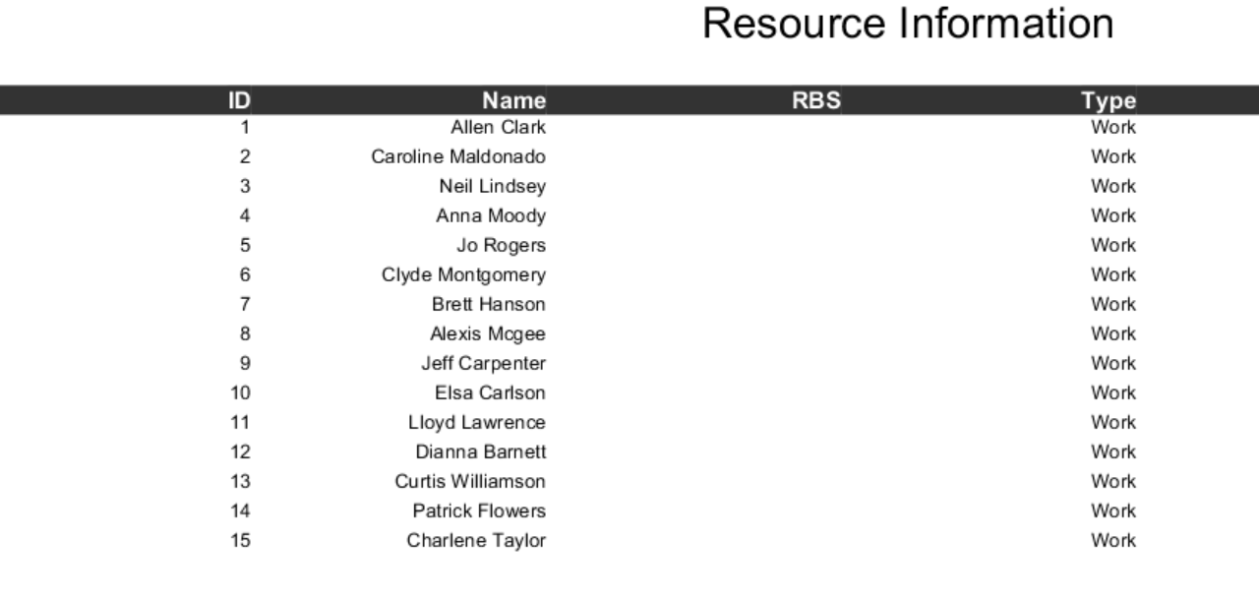

Figure : Resource Information Report

## Task Information Report:

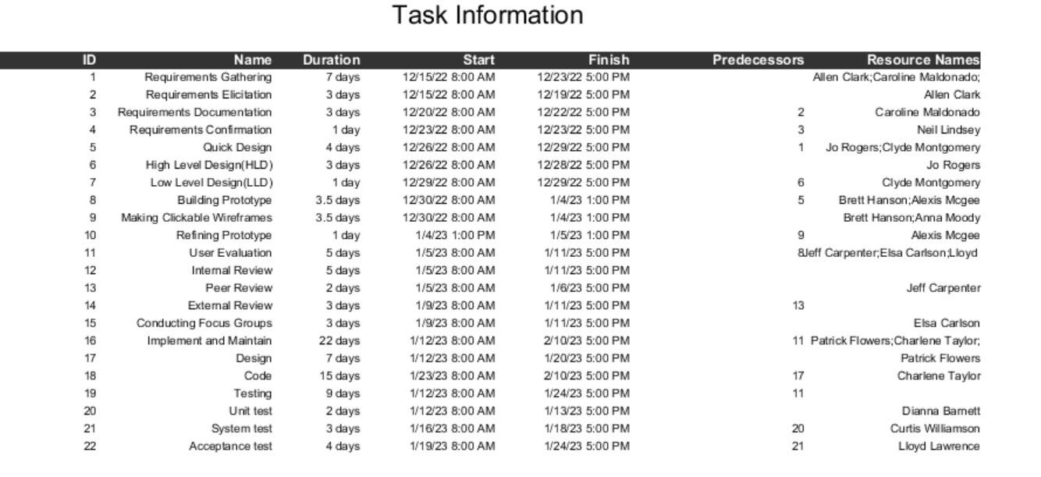

Figure : Task Information Report

## Who does what Report:

Figure : Who does what report