Assessment Title:

Project (Individual)

Course No.:

IT7405

19th of December 2024

Submission Date:

19th of December 2024

Due Date:

Stream:

01

Wakil Sarfaraz

Tutor Name:

Students Names & ids:

Course Title:

Web Development using non-relational databases

Khadija Alsatrawi

202200011

**By submitting this assessment for marking, either electronically or as hard copy, I confirm the following:**

* This assignment is **my own work.**
* Any information used has been properly referenced.
* I understand that a copy of my work may be used for moderation.
* I have kept a copy of this assignment.

Table of Contents

Task 1: Problem Statement Formulation and Definition 3

Motivation 3

Problem Statement / Project Definition 3

Functionalities 3

Task 2: Creating the No-SQL MongoDB Database and Data Modeling 4

Creation of a No-SQL MongoDB 4

CRUD operations Create 4

Create 4

Read 5

Update 6

Delete 7

Usage of MongoDB Index 8

Query Diagnosis and Analysis 9

Task 3: Using Django to build the Web Application using Bootstrap 11

Creation of a Virtual Environment for Django 11

Project settings 15

Connectivity of Django with MongoDB 16

Models 17

Views 18

userauth views: 20

Templates 20

Django Admin site 21

Django forms 21

Incorporation of Bootstrap 21

Task 4: Overall GUI and working, Report, GIT hub, Video and Reflection 23

Overall Navigational GUI 23

GIT hub 27

Reflection 27

# Task 1: Problem Statement Formulation and Definition

## Motivation

During my school years, I frequently had after-school classes to better understand my subjects. Mostly the instructions that offer after-school classes for students rely on social media to advertise their courses and register the students either through social media chats, calls, or physical attendance. This inspired me to create a website where students can view the courses and register themselves online through the same website.

## Problem Statement / Project Definition

The availability of education has increased in the current digital era. Nonetheless, educational institutions rely on social media to advertise their courses and register the students either through social media chats, calls, or physical attendance. Through the creation of a user-friendly, and effective online platform, this project seeks to better the way educational institutions handle student enrollment and course advertisement.

## Functionalities

1. Students can log in and sign up.
2. The students can register for courses when they are open to registration.
3. The students can withdraw from the class at any time.
4. The students can view all the courses in the courses list, and they can view all the courses in a category.
5. The students can view their registered courses.
6. The students cannot register under a course if they are not logged in

# Task 2: Creating the No-SQL MongoDB Database and Data Modeling

## Creation of a No-SQL MongoDB

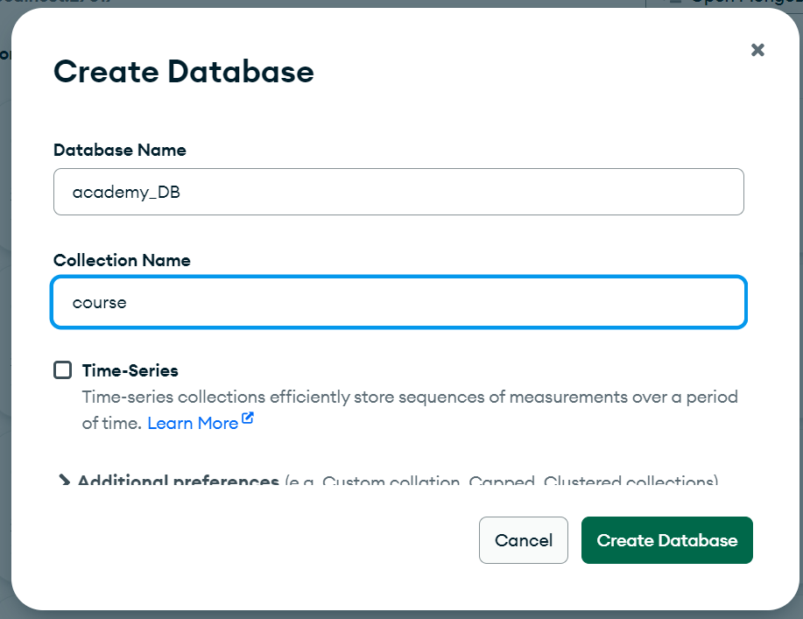

## CRUD operations Create

### Create

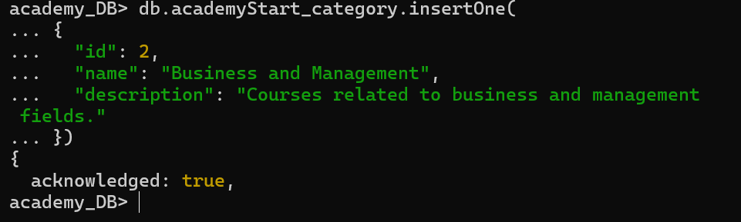

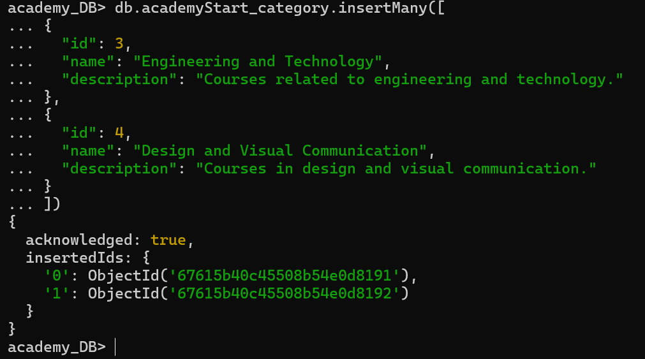

### Read

* 1. 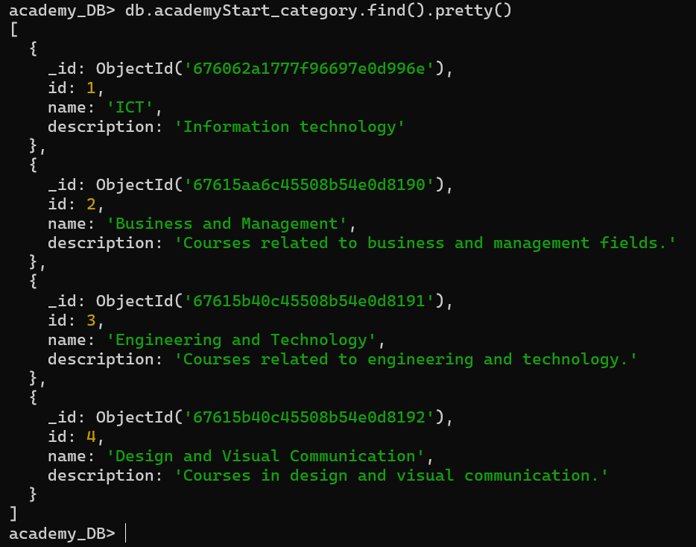
  2. 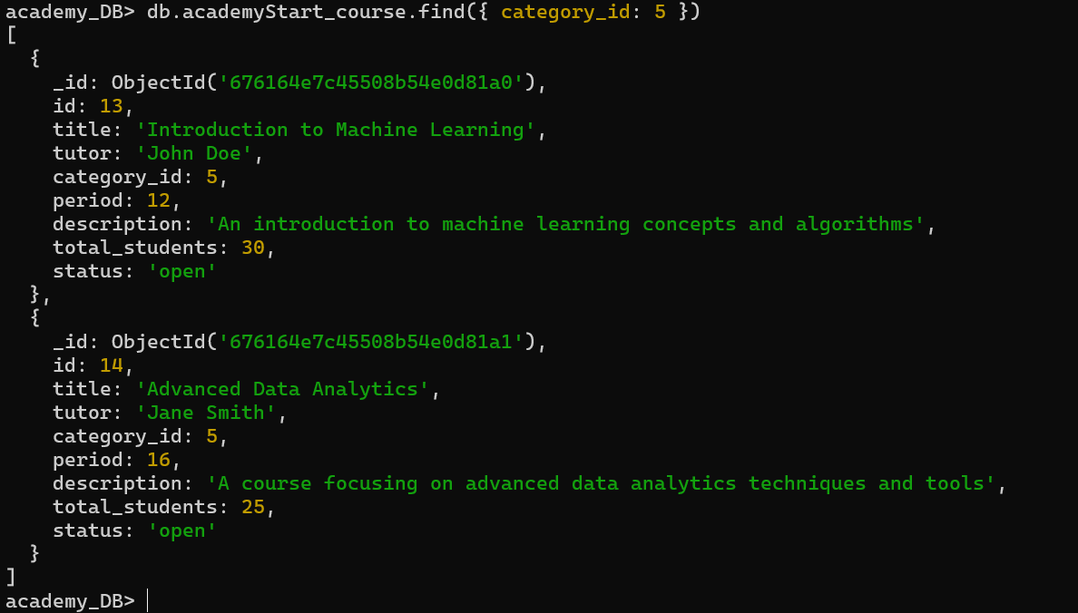

### Update

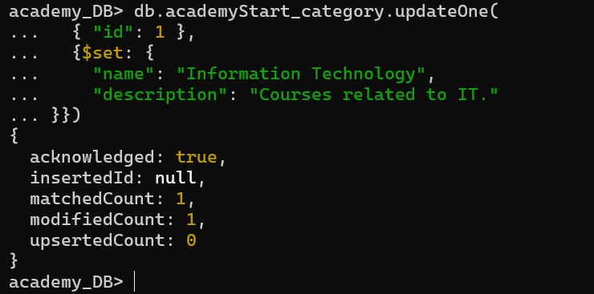

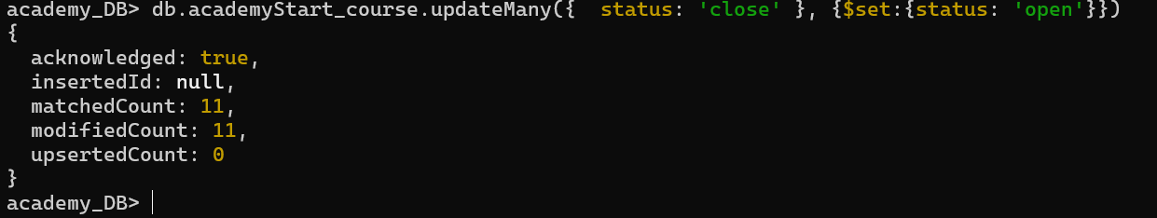

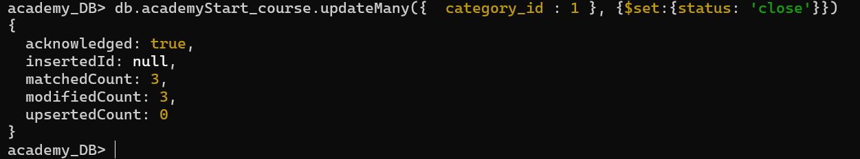

### Delete

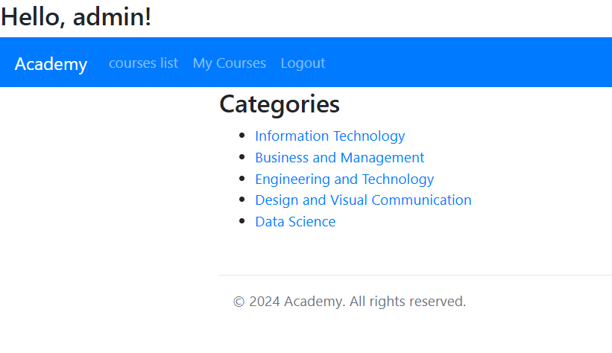

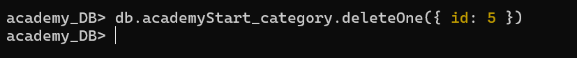

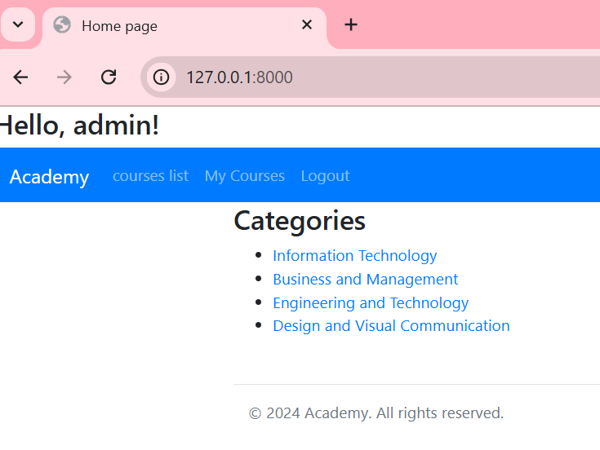

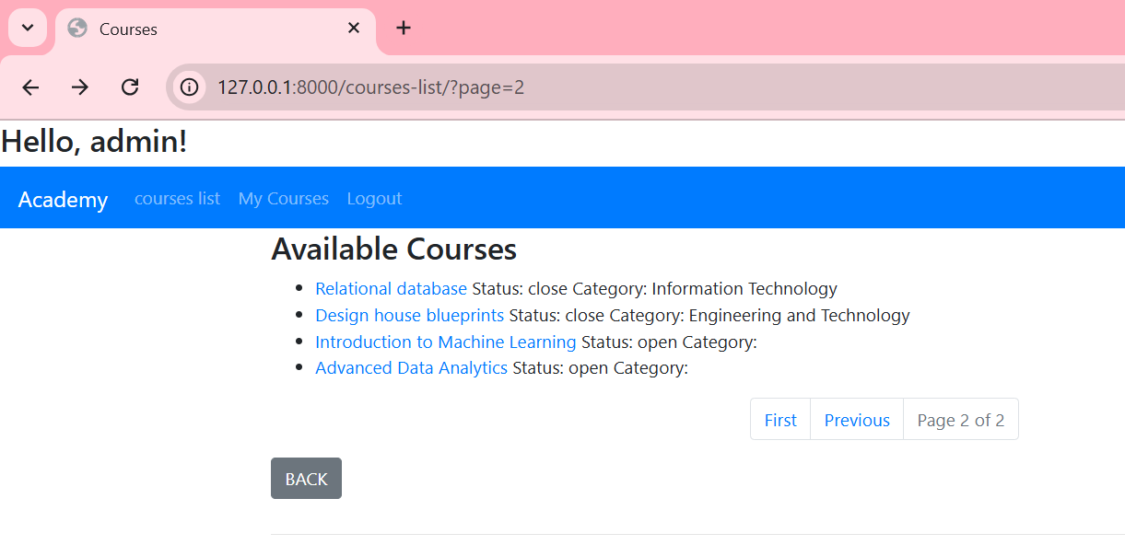



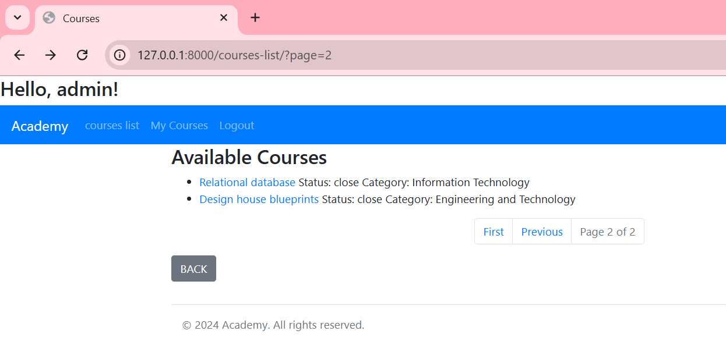

## Usage of MongoDB Index

* 1. 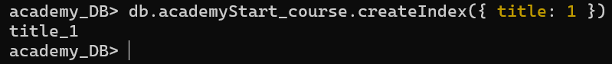
  2. 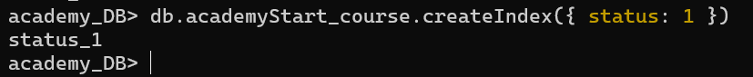

## Query Diagnosis and Analysis

* 1. 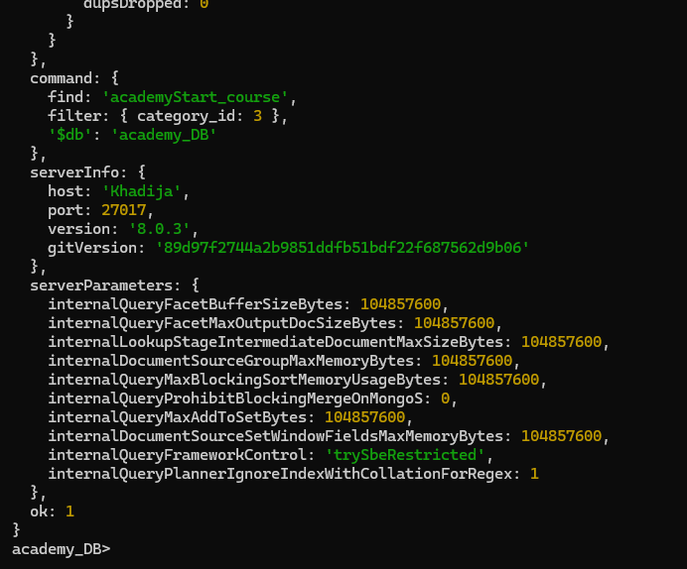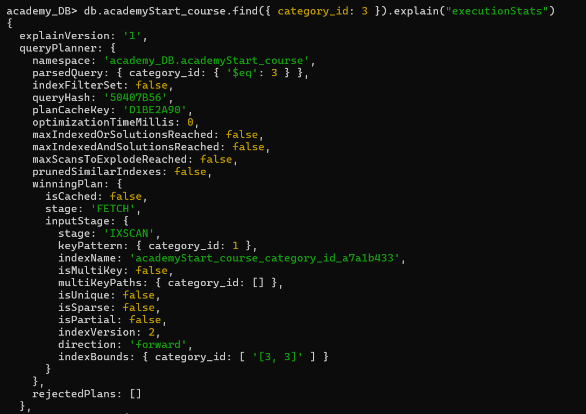
  2. 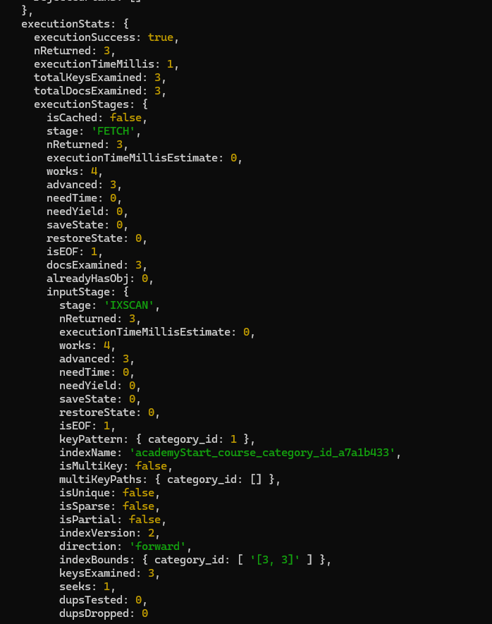

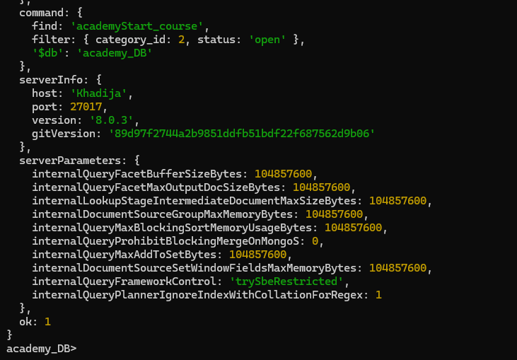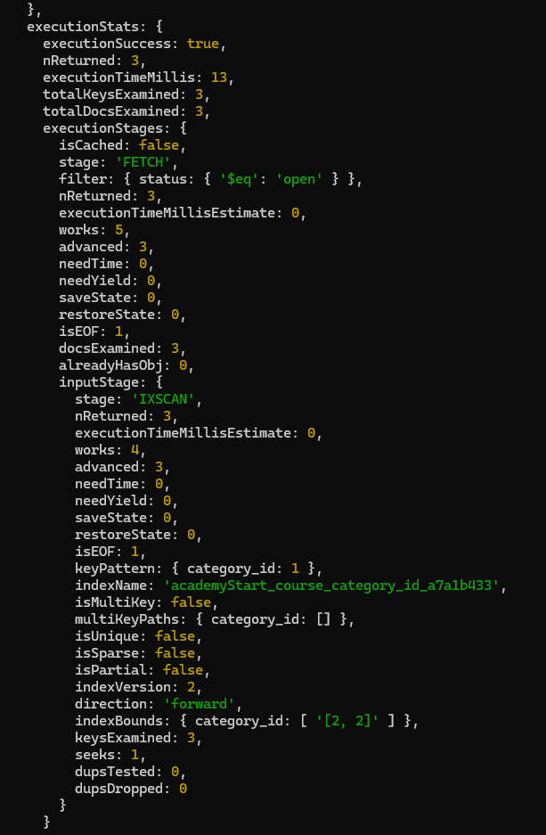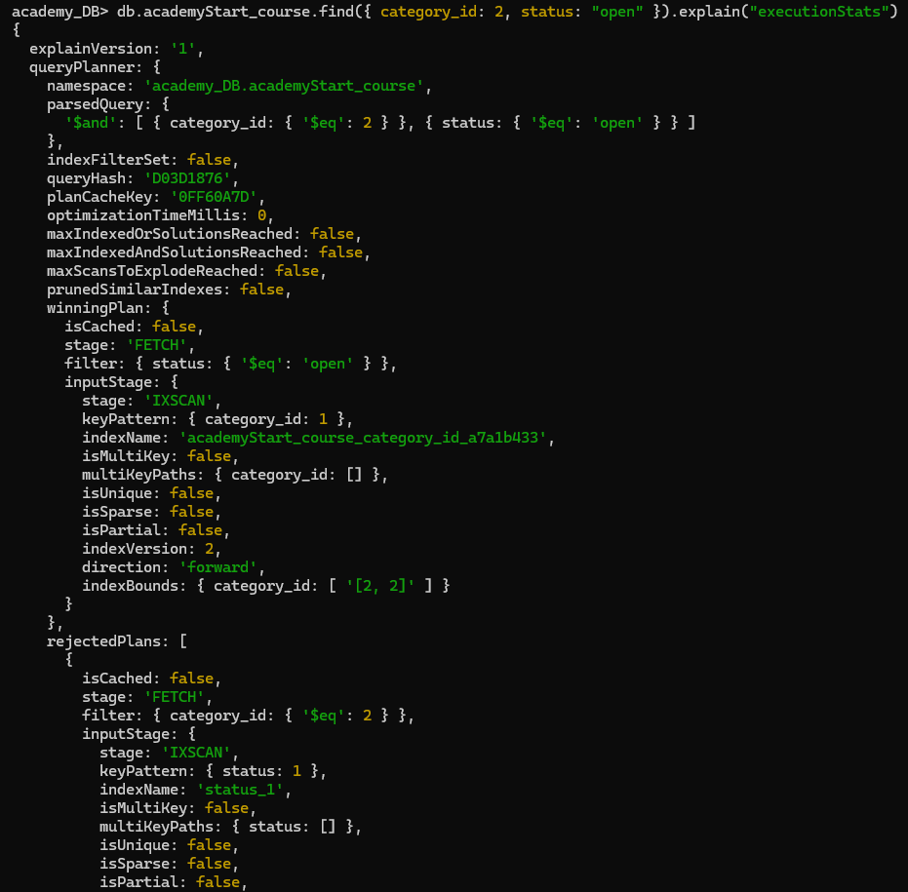

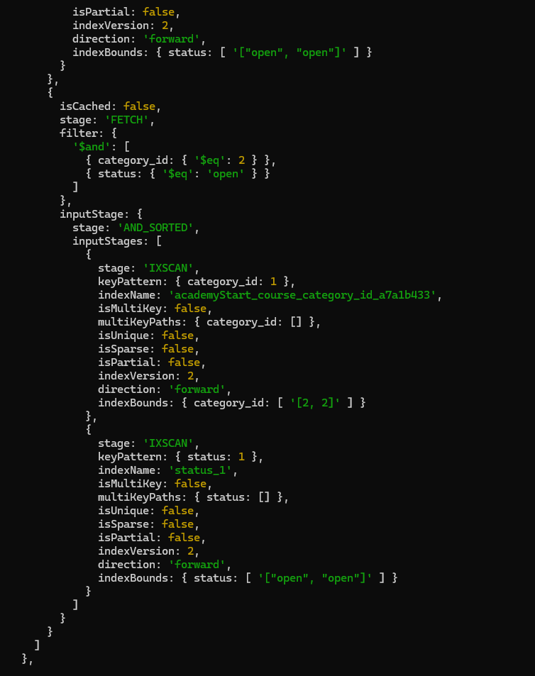

# Task 3: Using Django to build the Web Application using Bootstrap

## Creation of a Virtual Environment for Django

cd "C:\Users\Khadija_y\OneDrive\Desktop\project_NRD"

* 1. 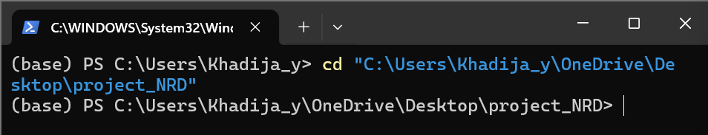

conda create --name NRDprojectEnv Django

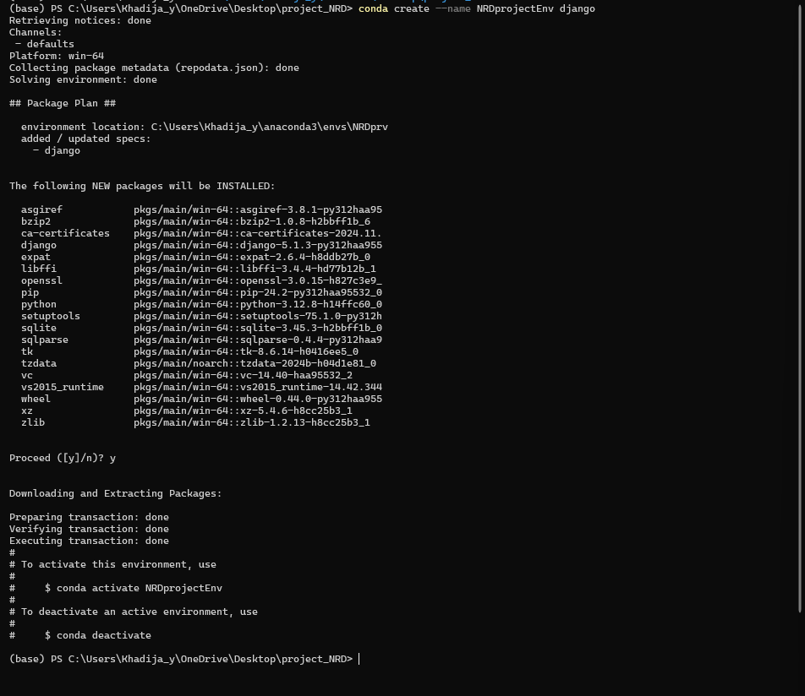

conda activate NRDprojectEnv



pip install Django

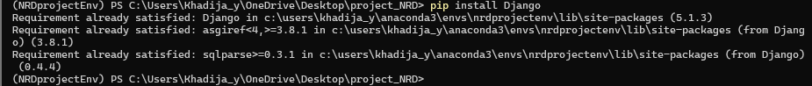

django-admin startproject academy



cd .\academy\



python manage.py startapp academyStart

python manage.py startapp userauth



python manage.py runserver

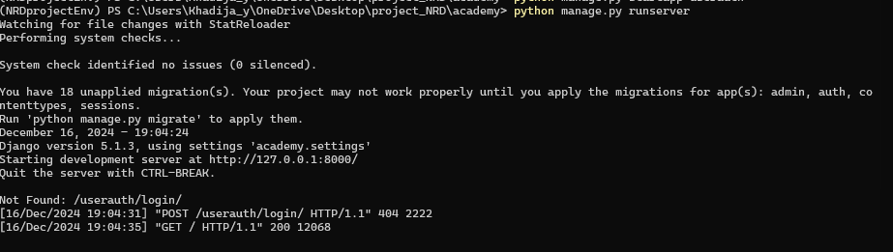

<http://127.0.0.1:8000>

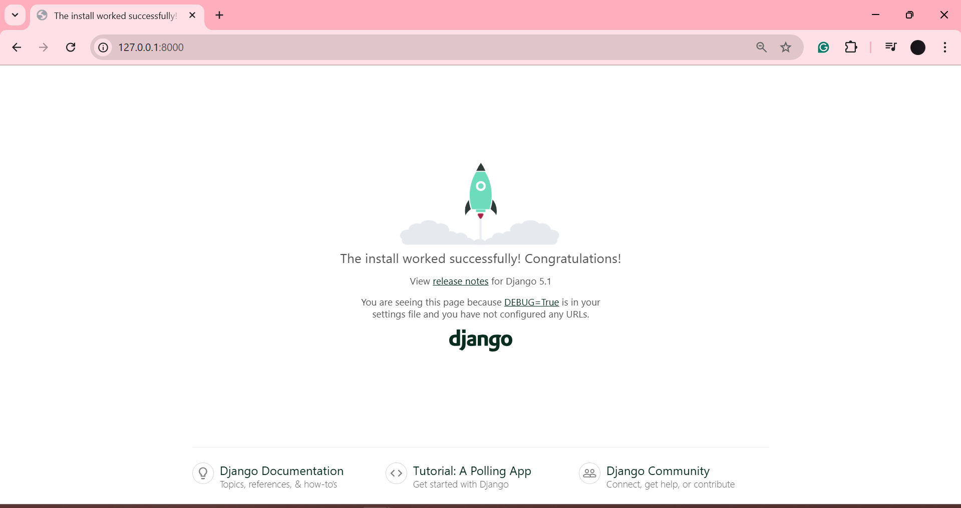

python manage.py makemigrations

python manage.py migrate

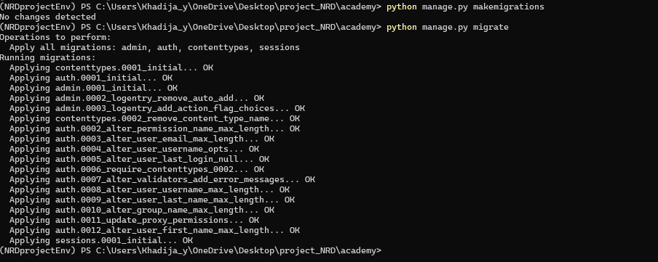

pip install djongo

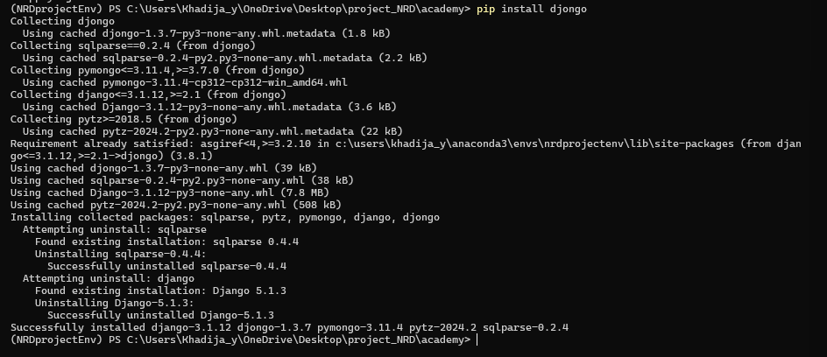

python manage.py makemigrations

python manage.py migrate

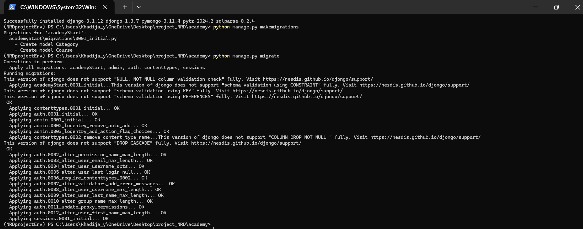

python manage.py createsuperuser

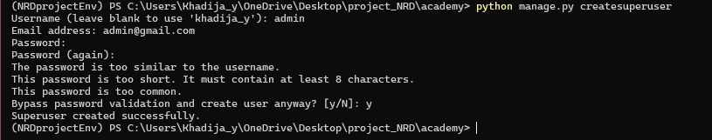

Email: admin@gmail.com

Password: admin

<http://127.0.0.1:8000/admin/>

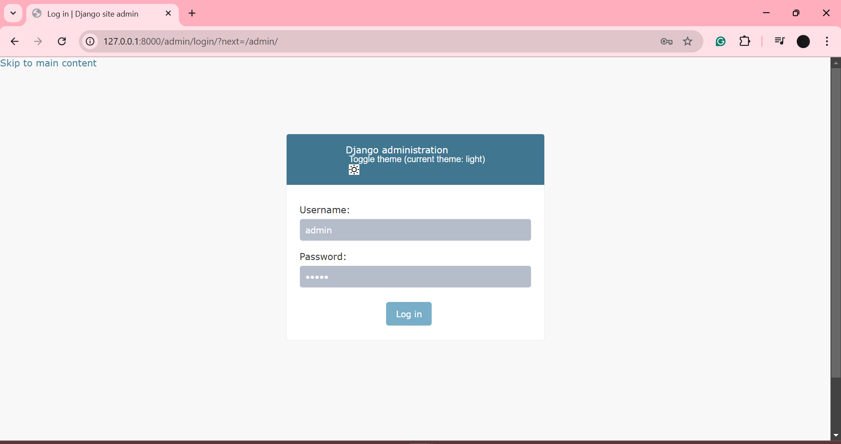

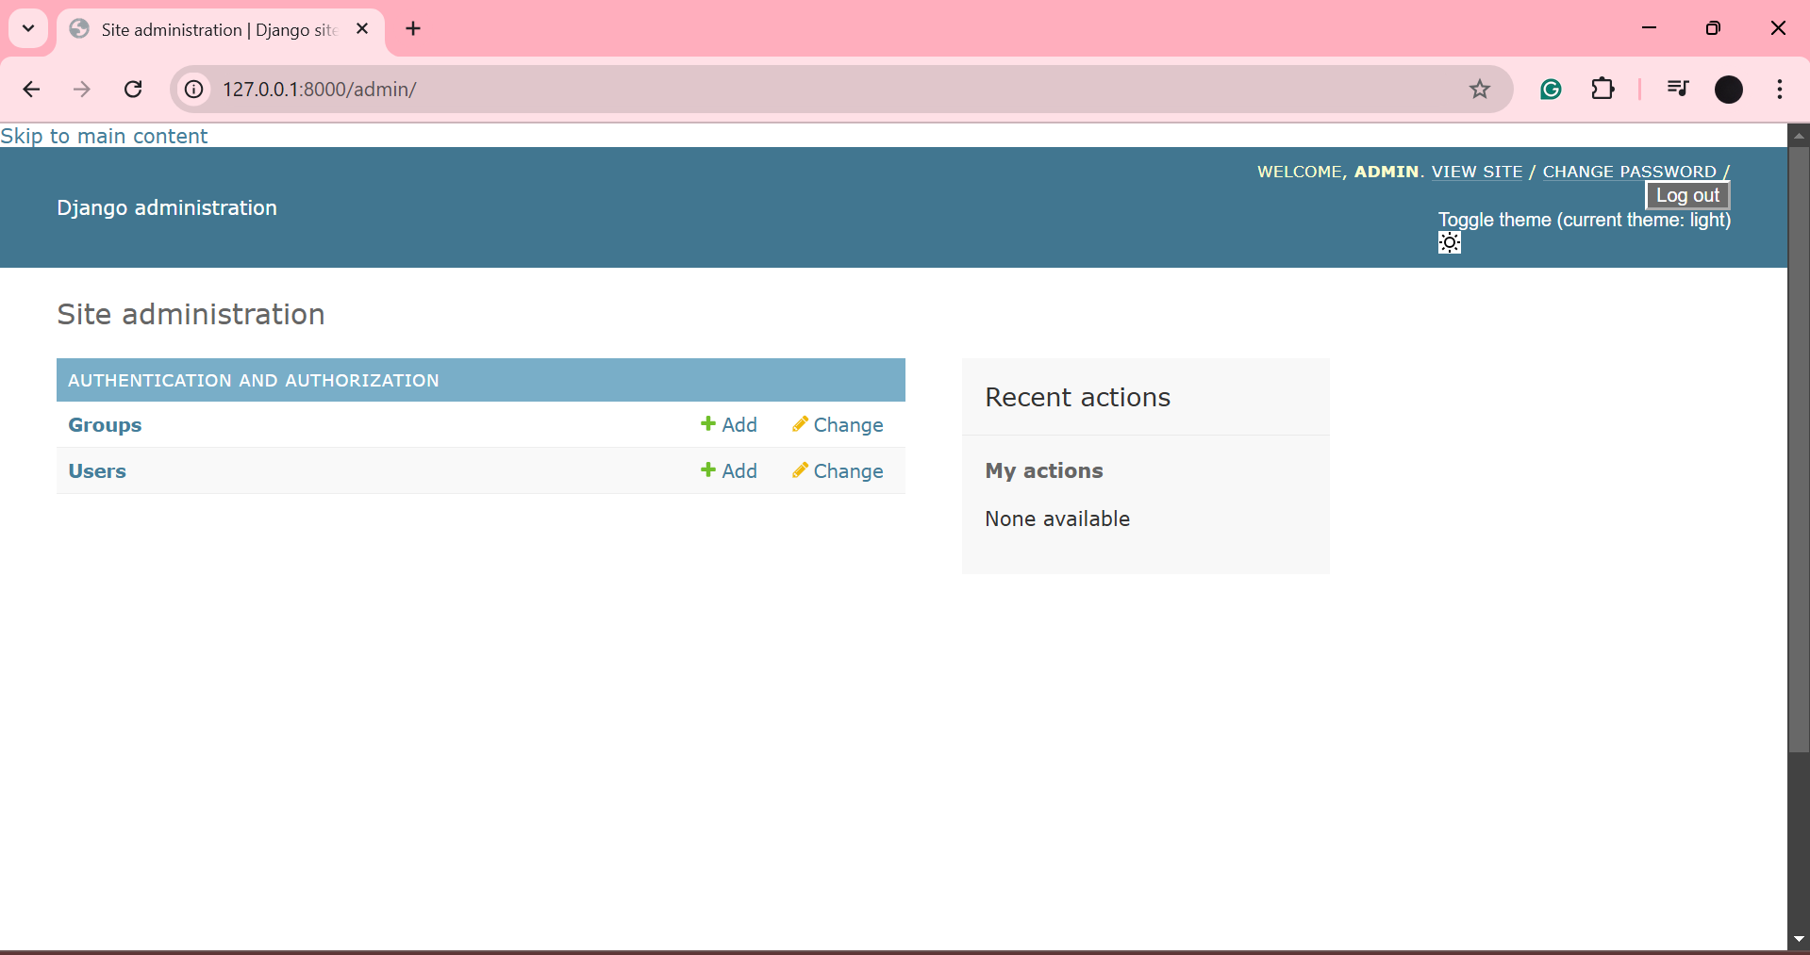

## Project settings

* 1. 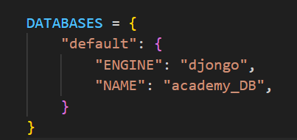
  2. 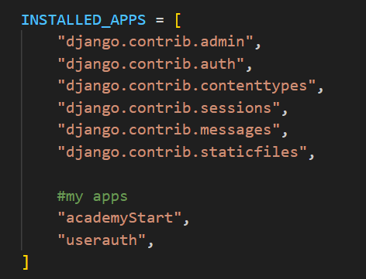
  3. 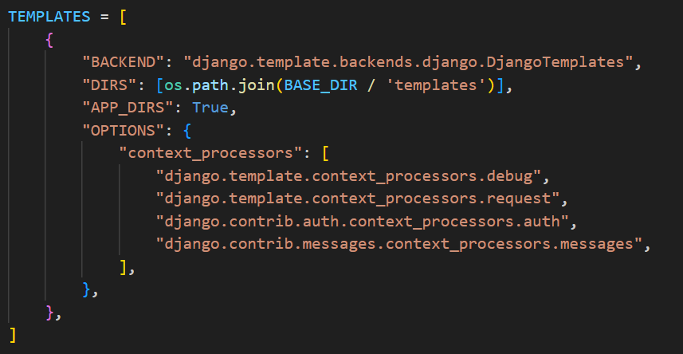
  4. 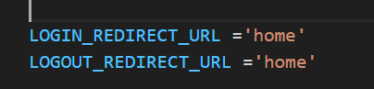

## Connectivity of Django with MongoDB

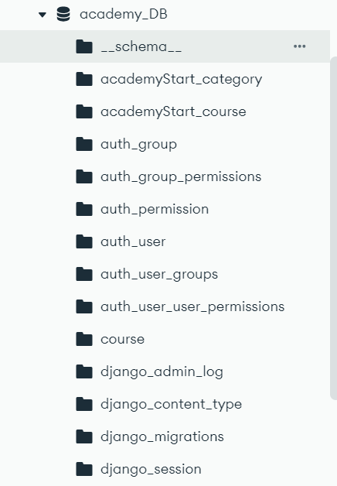



## Models

* 1. 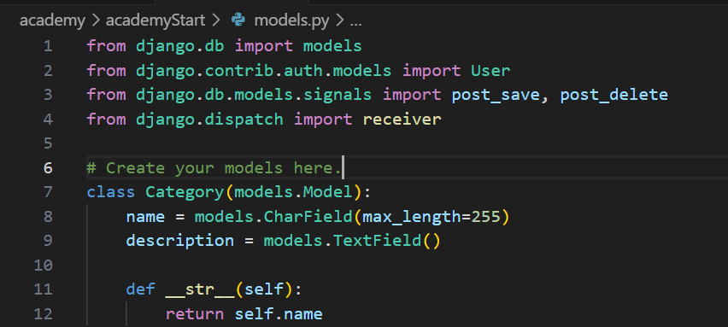

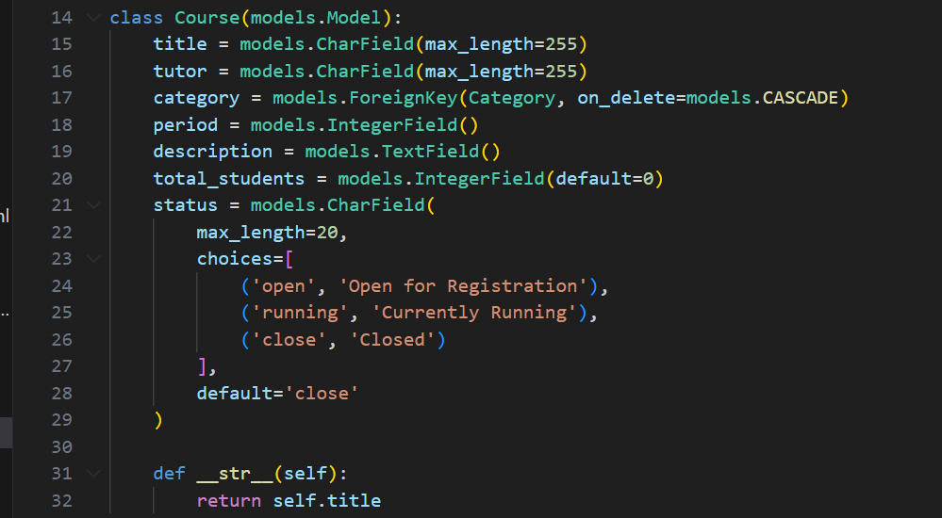

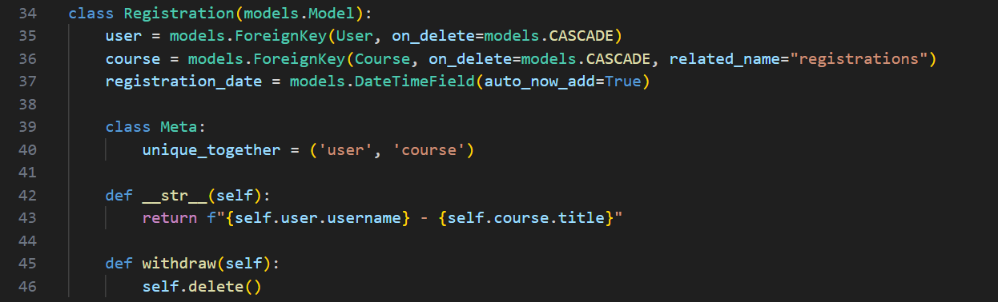

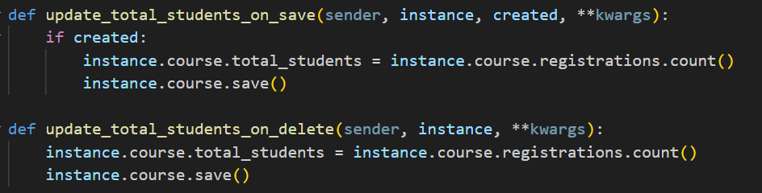

## Views

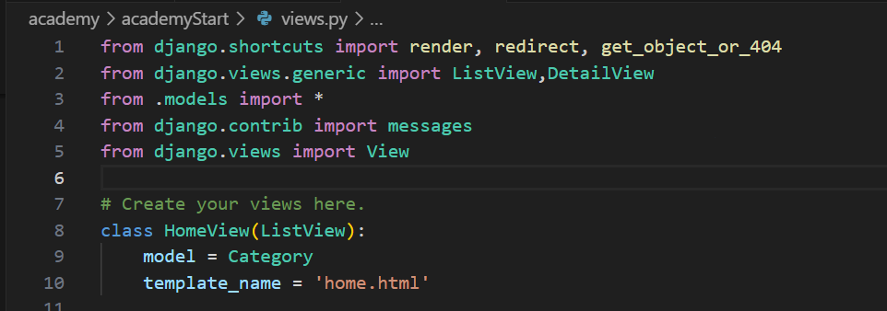

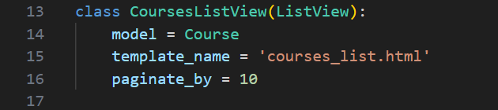

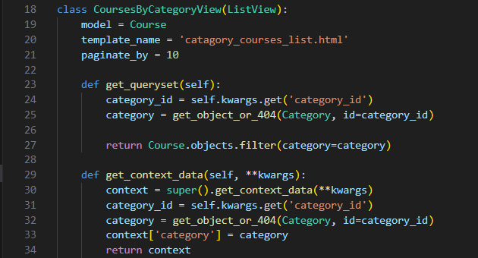

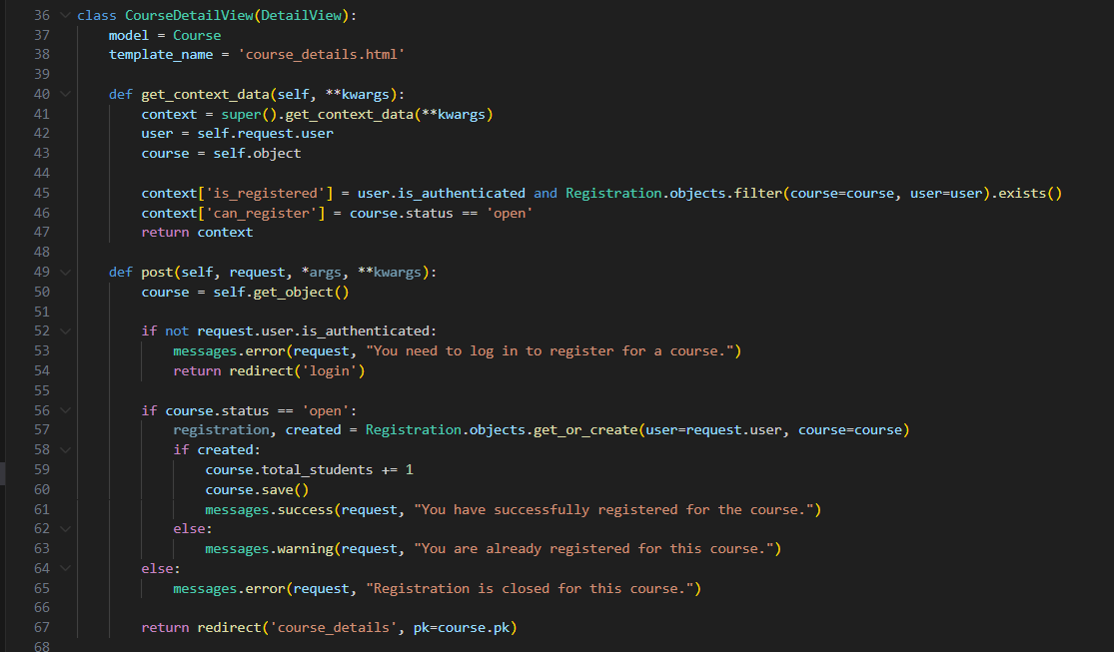

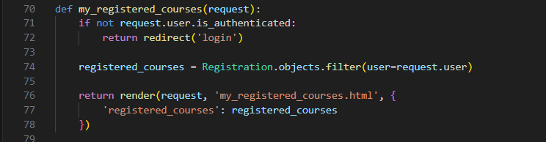

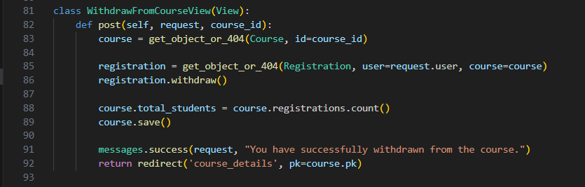

### userauth views:

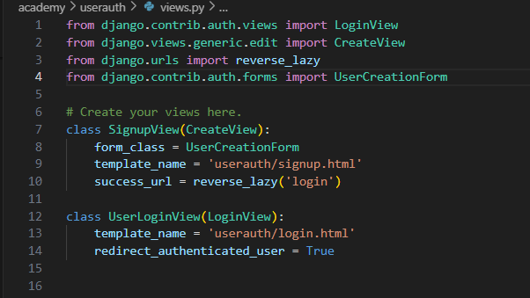

## Templates

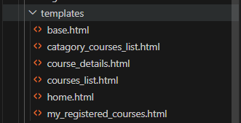

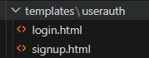

## Django Admin site

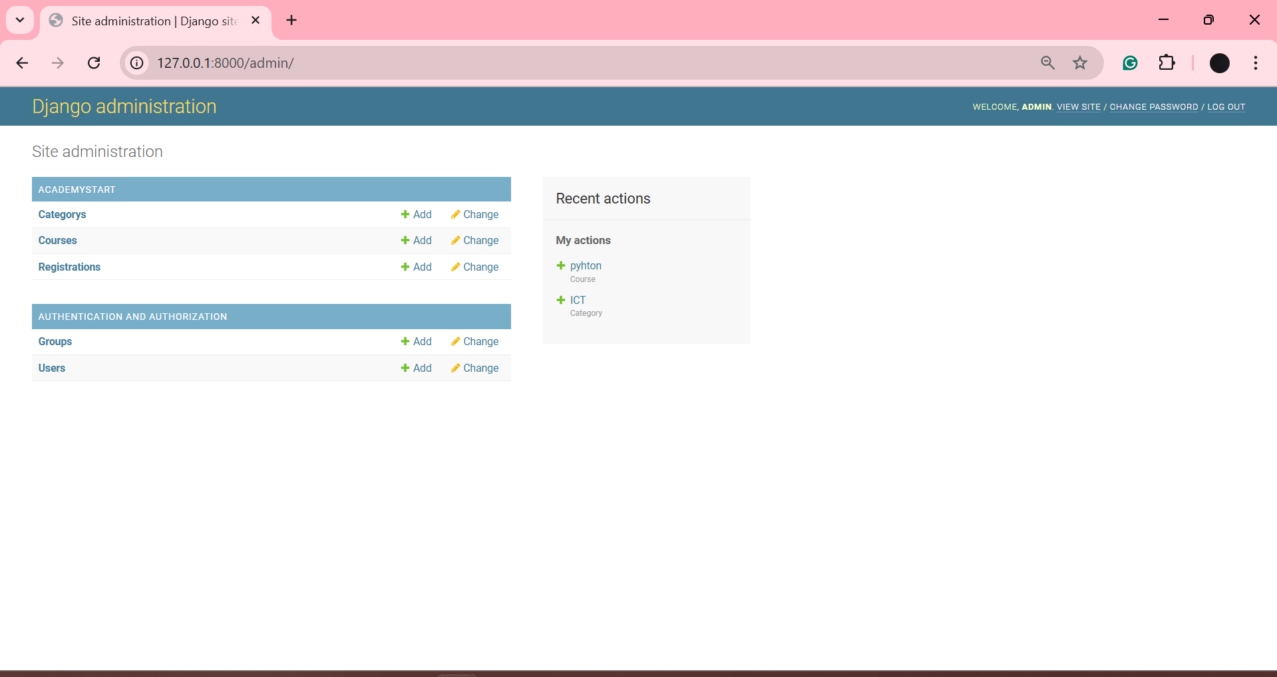

## Django forms



## Incorporation of Bootstrap

Base.html:

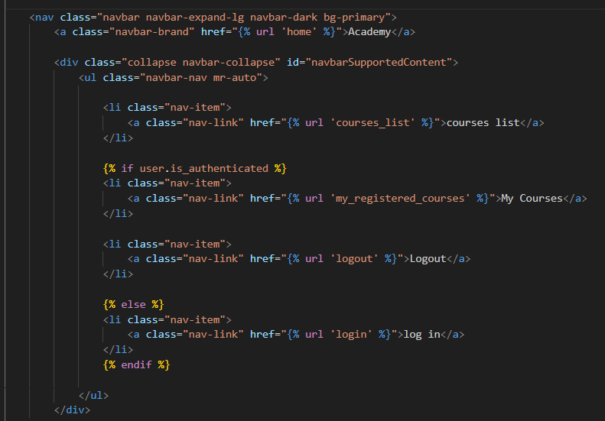

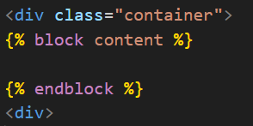

Buttons:







Courses list & Courses by category:

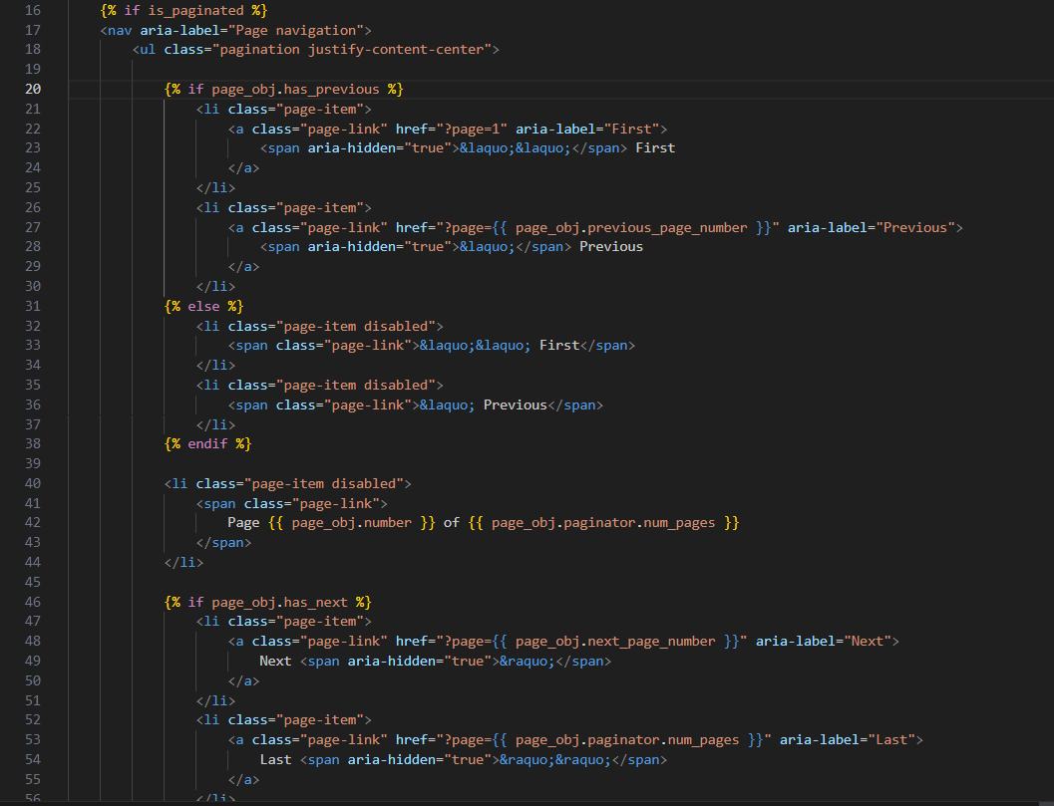

# Task 4: Overall GUI and working, Report, GIT hub, Video and Reflection

## Overall Navigational GUI

* 1. home page:

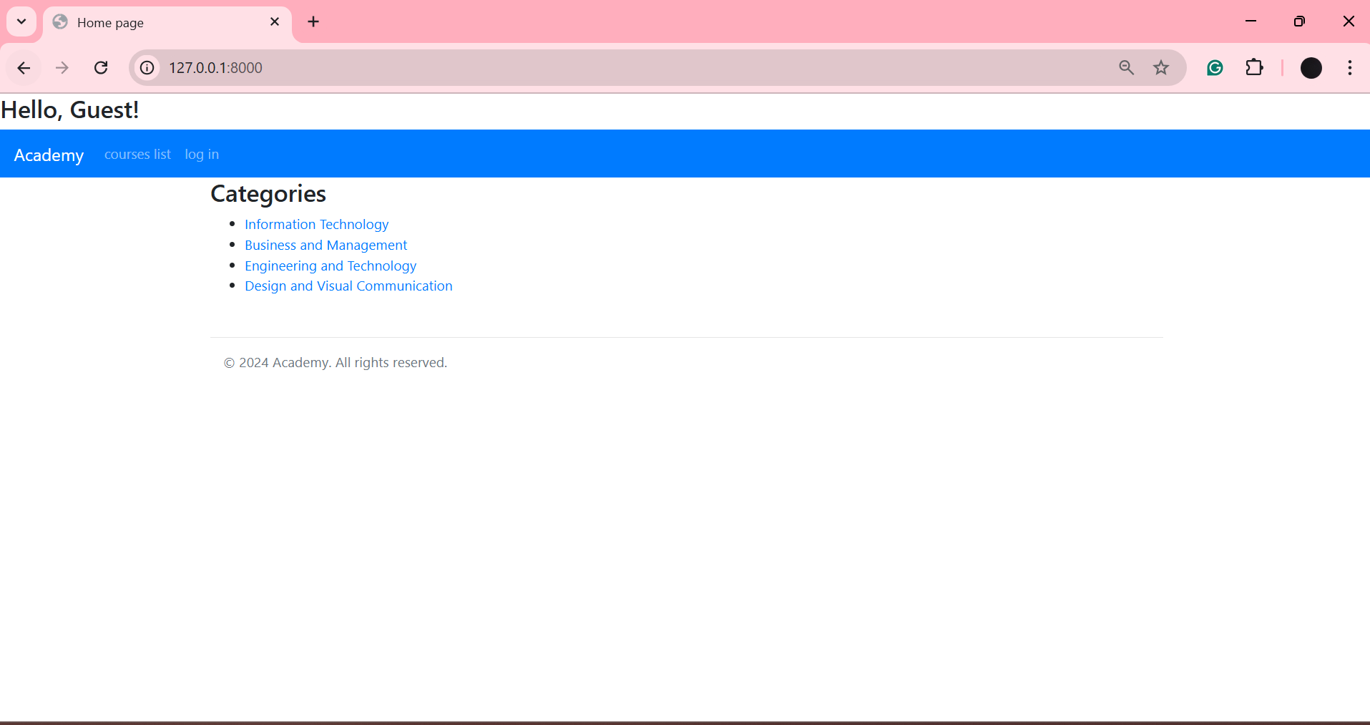

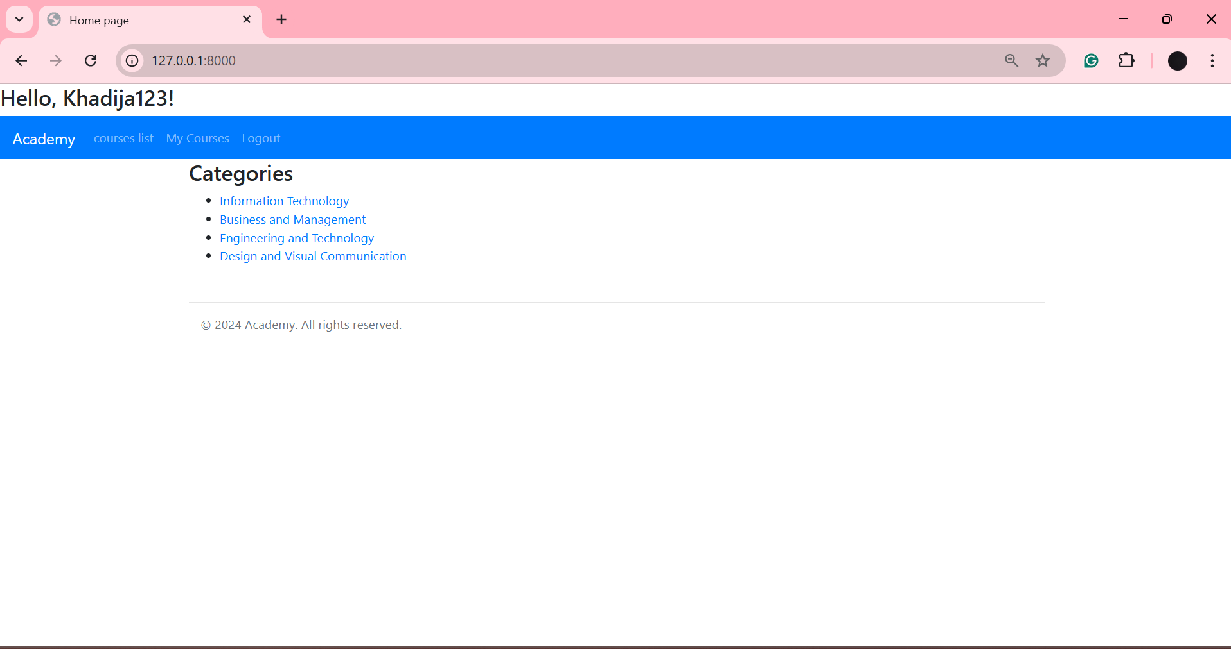

Log in:

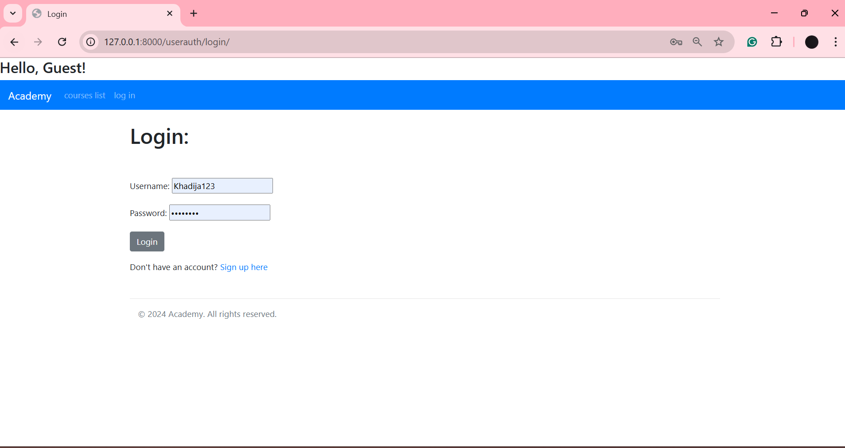

Sign up:

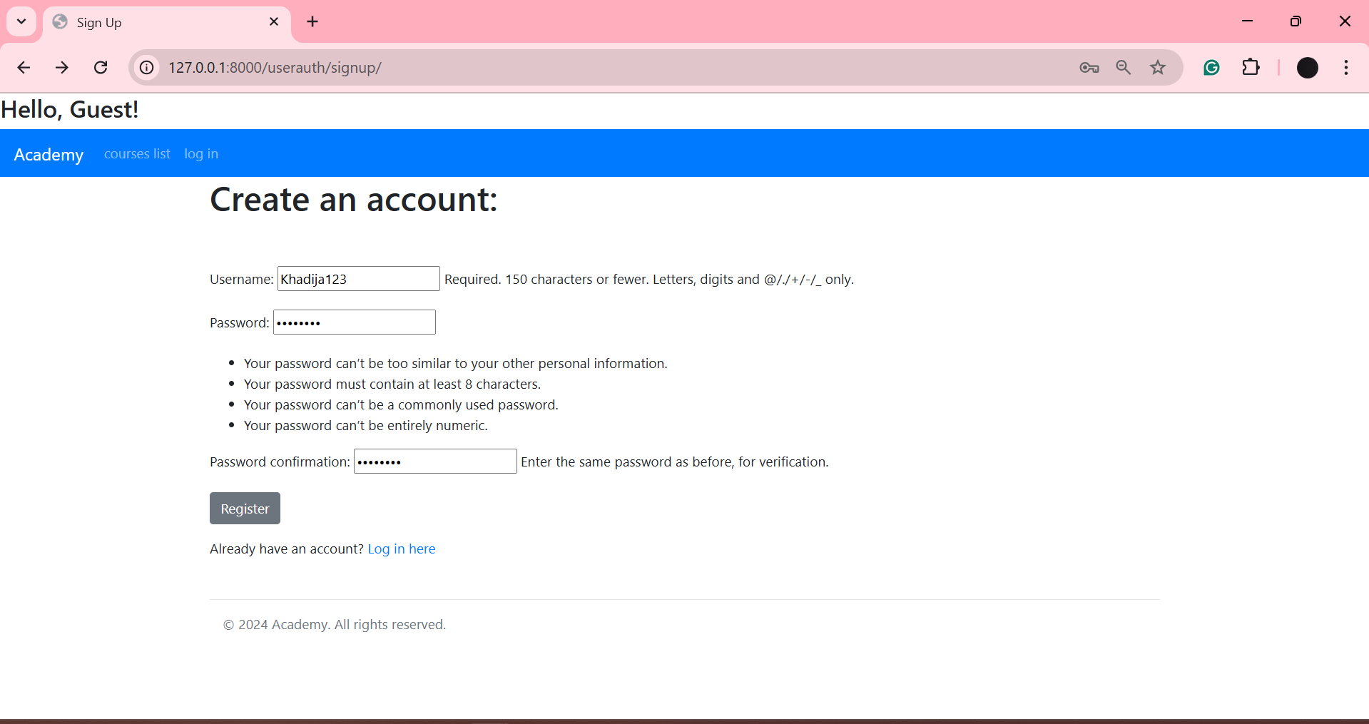

Courses by category:

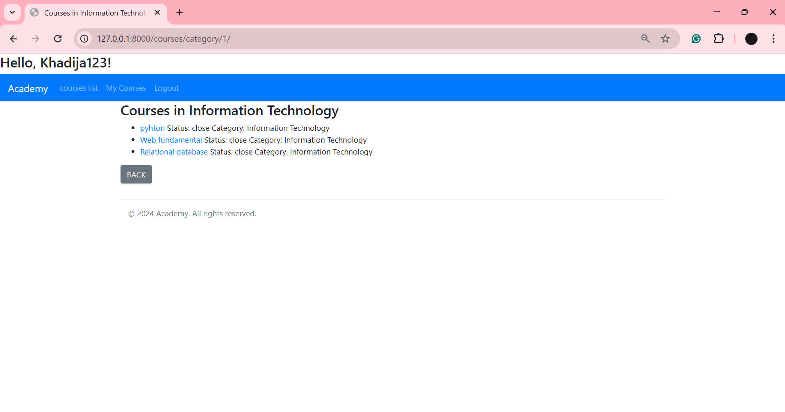

Courses list:

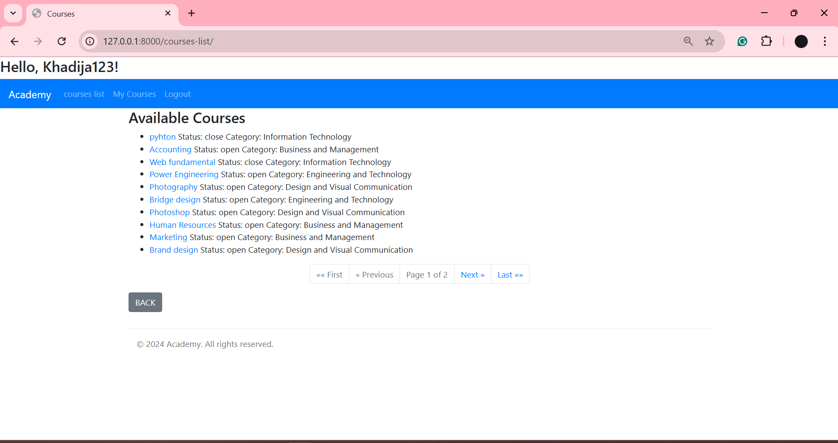

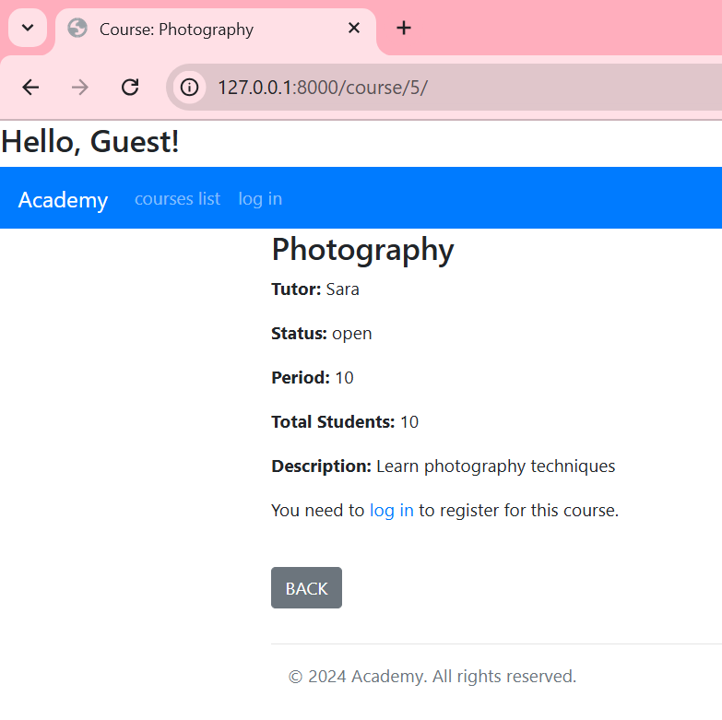Course details:

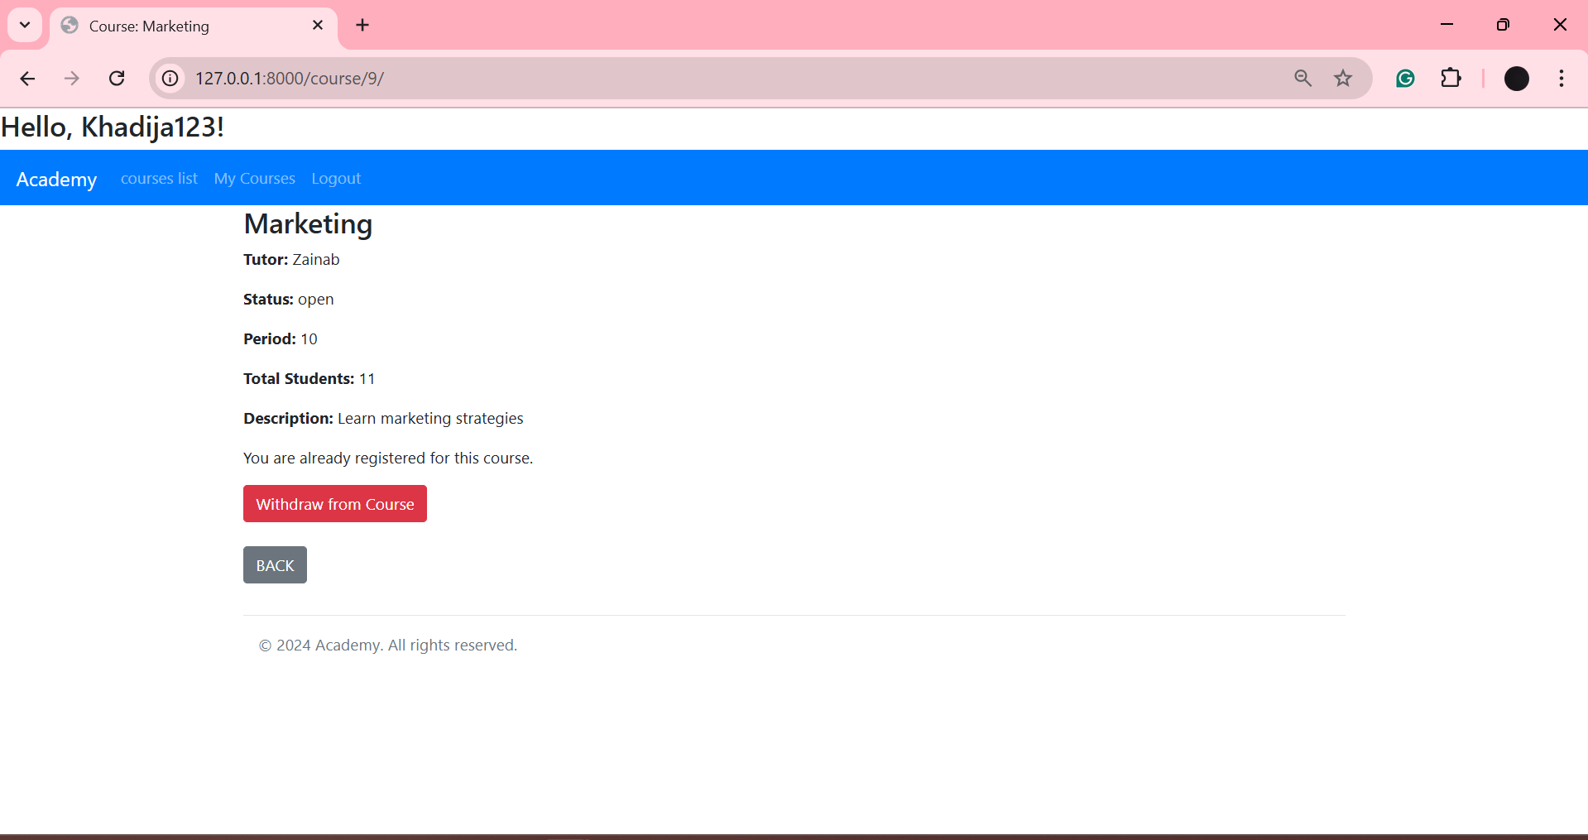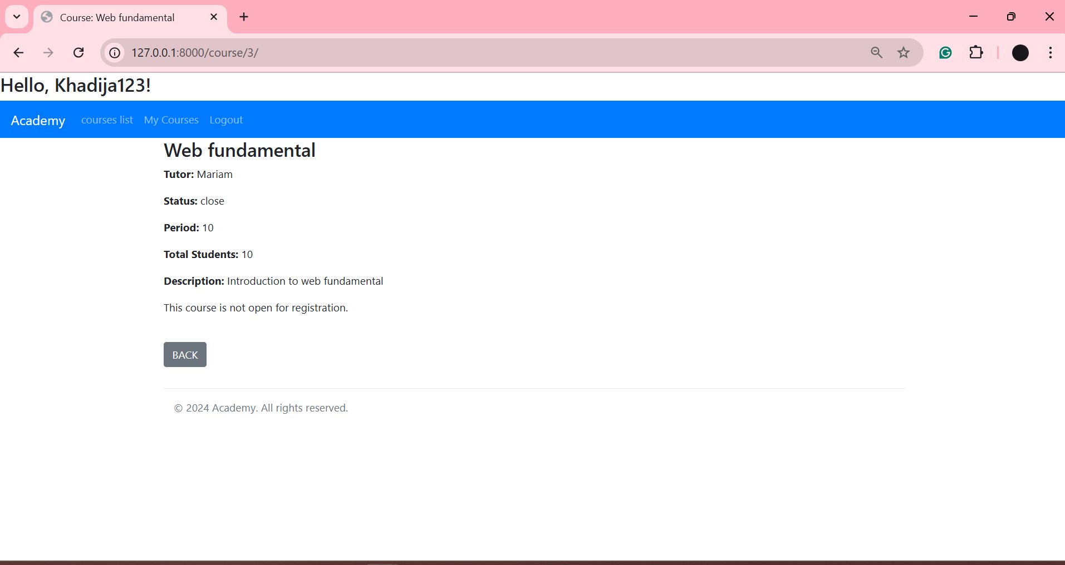

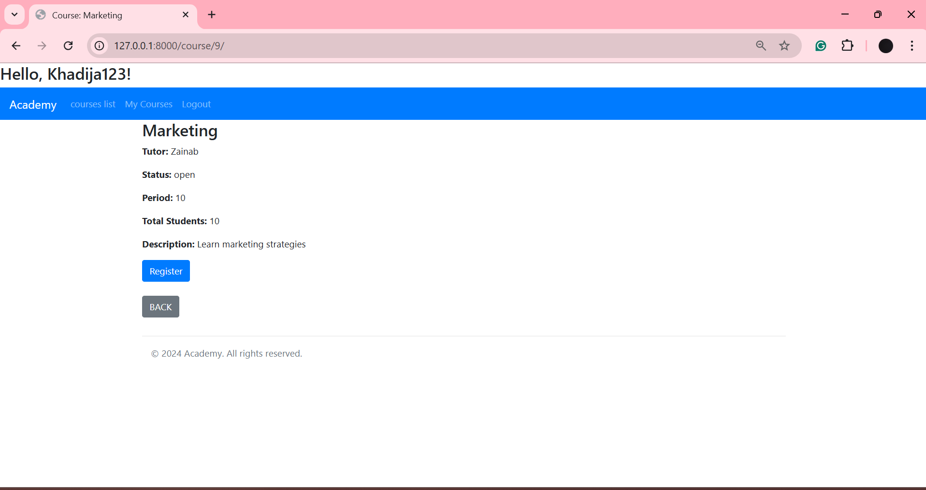

My courses:

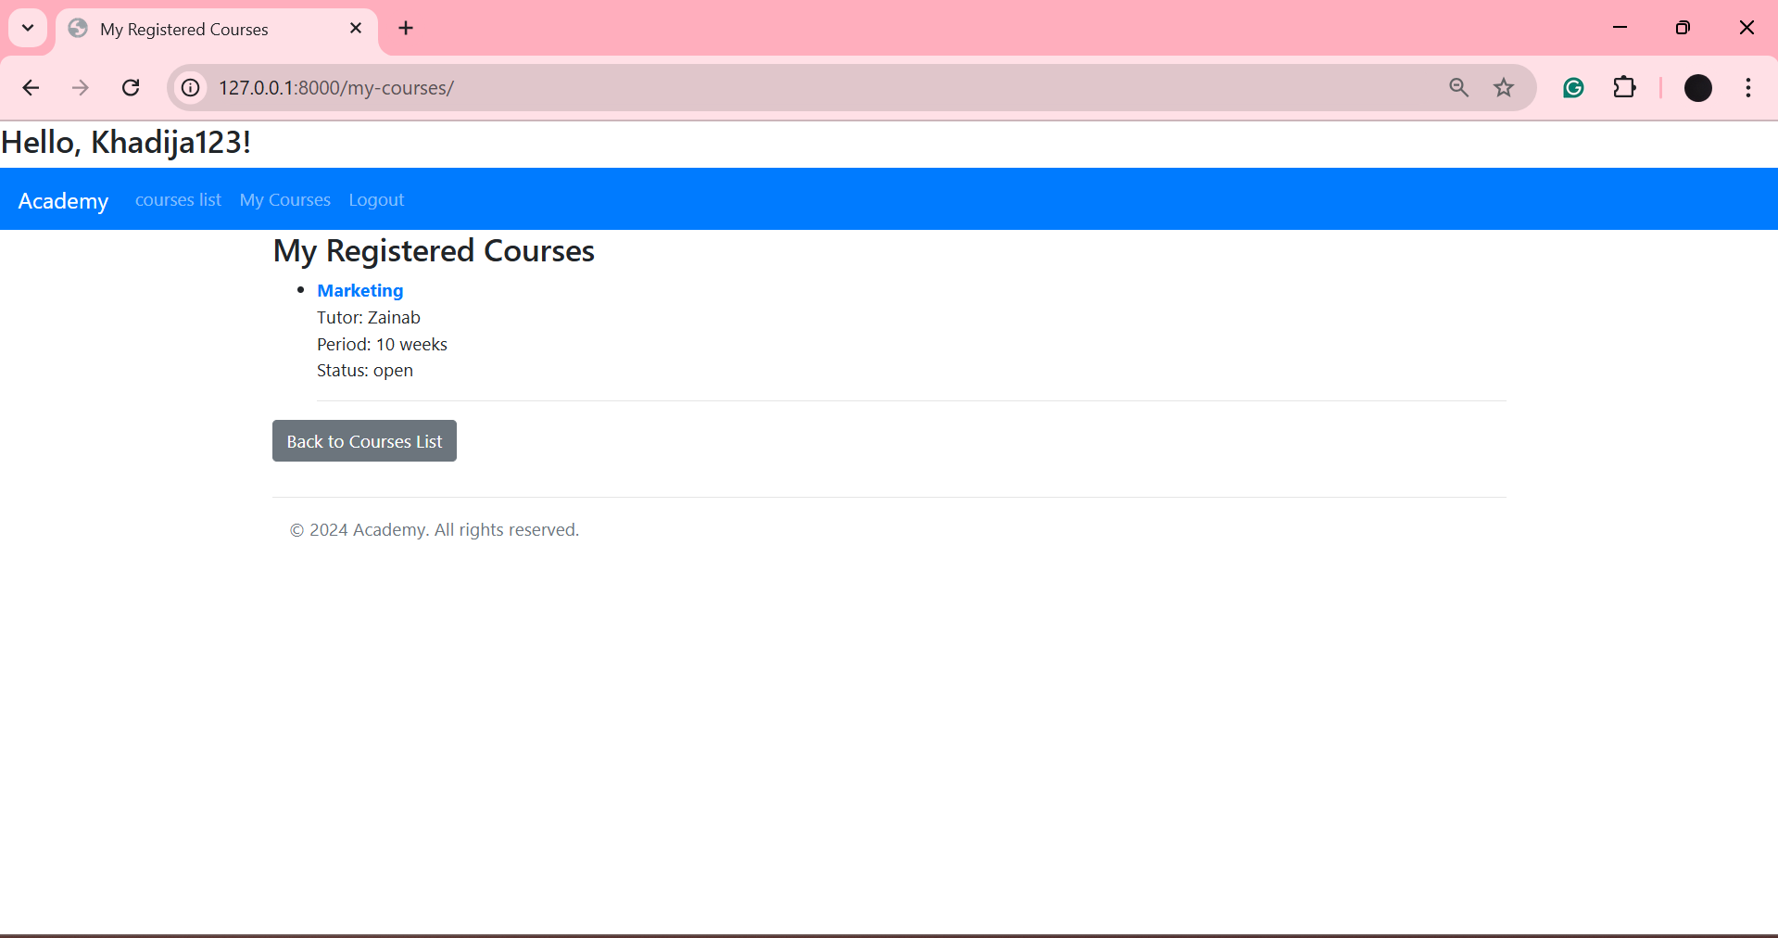

## GIT hub

<https://github.com/KhadijaYaser/NRD_project/tree/main>

## Reflection

Building a website using Python, Django, and MongoDB was a really challenging process, for this is my first time using a solution stick, and Django is a hard one to navigate, especially keeping in mind that Django is engineered to work with relational databases and not non-relational ones, yet after following the labs, the project went a bit smoother than expected. Despite all of the challenges, I was able to create a functional website where educational institutes can display their courses and have an automatic registration process.  
  
In this project, I hoped to do more, like having a completely customized user model, but that in itself came with many more challenges that I was not able to overcome because of the time factor and the lack of materials related to Django working with MongoDB. All of that had me subtitling for the automatic Django user model. Despite that, working with the auto-Django user model achieved most of what I was planning.  
  
As much as it was a hard job to navigate my way around Django, it was really satisfying to see the project fully complete and functional. To see most of my vision come to reality through my own creation is a great feeling.