# NIDA KHAN

# SP23-BSE-011

# BSE-5A

## USECASE 1:

## REGISTER BOOK:

## Fully Addressed Usecase:

|  |  |
| --- | --- |
| **Use Case Element** | **Details** |
| **Use Case Name** | Register |
| **Use Case ID** | UC-01 |
| **Primary Actor** | User |
| **Secondary Actors** | UserDatabase |
| **Brief Description** | This use case allows a new user to register by entering a unique username, password, and email. System verifies uniqueness and stores the user. |
| **Pre-conditions** | - System is running - User is on the registration form |
| **Post-conditions** | - User is added to the UserDatabase - Registration successful message shown |
| **Trigger** | User fills the registration form and clicks the "Register" button |
| **Main Flow** | 1. User enters registration details 2. System checks if username/email already exists 3. If unique, system saves user 4. Success message is shown |
| **Alternative Flow A1** | Condition: Username or email already exists System Response: Show error and stop registration |
| **Business Rules** | - Username must be unique - Email must be unique - All fields are required |
| **Exceptions** | - If fields are empty, system shows error - If internal error occurs, show "Registration failed" |

## Sequence diagram:

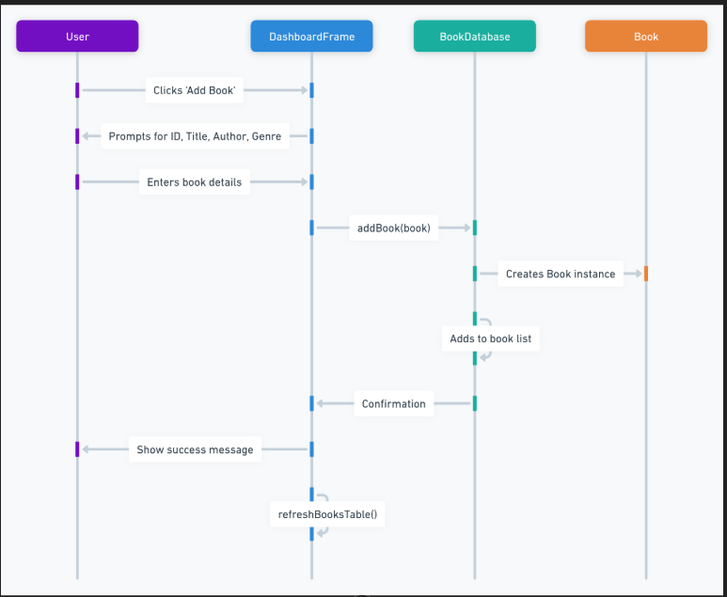

# Usecase 2:

# Logout

# Fully Adressed usecase:

|  |  |
| --- | --- |
| **Use Case Element** | **Details** |
| **Use Case Name** | Logout |
| **Use Case ID** | UC-03 |
| **Primary Actor** | Logged-in User |
| **Secondary Actors** | LoginFrame |
| **Brief Description** | This use case allows the user to securely logout and return to the login screen. |
| **Pre-conditions** | - System is running - User is logged in |
| **Post-conditions** | - Dashboard closed - Login screen shown |
| **Trigger** | User clicks the "Logout" button |
| **Main Flow** | 1. User clicks "Logout" 2. System asks for confirmation 3. User confirms 4. Dashboard closes and login screen opens |
| **Alternative Flow A1** | Condition: User cancels logout System Response: Stay on dashboard |
| **Business Rules** | - Logout must be confirmed before action is taken |
| **Exceptions** | - If frame closing or LoginFrame opening fails, show error dialog |

# Sequence diagram:

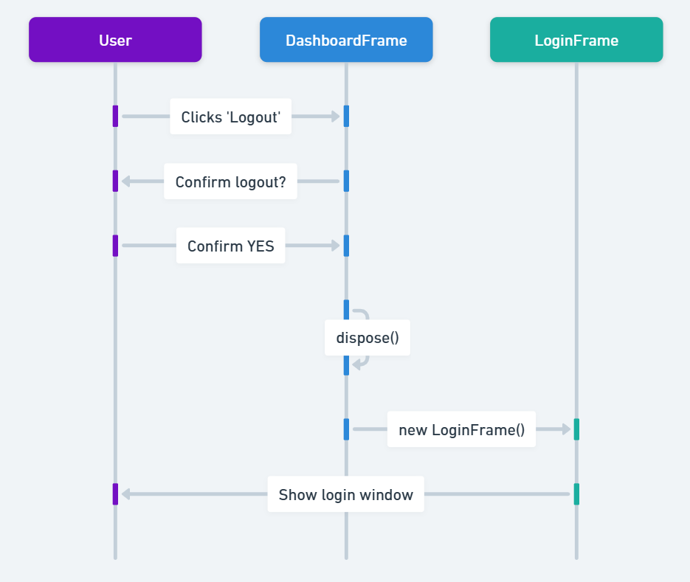

# Usecase 3:

# View All Books:

# Fully Adressed Usecase:

|  |  |
| --- | --- |
| **Use Case Element** | **Details** |
| **Use Case Name** | View All Books |
| **Use Case ID** | UC-02 |
| **Primary Actor** | Logged-in User |
| **Secondary Actors** | BookDatabase |
| **Brief Description** | This use case allows the user to view all books stored in the system. The books are displayed in a table on the dashboard. |
| **Pre-conditions** | - System is running - User is logged in - Book records exist in the system |
| **Post-conditions** | - Books displayed in table - If no books exist, table remains empty |
| **Trigger** | System loads dashboard OR user clicks “Refresh” |
| **Main Flow** | 1. System calls BookDatabase.getAllBooks() 2. Book list is fetched 3. Table is populated with book data |
| **Alternative Flow A1** | Condition: No books in database System Response: Show empty table |
| **Business Rules** | - All books with correct fields (ID, Title, Author, Genre, Availability) must be displayed |
| **Exceptions** | - If BookDatabase throws error, system shows error message |

# Sequence diagram:

