Lab 3B: Advanced Cybersecurity Risk Quantification
Name: Khadija Nafale Likoro
Registration Number: C11-CGRCE-17281 (GRC102)
Course: ICDFA Cohort 11
Date: 30 October 2026
Scenario: Lead GRC analyst at SecureBank Financial reviewing the SecureMobile banking platform.

Phase 1: Risk Exposure Calculation

Task 1: Annualized Loss Expectancy (ALE)
Formula: ALE = SLE x ARO
Vulnerability | SLE | ARO | ALE
1 API Authentication Bypass | $5000000 | 0.15 | $750000
2 Database Injection | 500000 records x $250 = $125000000 | 0.25 | $31250000
3 Session Hijacking | 5000 accounts x $1500 = $7500000 | 0.40 | $3000000
Total |  |  | $35000000

Task 2: Risk Priority Matrix
Vulnerability | SLE | ARO | ALE | Share of Total | Priority
Database Injection | $125000000 | 0.25 | $31250000 | 89.3% | CRITICAL
Session Hijacking | $7500000 | 0.40 | $3000000 | 8.6% | HIGH
API Bypass | $5000000 | 0.15 | $750000 | 2.1% | MEDIUM

Task 3: Risk Visualizations
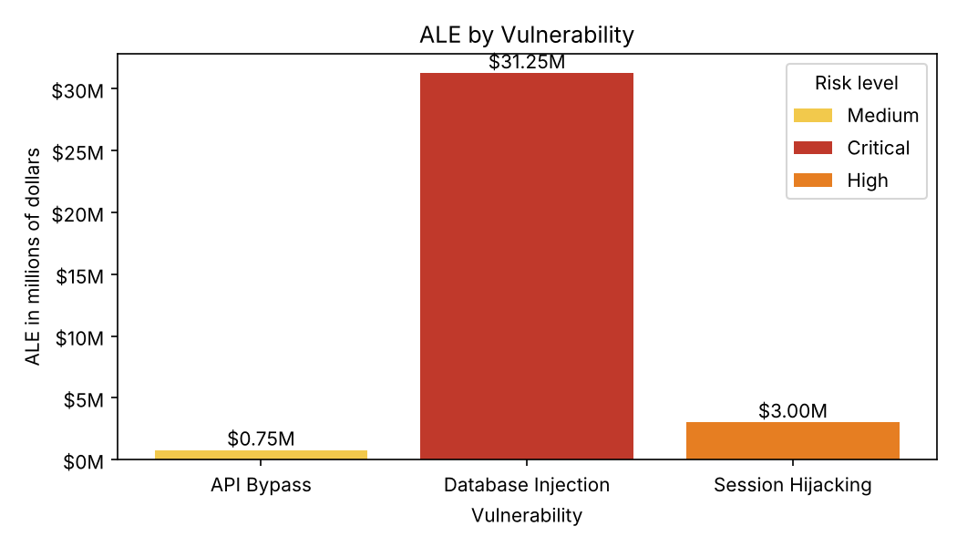
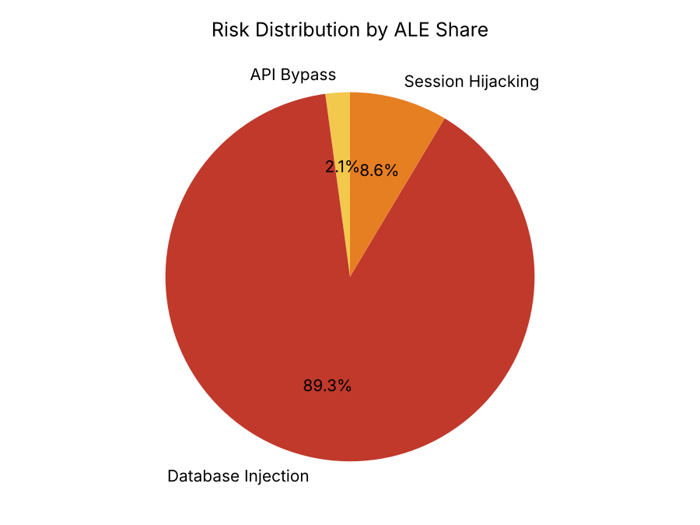
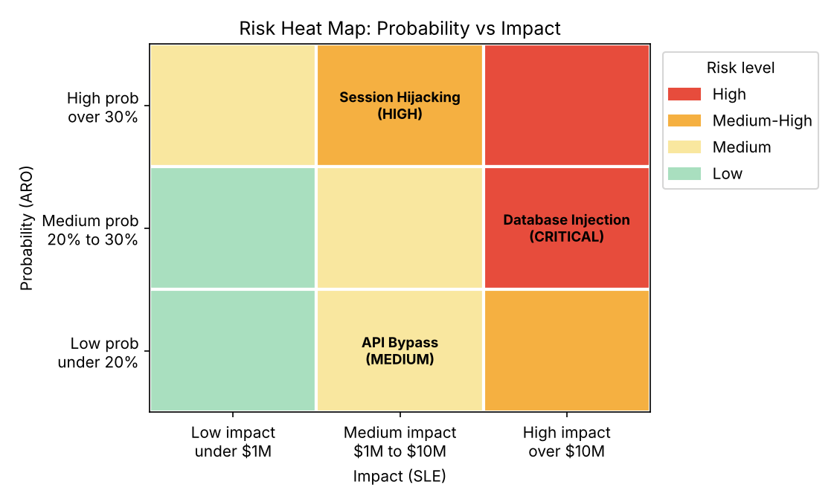
Database Injection alone makes up 89.3% of the total risk so it needs attention first.

Phase 2: Control Evaluation

Task 4: Cost-Benefit Analysis
Each control is matched to the risk it protects against. The API Gateway protects Finding 1 (90%). The WAF protects Finding 2 (75%). MFA protects Finding 3 (95%).
- Year 1 cost = Initial investment + Annual maintenance
- ROI = (Risk reduction - Year 1 cost) / Year 1 cost
- Payback period = Initial investment / (Risk reduction - Maintenance)
Control | Initial | Maintenance per Year | Risk Reduction per Year | ROI | Payback
API Gateway | $350000 | $50000 | $750000 x 0.90 = $675000 | ($675000 - $400000) / $400000 = 68.75% | 350000 / 625000 = 0.56 years (about 7 months)
WAF | $150000 | $25000 | $31250000 x 0.75 = $23437500 | ($23437500 - $175000) / $175000 = 13293% | About 2 days
MFA Enhancement | $200000 | $30000 | $3000000 x 0.95 = $2850000 | ($2850000 - $230000) / $230000 = 1139% | About 26 days

Task 5: Control Selection Analysis
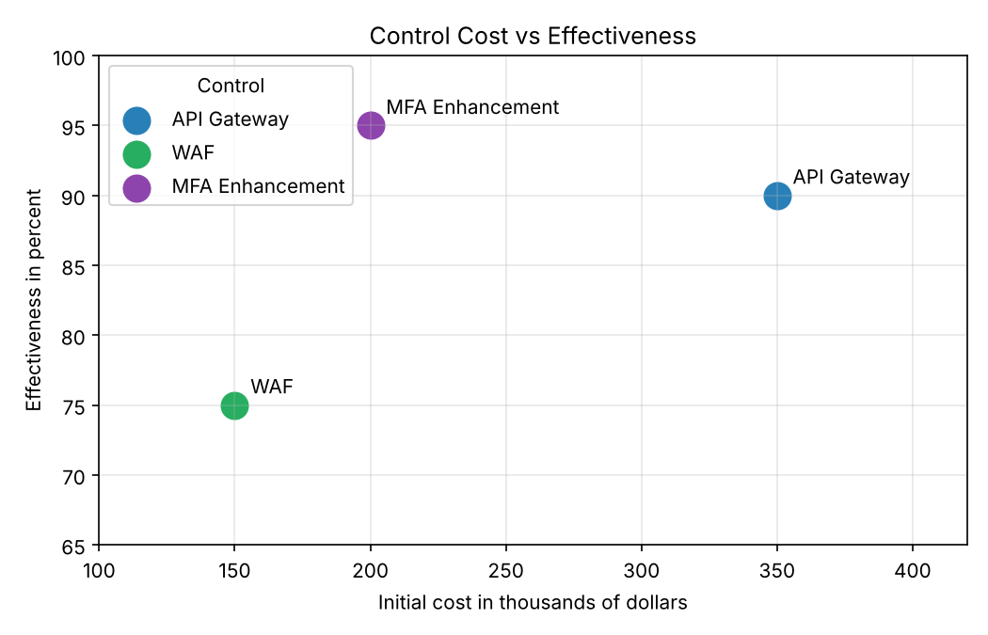
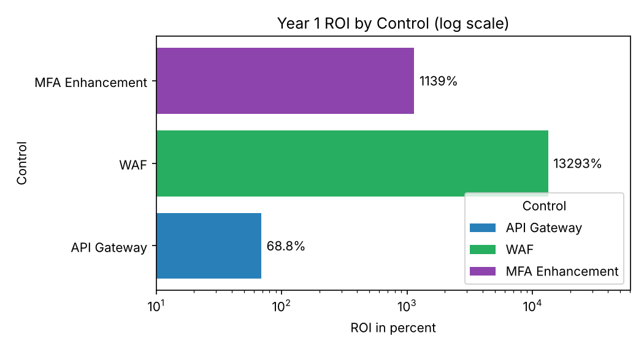
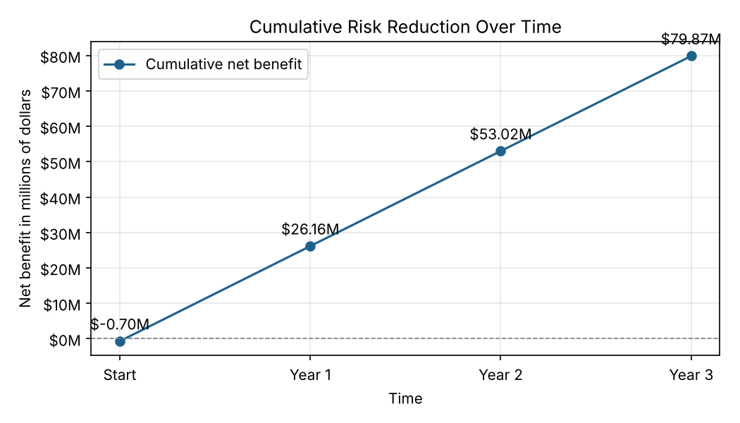
The cumulative line uses an upfront cost of $700000 and a yearly net gain of $26962500 less $105000 maintenance which is $26857500 per year. Year 1 = -$700000 + $26857500 = $26157500.

Phase 3: Executive Reporting

Task 6: Executive Dashboard
Top 3 Risks
- Database Injection: $31.25 million per year
- Session Hijacking: $3.0 million per year
- API Bypass: $0.75 million per year
Recommended Controls and Costs
- WAF: $150000 upfront and $25000 per year
- MFA Enhancement: $200000 upfront and $30000 per year
- API Security Gateway: $350000 upfront and $50000 per year
- Total: $700000 upfront and $105000 per year
Expected Risk Reduction
- ALE before controls: $35000000
- ALE after controls: $8037500
- Reduction: $26962500 (77%)
Overall Year 1 ROI = ($26962500 - $805000) / $805000 = 3249%
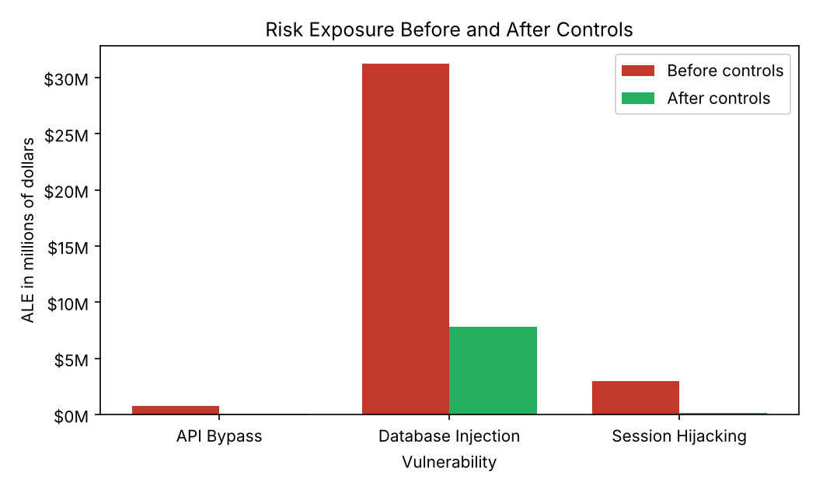
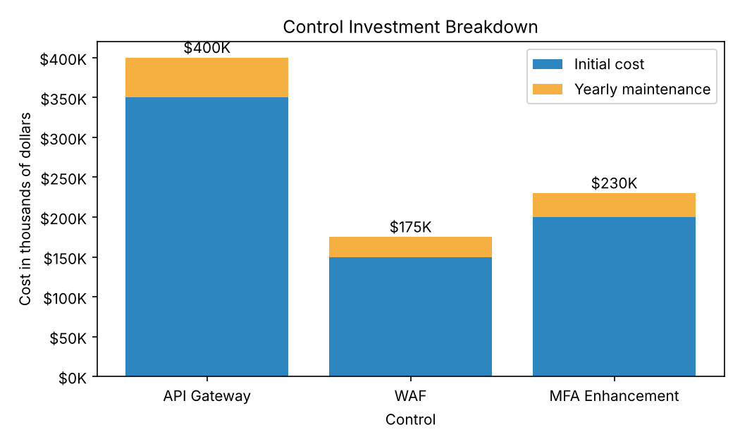
Before and after ALE values: API Bypass $750000 to $75000. Database Injection $31250000 to $7812500. Session Hijacking $3000000 to $150000.

Task 7: Risk Treatment Timeline
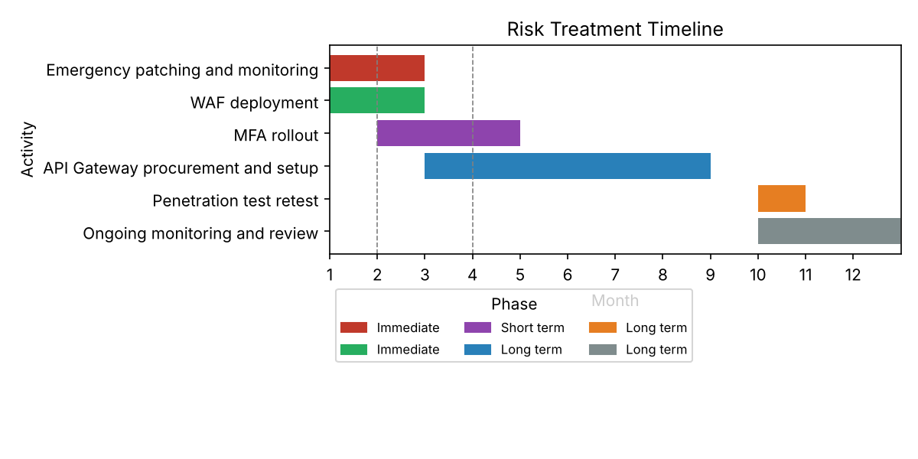
- First 30 days: emergency patching and WAF deployment and better monitoring to cut the 48 hour detection time
- Within 90 days: WAF finished and MFA rolled out
- Within 1 year: API Gateway live and penetration test retest done and quarterly reviews

Bonus Challenge: Risk-Control Matrix
Risk | Current ALE | Control | Residual ALE | Reduction
API Bypass | $750000 | API Gateway ($400000 in Year 1) | $75000 | $675000
Database Injection | $31250000 | WAF ($175000 in Year 1) | $7812500 | $23437500
Session Hijacking | $3000000 | MFA ($230000 in Year 1) | $150000 | $2850000
Total | $35000000 | $805000 | $8037500 | $26962500

Optimal control selection by budget:
Upfront Budget | Best Choice | Risk Reduction
Up to $150000 | WAF only | $23437500
Up to $350000 | WAF + MFA | $26287500
$700000 or more | All three controls | $26962500

The WAF gives by far the best return because the database injection risk is so large. MFA comes next. The API Gateway costs the most for the least gain but it still pays back in about 7 months so I recommend all three if the budget allows. Residual risk is $8037500 per year and most of it is the leftover 25% of the injection risk.

