

Computer Programming for Engineering

Python Project Report 2

Name: Khadijatu Nayi Alhassan

Student ID: 73692022

Date due: March 31, 2019.

**Introduction:**

This project is based on calculating probability using the Normal distribution, Poisson, Exponential and Geometric distribution. I chose this project because I wanted to apply the knowledge I acquired from taking A-level Statistics to help other students.

**Application of knowledge:**

The whole project is defined in a class named Probability, with five methods namely: normal_dist1, normal_dist2, geometric, exponential and poisson. Apart from the python in-built math module, I installed other libraries including sympy, numpy and matplotlib.

I installed these libraries by typing pip install (name of the library) in the command prompt. The constructor has no parameters but has three instance variables: self. constant, self. f_x and self.x, the independent variable in f_x. The product of self.f_x and self. constant gives the Probability Density Function of the normal distribution.

The first method, normal_dist1 takes mean, standard deviation and x1. The mean and standard deviation are characteristics of the normal distribution and x1 is a value in the data set. Normal_dist1 calculates the probability for a one-tail case. The limit of integration apart from infinity is the z-value which is calculated as z = x1 – mean/standard deviation. Below is an illustration of a one-tail case:

Fig.1

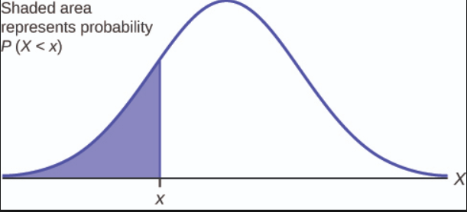

The other method for normal distribution is normal_dist2, which also works just like normal_dist1. The only difference is that it is used for calculating the probability in a two-tail case, thus it has two limits of integration. It takes mean, standard deviation, x1 and x2 as parameters. Below is an illustration of a two-tail case:

Fig.2

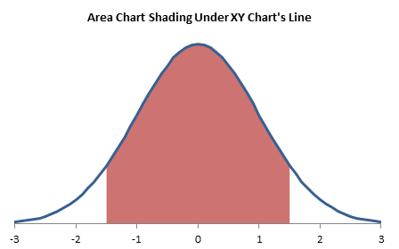

In executing normal_dist2, I used list methods max and min which is under chapter 4, page 129of the python book.

The next method is geometric, and it takes p, probability of success and x1, a value in the data set as parameters. It returns the probability based on calculation with the geometric distribution equation p(X>x) = (1-p) x1. This equation changes depending on the probability, whether greater than, less than, greater than or equal to, etc. It also calculates and returns the expectation and variance of the geometric distribution.

The probability of an exponential distribution is calculated using the formula 𝑃 (𝑋 < 𝑥) = **1** − e−λx. The exponential method takes L, x1 and sometimes x2 as the parameters. L corresponds to the Greek symbol lambda, which is the mean of the exponential distribution. X1 and x2 are values in the data set of the exponential distribution. The user chooses if he wants the probability calculated with one value of two values, so I made x2 a keyword argument. In the case where the user wants the probability with just one value, x2 is assigned None. Here I used selection statements which is under chapter 2, page 67. In this case, only probability of less than and greater than this value is calculated, with expected value and variance of the exponential distribution. In the case where the user wants to input two values, x2 is assigned a value and the probability between two limits is calculated.

The Poisson distribution uses the formula P (x; μ) = (e-μ) (μx) / x! The method poisson takes L which is the mean and x1, a value in the data set of the poisson distribution. In the method, I used for loops, which is under chapter 1, page 33 and accumulator pattern under chapter 2, page 54.

The calculations in each method is returned in a dictionary, applied from chapter 4, page 135.

References

Fig.1

One tail normal distribution. Retrieved from <https://www.google.com/search?rlz=1C1EJFC_enGH817GH817&tbm=isch&q=one+tail+normal+distribution&chips=q:one+tail+normal+distribution,online_chips:standard&usg=AI4_-kRqxTw3XirCj2mnT8l5cC2Ve-EOPw&sa=X&ved=0ahUKEwixx9KByKzhAhVIz4UKHcX1D88Q4lYIJygB&biw=1486&bih=631&dpr=1.25#imgdii=F878nAumj4lufM:&imgrc=lKv3-pxVNaLLpM>:

Fig.2

Normal distribution between two values. Retrieved from <https://www.google.com/search?rlz=1C1EJFC_enGH817GH817&tbm=isch&sa=1&ei=28ugXMrIHsGalwTz4qeICA&q=normal+distribution+between+two+values&oq=normal+distribution+betwee&gs_l=img.1.0.0j0i24l9.34655.41153..45058...0.0..1.316.2858.0j3j6j3......1....1..gws-wiz-img.......0i7i30j0i8i7i30j35i39j0i67j0i8i30.vAOUvlRsRpk#imgdii=fEOCnsJmhNm5YM:&imgrc=axiQ3kigzj58WM>: